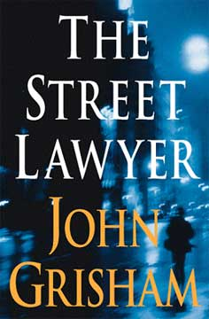 The Street Lawyer
Michael was in a hurry. He was scrambling up the ladder at Drake& Sweeney, a giant D.C. firm with eight hundred lawyers. But a violent encounter with a homeless man stopped him cold. Michael survived, but his assailant did not. Who was this man? Michael did some digging, and learned that he was a mentally ill veteran who’d been in and out of shelters for many years. Then Michael dug a little deeper, and found a dirty secret, and the secret involve Drake & Sweeney.
The fast track derailed; the ladder collapsed. Michael bolted from the firm and took a top-secret file with him. He landed in the streets, an advocate for the homeless, a street lawyer.
(Taken from the cover of The Street Lawyer.)

