THE POWER OF THE DRAGON
Develop Strength Bruce Lee’s Way.
By: Justin Frost and Ted Wong.
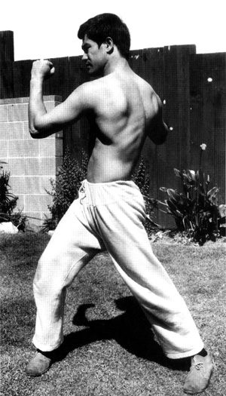
Bruce Lee E-Paper – I
Published by – The Wrong Brothers
Click Here to Visit our Home page
Email – wrongbrothers@yahoo.com

Did Bruce Lee take his training seriously?
"While Bruce was in Hong Kong filming in late 1971 or early 1972, he had his weight equipment and training gear shipped to him," says Ted Wong, who met Lee in 1967 and trained with him for more than six years. "He wanted to stay in shape. So we packed his bags, but we did not send any clothes because he said he could buy them cheap in Hong Kong. We just packed training equipment. When he saw all the bags filled with training equipment, he laughed and said, ‘Now I’m going to be able to do lots of training.’"
And train he did.
"Bruce considered training number one," says Wong. "He was constantly training. When he watched TV or went to the movies, he conditioned his knuckles. When he was driving, he worked the hand grips. If he walked to a bookstore and came to a hill, he always ran. He never wasted time."
Why was this man so obsessed with training? Several reasons.
First, according to Lee, training was important because you couldn’t perform up to your capabilities if you weren’t in shape, Wong recalls.
"Lee felt you had no business being in the martial arts if you weren’t in shape," says Wong. "If you weren’t in shape you couldn’t be 100 percent efficient."
Second, he had lofty goals.
"He wanted to be the best," says Wong. "He wanted to be the best martial artist."
And no one could dispute that he was.
Lee’s Thoughts on Strength
To get in excellent shape, Lee felt you needed strength, Wong notes.
"He considered strength training very important," Wong says. "He was constantly looking for ways to improve, including weight training and isometrics."
Although Lee felt strength was important, he did not believe bodybuilding was the answer, Wong says.
"He felt it was important to have definition, but he did not feel you had to overboard," Wong says. "He did not feel it was necessary to develop large muscles. On the other hand, strength and definition enhanced certain functions, such as kicking and punching."
And Lee’s conditioning entailed more than hand grips, sit-ups, weights, running and conditioning drills.
"A lot of the time he read books and analyzed different arts," Wong says. "He had a keen eye and an analytical mind. He did a lot of researching."
While you may never develop Lee’s skills, you can certainly train the way the "Little Dragon" did. Following are a few of the exercises Lee used to develop power.

Lee’s Strength Routine

Barbell Push
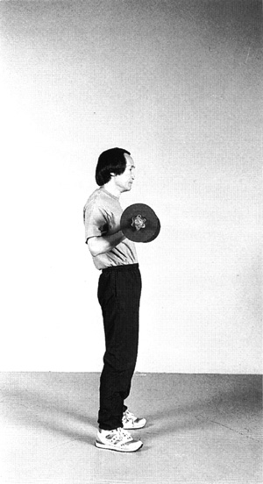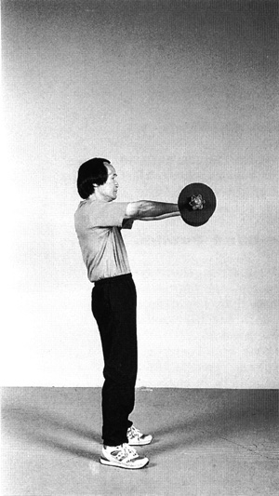
This exercise strengthens your arms, forearms, shoulders, biceps, lats, triceps, chest and abs.
"This exercise works almost your whole body," Wong says. "It’s really good; it’s effective. But it is also very difficult. Although Bruce lifted a lot of weight, most people can’t. I remember trying to lift what he used, and I couldn’t even hold it."
To begin, stand with your feet slightly wider than shoulder width. Squat, grab the barbell with an underhand grip and stand up. Keeping your elbows by your side, raise the weight straight out, hold for a second, return and repeat.
Do three sets of 8 to 12 repetitions. When you’re done, do three sets of 8 to 12 reps with an overhand grip.

Punching With a Dumbbell
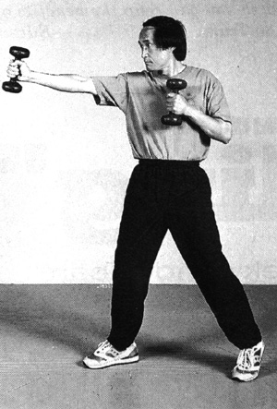
This exercise improves your shoulder endurance, which is vital for sparring.
"Bruce did this drill a lot." Wong says.
Hold a five-pound dumbbell in each hand, assume a fighting stance and alternate throwing punches with each hand.
"Do these moderately fast," Wong says.
To prevent an injury, however, don’t throw your punches too fast. Do two to three sets, 10 to 15 reps per set.

One-Hand Dumbbell Drill
This drill strengthens your wrist, which means your punches will be stronger. Lee used this exercise to enhance his one-inch punch, Wong notes.
"When your wrist is strong, you get more power," he says. "And it’s good when you’re in close range because there isn’t much room for your wrist to travel. This is a good drill for the one-inch punch."
To begin, stand with your feet about shoulder-width apart, and hold a five-pound dumbbell in your right hand. Keeping your arm to your side and using only your wrist, raise the dumbbell as high as you can and lower it as far as you can.
Do two sets of 25 reps. When you’re done, do two sets of 25 reps, moving your wrist from side to side as far as you can.

Isometrics
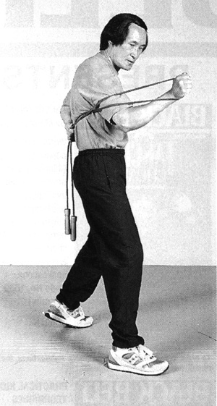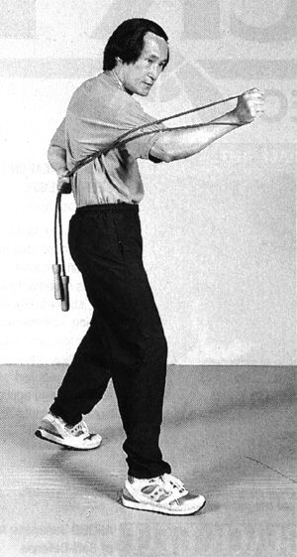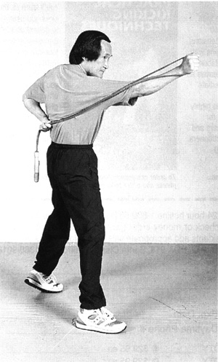
"This is isometric training for power punching," Wong says. "It was one of Lee’s favorite drills because it built speed and punching power at different ranges."
To do this, you can use a jump rope, a karate belt or a strand of rope.
To begin, assume a fighting stance and hold the rope in both hands. Place your left hand behind your back, wrap the other end around your shoulder and throw a short-range punch. Hold it for five seconds, extend your punch to ¾ distance, hold it for five seconds, extend it to full range and hold.
For each arm, do five sets of five reps.

Board Isometrics
This drill is for leg strength and mobility.
"This exercise really puts pressure on your knees," he says. "It’s intense."
To do this drill, you’ll need a four-foot long board with a shoulder harness strapped in the middle.
To begin, assume a fighting stance on the board and place the harness around your neck. Exerting a constant upward pressure, lean forward and then lean back.
"This drill enables you to develop explosive power and to close the gap [more efficiently]," He says.
Do three sets of one minute. As you improve, increase your time.

Hand Isometric Drills
This drill strengthens your forearms, which is great for trapping and punching.
You will need the board for this exercise also. Stand with your feet shoulder-width apart, wrap the straps around your forearms and exert pressure upward.
Do three sets of one minute. Don’t rest more than one minute between sets.

Bull Worker for Punching
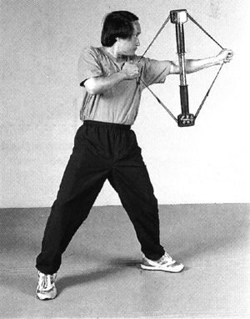
This drill also strengthens your punching power.
To do this drill, you’ll need a Bull Worker, which you may be able to find at a sporting goods store.
Assume a fighting stance, hold the bow straps in each hand, and throw as many punches as you can, as fast as you can.
"Do these real fast, and do as many as you can," Wong says.
Do two to three sets. You can throw backfists or straight punches. This device also enables you to adjust the tension.

Bull Worker for Trapping
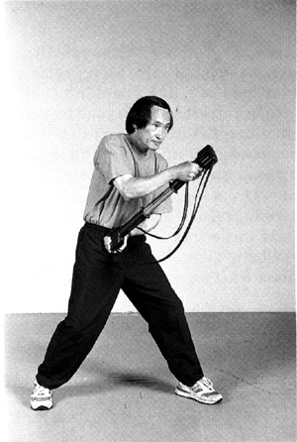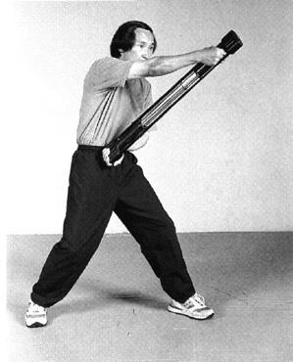
Again, you will also need the Bull Worker for this drill, which strengthens your forearms for trapping, grabbing and hitting.
Assume a fighting stance, place one end of the Bull Worker against your abs, and hold the other end at about head-height. As quickly as possible, pull the top part toward your abs, return and repeat.

What Made Bruce Great?
So what made Bruce Lee as great as he was?
Strength training? Genetics? Intensity?
"I think there are a lot of factors, but I think it was his drive," Wong says. "For example, he always told me you had to put 100 % effort into everything you did. He said, ‘When you throw a punch, put everything into it. Don’t just go through the motions.’ To this day I remember that, and it’s very important to me."

Important Note

This is the first E-Paper on Bruce Lee released by The Wrong Brothers. We will soon release the second E-Paper on Bruce Lee And Jeet Kune Do as soon as we have some new material on Bruce Lee. Our dream is to compile an E-book that contains all the information on Bruce Lee and Jeet Kune Do. So if you have any information on Bruce Lee or his exercises, then please contact me at wrongbrothers@yahoo.com . We will put it in our next E-Paper along with your name. All you Bruce Fans let’s join our hands together and publish an E-Book on Bruce that has never been compiled before. Come and be a member of Bruce Lee's P2P (Peer to Peer) Community.
Please Share Any Information or Exercises about Bruce Lee over P2P Networks (Kazzaa, Morpheus, Grokster, File Share, etc…)

– The Wrong Brothers, 12th Aug 2002

