**George Walton Lucas, Jr. 1944 –**

<http://en.wikipedia.org/wiki/George_Lucas>

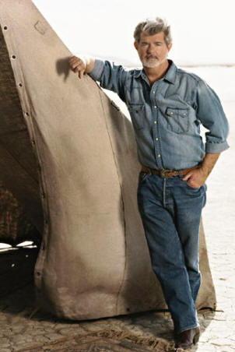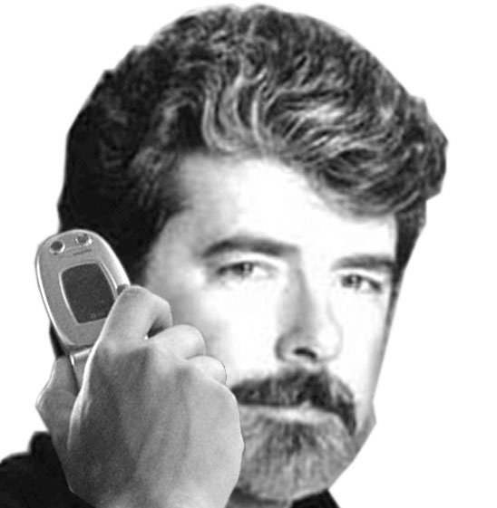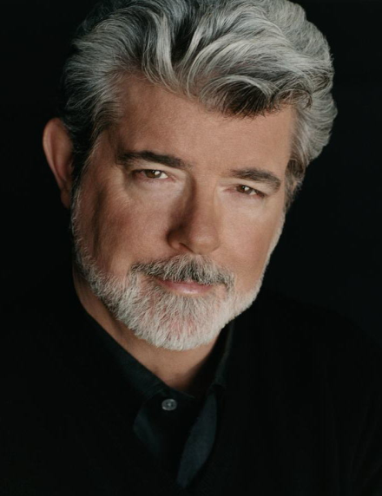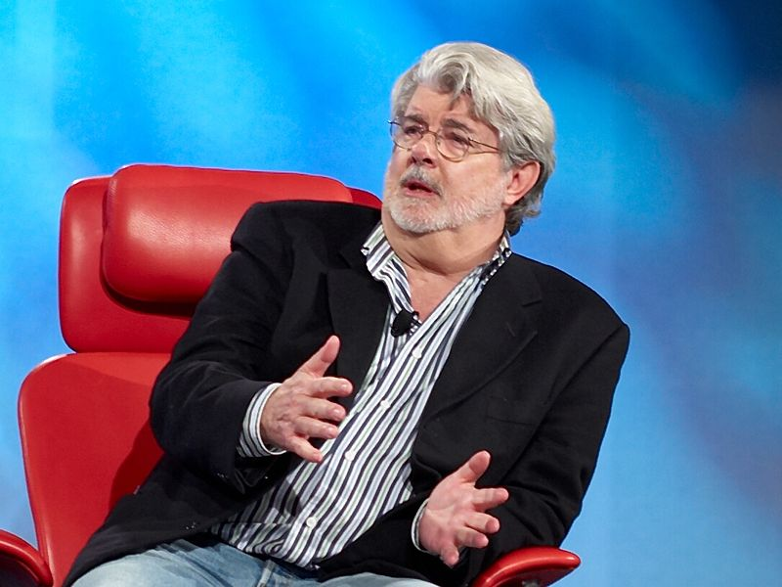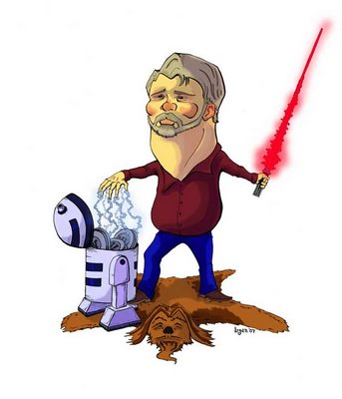

**George Walton Lucas, Jr.** (born [May 14](http://en.wikipedia.org/wiki/May_14), [1944](http://en.wikipedia.org/wiki/1944)) is an [Academy Award](http://en.wikipedia.org/wiki/Academy_Award)-nominated [American](http://en.wikipedia.org/wiki/United_States) [film director](http://en.wikipedia.org/wiki/Film_director), [producer](http://en.wikipedia.org/wiki/Film_producer), [screenwriter](http://en.wikipedia.org/wiki/Screenwriter) and [chairman](http://en.wikipedia.org/wiki/Chairman) of [Lucasfilm](http://en.wikipedia.org/wiki/Lucasfilm). He is the creator of the [epic](http://en.wikipedia.org/wiki/Epic_film) [*Star Wars*](http://en.wikipedia.org/wiki/Star_Wars) saga and the archaeologist-adventurer character [Indiana Jones](http://en.wikipedia.org/wiki/Indiana_Jones). Today, Lucas is one of the American film industry's most financially successful [independent](http://en.wikipedia.org/wiki/Independent_film) directors/producers, with an estimated net worth of $3.6 billion.[[1]](http://en.wikipedia.org/wiki/George_Lucas#cite_note-0)

|  |
| --- |
| Contents    * [1 Biography](http://en.wikipedia.org/wiki/George_Lucas" \l "Biography)   + [1.1 Early life and education](http://en.wikipedia.org/wiki/George_Lucas#Early_life_and_education)   + [1.2 Film career](http://en.wikipedia.org/wiki/George_Lucas#Film_career)   + [1.3 Awards, donations and other activities](http://en.wikipedia.org/wiki/George_Lucas#Awards.2C_donations_and_other_activities)   + [1.4 Personal life](http://en.wikipedia.org/wiki/George_Lucas#Personal_life) * [2 Filmography](http://en.wikipedia.org/wiki/George_Lucas#Filmography)   + [2.1 Student at USC (1965 to 1968)](http://en.wikipedia.org/wiki/George_Lucas#Student_at_USC_.281965_to_1968.29) * [3 Further reading](http://en.wikipedia.org/wiki/George_Lucas#Further_reading) * [4 References](http://en.wikipedia.org/wiki/George_Lucas#References) * [5 External links](http://en.wikipedia.org/wiki/George_Lucas#External_links) |

## [] Biography

### [] Early life and education

Lucas was born in [Modesto](http://en.wikipedia.org/wiki/Modesto), [California](http://en.wikipedia.org/wiki/California), the son of Dorothy Ellinore ([née](http://en.wikipedia.org/wiki/Married_and_maiden_names) Bomberger) and George Walton Lucas, Sr. (1913–1991), who owned a stationery store.[[2]](http://en.wikipedia.org/wiki/George_Lucas#cite_note-1) His father was mainly of British and [Swiss](http://en.wikipedia.org/wiki/Swiss_%28people%29)-[German](http://en.wikipedia.org/wiki/Germans) heritage and his mother, a member of a prominent Modesto family (one of her cousins is the mother of former U.S. Secretary of Agriculture and director of UNICEF [Ann Veneman](http://en.wikipedia.org/wiki/Ann_Veneman)), was mainly of [German](http://en.wikipedia.org/wiki/Germans) and [Scots](http://en.wikipedia.org/wiki/Scottish_people)-[Irish](http://en.wikipedia.org/wiki/Irish_people) heritage.[[*citation needed*](http://en.wikipedia.org/wiki/Wikipedia:Citation_needed)]

His parents sold retail office supplies and owned a walnut ranch in California. His experiences growing up in the sleepy suburb of Modesto and his early passion for cars and motor racing would eventually serve as inspiration for his Oscar-nominated low-budget phenomenon, [*American Graffiti*](http://en.wikipedia.org/wiki/American_Graffiti). Before young Lucas became obsessed with the movie camera, he wanted to be a race car driver, but a near fatal accident in his souped-up [Autobianchi Bianchina](http://en.wikipedia.org/wiki/Autobianchi_Bianchina) just days before his high school graduation quickly changed his mind. Instead, he attended [community college](http://en.wikipedia.org/wiki/Community_college) and developed a passion for cinematography and camera tricks.

During this time an [experimental filmmaker](http://en.wikipedia.org/wiki/Experimental_film) named [Bruce Baillie](http://en.wikipedia.org/wiki/Bruce_Baillie) tacked up a bedsheet in his backyard in 1960 to screen the work of [underground](http://en.wikipedia.org/wiki/Underground_film), [avant-garde](http://en.wikipedia.org/wiki/Avant-garde) 16 mm filmmakers like [Jordan Belson](http://en.wikipedia.org/wiki/Jordan_Belson), [Stan Brakhage](http://en.wikipedia.org/wiki/Stan_Brakhage) and [Bruce Conner](http://en.wikipedia.org/wiki/Bruce_Conner). For the next few years, Baillie's series, dubbed [Canyon Cinema](http://en.wikipedia.org/wiki/Canyon_Cinema), toured local coffeehouses.

These events became a magnet for the teenage Lucas and his boyhood friend John Plummer. The 19-year-olds began slipping away to San Francisco to hang out in jazz clubs and find news of Canyon Cinema screenings in flyers at the City Lights bookstore. Already a promising photographer, Lucas became infatuated with these abstract films.

"That's when George really started exploring," Plummer recalls. "We went to a theater on Union Street that showed art movies, we drove up to San Francisco State for a film festival, and there was an old beatnik coffeehouse in Cow Hollow with shorts that were really out there." It was a season of awakening for Lucas, who had been a D-plus slacker in high school.

At an autocross track, Lucas met his first mentor in the film industry - famed [cinematographer](http://en.wikipedia.org/wiki/Cinematographer) [Haskell Wexler](http://en.wikipedia.org/wiki/Haskell_Wexler), a fellow aficionado of sleek racing machines. Wexler was impressed by the way the shy teenager handled a camera, cradling it low on his hips to get better angles. "George had a very good eye, and he thought visually," he recalls.

Lucas then transferred to the [University of Southern California](http://en.wikipedia.org/wiki/University_of_Southern_California) [School of Cinematic Arts](http://en.wikipedia.org/wiki/USC_School_of_Cinematic_Arts). USC was one of the earliest universities to have a school devoted to [motion picture film](http://en.wikipedia.org/wiki/Motion_picture_film). During the years at USC, George Lucas shared a dorm room with [Randal Kleiser](http://en.wikipedia.org/wiki/Randal_Kleiser). Lucas was deeply influenced by the Filmic Expression course taught at the school by filmmaker [Lester Novros](http://en.wikipedia.org/wiki/Lester_Novros) which concentrated on the non-narrative elements of Film Form like color, light, movement, space, and time. Another huge inspiration was the Serbian montagist (and dean of the USC Film Department) [Slavko Vorkapich](http://en.wikipedia.org/wiki/Slavko_Vorkapich) who had been a colleague of [Sergei Eisenstein](http://en.wikipedia.org/wiki/Sergei_Eisenstein)'s before moving to Hollywood to make stunning [montage](http://en.wikipedia.org/wiki/Montage) sequences for studio features at [MGM](http://en.wikipedia.org/wiki/MGM) and [Paramount](http://en.wikipedia.org/wiki/Paramount_Pictures). Vorkapich taught the autonomous nature of the cinematic art form, emphasizing the unique dynamic quality of movement and kinetic energy inherent in motion pictures.

Lucas saw many inspiring movies in class, particularly the visual films coming out of the [National Film Board of Canada](http://en.wikipedia.org/wiki/National_Film_Board_of_Canada) like [Arthur Lipsett](http://en.wikipedia.org/wiki/Arthur_Lipsett)'s [21-87](http://en.wikipedia.org/wiki/21-87), the French-Canadian [cameraman](http://en.wikipedia.org/wiki/Cameraman) [Jean-Claude Labrecque](http://en.wikipedia.org/wiki/Jean-Claude_Labrecque)'s [cinéma vérité](http://en.wikipedia.org/wiki/Cin%C3%A9ma_v%C3%A9rit%C3%A9) *60 Cycles*, the work of [Norman McLaren](http://en.wikipedia.org/wiki/Norman_McLaren), and the documentaries of [Claude Jutra](http://en.wikipedia.org/wiki/Claude_Jutra). Lucas fell madly in love with [pure cinema](http://en.wikipedia.org/wiki/Pure_cinema) and quickly became prolific at making 16 mm nonstory noncharacter visual tone poems and [cinema verite](http://en.wikipedia.org/wiki/Cinema_verite) with such titles as *Look At Life*, *Herbie*, *1:42.08*, *The Emperor*, *Anyone Lived in a Pretty (how) Town*, *filmmaker*, and *6-18-67*. He was passionate and interested in camerawork and ing, defining himself as a filmmaker as opposed to being a director, and he loved making abstract visual films that create emotions purely through cinema. [[3]](http://en.wikipedia.org/wiki/George_Lucas#cite_note-2)

After graduating with a bachelor of [fine arts](http://en.wikipedia.org/wiki/Fine_arts) in film in 1967, he tried joining the [United States Air Force](http://en.wikipedia.org/wiki/United_States_Air_Force) as an officer, but was turned down because of his numerous speeding tickets. He was later drafted by the Army, but tests showed he had [diabetes](http://en.wikipedia.org/wiki/Diabetes), the disease that killed his paternal grandfather. Lucas was prescribed medication for the disease, but his symptoms are sufficiently mild that he does not require insulin and would not be considered diabetic under the disease's current classification. Is this type II? Not needing insulin does not mean he is not diabetic. He may have type II diabetes. Please clarify since this does not present an accurate representation of diabetes. Type I diabetics cannot have mild symptoms and must always use insulin for the rest of their lives.[*[dubious](http://en.wikipedia.org/wiki/Wikipedia:Disputed_statement" \o "Wikipedia:Disputed statement) –* [*discuss*](http://en.wikipedia.org/wiki/Talk:George_Lucas#Diabetes_-_misleading_statement)][[4]](http://en.wikipedia.org/wiki/George_Lucas#cite_note-3)

In 1967, Lucas re-enrolled as a USC graduate student in film production. Working as a teaching instructor for a class of [U.S. Navy](http://en.wikipedia.org/wiki/U.S._Navy) students who were being taught documentary cinematography, Lucas directed the short film [*Electronic Labyrinth: THX 1138 4EB*](http://en.wikipedia.org/wiki/Electronic_Labyrinth:_THX_1138_4EB), which won first prize at the 1967-68 National Student [Film Festival](http://en.wikipedia.org/wiki/Film_festival), and was later adapted into his first full-length [feature film](http://en.wikipedia.org/wiki/Feature_film), [*THX 1138*](http://en.wikipedia.org/wiki/THX_1138). Lucas was awarded a scholarship by [Warner Brothers](http://en.wikipedia.org/wiki/Warner_Brothers) to observe the making of [*Finian's Rainbow*](http://en.wikipedia.org/wiki/Finian%27s_Rainbow_%28film%29) (1968) which was being directed by [Francis Ford Coppola](http://en.wikipedia.org/wiki/Francis_Ford_Coppola), who at the time was revered among film school students of the time as a cinema graduate who had "made it".

### [] Film career

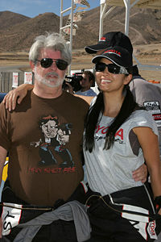

[Kelly Hu](http://en.wikipedia.org/wiki/Kelly_Hu) with George Lucas, [Willow Springs Raceway](http://en.wikipedia.org/wiki/Willow_Springs_Raceway), [CA](http://en.wikipedia.org/wiki/California). The shirt worn by Lucas says, "Han shot first."

Lucas co-founded the studio [American Zoetrope](http://en.wikipedia.org/wiki/American_Zoetrope) with Coppola—whom he met during his internship at Warner Brothers—hoping to create a liberating environment for filmmakers to direct outside the perceived oppressive control of the Hollywood [studio system](http://en.wikipedia.org/wiki/Studio_system). His first full-length feature film produced by the studio, [THX1138](http://en.wikipedia.org/wiki/THX1138) was not a success, but his second was: [*American Graffiti*](http://en.wikipedia.org/wiki/American_Graffiti) (1973). He then proposed a new [Flash Gordon](http://en.wikipedia.org/wiki/Flash_Gordon) film adaptation, but the rights were not available. But his new-found wealth and reputation enabled him to develop his own story in space instead. Even so he encountered difficulties getting [*Star Wars*](http://en.wikipedia.org/wiki/Star_Wars_Episode_IV:_A_New_Hope) made. It was only because [Alan Ladd, Jr.](http://en.wikipedia.org/wiki/Alan_Ladd,_Jr.) at [Fox Studios](http://en.wikipedia.org/wiki/Fox_Studios) liked *American Graffiti* that he forced through a production and distribution deal for the film, which ended up restoring Fox to financial stability after a number of flops.[[5]](http://en.wikipedia.org/wiki/George_Lucas#cite_note-4)

On a return on investment basis, *Star Wars* proved to be one of the most successful films of all time. During the filming of *Star Wars*, Lucas [waived his up front fee](http://en.wikipedia.org/wiki/List_of_incidents_famously_considered_great_blunders#Business) as director and negotiated to own the licensing rights — rights which the studio thought were nearly worthless. This decision earned him hundreds of millions of dollars, as he was able to directly profit from all the licensed games, toys, and collectibles created for the franchise.

Meanwhile, under the American Zoetrope banner Lucas developed [*Apocalypse Now*](http://en.wikipedia.org/wiki/Apocalypse_Now) to direct after *Star Wars*, but work on the latter film dragged on, so Coppola took over directing *Apocalypse Now*, leading to the breakdown of the American Zoetrope partnership. However the money from *Star Wars* enabled Lucas to set up his own studio, [Lucasfilm](http://en.wikipedia.org/wiki/Lucasfilm), in [Marin County](http://en.wikipedia.org/wiki/Marin_County,_California) in his native Northern California. [Skywalker Sound](http://en.wikipedia.org/wiki/Skywalker_Sound) and [Industrial Light & Magic](http://en.wikipedia.org/wiki/Industrial_Light_%26_Magic), the sound and visual effects subdivisions of Lucasfilm, respectively, have become among the most respected firms in their fields. Lucasfilm Games, later renamed to [LucasArts](http://en.wikipedia.org/wiki/LucasArts), is highly regarded in the gaming industry.

The animation studio [Pixar](http://en.wikipedia.org/wiki/Pixar) was founded as the Graphics Group, one third of the Computer Division of [Lucasfilm](http://en.wikipedia.org/wiki/Lucasfilm). Pixar's early computer graphics research resulted in groundbreaking effects in films such as [*Star Trek II: The Wrath of Khan*](http://en.wikipedia.org/wiki/Star_Trek_II)[[6]](http://en.wikipedia.org/wiki/George_Lucas#cite_note-PixarStory-5) and [*Young Sherlock Holmes*](http://en.wikipedia.org/wiki/Young_Sherlock_Holmes),[[6]](http://en.wikipedia.org/wiki/George_Lucas#cite_note-PixarStory-5) and the group was purchased in 1986 by [Steve Jobs](http://en.wikipedia.org/wiki/Steve_Jobs) shortly after he left [Apple Computer](http://en.wikipedia.org/wiki/Apple_Inc). Jobs paid U.S. $5 million to Lucas and put U.S. $5 million as capital into the company. The sale reflected Lucas' desire to stop the cash flow losses associated with his 7-year research projects associated with new entertainment technology tools, as well as his company's new focus on creating entertainment products rather than tools. A contributing factor was cash flow difficulties following Lucas' 1983 divorce concurrent with the sudden drop off in revenues from [*Star Wars*](http://en.wikipedia.org/wiki/Star_Wars) licenses following the release of [*Return of the Jedi*](http://en.wikipedia.org/wiki/Star_Wars_Episode_VI:_Return_of_the_Jedi). (Some twenty years later on [January 24](http://en.wikipedia.org/wiki/January_24), [2006](http://en.wikipedia.org/wiki/2006), Disney announced that it had agreed to buy Pixar for approximately $7.4 billion in an [all-stock deal](http://en.wikipedia.org/wiki/Stock_swap).)

Lucas was also influential in the development of industry-standard post-production tools such as the Avid Film and Video nonlinear or, first developed as the Droid, and also the Sound Droid, which later became the Digidesign Pro Tools sound ing and mixing software.

Lucas and director [Steven Spielberg](http://en.wikipedia.org/wiki/Steven_Spielberg) enjoy a friendship that dates to their college years, and that has resulted in collaborations on films including the [Indiana Jones](http://en.wikipedia.org/wiki/Indiana_Jones) movies [*Raiders of the Lost Ark*](http://en.wikipedia.org/wiki/Raiders_of_the_Lost_Ark) (1981), [*Indiana Jones and the Temple of Doom*](http://en.wikipedia.org/wiki/Indiana_Jones_and_the_Temple_of_Doom) (1984), [*Indiana Jones and the Last Crusade*](http://en.wikipedia.org/wiki/Indiana_Jones_and_the_Last_Crusade) (1989), and [*Indiana Jones and the Kingdom of the Crystal Skull*](http://en.wikipedia.org/wiki/Indiana_Jones_and_the_Kingdom_of_the_Crystal_Skull) (2008).

On [October 3](http://en.wikipedia.org/wiki/October_3), [1994](http://en.wikipedia.org/wiki/1994), Lucas started to write the three *Star Wars* prequels, and on [November 1](http://en.wikipedia.org/wiki/November_1) that year, he left the day-to-day operations of his filmmaking business and started a sabbatical to finish the prequels.

In 2006 [*Forbes Magazine*](http://en.wikipedia.org/wiki/Forbes_Magazine) estimated Lucas' personal wealth at [US$](http://en.wikipedia.org/wiki/United_States_dollar) 3.5 billion. In 2005 Forbes.com estimated the lifetime revenue generated by the *Star Wars* franchise at nearly $20 billion.

He recently announced that he would produce a [TV series](http://en.wikipedia.org/wiki/Star_Wars_Live-Action_TV_Series) about Star Wars, which would take place between episodes III and IV. Lucas purportedly also recently announced that he plans on making two additional Star Wars films that will take place after *The Return of the Jedi*, but this rumor was debunked at Star Wars Celebration 4 in Los Angeles, California which took place May 24th-May 28th, 2007. When Steve Sansweet, Director of Content Management and Head of Fan Relations at Lucasfilm, was asked about the proposed two films post-*Return of the Jedi* he stated that it was a misunderstanding of what Lucas was explaining. According to Sansweet, Lucas was referring to the two Star Wars television projects currently in production: *Star Wars: Clone Wars* which is a CG animated show set to debut in the Fall of 2008, and the yet to be titled Star Wars live action television series set to debut in 2009.

### [] Awards, donations and other activities

In 1991, The George Lucas Educational Foundation was founded as a nonprofit operating foundation to celebrate and encourage innovation in schools. The Foundation's content is available under the brand [Edutopia](http://en.wikipedia.org/wiki/Edutopia), in an award-winning magazine, and via documentary films. Lucas, though his foundation, was one of the leading proponents of the [E-rate](http://en.wikipedia.org/wiki/E-rate) program in the [universal service fund](http://en.wikipedia.org/wiki/Universal_service_fund),[[7]](http://en.wikipedia.org/wiki/George_Lucas#cite_note-6) which was enacted as part of the [Telecommunications Act of 1996](http://en.wikipedia.org/wiki/Telecommunications_Act_of_1996). On June 24, 2008, Lucas testified before the [United States House of Representatives](http://en.wikipedia.org/wiki/United_States_House_of_Representatives) subcommittee on [Telecommunications and the Internet](http://en.wikipedia.org/wiki/United_States_House_Energy_Subcommittee_on_Telecommunications_and_the_Internet) as the head of his Foundation to advocate for a free wireless broadband educational network.[[8]](http://en.wikipedia.org/wiki/George_Lucas#cite_note-7).

The [American Film Institute](http://en.wikipedia.org/wiki/American_Film_Institute) awarded Lucas its [Life Achievement Award](http://en.wikipedia.org/wiki/AFI_Life_Achievement_Award) on [June 9](http://en.wikipedia.org/wiki/June_9), [2005](http://en.wikipedia.org/wiki/2005).[[9]](http://en.wikipedia.org/wiki/George_Lucas#cite_note-8) This was shortly after the release of [*Star Wars Episode III: Revenge of the Sith*](http://en.wikipedia.org/wiki/Star_Wars_Episode_III:_Revenge_of_the_Sith), to which he jokingly made reference in his acceptance speech, stating that, since he views the entire [Star Wars](http://en.wikipedia.org/wiki/Star_Wars) series as one movie, he could actually receive the award now that he had finally "gone back and finished the movie."

On [June 5](http://en.wikipedia.org/wiki/June_5), [2005](http://en.wikipedia.org/wiki/2005), Lucas was named 100th "[Greatest American](http://en.wikipedia.org/wiki/The_Greatest_American)" by the [Discovery Channel](http://en.wikipedia.org/wiki/Discovery_Channel).

Lucas was nominated for four Academy Awards: [Best Directing](http://en.wikipedia.org/wiki/Academy_Award_for_Directing) and [Writing](http://en.wikipedia.org/wiki/Academy_Award_for_Writing_Original_Screenplay) for *American Graffiti*, and [Best Directing](http://en.wikipedia.org/wiki/Academy_Award_for_Directing) and [Writing](http://en.wikipedia.org/wiki/Academy_Award_for_Writing_Original_Screenplay) for *Star Wars*. He also received the Academy's [Irving G. Thalberg Award](http://en.wikipedia.org/wiki/The_Irving_G._Thalberg_Memorial_Award) in 1991. He appeared at the 79th Academy Awards ceremony in 2007 with Steven Spielberg and Francis Ford Coppola to present the [Best Director award](http://en.wikipedia.org/wiki/Oscar_for_Best_Director) to their friend [Martin Scorsese](http://en.wikipedia.org/wiki/Martin_Scorsese). During the speech, Spielberg and Coppola talked about the joy of winning an Oscar, making fun of Lucas, who has not won a competitive Oscar.

In 2005, Lucas gave [US$](http://en.wikipedia.org/wiki/United_States_dollar)1 million to help build the [Martin Luther King, Jr. National Memorial](http://en.wikipedia.org/wiki/Martin_Luther_King,_Jr._National_Memorial) on the [National Mall](http://en.wikipedia.org/wiki/National_Mall) in [Washington D.C.](http://en.wikipedia.org/wiki/Washington_D.C.) to commemorate American [civil rights](http://en.wikipedia.org/wiki/Civil_rights) leader [Martin Luther King, Jr.](http://en.wikipedia.org/wiki/Martin_Luther_King,_Jr.)[[10]](http://en.wikipedia.org/wiki/George_Lucas#cite_note-9)

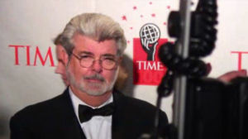

Lucas at the Time 100 2006 gala

On [September 19](http://en.wikipedia.org/wiki/September_19), [2006](http://en.wikipedia.org/wiki/2006), USC announced that George Lucas had donated $175 million to his [alma mater](http://en.wikipedia.org/wiki/Alma_mater) to expand the film school. It is the largest single donation to USC and the largest gift to a film school.[[11]](http://en.wikipedia.org/wiki/George_Lucas#cite_note-10) Previous donations led to the already existing George Lucas Instructional Building and Marcia Lucas Post-Production building.[[12]](http://en.wikipedia.org/wiki/George_Lucas#cite_note-USCLUC-11)[[13]](http://en.wikipedia.org/wiki/George_Lucas#cite_note-USCLPB-12)

On [January 1](http://en.wikipedia.org/wiki/January_1), [2007](http://en.wikipedia.org/wiki/2007) George Lucas served as the [Grand Marshal](http://en.wikipedia.org/wiki/Grand_Marshal) for the 2007 [Tournament of Roses Parade](http://en.wikipedia.org/wiki/Tournament_of_Roses_Parade), and made the coin toss at the [2007](http://en.wikipedia.org/wiki/2007_Rose_Bowl) [Rose Bowl](http://en.wikipedia.org/wiki/Rose_Bowl_Game). The toss favored Lucas's alma mater, the [Trojans](http://en.wikipedia.org/wiki/USC_Trojans). His team, which came into the game as [underdogs](http://en.wikipedia.org/wiki/Underdog_%28competition%29), went on to defeat the [Michigan](http://en.wikipedia.org/wiki/University_of_Michigan) [Wolverines](http://en.wikipedia.org/wiki/Michigan_Wolverines) (32-18).

### [] Personal life

In 1969, Lucas married film or [Marcia Lou Griffin](http://en.wikipedia.org/wiki/Marcia_Lucas), who went on to win an [Oscar](http://en.wikipedia.org/wiki/Academy_Awards) for her ing work on the original (Episode IV) *Star Wars* film. They adopted a daughter, Amanda, in 1981, and divorced in 1983. Lucas has since adopted two more children: Katie, born in 1988, and Jett, born in 1993. All three of his children have appeared in the prequels, as has Lucas himself. Lucas had also been in a long relationship and engaged with singer [Linda Ronstadt](http://en.wikipedia.org/wiki/Linda_Ronstadt). He has been dating [Mellody Hobson](http://en.wikipedia.org/wiki/Mellody_Hobson), president of Ariel Capital Management, since 2007 and she has accompanied him to several events including the [79th Academy Awards](http://en.wikipedia.org/wiki/79th_Academy_Awards) ceremony in February 2007, an [American Film Institute](http://en.wikipedia.org/wiki/American_Film_Institute) event in October 2007 and the [2008 Cannes Film Festival](http://en.wikipedia.org/wiki/2008_Cannes_Film_Festival) held in May.[[14]](http://en.wikipedia.org/wiki/George_Lucas#cite_note-13)[[15]](http://en.wikipedia.org/wiki/George_Lucas#cite_note-14)

Lucas was born and raised in a strongly [Methodist](http://en.wikipedia.org/wiki/Methodist) family. After inserting religious themes into *Star Wars* he would eventually come to identify strongly with the Eastern religious philosophies he studied and incorporated into his movies, which were a major inspiration for "the Force." Lucas eventually came to state that his religion was "[Buddhist](http://en.wikipedia.org/wiki/Buddhist) [Methodist](http://en.wikipedia.org/wiki/Methodist)."[[16]](http://en.wikipedia.org/wiki/George_Lucas#cite_note-15)

## [] Filmography

|  |  |  |
| --- | --- | --- |
| **Year** | **Title** | **Other Notes** |
| [2008](http://en.wikipedia.org/wiki/2008_in_film) | [*Star Wars: The Clone Wars*](http://en.wikipedia.org/wiki/Star_Wars:_The_Clone_Wars_%28film%29) | Producer, co-writer |
| [*Indiana Jones and the Kingdom of the Crystal Skull*](http://en.wikipedia.org/wiki/Indiana_Jones_and_the_Kingdom_of_the_Crystal_Skull) | Story, executive producer |
| [2005](http://en.wikipedia.org/wiki/2005_in_film) | [*Star Wars Episode III: Revenge of the Sith*](http://en.wikipedia.org/wiki/Star_Wars_Episode_III:_Revenge_of_the_Sith) | Writer and Director, executive producer, actor(cameo) |
| [2002](http://en.wikipedia.org/wiki/2002_in_film) | [*Star Wars Episode II: Attack of the Clones*](http://en.wikipedia.org/wiki/Star_Wars_Episode_II:_Attack_of_the_Clones) | Co-Writer and Director, executive producer |
| [1999](http://en.wikipedia.org/wiki/1999_in_film) | [*Star Wars Episode I: The Phantom Menace*](http://en.wikipedia.org/wiki/Star_Wars_Episode_I:_The_Phantom_Menace) | Writer and Director, executive producer |
| [1994](http://en.wikipedia.org/wiki/1994_in_film) | [*Radioland Murders*](http://en.wikipedia.org/wiki/Radioland_Murders) | Co-Writer, executive producer |
| [1989](http://en.wikipedia.org/wiki/1989_in_film) | [*Indiana Jones and the Last Crusade*](http://en.wikipedia.org/wiki/Indiana_Jones_and_the_Last_Crusade) | Co-Writer, executive producer |
| [1988](http://en.wikipedia.org/wiki/1988_in_film) | [*The Land Before Time*](http://en.wikipedia.org/wiki/The_Land_Before_Time) | Executive producer |
| [*Tucker: The Man and His Dream*](http://en.wikipedia.org/wiki/Tucker:_The_Man_and_His_Dream) | Executive producer |
| [*Willow*](http://en.wikipedia.org/wiki/Willow_%28film%29) | Co-Writer, executive producer |
| [*Powaqqatsi*](http://en.wikipedia.org/wiki/Powaqqatsi) | Executive producer |
| [1986](http://en.wikipedia.org/wiki/1986_in_film) | [*Captain EO*](http://en.wikipedia.org/wiki/Captain_EO) | Co-Writer, executive producer |
| [*Howard the Duck*](http://en.wikipedia.org/wiki/Howard_the_Duck_%28film%29) | Executive producer |
| [1985](http://en.wikipedia.org/wiki/1985_in_film) | [*Ewoks: The Battle for Endor*](http://en.wikipedia.org/wiki/Ewoks:_The_Battle_for_Endor) | Co-Writer, executive producer |
| [1984](http://en.wikipedia.org/wiki/1984_in_film) | [*Caravan of Courage: An Ewok Adventure*](http://en.wikipedia.org/wiki/Caravan_of_Courage:_An_Ewok_Adventure) | Co-Writer, executive producer |
| [*Indiana Jones and the Temple of Doom*](http://en.wikipedia.org/wiki/Indiana_Jones_and_the_Temple_of_Doom) | Co-Writer, executive producer |
| [1983](http://en.wikipedia.org/wiki/1983_in_film) | [*Star Wars Episode VI: Return of the Jedi*](http://en.wikipedia.org/wiki/Star_Wars_Episode_VI:_Return_of_the_Jedi) | Co-Writer, executive producer |
| [1981](http://en.wikipedia.org/wiki/1981_in_film) | [*Raiders of the Lost Ark*](http://en.wikipedia.org/wiki/Raiders_of_the_Lost_Ark) | Co-Writer, executive producer |
| [1980](http://en.wikipedia.org/wiki/1980_in_film) | [*Star Wars Episode V: The Empire Strikes Back*](http://en.wikipedia.org/wiki/Star_Wars_Episode_V:_The_Empire_Strikes_Back) | Co-Writer, executive producer |
| [1979](http://en.wikipedia.org/wiki/1979_in_film) | [*More American Graffiti*](http://en.wikipedia.org/wiki/More_American_Graffiti) | Executive producer |
| [1977](http://en.wikipedia.org/wiki/1977_in_film) | [*Star Wars Episode IV: A New Hope*](http://en.wikipedia.org/wiki/Star_Wars_Episode_IV:_A_New_Hope) | Writer and Director, executive producer |
| [1973](http://en.wikipedia.org/wiki/1973_in_film) | [*American Graffiti*](http://en.wikipedia.org/wiki/American_Graffiti) | Co-Writer, Director |
| [1971](http://en.wikipedia.org/wiki/1971_in_film) | [*THX 1138*](http://en.wikipedia.org/wiki/THX_1138) | Co-Writer, Director |

### [] Student at USC (1965 to 1968)

* [*Freiheit*](http://en.wikipedia.org/wiki/Freiheit_%28short_film%29) (1965)
* [*Look at Life*](http://en.wikipedia.org/wiki/Look_at_Life) (1965)
* [*Herbie*](http://en.wikipedia.org/wiki/Herbie_%28short_film%29) (1966)
* [*1:42:08*](http://en.wikipedia.org/wiki/1:42:08) (1966)
* *The Emperor* (1967)
* [*Electronic Labyrinth: THX 1138 4EB*](http://en.wikipedia.org/wiki/Electronic_Labyrinth:_THX_1138_4EB) (1967)
* [*Anyone Lived in a Pretty How Town*](http://en.wikipedia.org/wiki/Anyone_lived_in_a_pretty_how_town) (1967)
* [*6-18-67*](http://en.wikipedia.org/wiki/6-18-67) (1967)
* [*Filmmaker*](http://en.wikipedia.org/wiki/Filmmaker_%28George_Lucas_film%29) (1968)

## [] Further reading

* Rinzler, J.W. "The Making of Star Wars, The Definitive Story Behind the Orginal Film", Ebury Press, 2007.
* Silberman, Steve "Life After Darth" [Wired](http://en.wikipedia.org/wiki/Wired_%28magazine%29), November, 2005
* "George Lucas: Interviews" University Press of Mississippi (February 16, 2007)
* The Cinema of George Lucas (Hardcover) by Marcus Hearn, Publisher: Harry N. Abrams (March 1, 2005)
* Michael Rubin, "Droidmaker: George Lucas and the Digital Revolution" (2005) [[ISBN 0937404675](http://en.wikipedia.org/wiki/Special:BookSources/0937404675)]
* [In-Three's Dimensionalized TM](http://www.videopost.com/pages/inthree6.html) 3D Movies at ShoWest
* [*Edutopia*](http://en.wikipedia.org/wiki/Edutopia): ["Life On The Screen"](http://www.edutopia.org/magazine/ed1article.php?id=Art_1160&issue=sept_04) The filmmaker argues that students must learn a new language of image and sound in order to succeed.

## [] References

1. [**^**](http://en.wikipedia.org/wiki/George_Lucas#cite_ref-0) "[George Lucas ranks 243 on The World's Billionaires 2007](http://www.forbes.com/lists/2007/10/07billionaires_George-Lucas_PNOV.html)". [Forbes](http://en.wikipedia.org/wiki/Forbes) ([2007](http://en.wikipedia.org/wiki/2007)-[05-01](http://en.wikipedia.org/wiki/May_1)). Retrieved on [2007](http://en.wikipedia.org/wiki/2007)-[05-01](http://en.wikipedia.org/wiki/May_1).
2. [**^**](http://en.wikipedia.org/wiki/George_Lucas#cite_ref-1) [George Lucas Biography (1944-)](http://www.filmreference.com/film/89/George-Lucas.html)
3. [**^**](http://en.wikipedia.org/wiki/George_Lucas#cite_ref-2) Silberman, Steve. "Life After Darth" *Wired,* November 2005.
4. [**^**](http://en.wikipedia.org/wiki/George_Lucas#cite_ref-3) Lucas, George; Kasdan, Lawrence; Darabont, Bill; Casper, Drew."Interview and Q&A with George Lucas, Lawrence Kasdan, and Frank Darabont (Videotape)." Drew Casper, CTCS 469 Film & Television Style Analysis, Spring 2000; Norris Cinema Theater, [University of Southern California](http://en.wikipedia.org/wiki/University_of_Southern_California), 12 April 2000.
5. [**^**](http://en.wikipedia.org/wiki/George_Lucas#cite_ref-4) [Tom Shone](http://en.wikipedia.org/wiki/Tom_Shone): [*Blockbuster*](http://en.wikipedia.org/wiki/Blockbuster_%282004_book%29) *How Hollywood Learned to Stop Worrying and Love the Summer* (2004). London, Simon & Shuster UK. [ISBN 0-7432-6838-5](http://en.wikipedia.org/wiki/Special:BookSources/0743268385). Chapter 2.
6. ^ [***a***](http://en.wikipedia.org/wiki/George_Lucas#cite_ref-PixarStory_5-0) [***b***](http://en.wikipedia.org/wiki/George_Lucas#cite_ref-PixarStory_5-1) Hormby, Thomas ([2007](http://en.wikipedia.org/wiki/2007)-[01-22](http://en.wikipedia.org/wiki/January_22)), [*The Pixar Story: Dick Shoup, Alex Schure, George Lucas, Steve Jobs, and Disney*](http://lowendmac.com/orchard/06/0123.html), [Low End Mac](http://en.wikipedia.org/w/index.php?title=Low_End_Mac&action=edit&redlink=1), <<http://lowendmac.com/orchard/06/0123.html>>. Retrieved on [2007](http://en.wikipedia.org/wiki/2007)-[03-01](http://en.wikipedia.org/wiki/March_1)
7. [**^**](http://en.wikipedia.org/wiki/George_Lucas#cite_ref-6) [2008 Rep. Ed Markey's opening statement on universal service](http://markey.house.gov/index.php?option=content&task=view&id=3399&Itemid=125)
8. [**^**](http://en.wikipedia.org/wiki/George_Lucas#cite_ref-7) [Ars Technica report](http://arstechnica.com/news.ars/post/20080624-universal-service-fund-should-be-blown-up-like-death-star.html)
9. [**^**](http://en.wikipedia.org/wiki/George_Lucas#cite_ref-8) [2005 AFI Life Achievement Award: A Tribute to George Lucas on USA Network](http://www.afi.com/tvevents/laa/laa05.aspx)
10. [**^**](http://en.wikipedia.org/wiki/George_Lucas#cite_ref-9) [Quick Facts About the Memorial - Build the Dream](http://www.mlkmemorial.org/site/c.hkIUL9MVJxE/b.1191509/k.48EE/Quick_Facts_About_the_Memorial.htm)
11. [**^**](http://en.wikipedia.org/wiki/George_Lucas#cite_ref-10) Stuart Silverstein, [George Lucas Donates USC's Largest Single Gift](http://www.latimes.com/news/local/la-091906usc-lucas,0,5365847.story?coll=la-home-headlines), *The* [*Los Angeles Times*](http://en.wikipedia.org/wiki/Los_Angeles_Times), September 19, 2006.
12. [**^**](http://en.wikipedia.org/wiki/George_Lucas#cite_ref-USCLUC_11-0) [George Lucas Instructional Building](http://cinema.usc.edu/about/facilities/glucas-bldg.htm), USC School of Cinematic Arts.
13. [**^**](http://en.wikipedia.org/wiki/George_Lucas#cite_ref-USCLPB_12-0) [Marcia Lucas Post-Production](http://cinema.usc.edu/about/facilities/mlucas-post.htm), USC School of Cinematic Arts.
14. [**^**](http://en.wikipedia.org/wiki/George_Lucas#cite_ref-13) Kapos, Shia ([2007](http://en.wikipedia.org/wiki/2007)-[12-03](http://en.wikipedia.org/wiki/December_3)). "[Taking Names: Stars in Chicago, but finding love elsewhere](http://www.chicagobusiness.com/cgi-bin/mag/article.pl?article_id=28942)". Chicago Business. Retrieved on [2008](http://en.wikipedia.org/wiki/2008)-[05-19](http://en.wikipedia.org/wiki/May_19).
15. [**^**](http://en.wikipedia.org/wiki/George_Lucas#cite_ref-14) Germain, David ([2008](http://en.wikipedia.org/wiki/2008)-[05-19](http://en.wikipedia.org/wiki/May_19)). "['Indiana Jones' debut survives Cannes](http://www.suburbanchicagonews.com/couriernews/entertainment/957766,EL19_CANNES_WEB_051908.article)". The Courier News via [AP](http://en.wikipedia.org/wiki/Associated_Press). Retrieved on [2008](http://en.wikipedia.org/wiki/2008)-[05-19](http://en.wikipedia.org/wiki/May_19).
16. [**^**](http://en.wikipedia.org/wiki/George_Lucas#cite_ref-15) [The Religious Affiliation of Director George Lucas](http://www.adherents.com/people/pl/George_Lucas.html)

## [] External links

* [George Lucas](http://www.imdb.com/name/nm0000184/) at the [Internet Movie Database](http://en.wikipedia.org/wiki/Internet_Movie_Database)
* [*George Lucas*](http://www.allmovie.com/cg/avg.dll?p=avg&sql=2:100308) at [Allmovie](http://en.wikipedia.org/wiki/Allmovie)
* [George Lucas](http://www.nndb.com/people/539/000022473/) at the [Notable Names Database](http://en.wikipedia.org/wiki/NNDB)
* [George Lucas](http://www.isfdb.org/cgi-bin/ea.cgi?George_Lucas) at the [Internet Speculative Fiction Database](http://en.wikipedia.org/wiki/Internet_Speculative_Fiction_Database)
* [George Lucas biography](http://www.lucasfilm.com/inside/bio/georgelucas.html) at Lucasfilm.com