**Stewart Edward White 1873 – 1946**

<http://en.wikipedia.org/wiki/Stewart_Edward_White>

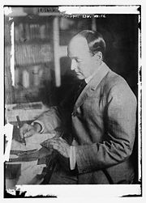 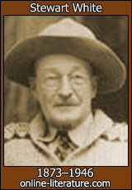 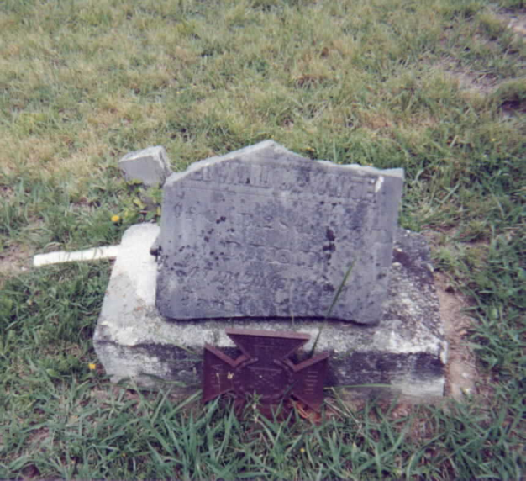

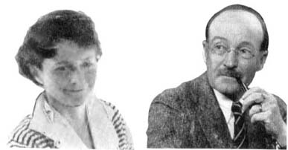

Betty and Stewart White

**Stewart Edward White** ([12 March](http://en.wikipedia.org/wiki/March_12) [1873](http://en.wikipedia.org/wiki/1873) – [September 18](http://en.wikipedia.org/wiki/September_18), [1946](http://en.wikipedia.org/wiki/1946)) was an [American](http://en.wikipedia.org/wiki/United_States) [author](http://en.wikipedia.org/wiki/Author).

Born in [Grand Rapids, Michigan](http://en.wikipedia.org/wiki/Grand_Rapids,_Michigan) he earned degrees from [University of Michigan](http://en.wikipedia.org/wiki/University_of_Michigan) (Ph.D., 1895; M.A., 1903).

From about 1900 until about 1922, he wrote adventure travel books. Starting in 1922, He and his wife Elizabeth "Betty" Grant White wrote numerous books they claimed were received through [channelling](http://en.wikipedia.org/wiki/Channelling_%28mediumistic%29) with [spirits](http://en.wikipedia.org/wiki/Spirit). They also wrote of their travels around the state of California. White died in [Hillsborough, California](http://en.wikipedia.org/wiki/Hillsborough,_California).

|  |
| --- |
| **Contents**     * [1 Honors](http://en.wikipedia.org/wiki/Stewart_Edward_White#Honors) * [2 Works](http://en.wikipedia.org/wiki/Stewart_Edward_White#Works) * [3 Notes](http://en.wikipedia.org/wiki/Stewart_Edward_White#Notes) * [4 References](http://en.wikipedia.org/wiki/Stewart_Edward_White#References) * [5 External links](http://en.wikipedia.org/wiki/Stewart_Edward_White#External_links) |

**Honors**

In 1927, the [Boy Scouts of America](http://en.wikipedia.org/wiki/Boy_Scouts_of_America) made White an *Honorary Scout*, a new category of Scout created that same year. This distinction was give to "American citizens whose achievements in outdoor activity, exploration and worthwhile adventure are of such an exceptional character as to capture the imagination of boys...". The other eighteen who were awarded this distinction were: [Roy Chapman Andrews](http://en.wikipedia.org/wiki/Roy_Chapman_Andrews); [Robert Bartlett](http://en.wikipedia.org/wiki/Robert_Bartlett); [Frederick Russell Burnham](http://en.wikipedia.org/wiki/Frederick_Russell_Burnham); [Richard E. Byrd](http://en.wikipedia.org/wiki/Richard_E._Byrd); [George Kruck Cherrie](http://en.wikipedia.org/wiki/George_Kruck_Cherrie); James L. Clark; [Merian C. Cooper](http://en.wikipedia.org/wiki/Merian_C._Cooper); [Lincoln Ellsworth](http://en.wikipedia.org/wiki/Lincoln_Ellsworth); [Louis Agassiz Fuertes](http://en.wikipedia.org/wiki/Louis_Agassiz_Fuertes); [George Bird Grinnell](http://en.wikipedia.org/wiki/George_Bird_Grinnell); [Charles A. Lindbergh](http://en.wikipedia.org/wiki/Charles_A._Lindbergh); [Donald Baxter MacMillan](http://en.wikipedia.org/wiki/Donald_Baxter_MacMillan); Clifford H. Pope; [George P. Putnam](http://en.wikipedia.org/wiki/George_P._Putnam); [Kermit Roosevelt](http://en.wikipedia.org/wiki/Kermit_Roosevelt); Carl Rungius; [Orville Wright](http://en.wikipedia.org/wiki/Orville_Wright). [[1]](http://en.wikipedia.org/wiki/Stewart_Edward_White#cite_note-time29aug1927-0)

**Works**

* *The Westerners* (1901)
* *The Claim Jumpers* (1901)
* *Conjurer's House* (1903)
* *The Forest* (1903)
* *Blazed Trail Stories* (1904)
* *The Mountains* (1904)
* *The Silent Places* (1904)
* *The Pass* (1906), with [S. H. Adams](http://en.wikipedia.org/wiki/Samuel_Hopkins_Adams)
* *The Mystery* (1907), with S. H. Adams
* *Arizona Nights* (1907)
* *The Riverman* (1908)
* *The Cabin* (1910)
* *The Rules of the Game* (1910)
* *The Land of Footprints* (1912)
* *African Camp Fires* (1913)
* *Gold* (1913)
* *Gray Dawn* (1915)
* *Rediscovered Country* (1915)
* *The forty-niners; a chronicle of the California trail and El Dorado* (1918)
* *Daniel Boone, wilderness scout* (1922)
* *Lions in the path; a book of adventure on the high veldt* (1926)
* *Dog days, other times, other dogs; the autobiography of a man and his dog friends through four decades of changing America* (1930)
* *The Betty Book (1939)*
* *Across the Unknown [with Harwood White] (1939)*
* *The Unobstructed Universe (1940)*
* *The Road I Know (1942)*
* *Anchors to Windward*
* *The Stars are Still There*
* *With Folded Wings (1947)*

**Notes**

1. [**^**](http://en.wikipedia.org/wiki/Stewart_Edward_White#cite_ref-time29aug1927_0-0) "[Around the World](http://www.time.com/time/magazine/article/0,9171,723029,00.html)" (August 29 1927). [*Time (magazine)*](http://en.wikipedia.org/wiki/Time_%28magazine%29). Retrieved on [2007](http://en.wikipedia.org/wiki/2007)-[10-24](http://en.wikipedia.org/wiki/October_24).

**References**

* J. C. Underwood, *Literature and Insurgency* (New York, 1914)
* Staff report (September 19, 1946). STEWART E. WHITE, NOVELIST, IS DEAD; Author of Stories of Adventure and Frontier Life Was 73-- Stricken After Fabled Career CHOKED LEOPARD TO DEATH Writer of 'Blazed Trail' Knew Yukon, Africa and West-- Honored as Geographer
* "Stewart White, Adventurer and novelist, dies; books captured thrills of own exciting life." Chicago Tribune, September 19, 1946

**External links**

[***Stewart Edward White***](http://en.wikisource.org/wiki/Author:Stewart_Edward_White)

* [Stewart Edward White](http://www.imdb.com/name/nm0925481/) at the [Internet Movie Database](http://en.wikipedia.org/wiki/Internet_Movie_Database)
* [Stewart Edward White Biography](http://www.spiritwritings.com/stewartedwardwhite.html)
* [Works by Stewart Edward White](http://www.gutenberg.org/author/Stewart+Edward+White) at [Project Gutenberg](http://en.wikipedia.org/wiki/Project_Gutenberg)

<http://www.spiritwritings.com/BettyStewartwhite>

# Stewart Edward White Biography

 Betty and Stewart White

Birth: March 12, 1873 in Grand Rapids, Michigan, United States

Death: September 18, 1946 in Hillsborough, California, United States

### BIOGRAPHICAL ESSAY

Author who published a number of books of "channeled'' material. Born March 12, 1873, at Grand Rapids, Michigan, he studied at the University of Michigan (Ph.D., 1895; M.A., 1903). In 1904 he married [Elizabeth (Betty) Grant](http://www.spiritwritings.com/bettywhite.html), and they settled in California where he became well known as an author of many books, articles, and short stories dealing with his experiences around the state in mining and lumber camps, and on exploration trips.

In 1922 he and Betty met a couple known in the literature as Joan and Darby. Several years earlier the couple had been playing with a Ouija board and made contact with a spirit entity, "Stephen,'' who became the source for a book they published in 1920 as [Our Unseen Guest](http://www.spiritwritings.com/OurUnseenGuest.pdf). Joan had become a full trance medium. Betty eventually followed a similar course and also became a medium in contact with a group of entities called simply "the Invisibles.'' Betty channeled numerous sessions with them. In 1937, after many years of quietly working with a very small group, Stewart told the story of Betty's development and repeated the basic teachings of "the Invisibles'' in what has become a classic work in the field, The Betty Book. White believed that these messages embodied a valuable philosophy and religious interpretation for daily life. Enough readers agreed and a second "Betty'' book was issued in 1939 as Across the Unknown.

Betty died in 1939, and in the months after her death, White received communication he believed to be from her through Joan. These were gathered into a book, The Unobstructed Universe (1940), which proved the most popular volume in the series and remains in print.

The continued response, possibly accelerated by the war, led to a number of further books. The Road I Know (1942) was an anthology of further selections from the material Betty had channeled. Anchors to Windward (1943) was a philosophical treatment of the Betty material. The Stars Are Still There (1946) grew out of specific questions sent to White during the war. With Folded Wings (1947), the last in the Betty book series, was published posthumously.

White died September 18, 1946, at Hillsborough, California. After his death, two manuscripts remained, both reflective of White's own development as a medium. One, The Job of Living, was published in 1948; the other, The Gaelic Manuscripts, was never published, though it circulated among White enthusiasts in mimeographed form.

### Sources:

Joan and Darby. [Our Unseen Guest](http://www.spiritwritings.com/ourunseenguest.pdf). New York: Harper & Brothers, 1920.

Melton, J. Gordon. The Betty Book Literature of Stewart Edward White. Evanston, Ill.: The author, 1971.

White, Stewart Edward. Across the Unknown. N.p., 1939.

------. Anchors to Windward. N.p., 1943.

------. [The Betty Book](http://gutenberg.net.au/ebooks03/0301111.txt). N.p., 1939.

------. [Gaelic Manuscripts](http://www.olypen.com/harmon/gaelic.htm) - also [here](http://www.isleofavalon.co.uk/GlastonburyArchive/gaelic/bwgaelx.html)

------. [The Road I Know](http://www.spiritwritings.com/RoadIKnowWhite.pdf). N.p., 1942.

------. [The Stars Are Still There](http://www.spiritwritings.com/StarsAreStillThere.pdf). N.p., 1946.

------. [The Unobstructed Universe](http://gutenberg.net.au/ebooks03/0301131.txt). N.p., 1940. (his most popular metaphysical work)

------. [With Folded Wings](http://www.spiritwritings.com/WithFoldedWingsWhite.pdf). N.p., 1947.

**The above writeup was reproduced by permission from "Stewart Edward White." Encyclopedia of Occultism and Parapsychology, 5th ed. Edited by J. Gordon Melton, 2001.**

**------------**

**Earlier Philosophical Books**

Before Stewart White came "out of the closet" about his wife's psychic abilities he produced two books in which he would discuss philosophical concepts without naming the source.

Credo, 1925

Why Be a Mud Turtle, 1928

### More general biographies:

White, Stewart. *Speaking for Myself* . 1943.

White, Stewart. *Dog Days: Other Times, Other Dogs: The Autobiography of a Man and His Dog Friends through Four Decades of Changing America*, 1930.

Alter, Judy. *Stewart Edward White*. Boise, ID: Boise State University, 1975.

Leichtmann, Robert & Johnson, David Kendrick. *Stewart White Returns.* 1980 (channeled posthumous interview)

Olivia A. Haehn, "Stewart Edward White." *Dictionary of American Biography*, Supplement 4: 1946-1950. American Council of Learned Societies, 1974 (Available online from Biography Resource Center. The Gale Group)

Eugene F. Saxton, "Stewart Edward White." *Nat. Cyc. Am. Biog*., Current Vol. F, 144-145

Tuska, Jon, and Vicki Piekarski, eds. "Stewart Edward White." *Encyclopedia of Frontier and Western Fiction*. New York: McGraw-Hill, 1983. 352-54

[Stewart Edward White (1873-1946)](http://web.cocc.edu/glyons/pop/western/authors/white.htm)

[T. Steward White](http://www.rootsweb.com/%7Emikent/white1924/personal/whitets.html) - 1840-1915 (Stewart White's father)

### Obituaries:

"Stewart E. White, novelist, is dead; author of stories of adventure and frontier life was 73--stricken after fabled career." New York Times, September 19, 1946

"Stewart White, Adventurer and novelist, dies; books captured thrills of own exciting life." Chicago Tribune, September 19, 1946

### Other Works (Fiction, etc.)

In addition to metaphysical works, White wrote over thirty volumes, including novels, histories, juvenile works, travel and adventure books, essays, and short stories.

* Adventures of Bobby Orde
* [Arizona Nights](http://onlinebooks.library.upenn.edu/webbin/gutbook/lookup?num=753)
* Back of Beyond
* [The Blazed Trail](http://onlinebooks.library.upenn.edu/webbin/gutbook/lookup?num=3413)
* The Cabin
* Call of the North
* Camp and Trail
* The Claim Jumpers (short story collection)
* Conjuror's House A Romance of the Free Forest
* Daniel Boone Wilderness Scout
* Folded Hills
* The Forest
* The Forty-Niners; A Chronicle of the California Trail and El Dorado
* The Glory Hole
* Gold (1913) - The Story of California trilogy
* The Gray Dawn (1915) - The Story of California trilogy
* The Hold-up
* [The Land of Footprints](http://onlinebooks.library.upenn.edu/webbin/gutbook/lookup?num=1378)
* The Leopard Woman
* The Mystery (with Samuel Hopkins Adams)
* Old California in Picture and Story
* On Tiptoe: a Romance of the Redwoods
* Ranchero
* [The Mountains](http://digital.library.upenn.edu/webbin/gutbook/lookup?num=1378)
* The Rediscovered Country
* [The Riverman](http://onlinebooks.library.upenn.edu/webbin/gutbook/lookup?num=1099)
* The Rose Dawn (1920) - The Story of California trilogy
* The Rules of the Game
* The sign at six
* [The Silent Places](http://etext.lib.virginia.edu/etcbin/toccer-new?id=WhiSile&tag=public&images=images/modeng&data=/texts/english/modeng/parsed&part=0)
* Simba
* Story of California (trilogy titles noted above)
* The Westerners
* Wild Geese Calling
* The Works of Edward Steward White-Arizona Nights-Two-Gun Man & the Rawhide

[Stewart Edward White Filmography](http://www.imdb.com/name/nm0925481/) - details on twelve films based on his writings

END