**Ancient Dinosaur Depictions**

[**http://www.genesispark.com/exhibits/evidence/historical/ancient/dinosaur/**](http://www.genesispark.com/exhibits/evidence/historical/ancient/dinosaur/)

[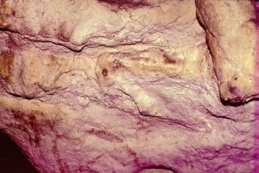](http://www.genesispark.com/wp-content/uploads/2011/11/ancient1.jpg)

To the right is a picture of a dinosaur fighting a mammoth from the book *Buried Alive* by Dr. Jack Cuozzo (click to enlarge). It was taken by the author in Bernifal Cave, one of the caverns in France that is renowned for Neanderthal artifacts. The cave was subsequently closed to the public. *Science News* was given the opportunity to publish the remarkable photo, but declined. It seems that evidence against the prevailing paradigm of naturalistic origin is selected against. It is buried alive by the scientific establishment. As Cuozzo says, this is natural selection in the most literal sense!

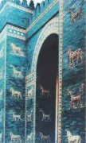 [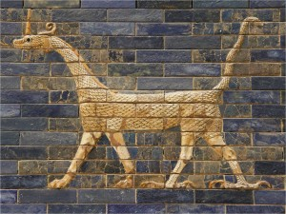](http://www.genesispark.com/wp-content/uploads/2011/11/ancient3.jpg) [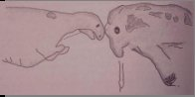](http://www.genesispark.com/wp-content/uploads/2011/11/ancient2.jpg)

In 600 BC, under the reign of King Nebuchadnezzar, a Babylonian artist was commissioned to shape reliefs of animals on the structures associated with the Ishtar Gate. Many centuries later German archaeologist Robert Koldewey stumbled upon the blue-glazed brick and that gate was rediscovered in 1899. The animals appear in alternating rows with lions, fierce bulls (rimi or reems in Chaldean), and curious long-necked dragons (sirrush). The lions and bulls would have been present at that time in the Middle East. But, on what creature did the ancient Babylonians model the dragon? (click the depiction to enlarge) Koldewey believed that the sirrush was a portrayal of a real animal and in 1918, he proposed that the dinosaur *Iguanodon* was the closest known match to the sirrush. The same word, sirrush, is mentioned in the book of Bel and the Dragon, from the *Apocrypha*. Both the description there and the image on these unearthed walls, which are now displayed in the Berlin Vorderasiatisches Museum, appear to fit a sauropod dinosaur. (Shuker, Karl P.N., “The Sirrush of Babylon,” *Dragons: A Natural History*, 1995, pp. 70-73.)

[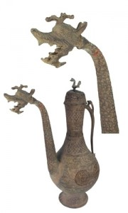](http://www.genesispark.com/wp-content/uploads/2011/11/Bronze-Lid-Persian-Dragon-Vessel.jpg)

To the right is a bronze Persian pot manufactured toward the end of the 1st Millennium AD that is part of the Genesis Park collection. The most fascinating element of this vessel is the stylized, scaled dinosaur-like dragon that forms the spout. Dragons form an integral part of Persian mythology and beliefs. The ceremonial undertones of this vessel lead us to believe that it was associated with Zoroastrianism. Several malevolent dragon-like creatures are mentioned at various points in the Zoroastrian scriptures. One such popular dragon myth involves Azi Dahaka – a three-headed Persian dragon that will devour one third of all men and animals at the end of the world.

[](http://www.genesispark.com/wp-content/uploads/2013/10/Turkish-Dragon-by-Levni-in-Surname3.jpg)

Although the Ottoman Empire ruled for over six centuries, there are not many depictions of dinosaurian creatures in their artwork (as compared to Medieval European art). Perhaps dragons were not as common in the eastern European/Middle East theater at that time. The Turkish painting to the left, entitled “Procession of the Trade Corporation during the Festival of 1720 in Constantinople” is in a surname (or historical album) called *The Surname-I Hümayun* archived at Topkapi Museum of Istanbul. It was written and illustrated under the direction of Abdulcelil Levni (aka Abdulcelil Çelebi) who was the official Ottoman court painter till he died in 1732. The picture shows the guildsmen, followed by clowns and what seems to be a mechanical three-headed dragon. (Click for an enlargement of the dragon.) Note the similarity to baby sauropods dinosaur. A [sauropod with multiple heads](http://www.genesispark.com/exhibits/evidence/cryptozoological/apatosaurs/diplodocus/), a condition known as polycephaly, while curious, is hardly unknown among dinosaur reports.

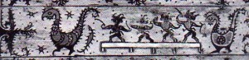

Up to the 1800s the Dayak peoples of Borneo and Sumatra produced multiple pieces of art depicting long-tailed, long-necked creatures with a headcrest. Some of these animals resemble hadrosaurs. This particular work, housed in the Ethnographical Museum of Budapest, depicts a creature that bears a striking resemblance to a Corythosaurus. It is apparently being hunted by these ancient Indonesian peoples. (Bodrogi, Tibor, *Art of Indonesia*, 1973.)

[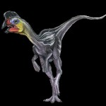](http://www.genesispark.com/wp-content/uploads/2011/11/oviraptor-black.jpg) [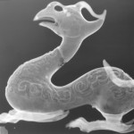](http://www.genesispark.com/wp-content/uploads/2011/11/ancient7.jpg) [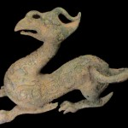](http://www.genesispark.com/wp-content/uploads/2011/11/ancient6.jpg)

Chinese stories and stylized dragon depictions are fairly common. But an unusual beaked dragon statue came up on the antiquities market and is now in the Genesis Park collection. The bronze styling on this artifact suggests it is from the Han Dynasty (206 B.C. – A.D. 220). It displays numerous characteristics of the beaked dinosaurs (like the *Oviraptor* depicted alongside for comparison): tridactyl feet configuration, metatarsal stance, scale-like representation all over the body (except for the horn which has a striated pattern), long (albeit slender) tail, elaborate head crest and a long neck. This piece was submitted for industrial X-Ray authentication and the patina was also chemically tested, showing that the artifact was clearly genuine. A beautifully preserved beaked dinosaur mummy (*Edmontosaurus)* was discovered in Alberta, Canada in 2013. The specimen sported a fleshy crest atop its head (like a rooster). Researchers theorized that the hat-like ornament was brightly colored to allow for identification. This was the first non-bony crest discovered on a dinosaur. It closely matches the look of the Chinese beaked dragon.

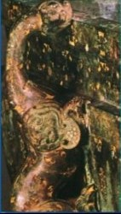 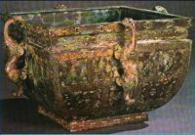

Another fascinating Chinese artifact is the Late Eastern Zhou Sauropod (Fang Jian) ornamental box to the right. Displaying a tridactyl foot, a long neck and a head that resembles a *Brachiosaur*, this depiction is compelling. (Fong, Wen ed., *The Great*

*Bronze Age of China*, Metropolitan Museum of Art, 1980, p. 285.)

[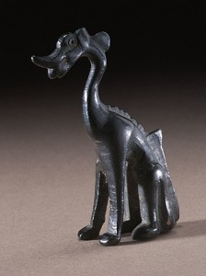](http://www.genesispark.com/wp-content/uploads/2011/11/Miniature-Seated-Chinese-Dragon.jpg)

The seated dragon sculpture in cast bronze to the left comes from the Tangy Dynasty and is currently housed at the Los Angeles County Museum of Art. Many more such dinosaur-like Chinese dragon depictions could be considered from this time period, like the painted ceramic dragon to the lower left, identified by the exhibiting museum as Tang Dynasty (618-906 AD). Next we consider an even older dragon artifact from the Shang dynasty (1766-1122 B.C.) that was advertised on the Chinese antiquities market as a dinosaur depiction. It displays relief lines in a scale-like pattern, a broad beak, a dermal frill, and a headcrest that is strikingly like the dinosaur *Saurolophus* (shown below on the right). This jade statute, now in the Genesis Park collection, is made of white colored nephrite with differential weathering, cleaving veins and earth penetration, demonstrating authenticity. (Click to enlarge.)

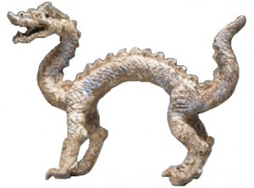  [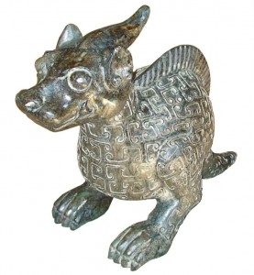](http://www.genesispark.com/wp-content/uploads/2011/11/ancient11.jpg) 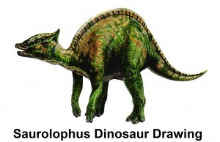

About 4,000 years ago, the Hongshan culture in China produced many wonderful jade dragon carvings (along with other clear animal representations). Over time these dragon productions became highly stylized and were especially popular as pendants. Most of these pieces only resemble dragons in a crude sense, but a few of the older dragon statues appear to be reproductions of certain dinosaurs. Notice the resemblance this jade dragon (lower left) bears to a small *Protoceratops* dinosaur. In the middle is a “baby dragon” carving. It appears to resemble an immature pterosaur, perhaps freshly out of the egg. Its body is still curled and the wings appear immature. Both the baby dragon and the unusual, red carving on the right, are part of the Genesis Park collection.

[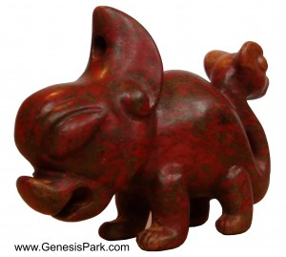](http://www.genesispark.com/wp-content/uploads/2011/11/Bloodstone-Hongshan1.jpg) [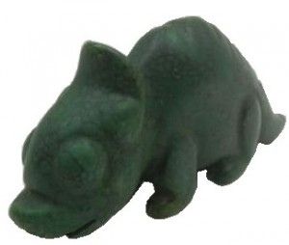](http://www.genesispark.com/wp-content/uploads/2013/10/Hongshan-Turquoise-Dragon5.jpg) [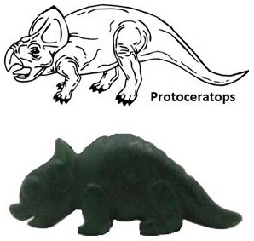](http://www.genesispark.com/wp-content/uploads/2013/10/Hongshan-Dragon-vs-Protoceratops.jpg) [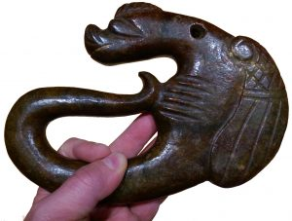](http://www.genesispark.com/wp-content/uploads/2013/10/Hongshan-Baby-Dragon2.jpg)

[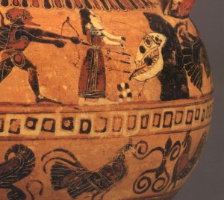](http://www.genesispark.com/wp-content/uploads/2011/11/ancient13.jpg)

The February 26, 2000 issue of *Science News* contained an article that commented on a Hesione vase artifact housed at the Boston Museum of Fine Arts (Hesman, 2000). On this ancient Greek vase are a series of somewhat unusual paintings, including one that portrays a monster with the head of a dinosaur. This pottery was created around 550 B.C. and depicts the Greek hero Heracles rescuing Hesione from this “monster of Troy.” Forced to concede that it is an amazingly realistic dinosaurian depiction, *Science News* concluded that the paintings on this unusual vase simply prove that ancient people dug up and assembled fossils. But there is no evidence for sophisticated [Ancient Paleontologists](http://www.genesispark.com/exhibits/evidence/historical/ancient-paleontologists/).

A 1971 landslide in the Girifalco region of southern Italy brought to light hundreds of ancient artifacts of a pre-Greek civilization. A lawyer named Mario Tolone Azzariti asserts that he found some dinosaurian representations among them (pictured below). To the left is a terracotta statue measuring about 18 cm long, shaped remarkably like a *Stegosaurus* dinosaur.  The triangular plates run downits back to the tail

. [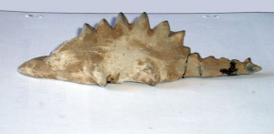](http://www.genesispark.com/wp-content/uploads/2011/11/Girifalco-Dinosaur2.jpg) [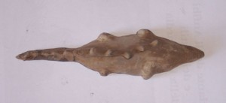](http://www.genesispark.com/wp-content/uploads/2011/11/Girifalco-Dinosaur.jpg) [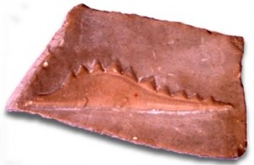](http://www.genesispark.com/wp-content/uploads/2011/11/Girifalco-Dinosaur3.jpg)

In the view from above (center) the object reveals a strange curving of the plates, as if the animal had been represented lumbering from side to side. The legs are large and awkward, as if carrying great weight, not at all like those of a lizard. There is also a clear representation of a *Stegosaurus* on a piece of broken pottery (right).

The art below is from the Mesopotamian cylinder seal of Uruk, an artifact currently housed at the Louvre. The animal on the right is an artist’s conception from a skeleton of an *Apatosaurus*.

[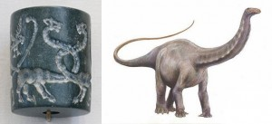](http://www.genesispark.com/wp-content/uploads/2011/11/Mesopotamian-Cylinder-Seal.jpg)

There are many striking similarities between these two depictions. The legs and feet on the artifact clearly fit the sauropods better than any other type of animal. The biggest difference is at the head. Cartilage forming the shape of a frill or ears may be stylized or accurate (since there is no way to know from the skeletons we have today). As for the musculature, the ancient artist draws with stunning realism. One has to ask where the artist got the model to draw so convincingly the trunk of a sauropod.

[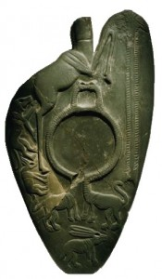](http://www.genesispark.com/wp-content/uploads/2013/10/Manshiyat-Ezzat-Cosmetic-Palette.jpg)

The January 2003 issue of *National Geographic* magazine presents an artifact described as a “cosmetic palette . . . from a cemetery of the first dynasties in Manshaat Ezzat.” These long-necked creatures displayed on page 78 fit the pattern of other ancient dinosaur-like depictions, including arching, muscular necks and stout bodies. This artifact depicts many lifelike animals (including a giraffe on the reverse).

[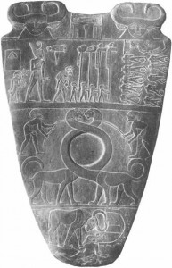](http://www.genesispark.com/wp-content/uploads/2011/11/Narmer-Palette-Pic.jpg) [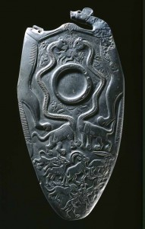](http://www.genesispark.com/wp-content/uploads/2013/10/two-Dog-Palette.jpg)

To the far right is displayed the Narmer Palette, which dates back to about 3,100 BC. It is from the ancient Egyptian capital of Hierakonpolis and shows the triumph of King Nar-mer with long necked dragons that appear to be in captivity. Immediately to the right is the Two Dog Palette from the same period. It is displaying a pair of “dinosaur-like” creatures along with numerous clear representations of living animals (clearly not drawn to scale).

An Egyptian apotropaic wand (or magical “knife”) dating from about 1750 BC displays a similar long-necked creature. Made from hippo tusk ivory, this artifact is currently housed in the British Museum. The preponderance of these long-necked depictions in ancient art motivated archaeologists who do not believe men and dinosaurs coexisted to invent a name for this particular creature. It is called a “serpopard,” supposedly a mosaic of a serpent and a leopard. But for those who believe that man was created in the beginning alongside the great reptiles, these palettes seem to be an attempt to depict a sauropod dinosaur. Note the “Four Dogs Palette” with the “serpopard” cut out for clarity.

[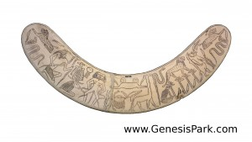](http://www.genesispark.com/wp-content/uploads/2011/11/Egyptian-Apotropaic-Wand-on-Hippo-Tusk-British-Museum-Hi-Res-White.jpg) [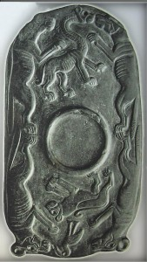](http://www.genesispark.com/wp-content/uploads/2013/10/Egyptian-Predynastic-Hierakonpolis-Four-Dogs-Palette1.jpg) [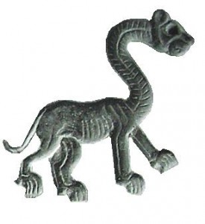](http://www.genesispark.com/wp-content/uploads/2013/10/Egyptian-Predynastic-Hierakonpolis-Four-Dogs-Palette2.jpg)

[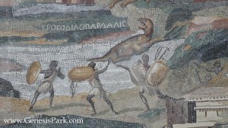](http://www.genesispark.com/wp-content/uploads/2011/11/palestrina-mosaic1.jpg)

To the left is a beautiful mosaic that was one of the wonders of the second century world. (Click to enlarge or see [The Nile Mosaic of Palestrina](http://www.genesispark.com/palestrina-mosaic-page) for more details). Housed in Palestrina, which is just south of Rome, this masterpiece depicts Nile scenes from Egypt all the way up into Ethiopia. Scholars now believe this is the work of Demetrius the Topographer, an artist from Alexandria who came to work in Rome. The top portion of this remarkable piece of art is generally believed to depict African animals being hunted by black-skinned warriors. These Ethiopians are pursuing what appears to be some type of dinosaur. The Greek Letters above the reptilian animal in question are KROKODILOPARDALIS, which is literally translated Crocodile-Leopard (apparently identifying an agile reptilian creature). The picture shown here is only a small portion of the massive mosaic. It also contains clear depictions of known animals, including Egyptian crocodiles and hippos. (See Finley, *The Light of the Past*, 1965, p. 93.)

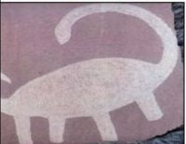 [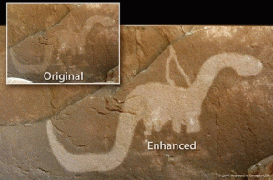](http://www.genesispark.com/wp-content/uploads/2013/10/Natural-Bridges-Dino-AIG-clean.gif) [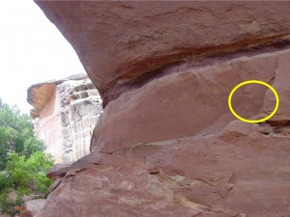](http://www.genesispark.com/wp-content/uploads/2013/10/Natural-Bridges-Dino-Location-AIG.jpg)

The picture above (on right) was drawn by North American Anasazi Indians that lived in the area that has now become Utah between 150 B.C. and 1200 A.D. Even noted anti-creationists agree that it resembles a dinosaur and that the brownish film which has hardened over the picture, along with the pitting and weathering, attests to its age. One evolutionist wrote, “There is a petroglyph in Natural Bridges National Monument that bears a startling resemblance to a dinosaur, specifically a Brontosaurus, with a long tail and neck, small head and all.” (Barnes, Fred A., and Pendleton, Michaelene, *Prehistoric Indians: Their Cultures, Ruins, Artifacts and Rock Art,* 1979, p.201.) Clearly a native warrior (on the left above the dinosaurian figure) and an *Apatosau*r-like creature are depicted. Yet another Native American rock pictograph found in Utah (upper left) seems to depict a sauropod dinosaur.

[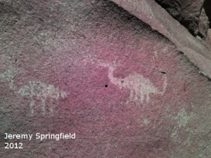](http://www.genesispark.com/wp-content/uploads/2013/10/Jeremy-Springfield-Petroglyph2.jpg) [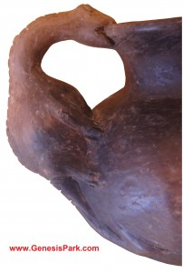](http://www.genesispark.com/wp-content/uploads/2011/11/Meso-American-Pot-Web1.jpg) [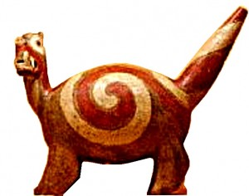](http://www.genesispark.com/wp-content/uploads/2013/10/Mississippian-Saurian2.jpg)

The petroglyph above to the left was discovered in 2012 by Jeremy Springfield on a trip to Hidden Mountain, just outside of Los Lunas, New Mexico. S8int website brought his story to our attention. The drawing is located on an isolated, inaccessible ledge near a very clear deer petroglyph. What were the ancient Pueblo peoples intending to depict, if not a saurian creature that they knew from that region?

The Mississippian culture flourished from 800 – 1500 AD through the southwestern United States and it is known for their building of mounds. Above in the center is a curious piece from this culture (click to enlarge). Apparently the swirling pattern on its sides signifies that the animal in question lived in water, while the eye markings allude to the beast’s unusually keen vision. Some of these Indian depictions of this rotund animal show tridactyl feet, a long neck and prominent tail held aloft. Above to the right, note the handle on a Mesoamerican pottery object made by Mississippi Caddo Indians. It seems to display a baby dinosaur. This circa 1200 AD artifact is housed at Creation Evidence Museum in Texas (click to enlarge).

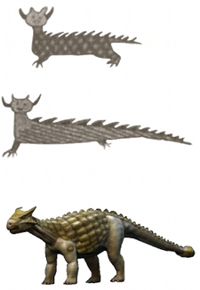

Henry Rowe Schoolcraft was a geologist and Indian agent who wrote extensively about the Sioux Indians. He heard stories about a monstrous creature called Unktehi, something like an ox but much larger, with great horns. Schoolcraft reproduced drawings of several types of Unktehi monsters on birchbark around 1850. These were based upon rock art describing a war party of five canoes crossing Lake Superior that encountered animals resembling giant turtles, snakes, and moose. But some (upper right) clearly look dinosaurian. Sioux Indians further west, when interviewed by ethnologists, described Unktehi as an immense reptile or serpent with legs. He was shaped like a giant scaly snake with feet and a notched backbone or crest like a giant saw and had

a heavy spiked tail. Still other

[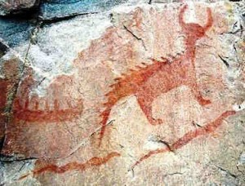](http://www.genesispark.com/wp-content/uploads/2016/01/agawa-rock-pictographs-ontario-lake-superior-by-Aaron-Peterson.jpg)

Indian reports describe Unktehi as a swamp-dwelling creature. Adrienne Mayor, an evolutionist, believes that the Sioux were weaving stories about fossils they encountered (Mayor, *Fossil Legends of the First Americans,* 2005, pp. 235-237). But the pictures and description bring to mind the dinosaur *Ankylosaurus* (lower right) with a low slung body, long tail, heavy armor, and prominent multiple horns. A plated and horned creature has also been discovered in Ojibwa Indian art (left – click to enlarge) on the Agawa Rock at Misshepezhieu, Lake Superior Provincial Park, Ontario, Canada.

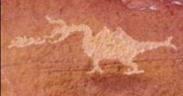

On the right is shown a photo of one of the curious “dinosaur” petroglyphs near Middle Mesa at the Wupatki National Park. This particular petroglyph is called “Puff the Magic Dragon,” and appears to be a depiction of a fire-breathing dinosaur. Though there is no certain way to date such petroglyphs, this carving is believed to be at least several hundred years old.

[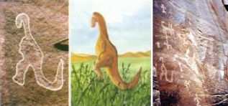](http://www.genesispark.com/wp-content/uploads/2011/11/Havasupai-Dino-Petroglyph.jpg)

On two occasions in the late 1800s, Samuel Hubbard, Curator of Archaeology of the Oakland Museum, visited an area of the Grand Canyon known as the Havasupai Canyon. As an evolutionist, he was amazed to find a petroglyph (carved rock drawing) of an elephant made by Native Americans. But another depiction was “cut into the sandstone much more deeply than the elephant.” Its height was 11.2 inches, with a neck approximately 5.1 inches in length and a tail of 9.1 inches. Hubbard photographed the petroglyph and eventually placed it in his scientific monograph *Discoveries Relating to Prehistoric Man* (1925, p. 10). What kind of animal is it? Dr. Hubbard believed that he had found an ancient drawing of a dinosaur. He wrote, “The fact that some prehistoric man made a pictograph of a dinosaur on the walls of this canyon upsets completely all of our theories regarding the antiquity of man. Facts are stubborn and immutable things. If theories do not square with the facts then the theories must change, the facts remain.” (Doheny, E. L., *Discoveries Relating to Prehistoric Man by the Doheny Scientific Expedition in the Hava Supai Canyon Northern Arizona*, 1924, p. 5.) In the far left picture, Paul Taylor compares this ancient drawing to the *Edmontosaurus.* (Click to enlarge the picture – courtesy of Don Patton.)

[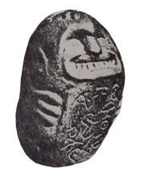](http://www.genesispark.com/wp-content/uploads/2011/11/granby-idol1.jpg) [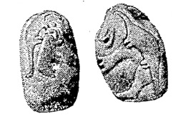](http://www.genesispark.com/wp-content/uploads/2011/11/granby-idol2.jpg)

A similar association of an American elephant and dinosaur is presented in the Granby Idol. This queer rock relic was unearthed by W.L. Chalmers near Grand Lake, high in the Colorado Rockies. He found the 66 pound stone (along with various ancient utensils) several feet below the surface while enlarging an irrigation reservoir on his homestead. The stone was made of an exceedingly hard green material, like nothing ever known of in the neighborhood. (“Is Pre-Glacial Man Coming Back?” *Hutchison News*, January 5, 1923.) On one side is a carved man, holding a tablet containing symbols. On the back are carved a mastodon and two dinosaurs. (Click to enlarge. Courtesy of s8int.com.) According to *The Le Grand Reporter* in 1923, Jean Allard Jeancon, archaeologist and Curator of the Colorado Historical and Natural History Society, stated, “If this stone can be proven genuine, it is the biggest find in all anthropological research and antedates anything on the American continent and is going to establish theremote antiquity of man. I have never seen such remarkable outlines of dinosaurs and mastodons!” Unfortunately this priceless artifact appears to have been lost somewhere in the bowels of the museum system. (Murphy, Jan, *Mysteries and Legends of Colorado: True Stories of the Unsolved and Unexplained*, 2007.) If a school teacher named Lela Smith had not taken three photos of the Buddha-like stone, the knowledge of this relic would have been lost.

[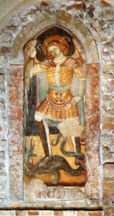](http://www.genesispark.com/wp-content/uploads/2011/11/Church-of-San-Zan-Degola-Web.jpg)

A wonderfully-preserved fresco (on the left – click to enlarge) depicting the archangel Michael overcoming the dragon is displayed at San Zan Degolà, a beautiful little 13th century church in Venice, Italy. The dragon’s proportions and especially its diminutive front legs bring to mind the small theropod dinosaurs like *Compsognathus*.

Choir stall railings and misericords (shelf-like seats for reclining while standing) in Medieval European churches are often adorned with ornate carvings. A common theme is the depictions of a dragon (symbolizing Satan) fighting a lion (symbolizing Christ). To the bottom-left is one such depiction, showing a dragon that looks very much like a sauropod dinosaur, taken from St. Remigius’ Church. The other three pictures below are taken from Carlisle Cathedral’s misericords, carved in the 15th century. Click to enlarge these pictures.

[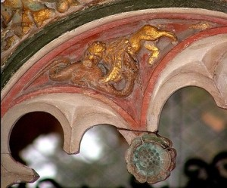](http://www.genesispark.com/wp-content/uploads/2011/11/ancient36-e1320370374899.jpg) [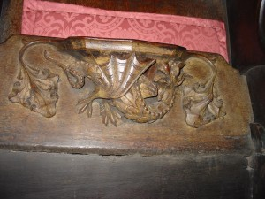](http://www.genesispark.com/wp-content/uploads/2011/11/ancient38.jpg) [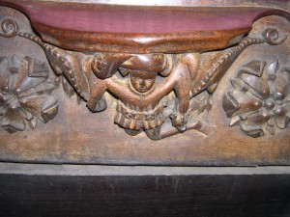](http://www.genesispark.com/wp-content/uploads/2011/11/ancient39.jpg) 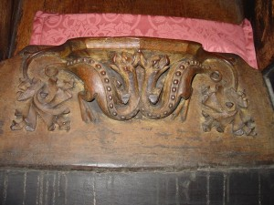 [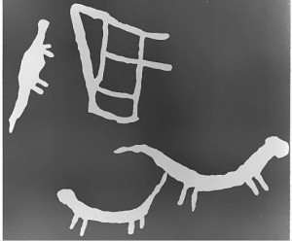](http://www.genesispark.com/wp-content/uploads/2011/11/Rhodesia-Cave-Painting.jpg)

“A fantastic mystery has developed over a set of cave paintings found in the Gorozomzi Hills, 25 miles from Salisbury. For the paintings include a brontosaurus – the 67-foot, 30-ton-like creature scientists believed became extinct millions of years before man appeared on earth. Yet the bushmen who did the paintings ruled Rhodesia from only 1500 BC until a couple of hundred years ago. And the experts agree that the bushmen always painted from life experiences. This belief is borne out by other Gorozomzi Hills cave paintings – accurate representations of the elephant, hippo, buck and giraffe. The mysterious pictures were found by Bevan Parkes, who owns the land the caves are on. Adding to the puzzle of the rock paintings found by Parkes is a drawing of a dancing bear.” (Anonymous, “Bushmen’s Paintings Baffling to Scientists,” *Los Angeles Herald-Examiner*, January 7, 1970.) To the left is a reproduction of just such a rock painting from a cave at Nachikufu near Mpika in northern Zimbabwe (formerly Rhodesia). It shows three long-necked, long-tailed creatures sketched in white. (Clark, Desmond J., “The Rock Paintings of Northern Rhodesia and Nyasaland,” in *Rock Art of Central Africa*, edited by Roger summers, 1959, pp. 28-29, Fig. 52.)

[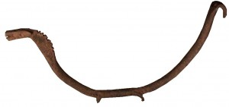](http://www.genesispark.com/wp-content/uploads/2013/10/Bambara-Sauropod-6.jpg)

The Bambara peoples of Mali Africa created wonderful wood and iron figurines in the 1800s. Humans, horses, antelopes, and much more are beautifully portrayed. To the right is an iron figure that was entitled “dinosaurian sculpture” by the auctioning gallery. It shows a four-legged creature with long neck and tail like a sauropod dinosaur. The neck has a slight widening and a ridged frill that makes it an especially fascinating depiction. The iron piece is actually a functional tool, with a hook at the end, perhaps used to retrieve a hot pot off the fire.

[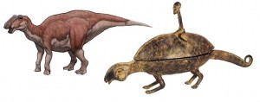](http://www.genesispark.com/wp-content/uploads/2011/11/Gryposaurus-and-Dogon-Bronze.jpg)

Another African tribe from the Mali region produced a dinosaurian object in the mid-1800s. Our friends at the s8int website note that this is the same time frame when Sir Richard Owen coined the term “dinosaur” in England. The bronze artifact to the left shows a Dogon tribesman riding a long-necked, long-tailed reptilian creature. The oddly bird-like head with strong jawline and ridged head and neck are reminiscent of certain “duck-billed” ornithopod dinosaurs like the *Gryposaurus,* whose skeleton is found in the Kaiparowits Formation in Utah. The diamond-shaped pattern on the skin matches fossilized skin impressions discovered on a hadrosaur in southern Utah. The sizes of the Dogon rider and the large-nosed *Gryposaurus* are modeled roughly in correct proportion.

[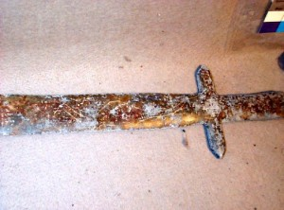](http://www.genesispark.com/wp-content/uploads/2013/10/Roman-style-lead-sword-with-dino.jpg)

In the 1920s thirty-one Roman-style lead artifacts were excavated near Tucson, AZ (see right). These are described on p. 331 of David Hatcher’s book *The Lost Cities of North & Central America* and were featured on the History Channel’s 2013 show *America Unearthed*. These lead objects appear to be religious in nature with Hebrew and Latin inscribed upon the swords, spears and crosses. They were buried about five feet below the desert surface in a layer of caliche (a cement-like mixture of desert soil and minerals). Skeptics have questioned the authenticity of these artifacts because the discovery site contains no other artifacts (like pottery, broken glass, bones, ashes or houses) that might validate the existence of Medieval colony. But perhaps this location was merely a ceremonial storage location. Supporters point out the value of the significant amount of burial work and expensive lead involved and wonder what the motivation could be for such an elaborate hoax? After all, just one cross weighs 62 pounds!

[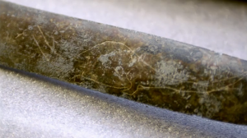](http://www.genesispark.com/wp-content/uploads/2016/01/Tucson-Artifact-Dinosaur-Comparison-with-Outlined.png)

Microscopic analysis of the mineralization build up on the implements seems to argue for them being genuine. A 1972 attempt to dig on location to search for additional objects was curtailed due to legal challenges. But one of the biggest objections to the authenticity of the Tucson Silverbell artifacts is the precise carvings of an apparent *Diplodocus* dinosaur on the sword (click right to see it highlighted). The artifacts have been stored at the Arizona Historical Society.

[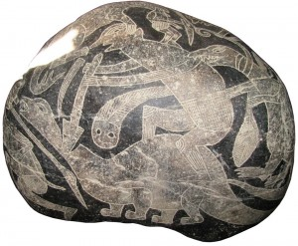](http://www.genesispark.com/wp-content/uploads/2013/10/Misc-Sauropod-Stone-clean-lower-res.jpg)

To the left is pictured an Ica Ceremonial Burial Stone from the Nasca culture (100 BC to 800AD) that is carved in a bas relief technique. In 1500s the Spanish Conquistadors brought back stories that there were stones with strange creatures carved on them found in Peru. Some of the stones were even brought back to Spain. The Incan Chronicler Juan de Santa Cruz Pachucuti Lumqui wrote in 1571 about the strange engraved stones in Ica. (See Swift, Dennis, *Secrets of the Ica Stones*, 2006.) Dom Geronomo Cabrera was a Spanish conquistador who settled the area of Ica in 1570.One of his descendants, Dr. Javier Cabrera, saw these stones as a child and began collecting them in the 1960s. He eventually accumulated over 11,000 such stones. Retired from the University of Lima, Dr. Cabrera focused upon validating these finds within the scientific community. His credibility was strengthened by long-necked creatures found on pottery in the museum of Lima (lower right).

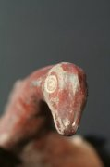 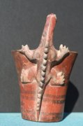 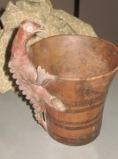

[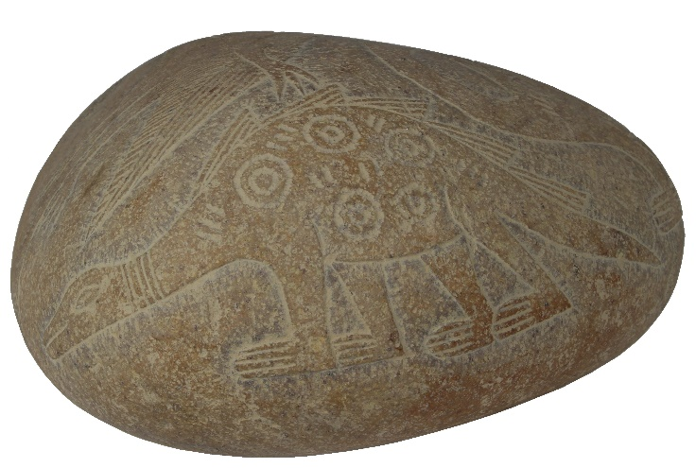](http://www.genesispark.com/wp-content/uploads/2013/10/Misc-Sauropod-Stone-clean-lower-res.jpg)

Beautiful tapestries (see below) have been found in the tombs of the area (dated from 200 – 700 AD) with a repeating pattern that looks like dinosaurs (pictures courtesy of Dennis Swift). Indeed, the depictions on some of the Ica Stones how the sauropod dinosaurs with a crest of spines much like those on the Acambaro figures, and preserved skin remains discovered by Paleontologist Stephen Czerkas:“Recent discovery of fossilized sauropod (diplodocid) skin impressions reveals a significantly different appearance for these dinosaurs. The fossilized skin demonstrates that a median row of spines was present… Some are quite narrow, and others are broader and more conical.” (Czerkas, “New Look for Sauropod Dinosaurs,” *Geology,* December, 1992, p. 1,068.)

[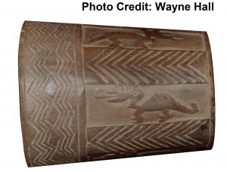](http://www.genesispark.com/wp-content/uploads/2013/10/Swift-Cup-Cleaned.jpg) [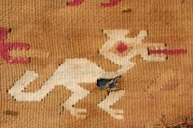](http://www.genesispark.com/wp-content/uploads/2011/11/ancient52.jpg) [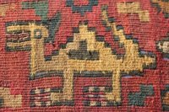](http://www.genesispark.com/wp-content/uploads/2011/11/ancient51.jpg) 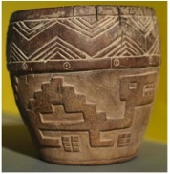

[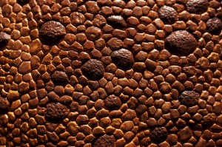](http://www.genesispark.com/wp-content/uploads/2013/08/Dino-Skin-with-Great-Bumps-CA-Museum-of-Nature.jpg) 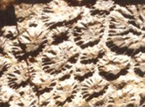

Also, of interest is the fact that the skin of many of the carved dinosaurs has rounded, bump-like depictions. Some scientists had pointed to this as evidence that this stone art is not scientifically accurate. However, more recent discoveries of fossilized dinosaur skin and embryos have silenced these same critics. For example, Luis Chiappe and colleagues discussed certain sauropod dinosaur embryos found in South America: “The general skin pattern consists of round, non-overlapping, tubercle-like scales…A rosette pattern of scales is present in PVPH-130″ (Chiappe, et al., 1998, p. 259). Note the skin depictions above to the right. “Both taxa show a round pattern of small polygonal scales, which in some places is interrupted by larger oval tubercles surrounded by the small scales, resulting in rosette-like structures. …which also match the most common textures known in dinosaurs.” (Christiansen, and Tschopp, “Exceptional Stegosaur Integument Impressions from the Upper Jurassic Morrison Formation of Wyoming,” *Swiss Journal of Geosciences* 103:2, 2010.)

[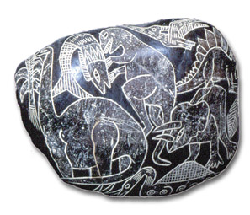](http://www.genesispark.com/wp-content/uploads/2011/11/Ica-Stone-Dinos-Eating-Hi-Res-Clean.jpg)

Theropod Dinosaur Eating a Large Fish

Other items of anatomical accuracy that attest to the authenticity of these Ica Stone depictions include the positioning of the tail and legs. Early critics said the Ica Stones were fakes, in part because their tails were sticking out while walking. Paleontologists

in the 1960s were confident that dinosaurs dragged their tails. The paleontologists were wrong and the Ica Stones were right.

[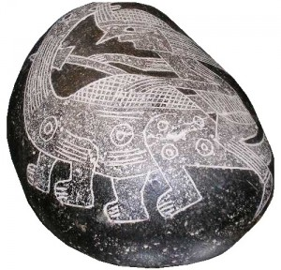](http://www.genesispark.com/wp-content/uploads/2011/11/Ica-Stone-Hunting-Dinos-Cleaned-Up1.jpg)

Scientists now believe dinosaurs held their massive tails off the ground while walking, because there are no drag marks on dinosaur trackways. The dinosaurs on the Ica Stones are accurately depicted standing upright, rather than with legs splayed out in a lizard-like position. The stylizing of animals depicted on the Ica Stones matches those found in the Nascan Lines (monkey with curled tail, hummingbird, and stylized dinosaur). Many of the Ica Stones were been blackened so that the artistic etchings stand out. While some fraudulent Ica Stones have been manufactured in recent years to sell to tourists, a number of the dinosaur stones were found in tomb excavations by experienced archaeologists. Moreover microscopic analysis of the patina (covering the stone surface), copper traces and oxidation in the etching grooves unambiguously distinguishes between the authentic and the recently forged artifacts. In 2015-2016 Genesis Park participated in research seeking a methodology to independently authenticate the Ica Stones. This resulted in an [article published in a peer reviewed creation journal.](http://www.genesispark.com/can-the-ica-stones-be-independently-authenticated/)

[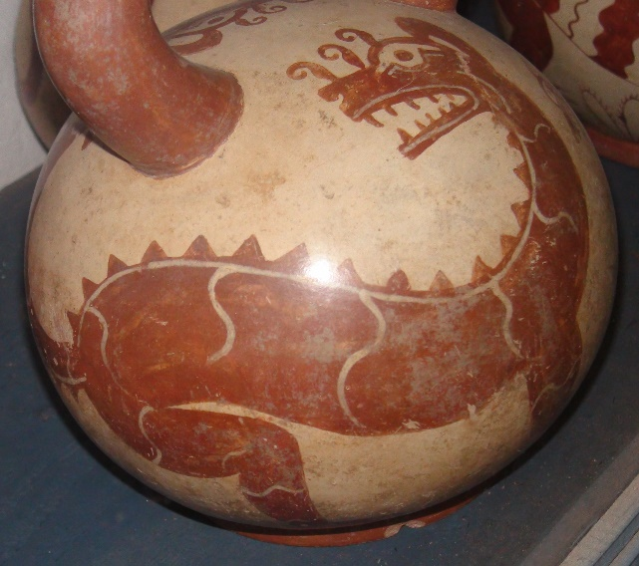](http://www.genesispark.com/wp-content/uploads/2013/08/Herrera-Museum-Moche-Pot-Clean.jpg) [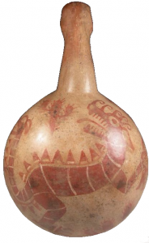](http://www.genesispark.com/wp-content/uploads/2011/11/Moche-Canchero-500-700-AD-cropped-clean.png) [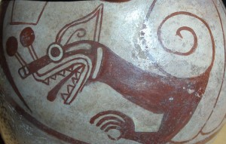](http://www.genesispark.com/wp-content/uploads/2013/08/Moche-Strombus-Shell2.jpg)

Not far from the South American Nasca sites are the Moche Indian archaeological locations. These Moche tribes inhabited northern Peru about 100-800 AD. Among the artifacts currently in the Lima museums are the Moche stirrup-spout pots (left). These are their main artistic medium, featuring red & white ceramic pots displaying realistic medical procedures, combative events, musical instruments, plants and animals. Official guides at Peru’s numerous museums and archaeological sites will tell you that the native cultures depicted only things that they saw in nature. So what inspired the dragon-like images like that on the canchero to the right? In Lima’s Larco Museum there are numerous ancient vases that quite clearly depict long-necked reptilian monsters with three or four toes, in some cases carrying a trophy head on their tail. These creatures bear a resemblance to those shown on the Ica stones, including the dermal frills. They have been dubbed “Strombus Monsters” because they are sometimes shown hiding in a Strombus shell. (Note the Moche pot on the left. Both this piece and the canchero are part of the Genesis Park collection – click to enlarge.)

[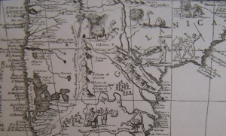](http://www.genesispark.com/wp-content/uploads/2011/11/Pategonia-Map.jpg)

A dictionary (Casamiquela, R., *Diccionario Tehuelche,* Va. Adelina: Patagonia Sur Libros, 2008.) on the language of the Patagonian natives (the Tehuelche groups) by the late historian Rodolfo Casamiquela displays a 16th century map (right). It depicts terrain of the Terra Magellanica (what is now Argentina) and shows a hunting party shooting at a ñandú and also displays some very dinosaurian-looking animals up above. Click to enlarge and look top center and to the right.

[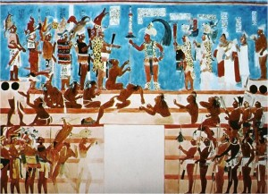](http://www.genesispark.com/wp-content/uploads/2013/10/Mayan-Dinosaur-Head-Parade-Bonampak.jpg) [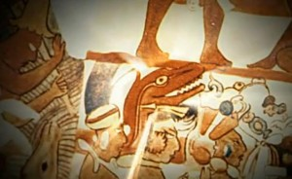](http://www.genesispark.com/wp-content/uploads/2013/10/Maya-dinosaur-head-being-carried-to-sacrifice-Bonampak.jpg)

The ancient Maya culture, which flourished around the 6th century, is famous for their excellent artwork. Bonampak is a Maya archaeological site in Mexico where there are a number of wonderful murals, including the remarkable one to the left. It shows the presentation of various war captives to the ruler, Chaan Muan, along with some trophy heads (perhaps brought for sacrificing). In addition to the human heads, the men are carrying an animal head and what looks a lot like a dinosaur head (enlarged in the picture to the right). Both the teeth and the large size make it doubtful that the Maya artist was depicting a lizard or snake.

In 1945 Waldemar Julsrud, a resident of Acambaro, Mexico who had archaeological experience, discovered clay figurines buried at the foot of El Toro Mountain. Eventually over 33,000 ceramic and stone figurines were found! These range from detailed artwork, to fine musical instruments, to roughly-shaped animal depictions, to monstrous creatures. There are clear similarities to Chupicuaro Cultural artifacts (800 BC to 200 AD) found in the area, a culture that Julsrud co-discovered.

[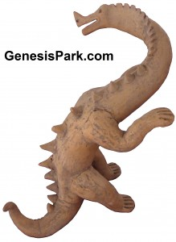](http://www.genesispark.com/wp-content/uploads/2013/10/Smiling-Dino-Clean.jpg) [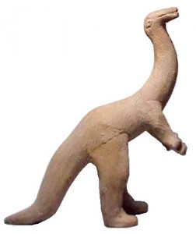](http://www.genesispark.com/wp-content/uploads/2011/11/acambaro-dino-hi-res.jpg) [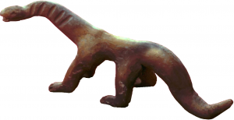](http://www.genesispark.com/wp-content/uploads/2013/08/Acambaro-Figurine4.jpg) [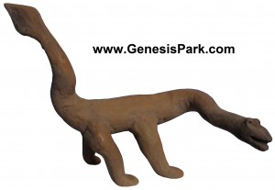](http://www.genesispark.com/wp-content/uploads/2013/10/Club-tailed-Dino-Clean.jpg)

But the authenticity of Julsrud’s find has been challenged because the huge collection included clear dinosaur figurines. In 1954 the Mexican government sent a team of archaeologists to investigate. In 1955 Charles Hapgood, Professor of Anthropology at the University of New Hampshire, conducted an elaborate investigation including radiometric dating and thermo-luminescence testing by the University of Pennsylvania. Subsequent investigations were conducted by the Mexican government. Thus Julsrud’s work has undergone considerable scrutiny. The Mexican government even imprisoned men for selling these artifacts on the black market. Moreover, the dinosaurs are modeled in very agile, active poses, fitting well with the latest scientific evidence and lending credence to the artists having actually observed these creatures. Like the Ica Stones, some sauropod’s are depicted with a distinctive spinal frill. The remains of an ice-age horse (now extinct), the unfossilized skeleton of a woolly mammoth, and a number of ancient human skulls were found at the same location as the ceramic artifacts, validating the antiquity of the site (Hapgood, Charles, *Mystery in Acambaro,* 2000, p.82.). Dr. Ivan T. Sanderson was amazed in 1955 to find that there was an accurate representation of a *Brachiosaurus*, almost totally unknown to the general public at that time. Sanderson wrote, “This figurine is a very fine, jet-black, polished-looking ware. It is about a foot tall. The point is it is an absolutely perfect representation of *Brachiosaurus*, known only from East Africa and North America. There are a number of outlines of the skeletons in the standard literature but only one fleshed out reconstruction that I have ever seen. This is exactly like it.” (Hapgood, p. 85.)

[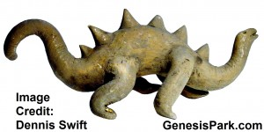](http://www.genesispark.com/wp-content/uploads/2013/10/Dennis-Swifts-Acambaro-Figurine.jpg) [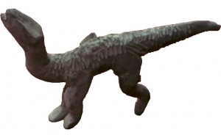](http://www.genesispark.com/wp-content/uploads/2011/11/acambaro-iguanadon-hi-res-clean.jpg) [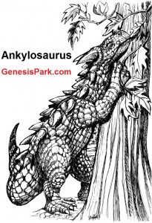](http://www.genesispark.com/wp-content/uploads/2013/10/Dobbs-Ankylosaurus-GP.jpg) [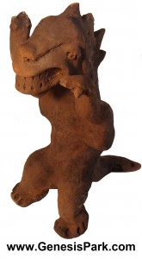](http://www.genesispark.com/wp-content/uploads/2013/10/T-Rex-Dino5.jpg) [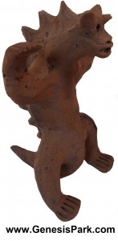](http://www.genesispark.com/wp-content/uploads/2013/10/Acambaro-Ankylosaurus.jpg)

Further evidence of the authenticity of Julsrud’s finds is a figurine that resembles the *Iguanodon* dinosaur figurine (above left, photo credit – Don Patton). This was one of the first dinosaur skeletons discovered. The early concept of its appearance was almost comical in the mid 1800s. By the turn of the century it had improved considerably but fell far short of what we now know. The Acambaro figurine exhibits knowledge we have gained only in recent decades. No hoaxer could have made this model in the 1940s. In fact, there is a movement in recent years to “slenderize” the sauropod dinosaurs, suggesting that they were more agile and less plump (much like the Acambaro figures). For example, in 2009 scientists “devised a new statistical model that can more accurately predict the mass of an animal based on the width of its bones” resulting in a downsizing of *Apatosaurus,* which had “been widely cited as weighing about 42 tons. According to the new equation, these creatures actually weighed about 20 tons, or less than half earlier estimates.” (Moskowitz, Clara, “Giant Dinosaurs Get Downsized,” *Live Science,* December 12, 2009.) Other recognizable Acamabaro shown above include figures are the *Tyrannosauru*s-like theropod figurine and the *Ankylosaurus*statue. The beak on this figurine is slightly broken off, but the distinct horns, short neck, dermal spikes, pudgy feet and powerful tail are all nicely replicated. (Both of these pieces are in the Genesis Park collection.) Genesis Park staff participated in research on Mount Toro in Acambaro where most of these artifacts have been excavated. Many figurines remain buried in the ground there and new pieces are regularly being exposed as a result of erosion, construction work, and farming.

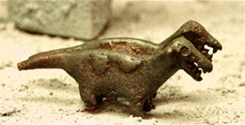 [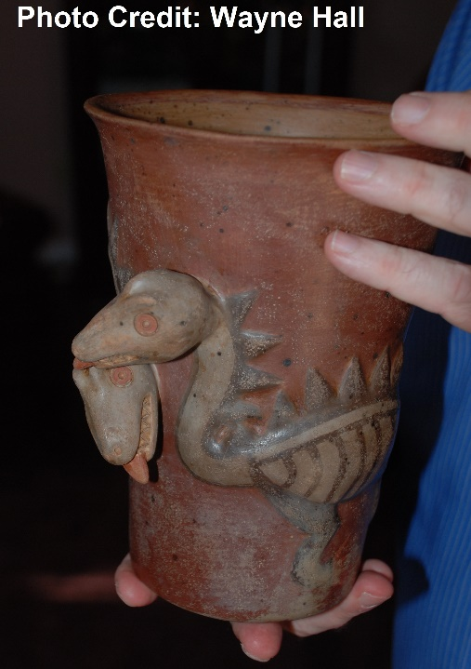](http://www.genesispark.com/wp-content/uploads/2013/10/Swift-Dueling-Dino-Vase.jpg)

To the right is an artifact from Tiwanaku, an important Pre-Columbian archaeological site in Bolivia. Tiwanaku is recognized by Andean scholars as one of the most important precursors to the Inca Empire. The sculptor depicted a dinosaur-like creature at least 800 years before European scientists discovered dinosaurs. The vase on left was also discovered in the Tiwanaku region. It depicts dueling dinosaurs and is believed to date from 500 – 1000 A.D. The style closely resembles the Nasca dinosaurian depictions (on the Ica Stones).

[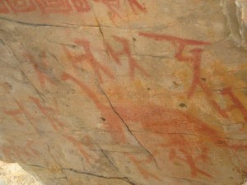](http://www.genesispark.com/wp-content/uploads/2011/11/Axel-Photo-Amazon-Warriors-and-Dinosaur2.jpg)

In May of 2012 researcher Vance Nelson brought to our attention a panel of pictographs found on a rock ledge at the edge of the Amazon rain forest basin in northern Peru. This artwork is said by secular archaeologists to be thousands of years old. Amazingly, one of the pictographs shows nine warriors hunting what appears to be a dinosaur. In the 1940s the American explorer Percy Fawcett brought back reports of a large dinosaur-like creature from this same region of the Amazon.

[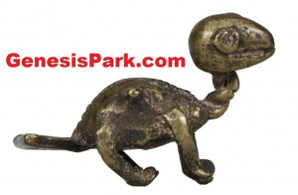](http://www.genesispark.com/wp-content/uploads/2011/11/Ashanti-Med-Res-White.jpg)

The Ashanti people of Ghana in western Africa are known for their bronze carvings that were used over the centuries as gold weights (used along with a scale in the gold dust trade). Eventually, these little statues became a bit of an art form and many accurately depict various African animals. The curious gold weight to the left dates back to the 1800s and is now part of the Penn Museum collection (Image #AF2478 commissioned by Genesis Park). It was unidentified initially, “despite diligent search in the animal kingdom.” (Plass, Margaret, *African Miniatures: The Goldweights of the Ashanti*, 1967, p.92.) A jeweler in Philadelphia first suggested that it resembles a juvenile dinosaur. (Heuvelmans, Bernard, *Les Derniers Dragons d’Afrique*, 1978, pp. 336–337.) It has a fan tail and a beak-like mouth, distinctive characteristics of some of the recently-discovered oviraptorosaur fossils.

[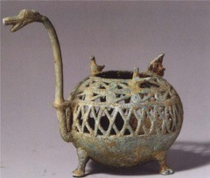](http://www.genesispark.com/wp-content/uploads/2011/11/thai-dragon-Incense-Burner.jpeg) [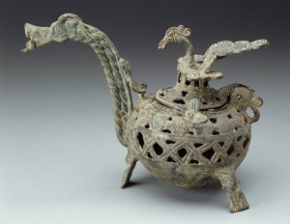](http://www.genesispark.com/wp-content/uploads/2011/11/Viet-Dragon-Incense-Burner.jpg)

To the left is an ancient Thai incense burner pictured in the book *Arts of Asia* *: Materials, Techniques, Styles* by Meher McArthur*.* Curiously enough, it looks like a stylized version of a sauropod, the fossilized bones of which were actually found in Thailand. Notice the birds perched on the back of the dragon, much as we see them do today on the back of a hippo. A similar motif is seen in a Viet incense burner to the right. This cast bronze work is dated to the 3rd century A.D. and is from the Dongson culture. The piece is housed at the Boston Museum of Fine Arts.

Deep in the jungles of Cambodia are ornate temples and palaces from the Khmer civilization. One such temple, Ta Prohm, abounds with stone statues and reliefs. Almost every square inch of the gray sandstone is covered with ornate, detailed carvings. These depict familiar animals like monkeys, deer, water buffalo, parrots, and lizards. However, one column contains an intricate carving of a stegosaur-like creature. But how could artisans decorating an 800 year old Buddhist temple know what a dinosaur looked like? Western science only began assembling dinosaurs skeletons in the past two centuries. (Pictures are courtesy of Don Patton.)

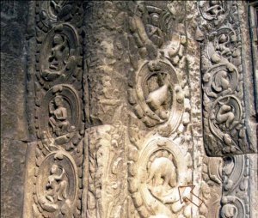 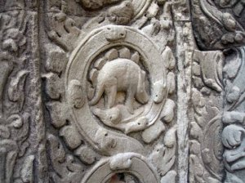 [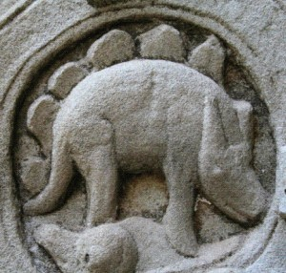](http://www.genesispark.com/wp-content/uploads/2013/10/Cambodia-Dinosaur-Closeup.jpg)

The slaying of a ferocious dragon by St. George is an extremely common motif in medieval art. Various European artists interpreted the dragon differently, depending on local knowledge and lore. A wonderful medieval depiction is seen at the Palau de La Generalitat in Barcelona Spain. St. George’s Chapel contains an altar cloth illustrating St. George’s slaying of a dragon. The depiction bears an amazing likeness to the *Nothosaurus*, a semi-aquatic reptile (comparison below). Notice the correct-size, the crocodilian body style, and the fascinating long, curved teeth at the front of the jaw that gives way to finer dentition towards the back.

[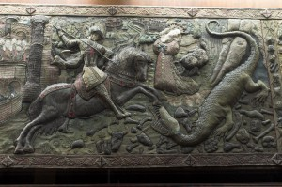](http://www.genesispark.com/wp-content/uploads/2011/11/ancient66.jpg) 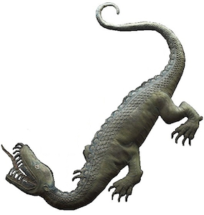 [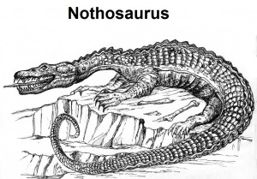](http://www.genesispark.com/wp-content/uploads/2013/10/Nothosaurus3.jpg) [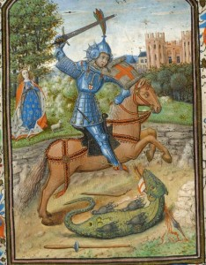](http://www.genesispark.com/wp-content/uploads/2011/11/George-Dragon-Book-of-Hours-Morgan-Museum.jpg) 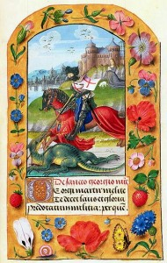

Yet another interpretation of St. George slaying the dragon is found in the Latin Book of Hours c. 1450 AD which is illuminated by the Master of Jean Chevrot and currently housed at the Morgan Library & Museum (right). Notice the Master’s attention to detail (click to enlarge), as seen in George’s armor, the birds in the sky, and the dragon’s genitals. The Fitzwilliam Museum contains another portrayal (left) of St. George destroying the dragon (probably by Bruges) from a Latin Book of Hours c. 1490 AD. This colorful work from the Flemish School portrays a remarkably dinosaur-like dragon.

The country of Georgia sits at the edge of Eastern Europe and Western Asia. High in the hills atop Mount Gergeti is the Holy Trinity Church (also known as Tsminda Sameba) which was originally constructed in the 1300s. The bell tower window contains

some unusual carvings that look quite a bit like two dinosaurs, perhaps engaged in head-butting combat. Inside the church is an ancient icon of St. George slaying a snake-like dragon. St. George has been revered in the Republic of Georgia since the 4th century. The weathering and patina of these dragons certainly seems to match the rest of the construction, suggesting it is an original carving.

[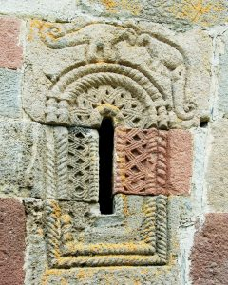](http://www.genesispark.com/wp-content/uploads/2013/10/Dinosaur-window-carving-Georgian-Church.jpg)

Some of the beautiful French chateaus built at the close of the Middle Ages and early 1500s have dramatic dragon illustrations carved into their walls, ceilings, and furniture. These include Château de Chambord, Château de Blois, and Château Azay-le-Rideau. Called “salamanders,” based on a legendary salamander that could survive fire, they became especially popular decorative elements on construction during the reign of Francis I. Often they are portrayed actually as a fire-breathing dragon, like the biblical Leviathan. A number of features make these “salamanders” different from the amphibians we know by that name today. They are depicted with long necks, scales, prominent teeth, powerful claws, and an upright posture. The form is much closer to the reptilian dragon depictions common in European art from that period. Note the similarities among these “salamander” dragons below and their resemblance to dinosaurs like *Thecodontosaurus, Plateosaurus* or *Baryonyx* (whose fossils are found in multiple locations around Europe). A number of royal household furnishings from that time also depict a similar dragon, like the antique French pot below to the right. A tapestry at Château de Blois portrays a dragon (and its baby) with gnarly horns on its head that are reminiscent of the dinosaur *Dracorex hogwartsia*. [Photo credit: Don Patton.]

[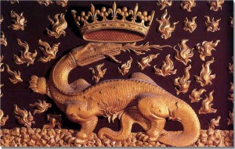](http://www.genesispark.com/wp-content/uploads/2013/10/blois-dragon10.jpg) [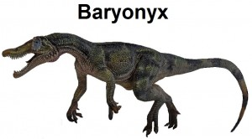](http://www.genesispark.com/wp-content/uploads/2013/10/Baryonyx-Walkeri-Clean3.jpg) [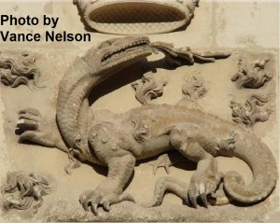](http://www.genesispark.com/wp-content/uploads/2013/10/chateau-dragon-revised-credit.jpg) 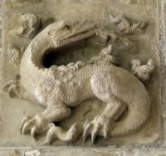 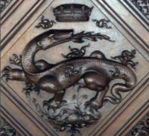 [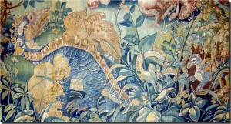](http://www.genesispark.com/wp-content/uploads/2013/10/blois-dragon5.jpg)

[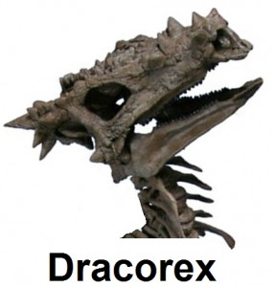](http://www.genesispark.com/wp-content/uploads/2013/10/Dracorex-Skeleton.jpg) [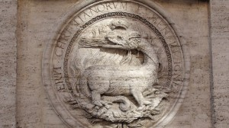](http://www.genesispark.com/wp-content/uploads/2011/11/Church-of-St.-Louis-the-French.jpg) [](http://www.genesispark.com/wp-content/uploads/2013/10/French-Salamander-Bowl-1890-Clean.jpg)

In Rome there is similar artwork on the outside at the Church of St. Louis of the French. This served for many years as the national church of France in Rome and was completed in the 1580s. Notice on the dragon artwork (to the left) the long neck, tridactyl feet, long tail, neck frill, the scales, and especially the dinosaurian-looking legs. They drop down straight, rather than being splayed out parallel to the ground like a salamander or lizard’s legs. Though exposed to the elements on the exterior of the church, the detailed work has been remarkably well preserved over nearly five centuries! Click to enlarge this amazing dragon carving.

[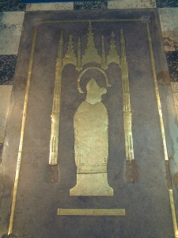](http://www.genesispark.com/wp-content/uploads/2011/11/Bishop-Bells-Tomb.jpg) [http://www.genesispark.com/wp-content/uploads/2013/10/Bishop-Bells-Dinos-300x63.jpg](http://www.genesispark.com/wp-content/uploads/2013/10/Bishop-Bells-Dinos.jpg)

In 1496 the Bishop of Carlisle, Richard Bell, was buried in Carlisle Cathedral in far northern England, near the Scottish border. The tomb (see far right) is inlaid with brass, having various animals engraved upon it. Although worn by the countless feet that walked over it since the Middle Ages, a particular depiction is intriguing in its similarity to a sauropod dinosaur. It appears to be two long-necked dinosaurs with necks entangled like the Egyptian Hierakonpolis dragon depictions mentioned above (perhaps an amorous posture). The long tails stick out straight like an *Apatosaurus* and of one (maybe the male) sports spikes at the end. Amongst the birds, dog, eel, bat, fox, etc. depicted around the tomb, this compelling representation of two long-necked creatures should be considered evidence that man and dinosaurs co-existed.

# Ancient Pterosaur Depictions

# <http://www.genesispark.com/exhibits/evidence/historical/ancient/pterosaur/>

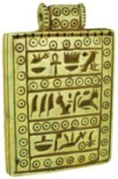

Many ancient historians tell of winged serpents, or pterosaurs, inhabiting the swamplands and deserts near Egypt. There is even an Egyptian hieroglyphic symbol for the winged serpent that appears prominently in the Book of the Dead and elsewhere. (Note the glyph to the bottom of the Egyptian limestone pendant pictured to the right.) The world famous gold throne of King Tut (lower left) has winged serpents forming the arm rests. Known as Wadjet, the winged serpent of Egypt, was revered as the protector of the Pharaohs and controller of the Nile waters. In fact, winged snakes are depicted on many of the coffins from ancient Egypt. Numerous depictions portray the Wadjet cobra goddess (or Uraeus), with feathered wings, unlike the leathery wings of a pterosaur. (See the papyrus at the center below where a “covering saraph” protects the god Osiris.) But an Egyptian-style scarab seal (shown below to the right) sporting bat-like wings was excavated at Achziv in northern Israel. The seal is dated from 1292 – 1075 BC and is housed in the British Museum collection. (Giveon, Raphael, *Scarabs From Recent Excavations in Israel*, 1988, p. 37.)

[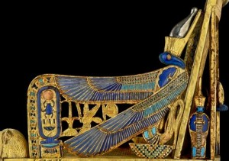](http://www.genesispark.com/wp-content/uploads/2011/11/Gold-Throne-of-King-Tut.jpg) 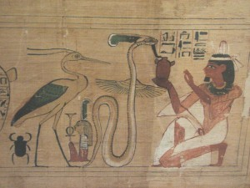 [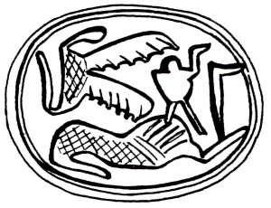](http://www.genesispark.com/wp-content/uploads/2011/11/Scarab-with-Winged-Serpent-Giveon-p.-37.jpg)

Below to the left is displayed an Egyptian Wadjet with feet, as shown in the Book of the Dead (Keel, Othmar, *Jahwe-Visionen und Siegelkunst,* 1977, p. 77.)  An Egyptian-style scarab seal found at Tel Gerisa in Israel (lower center and right) seems to depict a large pterosaur hunting an ibex (Giveon, Raphael, Scarabs From Recent Excavations in Israel, 1988, p. 70-71.) Not only is the leaf shaped tail vane of the pterosaur apparent, but it has a fascinating widened tip on the end of the beak, much like the Ornithocheirus. The long, snakelike head has a clear headcrest on it, much like pterodactyloid pterosaurs.  The two wings exhibit the unique corrugated features (as seen in the Solnhofen Rhamphorhynchus fossil). The level of detail is similar to that of the ibex. The seal dates from 1300-1150 BC and is now in the Tel Aviv University’s Institute of Archaeology. Similarly, an Egyptian statue residing in a Berlin museum depicts a flying serpent with legs sporting claws, three wing claws, a protopatagium (a portion of the wing above the arm known from pterosaur fossil impressions), and a tail vane. That pterosaur is shown hunting a falcon and also appeared to have the dental structure of a Scaphognathus. (Goertzen, John, “The Rhamphorhynchoid Pterosaur Scaphognathus crassirostris: A ‘Living Fossil’ Until the 17th Century,” 1998 ICC Paper.)

[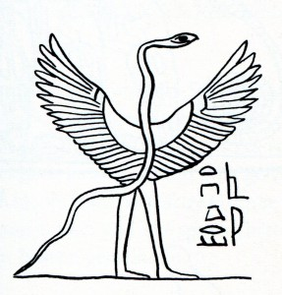](http://www.genesispark.com/wp-content/uploads/2011/11/Flying-Serpent-Images-Egyptian-from-Jahwe-Visionen-p-77.jpg) 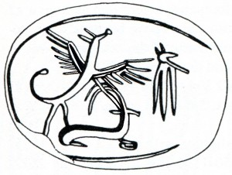 [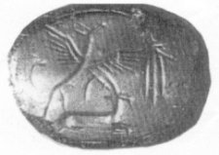](http://www.genesispark.com/wp-content/uploads/2011/11/Scarab-Seal-with-Winged-Serpent-Giveon-p-71.jpg) [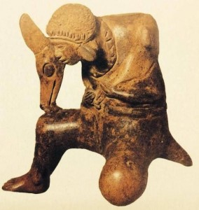](http://www.genesispark.com/wp-content/uploads/2011/11/Mayan-man-statue-with-pterodactyl-wrapped-around-him.jpg)

The Mayan worship of a feathered serpent god Quetzalcoatl has been traced all the way back to the first century BC. The widespread belief in the winged serpent, including the Aztec culture, has led even some evolutionary scholars to speculate if it might have been based upon a real animal in the Americas. “An ancient Mayan relief sculpture of a peculiar bird with reptilian characteristics has been discovered in Totonacapan, in northeastern section of Veracruz, Mexico. José Diaz-Bolio, a Mexican archaeologist-journalist responsible for the discovery, says there is evidence that the serpent-bird sculpture, located in the ruins of Tajín, is not merely the product of Mayan flights of fancy, but a realistic representation of an animal that lived during the period of the ancient Mayans – 1,000 to 5,000 years ago. If indeed such serpent-birds were contemporary with the ancient Mayan culture, the relief sculpture represents a startling evolutionary oddity. Animals with such characteristics are believed to have disappeared 130 million years ago.” (Anonymous, “Serpent-Bird of the Mayans,” Science Digest, vol. 64, Nov., 1968, p. 1.) To the left is a picture (photo credit – National Geographic) of just such a flying reptilian form. The details of what seems to be a pterodactyloid pterosaur are very realistically shown by the Maya artist, including the headcrest, the large eye, the leathery wing and the wing claws. It is unclear if the Maya figure is a hunter carrying the creature home or if it is a jacket.

[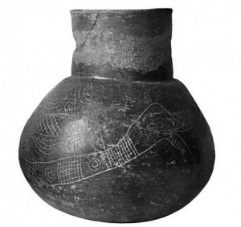](http://www.genesispark.com/wp-content/uploads/2011/11/Moundville-Alabama-Flying-Serpent-Pot.jpg) [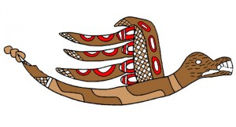](http://www.genesispark.com/wp-content/uploads/2011/11/Moundville-Winged-Serpent.jpg)

Pots with a fascinating pterosaur-like depiction have been found in Moundville, Alabama (see left). The “winged serpent” design seems to exhibit scales, ribbed wings, and a long tail. In some cases there is even the hint of teeth in the beak. Moundville is a Mississippian, Meso-American site that dates to around the 1300s. The Mississippian Culture flourished in what is now the Midwestern and Southeastern US from approximately 800 to 1500 AD. A similar pottery theme from this time frame exists all the way down in Central America. The native American Coclé culture of Panama was discovered by A. Hyatt Verrill. He noticed the oddly pterosaur-like representations on Coclé pottery and suggested it was so realistic that these native Americans must have been influenced by fossil discoveries. He describes the depiction (see right) as having “beak-like jaws armed with sharp teeth, wings with two curved claws, short, pointed tail, reptilian head crest or appendages, and strong hind feet with five-clawed toes on each.” The Coclé civilization dates from AD 1330-1520. But Verrill theorizes that this artwork was based on “accurate descriptions, or even drawings or carvings, of fossilized pterodactyls.” (Verrill, A. Hyatt, Strange Prehistoric Animals and their Stories, 1948, pp. 132-133.)

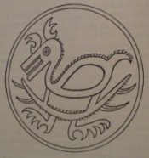

A common motif in Medieval art is the slaying of the dragon by St. Michael (taken from Revelation 12:7-9). Below to the left is a painting by Antonio del Pollaiuolo, an Italian Renaissance artist who worked in the late 1400s. This piece shows a number of pterosaurian features, including the webbed foot, four toes, bat-like wings, long snake-like neck, and hair below. In the center, note the winged Michael spearing the dragon from the Church of St. Marco in Venice. Beside it is an interpretation of the flying Michael and the angels overcoming Satan in the shape of a wyvern dragon (to the right). This is from the Liber Floridus, a Flemish manuscript dated from about 1448 AD. It depicts a winged reptilian form with enormous membrane wings.

[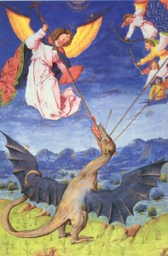](http://www.genesispark.com/wp-content/uploads/2011/11/St.-Michael-Angels-fight-the-Dragon-Lucifer.jpg) [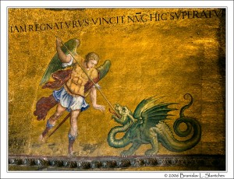](http://www.genesispark.com/wp-content/uploads/2011/11/St-Michael-Slaying-the-Dragon-San-Marco-in-Venice.jpg) [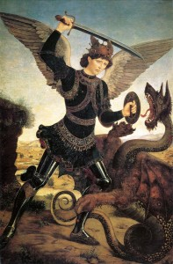](http://www.genesispark.com/wp-content/uploads/2011/11/michael-and-the-dragon-by-Antonio-del-Pollaiuolo.jpg)

But an even more common scene than the depictions of Michael and the dragon are the numerous renditions of St. George slaying the dragon, based on the legend of the saint saving a young lady from the fearsome great reptile.  In a work by Paolo Uccello from the 15th century (bottom left) you can see four claws on the feet, claws on the wings, and a stylized headcrest. Below in the center is another rendition of the legend by Rogier van der Weyden. This painting dates about 1435 and clearly shows four claws on the feet, shiny scales all over the body, a reptilian ear, and a beak full of teeth. While the wings look a bit odd, it could be that the reports received by the artist were from an observer who had seen a pterosaur on all fours with wings folded upward. This four-legged, flying dragon motif is very common in Medieval art. While the tiny wings appear ridiculous, it seems reasonable that the artist would draw stubby, erect wings because the eye witness had essentially seen only a portion of the total wingspan. Only about a third to a half of a pterosaur’s wings would be sticking out above the body as it walked.

[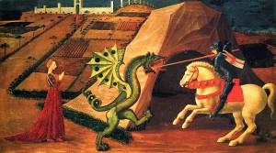](http://www.genesispark.com/wp-content/uploads/2011/11/Uccellos-Michael-killing-the-dragon.jpg) [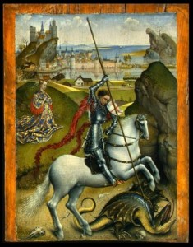](http://www.genesispark.com/wp-content/uploads/2011/11/Rogier-van-der-Weydens-St-George-1432-1435.jpg) [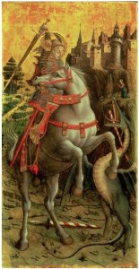](http://www.genesispark.com/wp-content/uploads/2011/11/George-Dragon-Isabella-Steward-Gardner-Museum.jpg)

The Isabella Stewart Gardner Museum in Boston, MA contains an intriguing depiction of St. George’s dragon from 1470 by the Italian artist Carlo Crivelli (above right). This gold and tempera on poplar wood panel was painted for the parish church at Porto San Giorgio on the Adriatic. Crivelli employed a winged dragon interpretation of the popular legend. The dragon bears a remarkable likeness to a pterosaur with the proper four anterior toes and the lateral fifth toe, ribbed wings, headcrest, and teeth. Some pterosaurs, like Jeholopterus (known as the “vampire pterosaur”), have fangs much like the dragon in this picture. Certain researchers have concluded that the pterosaur *Jeholopterus* would actually fly up to large dinosaurs, latch onto their skin, and drink their blood. Perhaps the most intimidating dragon portrayal of the St. George legend is the work found in the Højby Church in Zealand, Denmark (shown to the right). The church is recognized for its fine 15th century Gothic wall paintings. The impressive dragon fresco presents a truly fiercesome reptile, large enough to swallow the knight whole! Along with stylized elements like horns and ears, we see an impressive headcrest, strong legs like a Dimorphodon, and a prominent tail.

[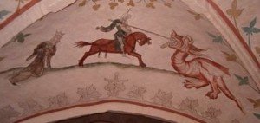](http://www.genesispark.com/wp-content/uploads/2011/11/H%C3%B8jby-odsherred-church-dragon-fresco.jpg) [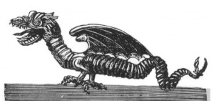](http://www.genesispark.com/wp-content/uploads/2011/11/French-Woodcarving.jpg)

European reports of flying serpents living in Egypt persist through the 1600s. The Italian naturalist Prosper Alpin wrote a fascinating natural history of Egypt in the 1580s. He described their crest (a small a bone or a piece of skin atop the head), their tail being “thick as a finger,” their length being “as long as a palm branch,” and their leaf-shaped tail. (Alpin, P., Histoire Naturelle de l’Egypte, tr. by R. de Fenoyl, 1979, pp. 407-409.) All is precisely like modern fossil reconstructions. A French wooden image, dating from the 16th century (above), also displays remarkable features of a pterosaur. There are two wings that clearly appear to have ribbed membranes rather than feathers. There appears to be a small head crest above and slightly in front of the eyes, the distinctive tail vane, and a hint of the twin skin flap above and behind the bony crest that is quite like the Egyptian seal.  A decaying dragon is shown on p. 817 of Dr. Francisco Hernández’ landmark book Rerum Medicarum Novae Hispaniae Thesaurus (published in 1651). It seems to be an original engraved work of Johannes Faber and presents a realistic-looking pterosaur.

[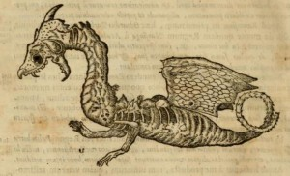](http://www.genesispark.com/wp-content/uploads/2011/11/Johannes-Faber-1651-Decaying-Dragon2.jpg)

Below on the left are two fascinating depictions of a flying serpent from the ceiling of the San Miniato al Monte church in Florence, Italy, built in the 11th century. Notice the beak, four claws on the foot, headcrest, coiled tail and bat-like wings on the blue one. These are all distinctive characteristics of pterosaurs. The tail makes it look like a Rhamphorhynchus. Note as well the reptilian forked tongue. These drawings stand beside carefully drawn dogs, eagles, lions, doves, etc.

[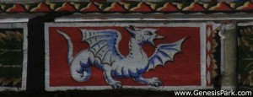](http://www.genesispark.com/wp-content/uploads/2011/11/San-Miniato-Dragon-Text.jpg) [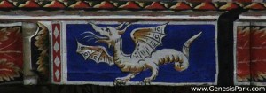](http://www.genesispark.com/wp-content/uploads/2011/11/San-Miniato-Dragon-2-Text.jpg)  [](http://www.genesispark.com/wp-content/uploads/2011/11/pterosaur7.jpg)

Above to the right is a drawing from a 17th century German tract about the dangers of witches and witchcraft. Witches were accused of causing houses to spontaneously combust. The dragons depicted flying in the background, with characteristic headcrests and tails, were apparently associated with witches. (Guazzo, Francesco Maria, Compendium Maleficarum, 1628, p. 23.) Many accounts from that time period describe creatures that sound suspiciously like pterodactyls. An official government report from 1793 states: “In the end of November and beginning of December last, many of the country people observed dragons appearing in the north and flying rapidly towards the east; from which they concluded, and their conjectures were right, that…boisterous weather would follow.” (“Flying Dragons at Aberdeen,” A Statistical Account of Scotland, 1793, p. 467.)

[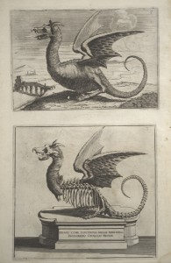](http://www.genesispark.com/wp-content/uploads/2013/10/Cornelius-Meyer-Dragon-Mount-Ancient-Rome.jpg)

A dragon was said to live in the wetlands near Rome in December of 1691. This creature inhabited a cave and supposedly terrorized the local population. A sketch (left) of the skeleton survived in the possession of Ingegniero Cornelio Meyer. A most remarkable thing about this animal is the clear head crest and the dual piece of skin from the crest. Five digits are clearly visible for each foot, of the proper length and with the first shorter and offset from the rest as is appropriate for the pterosaur Scaphognathus. There is a hint of a wing claw on the far wing where it curves forward. The membraned wings are in front of the legs, on the vertebrae, matching the fossils that we find. The femur is properly shown as a single bone. The tibia and fibula, the twin lower leg bones, are visible too. Although some have suggested that it could be a fossil or a faked composite, it is much too accurate to be a fabrication. The survival of the skin suggests that it is not a fossil since it includes accurate wing features, a head crest, and the ears (Goertzen, John, “The Rhamphorhynchoid Pterosaur Scaphognathus crassirostris: A ‘Living Fossil’ Until the 17th Century,” 1998 ICC Paper.). Yet another Medieval pterosaur-like dragon depiction (right) is presented in Conrad Gesner’s 1589 work, Book of Snakes.

[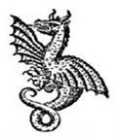](http://www.genesispark.com/wp-content/uploads/2011/11/Gesner-Flying-Serpent.jpg)

In 1704, Hoellischer Morpheus: Saducismus Triumphatus (below far right) was published, the theme of this work was the grotesque (including subjects like the occult and black arts). No doubt because the Bible referred to Satan as “that old dragon,” the dragons are among the creatures most often encountered in such works. Within this volume are drawings which depict flying dragons containing actual morphological features of certain species of pterosaurs. For example, on the frontispiece of the work is a clear depiction of a long tailed pterosaur represented with two feet, wings, and a snake-like tail ending in a tail vane.

[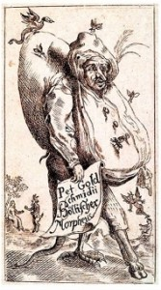](http://www.genesispark.com/wp-content/uploads/2011/11/pterosaur9.jpg) [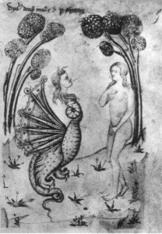](http://www.genesispark.com/wp-content/uploads/2011/11/Temptation-of-Adam-and-Eve-Speculum.jpg) [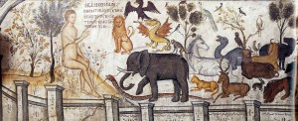](http://www.genesispark.com/wp-content/uploads/2011/11/Adam_naming_animals_-Moni-Ayou-Nikolaou.jpg)

Medieval portrayals of the the temptation of Eve (like the one to the immediate right) sometimes show the Satanic tempter as a winged serpent or flying dragon-like creature. This follows the line of thought expressed by the famous commentator Matthew Henry (from his Commentary Upon the Whole Bible, 1708-10): “Perhaps it was a flying serpent, which seemed to come from on high as a messenger from the upper world, one of the seraphim; for the fiery serpents were flying, Isa. xiv. 29. Many a dangerous temptation comes to us in gay fine colours that are but skin-deep, and seems to come from above; for Satan can seem an angel of light.” Note the dragon-like depiction to the upper left from “The Temptation” in *Speculum Humanæ Salvationis*at Bibliothèque Nationale in Paris, dated 1324. Above to the right is a fresco from the Saint Nicholas Anapafsa Monastery, which was built in the 1500s on a rock pinnacle at Meteora, Greece. Again, notice the dragon presented as a pterosaur-like creature coming to be named with the others.

[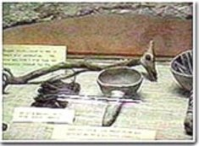](http://www.genesispark.com/wp-content/uploads/2011/11/pterosaur11.jpg)

At a museum in Manitou Springs, Colorado, there is an unusual carved artifact. It is an Indian prayer stick (see right), roughly a foot long, with a crested head, eyes on both sides, and beaked mouth. The beautiful artistic work stands out as strikingly like a pterodactyl!

To the left is a portrayal from a Saxon shield mount which reveals a pterosaur-like creature at rest. The wings that are folded back along its scaled sides, a long beak full of teeth, head crest, and an unmistakable tail vane all make the depiction compelling. The flying reptile widfloga (or far-ranging flyer) was known to the Saxons and this shield-boss came from their Sutton Hoo burial site. It is displayed at the British Museum (click to enlarge). Yet another compelling Medieval winged dragon depiction is at the Château Azay-le-Rideau in central France, an edifice that was built in the early 1500s. Exhibited there is a fascinating tapestry depicting what looks like a pterosaur fighting a lion (click to enlarge).

[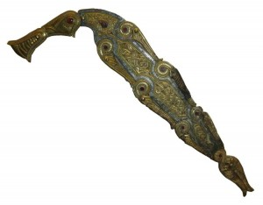](http://www.genesispark.com/wp-content/uploads/2011/11/pterosaur10.jpg) [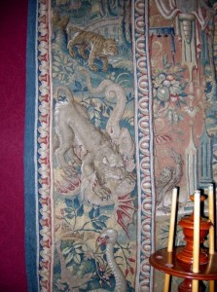](http://www.genesispark.com/wp-content/uploads/2011/11/pterosaur16.jpg) [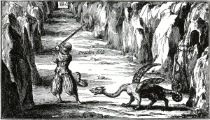](http://www.genesispark.com/wp-content/uploads/2011/11/Winkelried-the-dragon3.jpg)

Another pterosaur-like depiction from the Middle Ages is shown in Athanasius Kircher’s 1678 book Mundus Subterraneus. This drawing is is so compelling that Peter Wellnhofer (The Illustrated Encyclopedia of Pterosaurs, 1991, p. 20.) suggests it might have been based on fossil finds. But it is more likely based on even more ancient reports. In Kircher’s book, the character Winkelried was supposed to have killed the dragon in Switzerland during the earliest days of his particular settlement. While the erect wings (rather than tucked down on the body like a bird) are distinctively pterosaur-like, the fore-limbs are not correctly incorporated into the wing.  Kircher also includes a picture of a dragon (on right) that resembles the rhamphorynchoid pterosaurs.

[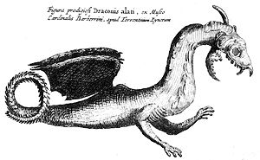](http://www.genesispark.com/wp-content/uploads/2011/11/Athanasius-Kircher-Flying-Draconis.jpg) [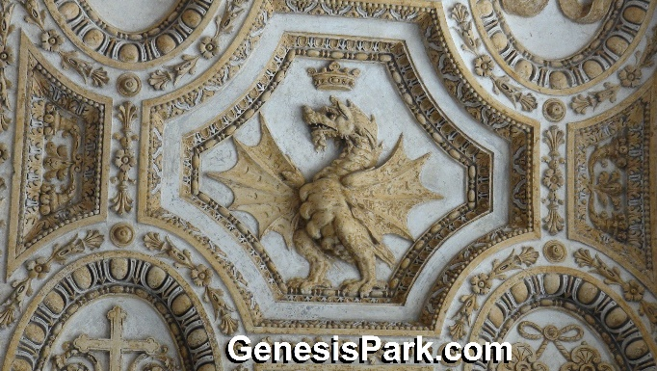](http://www.genesispark.com/wp-content/uploads/2011/11/St.-Peters-Dragon-3-Watermark.jpg)

Outside St. Peter’s Basilica in Rome there are a number of winged dragon depictions. The one shown to the left is particularly like a pterosaur. Note the headcrest, bat-like wings with three claws, and four claws on each foot. These were popularized by Pope Gregory XIII in the late 1500s when he adopted the winged serpent or dragon as his symbol or coat of arms. According to the Greek mythology a heroic figure named Jason, son of Aeson, captured a golden fleece that was guarded by a hissing dragon. This legend of Jason charming the Dragon is memorialized in a beautiful painting (see right) by the multi-talented European artist Salvator Rosa in the 1663-1664 timeframe. It is a good likeness of a pterosaur, drawn long before the flying reptiles were discovered by an Italian naturalist in the 1780s. From where did Rosa get this inspiration?

[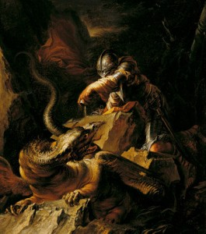](http://www.genesispark.com/wp-content/uploads/2011/11/Salvator-Rosa-Jason-Painting.jpg) [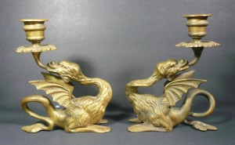](http://www.genesispark.com/wp-content/uploads/2011/11/European-medieval-Dragon-Candlesticks.jpg)

The wyvern, the two-legged flying dragon of Medieval lore, continued to be a popular emblem for coat of arms, crests, and even ornamental decorations on buildings well into the 18th century. The candlesticks to the left, part of the Genesis Park collection, came from an English estate sale. Notice the small bat-like wings, teeth in beak, upper body fur, spade-like tail, and long necks. These look quite like Rhamphorhynchoid pterosaurs, even exhibiting the correct number of toes.

Some who see the ancient artwork on these pages are very critical of the quality of the dinosaurian representations. But how accurately could they redraw animals from memory with basic tools? Try this exercise. Carefully look at a particular dinosaur in a book. Close the book and then try to draw it from memory. How close does your drawing resemble the original? Now choose an unfamiliar kind of dinosaur and try explaining it in detail to a friend. Without letting him see the picture, have your friend attempt to draw it. Now how close did that picture come to the original? This exercise helps us understand how difficult it was for ancient artists to accurately draw dragons from memory or first-hand reports.

# Ancient Plesiosaur and Mosasaur Depictions

# <http://www.genesispark.com/exhibits/evidence/historical/ancient/plesiosaur/>

[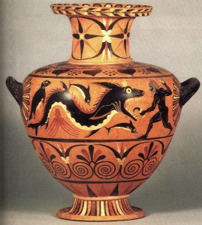](http://www.genesispark.com/wp-content/uploads/2011/11/Herakles-attacks-a-ketos1.jpg)

To the left is an urn from Caria, which was located in Asia Minor (modern Turkey). This artifact (described on page 114 of Thomas Carpenter’s 1991 book Art and Myth in Ancient Greece as “Herakles attacking a Ketos”) is estimated to be from 530 BC. It depicts what appears to be a Mosasaur with several obvious sea creatures. The animal behind the sea monster is a seal, while an octopus is below the creature along with what seems to be a dolphin. The thick jaws, big teeth, large eyes, and positioning of the flippers on this creature match a Mosasaur skeleton very well. Some Mosasaur species also had a narrow cranial crest behind the eye that may have had a fin attached the way it is depicted on the Carian urn (click to enlarge).

[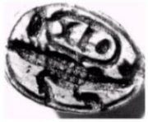](http://www.genesispark.com/wp-content/uploads/2013/09/Mitry-Collection-Plesiosaur.jpg)

An Egyptian seal with the cartouche (official name inscribed within an oval) of Tutmosis III (appx. 1400 B.C.) depicts a plesiosaur-like animal. The anterior and posterior flippers are distinctively represented with the narrow connection to the rotund body of the creature. The seal is from the Mitry collection and is of unquestioned authenticity. The ancient Egyptians are known for their keen observation and accurate zoological representations, particularly with regard to sea creatures.  Other such seals in the Mitry collection appear to have dinosaurian representations as well.

[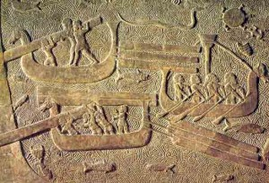](http://www.genesispark.com/wp-content/uploads/2011/11/Assyrian-Frieze-Sargon-Sea-Serpent.jpg)

Eye witness accounts and depictions of sea serpents have come down to us from throughout history. In some of these cases, the creature could well have had a large portion of its body underwater (really a plesiosaur form rather than a serpent form). The very first recorded sea serpent observation was made by Sargon II on a Mediterranean voyage to Cyprus at about 720 BC – 705 BC. This cryptid sighting seems to be memorialized by a very interesting frieze made during the Assyrian domination of Phoenicia (late 8th century BC). It shows Phoenician longboats loading up lumber. Notice the sea serpent with its neck upright in the background up top. Its large size can be judged by the sea turtle depicted just in front of it.

[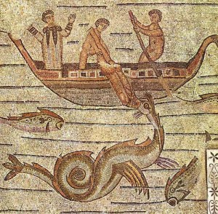](http://www.genesispark.com/wp-content/uploads/2011/11/Sea-Serpent-Mosaic.jpg)

Many ancient sea serpent depictions show the creature coiling vertically and displaying “humps” that come out of the water (making the plesiosaur identification even less likely). A good example is the mosaic to the left (click to enlarge), which shows mariners apparently mollifying a sea serpent with some meat. The Byzantine artist depicted a fluke- like tail, mane, and horse-like head that are remarkably like the modern reports of [Cadborosaurus](http://www.genesispark.com/exhibits/evidence/cryptozoological/plesiosaurs/other/) and [Ogopogo](http://www.genesispark.com/exhibits/evidence/cryptozoological/plesiosaurs/ogopogo/) given by eye witnesses of these mysterious monsters. In 1639 a sea serpent was observed in Cape Ann, off the Massachusetts coast, and a drawing of the encounter (right) was made. Although this massive serpentine form is not known in the fossil record, zoologist Karl Shuker speculated that some of these encounters might have involved a still- living Basilosaurus (lower right), a slender whale-like creature supposed to have been extinct for millions of years. (Shuker, Karl, Dragons: A Natural History, 1995, p. 38.) It possessed small fins, a flexible neck, a tail fluke, and could undulate its long body vertically (unlike terrestrial snakes that coil horizontally). The creature was given the name Basilosaurus because the early 19th century paleontologists thought it to be very reptilian. Indeed “Basilosaurus, which is over 20 m long and, unlike modern whales, must have looked like a classic sea serpent because of its tiny head and long, thin body.” (Benton, Michael, Vertebrate Paleontology, 2015, p. 373.)

[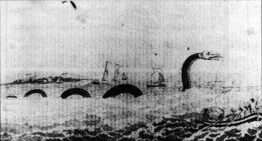](http://www.genesispark.com/wp-content/uploads/2011/11/Sea_serpent_Cape_Ann_1639.jpg) [Basilosaurus Skeleton3](http://www.genesispark.com/wp-content/uploads/2011/11/Basilosaurus-Skeleton3.jpg) [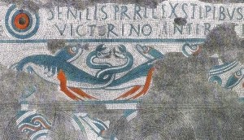](http://www.genesispark.com/wp-content/uploads/2013/06/Roman-Mosaic-from-Lydney-Park-Color-Cropped1.jpg) [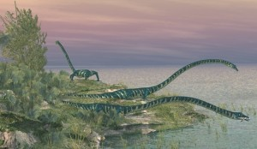](http://www.genesispark.com/wp-content/uploads/2011/11/tanystropheus-fishing-cropped.jpg)

To the far right is the Roman mosaic from about 200 AD found at Lydney Park Temple in Gloucestershire, UK. The mosaic depicts two long-necked sea dragons (click to enlarge). Some fish are shown in the mosaic as well. Creationist Paul Taylor likens the dragons to the web-footed Tanystropheus shown immediately to the right.

[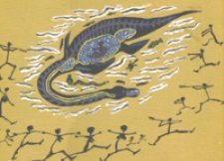](http://www.genesispark.com/wp-content/uploads/2011/11/plesiosaur5.jpg)

There are stories of a plesiosaur-like creature seen in Queensland, Australia. Both aboriginal peoples around Lake Galilee and tribes farther up to the north tell of a long-necked animal with a large body and flippers. “Elders of the Kuku Yalanji aboriginal tribe of Far North Queensland, Australia, tell stories of Yarru (or Yarrba), a creature which used to inhabit rain forest water holes. The aboriginal painting to the left depicts a creature with features remarkably similar to a plesiosaur. It even shows an outline of the gastro-intestinal tract, indicating that these animals had been hunted and butchered.” (CEN Technical Journal, Vol.12, No. 3, 1998, p. 345.)

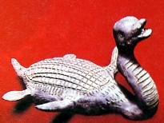 [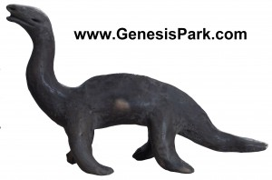](http://www.genesispark.com/wp-content/uploads/2011/11/Acambaro-Elasmosaurus2.jpg)

The [Ancient Dinosaur Depictions](http://www.genesispark.com/exhibits/evidence/historical/ancient/dinosaur/) page describes clay figurines found in Acambaro Mexico and dated from before the second century AD. A distinctive plesiosaur figure was also discovered (see left). The pudgy body, short tail, flippers, long neck and head are all compelling. Another of the many Acambaro dinosaurian figurines looks like the prototypical “sea monster.” Probably more than any other dinosaurian, the ceramic statue resembles the web-footed Nothosaurus with its slender body and back-swept limbs.

[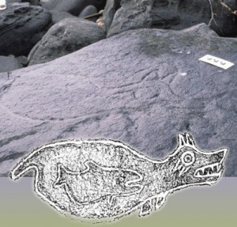](http://www.genesispark.com/wp-content/uploads/2011/11/Petroglyph-from-Makah-Indian-Reservation-in-WA.jpg) [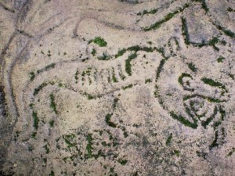](http://www.genesispark.com/wp-content/uploads/2011/11/northwest-sea-serpent-carving21.jpg)

Native Americans of the Pacific Northwest have legends of the “Sea Wolf” or “Sea Alligator,” a fearsome, toothy ocean creature that attacked and ate whales. What did these Indians observe as they traversed the region of the Oregon coast, Puget Sound, and Vancouver Island in their canoes? Could this whale-eating marine saurian be a Mosasaur? Rock carvings of the creature vary from across the region. The drawing to the far left is from an ancient petroglyph found at Makah Indian Reservation in WA. It shows a bulbous body, a head that sports a fin or crest (like the Carian urn above) with the typical prominent jaws and sharp teeth. It seems that a pilot whale (technically a member of the dolphin family) is depicted in the monster’s stomach. If this is so, the creature would scale to about 50 ft in length. The ancient rock carving to the right of it more closely resembles the streamlined, elongated form of the Mosasaur as we know it from the fossil record.

[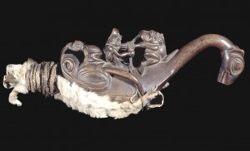](http://www.genesispark.com/wp-content/uploads/2011/11/Shamans-Rattle-Sea-Monster2.jpg)

Also from the Pacific northwest of America comes an intriguing sea monster shaman’s rattle, shaped roughly like a plesiosaur. This Tlingit artifact from Alaska shows a shaman on the back of the monster, tying up a witch. A frog (representing and evil spirit) is on the back of the long-necked creature and another frog is emanating from the witch’s mouth. The piece, currently housed in the British Museum in London, certainly bears a remarkable resemblance to the great marine reptiles.

For every ancient depiction of the great walking, flying, and swimming reptiles shown on these Genesis Park pages there are three or four others that could have been included. We have included only those that have been investigated by our staff or previously published.  One would think that such hard evidence would be highly problematic for evolutionary theory. Indeed Dr. Philip Kitcher, in his anti-creationist book Abusing Science, claimed that solid evidence that dinosaurs and man co-existed would “shake the foundations of evolutionary theory.” (1998, p. 121) Likewise, the evolutionary author Arthur Strahler insisted that “it is conceivable that a scientist will some day discover human bones among dinosaur bones in such a relationship that it is judged highly likely that humans and dinosaurs lived at the same time. Such a finding would deal a crushing blow to the widely favored hypothesis of a unique evolutionary sequence. In Popper language, the hypothesis of evolution would be falsified.” (Strahler, Arthur N., Science and Earth History: The Evolution /Creation Controversy, 1999, p. 17.) Unfortunately the history of Darwinian theories suggests that all such evidence would quickly be assimilated into evolutionary theory. Darwinism makes no firm predictions and the “Just So” stories can be changed on a dime. But one can at least hope that as more evidence comes to light, the credibility of the evolutionary story-tellers will at last wear thin!

# Strange News out of Essex or The Winged Serpent

# <http://www.genesispark.com/exhibits/evidence/historical/dragons/strange-news-out-of-essex-or-the-winged-serpent/>

[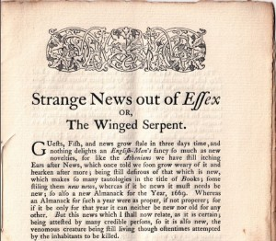](http://www.genesispark.com/wp-content/uploads/2015/08/Strange-News-Out-of-Essex-booklet.jpg)

A small, pamphlet-sized booklet entitled “Strange News out of Essex or The Winged Serpent” was originally printed about the year 1669. It recounts the attack of a winged, snake-like creature near Essex in England. The 1885 reprint of this booklet (pictured to the right) contains an Introduction which also mentions a couple of other dragon encounters that were experienced during that same time frame.

[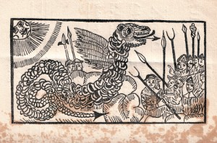](http://www.genesispark.com/wp-content/uploads/2015/08/Strange-News-Out-of-Essex-picture.jpg)

It seems that numerous respected townspeople claimed to have seen the monstrous serpent which lived on a particular remote hilltop glen. The reptile reportedly was several feet long and contained a mouth full of sharp teeth. It was said to sport undersized wings for its huge body…totally incapable of carrying it aloft. It is not unusual for the ancient reports of flying serpents to include very small wings. If they did encounter long-tailed pterosaur, this detail could be accounted for by seeing the pterosaur walking on all fours with only the tip of the wings erect.

The town reported no loss of livestock or harm to anyone from the beast. A couple of attempts were made by armed groups to track it down and kill it, but it wasn’t found at that time. The booklet ends by referencing various serpents, some real and some mythical, including serpents with bat-like wings.