1,000’s of IRAQI political prisoners are being HUMILATED, TORTURED, RAPED, & MURDERED by U.S. & BRITISH JAILERS!
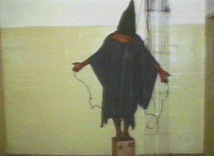

Iraqi being tortured w/electrocutes.
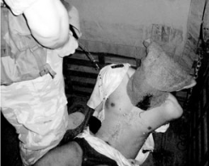

British interrogator urinating on Iraqi.
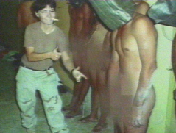

U.S. female interrogator mocking & posing with naked & tortured Iraqis.

1) Did you know?
Iraqi men, women, & children are routinely rounded up by the 1,000’s, accused of resisting US domination… & held 6 months in US run prisons, hooded & sleep deprived. If found not “guilty,” & if they survive the torture, they’re released with a few bucks & a cynical apology. If found “guilty,” they’re doomed to years of prison & even death for the “crime” of resisting a foreign colonial power.
2) Did you know?
The US govt violates international law, which states that colonialism & occupation is illegal, & a crime against humanity, whether Roman, Nazi-German, British, Japanese, French, or US, all colonialism.
3) Did you know?

International law states that people who are subjected to foreign occupation & colonial rule, have the right to resist & fight the occupation, by any means necessary, up to & including armed struggle. The Iraqi resistance/guerrilla movt has a legal, moral, & patriotic right to oppose US & British control.

4) Did you know? BUSH knowingly & criminally lied about the reasons for War against IRAQ!

IRAQ had NO weapons of mass destruction, none have been found @ all.

IRAQ had NO nuclear war materials, none have been found @ all.
- IRAQ had NOTHING @ all to do with 9/11, & has never committed terrorist acts against the US.
- IRAQ’s prior govt had more participation of Women, was secular, & less repressive than the US supported kingdoms of Saudi-Arabia, Kuwait, & Jordan whom all enjoy warm relations with U$ oil companies. The prior govt had more popular support & stability than US occupation. For the US, the real “crime” was the prior govt unwillingness to hand over their oil reserves to the U$ Oil Mafia.
5) Did you know?
Private US military/security contractors are running prisons in Iraq along w/the US & British military. These “private” thugs torture w/complete impunity. The pentagon says they’ve no authority over private citizens & that the Iraqi govt is in charge of monitoring abuse of inmates. But, since the US invasion there’s been no Iraqi govt., & the interrogators get away w/murder. Bush conveniently looks the other way & hinders international scrutiny. Most of the private security/prison employees come from the US penal system. Most perfected their brutal techniques on the over 2 million people imprisoned here in the US, most of whom are Black & Hispanic… & many wrongly convicted.

Council of Liberation Theology * 619-379-2822 * sdlaborinfo@email.com
California Coalition Against Poverty * 619-819-7806 * elcucui09@yahoo.com

