Mohamed Atta, Florida Entrepreneur

BY [DANIEL HOPSICKER](http://www.madcowprod.com/author/dhopsicker/) · PUBLISHED JUNE 12, 2007 · UPDATED AUGUST 5, 2014

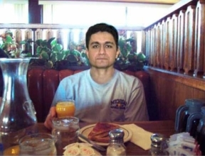Government records in Florida reveal that Mohamed Atta was the [president of a company](http://www.madcowprod.com/wp-content/uploads/2014/08/karamatta.jpg) in Orlando with a business partner whose web of dummy shell companies appear characteristic of the type used in terrorist financing and illicit money laundering, the [madcowmorningnews](http://www.madcowprod.com/)has learned.

One day after the 9/11 Commission Report says the terrorist ringleader finished making withdrawals in Virginia Beach, VA. totaling $18,000 from a SunTrust Bank account, on[april 5th, 2001](http://www.madcowprod.com/wp-content/uploads/2014/08/karamatta.jpg) ***Hassan Erroudani,*** an Orlando man with close ties to the Moroccan Embassy in Washington D.C., filed incorporation papers with the state of Florida listing the President of KARAM LLC as ***“Mohamed Atta.”***  
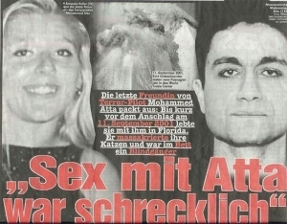The document lists an address for "President" Atta in ***Marseilles, France,*** which can be traced to a graphic design firm there. (Once again, Amanda Keller's testimony is vindicated. Atta told her he was French.)

***Died and went to IHOP***

Incorporation documents give the names of the KARAM LLC's officers as Hassan Erroudani, Mohamed Atta, and Jamal Erroudani.

Karam LLC was delisted in 2002 by the state of Florida for failing to file an annual report.

When the firm filed for reinstatement on January 13, 2003, it once again listed ***“Mohamed Atta”***as a corporate officer.

But Atta had now been [demoted to company secretary.](http://www.madcowprod.com/wp-content/uploads/2014/08/karam2003.jpg)

And his address has changed as well. Not to Paradise, or ***Virgin City***, but ***Orlando,***a long way from heaven, according to those who've been there.

Atta's current address, if Florida Division of Corporate Records can be believed, is 4124 West Colonial Dr, Orlando, FL., the location of an***International House of Pancakes.***

**Orlando, Land of Mystery & Magic**

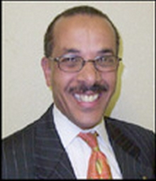Hassan Erroudani has close ties with the Moroccan Embassy in Washington D.C. He is also the President of the Moroccan-American Chamber of Commerce.

Moreover Florida records show Erroudani is also business partners, in a company called JMH INVESTMENT GROUP, with Mohammed Ariad, the economic counselor of the Moroccan Embassy in Washington D.C.

Atta was, of course, in Orlando on numerous occasions. For example, his car, a red 1989 Pontiac Grand Prix two-door coupe, was said to have been seen last in downtown Orlando.

Still, the idea that the “Mohamed Atta” who flew Flight 11 into the Twin Towers on September 11, 2001 had been listed as a corporate officer in a Florida company***, without it having become public knowledge*** by now, seemed a tad***unlikely***, perhaps even a little far-fetched.

At least, it did, until after we spoke with KARAM LLC principal and founder Hassan Erroudani, who we reached by phone at his Orlando home.

**Turkish baths, cigarettes…heroin?**

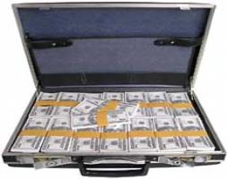We hadn't counted on either Erroudani’s ***flat refusal*** to answer***any*** questions about the “Mohamed Atta” listed as an officer in his company, or his tone of evident hostility.

Trust us… We had been nothing if not polite, even to the point of suggesting a reason for why the whole thing might be just a big misunderstanding…

“Was it perhaps just a case of two different men with similar names?” we asked helpfully.

Ennoudani’s forceful response: “I don’t have anything to say about that.”

And then he hung up.

Why would someone***do*** that… unless they possess what is commonly known as ***guilty knowledge?***His [behavior](http://blog.uwgb.edu/inside/index.php/multimedia/photos/07/14/lambeau_cottage_flag_poles/)seemed both ***inexplicable and suspicious.***

**Red flags & a Turkish Naval Attaché**

Among the red flags on their [flagpoles](http://www.aflag.com/) denoting Hassan Erroudani's various enterprises which we never got the opportunity to question him about:

* He ran a wire transfer service called Rapid Cash from out of his home. (Atta and Marwan made frequent use of wire services to get money.)
* He owned a company, [seawest car import/export](http://www.madcowprod.com/wp-content/uploads/2014/08/Seawest1.jpg), which appears to be in the business of exporting luxury vehicles to the Middle East.
* One of the corporate officer in Seawest, until recently, was one ***“Murat Oner.”***

Lt Cdr [murat oner](http://www.madcowprod.com/wp-content/uploads/2014/08/murat2.jpg) is the [turkish embassy's](http://www.goldgroup.net/?f) Naval Attaché in Washington.

(Recall whistleblower [sibel edmonds](http://www.justacitizen.com/)  long and courageous struggle to tell America what she knows about, among other things, Turkish influence in the international drug trade.)  
Other companies possibly related to the ***KARAM LLC*** scheme include KARAM MOTORS, another company which ships cars to Lebanon. Florida records show it was incorporated ***the same day***that ***KARAM LLC***filed for reinstatement, January 13, 2003.

Another Orlando company, Karam Moving and Storage, gave as its address a private home located two blocks south of the Orlando Executive Airport… the same airport where terror flight school owner Wally Hilliard’s Lear jet was confiscated with 43 lbs. of heroin onboard six months earlier.

**Terrorists & used car salesman**

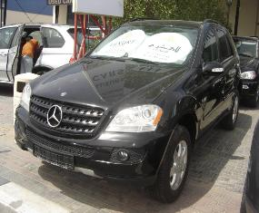What was going on in Central Florida that made Erroudani so reluctant to talk?

U.S. federal agencies recently announced new anti-money laundering strategies designed to begin to combat bulk cash smuggling and trade-based money laundering.

According to a May 3 2007 article in the Boston Globe, as traditional bank transfer avenues are shut down cash is increasingly being converted to goods, like cars, before being moved across borders and sold in seemingly legitimate transactions.

Moreover, terrorists appear to have an affinity for posing as used car salesmen. Among the many little-known facts about Mohamed Atta is that, in addition to being a draftsman, Mohamed Atta ***sold used cars*** while in Hamburg.

More recently, one of the alleged terrorists involved in the thwarted Kennedy Airport Terror Plot was a used car salesman…

The convicted al-Qaeda chief in Spain, Imad Yarkas,  sentenced to 27 years in prison for conspiracy to commit murder and for heading a terrorist organization, was a used car salesman…

The man accused in the Bali bombing of detonating bombs that killed nearly 200 people on that resort island was a used car dealer…

**Cash for cars. Come on down**

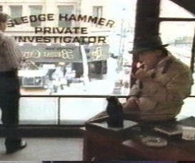The 15 British marines and sailors seized by an Iranian naval patrol off the coast of Iraq recently had just boarded a vessel suspected of smuggling cars.

“Almost every time there is a Muslim plot to blow up and kill US and or British targets there is a Muslim car dealer involved in financing the project,” fumed [sarasota pi bill warner](http://www.wbipi.com/contactus.html), an export in terrorist financing.

Warner is credited with revealing Islamist groups with ties to Al Qaeda operating networks used to export stolen luxury cars from a base in Tampa, FL, just miles from the headquarters of the US Central Command, the group tasked with eradicating the Islamist terrorist threat in the Middle East.

“Muslim used car scams are an updated version of the ***Hawala***money transfer,” states Warner.

“The***cars*** are the ***cash*** now. Vehicles sent to the Middle East from the US are funding terrorism. And a few have even been used as car bombs in Iraq.”

**Another friendly Arab Ally**

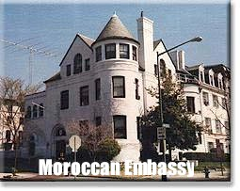Even before the latest revelations, connections between the 9/11 hijackers and the Moroccan Embassy had been exposed.

Mohamed Atta phoned the Moroccan Embassy in DC on January 2, 2001—for reasons unknown, speaking to persons unknown—a fact buried in the notes of the 9/11 Commission’s report.

And Atta bodyguard Marwan Al Shehhi, pilot of the second plane to hit the Twin Towers, had flown to Casablanca, Morocco and back, also for reasons unknown, and visiting person unknown, in early January of 2001.

Despite having overstayed his previous visa, he was able to reenter the US through Orlando without trouble.

To this date, no explanation for why Atta called the Moroccan Embassy or why Marwan Al-Shehhi went to Morocco have been offered.

**Military attaché, anyone?**

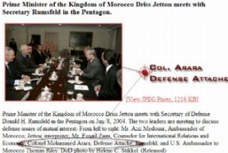A [madcowmorningnews](http://www.madcowprod.com/) exclusive reported that a 26-year old Moroccan man, whose name was on the FBI’s terrorist watch list, had been a business partner in a Florida firm with the Chief Military Attaché for the Moroccan Embassy in Washington, DC.

For our pains, we were contacted by a lawyer in Washington D.C. representing Col. Arara, who threatened us-***-without bothering to make any representation as to what about out story might have been in error-***-with yet another lawsuit.

***We didn't think anything was. We still don't.***

Florida records show that on June 30, 2000, ***Colonel Ahmed Arara***, the Military Attaché of the Embassy of the Kingdom of Morocco, incorporated Titim Holdings, Inc., with terror suspect Mohammed Arara.

“***Titim,***” a verb in Gaelic, means “to fall down.”

The Moroccan military attaché and his two Arab companions had launched “***Falling Down Inc.***”

**What "Falling Down" Looks Like**

Atta was at the Orlando International Airport in early August of 2001, officials  revealed last year, awaiting the arrival of ***Mohammad al-Kahtani***, who had been chosen by Osama bin Laden to replace Zacharias Moussaoui as the 20th hijacker.

Kahtani was denied entry into the United States by a Customs Official.***It is the only instance we are aware of where an American official took action may have saved lives on 9/11.***

(Asked why he'd denied the Saudi entrance into the U.S., the Customs officer told the 9/11 Commission, “***The guy gave me the creeps***.”)

Of course, Mohamed Atta may even have had relatives living in Central Florida. ***Majed Atta*** ran the Rainbow Grocery in a suburb near Orlando called Winter Garden, until he and his family packed their belongings into a U-Haul and abruptly left in August 2001…***just one week after telling his landlady that he planned to buy the home from her while opening a new grocery store in Orlando.***

**Welcome to TerrorLand, Take 17**

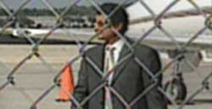Also in Winter Garden was ***Khalil bin Laden***, a brother of Saudi-born terrorist Osama bin Laden, who lived on a 20-acre ranch in Winter Garden behind an 8-foot high concrete wall and electronic gate. Khalil was one of several bin Laden family members allowed to leave the United States on chartered flights to Saudi Arabia several days after the 9/11 attack.

“There is evidence of deep links in Central Florida of people with documented ties to the terrorist hijackers, Osama bin Laden, and the al-Qaeda terrorist network,” the  Orlando Sentinel reported on September 23, 2001.

There was an ominous new theme in paradise: Long known for vacations, beaches, sunshine and fun, Central Florida’s Tomorrowland and Adventureland gave way to the new game in town.

***Welcome to TerrorLand.***

Take your shoes off and get comfortable. It looks like we'll be here awhile.