[Skip to content](https://dailyheadlines.net/list-of-dumbs-by-state-complete-list-of-military-underground-bases-in-usa-video/" \l "content)

* March 7, 2023

**List of DUMBs by State – Complete List of Military Underground Bases in USA March 7 2023**

[**https://dailyheadlines.net/list-of-dumbs-by-state-complete-list-of-military-underground-bases-in-usa-video/**](https://dailyheadlines.net/list-of-dumbs-by-state-complete-list-of-military-underground-bases-in-usa-video/)

**In America alone, there are over 120 Deep Underground Military Bases situated under most major cities, US AFBs, US Navy Bases, and US Army Bases, as well as underneath FEMA Military Training Camps and DHS control centers.**

**There are also many Deep Underground Military Bases under Canada.**

**Almost all of these bases are over 2 miles underground and have diameters ranging from 10 miles up to 30 miles across!**

**They have been building these bases day and night, unceasingly, since the 1940s. These bases are basically large cities underground connected by high-speed magneto-levity trains that have sped up to 1500 MPH.**

The Black Projects sidestep the authority of Congress, which as we know is illegal. There is much hard evidence out there. Many will react with fear, terror, and paranoia, but you must snap out of it and wake up from the brainwashing your media pumps into your heads all day long.

Are you going to be a rabbit in the headlights, or are you going to stand up and say enough is enough?

The US Government through the NSA, DOD, CIA, DIA, ATF, ONI, US Army, US Marine Corps, FEMA, and the DHS has spent in excess of 12 trillion dollars building the massive, covert infrastructure for the coming One World Government and New World Religion over the past 40 years.

There is the Deep Underground Military Base underneath Denver International Airport, which is over 22 miles in diameter and goes down over 8 levels. It’s no coincidence that the CIA relocated the headquarters of its domestic division, which is responsible for operations in the United States, from the CIA’s Langley headquarters to Denver.

Constructed in 1995, the government and politicians were hell-bent on building this airport in spite of it ending up vastly overbudget. Charges of corruption, constant construction company changes, and mass firings of teams once they had built a section of their work were reported so that no “one” group had any idea what the blueprint of the airport was.

Not only did locals not want this airport built nor was it needed, but everything was done to make sure it was built despite that. Masonic symbols and bizarre artwork of dead babies, burning cities, and women in coffins comprise an extensive mural as well as a time capsule – none of which is featured in the airport’s website section detailing the unique artwork throughout the building.

DIA serves as a cover for the vast underground facilities that were built there. There are reports of electronic/magnetic vibrations which make some people sick and cause headaches in others. There are acres of fenced-in areas which have barbed wire pointing into the area as if to keep things in, and small concrete stacks that resemble mini-cooling towers rise out of the acres of nowhere to apparently vent underground levels.

The underground facility is 88.3 square miles deep. Basically, this Underground Base is 8 cities on top of each other! The holding capacity of such leviathans bases is huge. These city-sized bases can hold millions and millions of people, whether they are mind-controlled, enslaved NWO World Army Soldiers or innocent and enslaved surface dwellers from the towns and cities of **America and Canada.**

[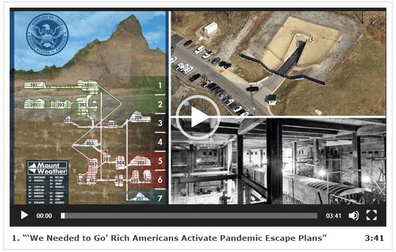](https://beforeitsnews.com/v3/r2/?url=https://amg-news.com/archives/7722)

There is Dulce Base, in New Mexico. Dulce is a small town in northern New Mexico, located above 7,000 feet on the Jicarilla Apache Indian Reservation. There are only one major motel and a few stores. It’s not a resort town and it is not bustling with activity. But Dulce has a deep, dark secret. The secret is harbored deep below the brush of Archuleta Mesa.

Function: Research of mind-related functions, genetic experiments, mind control training, and reprogramming. There are over 3000 real-time video cameras throughout the complex at high-security locations (entrances and exits). There are over 100 secret exits near and around Dulce. Many around Archuleta Mesa, others to the south around Dulce Lake, and even as far east as Lindrith. Deep sections of the complex connect into natural cavern systems.

Level 1 – garage for street maintenance.

Level 2 – garage for trains, shuttles, tunnel-boring machines, and disc maintenance.

Level 3 – everyone is weighed, in the nude, then given a jumpsuit uniform. The weight of the person is put on a computer I.D. card each day. Change in over three dollars requires a physical exam and X-ray.

Level 4 – Human research in ‘paranormal’ areas – mental telepathy, mind control, hypnosis, remote viewing, astral traveling – etc. The technology is apparently here to allow them to know how to manipulate the ‘Bioplasmic Body’ Development of a laser weapon that can remotely cause burns and discomfort on its target. They can lower your heartbeat with Deep Sleep ‘Delta Waves,’ induce a static shock, then reprogram, Via a Brain-Computer link.

Level 5 -security is severe. Armed guards patrol constantly and in addition to weight-sensitive areas there (are) hand print and eye print stations. Here, is the device that powers the transfer of atoms.

Level 6 – Level 6 is privately called ‘Nightmare Hall’. It holds the genetic labs. Experiments were done on fish, seals, birds, and mice that are vastly altered from their original forms.

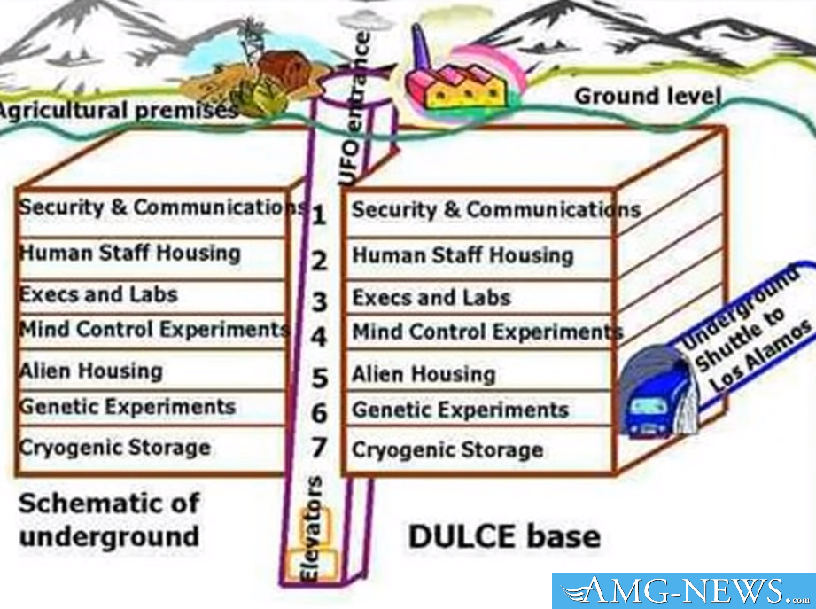

Then there is the Greenbrier Facility, in White Sulfer Springs, West Virginia under the Greenbriar Resort. The Continuity of Government facility intended since 1962 to house the United States Congress, code-named Casper, is located on the grounds of the prestigious Greenbrier resort.

The bunker is beneath the West Virginia wing, which includes a complete medical clinic. Construction of the facility, which began in 1959, required 2.5 years and 50,000 tons of concrete. The steel-reinforced concrete walls of the bunker, which is 20 feet below ground, are 2 feet thick.

The facility includes separate chambers for the House of Representatives and the Senate, as well as a larger room for joint sessions. These are located in the “Exhibit Hall” of the West Virginia Wing, which includes vehicular and pedestrian entrances which can be quickly sealed by blast doors. They don’t even hide this one, and it’s even a tourist attraction. The Underground vault was built to meet the needs of a Congress-in-hiding – in fact, the hotel is a replica of the White House.

The underground area has a chamber for the Senate, a chamber for the House, and a massive hall for joint sessions. Although the hotel says it gives tours of the 112,000 square area daily, the installation still stands at the ready, its operators still working undercover at the hotel. The secrecy that has surrounded the site has shielded it both from public scrutiny and official reassessment

Most Americans will not believe that an American Holocaust will happen until they see it happening with their own eyes. Till then, it is just another strange conspiracy theory for them to laugh at. This is no laughing matter. When it happens, it will be too late to stop it.

These Fascist criminals parade as our friends and leaders, while stripping away democratic rights that will be replaced with a Corporatist and Fascist dictatorship, unless people, and especially Americans, wake up now. Here are the locations of Deep Underground Military Bases in America:

**ARIZONA**  
1. Fort Huachuca. 31°50′ N 1100 19’48” W, saucer base below, intelligence training above, mind-control incl. too.  
2. Gates Pass Base  
3. Gila Mountain Area, south of Interstate 8 and approx. 30 east of Yuma, AZ. 290 N 116ºW. DUM base.  
4. Grand Wash Cliffs, on the western edge of the cliffs at the head of Grapevine Wash. Must be reached via hwy 93 and then unpaved roads. DUM base. Page 303 …  
5. Green Valley  
6. Hualapai Mountains, east side of the mountain range, about 35 mi. SE of Kingman, AZ  
7. Rincon Mtn., north side of Rincon Mtn  
8. Mt. Lemmon  
9. Page  
10. Safford, near Safford  
11. Santa Catalina Mountains – base

**ARKANSAS**  
12. In the vicinity of Hardy and Cherokee Village. 360 19′ N 9°29’W W. Installation purpose not known.  
13. Pine Bluff, Ark. area. 34° 13.4′ N 92º01.0’W to 34º30′ N 92° 30’W. saucer base.

**CALIFORNIA**  
14. 29 Palms Marine Base, Identified on the military map as airspace area R-2501 N. Saucer base southeast of Ludlow. This is a U.S. alien research/ diagnostic facility and UFO base.  
15. China Lake, mind control and weapons research  
16. Darwin, CA, 4 miles dues west of Darwin  
17. Deep Springs, CA, 37°22′ N 117º 59.3′ W. saucer base  
18. Fort Irwin, CA, 35°20’N 116°8’W W. saucer base  
19. Edwards Air Force Base, in the area where Diamond Cr. & the so. fork of the Yuba meet, there are 3 underground UFO bases. 34°8′ N 117° 48′ W  
20. George Air Force Base, CA – saucer base  
21. Helendale, Lockhead Underground Facility, 34º44.7′ N 1170 18.5′ W. Technology for secret projects. There are 3 saucer bases here.  
22. Los Angeles, On Hwy 14 towards Edwards A.F.B. after Palmdale, one turns off and after taking several streets to 170th street, north on 170th St. to the Rosamond-1 70th intersection, the second and lower and better-maintained dirt road will take you west, and if you take a right going north at the power lines and up to the hilltop you will see the top of an underground NORTHOP facility; Technology for the elite’s secret projects. This area was very active in the 1970s. Northrop’s facility is near the Tehachapi Mtns. It has been reported to go down 42 levels. It is heavily involved with electronics and hi-tech aerospace research.

**Also:**[**The Government Underground: Underground Military Bases, Bunkers and Tunnels Under the USA**](https://beforeitsnews.com/v3/r2/?url=https://amg-news.com/archives/9990)

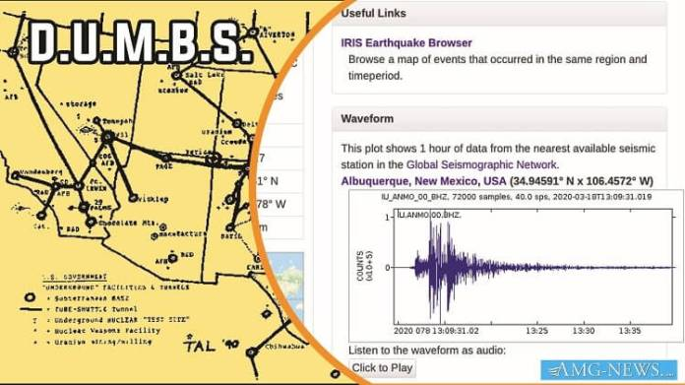  
23. Mt. Shasta  
24. Kern River, CA the hollowed-out mountain next to the hydroelectric facility at the Kern River Project near Bakersfield- reported saucer base  
25. Napa Valley- located at Oakville Grade north of Napa, CA. Tunnels also connect the wineries north of Napa, used for white slavery and mind-control. Has a saucer base.  
26. Norton Air Force Base- saucer base  
27. Quincy, CA, 39° 56.2′ N 120° 56.5′ W. saucer base  
28. Near Palmdale (if one takes Palmdale Blvd. til 240th St. and goes to Ave R-8. One the eastern limit of Ave. R-8 is McDonnell-Douglas’s facility called the Uano Facility. One can see it better from the Three Sisters Hills to the south of the facility. Strangely shaped disks raise out of the ground on pylons. These attached disks glow and change color. It is involved in hi-tech aerospace technology.  
29. Presidio, CA – A FEMA/DOD site for Region IX’s regional office  
30. San Bernardino, CO, 34º 50′ N to 34° 16′ N  
31. Santa Barbara County – placed in the thick diatomite strata  
32. Santa Rosa, 38º 26.4′ N 122º 42.9′ W, FEMA, Regional center for the west coast, what FEMA is doing is mostly kept secret. This is listed as a Communications Antenna Field but is doing much more.  
33. Sierra Nevada Mountains, CA – a very deep military base  
34. Tehachapi Ranch- 4 saucer bases, Tecachapi Canyon has a new underground base which was finished in Sept. ’95. This is the “Unholy 6” base of the Orions. 35° 20′ 118° 40′  
35. Trona, CA, 35° 45.5′ N 1 77º22.6′ W –several miles northwest of Trona, directly under Argus Peak. This DUM sits on China Lake’s NWC’s land and may have been built in the ’60s.

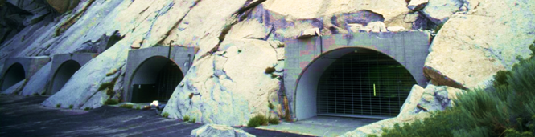

**COLORADO**  
36. Alamosa, 37° 28.1′ N 105°52.2’W W- reported saucer base  
37. Book Cliffs, CO, 39° 40′ N 108º 0′ W near Rifle, CO  
38. Boulder, CO–The headquarters for EMC, a type of Electra-magnetic mind control that is being broadcast to modify the thinking of Americans, and to control slaves.  
39. Colorado Springs, NORAD –Canada & U.S., & FEMA, hundreds of people on staff, contains at least 4.5 cubic miles of underground caverns and forty-five underground steel buildings. Many underground chambers are as large as 50, x 100 ‘. This complex tracks thousands of satellites, missiles, submarines, and UFOs. NORAD also controls many Monarch slaves who have ALEX, JANUS, ALEXUS endtime callback programming. NORAD installation has 1278 miles of road underground.  
40. Fort Collins- base for Gray aliens  
41. Grand Mesa- Orion saucer base  
42. Montrose Co.–north of Paradox, in Paradox Valley. The site in Paradox Valley can be reached via Hwy. 90 via Nucla. Page 304 …

**Also:**[**‘The Safest House in America’: Bulletproof Home Defense**](https://beforeitsnews.com/v3/r2/?url=https://amg-news.com/archives/6690)

**CONNECTICUT**  
43. Northwest Connecticut

**FLORIDA**  
44. Massive base- reported saucer base  
45. Eglin AFB, 30º 40′ N 86° 50′ W- Orion saucer base since 1978

**GEORGIA**  
46. Atlanta, GA –FEMA regional center, which is appropriately placed since Atlanta is to become a capital within the NWO redrawing of boundaries. Atlanta is believed to have several underground installations in its area, one to the north at Kennesaw Mtn., Marietta, GA connected to Dobbins AFB and one to the south of Atlanta at Forest Park.  
47. Thomasville, 30° 50.2′ N 83°58.9′ W, FEMA, regional center, they train groups in Search and Destroy missions for when Martial Law is imposed. This is SW Georgia in the area of tunnels.

**IDAHO**  
48. Lower Goose Lake area in the general area of Oakley, ID.–Wackenhut of the Illuminati run a “model prison” for the NWO. The worst of the federal prisoners are placed in this underground prison which has 7,100 cells which are filled with about 2,700 federal inmates. A track runs through the middle of the eerie underground facility. Food and showers are on the tracks, and the men are allowed showers once a week. A minimum of lighting is used and the men are beaten senseless if they talk at all. It sits 500′ underground.  
49. Southcentral Idaho–under the Snake River lava flows between Twin Falls and Idaho Falls.

**INDIANA**  
50. Bedford & Lawrence Co. area–continued activity in large old mines indicates a possible government use of the large old quarries.

**KANSAS**  
51. Atchison, KS–the DIPEF underground facility, which the govt. would run in an emergency. AT & T maintains an underground facility at Fairview, KS.  
52. Kinsley–an underground UFO base

**MARYLAND**  
53. Camp David–just north of the camp is an underground facility important to the intelligence agencies.  
54. below Ft. Meade, of the National Security Agency, 10 acres of the most sophisticated supercomputers that can be built, very large complex, massive surveillance of all the world’s communications, including all transmissions in the U.S. & world of telephones, telegraph, telex, fax, radio, TV and microwave transmissions.  
55. Olney, actually the facility is between Olney and Laytonsville, on Riggs Rd. off of Rt. 108. Another underground facility may also exist in the area, FEMA & possibly NSA, the facility may be 10 levels deep, purpose unknown.  
56. Suitland, MD- Classified archives of U.S. Govt. stored here in underground levels. Vaults have extensive amounts of documents that are not indexed. Restricted access with a coded security card. High-level intelligence groups operate in the area also.

**MASSACHUSETTS**  
57. Maynard, 42° 26.0′ N 71° 27.0′ W FEMA, regional center, Wackenhut is here too.

**MICHIGAN**  
58. Battle Creek, 42° 19.3′ N 85° 10.9′ W FEMA, regional center, activity secret (not validated)  
59. Gwinn, Ml, 46° 16.8’N 87° 26.5′ W, near Gwinn is a large underground base which is a key base for sending signals. An AFB is also nearby. Under Lake Superior is an alien base with roads 5,000′ deep.

**MISSOURI**  
60. 12 miles south of Lebanon, 36° 02.8′ N 115° 24.3′ W, near the newly created town of Twin Bridges-reported saucer base  
61. In the Bat/Dry/Dead Man/ Howell cluster of caves- reported saucer base  
62. St. Francis Mountains, MO (between St. Louis & New Madrid)

**NEBRASKA**  
63. North-central Nebraska  
64. Red Willow Co. near McCook, NE

**NEVADA**  
65. Blue Diamond, 36° 02.8’N 115°24.3 W -reported saucer base  
66-68. Groom Lake, also known as Dreamland, Area 51, The Area, the Spot, Red Square, Sally Corridor, Watertown Strip. 1150 50’N 37°20W. Run by the NWO along with demonic beings, the CIA is there and Wackenhut Security. Two large underground facilities close to but separate from Groom Lake but controlled by the demonic beings are Papoose Range and Cockeyed Ridge (S-4) underground bases. The purpose is the testing of various UFOs and other secret aircraft like the Aurora and Stealth. Also, biological work is done, including the biological raising of small greys. Many levels have been built t these three complexes, and a 7-mile long runway (which is actually 39 miles) Page 305 … has been built over Groom Lake, a dry lake. There is an S-2, an S-4, an S-6, an S-66 underground installations. S-66 is the most secret and it has 29 levels and is 11, 300′ deep.  
69. Quartzite Mountain SE of Tonopah, 37° 31 ‘N 116° 20’ W- reported saucer base  
70. Tonopah, Airforce, CIA? & ??, deals with secret aircraft

**NEW HAMPSHIRE**  
71-73. There may be as many as three underground installations in New Hampshire’s hills (according to reports).

**NEW JERSEY**  
74. Picatinny Arsenal, 4o° 38’N 74° 32′ W- saucer base, 1/4 cubic mile large & very deep underground.

**NEW MEXICO**  
The state of New Mexico and Colorado have been used for the construction of a series of underground bases. (All the rest of the states have too.) The Primary Underground facilities in New Mexico consist of 3 enormous underground bases in:

* The Dulce, NM area (an area I spent several days investigating in 1993).
* The White Sands–Alamogordo Area has 3 underground bases. Datil and Pie Town have two more underground bases. (Carlsbad Cavern which had underground activity, which is reported discontinued, and another base to the east of Carlsbad.).
* The Los Alamos area underground facility. the Taos area underground facility
* The New Mexico area has basically four underground systems out.
* One goes to the Four Corners area and then to Groom Lake (Area 51).
* One goes north toward Delta, CO, and Colorado Springs.
* The Taos facilities go north approximately along Interstate 25 and eventually ties in NORAD.
* The southern bases connect to Texas and Mexico.
* The Los Alamos facility dates at least back to 1940. One can only imagine what has been built with 1/2 century of labor on this underground system. Visitors to the deeper levels report humans kept in glass cylinders, plus many other strange things. I have had the opportunity to debrief some people who have been in the lower reaches of some of these facilities. There are special badges, special uniforms, tube elevators, etc. which for lack of time I will not describe.

75. Angel Peak- reported saucer base. Carlsbad Cavern area (now destroyed), 32° 25.0’N 1040 14.0W -old relics of saucer base left.  
76-78. Dulce, N.M., 36º 56.0’N 106°59.8’W,–South of Dulce, in the area of the Jicarilla Indian Reservation, another facility is east of the Dulce facility a number of miles. This is run directly by Illuminati w/ Army and Airforce help, CIA also conduct experiments at the center; the size of the installation is huge requiring small shuttle trains and has seven levels according to witnesses. Serves as a UFO base, biological experiments, production center for small-grey drones. Wackenhut provides some of the security on the ground.  
79. Kirtland AFB, NM, Sandia National Lab  
80. Manzano Mtn, near Albuquerque, known as the Kirtland Munitions Storage Complex, Airforce, 3,000-acre base within the Kirtland AFB/Sandia National Labs complex, guarded by 4 lethal rings of fences, use unknown, suspected UFO base. A new 285,000-sq. ft. bunker is being built near Manzano Base.  
81. Pie Town, 34° 17.9’N 1 108°08.7’W, in the area near Pie Town, UFO Base.  
82. Sandia Mountains NE of Albuquerque -reported saucer base  
83. to the north of Taos Pueblo  
84. White Sands, 32°22.8’N 106°28.8’W, a major hub for research, tied in with Dulce & NORAD, HO for NASA /military shuttle flights, radiation research ctr. and mind control.

**Also:**[**Run For The Hills! Bunkers For The Elites Hiding From Judgement Won’t Hide Them. . .**](https://beforeitsnews.com/v3/r2/?url=https://amg-news.com/archives/7722)

**NEW YORK**  
85. Adirondack Mountains (near Elizabethtown)  
86. New York Metro area  
87. Plattsburgh (near Canada and St. Albans) AFB, 49°40’N 73°33 W- two saucer bases in this area.

**OKLAHOMA**  
88. Ada, 34°46.4′ N 96°40.7W W, underground saucer base, this base does human cloning, and it is FEMA’s most sensitive base.  
89. Ashland Naval Ammunition Depot, 34°45.9’N 96° 04.3’W,- reported saucer base

**OREGON**  
90. Bull Run, north side of Bull Run Reservoir area near Mt. Hood, and very close to Larch Mtn. and south of Benson St. Park of the Columbia Gorge.  
91. Coos Bay area has had three separate but coordinating underground facilities built for UFOs. The facility farthest east, about 20 miles inland in the wilderness near Hwy 42, has been shut down. It is now an old abandoned facility well camouflaged. The coast facility is probably still operational.  
92. Klamath Falls, OR–since Sept. ’95 this has been a base for a number of NWO groups including the Air National Guard, FEMA, CIA, FBI, Spetznaz, and Page 306 …  
MOSAP training base. An underground concentration camp exists here.

**PENNSYLVANIA**  
93. Blue Ridge Summit, near Ft. Ritchie, known as ‘Raven Rock” or “Site R”, Army, major electronic nerve center, 650 ft. below the surface with about 350 staff and over a 716-acre area. possibly connected via tunnel to Camp David. The NOD installation is involved with psychic (demonic) and satellite control over slaves. This underground complex is to allow the government of the United States to escape a nuclear attack. The enormous complex radiates under Wash. D.C. and connects with many other sites. The tunnel system is used to move some of the mind-control sex slaves. The walls and ceilings of the tunnels are ceramic tiles with fluorescent lighting recessed into the ceilings.

**TEXAS**  
94. Ft. Hood, TX, 31° 15’N 97° 48′ W, home of some Delta Mind-Controlled soldiers and a reported saucer base.  
95. Denton, TX, 33° 13.2’N 97° 08.2’W – FEMA, regional center, activity secret  
96. Red River Arsenal, TX- reported saucer base

**VIRGINIA**  
97. Bluemont, Mount Weather base, Federal Preparedness Agency & FEMA, small-city underground, top-secret, the staff of several hundred, does secret work for FEMA and contains a complete secret government with the various agencies and cabinet-level ranking administrators that keep their positions for several administrations and help run the United States.  
98. Culpepper, 380 28.5 N 77°59.8’W, about 2 miles east of Culpepper off of Rt. 3, called Mount Pony, Illuminati–Fed. reserve, 140,000 sq. ft.,  
includes a facility for the storage of corpses, monitors all major financial transactions in the U.S. by means of the “Fed Wire”, a modern electronic system.  
99. Pentagon, Arlington, VA-  
100. Warrington Training Ctr. –two sites: one on Rt. 802 and the other on Bear Wallow Road, on Viewtree Mountain. One is Station A the other Station B. Army & ??, purpose unknown.

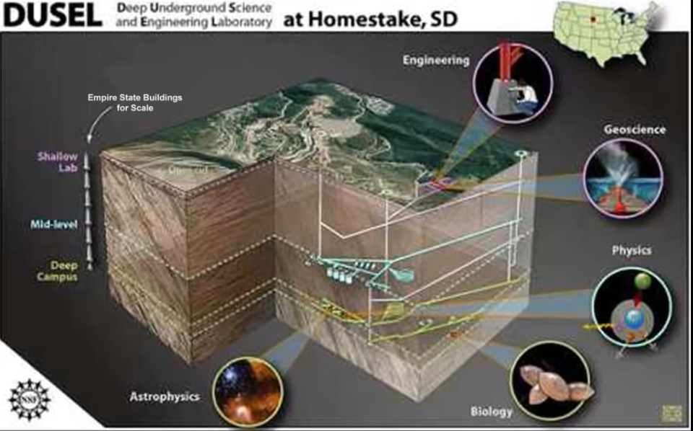

**WASHINGTON**  
101. Bothell, 47°45.7’N 122°12.2w W, FEMA, regional center, activity unknown

**WASHINGTON, D.C.**  
102. WHITE HOUSE, 38°53.5’N 77°02.0’W–The secret NOD underground installation which is connected to the intelligence groups like NSA and the CIA, as well as many other nefarious groups, lays under the White House with tunnels connecting this NOD installation with the House of the Temple. The Supreme council of the 33° of the Scottish Rite’s House of the Temple has a 14′ x 25′ room in it with 13 chairs where the Illuminati’s Grand Druid Council meets. The NOD Deep Underground Installation has numerous levels to it. One eye- witness, went to level 17 (via an elevator) and stated that he believes that deeper levels exist.

**WEST VIRGINIA**  
103. Sugar Grove, the Navy’s Strategic Intelligence Services microwave communications. There base here.  
104. White Sulphur Springs, under the Greenbriar Hotel, a mini-city large enough for 800 people equipped with its own crematorium, if there are any other purposes other than listening to U.S. microwave communication it is unknown by this author.

**UTAH**  
In Utah, the Kennecott Copper Company has been connected to the Illuminati and the KKK. These connections have been exposed in other writings by this author. Kennecott’s mine (reported to be owned by the World Bank) in the Salt Lake City area is serviced by Union Pacific, which is reported connected to the Mormon Church. The mine is receiving a heavy volume of big trucks after 11 p.m., for instance, on a normal night over 6 dozen large trucks with 2 trailers each roll into the mine. In other words, it appears that the heavy train & tractor-trailer activity indicates something besides mining.

**WYOMING**: Riverton, Wyoming Function unknown Tunnels to Salt Lake, Utah Denver, Colorado.