An apocalyptic horse with glowing red eyes welcoming visitors? Check √.  
  
Nightmarish murals? Check √.  
  
Strange words and symbols embedded in the floor? Check √.  
  
Gargoyles sitting in suitcases? Check √.  
  
Runways shaped like a Nazi swastika? Check √.  
  
OK, this place is evil.

But seriously, there are so many irregularities surrounding the **DIA** (Denver International Airport), that a voluminous book could be written on the subject.

The facilities and the art displayed lead many observers to believe that the DIA is much more than an airport: it is literally a New-Age cathedral, full of occult symbolism and references to secret societies.

The art at the DIA is NOT an aggregation of odd choices made by people with poor taste, like many people think. It is a cohesive collection of symbolic pieces that reflect the philosophy, the beliefs and the goals of the global elite. The DIA is the largest airport in America and it has cost over 4.8 billion dollars.

Everything regarding this airport has been meticulously planned and everything is there for a reason.

**The Airport**  
The airport facilities themselves raised a ton of questions regarding the true purpose of the mega-structure.

Numerous “creative” theories are floating around the DIA regarding underground military bases, aliens and/or reptilian creatures. While I’m aware that anything is possible, we will stick to the documented facts.  
  
The airport was built in 1995 on 34,000 acres. Its construction forced the Stapleton International airport to shut down, although it used more gates and runways than the DIA. The initial cost of construction was 1.7 billion $ but the final project elevated the bill to 4.8 billion: 3.1 BILLION $ over budget.

Numerous irregularities have been reported regarding the construction of the site:

* Different contractors have been hired for different parts of the airport. They’ve all been fired after their job was done. This lead observers to believe that it was a strategy to make sure nobody had the full scope of the project.
* 110 million cubic yards of earth have been moved, way more than usually required. This arose suspicion of construction taking place underground.
* 5300 miles of fiber optics were installed for communications (USA coast to coast is 3000 miles in comparison).
* Fueling system that can pump 1000 gallons of jet fuel per minute. This amount is totally absurd for a commercial airport.
* Granite imported from all over the world even if the project was already grossly over budget.
* Construction of a huge tunnel system (trucks can circulate in them) and underground trains. Most of those aren’t used at the moment.

Analysis of the data available makes me reach at least one conclusion: this gigantic structure will eventually become *much more than a regular commercial airport.*

It has the capacity to handle a huge amount of people and vehicles, leading observers to think that the structure might be used as military base and others even add that it will be used as a civilian concentration camp in the near future. I will not advance on this subject because I do not have proof of those claims. I however would understand why such plans would be top secret.

Let’s look at the soothing, traveler-friendly art on display at the DIA.

1- Horse of the Apocalypse

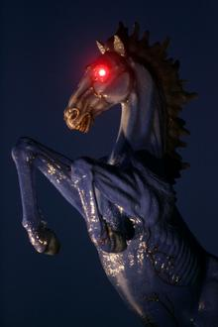[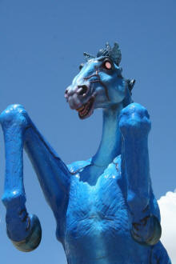](https://www.bibliotecapleyades.net/imagenes_sociopol/denver05_03.jpg)  
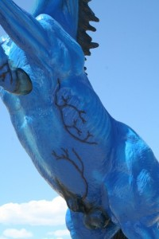

[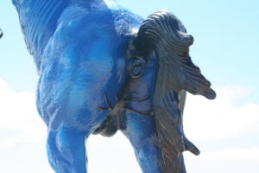](https://www.bibliotecapleyades.net/imagenes_sociopol/denver05_04.jpg)

So this is what welcomes you when you enter the gates of hell…sorry, I meant the gates of the airport.

A 32 foot high fiberglass stallion with veins popping out of its whole body and demonic eyes that glow red. Nice. I heard the children love it. Interesting fact: the horse killed his creator, Luis Jimenez, while he was working on it. A portion of the sculpture came loose and smashed him, causing fatal injuries. His friends now say that the horse is cursed.  
  
What does it represent? The 1st thing that came to mind when I saw this horrendous piece (for an airport anyways) is: the *Pale horse of the Apocalypse*.

It is the fourth horse in the book of Revelation in the Bible and is appropriately called “Death”.

“And I looked, and behold a pale horse;  
and his name that sat on him was  
Death, and Hell followed with him. And  
power was given unto them over the  
fourth part of the earth, to kill with  
sword, and with hunger, and with  
death, and with the beasts of the earth”.  
**-Revelation 6:7-8**

In other words, the horse “Death” brought killing with weapons, with hunger, and with disease.

That’s pretty extreme a family airport, right? Doesn’t seem like that horse should be there. You will soon realize that it fits perfectly with the rest of the DIA. By the way, this is one scary horse anus!

2- Masonic Capstone

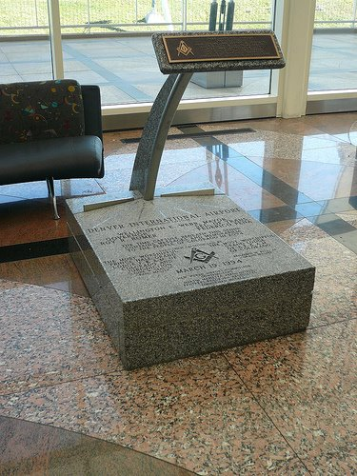

The stone is situated in the “Great Hall” of the airport (term that is also used by masons to refer to their meeting hall).

There’s Freemason symbols on the stone and on the “keypad” which seems to be written in Braille.

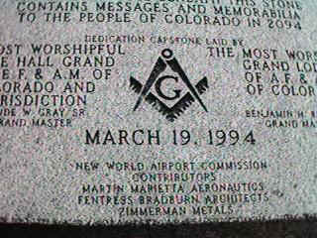

Notice on the capstone the mention *“New World Airport Commission”.*

This particular commission does not exist, so it most likely refers to the [New World Order](https://www.bibliotecapleyades.net/esp_sociopol_nwo.htm). There is also a time capsule buried under the stone to be opened in 2094. The angled arm is very enigmatic seems to have a purpose other than being decorative.

Any insights on this?

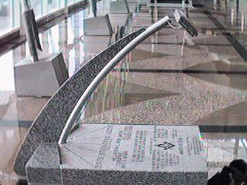

3 - Prophetic Murals  
  
Divided into four walls, the murals painted by [**Leo Tanguma**](http://www.leotanguma.com/) are supposed to represent peace, harmony and nature.

But I’m not getting these messages at all. When you analyze the symbolism of the murals, you realize that they tell a terrifying story of future events about to happen, as if it was some sort of prophecy. There are specific social and political references and other occult details that basically turn those paintings into a New World Order manifesto.

Tanguma reportedly confirmed that he was given guidelines for the paintings and was paid 100 000$ for the first ones. He later denied he was given instructions and refuted any questions regarding hidden meanings in his paintings. Previous Leo Tanguma murals were typical Chicano art, politically charged and community oriented.

However, his work at the DIA sends a totally different “vibe”, giving me the gut feeling that he simply drew someone else’s vision.

Let’s look at the paintings one by one:

**A) “Peace and Harmony with Nature“**

[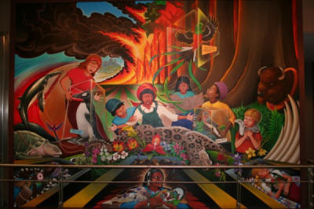](https://www.bibliotecapleyades.net/imagenes_sociopol/denver05_09.jpg)

So the airport’s official website says that the name of the mural is called “Peace and Harmony with Nature”. Really? At the center of the piece, saddened children with extinct animal and plant species.

In the background, a forest on fire and further back, a city on fire.

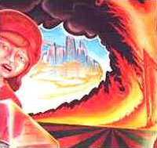

An interesting fact about that city is that it has been retouched and painted over many times during the years, as if it represents something important for the creators. It seems surrounded by an ill colored haze, as if it was attacked by a bio-chemical weapon.  
  
One of the children holds a [Mayan tablet](https://www.bibliotecapleyades.net/esp_tzolkin_maya.htm) depicting the end of civilization.



At the bottom, of this peaceful painting, we see three open-caskets containing dead girls from different cultures.

Left is a Black woman, center is a Native woman. Why are they laying there with the other animals? Are we predicting the extinction of those races? We already know that the military has developed race-specific chemical weapons.

Here’s what the [Project for New American Century](https://www.bibliotecapleyades.net/esp_sociopol_nwo.htm#Project_for_the_New_American_Century_(PNAC)) (**PNAC**), a think tank that defines the foreign and defense policy of the US has to say about this:

"...the art of warfare...

will be vastly different than it is today...  
“combat” likely will take place in new dimensions...

advanced forms of biological warfare that can “target”

specific genotypes may transform biological warfare

from the realm of terror to a politically useful tool."

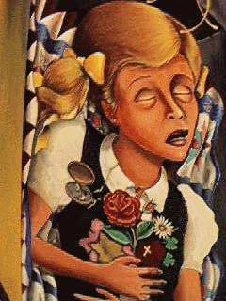

The girl above holds a Bible and a yellow “juden” star used by the Nazi to identify jews. It seems to symbolize the death of judeo-christian beliefs.

The group at the origin of the imagery of this airport are definitively NOT christian or jewish. [Secret societies](https://www.bibliotecapleyades.net/esp_sociopol_brotherhoodsecretsocieties.htm) have their own belief system that is way too complex to explain here.

I can however tell you that caskets are an important part of Masonic symbolism as you can see in the next image depicting the main symbols of freemasonry.

Tombs are also a big part of the [Skull and Bones](https://www.bibliotecapleyades.net/esp_sociopol_skullbones.htm)’ rituals.

[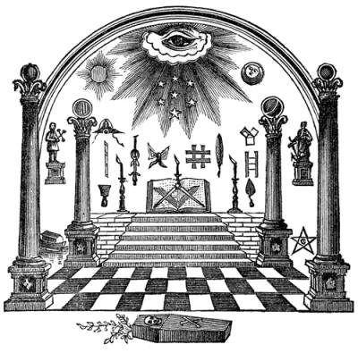](https://www.bibliotecapleyades.net/imagenes_sociopol/denver05_13.jpg)

**B) Children of the World Dream of Peace**  
The 2nd mural is a two part piece.

We read from left to right, so I will analyze it from left to right.

[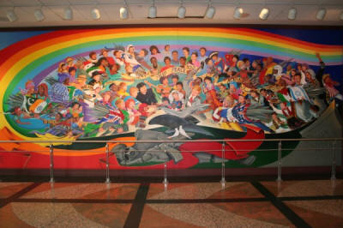](https://www.bibliotecapleyades.net/imagenes_sociopol/denver05_14.jpg)

Children of all colors, dressed in folkloric costumes give weapons wrapped in their country’s national flag to a… German boy? Huh? Yes the Bavarian costume leaves no doubt.

The boy at the center of the image, holding the hammer and apparently building something is German.

Even the American kid (dressed as a boy scout) seems eager to give his weapons and flag to the German boy. You’re in the largest airport of America, in the middle of the USA, and this is the mural we display. America joyfully submitting to Germany. It’s just too odd to compute. This obviously represents countries of the world giving up their military might and their national identity for “the common good”.

Another reference to a New World order, with one government and one army. But why is the German boy at the center of everything? There are so many allusions to Germany and Nazism in this airport, there is NO WAY it can be a coincidence.

I can’t help but to think of ”[Operation Paperclip](https://www.bibliotecapleyades.net/sociopolitica/sociopol_paperclip.htm" \t "_blank)“, which brought prominent Nazi scientists and researchers to the USA after WWII. Laying at the bottom of the mural is a broken figure holding a riffle (representing war) with two doves sitting on top of it (representing peace).

Heartwarming. Now follow the movement the of the rainbow that starts underneath that statue, going around the children and leading you to part II of the mural (which has recently painted over)

Part 2

[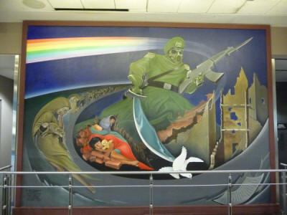](https://www.bibliotecapleyades.net/imagenes_sociopol/denver05_15.jpg)

The monster has awakened!

This big and aggressive militaristic figure is dressed in a Nazi uniform (notice the symbol on the hat) with a face shaped like a gas mask. His hands are holding a rifle and a scimitar that is rather violently molesting the peace bearing dove. On the left is depicted an endless lineup of crying parents holding their limp, dead baby. This is a truly atrocious painting, with no redeeming message or moral.

The fact that this was displayed at the main gate of the largest airport of America, during the age of political correctness (the nineties) is totally aberrant. The militaristic figure is glorified and all-powerful, situated at the center of the action. It has regained its powers that it seemed to have lost after WWII. It is back in full force and its leading the way to a new holocaust.  
  
Look closely at the people on the left and the dead children sleeping on bricks. There is no traces of violence on them. They’re simply devoid of life, as if they were poisoned by the deadly gas emanating from the rainbow above them.

The monster, protected by his gas mask, is pointing the lineup of victims towards the letter on the bottom left.

[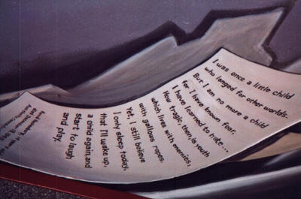](https://www.bibliotecapleyades.net/imagenes_sociopol/denver05_16.jpg)

It is an actual letter written by a Hama Herchenberg, 14 years old, that died December 18, 1943 in Auschwitz Concentration camp (as written at the bottom of the letter).

A little disturbing isn’t it.

Auschwitz was infamous for it use of toxic gas.

The camp commandant, Rudolf Höß, testified at the Nuremberg Trials that up to 3 million people had died at Auschwitz, about 90 percent of whom were Jews. Most victims were killed in Auschwitz II’s gas chambers using [Zyklon B](https://www.bibliotecapleyades.net/sociopolitica/sociopol_igfarben02e.htm#Zyklon)  
**(source: Wikipedia).**

The presence of a colorful rainbow and a teddy-bear in this image, symbols our minds instantly associate with youth and innocence, is totally sickening and twisted.

One last thing about the scimitar: it is a symbol often used in *Masonic imagery:*

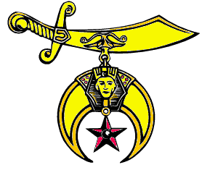

**C) Peace and Harmony with Nature**

[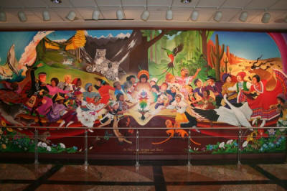](https://www.bibliotecapleyades.net/imagenes_sociopol/denver05_18.jpg)

What do you do when you’ve killed most of the world population with toxic gas?

You celebrate around a [genetically-modified](https://www.bibliotecapleyades.net/ciencia/ciencia_geneticfood.htm)-glowing plant of course! Happy people from all over the world irresistibly heading towards that plant, some are almost flying towards it.

Right above this plant (that doesn’t exist in real life) is a *Jesus-like* figure but is definitively not *Jesus*.

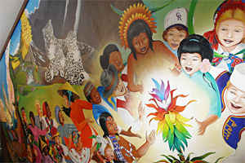

All of the instinct species of the 1st mural are all back in action and you even see a little dove appearing in the plant. How nice.

They feel so much better now that there’s much less people on earth now. The animals are happy too and they thank you for dying. People can now use high levels of scientific knowledge to live in a state of synthesized happiness provided by genetically modified plants. Good for them.

The whales are jumping in the air, high-fiving humans. If you look closely at the baby tigers, they have faces of human children. Its it quite bizarre. This whole piece freaks of genetic modification and magick.  
  
To sum up, those murals clearly depicted admitted goals you can read in documents calling for a New World Order:

* Massive [depopulation of the earth](https://www.bibliotecapleyades.net/esp_sociopol_depopu.htm)
* Death of judeo-christian beliefs
* One World government
* Restauration of nature

If you’ve read about the [Georgia Guidestones](https://www.bibliotecapleyades.net/sociopolitica/sociopol_georgiaguidestones.htm), you might notice that the themes are strikingly similar. Coincidence?

The *Georgia Guidestones* also feature a capstone with a time capsule buried under it. There is no “conspiracy theory” here, those are facts. Everything is written in stone for you to see. The elites own this place and they build monuments to celebrate their culture. Their “divine knowledge” is however inaccessible to you unless you’re a high ranking member.

There is so much to interpret in those murals that I’m convinced I’ve missed a lot of details (colors, shapes, movement, symbols).

4 - The Swastika Runway  
  
After seeing all of the allusions to Nazi Germany, would you be surprised if the runways were shaped like a swastika? Here’s an aerial view of the runways and below is how the runways appear in Google Map.

Draw your own conclusions.

[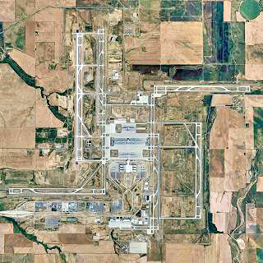](https://www.bibliotecapleyades.net/imagenes_sociopol/denver05_24.jpg)

I highly doubt that the guy who drew the runways did not notice their odd shape.

I mean, someone in the process of drawing and/or building had to say,

“Wait a minute, this kind of looks like that Nazi symbol! We should maybe change it! We don’t want our new 4,1G$ airport to be offensive or anything”.

But that did not happen for some reason.

5 - Other weirdness

Like I’ve said before, a book could be written on the DIA, so I’ll leave you with unsorted oddities you can see at the DIA.

**Garoyles**

[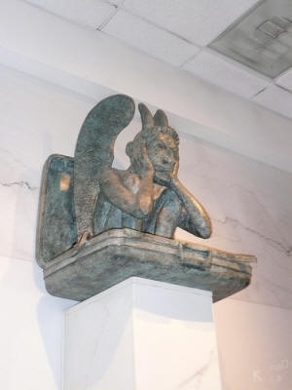](https://www.bibliotecapleyades.net/imagenes_sociopol/denver05_21.jpg)

The [symbolism of gargoyles](https://www.bibliotecapleyades.net/sumer_anunnaki/reptiles/reptiles.htm) has always been a *mystery*. Nobody can really explain the reason of their presence, specifically on religious buildings.

Are they remnants of past pagan beliefs that never went away? Do they represent something only “illuminated” people know about?

“What are these fantastic monsters doing in the cloisters under the very eyes of the brothers as they read? What is the meaning of these unclean monkeys, strange savage lions and monsters? To what purpose are here placed these creatures, half beast, half man?  
**-St Bernard of Clairvaux**

**12th century**

**The floor**

[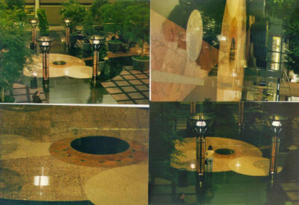](https://www.bibliotecapleyades.net/imagenes_sociopol/denver05_22.jpg)

These photos are of a strange set of symbols that run in the floor from the south end of The Great Hall on Level 5 and progress to the north end of The Great Hall.

Note the black disk which is occulting the sun. There is no mistaking the architecture in the floor as depicting the sun, and the black disk is beginning to eclipse it. When we arrive at the north end of The Great Hall, there is a statue of Jeppesen which is covering the sun.

Is it a reference to [the black sun](https://www.bibliotecapleyades.net/sociopolitica/sociopol_germany.htm), as worshiped by the Nazis?

**????**

[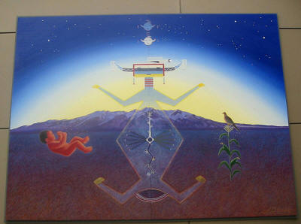](https://www.bibliotecapleyades.net/imagenes_sociopol/denver05_23.jpg)

Is it supposed to be “native” art representing mother earth?

Looks like an [alien “sprinkling” life on earth](https://www.bibliotecapleyades.net/esp_ciencia_life.htm). What's with the little faces at the top of the painting? Are they alien watching us from space? I don’t know, I can’t find any information about this piece.

It makes me think of *crop circles* for some reason.

**Additional sources of information or theories**