Denver Airport Adds a Talking Animatronic Gargoyle to Debunk Conspiracy Theories

**TOPICS:**[Conspiracy](https://www.activistpost.com/tag/conspiracy)[Denver Airport](https://www.activistpost.com/tag/denver-airport)[Jake Anderson](https://www.activistpost.com/tag/jake-anderson)

MARCH 5, 2019

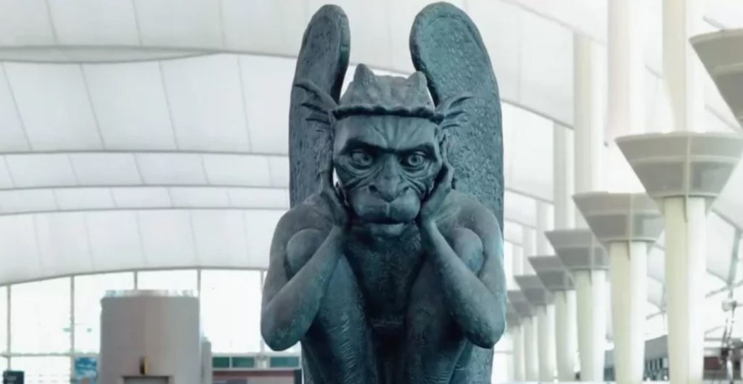By [**Jake Anderson**](https://themindunleashed.com/author/janderson1)

There’s no other airport in the world with as many conspiracy theories attached to it as the Denver International Airport (DIA). Claims of the 35,000-acre structure—the second largest airport in existence—being home to a clandestine military installation have dogged DIA since its bloated [**$4.8 billion**](https://www.buzzfeed.com/rickysans/the-mysterious-conspiracy-theories-surrounding-the-denver-ai) construction came to a finish in 1995. Airport executives are aware of the conspiracies and, in an attempt to dispel the myths, just built an interactive gargoyle to converse with wayward travelers.

The conspiracy theories related to the Denver Airport stem largely from the outlandish—and sometimes disturbing—murals, decor, and art exhibits festooning both its interior and exterior. There is, for example, the 32-foot tall steel armature sculpture of Blue Mustang, nicknamed Blucifer, who rears toward the sky with glowing red eyes. The [**sculpture**](https://www.independent.co.uk/travel/the-darkest-conspiracy-theories-about-denvers-bizarre-airport-a7808376.html) gained special notoriety when, during construction, its head fell off and severed an artery of creator Luis Jiménez, ultimately killing him.

Inside the airport, travelers pass by a ‘time capsule’ capstone engraved with a Masonic symbol. The dedication was created by the New World Airport Commission and is meant to be opened in the year 2094. Then there are the infamous murals of Leo Tanguma, which depict enormous, haunting tableaus of the world’s children ensconced in a fiery apocalypse and huddled populations overlooked by an armed skeletal sentry that many have described as looking freakishly Naziesque.

Some conspiracy theorists assert, persistently though largely without credible evidence, that there’s more going on at this airport than the usual flights and cheap peanuts. A 2013 [**article**](https://www.intellihub.com/denver-international-airports-department-of-defense-connection-exposed/) reported on a whistleblower claiming to have inside information confirming that the airport’s aerotropolis, or “Airport City”, which ferries 50 million travelers annually, also contains an underground military station contracted by the Department of Defense. This base, which ostensibly connects to a vast network of subterranean military installations via miles of tunnels, constitutes a top-secret Continuity of Government (COG) base that would serve as a fallback in case a severe national emergency compromised our central government.

The new interactive exhibit—a giant animatronic gargoyle—is voiced by a full-time actor who engages in humorous conversations with travelers as they pass by. In a video of the strange new feature, the glistening gargoyle, whose head and eyes swivel about like a robotic puppet at Chuck-e-Cheese, pokes fun at the airport’s conspiratorial reputation.

“*Welcome to Illuminati Headquarters… I mean, Denver International Airport*,” it says to delighted, and sometimes shocked, passersby.

The responses by the gargoyle, who states that he’s 243-years-old, are impromptu but so synchronized with people’s specific characteristics that it’s creepy. Check out this video from the airport:

While one might view this exhibit as an improbable or even inappropriate feature for an airport, DIA’s executives say it’s a strategic response to the conspiracy theories: **harnessing the chaos and embracing the spectacle.**

Spokesperson Emily Williams [**remarked**](https://me.mashable.com/culture/648/denver-international-airport-knows-about-the-conspiracy-theo):

I think that we recognize that conspiracy theories are part of our brand. It’s a fun way that we can engage with our passengers.

And, indeed, this isn’t the first time the airport has trolled travelers. Last year, they posted a [**series of advertisements**](https://www.flydenver.com/great_hall/denfiles) illustrated with alien imagery and Illuminati iconography.

“Yes, Den’s got some secrets,” one ad read. “Since the airport’s opening in 1995, there have been endless rumors and theories. People say our underground tunnels lead to secret meeting facilities for the world’s elite. Our blue horse is thought of to be cursed. Some believe we are connected to the new world order, the Freemasons, and are home to the lizard people.”

While many observers have expressed delight at the interactive gargoyle, the response on YouTube has not been as kind, with some suggesting the gambit is little more than a PR stunt to hide the truth.

On the video posted to Denver Airport’s [**YouTube page**](https://www.youtube.com/watch?time_continue=122&v=fKVOtx7Blfk), one commenter wrote:

Nothing to see here folks (at the Denver airport.) Just pay attention to this talking gargoyle with uplifting music behind it. Ignore the murals of genocide and freemason symbolism on statues throughout the complex. Life is good, you are not a slave.

Another commenter astutely pointed out:

Interesting that the gargoyle said he’s 243 years old and mentions illuminati conspiracy. Adam Weishaupt supposedly founded the illuminati in 1776. 243 years ago.

While the Denver Airport probably does not harbor a den of Illuminati operatives in its underground chamber, it might be worth considering the long-term consequences of disturbing the hell out of people right before they squeeze onto a crowded airplane. On the other hand, talking gargoyles and artful renditions of the apocalypse might be preferable to awkward small talk over $15 airport beers