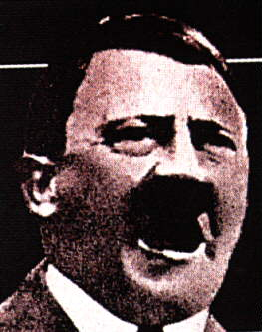
The Big Lie
Adolf Hitler

http://www.heretical.org/miscella/ahbiglie.html

Hitler details the fraud technique which exploits the essentially honest nature of Aryan folk and their feminine tendency to project that nature onto others
This military collapse [the First World War] was itself only the consequence of a large number of symptoms of disease and their causes, which even in peacetime were with the German nation. This was the first consequence, catastrophic and visible to all, of an ethical and moral poisoning, of a diminution in the instinct of self-preservation and its preconditions, which for many years had begun to undermine the foundations of the people and the Reich.
It required the whole bottomless falsehood of the Jews and their Marxist fighting organization to lay the blame for the collapse on that very man who alone, with superhuman energy and will power, tried to prevent the catastrophe he foresaw and save the nation from its time of deepest humiliation and disgrace. By branding Ludendorff as guilty for the loss of the World War they took the weapon of moral right from the one dangerous accuser who could have risen against the traitors to the fatherland. In this they proceeded on the sound principle that the magnitude of a lie always contains a certain factor of credibility, since the great masses of the people in the very bottom of their hearts tend to be corrupted rather than consciously and purposely evil, and that, therefore, in view of the primitive simplicity of their minds they more easily fall a victim to a big lie than to a little one, since they themselves lie in little things, but would be ashamed of lies that were too big. Such a falsehood will never enter their heads and they will not be able to believe in the possibility of such monstrous effrontery and infamous misrepresentation in others; yes, even when enlightened on the subject, they will long doubt and waver, and continue to accept at least one of these causes as true. Therefore, something of even the most insolent lie will always remain and stick - a fact which all the great lie-virtuosi and lying-clubs in this world know only too well and also make the most treacherous use of.
The foremost connoisseurs of this truth regarding the possibilities in the use of falsehood and slander have always been the Jews; for after all, their whole existence is based on one single great lie, to wit, that they are a religious community while actually they are a race - and what a race! One of the greatest minds of humanity† has nailed them forever as such in an eternally correct phrase of fundamental truth: he called them 'the great masters of the lie.' And anyone who does not recognize this or does not want to believe it will never in this world be able to help the truth to victory.
† Artur Schopenhauer
From Volume One, Chapter X of Mein Kampf

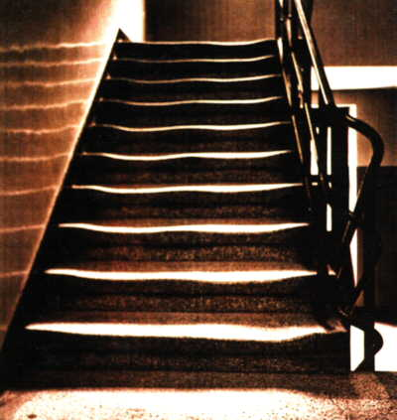
A staircase in one of the Auschwitz buildings. Due to another Big Lie, and a certain talent for religious invention, images like these are imbued with reverential significance

The people in their overwhelming majority are so feminine by nature and attitude that sober reasoning determines their thoughts and actions far less than emotion and feeling. Mein Kampf, vol. 1, ch. 6: 'War Propaganda.'

