**“I am a Cow”          By Joseph Gill 1997**

In 1997 David Icke was touring the USA giving talks to whoever would listen. While doing this he was advised by several people to call me up on the Big Island of Hawaii where I was retired.

When he called I had no idea who he was, but I enjoyed being interviewed by him for several hours.  I had been retired and living in Hawaii since 1989.  I had a very large library on Metaphysics and conspiracy investigation of over 8000 books; some very rare including over 2000 books on Secret Societies.  Some of my very rare books went back to the 16th century.

I had been a director at Sotheby’s worldwide Auctions, a company first established in 1725.  In that position and my dealings at the very top of the jewelry business, I was very familiar with people such as David Rockefeller and the Rothschild’s, including Countess Philippe de Rothschild who lived in Paris.  She made all the final decisions on any important issues regarding the family business.  I had done business with many of the richest old established families around the World.

As an advisor, I had been getting many calls from authors such as Bill Cooper, Richard Hoagland, Dr. Steven Greer, John Coleman, Ralph Epperson, Eustace Clarence Mullins, Antony Sutton, Zecharia Sitchin, Philip Corso, George Adamski, John Keel, Dr. John Mack, Gary Allen, Zbigniew Kazimierz Brzezinski, Manly Palmer Hall, Jordan  Maxwell, and many more. They wanted to get story and references regarding their books in progress at that time.

After David Icke had talked with me, he asked, “How do you feel when you know all these things are happening?”  I thought for a minute or so and said:

“I am a Cow’ and I live in this beautiful big green field with all my cow friends. Every once in a while a truck comes by to drop a block of salt over the fence for us to lick. When the grass gets short another truck comes by and throws big blocks of grass over the fence, I think they call them bales of hay.  Every week or so a big white truck comes by and takes some of my friends to heaven.  Well, myself being a very curious cow, I decided to jump over the fence and follow this big truck.

The story continues several hours later when I return back to my field and go to its center and mooo to all my friends that I needed to tell them what I had discovered.

Yes, I said, I followed that truck only for a short period where the truck turned off the road into a very large building.  They, those people, took our friends and put a big metal hook through our cow-friends back legs lifted them up, and skinned them alive.  The humans cut our friends up into little pieces and people who were all dressed in white sold all our body parts in a store.  Our brains were mixed with eggs and they ate them for breakfast. The humans used our skin to make shoes, coats, and belts to hold their pants up. They used our skin to cover their books and they extracted oil from our feet, neat foot oil to keep our skins soft.  Then they took the sickest of our friends and made cosmetics for the human's faces and to put all over their lips!  They even made soap to wash their bodies. They would spray our blood over their french-fried potatoes because they love the smell of our cooked blood and flesh.

About this time my best friend cow told me, "We love you Joseph but would you please go down to the other end of the field!  We do not want to hear this, even if it is the truth.   Please let us eat and live in bliss.

**See the attached COW STORY comic** that was obviously done after hearing David Icke tell the cow story, as he has many times in his talks around to World. I am honored to have had a bit part in helping David Icke and many others to unravel the many mysteries of the New World Order or Deep State.

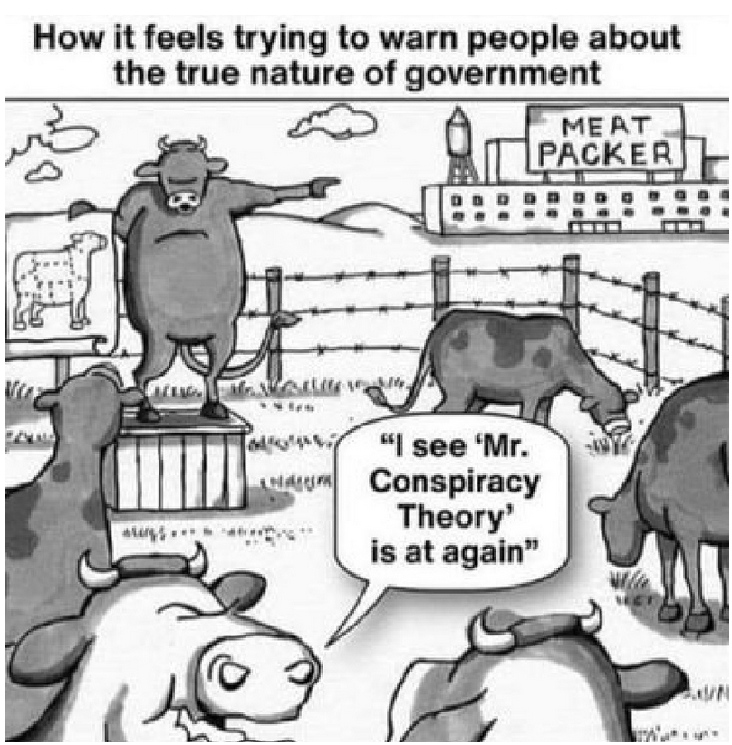

**A few things of many that I recommended to David Icke:**

Bible Myths and Their Parallels in Other Religions - Thomas William Doane 1882

FLYING SERPENTS AND DRAGONS - R.A. Boulay 1990

They Live – Movie - John Carpenter - Roddy Piper, Keith David, Meg Foster 1988

Ringmakers of Saturn - Norman R. Bergrun - Scotland 1986

Etidorhpa, or, The End of Earth - John Uri Lloyd 1896

Tree and Serpent Worship in India - James Fergusson 1873

The Worship of the Serpent, Traced Throughout the World - by John B. Deane 1833

Ophiolatreia, Serpent Worship in Various Parts of the World - ANON 1889

The Serpent Symbol & Reciprocal Principals of Nature - by Ephraim George Squier 1851

NOTE, You can download many of these rare books, and more, at [www.archive.org](http://www.archive.org)

Enjoy and PLEASE share this on Facebook, ETC…………………………..Joseph

**3 Web Sites of interest**<https://worldglobetrotters.com/>

<https://worldglobetrotters.com/world-symbolism/>

[https://archive.org/search.php?query=Joseph+O.+Gill&sort=creatorSorter&and[]=subject%3A%22Joseph+O.+Gill%22](https://archive.org/search.php?query=Joseph+O.+Gill&sort=creatorSorter&and%5b%5d=subject%3A%22Joseph+O.+Gill%22)

==============================================================