Sara Netanyahu, wife of Israeli Prime Minister, charged with fraud

**By Oren Liebermann and Michael Schwartz, CNN**

Updated 1611 GMT (0011 HKT) June 21, 2018

|  |
| --- |
|  |
|  |

|  |
| --- |
|  |



Now PlayingBenjamin Netanyahu's...

Benjamin Netanyahu's wife charged with fraud 01:49

**Jerusalem (CNN)**The wife of Israeli Prime Minister Benjamin Netanyahu was charged with fraud and breach of trust Thursday over the alleged misuse of state funds at the couple's official residence.

In a case known as the "Meals Ordering Affair," prosecutors say Sara Netanyahu used state money to pay for $100,000 worth of meals at the prime minister's residence, according to an indictment filed in Jerusalem's magistrate's court on Thursday.

Sara Netanyahu also illegally paid approximately $10,000 for private chefs, prosecutors said.

The charges carry a maximum sentence of 8 years in prison.

Her lawyers slammed the indictment, describing it as "false and hallucinatory".

"It's the first time in Israel and in the world that the wife of a leader is put on trial for food entrees," her legal team said in a statement. "There was no fraud, no breach of trust or any other felony. The food was not for the Netnayahu family, but for other people, including workers in the residence. We're certain in the end that justice will speak. Truth and logic will prevail."

[[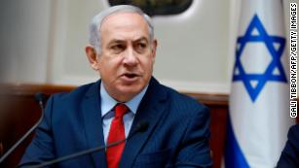](https://edition.cnn.com/2018/02/13/middleeast/netanyahu-corruption-probes-israel-intl/index.html)](https://edition.cnn.com/2018/02/13/middleeast/netanyahu-corruption-probes-israel-intl/index.html)

[Netanyahu corruption probes: What you need to know](https://edition.cnn.com/2018/02/13/middleeast/netanyahu-corruption-probes-israel-intl/index.html)

The indictment is a blow to an embattled power couple [already facing several other criminal investigations.](https://cnn.com/2018/02/13/middleeast/netanyahu-corruption-probes-israel-intl/index.html)Benjamin Netanyahu has been named a suspect in two separate criminal investigations and was questioned as a suspect in a third. Police say they have enough evidence to indict the Israeli leader on charges of fraud, bribery, and breach of trust in those cases.

From April 2009 until March 2013, Sara Netanyahu ordered meals from some of the most expensive restaurants in Jerusalem, according to the indictment, which painstakingly detailed each transaction by month. In December 2011, prosecutors say she ordered meals to the prime minister's residence totaling 24,164 shekels -- more than $6,500 dollars. Just a few months later in April 2012, the family ordered meals amounting to 26,061 shekels -- more than $7,100.

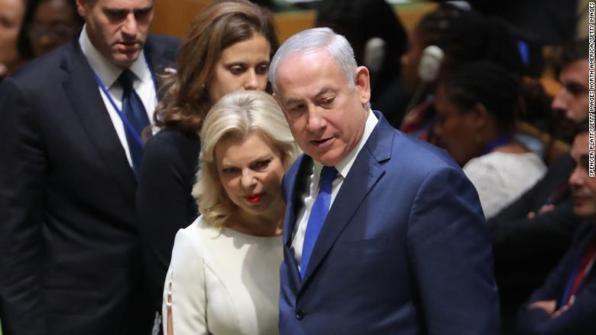

Sara Netanyahu with her husband Israeli Prime Minister Benjamin Netanyahu.

Under Israeli law, if there is no cook in the prime minister's residence, it is permissible to order prepared food. But prosecutors say the Netanyahu family had a cook in the house and yet still ordered the food, with Israeli taxpayers footing the bill.

Sara Netanyahu also used state funds to pay waiters to serve the meals on weekends and during private events, according to prosecutors, who said the hand-picked waiters were registered as "extra manpower" or "cleaners" to hide the fact that they were being illegally employed.

Prosecutors allege that Sara Netanyahu submitted claims "knowing that the claims were not true, believing they were not true, and through these claims, they have received goods by fraud." Prosecutors pointed to the "severity of the circumstances," citing the "sum of money, the planned, continuous, and systemic action, the character of the false presentations, and the carrying out of those deeds in the official residence of the Prime Minister."

Prosecutors also charged the former Deputy Director-General of the Prime Minister's Office, Ezra Saidoff, with fraud and breach of trust. Prosecutors say he coordinated with Sara Netanyahu, managing the meal payments and invoices to conceal them from oversight. He was also charged with forgery.

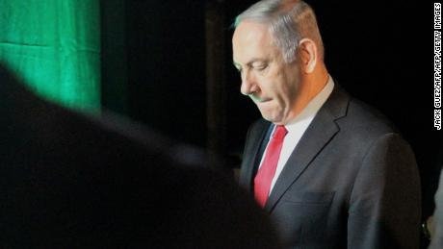

Play Video

Police find 'sufficient evidence' to indict Benjamin Netanyahu 00:45

A lawyer for Saidoff, Yehoshua Reznik, insisted Saidoff had done nothing wrong. "Mr. Saidoff acted with integrity and according to the law in all his actions and were done in coordination with all of the relevant parties in the office. The submission of the indictment sheet against Mr. Saidoff is fundamentally wrong and does not coincide with the factual and judicial situation as it appears from the evidence in the case," Reznik said.

The latest developments increase the pressure on the Prime Minister, who has already faced numerous calls from opposition politicians to resign. Like his wife, Benjamin Netanyahu has repeatedly proclaimed his innocence, decrying the investigations as a "witch hunt" and [saying "there will be nothing because there is nothing."](https://cnn.com/2018/03/02/middleeast/netanyahu-israel-corruption-questioning-intl/index.html)

Netanyahu has insisted he will not step down as Prime Minister, though an indictment against him would likely lead to his government coalition partners forcing him out.