Terrorism: How the Israeli state was won

[Opinion](https://mondoweiss.net/opinion/)

[Tom Suarez](https://mondoweiss.net/author/tom-suarez/) on January 1, 2017 [189 Comments](https://mondoweiss.net/2017/01/terrorism-israeli-state/#comments)

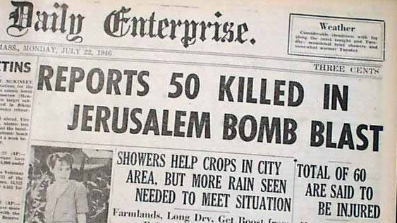

Initial reports on King David Hotel bombing said 50 dead; the blast killed 91. But as Suárez explains in State of Terror (p 146), the King David bombing was not, as is commonly believed, the most deadly terror attack of the pre-state period.



*On December 14, Tom Suárez spoke at The House of Lords, London, at the invitation of Baroness Jenny Tonge. Drawing from his recently published book*[*State of Terror*](http://www.state-of-terror.net/)*, he addressed the centennial of the Balfour Declaration and his views on the way toward ending today’s Israel-Palestine “conflict”. The following are Suárez’s remarks. The book was reviewed*[*here*](https://mondoweiss.net/2016/10/terror-thomas-suarez/)*by David Gerald Fincham.*

Good evening, thank you so much for taking time out of what I know are your busy schedules to be here now. My thanks to Jenny Tonge for making this meeting possible; and I would like to thank three people without whom the book would not exist: Karl Sabbagh, my publisher; Ghada Karmi, who inspired the book; and my partner, Nancy Elan, who was my constant alter-ego during my research and without whom I surely would have given up.

My work is based principally on declassified source documents in the National Archives in Kew. When I have had to rely on published works, I have trusted established historians who cite first-hand sources. Everything I will say here tonight is based on such source material.

Our topic is of course the so-called “conflict” in Israel-Palestine, a tragedy that has dragged on for so long that it feels static, indeed almost normalised. But unlike other deadly conflicts, this one is wholly in our power to stop—“our” meaning the United States and Europe. It is in our power to stop it, because we are the ones empowering it.

We are now approaching the centennial of the British Original Sin in this tragedy, the Balfour Declaration. The British role in Palestine was a case of ‘hit & run’: The Balfour Declaration, in which the British gave away other people’s land, was the hit; and thirty years later, Resolution 181—Partition—was the run, leaving the Palestinians abandoned in a ditch.

Zionism was of course among the incarnations of racial-nationalism that evolved in the late nineteenth century. Bigots were Zionism’s avid fans—it was the anti-Semites who championed the Zionists. Gertrude Bell, the famous English writer, traveler, archaeologist, and spy, reported, based on her personal experience, that those who supported Zionism did so because it provided a way to get rid of Jews.

The *London Standard’s* correspondent to the first Zionist Conference in 1897 I think described Zionism perfectly. He reported that

*…the degeneration which calls itself Anti-Semitism [bear in mind that ‘anti-Semitism’ was then a very new term] has begotten the degeneration which adorns itself with the name of Zionism.*

Indeed, most Jews and Jewish leaders dismissed Zionism as the latest anti-Semitic cult. They had fought for equality, and resented being told that they should now make a new ghetto—and worse yet, to do so on other people’s land. They resented being cast as a separate race of people as Zionism demanded.

They had had quite enough of that from *non-Jewish* bigots.

For others, the idea of going to a place where one could act out racial superiority was seductive. As the political theorist Eduard Bernstein put it at about the time the Balfour Declaration was being finessed, Zionism is “a kind of intoxication which acts like an epidemic”.



An Israeli soldier clears out of the way as a specially-built IDF vehicle begins to douse Bethlehem in “skunk spray”, chemical warfare intended to make life miserable for the civilian population. Photo: T Suárez

By the time the Balfour Declaration was finalised, thirty-plus years of Zionist settlement had made clear that the Zionists intended to ethnically cleanse the land for a settler state based on racial superiority; and it was the behind-the-scenes demands of the principal Zionist leaders, notably Chaim Weizmann and Baron Rothschild.

First-hand accounts of Zionist settlement in Palestine had already painted a picture of violent racial displacement. I will cite one of the lesser known reports, by Dr. Paul Nathan, a prominent Jewish leader in Berlin, who went to Palestine on behalf of the German Jewish National Relief Association. He was so horrified by what he found that he published a pamphlet in January, 1914, in which he described the Zionist settlers as carrying on

*a campaign of terror modelled almost on Russian pogrom models [against settlers refusing to adopt Hebrew].*

A few years later, the Balfour Declaration’s deliberately ambiguous wording was being finalized. Sceptics—and the British Cabinet—were assured that it did not mean a Zionist state. Yet simultaneously, Weizmann was pushing to create that very state immediately. He demanded that his state extend all the way to the Jordan River within three or four years of the Declaration—that is, by 1921—and then expand beyond it.

In their behind-the-scenes meetings, Weizmann and Rothschild treated the ethnic cleansing of non-Jewish Palestinians as indispensable to their plans, and they repeatedly complained to the British that the settlers were not being treated preferentially enough over the Palestinians. And they insisted that the British must lie about the scheme until it is too late for anyone to do anything about it.

In correspondence with Balfour, Weizmann justified his lies by slandering the Palestinians and Jews—that is, the Middle East’s indigenous Jews, who were overwhelmingly opposed to Zionism and whom Weizmann smeared with classic anti-Semitic stereotypes. The Palestinians he dismissed as, in so many words, a lower type of human, and this was among the reasons he and other Zionist leaders used for refusing democracy in Palestine—if the “Arabs” had the vote, he said, it would lower the Jew down to the level of a “native”.

With the establishment of the British Mandate, four decades of peaceful Palestinian resistance had proved futile, and armed Palestinian resistance—which included terrorism—began. Zionist terror became the domain of formal organizations that attacked anyone in the way of its messianic goals—Palestinian, Jew, or British. These terror organizations operated from within the Zionist settlements and were actively empowered and shielded by the settlements and the Jewish Agency, the recognized semi-autonomous government of the Zionist settlements, what would become the Israeli government.

There was no substantive difference between the acknowledged terror organizations—most famously, the Irgun, and Lehi, the so-called Stern Gang—and the Jewish Agency, and its terror gang, the Hagana. The Agency cooperated, collaborated, and even helped finance the Irgun.

The relationship between the Jewish Agency, and the Irgun and Lehi, was symbiotic. The Irgun in particular would act on behalf of the Hagana so that the Jewish Agency could feign innocence. The Agency would then tell the British that they condemn the terror, while steadfastly refusing any cooperation against it, indeed doing what they could to shield it.

The fascist nature of the Zionist enterprise was apparent both to US and British intelligence. The Jewish Agency tolerated no dissent and sought to dictate the fates of all Jews. Children were radicalised as part of the methodology of all three major organizations, and by extension, the Jewish Agency.

Britain’s wake-up call regarding the Zionists’ indoctrination of children came on the 8th of July, 1938. That day, the Irgun blew up a bus filled with Palestinian villagers. Now, this was not the first time the Irgun had done something of this sort, but this time the British caught the bomber. She was a twelve year old schoolgirl.

Teenagers, both boys and girls, were commonly used to plant bombs in Palestinian markets and conduct other terror attacks. Teachers were threatened or removed if they tried to intervene in the indoctrination of their students, and the students themselves were blocked from advancement if they resisted, even being taught to betray their own parents if those parents tried to instill some moderation. Jews who opposed and tried to warn of the emerging fascism were assassinated, and indeed most victims of Zionist assassinations—that is, targeted, rather than indiscriminate—were Jews.

From the beginning of World War II through to the summer of 1947, there were virtually no Palestinian attacks, even though Zionist terror against Palestinians continued. A British explanation for the Palestinians’ failure to respond in kind was that they understood that the attacks were a trap, intended to elicit a response that the Zionists would frame as an attack against which they would have to ‘defend’ themselves. This was a Zionist tactic noted by the British as early as 1918, and it remains Israel’s default strategy today, most blatantly in Gaza, but also in East Jerusalem and the West Bank.

As late as the fall of 1947, the Jewish Agency was concerned by the Palestinians’ failure to respond to its provocation, but when the end of 1947 came and the Jewish Agency could wait no longer for the civil war it needed, it was simply a matter of ratcheting up the terror.

Throughout the Mandate period, the takeover and ethnic cleansing of Palestine remained Zionism’s unwavering goal. As but one illustration, I will summarize a key meeting of twenty people held in London on the 9th of September, 1941.

“To be treated as most secret” is the red ink heading of the transcript. Present were Weizmann, who had called the meeting, David Ben-Gurion, and other Zionist leaders such as Simon Marks (of Marks & Spencer); and the prominent non-Zionist industrialist, Robert Waley Cohen. Discussing the path to the proposed Jewish State, the conversation ran along the lines of George Orwell’s still-to-be-published *Animal Farm*, in which all animals are equal, but some are more equal than others.

Anthony de Rothschild began by stressing that there would be no “discrimination … against any group of its citizens” in the Jewish state, not even “to meet immediate needs”. Weizmann and Ben-Gurion also assured the sceptics: “Arabs”—Palestinians—would have equal rights. However, they clarified that within that absolute equality, Jewish settlers would have to have special privileges. Weizmann’s ‘absolute equality’ included *the transfer of most non-Jews out of Palestine* while permitting “a certain percentage of Arab and other elements” to remain in his Jewish state, the insinuation being as a pool of cheap labour.

Anthony de Rothschild’s vision of equality and non-discrimination was equally compelling: it “depended on turning an Arab majority into a minority”, and to achieve this, there would be “no equal rights” for non-Jews.

Cohen found the scheme dangerous, submitting that the Zionists were “starting with the kind of aims with which Hitler had started”. Cohen did not stop there: he suggested that if a state with equality for everyone were indeed intended, the state should be named with a neutral geographic term. He suggested … ‘Palestine’. The others were horrified at this idea, arguing that if the state had a non-Jewish name, “they would never get a Jewish majority”, in effect acknowledging the use of messianic fundamentalism as a calculated political strategy.

In another obvious but rarely spoken admission, Ben-Gurion clarified that the ‘Jewish state’ was not based on Judaism; it was, rather, based on being a ‘Jew’, that is, by the Zionists’ *racial* definition.

Asked about borders of his settler state, Weizmann continued in the same surreal manner. He replied that he would consider the partition plan proposed by the Peel Commission four years earlier, in 1937, but that “the line” (the Partition) “would be the Jordan”. This was nonsensical: the Jordan was the Commission’s eastern border for the *two* states, and so Weizmann’s ‘partition’ meant 100% for his state, 0% for the Palestinians. He went further still: he would “very much” like to “cross the Jordan”, that is, take Transjordan along with Palestine.

At the end of the meeting Weizmann sought to put his proposals into effect officially in the name of all Jews worldwide. Those against his proposals were, in his word, “antisemites”.

Meanwhile, World War II was raging. What was the Jewish Agency’s reaction to the most terrible enemy Jewry has ever known? From the beginning, it was to lobby the Yishuv, the Jewish settlers, *not* to enlist in the Allied struggle against the Nazis, because doing so would not serve Zionism—even taking advantage of May Day 1940 to lecture the Yishuv to stay in Palestine rather than join the war effort. Another reaction was to conduct a massive theft ring of Allied weapons and munitions, “as if”, as one British military record put it, “paid by Hitler himself”.

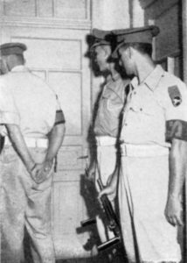

1952: The IDF militarily commandeers the UN office dedicated to peace-keeping along the Armistice Line in order to block the exposing of its violations. (See Suárez, State of Terror, 301-303.) Photo: John Scofield

Much has been written on the collaboration between the Zionists and fascists during the war, the best known of course being the Haavara Transfer agreement that broke the anti-Nazi boycott. One of the least known was Lehi’s attempted collaboration with the Italian fascists. In its nearly concluded ‘Jerusalem Agreement’ of late 1940, Lehi would help the fascists win the war, and in return the fascists would uproot any Jewish communities not in Palestine and force their populations to Palestine.

If this sounds like a scheme so extreme that only fanatical Lehi could have conjured it, it is essentially what the Israeli state ultimately succeeded at in the early 1950s—most catastrophically, when it conducted a false-flag terror campaign against Jews in Iraq to destroy that ancient community and move its population to Israel as ethnic fodder.

Violence targeting Jews was, and I would argue remains, a core tactic of Zionism. In fact, the single most deadly terror attack of the entire Mandate period was not the bombing of the King David Hotel in 1946 as is commonly thought. Even some of the Irgun’s bombings of Palestinian markets killed more people than the King David attack. But the most deadly single terror attack was the Jewish Agency’s bombing of the immigrant ship Patria in 1940, killing an estimated 267 people, of whom more than 200 were Jews fleeing the Nazis.

The Jewish Agency bombed the Patria because it was bringing the DPs to Mauritius, where the British had facilities for them. The Agency needed the DPs to be settlers in Palestine without delay, and was willing to risk the lives of all aboard in order to get the survivors to remain—which, indeed, they did.

In further violence against its Jewish victims, the Agency framed the dead for the bombing. It spread the lie that the DPs themselves blew up the vessel, that they committed mass suicide rather than not go directly to Palestine, posthumously conscripting the dead to serve the Zionist myth.

This was no aberration, but the driving principle of the Zionist project: Persecuted Jews served the political project, not the other way around.

Another major tactic of violence against Jews by the Jewish Agency and American Zionist leadership was the sabotaging of safe haven in order to force them to Palestine. As but one example, in 1944 US Zionist leaders sabotaged President Roosevelt’s provisional success in establishing a half million new homes for European DPs, most of these homes in the United States and Britain. When Roosevelt’s aide Morris Ernst visited the Zionist leaders in an attempt to save the program, he was, in his words, “thrown out of parlours and accused of treason”— ‘treason’, because he was Jewish, and the Zionists owned Jews.

Nor were those already settled safe. In 1946, the Ashkenazi Chief Rabbi of Palestine, Yitzhak Herzog, conducted a massive kidnapping operation of Jewish orphans that had been adopted by European families when their parents perished years earlier. Removing ten thousand children from their homes was the number he cited to the *NY Times* as his goal. In the National Archives, I found a copy of his own record of the trip.

Herzog railed against the fierce resistance he met in every country by horrified local Jewish leaders who tried to protect the children. But Herzog used his political clout to circumvent them. In France, for example, facing the steadfast refusal of the Jewish leaders to betray the children, Herzog

*met the Prime Minister of France from whom I demanded promulgation of a law which would oblige every family to declare the particulars of the children it houses,*

so that those of Jewish background could be exposed and put back in orphanages until they can be shipped to Palestine—quite a Kafkaesque twist on Passover for these children who had just been spared the Nazis.

Herzog’s justification for the kidnappings was that for a Jew to be raised in a non-Jewish home is “much worse than physical murder”. Yet even this ghastly justification fails to explain what was actually taking place, because at the same time Herzog was ‘rescuing’ Jewish orphans from this fate “much worse than physical murder”, his Jewish Agency colleagues were sabotaging Jewish adoptive homes in England for young survivors still in the camps. The real reason for all of it, of course, was that the children were needed to serve the settler project as demographic fodder.

To that end, the Jewish Agency had coerced President Truman to segregate Jewish DPs into Zionist indoctrination camps, despite objections that it echoed Nazi behaviour. For these people who had just survived the unthinkable, then severed from the rest of humanity into these brainwashing camps, there was no such thing as free thought.

The camps nurtured such fanaticism that it shocked a joint US-UK committee that visited in 1946. Before these camps, few DPs wanted to go to Palestine. But now the Committee found them in a delirious state, threatening mass suicide if they did *not* go to Palestine. Suggestions of new homes in the United States, which had always been the favored destination, were again met with threats of mass suicide.

DPs were also groomed to bring Zionist terrorism to Europe, bombing Allied trains and Allied facilities. The bombing of the British embassy in Rome in 1946, for example, was by DPs brainwashed in these camps, as was a near-catastrophe in the Austrian Alps in 1947 when DPs nearly blew a train off a steep trestle into a deep abyss, which would almost certainly have sent its two hundred civilians and Allied troops to their deaths.

German Jewish immigrants to Palestine during war were outraged by the Zionists’ exploitation of the Nazi horrors they had just fled. This outrage given voice by, among others, the prominent journalist Robert Weltsch, editor of Berlin newspaper until banned by the Nazis in 1938.

Weltsch warned that Zionist leaders

*have not yet understood that the enemy seeks the destruction of the Jews … We who have been here only a few years, we know what Nazism is.*

Zionists, rather, are “taking part in the crash of European Jewry only as spectators”, fighting the British and keeping Jews from joining the Allied struggle while getting comfortable and rich from their political project in Palestine. Recent immigrants from Germany and Central Europe, he said, have no representation among the Zionist ruling establishment. If they did,

*we would have demanded that the Yishuv should put itself at the disposal of Britain for the fight against Hitler and Nazism.*

But—and I am still quoting Weltsch—

*They do not want to fight against Hitler because his fascist methods are also theirs … They do not want our young men to join the [Allied] Forces … day after day they are sabotaging the English War Effort.*

These German Jewish immigrants were shunned by the Zionists, their publications and presses bombed. Even Kiosks were bombed for selling non-Hebrew papers to German Jewish immigrants.

In 1943, a man whom British records describe as “a Jew whose integrity is not open to question” risked his life to warn the British about the threat of Zionism. For his safety, he was referred to only by the code-name ‘Z’.

Z described Zionism as a parallel movement to Nazism. He warned that the Zionist indoctrination of Jewish youth was producing a society of extremists who will use any method necessary to achieve Zionist goals; and he pointed out that, as fascism in Europe has demonstrated, such a society is very difficult to undo once it has taken root. The result, I’m afraid, is what we, or more accurately the Palestinians, are facing today in the so-called ‘conflict’.

How trustworthy is this anonymous testimony? I found at the National Archives a private letter in which Z is identified — he was J.S. Bentwich, the Senior Inspector of Jewish Schools in Palestine.

Zionists

*would have got further towards rescuing the unfortunates in Axis Europe, had they not complicated the question by always dragging Palestine into the picture*

—so judged a report by US Intelligence in the Middle East, dated the 4th of June, 1943, entitled “Latest Aspects of the Palestine Zionist-Arab Problem”. It described “Zionism in Palestine” as

*a type of nationalism which in any other country would be stigmatised as retrograde Nazism,*

and stated that anti-Semitism was essential to it. Whereas

*assimilated Jews in Europe and America are noted for being … stout opponents of racialism and discrimination,*

Zionism has bred the opposite mentality in Palestine,

*a spirit closely akin to Nazism, namely, an attempt to regiment the community, even by force, and to resort to force to get what they want.*

US intelligence assailed “the crude conception” being spread of the Palestinian people as “a nomad tent-dweller … with a little seasonal agriculture”, as being “too absurd to need refutation”. The report noted the irony that it was from them that Zionist settlers learned the cultivation of Jaffa oranges. Whereas the Palestinians were self-sufficient, the Zionist settlements exist on massive external financing, and should Jews overseas ever tire of supporting the settlers, “the venture will collapse like a pricked balloon”. The conclusion of this early US intelligence report was however naïve, or at least premature: now that the world “has seen the lengths to which the Nazi creed has carried the nations”, it reasoned that the Zionists “are due to find themselves an anachronism”.

After the war, the Jewish Agency discussed its enemies. They were democracy; the Atlantic Charter, which of course became the basis for the United Nations; Reconstruction; and the fall in anti-Semitism, anti-Semitism having always been Zionism’s drug, without which it would be irrelevant. The Agency sought to exploit anti-Semitism and blamed declining anti-Semitism in the United States on America’s so-called “democratic attitude”.

Nor was this merely a post-war abuse. Even as Jews were still being carted off to the death camps, the New Zionist Organization’s Arieh Altman was typical in arguing that anti-Semitism must “form the foundation of Zionist propaganda”, and the Defence Security Officer in Palestine, Henry Hunloke, wondered if the Jewish Agency might even “stir up anti-Semitism … in order to force Jews … to come to Palestine”.

Now, today, when anything approaching this topic is raised, it is twisted by some into the pejorative *misstatement* that the speaker—in this case, me—is blaming Jews for anti-Semitism.

*NO*. Rather, it is the simple fact that Zionism requires anti-Semitism, is addicted to it, and seeks to insure that it, or at least the appearance of it, never ends. One need look no further than the satisfaction among many Zionists today at the *true* anti-Semitism of the incoming US administration of Donald Trump, with Israeli journalists like Yaron London openly applauding this anti-Semitism as welcome news. More about that in a few minutes.

I also mentioned Reconstruction. As one former settlement member, a man named Newton, explained, Zionist leaders were afraid that with the improvement of conditions in Europe the pressure on Palestine would subside. Any improvement in Europe was an anathema to their plans.

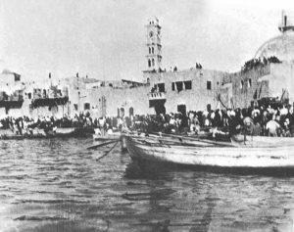

The ethnic cleansing of Jaffa, 1948, as survivors are rescued by boats. Photographer unknown.

What was the Jewish Agency’s reaction to Britain’s role in defeating the worst enemy Jewry has ever known? It saw an opportunity for extortion. The war had devastated Britain’s economy; but when Britain turned to the US for a long term loan to recuperate from its battle against the Nazis, the Agency tried to pressure Washington to deny the loan unless Britain acceded to Zionist demands. The loan was of course ultimately approved, but still in 1948 Zionists assailed US Congressmen for being pro- Marshall Plan, and the Truman administration itself dangled the loan in front of British officials when they tried to bring attention to Zionist atrocities.

By 1946, Zionist terrorism had become the defining daily challenge of life in Palestine, and one hundred thousand British troops proved unable to contain it. Anyone or anything that kept Palestine a functioning society was a target of the Zionists. Trains, roads, bridges, communications, oil facilities, and Coast Guard stations were constantly being bombed. Utility workers, telephone repairmen, railway workers, bomb disposal personnel were murdered. Police were long a favoured target and were gunned down by the dozens.

Among the smaller terror organizations that popped up was one specifically dedicated to Zionists’ long-running fear of Jews befriending non-Jews, the ultimate fear of course being polluting what for the Zionists was the pure Jewish race. As a sample of its methods, the terror group doused a disobedient Jewish girl with acid, severely injuring her and blinding her in one eye.

Zionist terror was aided by the Jewish Agency’s phenomenal intelligence network. The Agency had informers all the way to high-placed sympathetic US officials that fed them intelligence, such that the British learned not even to trust direct messages to US President Truman.

When the UN’s Palestine committee, UNSCOP, visited Palestine in the summer of 1947, the Agency had replaced the committee members’ drivers with spies; had replaced the waiters at the main restaurant they frequented with spies; and most productively, sent five young women to serve at what was called a “theatre network” of house attendants at the building where the members, all men, were being housed. The young women were required to be smart and educated, but above all, in the Agency’s word, to be “daring”. Whatever ‘daring’ meant, they extracted a wealth of information from the key people who were deliberating Palestine’s future.

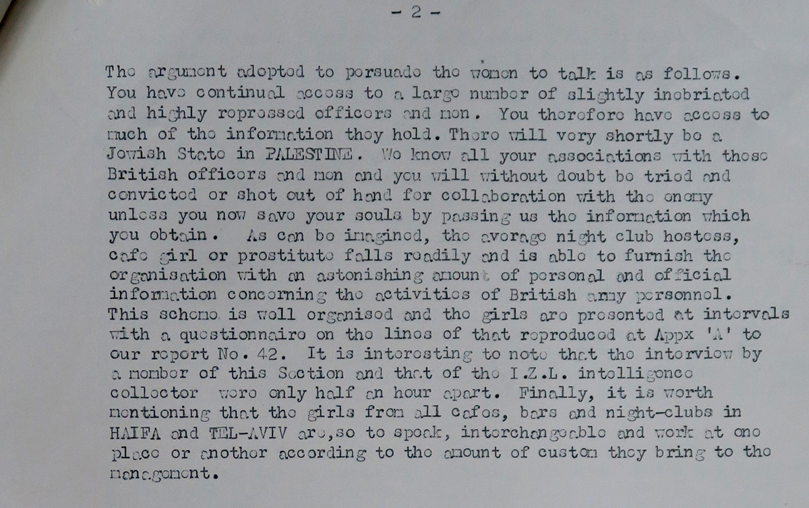

Extract from Airborne Field Security, Report No. 54, week ending 19 November 47, regarding Jewish sex workers forced to be Zionist spies. National Archives, Kew, FCO 141/14286.

Jewish sex workers were involuntarily recruited as spies. They were told that upon the Zionist victory they would be executed for ‘sleeping with the enemy’, but might be spared if they cooperated now. The practice was so widespread that a standard questionnaire was printed up that the women were to fill out after each British customer. [note: see document detail, above]

To demonstrate the degree to which Jewish Agency plants infiltrated the government and everyday life, a couple of months after one coast guard station was attacked and bombed by the Hagana, it blew up again … but the British were baffled, because this time *there had been no attack*. They discovered that the construction crew that had rebuilt the station after the previous attack were Hagana, and had simply embedded explosives in the reconstruction, to be detonated when desired.

But the worst problem of infiltration was in the military service, where deadly sabotage by Zionist plants who had joined the forces led, tragically, to orders to remove all Jews from service in Palestine, because there was no way to tell the Zionists from the Jews.

By 1948, this problem spread to key medical personnel. After the Jewish Agency poisoned the water supply of Acre with typhoid in order to expedite the ethnic cleansing of this city that lies on the Palestinian side of Partition, the bacteriologist hired by the British proved to be a Hagana plant or sympathizer, an obstacle to the availability of the vaccine. [Note: see document detail, below. For the injection of typhoid into the aqueduct at Acre, see e.g., Ilan Pappé, Ethnic Cleansing, pp 100-101, and Naeim Giladi, Ben Gurion’s Scandals, pp 10-11]

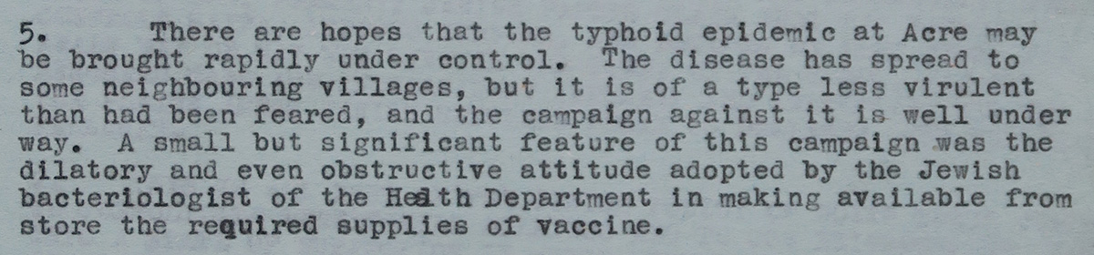

Hagana biological warfare and the “obstructive” attitude of the bacteriologist. Extract from telegram No. 1293, from High Commissioner Cunningham, “dispatched 1900 hrs. 8.5.48”, marked “IMMEDIATE. SECRET”. National Archives, Kew, WO 275/79.

Selling terror required effective marketing, and for that the Agency harnessed the plight of European Jews at the same time it was exploiting them. A very brief look at the iconic Zionist immigrant story is illustrative—that is of course the *USS Warfield*, renamed the *Exodus* for the obvious Biblical iconography.

The *Exodus* was sold to the world as the desperate attempt of 4,515 Holocaust survivors to reach their last hope of safety and a new life, their promised land. The British, instead, forced them back, not just to Europe, but to their ultimate nightmare: Germany.

That was the story the US and European public got.

In truth, the *Exodus* was a monstrous propaganda event, grand theatre, not for benefit but at the expense of Jewish survivors. The Jewish Agency knew that *Exodus* passengers would be turned back, for, among other reasons, their flooding of Palestine with settlers was a tactic to force its political goals. And remember that the entire *Exodus* cargo of immigrants equalled less than one percent of President Roosevelt’s resettlement plan that the Zionists sabotaged. The DPs themselves were products of the Zionist camps and had been rehearsed to repeat, as one witness described it, whatever Zionist mumbo-jumbo was demanded of them.

As for the return to Germany, it was the Jewish Agency, not the British, that forced the DPs back to Germany. Attempts were being made to find new homes for the Exodus passengers elsewhere—Denmark was one possibility—but this was sabotaged by Ben-Gurion, because it would spoil the Exodus plot.

There was in fact already an alternative to Germany. All the Exodus DPs had the right to disembark in Southern France rather than Germany, but the Agency used violence to prevent them from leaving. The Exodus show required the pathetic spectacle of their forced return to Germany.

The British decided to call the Agency’s bluff. They visited Golda Meir (then Meyerson), and spoke as though it went without saying that the Agency would do anything to spare the DPs the horrific return to Germany. They said that perhaps the DPs do not realize that they are free to disembark in southern France if they wish, or do not believe the British, and suggested that the Agency send a representative to tell them. Meir refused. To paraphrase Israeli Professor Idith Zertal, the greater the suffering of these survivors of the Holocaust, the greater their political and media effectiveness for the Zionists.

A few months after the *Exodus* affair, the UN recommended partition, with the assumption that a Zionist state would follow. This decision was directly influenced by the certainty of continuing Zionist terror if they did not, as was the disproportionately large land area the UN gave the Zionists.

According to British Cabinet papers, giving the Zionists so much land up front was an attempt to delay the Zionists’ expansionist wars. They knew they couldn’t stop Israeli expansionism, but they hoped to *delay* it. This appeasement of course failed: within a few months of Resolution 181, the Zionist armies were already waging their first expansionist war, confiscating more than half of the Palestinian side of Partition.

But in a consummately Orwellian irony, the fact that the British were occupying Palestine enabled Zionist leaders to juxtapose their settler project as a liberation movement against British colonizers, and thus for their 1948 terror campaign of expropriation and ethnic cleansing to be spun instead as a war of ‘independence’ or ‘emancipation’.

This so-called war of independence was in truth, to quote the British High Commissioner at the time, “operations based on the mortaring of terrified women and children”. Its broadcasts boasting of their successes, “both in content and in manner of delivery, are remarkably like those of Nazi Germany”. The Zionists were “jubilant” he reported, with “their campaign of calculated aggression coupled with brutality”.

British intelligence, meanwhile, reported that “the internal machinery of the Jewish State and all the equipment of a totalitarian regime is complete, including a Custodian of Enemy Property to handle Arab lands”.

In the Yishuv itself, “persecution of Christian Jews”, by which I assume they meant converts, “and others who offend against national discipline has shown a marked increase and in some cases has reached mediaeval standards”.

All this, to be sure, was *before* any Arab resistance.

Finally, on the 15th of May, 1948, Britain fled the scene of its crime, for which the Palestinians have been paying ever since. The post-statehood period continued full throttle with the same violent messianic goals, evolving with the new dynamics.

Now, there is no point in my having taken up your time here, no point any tree wasting its paper on this book, unless I thought that it had some value in the collective effort toward ending the conflict. So … How do I think that this book, how do I think my approach, might be constructive?

The historical record makes plain what should already have been obvious from the present reality—that Israel’s and Zionism’s pretenses regarding Jews and Judaism, and in particular its pretense of being a response to anti-Semitism and Jewish persecution, is a fraud. Indeed quite the opposite, it thrives by exacerbating and capitalizing on these, and has turned them into a cynical, deadly business.

Exposing *this*, in my opinion, is Israel’s—and the conflict’s—Achilles Heel. And this should be a simple case of the Emperor’s New Clothes—except that every time the child points out that the Emperor is naked, he or she is labelled an anti-Semite and silenced.

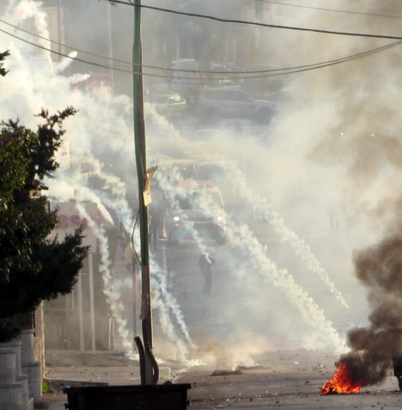

The IDF attacks the area between the ‘Azza and Aida refugee camps, Bethlehem, as an ambulance (center, background) tries to rescue victims. December, 2015. Photo: T Suárez

The US and other governments empower the conflict for their own geopolitical reasons, but why do the publics of those allegedly democratic countries give their tacit acquiescence?

Israel has one of the world’s largest militaries, but its most powerful weapon, the one without which all its others would be impotent, is its Narrative, its creation myth, its auto-biography.

Under the Twilight Zone of this Narrative, Israel is not merely a political entity like any other nation-state, but is transformed into the Old Testament kingdom whose name it adopted for that strategic purpose, striking a powerful chord in the collective Western sub-conscious.

We all know the Narrative more or less, but in order for that Narrative to be ever-present, Israel has crammed it into a 3-word mantra: ‘The Jewish State’.

This phrase—Israel’s self-identity—is a unique construct in the modern world. It is qualitatively distinct from any other country’s relationship with any other religion or cultural group. Judaism is not Israel’s state religion in the sense of a national faith that any nation might adopt. Rather, it presents itself as THE Jewish state, *the metaphysical embodiment of Jewry itself*, of Judaism, Jewish history, culture, persecution, and most cynical and exploitative of all, the Holocaust.

No country claims it is *the* Catholic state. Costa Rica, for example, is *a* Catholic state; it does not suggest that it owns Catholicism, Catholics, or historic Christian martyrdom. We do not have the British government issuing guidelines as to when criticism of the Costa Rican government becomes anti-Catholic hate speech. Norway is a Lutheran state; Tunisia is one of several nations that maintains Islam as a national faith; Cambodia is a Buddhist state. Israel, in contrast, would never acknowledge even the possibility of another Jewish state because it has body-snatched everything Jewish, and holds it hostage to empower its crimes.

Criticise Israeli terror, you will instead hit this three-word human shield—‘The Jewish State’— that Israel hides behind.  
What other country on this earth is permitted this perverse tribal claim over a religious or cultural group? This self-proclaimed exceptionalism should strike us as bizarre—even weird—yet we continue to be party to it.

We hear a lot about anti-Semitism these days, and there is of course anti-Semitism in the world, as there are all varieties of bigotry. But let’s just blurt out the obvious: Virtually all of the alleged anti-Semitism we hear about from the Zionists is a lie, smears calculated to silence anyone who seeks to end the horror.

This smear campaign has been compared to the McCarthy witch hunt of the 1950s, but it is in truth much worse, because whereas Communism is merely a political and economic theory that one can argue for or against, anti-Semitism is inherently evil. In other words, with McCarthyism, one could ultimately respond by saying, Well, let’s say I *am* a communist, so what?

Zionism’s abuse of anti-Semitism, its exploitation of Judaism and historic Jewish persecution for immoral ends, is profoundly anti-Semitic. Zionism, taken at its word, makes Judaism complicit in its crimes, and thus—taken at its word—succeeds where all the conventional bigots throughout the centuries were powerless.

Meanwhile, as we are seeing more bluntly than ever in the United States, true anti-Semitism is embraced by Zionists because it is invariably pro-Israel.

One hundred years ago, MP Edwin Montagu accused the British government of anti-Semitism for colluding with the Zionists. History has proven him correct. If Israel is forced to stop this anti-Semitic abuse, if it is forced to come out from hiding behind its human shield, the conflict will be seen for what it is and so could not continue. Israel-Palestine will become a democratic, secular country of equals.

And what more poetic year than the Balfour centennial for that to happen.