Jana Shearer: The Defilement and Death of a White Girl
How Life Imitates Film
By David Duke, July 23, 2008

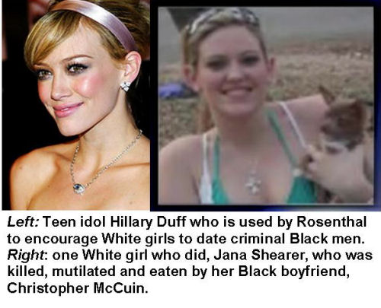
In Tyler Texas a pretty, young White woman, Jana Shearer, 21, met and started dating a Black man by the name of Christopher McCuin. She didn’t worry about the fact that he was a multiple felon or that he was Black, for during her entire life the media taught her that dating Blacks is a very desirable thing, even a fashionable thing to do, and like most young White girls today, she was saturated with the idea that resisting the social and sexual advances of Black males was tantamount to the greatest sin, that of racism. She gave into these converging forces and now she is dead.
With her natural defenses stripped away, the innocent girl was easy prey for the street wise McCuin. Ultimately, Jana paid for her media-induced naivety with her life, even her very flesh. To quote the Associated Press on January 9, 2008:
TYLER, Texas (AP) January 9, 2008 - A man killed his girlfriend, then filleted and cooked parts of her body before calling police to tell them what he was doing, authorities said Sunday.
Christopher Lee McCuin, 25, called 911 on Saturday and told an emergency dispatcher he had killed Jana Shearer, 21, and was boiling her body parts at his mother’s home, said Smith County Sheriff J.B. Smith.
When authorities arrived at the home, they found Shearer’s mutilated body, one ear boiling in a pot of water on the stove and a fork sticking out of some human flesh sitting on a plate on the kitchen table.
Before the long campaign of Hollywood movies and TV production to make race-mixing fashionable, quiet and decent young southern girls in Texas would not have considered having a relationship with a Black man, much less one with a criminal record. That was the time when love for your heritage, and loyalty to it was something carried, as they say, from generation to generation in the mother’s milk. Almost every White person recognized that there are intrinsic differences between the races and that those differences were the natural order of things.
If that moral sense was still prevalent Jana would still be alive, and that is also true for thousands of White women in the United States and around the world who have been murdered or raped by Blacks. Instead, over the past few years we have seen hundreds of thousands of young White women endure beatings, abuse, drug addiction, disease infection and murder at the hands of Black males.
Later in this broadcast I will tell you about a new film by Rick Rosenthal called Greta, a film which depicts Blacks with criminal records as very desirable boyfriends for White girls.
Yes, I can already imagine the response from the egalitarians reading this, the media has conditioned their response. Like a mantra, those of the living brain dead reading this are chanting, “there are good and bad among all races,” and ” many White men have hurt White women too.” Admittedly, both those statements are true. There are good and bad men in all races, and White men have committed crimes against women too. But, those mantras don’t change the damning fact of group differences.
FBI crime figures show that Blacks are at least ten times more violent than Whites and are far more likely to rape, beat, or murder women than Whites are. In every nation on earth where crime records are categorized by race there is a much higher crime rate for Blacks.
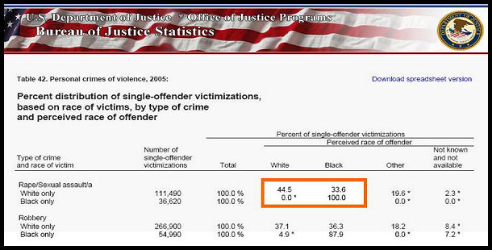
Here’s the Shocking Proof:
37,460 Reported Black Rapes or Sexual Assaults on Whites -
Zero White sexual attacks on Blacks!
Some people wrote to me and cursed me out saying my facts on the huge number of Black sexual attacks on White women could not be true. Here is a screen shot montage of the most up-to-date crime facts direct from the U.S. Department of Justice which monitors all types of crime categorized by race of the offender and race of the victim. http://www.ojp.usdoj.gov/bjs/pub/pdf/cvus0502.pdf
As you can see, Black offenders committed 37,460 rapes or sexual assaults against White women (shown by simply taking the percentage from the total). The same chart shows that Whites committed 0 (zero to less than ten) sexual attacks against Black women. (The number of reported White sexual attacks on Blacks is so low it is statistically 0)
I got some letters condemning me for even publishing these government figures. They accused me of being racist for simply publishing these government reports,”It makes Black males look bad” they tell me. Isn’t it ironic that these people are so worried about how Black males might look, but they aren’t in the least concerned about the 37, 460 White women who have suffered the terror and harm of rape and sexual abuse. (In actual reality the number of Black rapes against White women is at least double the Justice Department figure because those are just the reported rapes). And these figures are just one year’s attacks; similar rates of attack of White women occur year after year.
Next time you hear on TV or read in the media how racist and terrible White folks are to Black people think about the 37,460 White women who are raped by Blacks and the fact that no nationally known political figure (except me) even dares to mention it. If the numbers were reversed and White men were raping Black women by the tens of thousands, our cities would burn! But, we White folks are not supposed to object to this horrendous attack on White women and girls. Heck, we are not even supposed to know about it.
Blacks are also many times more likely to be users of hard drugs than Whites, and thus influence young impressionable women to get involved in life-destructive drugs as well.
Blacks are also many more times likely to have AIDS, gonorrhea, syphilis, and other sexually transmitted diseases than Whites. I am not talking about Blacks having a 50 percent greater chance of being violent or disease ridden. That would be bad enough. Figures like “50 percent higher” are similar to the percentages used when discussing rates of cancer or heart trouble associated with smoking.
Blacks are one thousand percent (10 times) more likely to be criminal predators. A white teenage girl in the company of Blacks has on average at least a 10 times greater chance of being beaten, killed, or being infected with AIDS or other STD’s. In terms of sexual disease the dangers to White men and women are staggering, an 18 times greater rate of HIV, 31 times greater rate of syphilis, and a 44 times greater rate of gonorrhea. That is an amazing 1,800 percent, 3,100 percent and 4,400 percent higher rate respectively! However, don’t expect the Surgeon General to put ads on television warning young Whites about the dangers of interracial dating and sex. Government and media are far more worried about appearing racist than preventing hundreds of thousands of lost or ruined lives!
Will interracial dating increase the rate of sexually transmitted diseases in the community at large?
Interracial dating will certainly increase the rate of AIDS, syphilis, herpes, gonorrhea, and just about every other sexually transmitted disease.The CDC’s HIV Surveillance study has been in progress from the 1980s until the present. When I first found the CDC data in 2000, Black heterosexual males were about 14 times more likely to be HIV-positive than White heterosexual men.It appears that the racial gap has widened since then, to a Black to White HIV infection rate ratio of about 18.6 for heterosexual males and 18.3 for females in 2004. That assumes the US population ratio, White non-Hispanic to Black non-Hispanic, in the 17-44 age group, was 5.639 for both males and females.Incidentally, that same population ratio was 5.791 in 2001, 5.744 in 2002, and 5.691 in 2003.Furthermore, Blacks are 31.1 times more likely to be infected with syphilis and 44.0 times more likely to be infected with gonorrhea, as compared with Whites.
(Source: “Sexually Transmitted Disease Surveillance 1997″; prepared by the U.S. Department of Health and Human Services, Centers for Disease Control and Prevention, Division of STD Prevention; published September 1998.) quote from Yahoo Answers!
At the San Francisco Zoo some men were recently mauled by a tiger. Now I am sure that many tigers pose no threat to humans, some of them are accustomed to human handlers feeding them, caring for them and many of them have no desire to eat human flesh or attack human beings. A person can truthfully say there are good and bad among both tigers and men. There are obviously tigers who would not harm people, and there are plenty of people who do hurt people. Still, I think most people would not leave their child in a room with a tiger for an afternoon.
There are some individual tigers who would pose no danger to a human, but there is obviously greater danger for the child with a average tiger than an average human. If someone tried to put your child into a cage with a tiger because he said that humans have hurt far more humans than have tigers, you would think they were loony and dangerous. It you tried to put your child in a cage with a tiger at the zoo you would probably be charged with attempted murder.
Whether egalitarians want to admit it or not, there are dramatic group differences in violence, drug use, and disease between Blacks and Whites. These are differences that profoundly affect the safety and well-being of Whites in a Black environment.
Of course, it is true that egalitarians blame Black violence, drug use, and sexual disease rates on Whites. They say that the sharp differences are all due to environment. That argument appears weak when you discover that everywhere in the world where there are great numbers of Blacks, even in nations where Whites have little influence, there are similar high rates of violence, crime and disease. And, even if the egalitarians would be right in saying that black violence, drug use and disease are caused by environment rather than DNA, it does not change the reality that Blacks are on average many times more dangerous than Whites.
To take our tiger analogy further, arguing that people shouldn’t take into account high rates of Black violence, drug use and disease is similar to someone saying to you, it’s okay to put your child in the tiger cage because the tiger’s violent behavior is caused by the cage! Whatever the cause, the fact remains that your child would be many times safer with humans than with tigers. And the same fact is true when it comes to Blacks, especially with young Black males.
No argument of heredity or environment can change the fact that putting Whites in Black neighborhoods or Black schools or bars or in Black relationships is a dangerous proposition. Millions of Whites have paid dearly because of that fact. White children face hate, intimidation, and violence in mostly Black schools where sexual, drug, and behavioral norms are far different from those in White groups. Many White elderly who once lived safely in their neighborhoods now live in fear because integration transformed their neighborhoods into slums of crime and drugs.
The controlled media tells us constantly of the evil of racial “discrimination,” yet they ignore the far worse human suffering that accompanies forced integration. In the name of anti-discrimination we have caused thousands of innocents to be murdered, millions to be beaten, raped, or robbed. Millions of White kids have been doomed to go to school where they face physical attacks and a terrible educational environment. Who dares to speak up for those who have lost the most basic of human rights, the right to life, to health, to property, to heritage?
Rick Rosenthal of Whitewater Films has a soon-to-be-released new movie called, Greta. The film stars Hillary Duff. She portrays an attractive and wholesome-looking White girl who over the objection of her grandparents has an interracial romance with a young Black man, Evan Ross. The Black fellow is portrayed as having a criminal record but, no matter, he has a “good heart.”
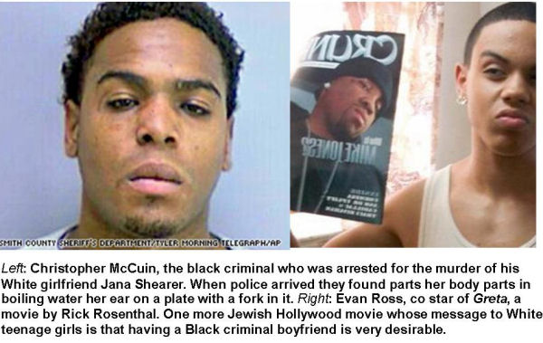
Hillary Duff is an idol for millions of young White girls who follow her movies and music devotedly. Many pubescent girls want to talk like her, dress like her and be like her.
Here is a quote from one of the Hollywood blogs about the movie:
Pop singer Hilary Duff plays the title character in the interracial teen romance Greta, which is shooting on location in New Jersey.
Duff’s character is a waitress who falls for an ambitious cook (Evan Ross) at the restaurant where they work. But as their summer romance heats up, she has to overcome the concerns of her grandparents (Ellen Burstyn, Michael Murphy) about her boyfriend’s criminal past…
Rosenthal, who is described by friends as “extremely dedicated to the Jewish community,” told reporters that he is “very pleased with this morality play for contemporary America.”
Rosenthal must be very pleased indeed with his good example for young White girls, get yourself a Black boyfriend, just like the idol you so admire, and don’t worry if he is a criminal, it’s the cool thing to do. After all, if Hillary Duff beds down with a Black boy it must really be the height of fashion.
Of course, in the real world, dating a Black is often a very dangerous thing that leads to tragic consequences. In the United States, almost half of all young Black males are either in jail, on probation, or on parole for criminal acts, and that’s not counting many of the sealed juvenile records or the ones who haven’t been caught yet. The undeniable fact is that the vast majority of them are criminal. It is not racism, prejudice or hatred to point out this fact, anymore than saying that tigers can be dangerous to people. This knowledge is obviously important for White people who want to survive and have their children survive and have well-being.
Miss Jana Shearer of Tyler, Texas was a victim of the predecessors of Rick Rosenthal. Even before Rosenthal made a film encouraging White girls to date Black criminals she was taught that it is right and good to date Black boys. She thought she was doing something cool, even noble when she dated Christopher McCuin. She was taught that his race didn’t matter, even his recent criminal record didn’t matter, he talked nice to her and seemed to have a “good heart.” She was taught that it would be evil of her not to be his girlfriend because he was Black and had a criminal record.
So, she dated him, slept with him. And now, she is dead, and likely some of her own flesh is now in his. And one more young girl is lost to the nation, her family and her people.
In our society today it is considered insensitive and very racist to even acknowledge these facts. The media tells us that it is evil to hurt the feelings of Blacks by simply stating these alarming facts of racial group differences. But which is really worse, uncomfortable feelings because of discussing Black rates of criminality, or thousands of White women who face the horrific pain of addiction, or physical beating, abuse or murder, or who suffer the long and horrendous death sentence of AIDS because they are brainwashed to see interracial dating as desirable.
The media says it is racist to point out the facts of high Black criminality. It is not racist, but absolutely normal for parents to want to prevent abuse, murder, drug addiction, or disease of their children. It is no wonder White parents have opposed forced integration and forced racial busing of schools. They know that mostly Black schools pose a far more dangerous and degenerate environment for their children. Really would any concerned parent want their child to be in schools that have a much higher rate of violence, drugs and sexual diseases, where the violence, disrespect of women and sexual degeneracy of gangsta rap are the dominant culture. Should White parents be condemned for wanting to keep their children safe?
I have discussed in many articles the incredible level of Jewish supremacy over much of the mass media. Hollywood is practically a Jewish colony in the incredibly high percentage of Jewish producers, directors and writers. Jewish writers such as Ben Stein and Neil Gabler have boasted about Jews being only 2 percent of the American population yet making up over 80 percent of movie and TV producers. These are the men who own and who have the ultimate control over movies and television, and they are complimented by similar numbers in writing and directing. Neil Gabler’s book, An Empire of Their Own, says it all in its title. It is truly an “empire of their own,” and not our own.
The International Movie Data Base lists 1,445 Movies that feature “interracial romance.” These movies promoting White race-mixing are produced, directed and written by Jews in an even higher percentage than their overall domination of Hollywood.
In influencing young audiences, Viacom’s Sumner Redstone (real name Murray Rothstein) has non-stop music videos on MTV and other programs promoting interracial dating and sex. Even Rothstein’s cable network for children, Nickelodeon, is saturated with pro-interracial propaganda that promotes interracial dating from an early age and that demonizes any White person who objects to it.
Rothstein is typical of the extremist Jews who dominate Hollywood and the mass media. Yet, he is but one of the many Jews who are even more over-represented in promoting interracial films than they are in films and TV as a whole. And by the way, I should mention that Redstone (Rothstein) is one of the biggest promoters of the Israeli “Jewish State.” That’s not a multi-cultural or multi-racial state but a “Jewish State.”
The first major film promoting interracial romance was Island in the Sun (1955), produced by the Jewish communist Rossen (born Rosen of Jewish immigrant parents from Russia). In the sixties they heated up their campaign considerably with Guess Who’s Coming to Dinner, produced by George Glass and Stanley Kramer, and written by William Rose. In Guess Who’s Coming to Dinner, a beautiful blonde White girl falls for a Black man who happens to be a Nobel Prize-winning doctor.
Here’s how the NY Times in 1991 describes the plethora of interracial films in an article titled “A Kiss is Just a Kiss”:
Jonathan Kaplan, the director of “Love Field,” says that in test screenings of his film, viewers have directly responded to what he says is a “not highly charged or steamy” scene in which Michelle Pfeiffer and Dennis Haysbert embrace.
But Hollywood could not ignore the enormous social changes of the 1960’s. Sidney Poitier became the breakthrough black leading man. Although the subject of the 1967 film “Guess Who’s Coming to Dinner” was interracial marriage, there was only one chaste kiss and an offscreen wedding. And Mr. Poitier’s character was a paragon (or parody) of perfection: handsome, brilliant and a Nobel Prize winner.
By the early 1970’s black paragons had given way to blaxploitation. The redoubtable Jim Brown typified black power - and for a brief spell, interracial sex (though not marriage) flourished in movies. Interracial couples were featured in such diverse films as “The Great White Hope,” “Mahogany,” “Blazing Saddles” and - with something to offend everyone - “Mandingo”…. NY Times 1991
Every film mentioned by the NY Times was written by Jews. Most of the Jews prominent in the making of these films were well known for their support of the Jewish supremacist State of Israel. Stanley Kramer, the same fellow who urges Whites to marry Blacks in Guess Who’s Coming to Dinner, purposefully made the first feature length movie filmed in Israel, to do his best to support Israel, a nation dedicated to the preservation of the Jewish people. Not only was his hypocrisy not exposed by the media, but few have even had the courage to expose the lies that the Jewish makers of race-mixing movies employed to brainwash White people and women in particular. One film historian writing for Scope put it pretty succinctly when he writes about The Great White Hope:
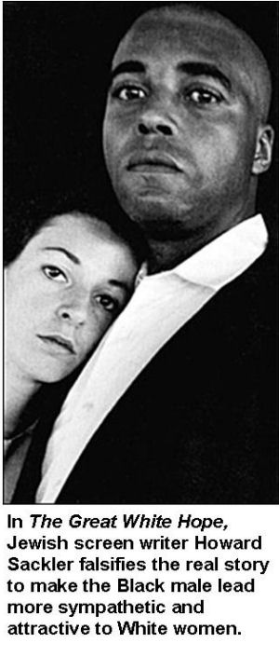
When one looks closely at The Great White Hope in light of these statements, it becomes clear that Ritt and scriptwriter Howard Sackler selected, condensed, and fictionalized events from Johnson’s life to create a liberal, humanist fable about one man’s fight against an unfair system, and thereby to highlight racism in white America….
Portraying him as a monogamist and victim of racial prejudice, Sackler ignored other parts of Johnson’s life, particularly his philandering… Sackler thus created a one-sided, romanticized account that stressed Johnson’s heroic aspects instead of following what actually happened in the case of Johnson.
Scope online journal of film-Archive: Articles, November 2003-Muhammad Ali, Jack Johnson, and the “Problem” of Interracial Relationships: A Review of Martin Ritt’s The Great White Hope (1970) Nicholas Naylor, Brunel University, UK
So here we have a case where White women are being conditioned by a film image of Black men as faithfully monogamous, sensitive, yet strong and manly - while in reality the actual character the movie is based upon was himself a philanderer and reprobate. It is similar to the race-mixing movies where OJ Simpson was portrayed for White women as the ultimate in desirable mates. Commercials depicted OJ as very desirable with White women chasing after him. In a popular made-for-TV movie called Cocaine and Blue Eyes, Simpson plays a kind detective who saves a beautiful, blue-eyed White girl from vile criminals, while in the real world OJ Simpson is a bloodthirsty criminal who brutally murdered his White wife.
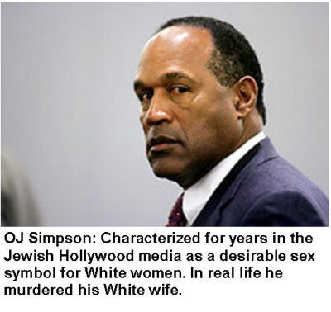
In a “Blaxploitation” film starring Jim Brown, 100 Rifles, Jewish producer Marvin Schwartz depicted Jim Brown as the strong and desirable mate for leading White sex symbol Raquel Welch, while in reality Brown was cited numerous times for beating White women and once for throwing a German model off of a second story balcony (NY Times March 28, 2002, Jim Brown, prisoner on his own terms). Black violence against women is so pervasive it is common for the Black stars in pro-interracial movies to have records of violent abuse toward women while at the same time portraying kind and sensitive Black lovers in the fictional, Jewish-created propaganda films.
As with the most effective propaganda, Jewish race-mixing films started off slowly over the years with the unlikely scenarios of gentlemanly, incredibly brilliant and successful Blacks. Much like the once-portrayed OJ Simpson film and TV image. Now it has reached its natural nadir in Greta where young White girls are taught that they shouldn’t even be wary of Black criminals.
Since the release of Guess Who’s Coming to Dinner there have been a plethora of Jewish movies touting the joys of interracial relationships and showing the evil character of any boy or girl who would refuse the sexual attentions of a potential Black bed partner.
Such films are being produced by the score, illustrated by movies such as the 2007 hit, Hairspray, a vicious anti-White film where Whites are portrayed committing sadistic violence against innocent Blacks, and in which the leading White girl character runs off to the superior Black culture and music in her school. The movie also depicts a very beautiful blonde girl who overcomes prejudice to do the right thing and have an affair with a Black boy. Hairspray was directed by Adam Shankman, whose biography touts his “traditional Jewish upbringing.”
As exampled by Rick Rosenthal, the Jewish-dominated Hollywood movie and entertainment industry has long been at the forefront of promoting White relationships with non-Whites, especially aimed at those they see as the most susceptible to the race-mixing propaganda, impressionable young girls. Many of these Jewish film and TV producers, directors and writers do this while at the same time supporting Jewish organizations that have programs against intermarriage of Jews with Gentiles. Every major Jewish organization has some kind of program to discourage Jews from intermarrying with non-Jews.
Most of these same Hollywood Jews enthusiastically support the state of Israel, a nation which even has laws where a marriage of a Jew and non-Jew is not legally recognized. And for those who are still ignorant on the subject, Israel’s law is not even a purely religious-based marriage restriction, but a genetic one. Religious Jews can freely marry atheist Jews in Israel, but no Jew can legally marry a non-Jew in Israel. A Jew in Israel is not defined ultimately by religion but by descent! This fact may come as quite a shock to those who don’t know it. I hope that those of you reading this can guess why you haven’t heard about it. The same Jewish-dominated media has purposefully kept it from your awareness, and for good reasons!
You might ask yourself some interesting questions. In the hundreds of movies chronicling Jewish historical and contemporary conflicts with other nationalities, why have you never seen Jews portrayed as the bad guys and the Gentiles as the good ones. Have you ever seen a film where the only really good Jews are the ones who side with the Gentiles against their fellow Jews? Yet, isn’t this theme found in many films showing conflicts between Whites and non-Whites? Even though famous Jewish histories say boldly that Jews dominated the world wide slave trade for 2000 years and specifically the slave trade of Africans to the Americas, why does the media only talk about collective White guilt for slavery, and never about any Jewish collective guilt.
It goes without saying that Hollywood from even before the days of the Academy Award winning movie Exodus has been very supportive of the Jewish community and of the Jewish supremacist state of Israel. Exodus romanticizes the theft of Palestinian land (Palestinians owned 90 percent of of the land area that became “Israel”), and the brutal suppression and terror committed against the Palestinian people in creating the Jewish supremacist state of Israel. Have you seen any movies showing how every major Jewish organization is bigoted and racist because practically every one of them has programs trying to prevent Jewish intermarriage with non-Jews. Yet, you probably couldn’t count the multitude of movies that portray White society as “racist?”
Have you seen any Hollywood films showing how Israel is a segregated state, with segregated apartment buildings, segregated schools, separate communities for Jews and non-Jews. The same Jewish-run media portrayed the racially separate apartheid state of South Africa as the paragon of evil. Why does segregated Israel get off the hook? Could the identity of those who run the media give you a clue?
Have you seen any love stories that reveal the vicious hatred that any Jew suffers in Israel who marries a Palestinian, and how marriage between Jews and non-Jews is illegal? Everyone has seen the Jewish-created film stereotype of the bigoted, unattractive and downright evil White person who opposes the marriage of his son or daughter to a Black. But, how often have you seen the media portray Jews who want to preserve their heritage as evil bigots?
Movies such as Greta and Hairspray show how these Jewish supremacists with their domination of media have made it fashionable for White girls to have Black boyfriends in much the same way as they used psychology to attract girls to certain brands of clothes. An example of how far this sickness has gone is the Nushawn Williams case in upstate New York.
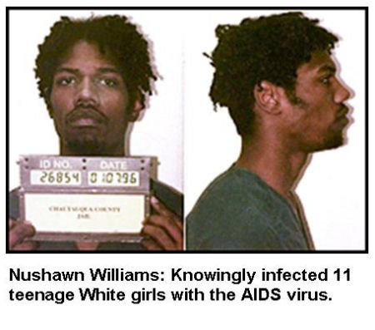
Williams was a Black drug dealer and HIV carrier (court records prove that he was fully aware of his AIDS infection). He was able to have sex with at least 100 young White girls, some as young as 13 years old, in a sleepy White community in Upstate New York. He got most of them involved in drug addiction and he knowingly infected at least 11 young girls (almost all of them White) with the AIDS virus. Don’t hold your breath for any movies showing the depravity of this Black criminal.

Officials Link Man to 11 Teen-Agers With H.I.V.
Published: October 28, 1997 New York Times
A 20-year-old man with H.I.V. (Nushawn Williams) has apparently infected at least 11 teen-age girls in western New York with the virus that causes AIDS, officials said yesterday, adding that the man - or his sex partners - may have infected up to 50 other people.
Six of the girls, including a 13-year-old, were infected after the man had been tested and told that he had H.I.V., officials said.
For officials in Chautauqua County - a lakeside sanctuary 70 miles south of Buffalo where crowds gather for podium-pounding oratory in the summertime - the disclosures signaled the worst health crisis they have ever faced, shocking residents and officials alike. “I’d characterize it as despicable,” Sheriff Joseph Gerace said. “It’s horrifying.”
Years before when interracial marriage and sex was considered a taboo in our society, and before Hollywood made Blacks out to be sex symbols in media, none of those young White women would have even considered associating with a strange Black man on the street. And those 11 girls (and countless others) would not be facing a long and agonizing death from AIDS.
Race-mixing movies and TV shows led directly to the ruined lives of these dozens of White teenage girls in rural New York, and you can be sure that what happened in the Nushawn Williams case will happen again, in fact it is certain that further tragedies much like this one are occurring even as you read these lines. White women are relentlessly being taught that black men are the most desirable mates. Blacks are thrust into romantic leads in movies, rich Black sports stars and entertainers are constantly shown with the most desirable of White women. In addition to the positive image of Black males shown on media, if a young White girl refuses a Black man’s attentions she is deemed racist and thus among the lowest of creatures. Her natural defenses against such predators are stripped from her by Jewish supremacists such as Rick Rosenthal.
Another disgusting aspect of this plague is pornography. Many forms of the sickest porn have now become mainstream in the United States and many college surveys show that it is now so pervasive that almost 9 out of 10 males and 2 out of 3 of girls have viewed triple-x rated hard core movies or film clips. Modern porn is permeated with interracial themes and the Black male and blonde woman is pervasive in the genre. In my book, Jewish Supremacism, I quote an article in the Jewish Quarterly by Jewish professor Nathan Abrams titled, “Triple Exthnics.” Abrams boasts how Gentile-hating Jews literally created the triple X porn industry and how Jews have made porn mainstream. Abrams goes on to quote leading Jewish pornographers who admit that their motivation beyond the money involved is “an atavistic hatred” of White Christians and our values. Certainly, this vile influence has also had a role in the defilement of not only the White women seduced into this filth, but also on the White men and women who are corrupted and poisoned by watching it.
I began this broadcast with the story of Jana Shearer, 21, a White girl who experienced the full and dubious joy of having a Black boyfriend. She began to date a Black criminal, Christopher McCuin, who later murdered her and actually cooked and apparently ate her flesh. This Horrendous scene sounds like the Mau Mau atrocities of Kenya, but can now be found in small communities like Tyler, Texas.
If Jewish supremacists such as Rick Rosenthal have their way, there will be many more victims like Jana Shearer, naive young girls taught that Black criminals make very desirable boyfriends. In addition to the horrendous damage done to the great numbers of White women by the promotion of this kind of behavior, interracial sex and marriage also destroys the heritage and unique character of our people, a heritage passed down unbroken for thousands of years, a precious identity that we have the right to preserve. It is no accident that the biggest promoters of race-mixing for Gentiles are Jewish supremacists who have consistently promoted the purity of their own heritage for thousands of years.
Nothing can show the unspeakable evil of the Jewish extremists more clearly than their targeting of the precious young women of our race for defilement and harm. Make no mistake about it, producers such as a Stanley Kramer and Rick Rosenthal are thoroughly evil enemies of our people responsible for terrible harm inflicted on thousands of innocent young White women. And, as these children of our race are destroyed, so is the precious genetic heritage passed down to them from thousands of generations of the European people.
Our fight is not over some sort of intellectual theory of government or economics.
Our struggle today is for the very survival of our people.
It is about stopping the horrible defilement and harm of millions of our sisters and brothers.
Those of you who are still on the sidelines -
How long will you do nothing as the wonderful women of our race are poisoned and defiled?
When will you devote far more of your time and money to survival of your own loved ones, your own people?
Our fight is about the defense of the innocent, protection of our children.
It is about enoblement of our people and complete rejection of the debasement offered by the masters of the media and the dominators of government.
It is about freedom and heritage, beauty and love.
It is a fight in which the best of us rededicate ourselves every day of our lives..
Won’t you join me in this worldwide fight for the truth?
Won’t you stand up for your people?
Only by our actions today can we provide a bright future for our children?
-david duke
http://www.davidduke.com/general/jane-shearer-the-defilement-and-death-of-a-white-girl_3382.html#more-3382

