The Holocaust
http://en.wikipedia.org/wiki/The_Holocaust
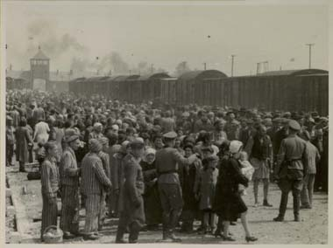
Selection procedure of Hungarian Jews at the Auschwitz camp on 26 May 1944, where the Nazis chose whom to kill immediately and whom to use as slave labor or for medical experimentation. The entrance to the main camp is in the background. Between 1.1 and 1.6 million people were murdered at Auschwitz alone; over 90% of the victims were Jews. Picture taken by SS Oberscharführer Bernhard Walter or SS Unterscharführer Ernst Hoffmann.
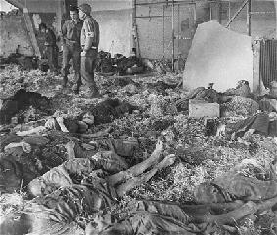
The Nazi concentration camp in Nordhausen.

The Holocaust, also known as Ha-Shoah (Hebrew: השואה), Khurbn (Yiddish: חורבן or Halokaust, האלאקאוסט) or Porajmos (Romani, also Samudaripen), is the name applied to the genocide of minority groups of Europe and North Africa during World War II by Nazi Germany and its collaborators.^{[1]}
Early elements of the Holocaust include the Kristallnacht pogrom of 8 and 9 November 1938 and the T-4 Euthanasia Program, leading to the later use of killing squads and extermination camps in a massive and centrally organized effort to exterminate every possible member of the populations targeted by Adolf Hitler and the Nazis.
The Jews of Europe were the most numerous of the victims of the Holocaust in what the Nazis called the "Final Solution of the Jewish Question" (die Endlösung der Judenfrage) or "the cleaning" (die Reinigung). It is commonly stated that approximately six million Jews were murdered in the Holocaust, though estimates by historians using, among other sources, records from the Nazi regime itself, range from five million to seven million.
Millions of other minority members also perished in the Holocaust. About 220,000 Sinti and Roma were murdered (some estimates are as high as 800,000) — between a quarter to a half of their European population. Other groups deemed by the Nazis to be "racially inferior" or "undesirable" included Poles (6 million killed, of whom 3 million were Christian, and the rest Jewish), Serbs (estimates vary between 500,000 and 1.2 million killed, mostly by Croat Ustaše), Soviet military prisoners of war and civilians in occupied territories including Russians and other East Slavs, the mentally or physically disabled, homosexuals, Africans, Jehovah's Witnesses, Communists and political dissidents, trade unionists, Freemasons, Eastern Christians, and Catholic and Protestant clergy, were also persecuted and killed.
Some scholars do not include the Nazi persecution of all of these groups in the definition of the Holocaust, rather limiting the Holocaust to the genocide of the Jews. However, taking into account all minority groups, the total death toll rises considerably, estimates generally place the total number of Holocaust victims at 9 to 11 million, though some estimates have been as high as 26 million.^{[2]}

Another group, whose deaths are related to the Holocaust but not always counted in the totals, comprise the thousands who committed suicide rather than face what they feared would be untold suffering ending in death. In 2006, the European Union financed a project to research these victims; despite religious prohibitions against suicide, it is estimated that in Berlin alone, 1,600 Jews killed themselves between 1938 and 1945.

Etymology and usage of the term
Main article: Names of the Holocaust
The term holocaust originally derived from the Greek word holokauston, meaning a "completely (holos) burnt (kaustos)" sacrificial offering to a god. Since the late 19th century, "holocaust" has primarily been used to refer to disasters or catastrophes. According to the Oxford English Dictionary, the word was first used to describe Hitler's treatment of the Jews from as early as 1942, though it did not become a standard reference until the 1950s. By the late 1970s, however, the conventional meaning of the word became the Nazi genocide. The term is also used by many in a narrower sense, to refer specifically to the unprecedented destruction of European Jews in particular. Some historians credited Elie Wiesel with giving the term 'Holocaust' its present meaning. The biblical word Shoa (שואה), also spelled Shoah and Sho'ah, meaning "calamity" in Hebrew, became the standard Hebrew term for the Holocaust as early as the early 1940s.^{[3]} Shoa is preferred by many Jews and a growing number of others for a number of reasons, including the potentially theologically offensive nature of the original meaning of the word holocaust.
The word "genocide" was coined during the Holocaust. ^{[citation needed]}

Features of the Nazi Holocaust
The Nazi Holocaust had several characteristics that, taken together, distinguish it from other genocides in history.

Efficiency
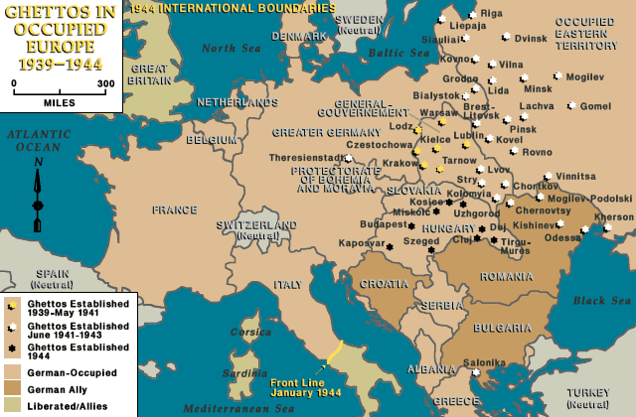
Ghettos established in Europe in which Jews were confined, in ghettos and later in temporary concentration locations and later shipped to extermination camps.
The Holocaust was characterized by the efficient and systematic attempt on an industrial scale to assemble and kill as many people as possible, using all of the resources and technology available to the Nazi state. Germany was, at the time, one of the world's leading nations in terms of technology, industry, infrastructure, research, education, bureaucratic efficiency, and many other fields.
For example, detailed lists of potential victims were made and maintained using Dehomag statistical machinery, and meticulous records of the killings were produced. As prisoners entered the death camps, they were made to surrender all personal property to the Nazis, which was then precisely catalogued and tagged, and for which receipts were issued (the issuing of receipts also helped to lull the victims into a false sense of security, as it made them believe that they would later be reunited with their property and luggage).
In addition, considerable effort was expended over the course of the Holocaust to find increasingly efficient means of killing more people. Early mass murders by German soldiers of thousands of Jews in Poland, Ukraine, and Belarus, by shooting, had caused widespread reports of discomfort and demoralization among the German troops. Commanders had complained to their superiors that the face-to-face killings had a severely negative psychological impact on soldiers^{[citation needed]}. Committed to destroying the Jewish population, the German Nazi government decided to pursue more mechanical methods, beginning with experiments in explosives and poisons.
In his book, Russia's War, British historian Richard Overy describes how the Nazis sought more efficient ways to kill people. In 1941, after occupying Belarus, they used mental patients from Minsk asylums as guinea pigs. Initially, they tried shooting them by having them stand one behind the other, so that several people could be killed with one bullet, but it was too slow. Then they tried dynamite, but few were killed and many were left wounded with hands and legs missing, so that the Germans had to finish them off with machine guns. In October 1941, in Mogilev, they tried a Gaswagen or "gas car". First, they used a light military car, and it took more than 30 minutes for people to die; then, they used a larger truck exhaust and it took only eight minutes to kill all the people inside.^{[4]}
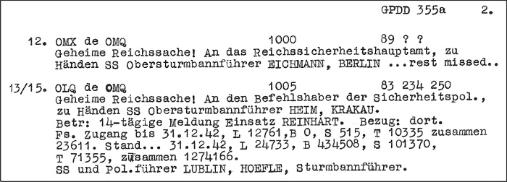
The Nazis methodically tracked the progress of the Holocaust in thousands of reports and documents. Pictured is the Höfle Telegram sent to Adolf Eichmann in January, 1943, that reported that 1,274,166 Jews had been killed in the four Aktion Reinhard camps during 1942.
In the spring of 1942, the Aktion Reinhard camps began operating. Carbon monoxide was used in the gas chambers at Belzec, Sobibór, and Treblinka, whereas Zyklon B was employed at Majdanek and Auschwitz.
The disposal of large numbers of bodies presented a logistical problem as well. Incineration was at first considered infeasible until it was discovered that furnaces could be kept at a high enough temperature to be sustained by the body fat of the bodies alone. With this technicality resolved, the Nazis implemented their plan of mass murder on its full scale.
Alleged corporate involvement in the Holocaust has created significant controversy in recent years. Rudolf Höß, Auschwitz camp commandant, said that far from having to advertise their slave labour services, the concentration camps were actually approached by various large German businesses, some of which are still in existence. Technology developed by IBM also played a role in the categorization of prisoners, through the use of punched card machines.^{[5]}

Scale
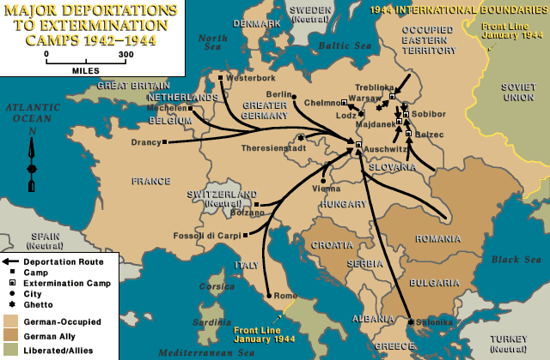
Major deportation routes to the extermination camps in Europe. It should be possible to replace this fair use image with a freely licensed one. If you can, please do so as soon as is practical.
The Holocaust was geographically widespread and systematically conducted in virtually all areas of Nazi-occupied territory, where Jews and other victims were targeted in what are now 35 separate European countries, and sent to labor camps in some countries or extermination camps in others. The mass killing was at its worst in Central and Eastern Europe, which had more than 7 million Jews in 1939; about 5 million Jews were killed there, including 3 million in occupied Poland and over 1 million in the Soviet Union. Hundreds of thousands also died in the Netherlands, France, Belgium, Yugoslavia, and Greece.
Documented evidence suggests that the Nazis planned to carry out their 'final solution' in other regions if they were conquered, such as the United Kingdom and the Republic of Ireland.^{[6]} The extermination continued in different parts of Nazi-controlled territory until the end of World War II, only completely ending when the Allies entered Germany itself and forced the Nazis to surrender in May 1945.

Cruelty
The Holocaust was carried out without any reprieve even for children or babies, and victims were often tortured before being killed. Nazis carried out deadly medical experiments on prisoners, including children. Dr. Josef Mengele, medical officer at Auschwitz and chief medical officer at Birkenau, was known as the "Angel of Death" for his medical and eugenical experiments, e.g., trying to change people's eye color by injecting dye into their eyes. Aribert Heim, another doctor who worked at Mauthausen, was known as "Doctor Death".
The guards in the concentration camps carried out beatings and acts of torture on a daily basis. For example, some inmates were suspended from poles by ropes tied to their hands behind their backs so that their shoulder joints were pulled out of their sockets. Women were forced into brothels for the SS guards. Russian prisoners of war were used for experiments, such as being immersed in ice water or being put into pressure chambers in which air was evacuated to see how long they would survive as a means to better protect German airmen.
Homosexual men suffered unusually cruel treatment in the concentration camps. They faced persecution not only from German soldiers but also from other prisoners, and many homosexual men were beaten to death. Additionally, homosexuals in forced labor camps routinely received more grueling and dangerous work assignments than other non-Jewish inmates, under the policy of "Extermination Through Work". German soldiers also were known to use homosexuals for target practice, aiming their weapons at the pink triangles their human targets were forced to wear.

Children and adult prisoners
Children under the age of about 12 were generally deemed unfit for work and were therefore immediately taken to the gas chambers.
Upon having their prisoner ID tattooed on them, older children were sent to work in either a factory, quarry, or some other strenuous and monotonous place of work. Their shifts lasted from 10 to 14 hours. After the day's work was finished, the children were subjected to incredibly long roll calls, during which some even died. This routine continued for what could be months until the prisoners were either sent to the gas chambers or died from malnourishment or exhaustion.
Between the time of registration into the camp and death, prisoners were subjected to a number of demeaning and torturous ordeals. Prisoners were often beaten, whipped, or hung from beams with their hands behind them. This ordeal was done with their feet just inches from the ground. Prisoners were also regularly shot so that the SS could maintain a feeling of control.
These dreadful ordeals combined to create a genuinely miserable experience within the camps. As a result, many inmates embraced or welcomed death. ^{[citation needed]}

Experiments
Main article: Nazi human experimentation
At the Auschwitz concentration camp, Dr. Josef Mengele was infamous for carrying out medical experiments on human subjects. These included placing subjects in pressure chambers, testing various drugs on them, freezing them to death, and various other usually fatal traumas. Of particular interest to Mengele were twins, gypsies, dwarves and infants.^{[citation needed]} Beginning in 1943, twins were selected and placed in special barracks.^{[citation needed]}
Almost all of Mengele's experiments were of little scientific value, including attempts to change eye color by injecting chemicals into children's eyes, various amputations and other brutal surgeries, and in at least one case attempting to create artificial conjoined twins by sewing the veins of twins together. This operation was not successful and only caused the children's hands to become badly infected.
The full extent of Mengele's work will never be known because the two truckloads of records he sent to Dr. Otmar von Verschuer at the Kaiser Wilhelm Institute were destroyed by the latter. Subjects who survived Mengele's experiments were almost always killed after the experiments for dissection.
While Mengele's experiments were the most notorious, his behavior was not an isolated aberration. Other Nazi physicians also engaged in human experimentation at several concentration camps, including Dachau, Buchenwald, Ravensbrück, Sachsenhausen, and Natzweiler concentration camps. ^{[citation needed]}

Victims
Main article: Holocaust victims
The victims of the Holocaust were Jews, Poles, Serbs, Russians, Belarusians, Communists, homosexuals, Roma & Sinti (also known as Gypsies), the mentally ill and physically disabled, intelligentsia and political activists, Jehovah's Witnesses, Roman Catholics and Protestant clergy, trade unionists, psychiatric patients, Africans, Asians, enemy nationals, common criminals, people labeled as "enemies of the state"; especially a large portion of the country's rich and liberal dissidents, and many who did not belong to the Aryan race. These victims all perished alongside one another in the camps, according to the extensive documentation left behind by the Nazis themselves (written and photographed), eyewitness testimony (by survivors, perpetrators, and bystanders), and the statistical records of the various countries under occupation.^{[citation needed]}

Death toll
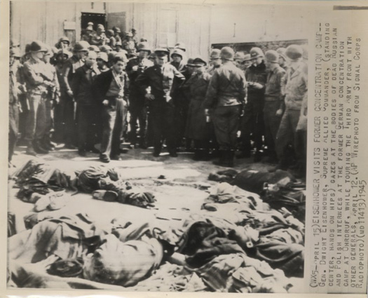
General (later US President) Dwight Eisenhower inspecting prisoners' corpses at a liberated concentration camp, 1945
The exact number of people killed by the Nazi regime may never be known, but scholars, using a variety of methods of determining the death toll, have generally agreed upon common range of the number of victims. Recently declassified British and Soviet documents have indicated the total may be somewhat higher than previously believed.^{[7]} However, the following estimates are considered to be highly reliable. The estimates:
- About 6.0 million Jews, including 3.0–3.5 million Polish Jews^{[8]}
- 1.8 –1.9 million non-Jewish Poles (includes all those killed in executions or those that died in prisons, labor, and concentration camps, as well as civilians killed in the 1939 invasion and the 1944 Warsaw Uprising)^{[9]}
- 200,000–800,000 Roma & Sinti (Gypsies)
- 200,000–300,000 people with disabilities
- 80,000–200,000 Freemasons^{[10]}
- 100,000 communists
- 10,000–25,000 homosexual men
- 2,500-5,000 Jehovah's Witnesses^{[11]}
Raul Hilberg, in the third edition of his ground-breaking three-volume work, The Destruction of the European Jews, estimates that 5.1 million Jews died during the Holocaust. This figure includes "over 800,000" who died from "Ghettoization and general privation;" 1,400,000 who were killed in "Open-air shootings;" and "up to 2,900,000" who perished in camps. Hilberg estimates the death toll in Poland at "up to 3,000,000."^{[12]} Hilberg's numbers are generally considered to be a conservative estimate, as they generally include only those deaths for which some records are available, avoiding statistical adjustment.^{[13]} British historian Martin Gilbert used a similar approach in his Atlas of the Holocaust, but arrived at a number of 5.75 million Jewish victims, since he estimated higher numbers of Jews killed in Russia and other locations.^{[14]}
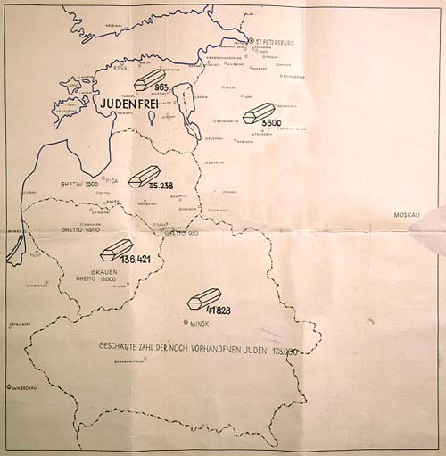
Map titled "Jewish Executions Carried Out by Einsatzgruppe A" from the December 1941 Jäger Report by the commander of a Nazi death squad. Marked "Secret Reich Matter," the map shows the number of Jews shot in the Baltic region, and reads at the bottom: "the estimated number of Jews still on hand is 128,000". Estonia is marked as judenfrei ("free of Jews").
Lucy S. Dawidowicz used pre-war census figures to estimate that 5.934 million Jews died. Using official census counts may cause an underestimate since many births and deaths were not recorded in small towns and villages. Another reason some consider her estimate too low is that many records were destroyed during the war. Her listing of deaths by country of origin is available in the article about her book, The War Against the Jews.^{[15]}
One of the most authoritative German scholars of the Holocaust, Prof. Wolfgang Benz of the Technical University of Berlin, cites between 5.3 and 6.2 million Jews killed in Dimension des Volksmords (1991), while Yisrael Gutman and Robert Rozett estimate between 5.59 and 5.86 million Jewish victims in the Encyclopaedia of the Holocaust (1990).^{[16]}
The following groups of people were also killed by the Nazi regime, but there is little evidence that the Nazis planned to systematically target them for genocide as was the case for the groups above.
- 3.5–6 million other Slavic civilians
- 2.5–4 million Soviet POWs
- 1–1.5 million political dissidents
Additionally, the Ustaša regime, the Nazis' allies in Croatia, conducted its own campaign of mass extermination against the Serbs in the areas which it controlled, resulting in the deaths of 500,000–1.2 million Serbs.
The summary of various sources' estimates on the number of Nazi regime victims is given in Matthew White's online atlas of 20th century history.

Searching for records of victims
Initially after World War II, there were millions of members of families broken up by the war or the Holocaust searching for some record of the fate and/or whereabouts of their missing friends and relatives. These efforts became much less intense as the years went by. More recently, however, there has a been a resurgence of interest by descendants of Holocaust survivors in researching the fates of their lost relatives. Yad Vashem provides a searchable database of three million names, about half of the known direct Jewish victims. Yad Vashem's Central Database of Shoah Victims Names is searchable over the Internet at yadvashem.org or in person at the Yad Vashem complex in Israel.
Other databases and lists of victims' names, some searchable over the Web, are listed in Holocaust (resources).

Execution of the Holocaust

Concentration and Labor Camps (1933-1945)
Main articles: Nazi concentration camps and Nazi concentration camp badges
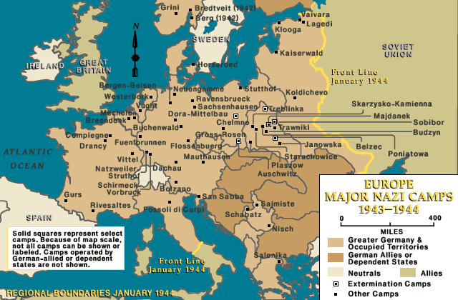
Major concentration camps in Europe, 1944. It should be possible to replace this fair use image with a freely licensed one. If you can, please do so as soon as is practical.
The Nazis were the only political party with paramilitary organisations at their disposal, the SS and the SA, which had perpetrated surprise attacks on the offices and members of other parties throughout the 20s. After the 1932 elections it became clear to the Nazi leaders that they would never be able to secure a majority of the votes and that they would have to rely on other means to gain power. While gradually intensifying the acts of violence to wreak havoc among the opposition leading up to the 1933 elections, the Nazis set up concentration centers within Germany, many of which were established by local authorities, to hold, torture, or kill political prisoners and "undesirables" like outspoken journalists and communists.
These early prisons - usually basements and storehouses - were eventually consolidated into full-blown, centrally run camps outside of the cities and somewhat removed from the public eye. By 1939, six large concentration camps, located in Nazi-occupied Poland, had been established. After 1939, with the beginning of the Second World War, the concentration camps increasingly became places where the non-political enemies of the Nazis, including Jews and POWs, were either killed or forced to act as slave laborers, and kept undernourished and tortured.
During the War, concentration camps for Jews and other "undesirables" were spread throughout Europe, with new camps being created near centers of dense "undesirable" populations, often focusing on areas with large Jewish, Polish intelligentsia, communist, or Roma & Sinti (Gypsy) populations. Most of the camps were located in the area of General Government in occupied Poland, but there were camps in every country occupied by the Nazis. The transportation of prisoners was often carried out under horrifying conditions using rail freight cars, in which many died before they reached their destination. Concentration camps also existed in Germany itself, and while not specifically designed for systematic extermination, many concentration camp prisoners died because of harsh conditions or were executed.

Persecution (1938-1941)
In Mein Kampf, Adolf Hitler writes that Freemasonry has "succumbed" to the Jews and has become an "excellent instrument" to fight for their aims and to use their "strings" to pull the upper strata of society into their alleged designs. He continues, “The general pacifistic paralysis of the national instinct of self-preservation begun by Freemasonry is then transmitted to the masses of society by the Jewish press”.^{[17]}
Many scholars date the beginning of the Holocaust itself to the anti-Jewish riots of the Night of Broken Glass ("Kristallnacht") of November 9, 1938, in which Jews were attacked and Jewish property was vandalized across Germany. Approximately 100 Jews were killed, and another 30,000 sent to concentration camps, while over 7,000 Jewish shops and 1,574 synagogues (almost every synagogue in Germany) were damaged or destroyed. Similar events took place in Vienna at the same time.
A number of deadly pogroms by local populations occurred during the Second World War, some with Nazi encouragement, and some spontaneously. This included the Iaşi pogrom in Romania on June 30, 1941, in which as many 14,000 Jews were allegedly killed by Romanian residents and police, and the Jedwabne pogrom in which between 380 and 1,600 Jews were allegedly killed by local Poles.
The preserved records of the Reichssicherheitshauptamt (Reich Security Main Office) show the persecution of the Freemasons.^{[18]} RSHA Amt VII, Written Records - overseen by Professor Franz Six - was responsible for "ideological" tasks, by which was meant the creation of anti-semitic and anti-masonic propaganda. While the number is not accurately known, it is estimated that between 80,000 and 200,000 Freemasons were exterminated under the Nazi regime.^{[19]} Freemasonic Concentration Camp inmates were graded as “Political” prisoners, and wore an inverted (point down) red triangle.^{[20]}
In 1938, a forget-me-not badge – made by the same factory as the Masonic badge, and first used by the Grand Lodge Zur Sonne, in 1926 – was chosen for the annual Nazi Party Winterhilfswerk. Winterhilfswerk was a supposed charitable organization, which actually collected money used for rearmament. This coincidence enabled Freemasons to wear forget-me-not badge as a secret sign of membership.^{[21][22][23]}

Euthanasia (1939-1941)
Main article: T-4 Euthanasia Program
The T-4 Euthanasia Program was established to "maintain the genetic purity" of the German population by systematically killing citizens who were physically deformed, disabled, handicapped, or suffering from mental illness. Between 1939 and 1941, over 200,000 people were killed.

Ghettos (1940-1945)
Main articles: Ghetto, Warsaw Ghetto, and Wilna Ghetto
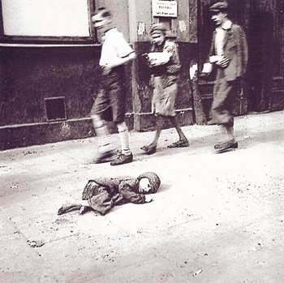
A child dying in the streets of the crowded Warsaw Ghetto, where hunger and disease were extremely prevalent.
After the invasion of Poland, the Nazis created ghettos to which Jews (and some Roma & Sinti) were confined, until they were eventually shipped to death camps and killed. The Warsaw Ghetto was the largest, with 380,000 people and the Łódź Ghetto, the second largest, holding about 160,000, but ghettos were instituted in many cities (list). The ghettos were established throughout 1940 and 1941, and were immediately turned into immensely crowded prisons; though the Warsaw Ghetto contained 30% of the population of Warsaw, it occupied only about 2.4% of city's area, averaging 9.2 people per room. From 1940 through 1942, disease (especially typhoid fever) and starvation killed hundreds of thousands of Jews confined in the ghettos.
On July 19, 1942, Heinrich Himmler ordered the start of the deportations of Jews from the ghettos to the death camps. On July 22, 1942, the deportations from the Warsaw Ghetto inhabitants began; in the next 52 days (until September 12, 1942) about 300,000 people were transported by train to the Treblinka extermination camp from Warsaw alone. Many other ghettos were completely depopulated. The first ghetto uprising occurred in September 1942 in the small town of Łachwa in southeast Poland. Though there were armed resistance attempts in the larger ghettos in 1943, such as the Warsaw Ghetto Uprising and the Białystok Ghetto Uprising, in every case they failed against the Nazi military, and the remaining Jews were either slaughtered or sent to the extermination camps.

Death squads (1941-1943)
Main article: Einsatzgruppen
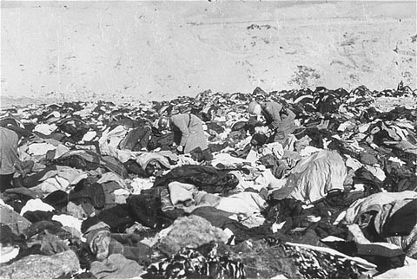
The 1941 massacre at Babi Yar was similar to many other mass murders of Jews. Over 33,000 Jews were shot in the course of two days by Nazi Einsatzgruppen and local Ukrainian forces.
As many as 1.6 million Jews were murdered in open-air shootings by Nazis and their collaborators, especially in 1941 before the establishment of the concentration camps. During the invasion of the Soviet Union, over 3,000 special killing units (organized into the four Einsatzgruppen) followed the Wehrmacht, conducting mass murders of Poles, Communist officials, and the Jewish population that lived in Soviet territory.
Poles were an early target in the AB Action, in which 30,000 Polish intellectual and political figures were rounded up, and 7,000 eventually murdered. By the summer of 1941, the Einsatzgruppen turned to targeting Jews, starting with the extermination of 2,200 Jews in Bialystok on June 27, 1941, and quickly increased in scale. 1,500 Jews were murdered in Kaunas on June 26 by the German SS forces. 4,000 Jews murdered in Lviv on June 30-July 3, 1941 by Ukrainian collaborators. From September to the end of 1941, a series of mass murders took place throughout Poland, Lithuania, Ukraine, and Latvia: over 33,000 Jews were killed at Babi Yar, 25,000 at Rumbula by Latvian Nazis (Arajs Commando), over 36,000 at Odessa by Romanian forces, 19,000 at the Ninth Fort of Kaunas and 40,000 (up to 100,000 by 1944) at Paneriai by the German SS forces[3]. These, and similar slaughters throughout Europe, murdered around 100,000 Jews per month for five months.^{[citation needed]} By the end of 1943, another 900,000 Jews would be murdered in this manner, but the pace was not fast enough for the Nazi leadership, who, at the end of 1941 and the beginning of 1942, began the implementation of the Final Solution, the complete extermination of the Jews of Europe.
Serbs were victims of an extermination policy of Croat NDH since this Nazi puppet state was formed in 1941. The murders took many forms: burning of live Serbs forced into churches; slaughter of Serbs by small death squads, often numbering only three, called "black threes", who rampaged by night through villages in which dogs were first poisoned. The squads filled foiba pits with still-living Serbs, often connected by barbed wire, and practiced extremely cruel methods of torture and execution such as gouging eyes and cutting salted necks. They also nailed guts of slaughtered victims to the roofs. Extermination in Jasenovac camp existed since its onset in 1941, at the time when Germans had not yet started their systematic genocide, and it has appalled even the SS, though soon enough they were organizing systematic extermination in their camps too.^{[citation needed]}

Extermination camps (1942-1945)
Main article: Nazi extermination camp
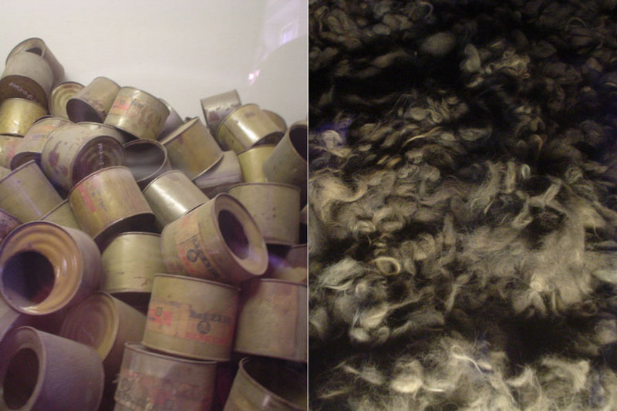
Empty poison gas canisters and piles of hair in the memorial museum of Auschwitz-Birkenau.
In December 1941, the Nazis opened Chelmno, the first of what would soon be seven extermination camps, dedicated entirely to mass extermination on an industrial scale, as opposed to the labor or concentration camps. Over three million Jews would die in these extermination camps. The method of killing at these camps was by poison gas (Zyklon B or carbon monoxide), usually in "gas chambers", although many prisoners were killed in mass shootings and by other means. The bodies of those killed were destroyed in crematoria (except at Sobibór where they were cremated on outdoor pyres), and the ashes buried or scattered.
In 1942, the Nazis began this most destructive phase of the Holocaust, with Aktion Reinhard, opening the extermination camps of Belzec, Sobibór, and Treblinka. More than 1.7 million Jews were killed at the three Aktion Reinhard camps by October 1943. The largest death camp built was Auschwitz-Birkenau, which had both a labor camp (Auschwitz) and an extermination camp (Birkenau); the latter possessing four gas chambers and crematoria. This camp was responsible for the deaths of an estimated 1.6 million Jews (including about 438,000 Jews from Hungary in the course of a few months), 75,000 Poles and gay men, and some 19,000 Roma. At the peak of operations, Birkenau's gas chambers killed approximately 8,000 a day.
Upon arrival in these camps, all valuables were taken from the prisoners, and the women had to have their hair cut off[4]. According to a Nazi document, the hair was to be used for the manufacture of stockings[5]. Prisoners were divided into two groups: those too weak for work were immediately executed in gas chambers (which were sometimes disguised as showers) and their bodies burned, while others were first used for slave labor in factories or industrial enterprises located in the camp or nearby. Shoes, stockings, and anything else of value was recycled for use in products to support the war effort, regardless of whether or not a prisoner was sent to death. Some prisoners were forced to work in the collection and disposal of corpses, and to extract gold teeth from the dead.

Death marches and liberation (1944-1945)
Main article: Death marches (Holocaust)
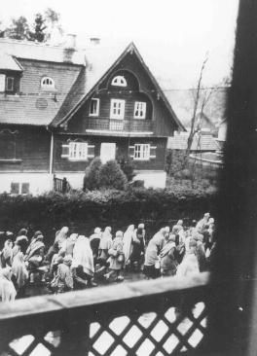
Dachau concentration-camp inmates on a death march through a German village in April 1945. Courtesy of the United States Holocaust Memorial Museum.
As the armies of the Allies closed in on the Reich at the end of 1944, the Nazis decided to abandon the extermination camps, moving or destroying evidence of the atrocities they had committed there. The Nazis marched prisoners, already sick after months or years of violence and starvation, for tens of miles in the snow to train stations; then transported for days at a time without food or shelter in freight trains with open carriages; and forced to march again at the other end to the new camp. Prisoners who lagged behind or fell were shot. The largest and most well known of the death marches took place in January 1945, when the Soviet army advanced on Poland. Nine days before the Soviets arrived at the death camp at Auschwitz, the SS guards marched 60,000 prisoners out of the camp toward Wodzislaw, 56 km (35mi) away, where they were put on freight trains to other camps. Around 15,000 died on the way. In total, around 100,000 Jews died during these death marches.^{[24]}
In July 1944, the first major Nazi camp, Majdanek, was discovered by the advancing Soviets, who eventually liberated Auschwitz in January 1945. In most of the camps discovered by the Soviets, the prisoners had already been transported away by death marches, leaving only a few thousand prisoners alive. Concentration camps were also liberated by American and British forces, including Bergen-Belsen concentration camp on April 15, 1945. Some 60,000 prisoners were discovered at the camp, but 10,000 died from disease or malnutrition within a few weeks of liberation.

Resistance and rescuers

Jewish Resistance
Main article: Jewish resistance movement
Due to the organization and overwhelming military might of the Nazi German state and its supporters, few Jews and other Holocaust victims were able to resist the killings. There are, however, many cases of attempts at resistance in one form or another, and over a hundred armed Jewish uprisings.
The largest instance of organized Jewish resistance was the Warsaw Ghetto Uprising, from April to May of 1943, as the final deportation from the Ghetto to the death camps was about to commence, the ZOB and ZZW fighters rose up against the Nazis. Most of the resistors were killed, but the few who did survive the war are currently residing in Israel. There were also other Ghetto Uprisings, though none were successful against the German military.
There were also major resistance efforts in three of the extermination camps. In August 1943, an uprising also took place at the Treblinka extermination camp. Many buildings were burnt to the ground, and seventy inmates escaped to freedom, but 1,500 were killed. Gassing operations were interrupted for a month. In October 1943, another uprising took place at Sobibór extermination camp. This uprising was more successful; 11 SS men and a number of Ukrainian guards were killed, and roughly 300 of the 600 inmates in the camp escaped, with about 50 surviving the war. The escape forced the Nazis to close the camp. On October 7, 1944, the Jewish Sonderkommandos (those prisoners kept separate from the main camp and involved in the operation of the gas chambers and crematoria) at Auschwitz staged an uprising. Female prisoners had smuggled in explosives from a weapons factory, and Crematorium IV was partly destroyed by an explosion. The prisoners then attempted a mass escape, but all 250 were killed soon after.
There were a number of Jewish partisan groups operating in many countries (see Eugenio Calò for the story of a Jewish Italian partisan). Also, Jewish volunteers from the Palestinian Mandate, most famously Hannah Szenes, parachuted into Europe in a failed attempt to organize resistance.

Resistance of Jehovah's Witnesses
Main article: Persecution of Jehovah's Witnesses
Jehovah's Witnesses in Germany were persecuted between 1933 and 1945. They were scorned by the name Ernste Bibelforscher (Earnest Bible Students) at that time, because Jehovah's Witnesses would not give allegiance to the Nazi party, and refused to serve in the military, they were detained, put in concentration camps, or imprisoned during the Holocaust. Unlike Jews, homosexuals and Gypsies, who were persecuted for racial, political and social reasons, Jehovah's Witnesses were persecuted on religious ideological grounds. The Nazi government gave detained Jehovah's Witnesses the option: if they were to renounce their faith, submit to the state authority, and support the German military, they would be free to leave prison or the camps. Approximately 12,000 Jehovah's Witnesses were sent to concentration camps where they were forced to wear a purple triangle that specifically identified them as Jehovah's Witnesses. In the end, about 2,000 of their members who were incarcerated perished under the Nazi system. All lost their employment. Dr. Detlef Garbe Historian and director at the Neuengamme (Hamburg) Memorial stated: “Taking everything into consideration, it has been established that no other religious movement resisted the pressure to conform to National Socialism with comparable unanimity and steadfastness.”^{[25]}

Rescuers
See also: Righteous Among the Nations and List of people who assisted Jews during the Holocaust
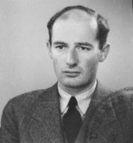
Swedish diplomat Raoul Wallenberg and his colleagues saved as many as 100,000 Hungarian Jews by providing them with diplomatic passes.
In three cases, entire countries resisted the deportation of their Jewish population. King Christian X of Denmark and his subjects saved the lives of most of the 7,500 Danish Jews by spiriting them to safety in Sweden via fishing boats in October 1943. Moreover, the Danish government continued to work to protect the few Danish Jews captured by the Nazis. When the Jews returned home at war's end, they found their houses and possessions waiting for them, exactly as they left them. In the second case, the Nazi-allied government of Bulgaria, led by Bogdan Filov, did not deport its 50,000 Jewish citizens, after yielding to pressure from the parliament deputy speaker Dimitar Peshev and the Bulgarian Orthodox Church, saving them as well, though Bulgaria did not prevent Germany from deporting Jews to concentration camps from areas in occupied Greece and Macedonia. The government of Finland refused repeated requests from Germany to deport its Finnish Jews to Germany. German requirements for the deportation of Jewish refugees from Norway was largely refused. In Rome, some 4,000 Italian Jews and prisoners of war avoided deportation. Many of these were hidden in safe houses and evacuated from Italy by a resistance group that was organised by an Irish priest, Monsignor Hugh O'Flaherty of the Holy Office. Once a Vatican ambassador to Egypt, O' Flaherty used his political connections to great effect in helping to secure sanctuary for dispossessed Jews.
Another example of someone who assisted Jews during the Holocaust is Portuguese diplomat Aristides de Sousa Mendes. It was in clear disrespect of the Portuguese state hierarchy that Sousa Mendes issued about 30,000 visas to Jews and other persecuted minorities from Europe. He saved an enormous number of lives, but risked his career for it. In 1941, Portuguese dictator Salazar lost political trust in Sousa Mendes and forced the diplomat to quit his career. He died in poverty in 1954.
Some towns and churches also helped hide Jews and protect others from the Holocaust, such as the French town of Le Chambon-sur-Lignon which sheltered several thousand Jews. Similar individual and family acts of rescue were repeated throughout Europe, as illustrated in the famous cases of Anne Frank, often at great risk to the rescuers. In a few cases, individual diplomats and people of influence, such as Oskar Schindler or Nicholas Winton, protected large numbers of Jews. Swedish diplomat Raoul Wallenberg, the Italian Giorgio Perlasca, Chinese diplomat Ho Feng Shan and others saved tens of thousands of Jews with fake diplomatic passes. Chiune Sugihara saved several thousands of Jews by issuing them with Japanese visas against the will of his Nazi-aligned government.
There were also groups, like members of the Polish Żegota organization, that took drastic and dangerous steps to rescue Jews and other potential victims from the Nazis. Witold Pilecki, member of Armia Krajowa (the Polish Home Army), organized a resistance movement in the Auschwitz concentration camp from 1940, and Jan Karski tried to spread word of the Holocaust.
Since 1963, a commission headed by an Israeli Supreme Court justice has been charged with the duty of awarding such people the honorary title Righteous Among the Nations.

Perpetrators and collaborators

Who was directly involved in the mass murder?
A wide range of German soldiers, officials, and civilians were in some way involved in the Holocaust, from clerks and officials in the government to units of the army, the police, and the SS. Many ministries, including those of armaments, interior, justice, railroads, and foreign affairs, had substantial roles in orchestrating the Holocaust; similarly, German physicians participated in medical experiments and the T-4 euthanasia program. And, though there was no single military unit in charge of the Holocaust, the SS under Himmler was the closest. From the SS came the Totenkopfverbände concentration camp guards, the Einsatzgruppen killing squads, and many of the administrative offices behind the Holocaust. The Wehrmacht, or regular German army, participated directly far less than the SS in the Holocaust (though it did directly take part in the massacre of some Jews in Russia, Serbia, Poland, and Greece), but it supported the Einsatzgruppen, helped form the ghettos, ran prison camps, occasionally provided concentration camp guards, transported prisoners to camps, had experiments performed on prisoners, and used substantial slave labor.
German police units, all under the control of the Nazis during the war, also directly participated in the Holocaust; for example, Reserve Police Battalion 101, in just over a year, shot 38,000 Jews and deported 45,000 more to the extermination camps.^{[26]} Even private firms helped in the machinery of the Holocaust. Nazi bankers at the Paris branch of Barclays Bank volunteered the names of their Jewish employees to Nazi authorities, and many of them ended up in the death camps. [6]

European collaborationist countries
In addition to the direct involvement of Nazi forces, collaborationist European countries helped the Nazis in the Holocaust. Collaboration took the form of either rounding up of the local Jews for deportation to the German extermination camps or a direct participation in the killings.

Fascist Italy
In Fascist Italy, a law from 1938 restricted civil liberties of Jews. This effectively reduced the country's Jews to second-class status, though Mussolini never made it official policy to deport Jews to concentration camps. After the fall of Mussolini and his creation, the Italian Social Republic, Jews started being deported to German camps. The deported numbered about 8,369, and only about a thousand survived. Several small camps were built in Italy and the so-called Risiera di San Sabba hosted a crematorium; from 2,000 to 5,000 people were killed in San Sabba, only a few of whom were Jews.

Vichy France
In France, Philippe Pétain, who became premier after Paris had fallen to the German Army, arranged the surrender to Germany. He then became the head of the Vichy government, which collaborated with Nazism, claiming that it would soften the hardships of occupation. Opposition to the German occupation of northern France and the collaborationist Vichy government was left to the French Resistance within France and the Free French Forces led by Charles de Gaulle outside of France. The police, the Milice ("militia", which worked as the Gestapo's aid), as well as members of Jacques Doriot's Parti Populaire Français (PPF) rounded up 75,000 Jews for deportation to concentration camps. The Vichy regime attracted all of the far-right counterrevolutionary sectors of French society, monarchists and other pseudo-fascist movements.^{[27]} La Cagoule, a terrorist group and Eugène Schueller, the founder of L'Oréal, are examples of such groups. Antisemitism, as the Dreyfus Affair had shown at the end of the 19th century, was widespread in France, especially among anti-republican synpathizers. The Vichy government eagerly participated in the Holocaust, for example with the July 16, 1942 rafle du Vel'd'Hiv, in which 12,884 Jews were arrested, including 4,051 children which the German authorities had not asked for. They were all sent to Drancy transit camp anyway.^{[27]}
Klaus Barbie, "the Butcher of Lyon", captured and deported 44 Jewish children hidden in the village of Izieu, killed Resistance leader Jean Moulin, and was in total responsible for the deportation of 7,500 people, 4,342 murders, and the arrest and torture of 14,311 resistance fighters were in some way attributed to his actions or commands.
Maurice Papon was the number two official in the Bordeaux region and supervisor of its "Service for Jewish Questions". In 1997, following revelations from Le Canard Enchaîné newspaper, he was finally charged with complicity of crimes against humanity. Papon was accused of ordering the arrest and deportation of 1,560 Jews, including children and the elderly, between 1942 and 1944; most of his victims were sent to Auschwitz. As during Adolf Eichmann's trial, one of the main issue was to determine to what extent an individual should be held responsible in a chain of responsibility. In 1998, he was given a 10-year prison term. However, he was released on grounds of poor health in 2002. Many people thought both the relatively light sentence and his release were scandalous, especially when it was known to all that following the war, Papon went on to enjoy a civil service career, which led him to be the chief of the Paris police, held by historian Luc Einaudi as being directly responsible for the 1961 Paris massacre during the Algerian War (1954-62); Papon even became budget minister of president Valéry Giscard d'Estaing in the 1970s. He was finally arrested because of the Canard Enchaîné 's revelations, which themselves followed a fiscal control ordered by Papon with the aim of intimidating the satirical newspaper.

Antonescu's Romania
The Romanian Antonescu regime was directly responsible for the deaths of between 280,000 and 380,000 Jews. An official report[7]. released by the Romanian government concluded, "Of all the allies of Nazi Germany, Romania bears responsibility for the deaths of more Jews than any country other than Germany itself. The exterminations committed in Iasi, Odessa, Bogdanovka, Domanovka, and Peciora, for example, were among the most hideous acts committed against Jews anywhere during the Holocaust."^{[28]} In cooperation with German Einsatzgruppen and Ukrainian auxiliaries, Romanians killed hundreds of thousands of Jews in Bessarabia, northern Bukovina, and Transnistria. Some of the larger massacres included 54,000 Jews killed in Bogdanovka, a Romanian concentration camp along the Bug River in Transnistria, between 21 and 31 December 1941. Nearly 100,000 Jews were killed in occupied Odessa and over 10,000 were killed in the Iasi pogrom. The Romanians also massacred Jews in the Domanevka and Akhmetchetka concentration camps.

Hungary
The Hungarian Horthy regime deported 20,000 Jews from annexed Transcarpathian Ukraine in 1941 to Kamianets-Podilskyi in the German-occupied Ukraine, where they were shot by the German Einsatzgruppen detachments. Hungarian army and police units killed several thousand Jews and Serbs in Novi Sad in January 1942. However Horthy resisted German demands for mass deportation of Hungarian Jews, and most survived until October 1944, when the Horthy regime fell from power and was replaced by the Arrow Cross Party led by Ferenc Szálasi. At this late date in the war, with German defeat appearing very likely, Hungarian police nevertheless participated fully with SS in the roundup of 440,000 Jews for deportation to the extermination camps. Moreover, 20,000 Budapest Jews were shot by the banks of the Danube by Hungarian forces under the direct orders of The Arrow Cross, the Hungarian version of the German Nazi Party. 70,000 Jews were forced on a death march to Austria—thousands were shot and thousands more died of starvation and exposure.^{[29]}
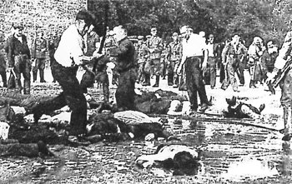
Killing of 5,000 Jews in Kaunas by Lithuanian nationalists in June 1941. The SS urged anti-communist partisan leader Klimajtis to attack the Jews to show that "the liberated population had resorted to the most severe measures against the ... Jewish enemy."

Ustaše's Croatia
The Croatian Ustaše regime killed hundreds of thousands of Serbs (estimates vary widely, but by all sources more than 330,000-390,000, and possibly well over a million), over 20,000 Jews and 26,000 Roma, primarily in the Ustase's Jasenovac concentration camp near Zagreb. The Ustase also deported 7,000 more Jews to Nazi extermination camps.^{[30]} Croats were also victims of the Nazi regime and those who opposed it ended in concentration camps. A lot of Croats risked their lives during the Holocaust in order to save Jews from extermination by the Nazis (Croatian Righteous Among the Nations).

Serbia
Serbia was set up as a Nazi puppet state under Serbian army general Milan Nedić, which was known as Nedić's Serbia. The internal affairs of the Serbian puppet state were moderated by German racial laws, that were introduced in all occupied teritories with immediate effects on Jews, Roma people, as well as imprisonment of left oriented persons. The two major concentration camps in Serbia were: Sajmište and Banjica. Of 40,000 Serbian Jews around one half lost their lives in Nazi concentration camps both in Serbia and German Reich, where most of the captured Serbian Jews were transferred. Under Nedić, Belgrade was declared to be Judenfrei in 1942. Serbs were also victims of the Nazi regime, and most of the victims in Banjica were Serbian. Nazis had a policy of killing 100 Serbs for each killed German soldier and 50 killed Serbs for each wounded, resulting in widespread taking of hostages and executions such as Kragujevac massacre. Despite these represive measures, Serbs rebelled, and most Serbs saw Jews as their fellow victims in World War II, dying together in Nazi represion and genocide in Sajmište, Banjica and Jasenovac. Legends about Serbs saving the Jews in WWII are widespread in Serbia, and 152 Serbs have been honored as righteous Gentiles.

Greece
This article or section does not cite its references or sources.
You can help Wikipedia by introducing appropriate citations. This article has been tagged since November 2006.
The Jews of Greece mainly lived in the area around Thessaloniki, where there had been occasional conflicts between Jews and Greeks. In Thessaloniki there had been an anti-Semitic nationalist party called National Union of Greece (Ethniki Enosis Ellados, EEE), which was revived by Nazi authorities in the city. Members of the EEE assisted occupying forces to identify Jews and collaborated on the deportation of local Jews with remarkable efficiency, either for ethnic hatred or for more prosaic reasons such as obtaining profits. By the time of the German withdrawal from Greece in 1944, nearly 90% of the Jewish community in Thessaloniki had been annihilated.
Athenian Jews, on the other hand, went through a different experience. They were a minor part of the city's population and in the city there had not been an anti-Semitic atmosphere, and most Jews eluded deportation by either being helped by Greeks into hiding or joining the Greek Resistance in the mountains. This, however, did not exempt Athenian Jews from organized crime against them. Just like the Nazi authorities had restored the EEE in Thessaloniki, in Athens the German occupation authorities created the ESPO (Ethniko-Socialistike Patriotike Organosis), whose members attacked or assisted Germans to locate local Jews. The ESPO's most notorious action was the ransacking the synagogue on Melidoni Street, Athens. Other ESPO members were recruited as guards in the Haïdari internment camp, just outside Athens.
In any case, the three quisling governments headed by Georgios Tsolakoglou, Konstantinos Logothetopoulos and Ioannis Rallis to different extents were unable to stop (or participated) in the deportation or prosecution of Greek Jews. Rallis, for instance, was known to hold the point of view that the houses left by deported Jews in Thessaloniki would be very welcome for the Greek Pontian refugees which came to Greece after the 1922 Asia Minor catastrophe.

Bulgaria
Bulgaria, mainly through the influence of the Bulgarian East Orthodox Church, saved all of its own Jewish population from deportation and certain death. However, although civil and military administration for parts of Northern Greece and Macedonia had been turned over to Bulgaria by Germany, Bulgaria did not prevent the deportation by German authorities of the Jews from those territories to the concentration camps.^{[31]}

Slovakia
Slovakia's Tiso regime deported approximately 70,000 Jews, of whom 65,000 were killed.^{[32]}

German-occupied Soviet territories
In the German-occupied Soviet territories, local Nazi collaborationist units represented over 80% of the available German forces providing a total of nearly 450,000 personnel organised in so-called "Schutzmannschaften" formations. Practically all of these units participated in the round-ups and mass-shootings. The overwhelming majority were recruited in the western Ukraine and the Baltic region, areas recently occupied by the Soviets for which the Jews were typically scapegoated, which exacerbated pre-Nazi anti-Semitic attitudes. Thus, for instance, Ukrainian nationalists killed 4,000 Lviv Jews in July 1941, and an additional 2,000 in late July 1941 during the so-called Petliura Days pogrom Nazi Einsatzgruppen, together with Ukrainian auxiliary units, killed 33,000 Kievan Jews in Babi Yar in September 1941. Ukrainian auxiliaries participated in a number of killings of Jews, among them in Romanian concentration camps in Bogdanovka and in Latvia.

Baltic collaborators
Some Lithuanian and Latvian auxiliary military units (Schutzmannschaft) with Nazi Einsatzgruppen detachments participated in the extermination of the Jewish population in their countries, as well as assisting the Nazis elsewhere, such as deportations from the Warsaw Ghetto. The Arajs Commando, a Latvian volunteer police unit, for example, shot 26,000 Latvian Jews, at various locations after they had been brutally rounded-up for this purpose by the regular police and auxiliaries and was responsible for assisting in the killing of 60,000 more Jews.^{[33]}
About 75% of Estonia's Jewish community, aware of the fate that otherwise awaited them, managed to escape to the Soviet Union; virtually all the remainder (between 950 and 1,000 people) were killed by Einsatzgruppe A and local collaborators before the end of 1941.^{[34]}

European occupied countries

The Netherlands
Of the 140,000 Dutch Jews, the German occupiers deported about 107,000 of which 101,800 were murdered. This death toll of 73% is the highest in Western Europe. Reasons that have been suggested to explain this phenomenon are: the occupation regime in the Netherlands was formed by fanatic Austrian Nazis; ^{[citation needed]} the degree of efficiency and the high level of administrative organization of the pre-war Dutch civilian administration; the typical Dutch landscape without mountains or woods made it practically impossible to find shelter; the majority of the Dutch Jews lived in the larger cities and thus they formed relatively easy targets for persecution and segregation; the Jewish leaders chose, "in order to prevent worse", a policy of collaboration with the Nazis; the Dutch pre-war society can be characterized as a conglomerate of different groups, which lived separately from another and this fact made it easy for the Germans to segregate and persecute the Jewish section of society; because the Jews were cut off from public life, they lost almost all of the support that could have been provided by other groups in society; active assistance by Dutch collaborators, such as the Henneicke Column group that hunted and "delivered" 8,000 to 9,000 Jews for deportation.^{[35]} All of these circumstances made it relatively easy for the SS, regularly aided by Dutch police officers, to round up the Jewish population.

Norway
After Norway was invaded, the Nazis took control of the government and the true government went into exile. Power was given to the German Reichskommisioner Josef Terboven and the Norwegian Fascist leader Vidkun Quisling. Quisling had attempted to establish himself as the leader of occupied Norway, but the Nazis only used him as leader of a puppet government. The Nazis, as well as some Norwegian police units, rounded up 750 Jews. However, the Nazis and their collaborators were very unpopular in Norway, causing a strong resistance movement, so the German government's aims for Norway were never fulfilled. Many Jews and other people were saved by the actions of Norwegians, including Norwegian police. Still, detailed lists of Jews (and assumingly most other persons as well) existed at the time of the occupation. This caused the rounding-up of Jews in Norway, to be much more efficient than in similar countries (like Denmark). Quisling and other Norwegians, who collaborated with the Nazis, were executed as traitors after the war.^{[citation needed]}
Also, 245 Sinti and Roma were deported to the Nazi extermination camps, of which 190 were murdered.

Who authorized the killings?
Hitler authorized the mass killing of those labelled by the Nazis as "undesirables" in the T-4 Euthanasia Program. Hitler encouraged the killings of the Jews of Eastern Europe by the Einsatzgruppen death squads in a speech in July, 1941, though he almost certainly approved the mass shootings earlier. A mass of evidence suggests that sometime in the fall of 1941, Himmler and Hitler agreed in principle on the complete mass extermination of the Jews of Europe by gassing, with Hitler explicitly ordering the "annihilation of the Jews" in a speech on December 12, 1941 (see Final Solution). To make for smoother intra-governmental cooperation in the implementation of this "Final Solution" to the "Jewish Question", the Wannsee conference was held near Berlin on January 20, 1942, with the participation of fifteen senior officials, led by Reinhard Heydrich and Adolf Eichmann, the records of which provide the best evidence of the central planning of the Holocaust. Just five weeks later on February 22, Hitler was recorded saying "We shall regain our health only by eliminating the Jew" to his closest associates.
Arguments that no documentation links Hitler to "the Holocaust" ignore the records of his speeches kept by Nazi leaders such as Joseph Goebbels and rely on artificially limiting the Holocaust to exclude what we do have documentation on, such as the T-4 Euthanasia Program and the Kristallnacht pogrom.

Who knew about the killings?
Some claim that the full extent of what was happening in German-controlled areas was not known until after the war. However, even though Hitler did not talk about the camps in public, numerous rumors and eyewitness accounts from escapees and others gave some indication that Jews were being killed in large numbers. Since the early years of the war, the Polish government-in-exile published documents and organised meetings to spread word of the fate of the Jews. By early 1941, the British had received information via an intercepted Chilean memo that Jews were being targeted, and by late 1941 they had intercepted information about a number of large massacres of Jews conducted by German police.^{[citation needed]} In an entry in the Friedrich Kellner Diary dated October 28, 1941, the German justice inspector Friedrich Kellner recorded a conversation he had in Laubach with a German soldier who had witnessed a massacre in Poland. Churchill, who was privy to intelligence reports derived from decoded German transmissions, first began mentioning "mass killings" in public at the same time. In the summer of 1942, a Jewish labor organization (the Bund) got word to London that 700,000 Polish Jews had already died, and the BBC took the story seriously, though the United States State Department did not.^{[36]} In the United States, in November of 1942, a telegram from Europe which contained word about Hitler's plans was released by Stephen Wise of the World Jewish Congress, after a long wait for permission from the government.^{[37]} This led to attempts by Jewish organizations to put Roosevelt under pressure to act on behalf of the European Jews, many of whom had tried in vain to enter either Britain or the U.S.
On December 17, 1942, however, after receiving a detailed eyewhitness account from Jan Karski, the Allies issued a formal declaration confirming and condemning Nazi extermination policy toward the Jews.^{[38][39]} The US State Department was aware of the use and the location of the gas chambers of extermination camps, but refused pleas to bomb them out of operation. On May 12, 1943, Polish government-in-exile and Bund leader Szmul Zygielbojm committed suicide in London to protest the inaction of the world with regard to the Holocaust, stating in part in his suicide letter:
I cannot continue to live and to be silent while the remnants of Polish Jewry, whose representative I am, are being killed. My comrades in the Warsaw ghetto fell with arms in their hands in the last heroic battle. I was not permitted to fall like them, together with them, but I belong with them, to their mass grave.
By my death, I wish to give expression to my most profound protest against the inaction in which the world watches and permits the destruction of the Jewish people.
The death camps were discussed between American and British leaders at the Bermuda Conference in April of 1943. The large camps near Auschwitz were finally surveyed by plane in April of 1944, many months after the German air force ceased to be a serious danger. While all important German cities and production centers were bombed by Allied forces until the end of the war, no attempt was made to collapse the system of mass annihilation by destroying pertinent structures or train tracks, even though Churchill was a proponent of bombing parts of the Auschwitz complex. Throughout the war, Britain also pressed European leaders to prevent "illegal" Jewish immigration and sent ships to block the sea-route to Palestine (from which Britain withdrew in 1948), turning back many refugees. ^{[40]}
Debate also continues on how much average Germans knew about the Holocaust. Recent historical work suggests that the majority of Germans knew that Jews were being indiscriminately killed and persecuted, even if they did not know of the specifics of the death camps. Robert Gellately, a historian at Oxford University, conducted a widely-respected survey of the German media before and during the war, concluding that there was "substantial consent and active participation of large numbers of ordinary Germans" in aspects of the Holocaust, and documenting that the sight of columns of slave laborers were common, and that the basics of the concentration camps, if not the extermination camps, were widely known.^{[41]}

Historical and philosophical interpretations
The Holocaust and the historical phenomenon of Nazism, which has since become the dark symbol of the 20th century's crimes, is the subject of numerous historical, psychological, sociological, literary, and philosophical studies. All types of scholars have tried to give an answer to what appears as the most irrational act of the Western World, which, until at least World War I, had been so sure of its eminent superiority to other civilizations. Frankfurt school philosopher Theodor Adorno and Max Horkheimer thus began the Dialectic of Enlightenment:
"Enlightenment, understood in the widest sense as the advance of thought, has always aimed at liberating human beings from fear and installing them as masters. Yet the wholly enlightened earth is radiant with triumphant calamity.^{[42]}
Theodor Adorno went as far as ceasing to work as a composer, declaring: "writing any more poetry after Auschwitz is barbaric" (Nach Ausschwitz noch ein Gedicht zu schreiben ist barbarisch). Thus, Auschwitz became the metonymic name for the Holocaust and the Nazi barbarity. Although Adorno later retracted this statement, declaring that "Perennial suffering has as much right to expression as the tortured have to scream...", the concepts of civilization and of progress themselves were severely called into question, and in a much greater manner than had happened due to World War I's massive killings. Germany, which was considered one of the most enlightened European countries, radiant with literature and philosophy (Goethe, Hegel, etc.), art (Bach, Bauhaus, etc.), and which had quickly followed in Great Britain's and France's steps during the competition induced during the New Imperialism period (starting in 1860s), had made itself guilty of one of the biggest crimes against humanity ever committed. Thus, the juridical concept of crimes against humanity was created to qualify what could not be qualified. It was left to literature, such as Primo Levi's If This Is a Man (1947) or Robert Antelme's The Human Race (1947) to describe what poetry, according to Adorno, could not describe.
Thus, until this day, many different people have tried to explain what many deemed unexplainable due to its horror. One important philosophical question, addressed as early as 1933 by Wilhelm Reich in Mass Psychology of Fascism, was the mystery of the obedience of the German people to such an "insane" operation. Hannah Arendt, in her 1963 report on Adolf Eichmann, presented him as a symbol of dull obedience to authority in what was at first seen as a scandalous book, Eichmann in Jerusalem: A Report on the Banality of Evil (1963), which has since become a classic of political philosophy. Thus, Arendt opposed herself to the first, immediate, explanation, which accused the Nazis of "cruelty" and of "sadism". Later, the historians' debate concerning functionalism and intentionalism also demonstrated that the question could not be simplified to a question of cruelty. Many people who participated in the Holocaust were normal people, according to Arendt, and that is the real scandal. This led Stanley Milgram's to conduct psychological experiences on obedience, opening up the way to understanding the psychological experiences of "authority" and charisma. The question of charisma was renewed by Gustave Le Bon's 19th century studies about crowd psychology. Thus, his work acquired new force, although Hitler himself had been inspired by Le Bon's description of propaganda techniques to write Mein Kampf. Furthermore, Hannah Arendt and some authors such as Sven Lindqvist and Olivier LeCour Grandmaison tried to point toward a relative continuity between the crimes committed against "primitive" people during colonialism and the Holocaust. They most notably argued that many techniques that the Nazis industrialized had been experimented on in other continents, starting with the concentration camps invented during the Second Boer War if not before. This thesis was met with fierce opposition by some groups who argued that nothing could be compared to the Holocaust, not even other genocides: although the Herero genocide (1904-07) and the Armenian genocide (1915-17) are commonly considered as the first genocides in history, many argued that the Holocaust had taken proportions that even these crimes against humanity had not achieved.
The Holocaust was indeed characterized by an industrial project of extermination; compared to it, other genocides seemed to lack "professionalism". This led authors such as Enzo Traverso to argue in The Origins of Nazi Violence that Auschwitz was "an authentic product of Western civilization".^{[43]} Beginning his book with a description of the guillotine, which according to him marks the entry of the Industrial Revolution into capital punishment, and writes: "Through an irony of history, the theories of Frederick Taylor" (taylorism) were applied by a totalitarian system to serve "not production, but extermination." (see also Heidegger's comments). In the wake of Hannah Arendt, Traverso describes the colonial domination during the New Imperialism period through "rational organization", which lead in a number of cases to extermination. However, this argument, which insists on the industrialization and technical rationality through which the Holocaust itself was carried out (the organization of trains, technical details, etc. — see Adolf Eichmann's bureaucratic work), was in turn opposed by other people. These point out that the 1994 Rwandan genocide only used machetes.
Others have presented the Holocaust as a product of German history, analyzing its deep roots in German society: "German authoritarianism, feeble liberalism, brash nationalism or virulent anti-Semitism. From A. J. P. Taylor's The Course of German History fifty-five years ago to Daniel Goldhagen's recent Hitler's Willing Executioners, Nazism is understood as the outcome of a long history of uniquely German traits", writes Russell Jacoby.^{[44]} Furthermore, while many pointed out that the specificity of the Holocaust was also rooted in the constant antisemitism from which Jews had been the target since the foundation of Christianism (and the myth of the "deicide people"), others underlined that in the 19th century, pseudo-scientific racist theories had been elaborated in order to justify, in a general way, white supremacy. In his works on "biopolitics", philosopher Michel Foucault also traced the origins of "state racism" to the eugenicist policies invented during the 19th century (it is one of the few praise that Foucault accorded to Freud's psychoanalysis, that he adamantly opposed himself to such a project of "racial hygiene").

Why did people participate in, authorize, or tacitly accept the killing?

Obedience
Stanley Milgram was one of a number of post-war psychologists and sociologists who tried to address why people obeyed immoral orders in the Holocaust. Milgram's findings demonstrated that reasonable people, when instructed by a person in a position of authority, obeyed commands entailing what they believed to be the death or suffering of others. These results were confirmed in other experiments as well, such as the Stanford prison experiment. In his book Mass Psychology of Fascism (1933), Wilhelm Reich also tried to explain this obedience. The work became known as the foundation of Freudo-Marxism. Nobel prize winner Elias Canetti also addressed the problem of mass obedience in Masse und Macht (1960 - "Crowds and Power"), developing an original theory of the consequences of commandments orders both in the obedient person and in the commander, who may well become a "despotic paranoiac". Two recent "experiments", one called The Third Wave and one conducted by Jane Elliott, tried answer the question of: "How can a people be a part of something terrible and then claim at the demise that they were not really involved?"

Psychological mechanisms
The Holocaust is a clear example of two factors at work. One is described by the "boiling frog" theory, which says that an enormous change will not be noticed if it occurs in gradual steps. The other factor is the primal and powerful mechanism of herding, which has its home in the limbic system and ensures that individuals conform to the group. This mechanism has evolved through natural selection to ensure that human groups survive. Together, these factors make conforming to the group a stronger impulse than breaking out, even if the individual does not agree with what the group is doing. So long as the gradual changes in group behaviour are small, herding can eventually take the group towards a state that is far removed from past behavior and is more and more extreme. Thus, participants in the Holocaust may have privately felt horror or disgust at what they were ordered to do but stayed in line with the group. These effects have been exploited many times in history by demagogues and revolutionaries; they are also seen in bullying.^{[45]}
Studies of mass psychology, kick-started by Carl Jung but currently being developed under various labels, including socionomics (see references on that page), suggest that the causal mechanism for crowd behaviour is the reverse of what is commonly believed. The socionomic perspective says that, rather than persecution making people fearful and downtrodden, fearful and downtrodden people look for someone to persecute.^{[46]}
The Jungian-socionomic analysis says that after the humiliation of World War I, the economic ruin of the Weimar Republic, being forced to pay war reparations and the Great Depression, it was natural for the German people to become angry and look for someone on whom to vent their anger; herding behaviour amplifed this anger and the Holocaust was the result.^{[46]}

Functionalism versus intentionalism
Main article: Functionalism versus intentionalism
A major issue in contemporary Holocaust studies is the question of functionalism versus intentionalism. The terms were coined in a 1981 article by the British Marxist historian Timothy Mason to describe two schools of thought about the origins of the Holocaust. Intentionalists hold that the Holocaust was the result of a long-term masterplan on the part of Hitler's and that Hitler was the driving force behind the Holocaust. Functionalists hold that Hitler was anti-Semitic, but that he did not have a masterplan for genocide. Functionalists see the Holocaust as coming from below in the ranks of the German bureaucracy with little or no involvement on the part of Hitler. Functionalists stress that the Nazi anti-Semitic policy was constantly evolving in ever more radical directions and the end product was the Holocaust.
Intentionalists like Lucy Dawidowicz argue that the Holocaust was planned by Hitler from the very beginning of his political career, at very least from 1919 on, if not earlier. Later, Dawidowicz was to date the decision for genocide back to November 11, 1918. Other Intentionalists like Andreas Hillgruber, Karl Dietrich Bracher, Gerhard Weinberg and Klaus Hildebrand suggested that Hitler had decided upon the Holocaust sometime in the early 1920s. More recent intentionalist historians like Eberhard Jäckel continue to emphasize the relative earliness of the decision to kill the Jews, although they are not willing to claim that Hitler planned the Holocaust from the beginning. Saul Friedländer has argued that Hitler was an extreme anti-Semite from 1919 on, but he did not decide upon genocide until the middle of 1941. Yet another group of intentionalist historians such as the American Arno J. Mayer claimed Hitler only ordered the Holocaust in December 1941.
Functionalists like Hans Mommsen, Martin Broszat, Götz Aly, Raul Hilberg and Christopher Browning hold that the Holocaust was started in 1941-1942 as a result of the failure of the Nazi deportation policy and the impending military losses in Russia. They claim that what some see as extermination fantasies outlined in Hitler's Mein Kampf and other Nazi literature were mere propaganda and did not constitute concrete plans. In Mein Kampf Hitler repeatedly states his inexorable hatred of the Jewish people, but nowhere does he proclaim his intention to exterminate the Jewish people.
Furthermore, Functionalists point to the fact that in the 1930s, Nazi policy aimed at trying to make life so unpleasant for German Jews that they would leave Germany. Adolf Eichmann was in charge of facilitating Jewish emigration by whatever means possible from 1937 until October 3, 1941, when German Jews were forbidden to leave, Reinhard Heydrich issuing an order to that effect. Functionalists point to the SS's support for a time in the late 1930s for Zionist groups as the preferred solution to the "Jewish Question" as another sign that there was no masterplan for genocide. The SS only ceased their support for German Zionist groups in May 1939 when Joachim von Ribbentrop informed Hitler of this, and Hitler ordered Himmler to cease and desist as the creation of Israel was not a goal Hitler thought worthy of German foreign policy.
In particular, Functionalists have noted that in German documents from 1939 to 1941, the term "Final Solution to the Jewish Question" was clearly meant to be a "territorial solution", that is the entire Jewish population was to be expelled somewhere far from Germany and not allowed to come back. At first, the SS planned to create a gigantic "Jewish Reservation" in the Lublin, Poland area, but the so-called "Lublin Plan" was vetoed by Hans Frank, the Governor-General of occupied Poland who refused to allow the SS to ship any more Jews to the Lublin area after November, 1939. The reason why Frank vetoed the "Lublin Plan" was not due to any humane motives, but rather because he was opposed to the SS "dumping" Jews into the Government-General. In 1940, the SS and the German Foreign Office had the so-called "Madagascar Plan" to deport the entire Jewish population of Europe to a "reservation" on Madagascar. The "Madagascar Plan" was cancelled because Germany could not defeat the United Kingdom and until the British blockade was broken, the "Madagascar Plan" could not be put into effect. Finally, Functionalist historians have made much of a memorandum written by Himmler in May, 1940 explicitly rejecting extermination of the entire Jewish people as "un-German" and going on to recommend to Hitler the "Madagascar Plan" as the preferred "territorial solution" to the "Jewish Question". Not until July 1941 did the term "Final Solution to the Jewish Question" come to mean extermination.
Recently, a synthesis of the two schools has emerged that has been championed by such diverse historians such as the Canadian historian Michael Marrus, the Israeli historian Yehuda Bauer and the British historian Ian Kershaw that contends that Hitler was the driving force behind the Holocaust, but that he did not have a long-term plan and that much of the initiative for the Holocaust came from below in an effort to meet Hitler's perceived wishes.
Another controversy was started by the sociologist Daniel Goldhagen, who argues that ordinary Germans were knowing and willing participants in the Holocaust, which he claims had its roots in a deep eliminationist German anti-Semitism. Most historians have disagreed with Goldhagen's thesis, arguing that while anti-Semitism undeniably existed in Germany, Goldhagen's idea of a uniquely German "eliminationist" anti-Semitism is untenable, and that the extermination was unknown to many and had to be enforced by the dictatorial Nazi apparatus.

Religious hatred and racism
The German Nazis considered their duty to overcome natural compassion and execute orders for what they believed to be higher ideals. Much research has been done to explain how ordinary people could have participated in such heinous crimes, but there is no doubt that, like in some religious conflicts in the past, some people poisoned with racial and religious ideology of hatred committed the crimes with sadistic pleasure. Crowd psychology has attempted to explain such heinous acts, although Gustave Le Bon's The Crowd: A Study of the Popular Mind (1895) was also a major influence of Mein Kampf, in particular relating to the propaganda techniques described in it. Sadistic acts were perhaps most notable in the case of the genocide committed by members of the Ustaše, whose enthusiasm and sadism in their killings of Serbs appalled Germans, Italians, and even German SS officers, who even acted to restrain the Ustashe. However, concentration camp literature, such as the one written by Primo Levi or Robert Antelme, described numerous individual sadistic acts, including ones committed by Kapos.
Some authors, such as liberal philosopher Hannah Arendt in The Origins of Totalitarianism (1951), Swedish writer Sven Lindqvist or French historian Olivier LeCour Grandmaison have also linked the Holocaust to colonialism. They argue that techniques put in place during the New Imperialism period (first of all, concentration camps during the Boer War), as well as the pseudo-scientific theories elaborated during this period (e.g. Arthur de Gobineau's 1853 Essay on the Inequality of the Human Races) had been fundamental in preparing the conditions of possibility of the Holocaust. Others authors have adamantly opposed these views, on behalf of the "unicity" of the Holocaust, compared to any other type of genocide.^{[citation needed]} Philosopher Michel Foucault also traced the origins of the Holocaust and of "racial policies" to what he called "state racism", which is a part of "biopolitics".
Finally, many have pointed the ancient roots of antisemitism, which has been present in the Western world since the foundation of Christianity. These sentiments were not different in pre-war Germany than elsewhere, but the Nazis were the first political party to organize, promote, and officialize antisemitism, while withdrawing legal protection from Jews. Modern ecumenism efforts, in particular by the Roman Catholic Church who asked pardon to the Jews, are being done in order to avoid any repetition of such acts.

Aftermath
Until recently, Germany refused to allow access to massive Holocaust-related archives located in Bad Arolsen due to, among other factors, privacy concerns. However, in May 2006, a 20-year effort by the United States Holocaust Memorial Museum led to the announcement that 30-50 million pages would be made accessible to historians and survivors.^{[47]}

Displaced Persons and the State of Israel
Main article: Sh'erit ha-Pletah
This section does not cite its references or sources.
You can help Wikipedia by introducing appropriate citations.This article has been tagged since July 2006.
The Holocaust and its aftermath left millions of refugees, including many Jews who had lost most or all of their family members and possessions, and often faced persistent anti-Semitism in their home countries. The original plan of the Allies was to repatriate these "Displaced Persons" to their country of origin, but many refused to return, or were unable to as their homes or communities had been destroyed. As a result, more than 250,000 languished in DP camps for years after the war ended.
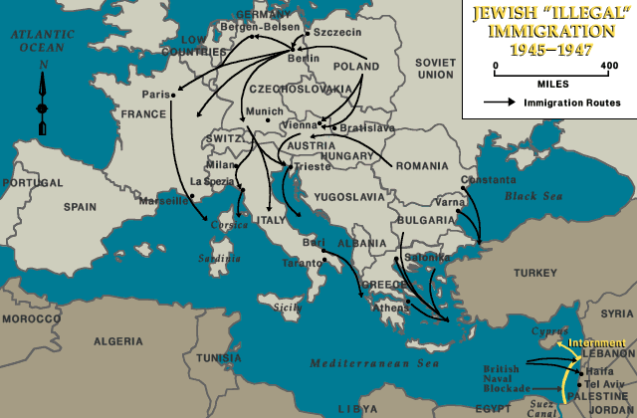
Jews were smuggled into Palestine by Berihah using a number of routes.
While Zionism had been prominent before the Holocaust, afterwards it became almost universally accepted among Jews. Many Zionists, pointing to the fact that Jewish refugees from Germany and Nazi-occupied lands had been turned away by other countries, argued that if a Jewish state had existed at the time, the Holocaust could not have occurred on the scale it did. With the rise of Zionism, Palestine became the destination of choice for Jewish refugees, but local Arabs opposed the immigration, the United Kingdom refused to allow Jewish refugees into the Mandate, and many countries in the Soviet Bloc made any emigration illegal. Former Jewish partisans in Europe, along with the Haganah in Palestine, organized a massive effort to smuggle Jews into Palestine, called Berihah, which eventually transported 250,000 Jews (both DPs and those who hid during the war) to the Mandate. By 1952, the Displaced Persons camps were closed, with over 80,000 Jewish DPs in the United States, about 136,000 in Israel, and another 20,000 in other nations, including Canada and South Africa.

Legal proceedings against Nazis
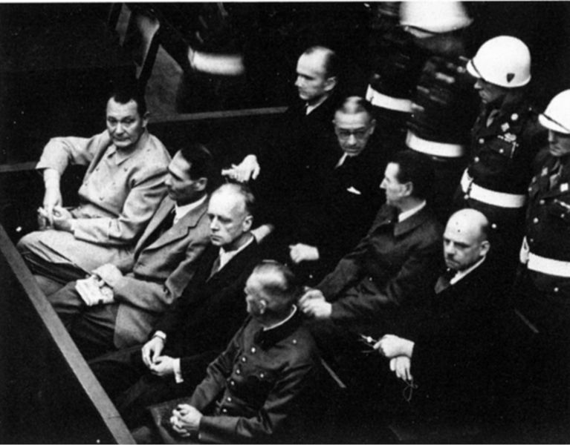
Defendants at the Nuremberg Trials - Front row: Göring, Heß, von Ribbentrop, and Keitel. Second row: Dönitz, Raeder, Schirach, Sauckel.
The juridical notion of crimes against humanity was invented following the Holocaust. The sheer number of people murdered and the transnational nature of the slaughter shattered any notion of national sovereignty taking precedence over international law when prosecuting these crimes. There were a number of legal efforts established to bring Nazis and their collaborators to justice. Some of the higher ranking Nazi officials were tried as part of the Nuremberg Trials, presided over by an Allied court; the first international tribunal of its kind. In total, 5,025 Nazi criminals were convicted between 1945-1949 in the American, British and French zones of Germany. Other trials were conducted in the countries in which the defendants were citizens — in West Germany and Austria, many Nazis were let off with light sentences, with the claim of "following orders" ruled a mitigating circumstance, and many returned to society soon afterwards.
An ongoing effort to pursue Nazis and collaborators resulted, famously, in the capture of Holocaust organizer Adolf Eichmann in Argentina (an operation led by Rafi Eitan) and to his subsequent trial in Israel in 1961. Simon Wiesenthal became one of the most famous Nazi hunters. Some former Nazis, however, escaped any charges. Thus, Reinhard Gehlen a former intelligence officer of the Wehrmacht, set up the ODESSA network, which helped many ex-Nazis to escape in Franquist Spain, Latin America or in the Middle East. Gehlen managed to turn around and work for the CIA, and created in 1956 the Bundesnachrichtendienst (BND), the German intelligence agency, which he directed until 1968. Klaus Barbie, known as "the Butcher of Lyon" for his role at the head of the Gestapo, was protected from 1945 to 1955 by the MI-5 and the CIA, before fleeing to South America where he had a hand in Luis García Meza Tejada's 1980 Cocaine Coup in Bolivia. Barbie was finally arrested in 1983 and sentenced to life imprisonment for crimes against humanity in 1987. In October 2005, Aribert Heim (aka "Doctor Death") was found to be living for twenty years in Spain, protected by ODESSA. Paul Schäfer, who had founded Colonia Dignidad in Chile, was arrested in 2005 on child sex abuses charges. Furthermore, some "enlightened" Nazis were pardoned and permitted to become members of the Christian Democracy, among whom Kurt Georg Kiesinger, who became Germany's Chancellor for a period in the 1960s, Hans Filbinger, who became Minister President of Baden-Württemberg, and Kurt Waldheim, who became Secretary-General of the United Nations and President of Austria.

Legal action against genocide
The Holocaust also galvanized the international community to take action against future genocide, including the Convention on the Prevention and Punishment of the Crime of Genocide in 1948. While international human rights law moved forward quickly in the wake of the Holocaust, international criminal law has been slower to advance; after the Nuremberg trials and the Japanese war crime trials it was over forty years until the next such international criminal procedures, in 1993 in Yugoslavia. In 2002, the International Criminal Court was set up.
Although the Holocaust is often cited as the canonical example of genocide, none of its perpetrators were tried for that crime, as the crime of genocide had not been established at that stage. The first-ever convictions for genocide under the 1948 Convention were handed down on September 2, 1998, when the International Criminal Tribunal for Rwanda found Jean-Paul Akayesu, the former mayor of a small town in Rwanda, guilty of nine counts of genocide committed during the Rwandan Genocide in 1994. No state has as yet been convicted of genocide. Only one inter-state case has so far been brought before the International Court of Justice, that of Bosnia and Herzegovina v. Serbia and Montenegro, which has yet to be resolved.

Holocaust denial
Main article: Holocaust denial
Holocaust denial, (referred to by its supporters as Holocaust revisionism), is the belief that the Holocaust did not occur, or, more specifically: that far fewer than around six million Jews were killed by the Nazis (numbers below one million, most often around 30,000 are typically cited); that there never was a centrally-planned Nazi attempt to exterminate the Jews; and/or that there were not mass killings at the extermination camps. Those who hold this position often further claim that Jews and/or Zionists know that the Holocaust never occurred, yet that they are engaged in a massive conspiracy to maintain the illusion of a Holocaust to further their political agenda. As the Holocaust is generally considered by historians to be one of the most documented events in recent history, these views are not accepted as credible by scholars, with organizations such as the American Historical Association, the largest society of historians in the United States, stating that Holocaust denial is "at best, a form of academic fraud."^{[48]}
Holocaust deniers almost always prefer to be called Holocaust revisionists. Most scholars contend that the latter term is misleading. Historical revisionism, in the original sense of the word, is a well-accepted and mainstream part of the study of history; it is the reexamination of accepted history, with an eye towards updating it with newly discovered, more accurate, and/or less biased information, or viewing known information from a new perspective. In contrast, negationists typically willfully misuse or ignore historical records in order to attempt to prove their conclusions, as Gordon McFee writes:
'Revisionists' depart from the conclusion that the Holocaust did not occur and work backwards through the facts to adapt them to that preordained conclusion. Put another way, they reverse the proper methodology [...], thus turning the proper historical method of investigation and analysis on its head.^{[49]}
Public Opinion Quarterly summarized that: "No reputable historian questions the reality of the Holocaust, and those promoting Holocaust denial are overwhelmingly anti-Semites and/or neo-Nazis." Holocaust denial has also become popular among Muslim opponents of Israel. The doctoral dissertation of Mahmoud Abbas, President of the Palestinian National Authority since 2005, raised doubts that gas chambers were used for the extermination of Jews and suggested that the number of Jews killed in the Holocaust was "less than a million."^{[50][51]} Abbas has, however, not espoused this position since his appointment as Palestinian Prime Minister in 2003, and has denied being a Holocaust denier. In late 2005 Iranian president Mahmoud Ahmadinejad described the Holocaust of European Jewry as "the myth of the Jews' massacre."^{[52][53]} Public espousal of Holocaust denial is a crime in ten European countries (including France, Poland, Austria, Switzerland, Belgium, Romania, and Germany), while the Nizkor Project attempts to counter it on the Internet.

Survivors welfare
As of 2005, of the nearly 400,000 Holocaust survivors residing in Israel, 40% live below the poverty line, increasing significantly since 1999 and resulting in heated and dramatic protests on the part of survivors against the Israeli government and related agencies. The average rate of cancer among survivors is nearly two and a half times that of the national average. The average cases of colon cancer among survivors are nine times higher than the national average, which is attributed to the conditions of starvation experienced by survivors as well as extreme stress.^{[54][55]}

Impact on culture

Holocaust theology
Main article: Holocaust theology
On account of the magnitude of the Holocaust, many theologians have re-examined the classical theological views on God's goodness and actions in the world. Some believers and former believers question whether people can still have any faith in God after the Holocaust, and some of the theological responses to these questions are explored in Holocaust theology.

Art and literature
Main article: The Holocaust in art and literature
German philosopher Theodor Adorno famously commented that "writing poetry after Auschwitz is barbaric," and the Holocaust has indeed had a profound impact on art and literature, for both Jews and non-Jews. Some of the more famous works are by Holocaust survivors or victims, such as Elie Wiesel, Primo Levi, and Anne Frank, but there is a substantial body of literature and art in many languages. Indeed, Paul Celan wrote his poem Todesfuge as a direct response to Adorno's dictum.
The Holocaust has also been the subject of many films, including Oscar winners Schindler's List and Life Is Beautiful. With the aging population of Holocaust survivors, there has been increasing attention in recent years to preserving the memory of the Holocaust. The result has included extensive efforts to document their stories, including the Survivors of the Shoah project and Four Seasons Documentary, as well as institutions devoted to memorializing and studying the Holocaust, including Yad Vashem in Israel and the US Holocaust Museum.

Freemasonry
After the World War II, the forget-me-not^{[56]} flower was used again as a Masonic emblem at the 1948, first, Annual Convention in of the United Grand Lodges of Germany, Ancient Free & Accepted Masons. The badge is now worn in the coat lapel by Freemasons around the world to remember all those that have suffered in the name of Freemasonry, and specifically those during the Nazi era.^{[57][58]}

Holocaust Memorial Days
Main article: Yom HaShoah
In a unanimous vote, the United Nations General Assembly voted on November 1, 2005, to designate January 27 as the "International Day of Commemoration in Memory of the Victims of the Holocaust." January 27, 1945 is the day that the former Nazi concentration and extermination camp of Auschwitz-Birkenau was liberated. Even before the UN vote, January 27 was already observed as Holocaust Memorial Day in the United Kingdom since 2001, as well as other countries, including Sweden, Italy, Germany, Finland, Denmark and Estonia. Israel observes Yom HaShoah vea hagvora, the "Day of Remembrance of the Holocaust and the courage of the Jewish people ," on the 27th day of the Hebrew month of Nisan, which generally falls in April. This memorial day is also commonly observed by Jews outside of Israel.

References
- ^ Donald L Niewyk, The Columbia Guide to the Holocaust, Columbia University Press, 2000, p.45: "The Holocaust is commonly defined as the murder of more than 5,000,000 Jews by the Germans in World War II." There is a debate among scholars over whether the Holocaust only refers to Jewish victims, or to all groups targeted by the Nazis, or to some subset of those groups. All scholars agree that other groups were targeted by the Nazis, but not all believe that the victims are part of the Holocaust. This article uses a wide definition of the Holocaust to include all groups systematically targeted by the Nazis.
- ^ Holocaust Forgotten lists 5 million non-Jewish victims of the Holocaust, Niewyk suggests that the broadest definitions of the Holocaust would have as many as 17 million victims. The 26 million number is given in Service d'Information des Crimes de Guerre: Crimes contre la Personne Humain, Camps de Concentration (Paris, 1946), 197. For details on the number of victims given in the introduction, please see the death toll section.
- ^ "The Holocaust: Definition and Preliminary Discussion," Yad Vashem (accessed June 8, 2005) And www.berkeleyinternet.com/holocaust/
- ^ Richard Overy, Russia's War. Penguin Books; 1998.
- ^ Black, Edwin (2001). IBM and the Holocaust: The Strategic Alliance Between Nazi Germany and America's Most Powerful Corporation. Three Rivers Press, 560. ISBN 0609808990.
- ^ Martin Gilbert, The Oxford Companion to World War II Oxford: Oxford UP, 1995
- ^ Douglas Davis, "7 million died in Holocaust," Jerusalem Post, May 20, 1997 (accessed June 8, 2005).
- ^ "How many Jews were murdered in the Holocaust? How do we know? Do we have their names?," Yad Vashem (accessed June 8, 2005). A detailed breakdown of various estimates of the victims is available from the Online Library of the United States Holocaust Museum (accessed August 10, 2005)
- ^ Poles: Victims of the Nazi Era at the US Holocaust Museum
- ^ Freemasons for Dummies, by Christopher Hodapp, Wiley Publishing Inc., Indianapolis, 2005, p.85, sec. Hitler and the Nazi
- ^ According to the United States Holocaust Museum [1].
- ^ Hilberg, Raul. The destruction of the European Jews (Yale Univ. Press, 2003, c1961).
- ^ Yisrael Gutman, Michael Berenbaum, Raul Hilberg, Franciszek Piper, Yehuda Bauer, Anatomy of the Auschwitz Death Camp, Indiana University Press, 1998, p.71.
- ^ Gilbert, Martin, Atlas of the Holocaust, New York: William Morrow and Company, Inc, 1993.
- ^ Lucy Dawidowicz, The War Against The Jews, 1933-1945, New York : Holt, Rinehart and Winston, 1975 ISBN 0-03-013661-X
- ^ Wolfgang Benz in Dimension des Volksmords: Die Zahl der Judischen Opfer des Nationalsocialismus (Munich: Deutscher Taschebuch Verlag, 1991). Israel Gutman, Encyclopedia of the Holocaust, Macmillan Reference Books; Reference edition (October 1, 1995)
- ^ A. Hitler, Mein Kampf, pages 315 and 320.
- ^ Documented evidence from the US Holocaust Memorial Museum pertaining to the persecution of the Freemasons accessed 21 May 2006
- ^ Freemasons for Dummies, Christopher Hodapp, ISBN 0-7645-9796-5, Hungry Minds Inc,U.S., 2005.
- ^ The Encyclopedia of the Holocaust, volume 2, page 531, citing Katz, Jews and Freemasons in Europe.
- ^ (German) Das Vergißmeinnicht-Abzeichen und die Freimaurerei, Die wahre Geschichte Accessed July 8, 2006.
- ^ "THE BLUE FORGET-ME-NOT" - ANOTHER SIDE OF THE STORY Accessed July 8, 2006.
- ^ Die Freimaurer-Logen Deutschlands und deren Grosslogen 1737-1972 (Quatuor Coronati Bayreuth, Hamburg 1974). Second revised edition, Karl Heinz Francke and Dr. Ernst-Günther Geppert, Die Freimaurer-Logen Deutschlands und deren Grosslogen 1737-1985 (Hamburg 1988).
- ^ Gilbert, The Oxford Companion to World War II
- ^ Persecution and Resistance of Jehovah's Witnesses During the Nazi-Regime 1933-1945 Social Disinterest, Governmental Disinformation, Renewed Persecution, and Now Manipulation of History? p.251
- ^ Donald L Niewyk, The Columbia Guide to the Holocaust, Columbia University Press, 200, p 83-87. For Reserve Police 101 see Browning, Christopher R., Ordinary Men: Reserve Police Battalion 101 and the Final Solution in Poland, New York, Harper Collins, 1992
- ^ ª ^{b} See René Rémond's classic study on "The Right [wings] in France" (Les Droites en France), and also Zeev Sternhell's arguments according to which fascism was invented in France at the early 20th century, before being adopted and transformed into a popular movement in Italy. French historians, such as Pierre Milza and Serge Bernstein, have argued that there was no "French fascism", because although some groups, such as the PPF and others, adopted fascist and even Nazi postures, fascism never became really popular. Against Sternhell, they argue that fascism cannot be reduced to an intellectual movement, and must necessarily be considered in its mass dimension.
- ^ "Romania: Facing the Past" available in Romanian and English, published online March, 2005.
- ^ "The Holocaust in Hungary" Prof. Jonathan Petropoulos, Claremont McKenna College. See also the Hungarian Holocaust Museum, also
- ^ "Jasenovac" at the Jewish Virtual Library
- ^ Boyadjieff, Christo. Saving the Bulgarian Jews in World War II. excerpted at Salvation of Bulgarian Jews during WW II Collection of Materials - URL retrieved September 20, 2006.
- ^ "Victims and Perpetrators, Michal Kabác: Slovak Hlinka Guard," PBS (accessed June 8, 2005).
- ^ "The Holocaust in Latvia: An introduction" by Andrew Ezergailis, book excerpt, The Historical Institute of Latvia, 1996.
- ^ Max Jakobson Commission Investigation of Crimes Against Humanity, "[2] Report"
- ^ Ad van Liempt, A Price on Their Heads, Kopgeld, Dutch bounty hunters in search of Jews, 1943, NLPVF (accessed June 8, 2005).
- ^ Richard Breitman, "What Diplomats Learned about the Holocaust," US National Archives (accessed August 30, 2005).
- ^ Robert S. Wistrich: Hitler and the Holocaust. Chapter 7. London 2001.
- ^ When did the American press first report on the "Final Solution"? (USHMM Research Library). Accessed 2006-08-17
- ^ "11 Allies Condemn Nazi War on Jews: United Nations Issue Joint Declaration of Protest on 'Cold-Blooded Extermination'". New York Times, 18 December 1942, pp.1, 10.
- ^ Robert S. Wistrich: Hitler and the Holocaust. Chapter 7. London 2001.
- ^ John Ezard, "Germans knew of Holocaust Horror about Death Camps," Guardian, February 17, 2001.
- ^ Theodor Adorno and Max Horkheimer, Dialectic of Enlightenment, 2002 translation)
- ^ See also Enzo Traverso, "Nazism’s roots in European culture - Production line of murder" in Le Monde diplomatique, February 2005
- ^ "Savage Modernism", Russell Jacoby, The Nation, October 13, 2003 issue
- ^ Bullying in Schools - URL retrieved September 2, 2006
- ^ ª ^{b} Prechter, Robert R., Jr. 2000. The Wave Principle of Human Social Behavior and the New Science of Socionomics. New Classics Library. ISBN 0932750494.
- ^ Germany to open Holocaust archives Al-Jazeera 19 April, 2006
- ^ Donald L. Niewyk, ed. The Holocaust: Problems and Perspectives of Interpretation, D.C. Heath and Company, 1992.
- ^ Gord McFee, "why 'Revisionism' isn't," The Holocaust History Project (accessed June 8, 2005).
- ^ Was Abu Mazen a Holocaust Denier? By Brynn Malone (History News Network)
- ^ Abu Mazen: A Political Profile. Zionism and Holocaust Denial by Yael Yehoshua (MEMRI) April 29, 2003
- ^ Iranian Leader Denies Holocaust BBC News 14 December, 2005
- ^ Tom Smith, "The Polls--A Review: The Holocaust Denial Controversy." Public Opinion Quarterly 59 (Summer 1995): 269-295.
- ^ "40% of Holocaust survivors in Israel live below poverty line", Haaretz, December 29, 2005.
- ^ "Social Safety Nets" (PDF), In Re Holocaust Victim Assets Litigation (Swiss Banks), September 11, 2000.
- ^ Das Vergissmeinnicht The Forget-Me-Not Accessed February 6, 2006.
- ^ Flower Badge as told by Galen Lodge No 2394 (UGLE) Accessed March 4, 2006.
- ^ Flower Badge Accessed March 4, 2006.

See also
Find more information on The Holocaust by searching Wikipedia's sister projects:
Dictionary definitions from Wiktionary
Textbooks from Wikibooks
Quotations from Wikiquote
Source texts from Wikisource
Images and media from Commons
News stories from Wikinews
Learning resources from Wikiversity
- Holocaust in Poland
- Rescue of the Danish Jews
- International Holocaust Cartoon Competition
- Anti-Semitism
- Aryanization
- Bereavement in Judaism
- Genocide
- Anti-Catholicism
- World domination
- Historikerstreit
- Death marches
- International response to the Holocaust
- Phases of the Holocaust
- Jews outside Europe under Nazi occupation
- History of gays in Nazi Germany and the Holocaust
- History of the Roma and Sinti during the Holocaust
- Holocaust memorials
- Involvement of Croatian Catholic clergy with the Ustaša regime
- Sh'erit ha-Pletah (Jewish Holocaust survivors)
- Wiedergutmachung (reparations to individual survivors)
- War crimes of the Wehrmacht
- Extermination through labour
- German war crimes
- Nazi
- Japanese war crimes

Eugenics
- Rhineland Bastard

Individuals and the Holocaust
- List of famous Holocaust survivors
- List of victims of Nazism
- List of people who helped Jews during the Holocaust (see also Righteous Among the Nations)
- Rudolf Vrba

Nazi concentration camps
See List of Nazi concentration camps, Nazi extermination camp
- Auschwitz
- Belzec
- Bergen-Belsen
- Chełmno
- Dachau
- Flossenbürg
- Grini
- Jasenovac
- Klooga
- Majdanek
- Mauthausen-Gusen
- Ravensbrück
- Treblinka

Ghettos
- Warsaw Ghetto
- Judenrat (Jewish administrative bodies established in the ghettos by order of the Nazis)

Massacres and pogroms
- in Białystok
- Babi Yar Massacre
- Iaşi pogrom
- Jedwabne Massacre
- Kaunas Pogrom
- Kristallnacht
- Lviv pogroms
- in Paneriai
- Odessa Massacre

Jewish resistance

Poland
- Resistance groups
  - Żydowski Związek Walki
  - Żydowska Organizacja Bojowa
- Uprisings
  - Warsaw Ghetto
  - Białystok
  - Marcinkace
  - Sobibór
======================================================================================================
END

