Francis Parker Yockey 1917–1960
http://en.wikipedia.org/wiki/Francis_Parker_Yockey
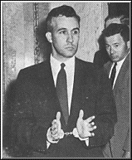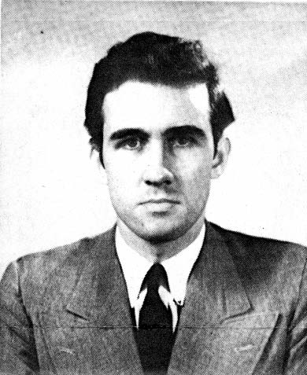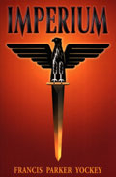
Francis Parker Yockey, (September 18, 1917 – June 16, 1960), was an American philosopher and polemicist best known for his neo-Spenglerian book Imperium, published under the pen name Ulick Varange [1] in 1948. [2]

Contents
- 1 Early life
- 2 Later life and works
- 3 Legacy
- 4 References
- 5 External links

Early life
Yockey was born in Chicago, Illinois and had family ties to Michigan. His parents were anglophiles who raised him to appreciate European high culture. Subsequently, Yockey was introduced to classical music through his mother, who studied at the Chicago Music College. He proved to have a prodigious talent for the piano and developed his repertoire to include Liszt, Beethoven, Chopin, and Haydn.
He flirted with Marxism momentarily in his youth, but later became a devotee of the elitist and anti-materialist Oswald Spengler after reading Spengler's seminal text, Der Untergang des Abendlandes (The Decline of the West), in 1934. While still a university student in the late 1930s, Yockey had his first political essay published in Social Justice, a periodical distributed under the auspices of Fr. Charles Coughlin, the so-called “radio priest,” who at the time was widely known for his sympathetic view of the anti-Bolshevist policies associated with Hitler's Germany, Mussolini's Italy, and Franco's Spain.
Yockey attended at least seven universities, including Georgetown's School of Foreign Service, before graduating cum laude from the University of Notre Dame Law School in 1941.

[] Later life and works
Over time, Yockey contacted a number of far-right organizations. These included the German-American Bund, the German-American National Alliance, William Dudley Pelley's Silver Shirts, Sir Oswald Mosley's Union Movement, and James H. Madole's National Renaissance Party. Yockey and George Lincoln Rockwell were alleged to be foes, due primarily to Rockwell's offense at Yockey's anti-Americanism and sympathies with the Soviet Union and other anti-zionist leftist movements. Proponents of universal Nazism, like Colin Jordan, disagreed with Yockey's view on race, and saw Yockeyism as a kind of "New Strasserism".
In 1943, Yockey was invalided out of the U.S. Army, with a diagnosis of "dementia praecox, paranoid type", a condition now known as paranoid schizophrenia. [3] [4]
In early 1946, Yockey began working for the United States War Department as a post-trial review attorney for the Nuremberg Trials in Germany. He soon began agitating against Allied occupation of Germany, as well as what he perceived to be the biased procedures of the Nuremberg tribunal. Eventually, he was fired for "abandonment of position" in November 1946.
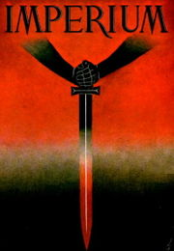
Jacket of Imperium
Without notes, Yockey wrote his first book, Imperium, in Brittas Bay, Ireland over the winter and early spring of 1948. It is a Spenglerian critique of 19th century materialism and rationalism. It has been endorsed by conservative thinkers around the world including German General Otto Remer, Professor of Classics at the University of Illinois, Revilo P. Oliver, and Italian esotericist Julius Evola. Yockey becamed embittered with Sir Oswald Mosley after the latter refused to publish Imperium upon its completion.
Along with Mosleyites Guy Chesham and John Gannon, Yockey formed the European Liberation Front (ELF) in 1948-49. The ELF issued a newsletter, Frontfighter, and published Yockey's virulent anti-American polemic, "The Proclamation of London".
In late 1952, Yockey traveled to Prague and witnessed the Prague Trials. He believed they "foretold a Russian break with Jewry", a view he put forward in his most controversial article What Is Behind The Hanging Of The Eleven Jews In Prague?.
Yockey met Egyptian President Gamal Abdel Nasser, who he called "a great and vigorous man", in Cairo in 1953. He worked briefly for the Egyptian Information Ministry writing anti-Zionist propaganda. Yockey saw the rise of non-aligned states in the Third World, and in particular the Arab Revolt, as significant geopolitical challenges to "the Jewish-American power" [5].
Yockey was found dead with an empty cyanide capsule nearby while in a jail cell in San Francisco under FBI supervision, after having been incarcerated on charges of using false passports.
Maurice Bardèche, a French writer of fascist sympathies, wrote about his meeting with Yockey in his semi-autobiographical novel Suzanne et le taudis. Yockey, called "Ulrich Clarence" in the book, was described by Bardèche as a complete lunatic.

[] Legacy
The National Youth Alliance was founded in 1968 by Willis Carto with the intent to promote Yockey's political philosophy and his book Imperium.

[] References
- Dreamer of the Day: Francis Parker Yockey and the Postwar Fascist International by Kevin Coogan, Autonomedia, Brooklyn, NY 1998 ISBN 1-57027-039-2 (publisher's blurb, Table of contents)
- Varange: Life and Thoughts of Yockey by Kerry Bolton, (Renaissance Press, New Zealand, Catalogue)
- Imperium by F. Yockey ISBN 0-911038-10-8
- The Enemy of Europe: The Enemy of Our Enemies by Francis Parker Yockey and Revilo P. Oliver ISBN 0-942094-00-X Oliver's part 2nd section 3rd 4th 5th and 6th
- The Beast Reawakens by Martin A. Lee, New York: Little, Brown and Company, 1997. ISBN 0-316-51959-6

[] External links
Wikiquote has a collection of quotations related to:
Francis Parker Yockey
- "Imperium" e-book
- The Francis Parker Yockey Collection
- On Propaganda in America, an extract from Imperium
- Full text of Imperium in a single html file
- Review of Dreamer of the Day
- "The Tragic Life of a Spenglerian Visionary" -- Review of Dreamer of the Day
- "An American National Bolshevik" -- Review of Dreamer of the Day
- Dave Emory's For The Record broadcast #237 Interview with Kevin Coogan
- Dave Emory's For The Record broadcast #354 Interview with Kevin Coogan
- Gnostic Liberation Front's Yockey collection second page third page (criticism)
- Imperium the foe of the NWO
============================================================================================================================
END

