MURRAH, ALFRED PAUL (1904–1975).

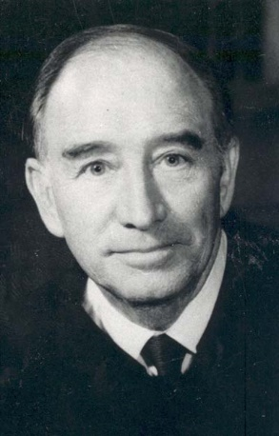

Attorney and federal judge Alfred Paul Murrah, Sr., was born October 27, 1904, near Earl, Indian Territory, a now-extinct community but then part of the Chickasaw Nation. His parents were George Washington and Lanora M. Simmons Murrah.

Soon after Murrah's birth the family moved to Verden in present Grady County. Murrah's mother died when he was seven, and Murrah, his father, and a brother moved to Alabama. On his father's death, while Alfred was in his early teens, Murrah became a "knight of the road" for a time, riding freight cars throughout the southern and southeastern United States and doing odds jobs such as washing dishes and selling newspapers.

Deciding to return to Oklahoma, Murrah and a brother boarded a freight train headed west, hid under a piece of machinery, and made it to Oklahoma City before a railroad policeman found them and rudely evicted them from their accommodations. Making his way to Tuttle in Grady County, Murrah persuaded a family named MacPhail to give him room and board in return for milking their six cows. He also talked the high-school principal into allowing him to attend school, and he secured a second job at the Star Pharmacy. In 1923 he graduated as a member of the debate team, president of the senior class, and valedictorian.

Entering the University of Oklahoma, Murrah worked his way through college, receiving the bachelor of laws degree in 1928. After practicing briefly in Oklahoma City, he and Luther Bohanon formed a partnership in Seminole, Oklahoma, during the heyday of the nearby oil-field boom. Murrah described Seminole in those days as a "Klondike oil town." The firm subsequently moved to Oklahoma City. Murrah's practice was almost exclusively workers compensation and personal injury litigation.

In 1937, at age thirty-two, Murrah was appointed U.S. District Judge for the Western, Eastern, and Northern Districts of Oklahoma. His appointment came on recommendation of U.S. Sen. Josh Lee, who had been Murrah's professor at the University of Oklahoma and whose elections to Congress and then to the Senate Murrah had masterminded. In 1940 Murrah was elevated to the U.S. Court of Appeals for the Tenth Circuit.

A tireless worker for improvements in the administration of justice, Murrah served for many years as chair of the Committee on Pretrial Practice and Procedure of the Judicial Conference of the United States, chair of the Council of Judges of the National Council on Crime and Delinquency, chair of the Judicial Panel on Multidistrict Litigation, and director of the Federal Judicial Center.

Murrah and Agnes "Babe" Milam married on June 29, 1930, and had three children, Ann, Paul, Jr., and Sue. Murrah died October 30, 1975. The Alfred P. Murrah Federal Building in Oklahoma City, opened in 1978 and destroyed April 19, 1995, by a terrorist bomb attack, was named in his honor.

Von R. Creel

**See also:**[LUTHER LEE BOHANON](http://www.okhistory.org/publications/enc/entry.php?entryname=LUTHER%20LEE%20BOHANON), [GOVERNMENT AND POLITICS](http://www.okhistory.org/publications/enc/entry.php?entryname=GOVERNMENT%20AND%20POLITICS), [EDGAR SULLINS VAUGHT](http://www.okhistory.org/publications/enc/entry.php?entryname=EDGAR%20SULLINS%20VAUGHT)

**Bibliography**

Von Russell Creel, Bob Burke, and Kenny A. Franks, *American Jurist: The Life of Alfred P. Murrah* (Oklahoma City: Oklahoma Heritage Association, 1996).

Alfred P. Murrah Papers, Western History Collections, University of Oklahoma, Norman.

**Citation**

The following (as per *The Chicago Manual of Style*, 16th edition) is the preferred citation for articles:  
Von R. Creel, "Murrah, Alfred Paul," *The Encyclopedia of Oklahoma History and Culture*, www.okhistory.org (accessed April 21, 2018).

© Copyright Oklahoma Historical Society 2009.

[About the Encyclopedia](http://www.okhistory.org/publications/encabout.php) | [Terms of Use](http://www.okhistory.org/publications/encterms.php) | [Using the Encyclopedia](http://www.okhistory.org/publications/enchowto.php)