Revilo Pendleton Oliver 1908-1994
http://en.wikipedia.org/wiki/Revilo_P._Oliver
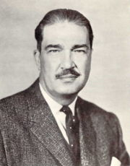
Revilo P. Oliver in 1963
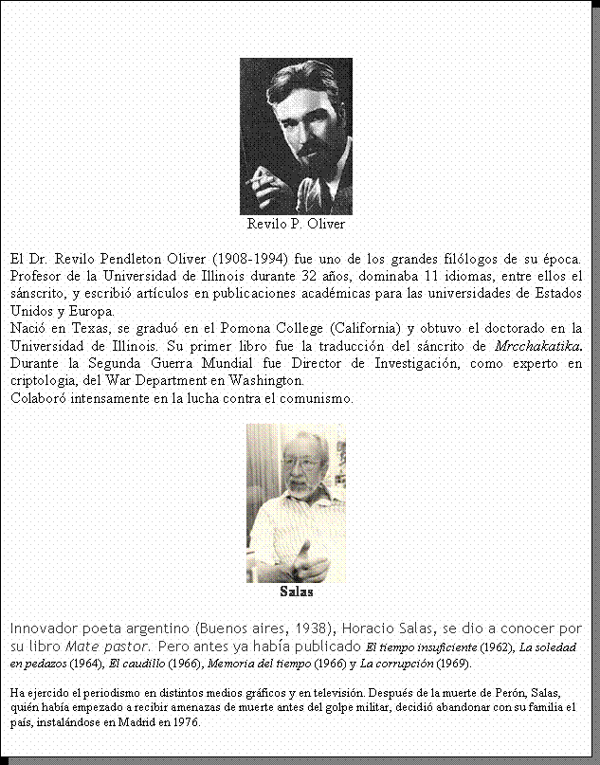
Revilo Pendleton Oliver (7 July 1908-10 August 1994) was an American professor of Classical philology, Spanish, and Italian at the University of Illinois at Urbana-Champaign, who wrote and polemicized extensively for Racial Nationalist causes. He has been described as "one of America's most notorious fascists" and, according to B'nai Brith Canada, was "a long time proponent of antisemitism".^{[1]}
Starting on the original staff of National Review magazine as a mainstream conservative, Oliver gradually became considerably more extreme in his polemics and soon fell out with William F. Buckley. Oliver then joined Robert Welch as a founding member of Buckley's rival, the John Birch Society, and wrote for their magazine American Opinion. He also had a variably close relationship with the Liberty Lobby. He briefly came to some national notoriety after the publication of an article following the Kennedy assassination, titled "Marxmanship in Dallas",^{[2]}, for which he was called to testify before the Warren Commission.^{[3]}
Oliver broke from the Birch Society (as he had already done with conventional American conservatism and National Review) and openly embraced an anti-Jewish racial viewpoint. He was an orial advisor for the Institute for Historical Review, and a regular contributor to the neo-Nazi periodical, Liberty Bell. His writings have been promoted by Kevin Alfred Strom of National Vanguard.
Oliver believed that religion was one of the major weaknesses of his nation and civilization. An atheist and materialist, he characterized Christianity as "a spiritual syphilis," which "has rotted the minds of our race and induced paralysis of our will to live."^{[4]}

Contents
- 1 Biography
- 2 Pseudonyms
- 3 As a Palindrome
- 4 Works
- 5 References
- 6 External links
  - 6.1 Critical links

Biography
Oliver was born near Corpus Christi, Texas on 7 July 1908. He attended two years of high school in Illinois. Disliking the severe winters, and once requiring hospitalization "for one of the first mastoidectomies performed as more than a daring experiment," he moved to California. He began the study of Sanskrit, using Max Müller’s handbooks and Monier Williams' grammar, later finding a Hindu missionary to provide tuition. As an adolescent, he found amusement in going to watch evangelists "pitch the woo at the simple-minded", attending performances of Aimee Semple McPherson and Katherine Tingley. He entered Pomona College in Claremont, California, when he was sixteen.
In 1930, Oliver married Grace Needham. He began attending the University of Illinois and studied under William Abbott Oldfather. His first book was an annotated translation, from the Sanskrit, of Mricchakatika (The Little Clay Cart) published by the University of Illinois in 1938. He received the degree of Philosophiae Doctor in 1940. That same year, the University published his Ph.D. thesis: Niccolò Perotti's translations of the Enchiridion (republished in 1954 as Niccolo Perotti's Version of the Enchiridion of Epictetus, with an Introduction and List of Perotti's Writings). He began teaching graduate classes immediately after receiving the degree. For a number of years he also gave graduate courses in the Renaissance, which put him also in the Department of Spanish and Italian.
During the Second World War, Oliver worked with distinction at the U.S. Army Signal Corps installation, Arlington Hall, in cryptanalysis. From 1942 until the autumn of 1945, he came to be in charge of a rapidly expanding department, and advanced from Analyst to Director of Research (eventually responsible for the work of about 175 persons). He claimed that in his privileged position, he learned what he called "the ultimate secret of Pearl Harbor" (that Franklin Roosevelt had incited the Japanese into the attack).^{[5]}
Oliver left Washington D.C. (which he called the "District of Corruption") in 1945. He was convinced that within a few years, the facts of pro-Soviet actions and other operations would become known, and the American people would react with a violent "housecleaning" of the government. Confident that the future popular reaction was inevitable, Oliver returned to the University as an Assistant Professor, became an Associate Professor in 1947, and Professor in 1953. He held a Guggenheim Fellowship in 1946-47, and a Fulbright (Italy), 1953-54.
In 1955 Oliver's friend, Professor Willmoore Kendall, discussed plans for the journal which was eventually called National Review. Kendall "desiderated a "conservative" antidote to the New Republic, etc.," and had among his pupils at Yale, William F. Buckley Jr.. Kendall convinced Oliver to write on political subjects for the journal.^{[6]}
In 1958, Oliver joined Robert Welch in being one of the founding members of the anti-Communist John Birch Society. Oliver wrote frequently for the Birch Society magazine American Opinion, his most widely-noted piece being a two-part article called "Marxmanship in Dallas" that asserted that Lee Harvey Oswald had carried out the assassination of President Kennedy as part of a Communist conspiracy. In Oliver's view, the Communists wished to eliminate Kennedy as a puppet who had outlived his usefulness. Oliver testified before the Warren Commission on the basis for his assertions, but was not taken particularly seriously.
In the 1960s Oliver supposedly broke with conventional American conservatism having become convinced that Welch had either cozened him from the start or sold out later, and severed his connections with what he called "the Birch hoax." He thus came to openly embrace an essentially Nazi worldview, and eventually to assist William L. Pierce in forming the National Alliance, a White Nationalist organization, a significant portion of whose supporters and members have re-formed under the name National Vanguard.
He retired as Emeritus in 1977.
According to the corresponding German Wikipedia page, Oliver, who was suffering from leukemia and emphysema, brought on by his longstanding habit of smoking, shot himself at the age of 86 on August 10, 1994 in Urbana, in order to spare himself further suffering.

[] Pseudonyms
He also used the pen names "Ralph Perier" (for The Jews Love Christianity and Religion and Race) and "Paul Knutson" (for Aryan Asses). It is claimed that Oliver was the actual author of the Introduction (cred to Willis Carto) to Francis Parker Yockey's Imperium.

[] As a Palindrome
"Revilo P. Oliver" is a palindrome--a phrase that reads the same backwards and forwards. One of his articles was denounced as a transparent fraud because the palindrome looked suspicious, but according to Oliver, it was a family custom that went back six generations.^{[7]}

[] Works
- America's Decline: The Education of a Conservative ISBN 0-87700-562-1
- The Enemy of Europe: The Enemy of Our Enemies with Francis Parker Yockey ISBN 0-942094-00-X
- "Populism" and "Elitism", 1982 ISBN 0-942094-01-8
- The Yellow Peril, 1983 ISBN 0-942094-11-5 [1]
- The Jewish Strategy, Palladian Books, 2002 (Introduction – Autobiographical Note; excerpt from Chapter 4; excerpt from Chapter 6; excerpt from Chapter 7; Chapter 8; Chapter 9; Chapter 11; Chapter 12)
- The Origins of Christianity
- Reflections on the Christ Myth

[] References
- ^ Farber, Bernie M. (January 1997). FROM MARCHES TO MODEMS: A REPORT ON ORGANIZED HATE IN METRO TORONTO. Focal Point Publications. Retrieved on 2006-09-01.
- ^ Oliver, Revilo P. Marxmanship in Dallas. Retrieved on 2006-09-01.
- ^ The Testimony of Professor Revilo Pendleton Oliver before the Warren Commission (1964-09-09). Retrieved on 2006-09-01.
- ^ Oliver, Revilo P. (November 1990). A CRINGING LORD. Liberty Bell. Retrieved on 2006-09-01.
- ^ Oliver, Revilo P. (July 1989). THE FINAL SECRET OF PEARL HARBOR. Liberty Bell. Retrieved on 2006-09-01.
- ^ Oliver, Revilo P. (July 1989). THE NEW ORDER CHANGETH, TOO. Liberty Bell. Retrieved on 2006-09-01.
- ^ Oliver, Revilo P. (2002). “Introduction”, The Jewish Strategy. Palladian Books. “My first name, an obvious palindrome, has been the burden of the eldest or only son for six generations.”

[] External links
- Revilo Pendleton Oliver site with a biographical sketch, audio for 12 of his speeches, and many of his writings.
- The Revilo P. Oliver Collection on the Stormfront site.
- Revilo P. Oliver Papers in the University of Illinois Archives Holdings
- mini-AIR from August 2001 first mentioning Revilo P. Oliver

[] Critical links
- Nasty Nazis Who Know Next to Nothing; Or, An Article Even My Foes Would Cheer by James Patrick Holding, an article challenging Oliver's claim that Jesus never existed.
Retrieved from "http://en.wikipedia.org/wiki/Revilo_P._Oliver"
Categories: American academics | People from Corpus Christi, Texas | Anti-Semitic people | Atheist philosophers | American neo-Nazis | American atheists | 1908 births | 1994 deaths | Libertarians
================================================================================================================================
END

