**CIA RUNS PEDOPHILE RINGS**

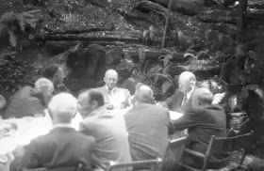 *Eisenhower at Bohemian Grove 1950.*  
  
The media has been telling us about**the child abuse and child murders**associated with such places as:  
  
**1.** The Arthur G Dozier School, in Marianna in Florida  
  
**2.** Boys town, in Omaha  
  
**3.** Colonia Dignidad, in Chile  
  
**4.** Certain children's homes and hospitals in Australia, Canada, the USA and the UK  
  
**5.** Certain child brothels in Thailand, Cambodia, London etc.  
  
**6.** Marc Dutroux's cellars in Belgium.  
  
**7.** Certain pool parties in Hollywood.  
  
[**Elliot Rodger - sex slave?**](https://www.google.co.uk/url?sa=t&rct=j&q=&esrc=s&source=web&cd=2&cad=rja&uact=8&ved=0CCkQFjAB&url=http%3A%2F%2Faanirfan.blogspot.com%2F2014%2F06%2Felliot-rodger-sex-slave.html&ei=1r9pVKKFJobTaK_TgXA&usg=AFQjCNHQpZJFj8Eg24crfOO1LhJxebBcwg&sig2=UrM0uwzKay44XahOaajv6w&bvm=bv.79142246,d.d2s).  
  
[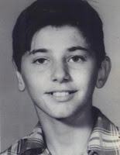](https://3.bp.blogspot.com/_NE-72ZXux-g/TNr4a7Vft4I/AAAAAAAAP9s/vaCwpyLMzNw/s1600/teenroger.jpg)  
*Roger Dean Kiser-Founder of "The Whitehouse Boys", the boys of the Arthur G Dozier School. (*[*http://www.thewhitehouseboys.com/*](http://www.thewhitehouseboys.com/)*)*  
  
**It has become clear that all of the above child abuse can be linked to the CIA, and its friends.**  
You could say that the culprits are a 'Zionist-Nazi-Mafia faction' within the CIA, Mossad and the Pentagon.  
  
If the CIA wants to control the boss of MI6, or the Secretary General of NATO, or a top Hollywood entertainer, or the President of the United States, or a member of a royal family, or a newspaper editor, or a key employee of Google, it can supply them with young girls or boys.

In order to get the system in place, the CIA has to know where children will be available for abuse.

A guide book is helpful.

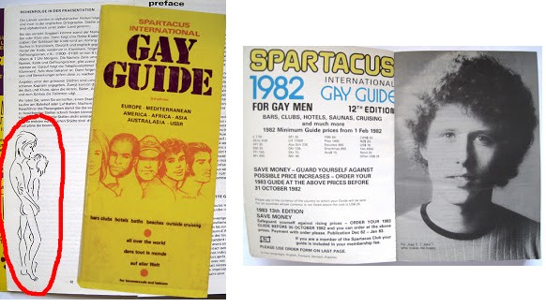

In 1964, an American called Bob Damron published a book listing gay bars.

The CIA is reported to have photographs of certain top foreign dignitaries visiting such bars.

From 1969/1970 onwards you could buy the **Spartacus** guide book which listed the child brothels all around the world from Port Au Prince to Pattaya.

It was a **very** fat guide book.

It was advertised in the mainstream media and was available in the larger bookshops.  
  
In other words, the security services seemed to be encouraging people to buy the book.



**Now, the big question is, how on earth did the Spartacus editors know the details of all these brothels around the world?**

**The people most likely to know all the details were the CIA and its friends.**  
The CIA has been linked to child abuse and child murder worldwide.  
  
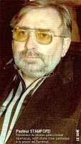  
*Former priest, John Stamford, publisher of Spartacus.*[*BOYLINKS - USA, UK, EUROPE, THE WORLD*](https://www.google.co.uk/url?sa=t&rct=j&q=&esrc=s&source=web&cd=2&cad=rja&uact=8&ved=0CDYQFjAB&url=http%3A%2F%2Faangirfan.blogspot.com%2F2013%2F07%2Fboylinks-usa-uk-europe-world.html&ei=X803U7yFL4-RhQel7IDgCg&usg=AFQjCNFA2L5AMH0KUhuhZH3Lqn96rqSWDQ&sig2=mwNdvCbP8KV5U29RK-wP2w)  
  
The Spartacus Club and Spartacus International were run from Amsterdam by **John Stamford,**a former Roman Catholic priest from the UK.  
  
In 1995, Stamford died mysteriously in prison in Belgium, aged 56.  
  
Spartacus members got a '10% Discount' at the Elm Guest House boy brothel in London.

[Ex-Tory minister 'pictured in child sex abuse video' confiscated by customs](http://news.google.co.uk/news/url?sr=1&ct2=uk%2F10_0_s_0_1_a&sa=t&usg=AFQjCNGzeX4S1jgFqE5ullKSOVx1SDwzrA&cid=43982361754699&url=http%3A%2F%2Fwww.mirror.co.uk%2Fnews%2Fuk-news%2Fex-tory-minister-pictured-child-sex-3300248&ei=A7Q3U_irDqr-iAbKHA&rt=HOMEPAGE&vm=STANDARD&bvm=section&did=3127371365844883143&sid=1925893269306323499)  
  
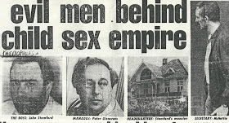  
  
**Peter Glencross**, commercial manager of Spartacus, helped persuade Carole Kasir to turn her Elm Guest House into a boy brothel.  
  
Peter Glencross reportedly set out to create a network of child brothels for Spartacus members.  
  
Customers of the Elm Guest house included members of MI5 and a cabinet minister, reportedly.  
  
[Elm guest house scandal: Coded advert that gave signal to perverts](http://www.mirror.co.uk/news/latest-news/adverts-for-elm-guest-house-included-1571994)

[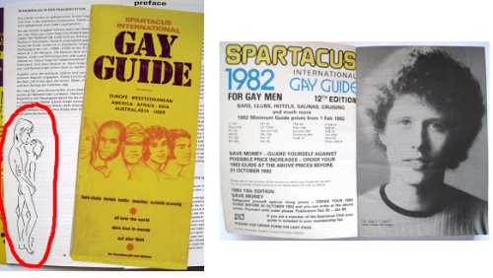](http://theneedleblog.files.wordpress.com/2013/01/spartacus.png)  
  
**According to the German blog [brunoleaks](http://brunoleaks.blogspot.co.uk/2011/08/2teil-die-ganze-geschichte-vom.html):**  
  
John D. Stamford "was responsible for the exploitation of children in Thailand, Sri Lanka, the Philippines …"  
  
In London five star accolades are given, by Spartacus, to - *Heaven* (Richard Branson), *Subway, Napoleon, Bolts, the Tent*...  
  
[**Spartacus | theneedleblog**](https://www.google.co.uk/url?sa=t&rct=j&q=&esrc=s&source=web&cd=5&cad=rja&ved=0CFEQFjAE&url=http%3A%2F%2Ftheneedleblog.wordpress.com%2F2013%2F01%2F14%2Fspartacus%2F&ei=KEQOUdDGIa620QXz74GoAQ&usg=AFQjCNEvavt4-jtpqGvKg-UL6mdzRfFgPA&sig2=ywZxjkh5d7LUmKsugYt0rQ)  
  
*Ecole en Bateau, a front for a paedophile ring.*[*Azimuth Trust was linked to 'boat schools*](https://www.google.co.uk/url?sa=t&rct=j&q=&esrc=s&source=web&cd=5&cad=rja&uact=8&ved=0CDkQFjAE&url=http%3A%2F%2Fspotlightonabuse.wordpress.com%2F2013%2F04%2F17%2Fazimuth-trust-was-linked-to-french-boat-schools-paedophile-ring%2F&ei=nkq4U-mgFZCw7AbpxIGIAw&usg=AFQjCNEo8i9soSnYMM59lJo2sunwTdso0Q&sig2=2oI8kBX5QO7_dvBGpfzf-g&bvm=bv.70138588,d.ZGU)*'*  
  
"The details of each of the Spartacus members, including their sexual preferences, the desired age of the children and preferred countries of origin were stored on a computer.  
  
[Paedophiles who prey on youngsters worldwide - World - News ...](https://www.google.co.uk/url?sa=t&rct=j&q=&esrc=s&source=web&cd=1&cad=rja&ved=0CDQQFjAA&url=http%3A%2F%2Fwww.independent.co.uk%2Fnews%2Fworld%2Fpaedophiles-who-prey-on-youngsters-worldwide-1310556.html&ei=KEQOUdDGIa620QXz74GoAQ&usg=AFQjCNH3WZ6vcY1_jlmoPLPRqwz7YxeOGQ&sig2=qcXEcZg-ydxdi1fq3UUQSA)  
  
"An estimated 200,000 Nepalese children have been sold into sexual slavery in India; in Thailand up to a quarter of a million children work in brothels; and in Colombia one third of prostitutes are thought to be under 14."  
  
[Paedophiles who prey on youngsters worldwide - World - News ...](https://www.google.co.uk/url?sa=t&rct=j&q=&esrc=s&source=web&cd=1&cad=rja&ved=0CDQQFjAA&url=http%3A%2F%2Fwww.independent.co.uk%2Fnews%2Fworld%2Fpaedophiles-who-prey-on-youngsters-worldwide-1310556.html&ei=KEQOUdDGIa620QXz74GoAQ&usg=AFQjCNH3WZ6vcY1_jlmoPLPRqwz7YxeOGQ&sig2=qcXEcZg-ydxdi1fq3UUQSA)

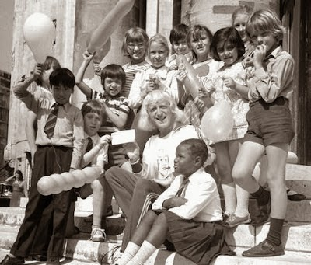  
*In 1955, we have the earliest recorded instance of child abuse by Sir Jimmy Savile (above), who is believed to have worked for the security services. In the late 1950's, Savile visited Moscow. On one occasion he gave a talk to the Israeli cabinet. He was a friend of the Chief of the UK Defence Staff.*  
  
We can go back at least as far as 1950 when Eisenhower, Hoover and Edward Teller attended the Bohemian Grove in California.  
  
Bohemian Grove is where the top people meet and reportedly get involved in child abuse and worse.  
  
In other words, there is a long history of the top people being involved in child abuse.  
  
[BOHEMIAN GROVE AND THE US MILITARY](https://www.google.co.uk/url?sa=t&rct=j&q=&esrc=s&source=web&cd=11&cad=rja&ved=0CF4QFjAK&url=http%3A%2F%2Faangirfan.blogspot.com%2F2012%2F07%2Fbohemian-grove-and-us-military.html&ei=d2XlUt-AGsqThQfNyIHADw&usg=AFQjCNHs6xhD_LqlWtETBBH6Jb1XCeeo7g&sig2=hB5A17tJnNje2k-0jmIJrw)  
  
..  
  
What we are talking about is child sex slaves, produced by the CIA.  
  
**In 1953 the US government sanctioned Project MKUltra, the CIA's programme to produce mind-controlled people, including child sex slaves.**  
  
Experiments are carried out on large numbers of children taken from children's care homes, such as Boys Town.  
  
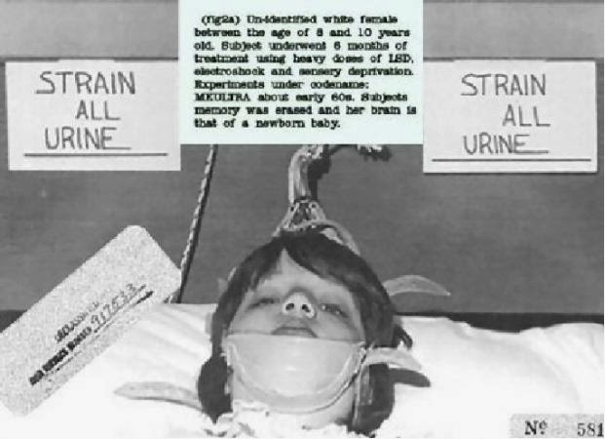  
*A child victim of the CIA's MK ULTRA*  
  
The MK ULTRA scientists, working in around 80 institutions, included Nazi war criminals.  
  
[Donald Ewen Cameron](http://en.wikipedia.org/wiki/Donald_Ewen_Cameron) worked on the programme in Canada and [William Sargant](http://en.wikipedia.org/wiki/William_Sargant) worked on the programme in London.  
  
The MK ULTRA scientists made use of torture.  
  
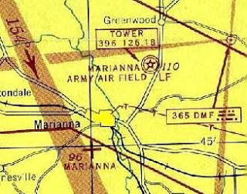  
*Marianna and Marianna****Army****Air Field.*  
  
From the 1940s onwards, the **Arthur G Dozier School**, in Marianna in Florida, was a home for boys.  
  
It is situated near a military base and may be linked to the CIA's MK ULTRA mind control programme.  
  
When a child is being mind-controlled, he is often forced to watch the murder of another child.  
  
Excavators have discovered at least 50 bodies buried in the grounds of the school, which was shut in 2011.  
  
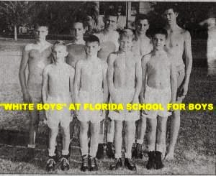  
  
In 2008, the Governor of Florida, Charlie Crist, was forced to launch an investigation into the "hundreds of unmarked graves located at the school".  
  
Rape, torture and murder took place at this school in the 1940s, 1950s and 1960s.  
  
Dick Colon said he was forced to lie face-down on a blood-soaked pillow that had small pieces of lip, tongue and skin from the previous boy's beating.  
  
Colon recalls looking through the steamed-up window of a tumble-drier in the school laundry and seeing a black boy inside, churning round and round.  
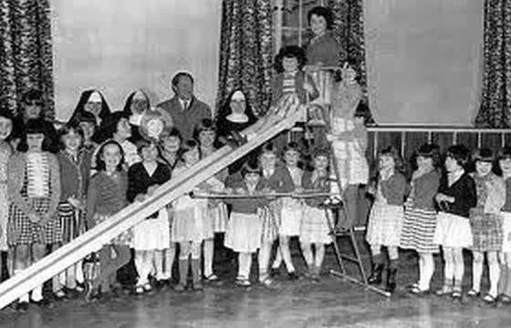  
*Nazareth Lodge*  
  
In the 1950s and 1960s, in Northern Ireland, there was 'Nazi-style' abuse of children in children's care homes.  
  
One former resident says that "he was in a chain gang polishing floors, bathed in detergent as punishment and sexually assaulted by a woman when he was aged five or six.  
  
[Church-run 'hell hole' homes were 'like Nazi concentration camps'](http://www.belfasttelegraph.co.uk/news/local-national/northern-ireland/child-abuse-inquiry-churchrun-hell-hole-homes-were-like-nazi-concentration-camps-29957460.html) / [Children Forced To 'Eat Their Own Vomit' In Church-Run 'Hell Hole'](http://www.huffingtonpost.co.uk/2014/01/28/northern-ireland-child-abuse_n_4679717.html) / [Children's homes 'like Auschwitz'](http://www.belfasttelegraph.co.uk/news/local-national/northern-ireland/childrens-homes-like-auschwitz-29957371.html)  
  
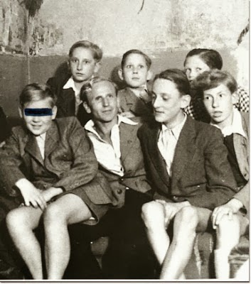  
*Schneider*  
  
The top Zionists and the top Nazis work together.  
  
In the mid 1950s, the charity Colonia Dignidad was set up in Chile by a 'Jewish Nazi' called Paul Schäfer Schneider.  
  
Reportedly, the CIA, Mossad and the West German secret service used Colonia Dignidad for experiments involving the torture and mind control of kidnapped children.  
  
"It was known since 1964 that the members of the commune were being subjected to torture; it was known since 1977 that political prisoners were tortured there; and the child abuse was known about since the 1970s."  
  
[Child abuse charity, CIA child torture, Colonia Dignidad](https://www.google.co.uk/url?sa=t&rct=j&q=&esrc=s&source=web&cd=1&cad=rja&ved=0CC0QFjAA&url=http%3A%2F%2Faangirfan.blogspot.com%2F2013%2F07%2Fchild-abuse-charity-cia-child-torture.html&ei=EGnmUuCqMcP17AaN9oG4Ag&usg=AFQjCNHsJjWBOqW86z03xM4q4cZvJ5hn0g&sig2=wUrLmsSyq6_Z4Sqp6gNYJw)  
  
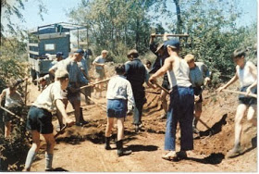  
*Colonia Dignidad, which became Villa Baviera.*  
  
"Germans in the colony knew how to keep a person alive for several days or weeks while putting him or her through the most terrible agony and humiliation..."  
  
Colonia Dignidad is said to have links to a large number of Nazis linked to Operation Paperclip, MK ULTRA brainwashing, satanic ritual abuse, AmeriCares, the Knights of Malta and the Vatican.  
  
German authorities investigated charges that from thirty to forty children reported missing from the Bonn and Cologne areas wound up at Colonia Dignidad.  
  
[Child abuse charity, CIA child torture, Colonia Dignidad](https://www.google.co.uk/url?sa=t&rct=j&q=&esrc=s&source=web&cd=1&cad=rja&ved=0CC0QFjAA&url=http%3A%2F%2Faangirfan.blogspot.com%2F2013%2F07%2Fchild-abuse-charity-cia-child-torture.html&ei=EGnmUuCqMcP17AaN9oG4Ag&usg=AFQjCNHsJjWBOqW86z03xM4q4cZvJ5hn0g&sig2=wUrLmsSyq6_Z4Sqp6gNYJw)  
  
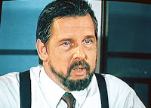  
*Michael Townley - "the primary liaison between Colonia Dignidad and the Pinochet regime was an American CIA agent named Michael*[*Townley*](http://en.wikipedia.org/wiki/Michael_Townley)*who also served as a member of the Chilean secret police in addition to helping plan the military coup that ousted Allende."*[*Latin American Cults Part I*](https://www.google.co.uk/url?sa=t&rct=j&q=&esrc=s&source=web&cd=1&cad=rja&ved=0CDEQFjAA&url=http%3A%2F%2Fvisupview.blogspot.com%2F2011%2F09%2Flatin-american-high-weirdness-cults.html&ei=PTbYUf67BIjY0QXTooHABA&usg=AFQjCNG63ROG2jhrT-VWvJefBeFTrYmscQ&sig2=xzdZnL81Oke1ebXjKqxRBw)  
  
In 1956, John Ross led a fact-finding committee investigating Australian children's homes to which British children had been sent.  
  
He wanted 26 institutions blacklisted. His report was ignored by the government.  
  
Large numbers of children have been tortured and raped in children's care homes in Australia.  
  
The CIA is said to control the key people in Australia.  
  
  
[Boys' home horror recalled](https://www.google.co.uk/url?sa=t&rct=j&q=&esrc=s&source=web&cd=4&cad=rja&ved=0CFIQFjAD&url=http%3A%2F%2Fwww.abc.net.au%2Fnews%2F2009-11-16%2Fwe-were-scum-boys-home-horror-recalled%2F1143634&ei=Cv63UuvMNKiS7Qb7yIGQCg&usg=AFQjCNHgoSAwAxolgvBOZ5xum73KQrGXLA&sig2=EyXMIptOUYgkw2bVhEpSnA).  
  
Often the police have been involved in the abuse.  
  
Two journalists from Australia's Sun-Herald claimed see evidence of the satanic ritual abuse of children.  
  
They interviewed six mothers whose children had disclosed experiences of Satanic Ritual Abuse and organised abuse in New South Wales.  
  
[LAND OF CHILD ABUSING CLERGY, POLITICIANS](https://www.google.co.uk/url?sa=t&rct=j&q=&esrc=s&source=web&cd=1&cad=rja&ved=0CC0QFjAA&url=http%3A%2F%2Faangirfan.blogspot.com%2F2013%2F12%2Fland-of-child-abusing-clergy.html&ei=6FflUrOuAYeRhQf70oAI&usg=AFQjCNFvj7tupK0OEUTzBrrWz_lF51F2aQ&sig2=x6xnFa8x2BoSIlnor5s_Og)..  
  
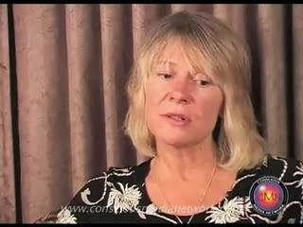  
*Cathy O'Brien*  
  
In 1957, Cathy O'Brien was born.  
  
She became a child victim of the mind control government project named Project Monarch, part of MK ULTRA  
  
She recalls that as a child she was sexually abused by international [pedophile](http://en.wikipedia.org/wiki/Pedophile) rings, drug barons and [satanists](http://en.wikipedia.org/wiki/Satanists).  
  
[THE BUSH FAMILY](https://www.google.co.uk/url?sa=t&rct=j&q=&esrc=s&source=web&cd=4&cad=rja&ved=0CEEQFjAD&url=http%3A%2F%2Faangirfan.blogspot.com%2F2013%2F06%2Fthe-bush-family.html&ei=YTXlUu_rLdOqhQfmj4EI&usg=AFQjCNE9EsuKBX0N9Kse_5TQM_LOn8br3w&sig2=nB9UOR-Dtj2GlZWmXvj8yg).  
  
[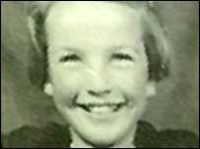](http://bp1.blogger.com/_NE-72ZXux-g/Rw0kBVtVbgI/AAAAAAAABms/HybAzpAtMfs/s1600-h/moira-anderson.jpg)  
*Moira.*  
  
In 1957, 11-year-old Moira Anderson was last seen boarding a bus in Coatbridge, near Glasgow, Scotland.  
  
According to The Sunday Times ([Pressure on police to release paedophile dossier](http://www.timesonline.co.uk/article/0,,2090-2148346,00.html)), 23 April 2006, Strathclyde Police have a dossier listing members of a child-abuse ring.  
  
The dossier is said to implicate senior public figures, including senior police officers and members of the Crown Office and former Scottish Office.  
  
[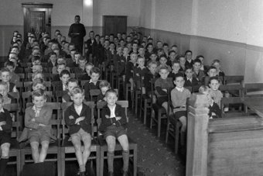](http://www.abc.net.au/news/2014-01-30/boys-at-salvation-army27s-bexley-boys27-home/5227916)  
[The Bexley Boys Home in Australia - opened in 1915 and closed in 1979.](http://www.abc.net.au/news/2014-01-30/boys-at-salvation-army27s-bexley-boys27-home/5227916)  
  
From the 1960s and 1970s onwards [Boys were being 'rented out' for abuse at a Salvation Army boys' home in Australia.](https://www.google.co.uk/url?sa=t&rct=j&q=&esrc=s&source=web&cd=2&cad=rja&ved=0CEMQFjAB&url=http%3A%2F%2Fwww.abc.net.au%2Fnews%2F2014-01-30%2Fboys-rented-out-for-abuse-at-salvos-boys-home%2F5227854&ei=zPTpUsCUN-iy0QWplIH4CA&usg=AFQjCNGZGBpkHMVQTaqnTGqFMQabFAhJLg&sig2=LhcsPDRkpx7ZSTOdELcFNw)  
  
"A man named FV told police that in 1974 the Superintendent of the Bexley home, Captain Lawrence Wilson, introduced him to a woman in Salvation Army uniform who was accompanied by a man.  
  
"FV said they took him back to their home and sexually abused him."  
  
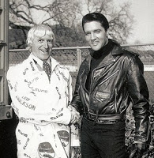  
*Sir Jimmy Savile with Elvis.*  
  
In 1960, Jimmy Savile visited visits Elvis Presley in California.  
  
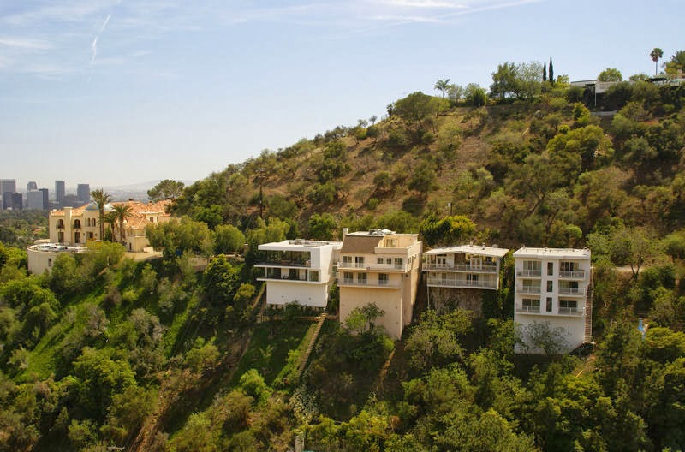  
*Laurel Canyon*  
  
Billy Bryars, the son of an oil magnate, ran a 'boy brothel' at the summit of Laurel Canyon in California.  
  
Customers at the boy brothel were said to include J. Edgar Hoover and his 'gay' partner Clyde Tolson.  
  
[Inside The Laurel Canyon](https://www.google.co.uk/url?sa=t&rct=j&q=&esrc=s&source=web&cd=1&cad=rja&uact=8&ved=0CC8QFjAA&url=http%3A%2F%2Fwww.whale.to%2Fb%2Finside_the_lc.html&ei=4seKU5CgBYKLOMG8gJgJ&usg=AFQjCNEeeD-PThDQjlIXoDyGh4-k3Hc8rw&sig2=nAdMhNvHwGWStMqvUlxG8w&bvm=bv.67720277,d.ZWU).  
  
California is a major site for CIA mind-control experiments.  
  
Elvis is said to have been mind-controlled.  
  
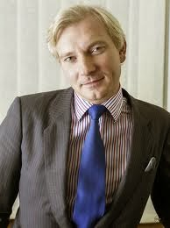  
[Harvey Proctor.](https://www.google.co.uk/url?sa=i&rct=j&q=&esrc=s&source=images&cd=&cad=rja&docid=Siwlv6cB93M-4M&tbnid=vwecyUNUH_J-aM:&ved=0CAMQjhw&url=http%3A%2F%2Faangirfan.blogspot.com%2F2012%2F10%2Fchild-abuse-list-ritual-abuse.html&ei=BOzkUuuKIYfX0QX52IDQDg&psig=AFQjCNF0qv5Z33aORXVWyNSPcRIqHjX2fg&ust=1390820605157011)  
  
In 1961, in the UK, the Conservative Party's Monday Club was set up.  
  
Its members have included Harvey Proctor, Rhodes Boyson and Peter Bottomley.  
  
Members of the Monday Club are said to have visited the Elm Guest house boy brothel, and taken young boys to Amsterdam.  
  
The Elm Guest House has been linked to MI5.  
  
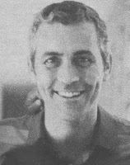  
*John Wetterer*  
  
In 1963, John Wetterer was active in Vietnam.  
  
John Wetterer, set up the Shoeshine Boys Foundation.  
  
Allegedly, the Shoeshine Boys was a pedophile ring serving the American military.  
  
Wetterer was helped by Robert Macauley, the founder of AmeriCares, an organisation which has been linked to the CIA.  
  
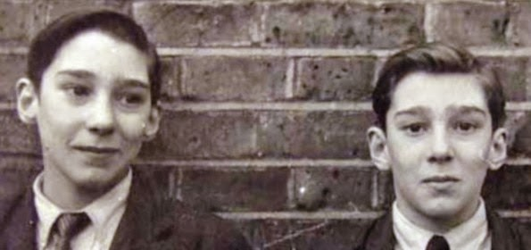  
*Kray Twins, possible victims of mind control.*[*KRAY TWINS BRAINWASHED?*](https://www.google.co.uk/url?sa=t&rct=j&q=&esrc=s&source=web&cd=1&cad=rja&uact=8&ved=0CCEQFjAA&url=http%3A%2F%2Faangirfan.blogspot.com%2F2012%2F06%2Fkray-twins-brainwashed.html&ei=fr1pVNn5D5XhaquogJAC&usg=AFQjCNHC9G3duNTCijZuHC1CY4lJQcH4Pg&sig2=pyFBTctpSFxhOsF5hVeFxA&bvm=bv.79142246,d.d2s)  
  
In 1963, Winston Churchill's close friend Lord Boothby was introduced to the Kray twins.  
  
The Kray Twins were  murderous gangsters who reportedly supplied young boys to the elite.  
  
The Kray Twins reportedly had a connection to the security services.  
  
[KRAY TWINS BRAINWASHED?](https://www.google.co.uk/url?sa=t&rct=j&q=&esrc=s&source=web&cd=1&cad=rja&uact=8&ved=0CCEQFjAA&url=http%3A%2F%2Faangirfan.blogspot.com%2F2012%2F06%2Fkray-twins-brainwashed.html&ei=fr1pVNn5D5XhaquogJAC&usg=AFQjCNHC9G3duNTCijZuHC1CY4lJQcH4Pg&sig2=pyFBTctpSFxhOsF5hVeFxA&bvm=bv.79142246,d.d2s)  
  
  
*Reportedly, around 50,000 aboriginal (native Indian) children died in residential schools in Canada*  
  
Canada has been a major centre of CIA mind-control experiments.  
  
In 1964, William Combes says he witnessed "the abduction of ten fellow residential school children by the Queen of England and her husband in October, 1964 at the Catholic school in Kamloops, British Columbia, Canada."  
  
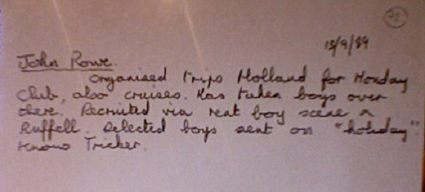  
[ukpaedos-exposed.com](https://www.google.co.uk/url?sa=i&rct=j&q=&esrc=s&source=images&cd=&cad=rja&docid=ZU76_wcCblj36M&tbnid=BXV_YGNA1NnMjM:&ved=0CAQQjB0&url=http%3A%2F%2Fukpaedos-exposed.com%2Fuk-child-abusers-named-and-shamed%2Fcouncillorspolitical-party-affiliated%2Felm-guest-house-child-sexual-abuse%2Felm-guest-house-links-to-holland%2F&ei=ojflUryyLYeU0QXB3IDIAg&psig=AFQjCNE0gzFDoLE5ujBp-C_iIleGDKPzHg&ust=1390839931018260).  
  
In the 1960's, child abuse was taking place at the Kincora boys home, in Belfast  
  
Reportedly, Kincora was run as a boy brothel by MI5, which wanted to blackmail and control certain political leaders.  
  
Jimmy Savile used to visit Northern Ireland.  
  
In 1963, a male victim came forward to claim that Jimmy Savile raped him in Cheshire but he was told by police to "forget about it".  
  
From 1965 - 1988, Sir Jimmy Savile was a volunteer porter and fundraiser at Stoke Mandeville hospital.  
  
He had his own quarters there.  
  
Reportedly, satanic ritual abuse took place at the hospital.  
  
In 1965, Greystone Heath approved school for boys in Warrington was being used by a child abuse ring.  
  
[http://www.nickdavies.net/1998/04/01...se-in-britain/](http://www.nickdavies.net/1998/04/01/the-sheer-scale-of-child-sexual-abuse-in-britain/)  
  
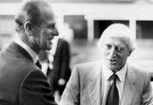  
  
In 1966, Lord Mountbatten introduced Savile to Prince Philip.  
  
In 1966,Jimmy Savile was awarded was honorary green beret by the Royal Marines.  
  
In 1966, Michael Trestrail, 'linked to the Elm guest house boy brothel', became the Duke of Edinburgh's "personal police officer".  
  
In 1967, Prince Edward became the Grand Master of the United Grand Lodge of England, the governing body of Freemasonry in England and Wales.  
  
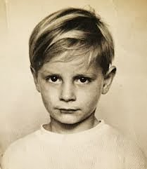  
*Guy Marsden*  
  
In 1967, Jimmy Savile's nephew, 13 year old Guy Marsden, was frequently taken to the homes of wealthy celebrities.  
  
In these homes, men sexually abused girls and boys as young as 10, with Savile present.  
  
In 1969, Savile visited the island of Jersey, famous for child abuse, child torture and child murder.  
  
In 1969, the BBC's Savile recorded 'Christmas Songs of Praise' from Calder High School.  
  
The BBC is said to be run by the security services. Its key employees usually have links to the military and Israel.  
  
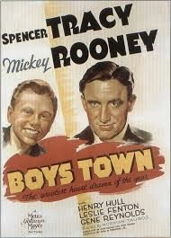  
  
From at least the 1970s onwards, Boys were being sexually abused at Boys Town, in Omaha.  
  
Larry King got children for his Franklin child abuse ring from Boys Town, Omaha.  
  
Child victims said that King took part in the satanic ritual murder of children.  
  
[www.francesfarmersrevenge.com: theNSAisWATCHIN](https://www.google.co.uk/url?sa=t&rct=j&q=&esrc=s&source=web&cd=5&cad=rja&uact=8&ved=0CDsQFjAE&url=http%3A%2F%2Farchive.today%2Fwww.francesfarmersrevenge.com&ei=-BBrVMkbi-5otOmAsAo&usg=AFQjCNFnqWhhM8tRKUenOu6lLPtfotzLbQ&sig2=1ZDV9BVHIfNNCiDjXv9HHQ&bvm=bv.79908130,d.d2s).

The "Washington Post", "New York Times", "Village Voice" and "National Law Journal" referred to the accusations.  
  
King was linked to Iran-Contra.  
  
King was said to have provided the CIA with information gained from the users of the child sex ring.  
  
[BOYS TOWN AND THE POPE](https://www.google.co.uk/url?sa=t&rct=j&q=&esrc=s&source=web&cd=1&cad=rja&ved=0CC0QFjAA&url=http%3A%2F%2Faangirfan.blogspot.com%2F2010%2F03%2Fboys-town-and-pope.html&ei=C3LlUoLZK5GThgf54YGQAw&usg=AFQjCNHGNOhjUny6vDSwFMbSZCOF-VYrHA&sig2=LclXCVn1R2ZdNUYdgrwdyw) / [OMAHA IS FAMOUS](https://www.google.co.uk/url?sa=t&rct=j&q=&esrc=s&source=web&cd=4&cad=rja&ved=0CEEQFjAD&url=http%3A%2F%2Faangirfan.blogspot.com%2F2009%2F12%2Fomaha-is-famous.html&ei=C3LlUoLZK5GThgf54YGQAw&usg=AFQjCNFM3Xdu2nEHF8TstVvVR0QXJWR-Fw&sig2=3mESNYLRREFHknVGP7gzpQ).  
  
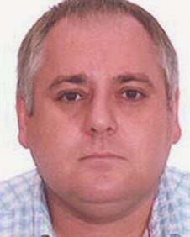  
  
Around 1969, Warwick Spinks (above) was caught on secret camera offering to supply a video in which a 10 year old boy was killed and another featuring the horrific abuse of a young boy.  
  
The untouchable "Warwick Spinks ... built businesses and bought properties in South Africa, Namibia, Poland, Czech Republic, Slovakia, Switzerland, France and England..."  
  
[WARWICK SPINKS](https://www.google.co.uk/url?sa=t&rct=j&q=&esrc=s&source=web&cd=1&cad=rja&uact=8&ved=0CCEQFjAA&url=http%3A%2F%2Faangirfan.blogspot.com%2F2012%2F11%2Fwarwick-spinks-and-violent-pedophile.html&ei=QitqVKLVIs7kaomPgfgL&usg=AFQjCNFfcwYJ-_qEebRc2w3PLU8uIKeu-w&sig2=CtLtHZft2DiHv0rph7FZ9A&bvm=bv.79142246,d.d2s)  
  
In the early 1970's, soldier John Peters, who helped make the 'Bjorn tape' video involving the horrific sex assault of an 8 year old boy, managed to go absent without leave.  
  
[PEDOPHILE RING IN PRIME MINISTER'S HOME?](https://www.google.co.uk/url?sa=t&rct=j&q=&esrc=s&source=web&cd=7&cad=rja&ved=0CFwQFjAG&url=http%3A%2F%2Faangirfan.blogspot.com%2F2012%2F10%2Fpedophile-ring-in-prime-ministers-home.html&ei=eNTkUomMMJSthQeJ-YDYDA&usg=AFQjCNE0-Vh0O3M-c2MYsjQCytBRnEgWAQ&sig2=6itiTbSyKPP4jMC9bX08NA)  
  
In the 1970's and 1980's, pedophile rings for top people were operating in children's care homes in Islington in London.  
  
This happened "under the watch of Margaret Hodge", the Islington politician who is a friend of Tony Blair.  
  
In the 1970's, Sir Jimmy Savile becomes a regular visitor to the Haut de La Garenne children's care home on the child abuse island of Jersey.  
  
In 1970 there was the first recorded instance of child abuse by Sir Jimmy Savile at Duncroft school in Surrey.  
  
  
*Savile and Heath*  
  
In 1970, Edward Heath, who was a frequent visitor to the child abuse island of Jersey, became Prime Minister.  
  
  
*Claire*  
  
In 1971, Claire McAlpine, who had been a young dancer on BBC TV,committed suicide at the age of 15.  
  
In her diary she named showbusiness personalities whom she claimed had "used" her.  
  
The allegations were dismissed by the police and by the BBC, and Jimmy Savile denied having known her.  
  
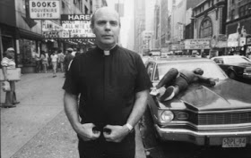  
*Father Bruce Ritter mixing with the teenage boy prostitutes of New York.*  
  
In 1972, Father Bruce Ritter, a vice president of Americares, set up a charity called Covenant House, 'as a cover for a pedophile ring'.  
  
[Cia's 'Christian' faction; AmeriCares, pedophile rings](https://www.google.co.uk/url?sa=t&rct=j&q=&esrc=s&source=web&cd=1&ved=0CC0QFjAA&url=http%3A%2F%2Faangirfan.blogspot.com%2F2013%2F05%2Fcias-christian-faction-americares.html&ei=Vw_mUqiOF8qrhQfK5YDgDw&usg=AFQjCNFpH8DLVVgGeUhBSHzx-V8A_5e8sA&sig2=SxhVTHv-yLozRpv3IfQ7Zw).  
  
In 1973, Michael Trestrail, linked to Elm Guest House, became the Queen's bodyguard.  
  
From 1973 - 1982, Children from Grafton Close Children's Home were being abused at the Elm guest house by top people.  
  
[PEDOPHILE RINGS; NAYPIC](https://www.google.co.uk/url?sa=t&rct=j&q=&esrc=s&source=web&cd=2&cad=rja&ved=0CDMQFjAB&url=http%3A%2F%2Faangirfan.blogspot.com%2F2013%2F01%2Fpedophile-rings-naypic.html&ei=E2_lUueqComThgei34D4AQ&usg=AFQjCNFWE-J8HUDy3x7WS0oteKHs0rUMPg&sig2=VUgeJGiWBv1TiPN2ksa6sg).  
  
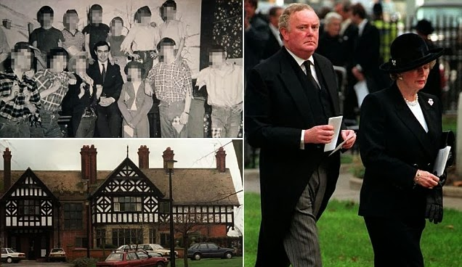  
*Right - Sir peter Morrison with Thatcher. Left - North Wales children's care home used as a boy brothel.*[*ENEMIES OF THE PEOPLE.*](https://www.google.co.uk/url?sa=i&rct=j&q=&esrc=s&source=images&cd=&cad=rja&docid=gjQ00ORs_w2shM&tbnid=cG-CAAGGiGN6iM:&ved=0CAMQjhw&url=http%3A%2F%2Feotp.org%2Ftag%2Fjimmy-savile%2F&ei=sWflUvaxA-aX0QXC9IHwBA&psig=AFQjCNF0fzKKdhALnnRossIFGUEvTMEoLg&ust=1390852397283847)  
  
From 1974 - 1990, child abuse rings were operating at various children's homes in North wales.  
  
Margaret Thatcher's close friend Sir Peter Morrison, and a McAlpine, were reportedly involved.  
  
In the mid 1970's, the Paedophile Information Exchange (PIE) was active in promoting the idea of legalising sex with children over 4.  
  
PIE was financed and organised by people linked to the security services, reportedly.  
  
In 1975, Prince Edward served as President of The Scout Association.  
  
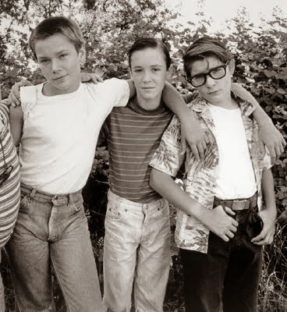  
*A large number of child celebrities are reported to be victims of the CIA's MK ULTRA mind-control.*  
  
In 1975, Project MKUltra was brought to public attention by the [Church Committee](http://en.wikipedia.org/wiki/Church_Committee) of the U.S. Congress.  
  
In 1975, Jimmy Savile made a 10 day 'state visit' to Israel.  
  
He met President Ephraim Katzir and Jerusalem mayor Teddy Kollek, and was organised by John Levy of the Friends of Israel Educational Trust.  
  
In 1975, Sir Jimmy Savile reportedly beat and raped a girl at Stoke Mandeville hospital as part of a satanic ritual with other adults in the hospital basement.  
  
He chanted 'Hail Satan' in Latin.  
  
[http://www.express.co.uk/news/uk/370...f-satanic-ring](http://www.express.co.uk/news/uk/370439/Jimmy-Savile-was-part-of-satanic-ring)  
  
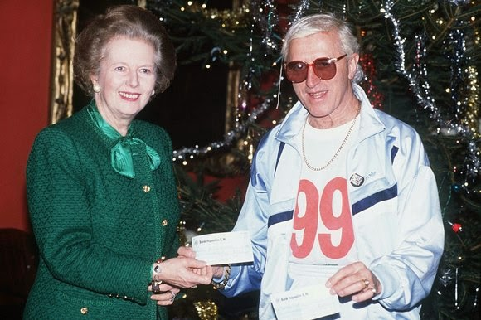  
*Savile and Thatcher. Jimmy Savile spent several Christmases at Margaret Thatcher's home.*  
  
From 1975 - 1980, we had 'the Yorkshire Ripper murder spree'.  
  
Jimmy Savile was viewed as a suspect in the Ripper murders and was questioned by West Yorkshire Police.  
  
Moulds were taken of his teeth.  
  
In 1976, Jimmy Savile, at Haut de La Garenne on the child abuse island of Jersey, sexually abused ''John'' who was aged 10 at time of assault.  
  
Two top police officers officers have claimed that Jersey's Haut de la Garenne care home was at the centre of a ''well-protected paedophile ring''.  
  
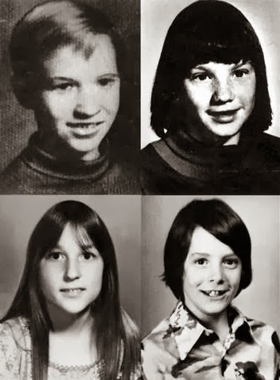  
*Victims of the Oakland county child killer.*  
  
From 1975 until 1976, Francis D Shelden owned North Fox Island, in Lake Michigan.  
  
The island was a major centre of child abuse activity.  
  
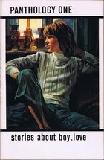  
  
Reportedly, Shelden is actually Frank Torey, the editor of Spartacus and PAN (see photo) along with John Stamford.  
  
<http://catherinebroad.wordpress.com/...circa-1975-76/>  
  
The Oakland County Child Killer is an unidentified serial killer responsible for the murders of four or more children, two girls and two boys, in Oakland County, Michigan, United States in 1976 and 1977.  
  
It has been alleged that Frank Shelden/FrankTorey was the killer.  
  
[Oakland County Child Killer](https://www.google.co.uk/url?sa=t&rct=j&q=&esrc=s&source=web&cd=1&cad=rja&uact=8&ved=0CDAQFjAA&url=http%3A%2F%2Fen.wikipedia.org%2Fwiki%2FOakland_County_Child_Killer&ei=fzRqVIbHFrHHsQT8lILIDA&usg=AFQjCNGiRZ-T08lHgroVtspHaPzKcgCgYw&sig2=ljM3nIRbpPemioalorz_SQ&bvm=bv.79142246,d.cWc).  
In 1976, Jimmy Savile was in Belfast, the site of the Kincora Boy's Home brothel, and several mysterious killings of children..  
  
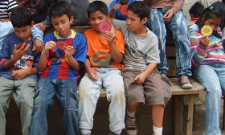  
*Guatemalan children with the Toybox charity which has links to the 'CIA front' organisation World Vision.*  
  
In 1976, John Hugh Wetterer, a Vietnam War veteran, founded an orphanage in Guatemala City called Mi Casa.  
  
According to reports, it becomes a centre of child abuse.  
  
[JOHN WETTERER, GEORGE BUSH, CHILD ABUSE IN Guatemala](https://www.google.co.uk/url?sa=t&rct=j&q=&esrc=s&source=web&cd=1&cad=rja&ved=0CC0QFjAA&url=http%3A%2F%2Faangirfan.blogspot.com%2F2013%2F07%2Fjohn-wetterer-george-bush-child-abuse.html&ei=sw3mUpywAY62hAf-soCABQ&usg=AFQjCNEmKFsiv7SMF5CG-0hcfvKD7QfeWw&sig2=cvHHLKHKqDbDBunF1LHr-g). / [Cia's 'Christian' faction; AmeriCares, pedophile rings](https://www.google.co.uk/url?sa=t&rct=j&q=&esrc=s&source=web&cd=1&ved=0CC0QFjAA&url=http%3A%2F%2Faangirfan.blogspot.com%2F2013%2F05%2Fcias-christian-faction-americares.html&ei=Vw_mUqiOF8qrhQfK5YDgDw&usg=AFQjCNFpH8DLVVgGeUhBSHzx-V8A_5e8sA&sig2=SxhVTHv-yLozRpv3IfQ7Zw).  
  
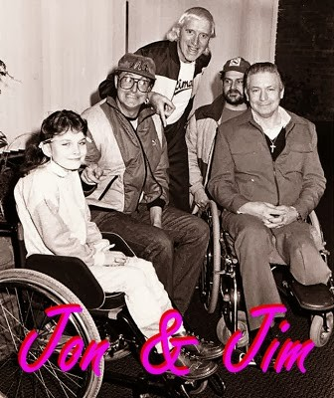  
  
In 1977, in London, Peter Righton, and other members of P.I.E., began sexually abusing an 11-year-old boy.  
  
The abuse continued for several years.  
  
Sir Cyril Smith and other VIPs were allegedly involved.  
  
<http://www.mirror.co.uk/news/uk-news...ophile-1815932>  
  
From 1979-81, an 11-year-old called Vincent was being abused at Elm Guest house and at a house in notorious Bexhill.  
  
In 1979, Margaret Thatcher became UK Prime Minister.  
  
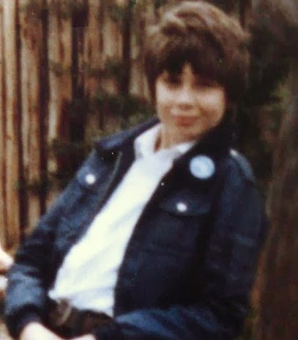  
*Martin Allen*  
  
In 1979, Martin Allen, 15, disappeared.  
  
He was last seen by a friend at King’s Cross Tube station as he made his way home from school.  
  
A man and boy were seen acting suspiciously at Earl's Court, just a few miles from Elm Guest House.  
  
A photofit of the man 'bears a remarkable resemblance to Harvey Proctor'.  
  
<http://ukpaedos-exposed.com/cold-cas...n-london-1979/>  
  
**~~~~~~~~~~~~**  
  
[**The Real Reason Why Germany Halted Its Gold Repatriation From The NY Fed**](https://www.google.co.uk/url?sa=t&rct=j&q=&esrc=s&source=web&cd=1&cad=rja&uact=8&ved=0CCMQqQIwAA&url=http%3A%2F%2Fwww.zerohedge.com%2Fnews%2F2014-11-16%2Freal-reason-why-germany-halted-its-gold-repatriation-ny-fed&ei=tF1qVIycGsTVapqwgPAM&usg=AFQjCNFT7aWQhQyTujdxpY5LocifUao3NA&sig2=O6L5_K-g2CtjmxuEeipMow&bvm=bv.79142246,d.d2s).

[Anon](https://www.blogger.com/profile/16577270335071593954)at [10:05](https://aanirfan.blogspot.com/2014/11/the-cia-runs-pedophile-rings.html?m=1)

[Share](javascript:void(0);)

**45 comments:**

1. https://resources.blogblog.com/img/blank.gif

**Anonymous**[17 November 2014 at 12:35](https://aanirfan.blogspot.com/2014/11/the-cia-runs-pedophile-rings.html?showComment=1416256554392&m=1#c6023246894009598391)

http://www.globalresearch.ca/25th-anniversary-of-el-salvador-jesuit-murders/5414498

[Reply](javascript:;)

1. https://resources.blogblog.com/img/blank.gif

**Anonymous**[17 November 2014 at 13:10](https://aanirfan.blogspot.com/2014/11/the-cia-runs-pedophile-rings.html?showComment=1416258655988&m=1#c915627534982744755)

http://www.dailymail.co.uk/news/article-2834948/Elvis-sex-secrets-exposed-Priscilla-couldn-t-tempt-black-negligee-loved-virgins-watching-girls-mud-wrestle-white-panties-spying-couples-two-way-mirror-Hollywood-home.html

[Reply](javascript:;)

1. https://resources.blogblog.com/img/blank.gif

**Anonymous**[17 November 2014 at 13:13](https://aanirfan.blogspot.com/2014/11/the-cia-runs-pedophile-rings.html?showComment=1416258808935&m=1#c4539515005585534528)

http://www.dailymail.co.uk/news/article-2837490/Inside-depraved-town-planet-Outrage-Brazilian-paedophile-mayor-forced-terrified-families-hand-HUNDREDS-girls-gave-mobile-phone-house-buy-silence.html

[Reply](javascript:;)

1. https://resources.blogblog.com/img/blank.gif

**Anonymous**[17 November 2014 at 14:11](https://aanirfan.blogspot.com/2014/11/the-cia-runs-pedophile-rings.html?showComment=1416262278470&m=1#c907507744426303536)

I hear GO2 (German Intelligence General Operations 2) have infiltrated the UK side of things... Explains why Thatcher's Government/cabinet sold UK out to a federal Europe run by Germany and why GCHQ sold its sorry arse!

[Reply](javascript:;)

[Replies](javascript:;)

* 1. https://resources.blogblog.com/img/blank.gif

**Anonymous**[27 October 2019 at 18:23](https://aanirfan.blogspot.com/2014/11/the-cia-runs-pedophile-rings.html?showComment=1572225816071&m=1#c5258696680665488704)

Ted Heath sold out the UK. Thatcher's hands were tied, but she refused the Euro.

[**Reply**](javascript:;)

1. https://resources.blogblog.com/img/blank.gif

**Anonymous**[17 November 2014 at 17:24](https://aanirfan.blogspot.com/2014/11/the-cia-runs-pedophile-rings.html?showComment=1416273881966&m=1#c6104711636185465934)

http://searchengineland.com/google-hummingbird-172816

[Reply](javascript:;)

1. https://resources.blogblog.com/img/blank.gif

**Anonymous**[18 November 2014 at 01:03](https://aanirfan.blogspot.com/2014/11/the-cia-runs-pedophile-rings.html?showComment=1416301399693&m=1#c8506185557729460089)

The Frances Farmer's Revenge link is dead, but the material is available here. The specific article about Boystown: http://archive.today/l7Ui0 other articles by Frances Farmer's Revenge :http://archive.today/www.francesfarmersrevenge.com

[Reply](javascript:;)

1. https://resources.blogblog.com/img/blank.gif

**Anonymous**[18 November 2014 at 01:49](https://aanirfan.blogspot.com/2014/11/the-cia-runs-pedophile-rings.html?showComment=1416304152279&m=1#c400502383269766810)

I believe I have just encountered a bit of synchronicity or the Baader-Meinhof Phenomenon while perusing your research Aangirfan and these always interesting comments from your readers.  
  
In the article entitled "Satanic Ritual Abuse of Children" under the "Who's Who of Satanic Child Abuse" from Chis Spivey's site, from the testimony of a one "Helen G.", we have the listing of Beaulieu Palace under places where children were taken for ritual purposes, where the author maintains many ceremonies where held and many bodies buried in the "New Forest" or cut up, weighted, and tossed into the sea.  
  
Then, as I stumbled across this new link to a Daily Mail article on Elvis Presley's "secret sex life" from above:  
  
http://www.dailymail.co.uk/news/article-2834948/Elvis-sex-secrets-exposed-Priscilla-couldn-t-tempt-black-negligee-loved-virgins-watching-girls-mud-wrestle-white-panties-spying-couples-two-way-mirror-Hollywood-home.html  
  
We have:  
  
"A 14-year old Priscilla Beaulieu, whose father was an officer in the U.S. Air Force and stationed nearby in Weisbaden, was hanging around the Eagle Club, the local military canteen, when she was spotted by Currie Grant, an airman first class in the Air Force and the club’s assistant manager."  
  
Who we all know became Mrs. Elvis Presley. Really there are no odd connections to and from the points in question, I just thought it an odd coincident. Good Day Aang and Irfan!

[Reply](javascript:;)

1. https://resources.blogblog.com/img/blank.gif

**Anonymous**[22 September 2015 at 08:43](https://aanirfan.blogspot.com/2014/11/the-cia-runs-pedophile-rings.html?showComment=1442936638449&m=1#c2002236188386809143)

Isn't Cathy O'Brien still mind controlled? By the way she behaved on the last Richie Allen show, it sure appears so. Mark Phillips is her handler. Her daughter is still part of that evil set up unfortunately.

[Reply](javascript:;)

1. https://lh3.googleusercontent.com/zFdxGE77vvD2w5xHy6jkVuElKv-U9_9qLkRYK8OnbDeJPtjSZ82UPq5w6hJ-SA=s35

[**David Howard**](https://www.blogger.com/profile/14856149779154737946)[3 December 2016 at 18:31](https://aanirfan.blogspot.com/2014/11/the-cia-runs-pedophile-rings.html?showComment=1480818679080&m=1#c7674110479756079944)

How come WikiLeaks never exposed Donald Trump's pedophile ties? https://www.youtube.com/watch?v=gkhqMbY5e9w

[Reply](javascript:;)

[Replies](javascript:;)

* 1. https://resources.blogblog.com/img/blank.gif

**Anonymous**[6 July 2017 at 21:17](https://aanirfan.blogspot.com/2014/11/the-cia-runs-pedophile-rings.html?showComment=1499401028914&m=1#c3524056057295129479)

Link not working?

* 1. https://lh3.googleusercontent.com/zFdxGE77vvD2w5xHy6jkVuElKv-U9_9qLkRYK8OnbDeJPtjSZ82UPq5w6hJ-SA=s35

[**Unknown**](https://www.blogger.com/profile/17968534600662184077)[7 January 2018 at 05:32](https://aanirfan.blogspot.com/2014/11/the-cia-runs-pedophile-rings.html?showComment=1515331968852&m=1#c5264064493283447804)

He's also a pedophile? 😱

* 1. https://lh3.googleusercontent.com/zFdxGE77vvD2w5xHy6jkVuElKv-U9_9qLkRYK8OnbDeJPtjSZ82UPq5w6hJ-SA=s35

[**MK ULTRA**](https://www.blogger.com/profile/17421126778320642138)[9 January 2018 at 18:28](https://aanirfan.blogspot.com/2014/11/the-cia-runs-pedophile-rings.html?showComment=1515551310810&m=1#c3757139803995774130)

If you want to see something on Trump watch this video, towards the middle it exposes something even worse https://youtu.be/WvdTv9dAH3o

* 1. https://resources.blogblog.com/img/blank.gif

**Anonymous**[12 January 2018 at 00:54](https://aanirfan.blogspot.com/2014/11/the-cia-runs-pedophile-rings.html?showComment=1515747281479&m=1#c8516937882364892056)

Video removed 😕

* 1. https://lh3.googleusercontent.com/zFdxGE77vvD2w5xHy6jkVuElKv-U9_9qLkRYK8OnbDeJPtjSZ82UPq5w6hJ-SA=s35

[**David Howard**](https://www.blogger.com/profile/14856149779154737946)[2 July 2019 at 19:44](https://aanirfan.blogspot.com/2014/11/the-cia-runs-pedophile-rings.html?showComment=1562121872608&m=1#c1429530264726893122)

https://www.change.org/p/coming-soon-polygraph-justice

[**Reply**](javascript:;)

1. https://lh3.googleusercontent.com/zFdxGE77vvD2w5xHy6jkVuElKv-U9_9qLkRYK8OnbDeJPtjSZ82UPq5w6hJ-SA=s35

[**PiperSteve**](https://www.blogger.com/profile/00811258254521468388)[5 December 2016 at 12:37](https://aanirfan.blogspot.com/2014/11/the-cia-runs-pedophile-rings.html?showComment=1480970273602&m=1#c3060755602992557654)

Abuse "Nazi Style". Don't exactly know what that means. During the National Socialist era 1933-45, there was very, very strict rules about proper conduct in the Hitler Youth. My 92 year old Mother-in-law, was a member of the H.Y. and was very forthright that any such abuse was dealt with severly and so was very rare. Any abuse after that time in Germany was the usual pedophiles and perverts that turn up in all democracies",churches/synagogues,etc.

[Reply](javascript:;)

1. https://lh3.googleusercontent.com/zFdxGE77vvD2w5xHy6jkVuElKv-U9_9qLkRYK8OnbDeJPtjSZ82UPq5w6hJ-SA=s35

[**Unknown**](https://www.blogger.com/profile/14479358756785927639)[6 December 2016 at 17:29](https://aanirfan.blogspot.com/2014/11/the-cia-runs-pedophile-rings.html?showComment=1481074195967&m=1#c5721011893669706005)

These people are the SICKEST PEOPLE ON EARTH !!!! To do this to anyone worse yet CHILDREN !!!!! DISCUSTING

[Reply](javascript:;)

1. https://lh3.googleusercontent.com/zFdxGE77vvD2w5xHy6jkVuElKv-U9_9qLkRYK8OnbDeJPtjSZ82UPq5w6hJ-SA=s35

[**Dangerous Dan**](https://www.blogger.com/profile/07197723279455122823)[12 January 2017 at 16:51](https://aanirfan.blogspot.com/2014/11/the-cia-runs-pedophile-rings.html?showComment=1484268715009&m=1#c3623849426884121372)

https://wikileaks.org/wiki/FBI_pedophile_symbols  
http://www.veteranstoday.com/2015/02/07/power-pedophilia-and-the-us-government/  
http://www.theforbiddenknowledge.com/hardtruth/list_of_satanist.htm  
Leolla disappered as did her publishers website.  
http://theconspiracyzone.podcastpeople.com/posts/26837

[Reply](javascript:;)

1. https://resources.blogblog.com/img/blank.gif

**Anonymous**[19 February 2017 at 12:17](https://aanirfan.blogspot.com/2014/11/the-cia-runs-pedophile-rings.html?showComment=1487535429215&m=1#c2894566489864193039)

They will have to answer to every horrific act they have inflicted upon these precious innocent children!! Maybe not now, but they will be. Even if they all are dead they will be risen from their graves and still will have to face the wrath of God. Be sure of this: The wicked will not go unpunished, but those who are righteous will go free.  
Proverbs 11:21 King James Version

[Reply](javascript:;)

1. https://lh3.googleusercontent.com/zFdxGE77vvD2w5xHy6jkVuElKv-U9_9qLkRYK8OnbDeJPtjSZ82UPq5w6hJ-SA=s35

[**Iviewit Technologies, Inc.**](https://www.blogger.com/profile/18047211198868637367)[20 February 2017 at 03:37](https://aanirfan.blogspot.com/2014/11/the-cia-runs-pedophile-rings.html?showComment=1487590657280&m=1#c369171846171487217)

PART 1  
Where did 6 Million Nazis Go????????????  
  
QUESTION? Why would Hitler decide late in the war, when news came that the crush was coming from those pesky Ruskies and the US, to suddenly murder his total free slave labor force, the Jews et al in the LABOR camps??? Why contract in IBM to label their arms with numbers??? Why not just work them to death and benefit from free slave labor, why the sudden rush to turn labor camps into death camps, especially where you are getting your asses whipped and need the labor to build fighting forces???  
  
QUESTION? Where did 6 million hard core Nazi soldiers go after WWII only a handful tried? Well, we thought S. America but what if they really they went to the concentration camps and assumed the murdered peoples identities and even their entire bloodlines and ASSETS, ah back to that IBM Question of accounting for them with tattoo numbers? Instantly, Nazis turned into Jews and prized were the identities of Rabbis, Lawyers and Accountants, those numbers on the arms tracked their financial lines, their bloodlines, bank accounts, businesses, etc. of those who identities they stole, along with their wealth after exterminating their bloodlines. There were even Priests and other labor camp workers they killed for their identities and to be able to infiltrate various organizations like the catholic church, the legal systems of the world and more.  
  
So with the help of Pope Ratzinger (at that time he was not the Pope but rather a Nazi pilot of the most murderous gang of them, an infantry soldier and even a Hitley youth and he was part of the group that dropped bombs killing millions) aka Ratzi the Natzi (see info below or @  
  
www.facebook.com/notes/eliot-bernstein/pope-ratzi-the-natzi-pedophile-benedict-xvi/176537962376945

[Reply](javascript:;)

[Replies](javascript:;)

* 1. https://lh3.googleusercontent.com/zFdxGE77vvD2w5xHy6jkVuElKv-U9_9qLkRYK8OnbDeJPtjSZ82UPq5w6hJ-SA=s35

[**Unknown**](https://www.blogger.com/profile/17834452690404254508)[25 March 2017 at 11:02](https://aanirfan.blogspot.com/2014/11/the-cia-runs-pedophile-rings.html?showComment=1490464943075&m=1#c5205937957059416595)

This would explain the anti Jewish, anti Zionists in Israel and elsewhere. Very insightful.

* 1. https://lh3.googleusercontent.com/zFdxGE77vvD2w5xHy6jkVuElKv-U9_9qLkRYK8OnbDeJPtjSZ82UPq5w6hJ-SA=s35

[**Ekuldom**](https://www.blogger.com/profile/10369995433048813120)[10 July 2019 at 12:25](https://aanirfan.blogspot.com/2014/11/the-cia-runs-pedophile-rings.html?showComment=1562786755683&m=1#c2121077263909647923)

Profound revelation. You made me think that the Jews assumed the Germans identities much later after killing them all and making them pose as dead jews. Really profound :)  
But i know some of my jewish friends and acquaintances really went through hell for this new world order.  
See the Elites are following the Hegelian concept. Man can only fear God if he is confronted with suffering. And with profound suffering he will become a true religious fanatic. Maintaining this so called order. Like before religion there was no order. there was major order and organization of tribes and tradition.

[**Reply**](javascript:;)

1. https://lh3.googleusercontent.com/zFdxGE77vvD2w5xHy6jkVuElKv-U9_9qLkRYK8OnbDeJPtjSZ82UPq5w6hJ-SA=s35

[**Iviewit Technologies, Inc.**](https://www.blogger.com/profile/18047211198868637367)[20 February 2017 at 03:39](https://aanirfan.blogspot.com/2014/11/the-cia-runs-pedophile-rings.html?showComment=1487590759467&m=1#c6618324717728830594)

https://www.facebook.com/notes/eliot-bernstein/where-did-6-million-nazis-go/1348176998546363

[Reply](javascript:;)

1. https://lh3.googleusercontent.com/zFdxGE77vvD2w5xHy6jkVuElKv-U9_9qLkRYK8OnbDeJPtjSZ82UPq5w6hJ-SA=s35

[**A Kinders Garten Vintage Homeschool**](https://www.blogger.com/profile/15350116155629136850)[20 February 2017 at 21:16](https://aanirfan.blogspot.com/2014/11/the-cia-runs-pedophile-rings.html?showComment=1487654173822&m=1#c9097138145823843498)

very concise timeline....many of the mentioned people & scenarios I have read before...when my girls were young, I never let them out of my sight as I feared them being sold down the river....most thought I was "overbearing" but I remember when I was young, we went to TJ for our dental work...while walking down a street with my family looking in shops, a shopkeeper grabbed my arm & tried to drag me to the back of his store but my dad was on it and grabbed me & told the guy in his face, "NO, NO" & shook his finger at him....consequently, the person backed off & we did not go to TJ any more after that...

[Reply](javascript:;)

[Replies](javascript:;)

* 1. https://resources.blogblog.com/img/blank.gif

**Anonymous**[27 March 2017 at 10:30](https://aanirfan.blogspot.com/2014/11/the-cia-runs-pedophile-rings.html?showComment=1490635815595&m=1#c4809410105327019863)

that happened to me at 15 same thing happened

* 1. https://resources.blogblog.com/img/blank.gif

**Anonymous**[23 May 2017 at 17:51](https://aanirfan.blogspot.com/2014/11/the-cia-runs-pedophile-rings.html?showComment=1495587064543&m=1#c6106368675181712125)

Reading, I suddenly remembered a man offering me a cigarette. I was about 15, 16. Having none I took it. I know now that it was laced with some drug. He smiled and asked me if I about how I felt. I became frightened and got away from him. I may have escaped a bad fate.

[**Reply**](javascript:;)

1. https://resources.blogblog.com/img/blank.gif

**Anonymous**[28 November 2017 at 18:37](https://aanirfan.blogspot.com/2014/11/the-cia-runs-pedophile-rings.html?showComment=1511923060562&m=1#c3744537196633284454)

:) Skull & Bones directive is drug trafficking and child trafficking.

[Reply](javascript:;)

1. https://lh3.googleusercontent.com/zFdxGE77vvD2w5xHy6jkVuElKv-U9_9qLkRYK8OnbDeJPtjSZ82UPq5w6hJ-SA=s35

[**laura**](https://www.blogger.com/profile/17287416700554068127)[7 January 2018 at 21:49](https://aanirfan.blogspot.com/2014/11/the-cia-runs-pedophile-rings.html?showComment=1515390586921&m=1#c8844691824133429166)

they protect the pedophile rings

[Reply](javascript:;)