**Historic Loch Ness house fire not thought to be deliberate**

Written byEilidh Davies

[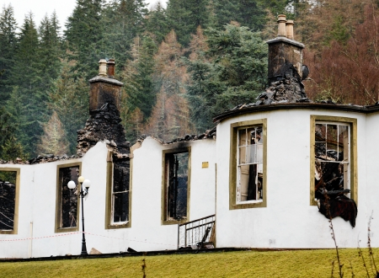](http://www.inverness-courier.co.uk/imagelibrary/Client_Images/Client00007/ResizeCache/02580000/02580526%20-%20800x700.jpg)

Boleskine House

A FIRE which gutted a Loch Ness mansion is not believed to have been started deliberately.

Boleskine House, which overlooks the loch near Foyers, was ravaged by a fierce blaze on Wednesday, December 23.

A total of 23 firefigthers worked in dangerous conditions to bring the inferno under control.

It is understood the Dutch owner’s daughter and her partner, who were living in the house at the time, had gone shopping in Inverness and returned to find the property ablaze.

Boleskine House has a chequered and colourful history. It was built in the late 1700s and achieved notoriety when it became the home of Aleister Crowley, the self- proclaimed “wickedest man on earth”, in 1899.

Occultist Crowley, also known as “The Great Beast 666” became infamous for stories of conducting black magic and various other rituals while residing at the house. He died in 1947.

Boleskine House was bought by rock guitar legend Jimmy Page of Led Zeppelin fame, a fan of Crowley, in 1970.

However, after arranging for the house to be restored he spent little time at Boleskine, leaving things in the care of his friend Malcolm Dent, who lived there with his family.

Jimmy Page sold the house in 1992, having spent less than six weeks at the property.

It was then bought by a hotelier, the late Ronald MacGillivray and his wife Annette, who carried out extensive renovations of the property transforming it into a luxury residence before selling it to the current owner.

A spokesman for the Scottish Fire and Rescue Service said no definite cause of the blaze has been identified, but he added: “We do not believe the fire was deliberately started.”