Carroll Quigley 1910-1977
http://en.wikipedia.org/wiki/Carroll_Quigley
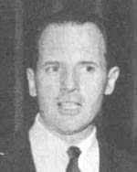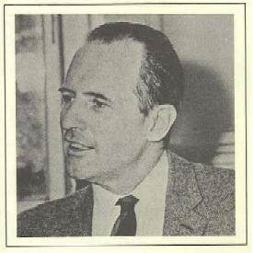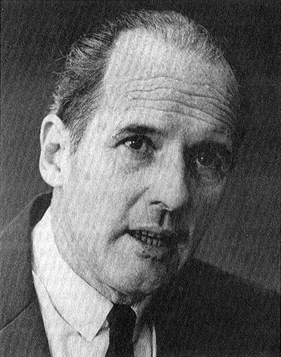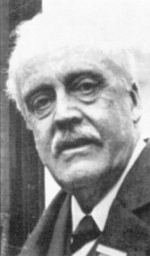
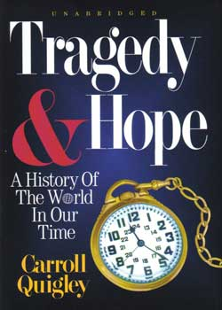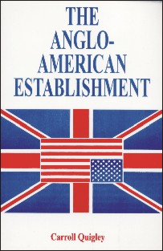
----------------------------------------------------------------------------------------------------------------------------------------------------------------------------------------------------------------------------------------------
Carroll Quigley (November 9, 1910 - January 3, 1977) was a noted historian, polymath, and theorist of the evolution of civilizations.
Quigley was born in Boston, where he attended school and planned to pursue a career in biochemistry, but he soon shifted to history, to which he brought an analytical, scientific approach. After receiving a B.A., M.A., and Ph.D in history from Harvard University, he taught at Princeton and Harvard. In 1941 Quigley joined the Edmund A. Walsh School of Foreign Service at Georgetown University where he came to teach a highly regarded course, Development of Civilization..
Endowed with a Napoleonic constitution and willing to work 16 hours a day, Quigley was a rapid, acute reader who devoured the contents of countless thousands of books and came to possess an exceptional range of knowledge in many fields. Not one to hide his light under a bushel basket, he claimed to have read everything worth reading. Fields of special expertise included aspects of primitive and archaic culture (e.g., primitive poison fishhooks), the impact of weapons technology on social organization, and the Anglo-American elite. He emphasized "inclusive diversity" as a value of Western Civilization long before diversity became commonplace, and he denounced Platonic doctrines as an especially pernicious deviation from this ideal preferred Thomas Aquinas's pluralism.
As a spell-binding lecturer, Quigley made a strong impression on many of his students including future U.S. President Bill Clinton, who named Quigley as an important influence during his acceptance speech to the 1992 Democratic National Convention, saying,
As a teenager, I heard John Kennedy’s summons to citizenship. And then, as a student at Georgetown, I heard that call clarified by a professor named Carroll Quigley, who said to us that America was the greatest Nation in history because our people had always believed in two things–that tomorrow can be better than today and that every one of us has a personal moral responsibility to make it so.
In addition to his academic work, Quigley served as a consultant to the U.S. Department of Defense, the U.S. Navy, the Smithsonian Institute, and the House Select Committee on Astronautics and Space Exploration, which went on to establish NASA. Although Quigley remained a sought-after lecturer, he received fewer offers to consult over time perhaps because he was unwilling to say what was politically acceptable.
Quigley served as a book reviewer for the "Washington Star" and was a contributor and editorial board member of "Current History."
Quigley authored several influential books:
- Tragedy and Hope: A History of the World in Our Time (1966) ISBN 0-945001-10-X
- Evolution of Civilizations (1961) ISBN 0-913966-56-8
- The Anglo-American Establishment (1982) ISBN 0-945001-01-0
Although he received only limited public and professional recognition for his contributions, Quigley was in fact a leading theorist of the rise and fall of civilizations, developing a 7-stage model (Mixture, Gestation, Expansion, Age of Conflict, Universal Empire, Decay, and Invasion) that was integrated into a framework of analysis that included dimensions of power (military and political), wealth (economic and social), and outlook (intellectual and religious).
The penetration of Quigley's analytical mind, his flow of novel concepts, his penchant for provocative formulations, his ceaseless crossing of disciplinary boundaries, and his willingness to challenge specialists and authorities led to a fair amount of controversy, though in fact his political and social views were moderate. He was an early and fierce critic of the Vietnam War, and he was against the activities of the military-industrial complex that, in his mind, threatened to transform the United States into an empire and thereby doom it to eventual corruption, fossilization, and decline. He was ever on the alert for signs of the processes by which a dynamic "instrument" of society that satisfied the needs of individuals could turn into a stagnant, self-aggrandizing "institution." A central concern of Quigley was whether Western Civilization could renew its best traditions, including investing in innovation and emphasizing spiritual values and interpersonal relations rather than material thing after the Age of Conflict between 1895 and 1945 or whether it would slide into an era of Universal Empire. Initially full of hope on this subject, he, a political centrist, grew more pessimistic about it in his later years. Quigley said of himself that he was a conservative defending the liberal tradition of the West.
Quigley became well known among those who believe that there is an international conspiracy to bring about a one-world government. In his book Tragedy and Hope, he based his analysis on his research in the papers of an Anglo-American elite organization that, he held, secretly controlled the U.S. and UK governments through a series of Round Table Groups. The Round Table group in the US was the Council on Foreign Relations. He argued that both the Republican and Democratic parties were controlled by an "international Anglophile network" that shaped elections.
In The Anglo-American Establishment, published in 1982, 5 years after his death because of its controversial material (several publishers would not publish it in when it was written in 1949, but his manuscript was after his death found on the Island of Rhodes), Carroll Quigley showed that the Munich Pact had secretly been prepared as early as 1937 by Great Britain politicians to give Germany and the Soviet Union a common border to eventially destroy the latter in a war between the two. He showed also that the crisis had been staged by Neville Chamberlain.
Conspiracy theorists assailed Quigley for his approval of the goals (not the tactics) of the Anglo-American elite while selectively using his information and analysis as evidence for their views. Quigley himself thought that the influence of the Anglo-American elite had slowly waned after World War II and that, in American society after 1965, the problem was that no elite was in charge and acting responsibly.
No matter how reasonable Quigley's thinking on this and other subjects was, the association of his findings with conspiracy theorists, in combination with the sheer originality of his ideas, caused rumors to circulate about his mental status. In addition, toward the end of his Georgetown career, Quigley ran into criticism from students unhappy about his grading, was roughed up in class by student antiwar protesters, and had his "Development of Civilization" course taken away from him in an academic power game. Teaching appears to have lost some of its charm for him, and he eventually retired to work on his book manuscripts.
Nowadays, Quigley is often spoken of in reference to his writings about the Anglo-American Establishment or as an influence on Clinton. But his theory of civilization, his methods of thinking, and his philosophy of social good have much more general and enduring importance. Among other things, they provide a valuable framework for understanding the interaction of civilizations in a global era. In addition, Quigley's teachings and his dynamic persona had a profound impact on thousands of students and intellectuals.

Quotes
There does exist, and has existed for a generation, an international Anglophile network which operates, to some extent, in the way the radical Right believes the Communists act. In fact, this network, which we may identify as the Round Table Groups, has no aversion to cooperating with the Communists, or any other groups, and frequently does so. I know of the operations of this network because I have studied it for twenty years and was permitted for two years, in the early 1960's, to examine its papers and secret records. I have no aversion to it or to most of its aims and have, for much of my life, been close to it and to many of its instruments. I have objected, both in the past and recently, to a few of its policies (notably to its belief that England was an Atlantic rather than a European Power and must be allied, or even federated, with the United States and must remain isolated from Europe), but in general my chief difference of opinion is that it wishes to remain unknown, and I believe its role in history is significant enough to be known. (p. 950}
The argument that the two parties should represent opposed ideals and policies, one, perhaps, of the Right and the other of the Left, is a foolish idea acceptable only to the doctrinaire and academic thinkers. Instead, the two parties should be almost identical, so that the American people can "throw the rascals out" at any election without leading to any profound or extreme shifts in policy. {p. 1247}
- Both from Tragedy and Hope
The Rhodes Scolarships, established by the terms of Cecil Rhodes's seventh will, are known to everyone. What is not so widely known is that Rhodes in five previous wills left his fortune to form a secret society, which was to devote itself to the preservation and expansion of the British Empire. And what does not seem to be known to anyone is that this secret society was created by Rhodes and his principal trustee, Lord Milner, and continues to exist to this day. To be sure, this secret society is not a childish thing like the Ku Klux Klan, and it does not have any secret robes, secret handclasps, or secret passwords. It does not need any of these, since its members know each other intimately. It probably has no oaths of secrecy nor any formal procedure of initiation. It does, however, exist and holds secret meetings, over which the senior member present presides. At various times since 1891, these meetings have been presided over by Rhodes, Lord Milner, Lord Selborne, Sir Patrick Duncan, Field Marshal Jan Smuts, Lord Lothian, and Lord Brand. They have been held in all the British Dominions, starting in South Africa about 1903; in various places in London, chiefly Piccadilly; at various colleges at Oxford, chiefly All Souls; and at many English country houses such as Tring Park, Blickling Hall, Cliveden, and others. (p. ix)
No country that values its safety should allow what the Milner group accomplished in Britain, that is, that a small number of men should be able to wield such power in administration and politics, should be given almost complete control over the publication of the documents relating to their actions, should be able to exercise such influence over the avenues of information that create public opinion, and should be able to monopolize so completely the writing and teaching of the history of their own period. (p. xi)
- Both from The Anglo-American Establishment

===================================================================================================================================
END

