WILLIAM CARROLL QUIGLEY November 9, 1910 - January 3, 1977

http://www.tboyle.net/Catholicism/Carroll_Quigley.html

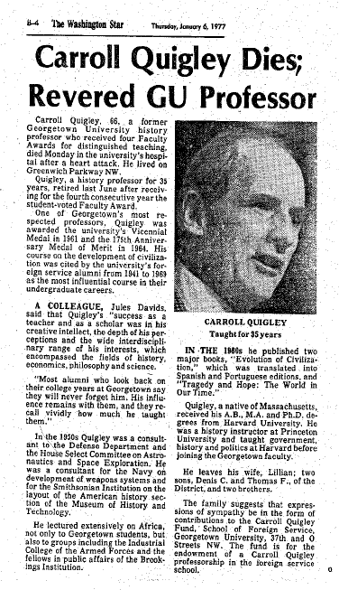
The January 6, 1977, obituary of Carroll Quigley
published in The Washington Star,
for which for many years he wrote book reviews.
_______
Carroll Quigley died in early January 1977. A few weeks later his long-time research assistant and personal friend, Miss Helen E. Veit, telephoned me to ask if I would be her lawyer for the probate of Quigley's last will and testament, which left to her all rights to his books, papers and research materials, but which Quigley's widow was intending to contest.
Happily, a compromise between Lillian Quigley and Helen Veit was reached and a will contest avoided. Carroll Quigley's wishes were all honored.
I hope that someday Carroll Quigley will have an appropriate web site on the internet. A very impressive "Carroll Quigley" site could be constructed. I have a huge collection of his writings, as well as many tape recordings of his lectures. It amazes me, more than twenty years after his death, how relevant many of Quigley's writings and lectures remain.
Among Quigley's most valuable insights are those concerning education.
Carroll Quigley was not only a natural-born "great" teacher; he was also a serious student of what it takes to be(come) a "great" teacher.
One of his essays with the most lasting value is surely his famous article "Is Georgetown University Committing 'Suicide'?"
A second is his thoughtful "Father Walsh as I Knew Him".
A most interesting piece written by Carroll Quigley is his account of how and by whom, actually, the G.U. School of Foreign Service was founded: "Constantine McGuire: Man of Mystery".
As anyone can see, many of the people still interested in Carroll Quigley seem to have taken entirely out of context the extensive references that he made in his book Tragedy and Hope: A History of the World in Our Time to a high-level Anglophile conspiracy that he said flourished before World War II. It seems many people believe that Quigley thought that this vast conspitacy somehow continues to operate right up to our own day.
But as Dr.Quigley once told me, the reality is much scarier. Instead of a secret cabal now being in charge, no one is in charge. We have instead a kind of chaos or anarchy.

Helen Elizabeth Veit was the person closest to Carroll Quigley during the last ten years of his life. No one living to-day has a better understanding of the man and of his thinking.
Sadly, the last few years of Dr. Quigley's life as a teacher coincided with the late 1960s and early 1970s, when student unrest and anti-intellectualism unsettled college campuses all over this country. In 1969-70 that spirit came violently to Georgetown University and focused especially on the very few teachers like Prof. Quigley who adamantly refused to lower academic standards, no matter what political cause du jour was being offered as a reason.
When, therefore, in May 1970, Dr. Quigley and a very few other G.U. professors refused - with, by the way, no support from the craven University Administration of the day - to accede to demands that all classes and examinations be canceled in supposed support of "a nationwide protest" against American military involvement in Indo-China, a band of student activists vowed to prevent classes and examinations from being held, no matter what. Several of these protesters invaded Dr. Quigley's classroom, physically roughed him up, and prevented his final examination from being given that day.
Much of the joy of teaching left Carroll Quigley in the next few years. He complained bitterly that his 1970s college students were woefully under-educated and ill-prepared for college level work and that too many of them had their minds elsewhere, fixated more on bringing about a social revolution than on achieving an education.
And then, when a few years later Dr. Quigley died suddenly, just months after retiring from teaching, some remaining leftist students at G.U., who had so strongly opposed Quigley's tough grading standards, his teaching of the detested "canon of dead white males," and especially his insistent reliance on logic and reasoning, rather than on emotion and intuition, decided that they would have the last word on the man by writing in the school newspaper a shallow obituary criticizing Quigley for not having been more a part of their "real" lives.
Helen Veit wrote a most fitting and eirenic reply, which I reproduce here:
Quigley: Another Side of a Reflective Man
To the Editor:
As a student, academic assistant, and friend of Carroll Quigley, I am unhappy to think that Bob McGillicuddy's article, "Carroll Quigley: A Student's Elegy" (the Voice, Feb. 8, 1977), should be the Georgetown student's last picture of this man.
Surely, after his long and dedicated service to Georgetown and its students, he deserves a more sympathetic understanding in the personal sense, to complement McGillicuddy's insights into his thought. I do not seek to make excuses for him. He would be the last person to want that: accepting personal responsibility for one's actions was one of his first principles. But a better perspective may be gained by viewing recent events in the context of his whole career.
Until 1969-71, teaching Georgetown students was one of the most important and rewarding aspects of his life. Then came the campus disturbances, which, for reasons related more to his dynamic and outspoken personality than to any substantive grievance, focused disproportionately on him. At that point, he did, indeed, "turn inward," to concentrate on his writing and live his private life. After more than thirty years of almost uninterrupted teaching, it seems only reasonable that he should want time for other things, for activities made difficult or impossible by his commitment to lecture to hundreds of students a year.
It is understandably difficult for a student to see that teaching was not the only thing in Carroll Quigley's life, but anyone who listened to him must remember his frequent references to the books he wanted to write when he had time, and must know how much he loved and learned from his West Virginia farm. As an undergraduate, 1, too, believed teaching was all-important to him; later I learned that he wanted his retirement to be virtually a second career, during which he would write books summing up a lifetime of intense study and experience. Sadly, in the event, his life of teaching was his only life.
Impatient he may have been; arrogant he was not. His emphatic manner derived from his experience of teaching large classes and the need for catching and retaining their attention. But he never believed that he had "answers"; what he taught was methods of approaching problems. He often stressed how little we know about the important things of life, especially human relationships. What he sought above all was to help people to become mature, by realizing their potentials and understanding that material things, however necessary, should never be ends themselves, while what is important is seeking the truth in cooperation with others, with the knowledge that one will never find it.
Nor was he ever cynical, much as he deplored inefficiency and ignorance. His beliefs and principles were of the highest order; his greatest joy came from finding people who could meet his standards, and from whom he could learn.
Students should grant to others the same degree of understanding they ask for themselves; they should realize that even professors have private lives and the need for intellectual activities outside the classroom. Carroll Quigley's impatience came from his deep awareness that a man who wants to do so much can never have enough time. He was a man in a hurry -- events have proved him right.
Helen E. Veit
Washington, D. C., SFS '69

THE LAST WILL AND TESTAMENT OF CARROLL QUIGLEY
