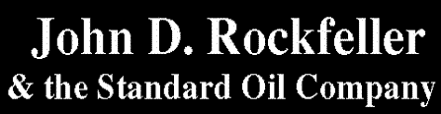
http://www.micheloud.com/FXM/SO/introduc.htm

Francois@micheloud.com
Francois Micheloud

- Foreword
- Introduction
- John D. Rockefeller 1839-1937
- The Oil Industry
Beginnings of Oil
Structure of the industry
The four main players
  - The crude oil producers
  - The transporters
  - The refiners
  - The retailers
The end products
  - Kerosene
  - Lubricants
  - Refined OIl
- Oligopolies, trusts and monopolies
Anarchy of the first drillings
Rockefeller's Vision
- Rockefeller's commercial practices
Silence is Golden
Industrial Spying
Costs Control
- Economies of scale
- Les petits ruisseaux font les grandes rivières
Alliance with the railroads
- The rebate system
Pipelines
Price policy
Other methods

- Chronology of the Standard Oil Company
  - The South Improvement Company
  - The 1872 Oil War
  - Alliance with refiners and counter alliance of the producers
  - Consolidation of refineries
  - Conquest of the pipelines
  - Expropriation of the retailers
  - The Standard Oil Trust
  - Dissolution of the Trust
  - The Sherman Antitrust Act of 1890
  - Death of the Standard Oil
- Conclusion
- A short Chronology
- Bibliography
- Contents and documents
- Pictures

2. Introduction
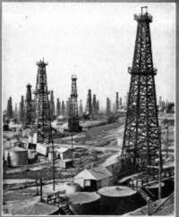
It is in the greatest anarchy that the men of the second part of the 19th century discovered the wonderful properties of this liquid that was known from Antiquity. It seemed that by a simple distillation, an abundant and easily extractable natural resource could be transformed with no waste in a lubricant and lighting oil far superior to those that were known so far, and much cheaper.
Only the most crazy gold rush can be compared to the incredible boom that the oil regions witnessed immediately. But the anarchic competition of the first times was slowly superseded by a more rigorous organization, as a mysterious company ate one refiner after the other, pipelines after transporters and integrated the whole industry in a frictionless machine. The time was one of industrial concentration, and oil was no exception. Under the strong and inflexible leadership of John D. Rockefeller, the ubiquitous Standard Oil ate progressively almost the whole oil industry, controlling in 1900 about 90% of the refined oil production in the USA.
Resistance against this "conspiration against trade" was a strong as it was disorderly, with the independent producers speaking of laissez-fairest individualism and the Standard of "reducing the waste and the reckless competition that could only harm the interests of the producers". The resistance slowly organized itself to try to escape strangulation. But the oilmen were not made for the joint, long-term action necessary to destroy the Standard Oil. During 40 years, trial after trial came, until the public believed that they were not bandits but Destiny itself. Only in 1911 an effective dissolution of this "Anaconda" that strangled the industry finally succeeded. The giant was killed and from his remains two dozens of independent, competing companies were created. The first great industrial monopoly had lived, and on his still warm body a century of struggle against the trusts, the oligopolies and the monopolies opened, so powerful and so foreign to the American Dream.
If Rockefeller's commercial methods may shock some people today, it must be remembered that they were part of the continent and part of the century. May the bleeding hearts which will be scandalized by this tale recall that the museums, foundations, universities, scolarships, chairs which today live off a wealth whose origin is now forgotten, have been created by the same barons, the Frick, Astor, Vanderbilt, Carnegie, Hearst or Rockefeller that led their businesses recklessly, destroying the weak and twisting the arms of the powerful, often conducting their trade with armed hands. Just thinks that the laws that today rule trade and the financial markets have often been created after today illegal acts that lead these men to fortune and that posterity did forget, dazzled by the mansions and the philanthropic image that they were careful to leave behind.
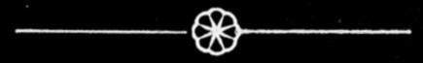

3. John D.Rockefeller 1839-1937
«The only time ever saw John Rockefeller enthusiastic was when a report came in from the creek that his buyer had secured a cargo of oil at a figure much below the market price. He hounded from his chair with a shout of joy, danced up and down, hugged me, threw up his hat, acted so like a mad man that I have never forgotten it . . .»

.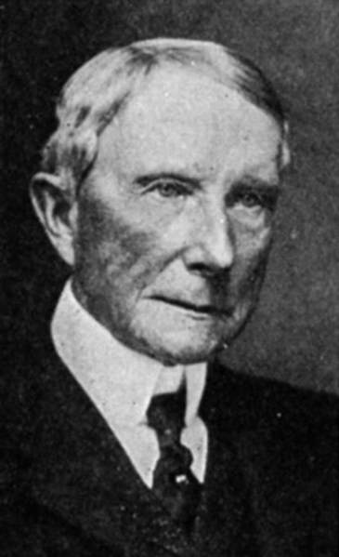 | John D Rockefeller had been raised in the strictest Baptist faith, in the paternal farm near Cleveland, Ohio. Greedy since his childhood, he used to buy candies wholesale to resell them to his siblings at a profit. After mandatory school, he works at 16 as an accountant for a grocer in Cleveland, giving the greatest satisfaction to his employer by his diligence. He was the kind of accountant that saw everything and forgot nothing. Rockefeller did not forget this early experiences when he came to run his own business  To learn more about John D. Rockefeller's personality, read the excellent biography by Ron Chernow : Titan : The Life of John D. Rockefeller Sr.
A very religious man, John D. Rockefeller thought that God would reward the chosen ones. He had the frugal man's hatred for waste, disorder and middlemen. He did not like public life and the only places where he was to be seen was his office, his house and the Baptist church. His innate taste for secret was reinforced by the public's critic, and his face was one of the least familiar in the Standard Oil Company.  He was never seen either in the oil regions. People began to bestow an suspicious admiration on this man that nobody never saw but who seemed to control everything. The result of this awe was to neutralize the common resistance efforts from the independents. Rockefeller never smiled, except for an exceptionally profitable deal, and he decided young that the oil business was his. With a calculating coldness and an enormous determination he began very soon. In 1863 with and associate and a chemist, he builds his first refinery in Cleveland, producing naphtha and kerosene. Reinvesting constantly the profits and keeping costs and wages as low as possible, John D. Rockefeller grew quickly his business.
  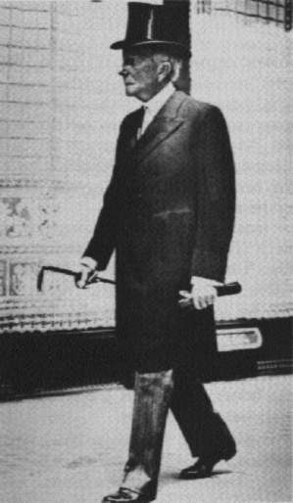
  Rockefeller toward the end of his life

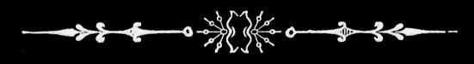

 | 4.1 The Oil Industry
 | .  The beginnings  In 1855, Benjamin Sillian, chemistry professor at Yale, discovered that a mineral liquid (used so far by the Indians and the first settlers to make a bad, smoky and smelly light, and before that as a medicine), this same liquid could, after a simple distillation make lubricants and a wonderful, clean source of light, far cheaper that whale oil or natural gas. Following the spirit of the time, the professor started a company and began to dig for oil. In 1859 his well was producing more than 1000 gallons a day. The news of this stupendous discovery burst like a grenade and led immediately to a rush of a scale never seen since the crazy times of the gold rushes. In one year, more than 2000 new wells were dug, each spitting more than 1000 barrels a day. A new industry was born.  Structures of the oil industry  The oil industry differed from other industries like for example steel in that, at least in the beginning, it knew little barriers to entry. Crude oil producers and refiners could, with a minimum of capital, start a venture that was in direct competition with long established companies. Change in the method of refining around 1875 raised the minimum size of an efficient refinery and allowed economies of scale to benefit the big refiners. The capital needs (for derricks, pipelines, stills, tankers and scientific research) increased rapidly and soon shaped the industry as we know it : huge initial investments but once it works the marginal costs are very small. | .
  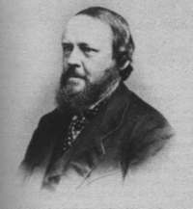
  Benjamin Sillian discovered the properties of oil and made them public in 1855
  Working for a journalist who had heard of rock-oil in college, Sillian investigated the properties of this liquid. The professor published a report that spread quickly. Here is an excerpt :
  «From the rock-oil might be made as good an illuminant as any the world new. It also yielded gas, paraffin, lubricating oil. In short, your company have in their possession a raw material from which, by simple and not expensive process, they may manufacture very valuable products. It is worthy of note that my experiments prove that nearly the whole of the raw product may be manufactured without waste, and this solely by a well-directed process which is in practice in one of the most simple of all chemical processes.» (distillation)
4.2 Structures of the Industry
 | .  Four main players  To understand the structure of the oil industry at this time, we can divide it in four stages (between the well and the lamp). For each stage there is a player.  The crude oil producers  Among the most enterprising Americans, these men were all looking for the same thing in the muddy oil fields : fortune. Many found it, as the profits were huge in the beginnings. It was not unusual for an oilmen to get a 100 % return on his invested capital. The equipment needed was rather simple (concession, derrick, casks) to be a competitor for those producers already present. The wildcatter (independent digger), young man struck with oil fever gathered his savings or those of his family and borrowed as much as he could and he could start ! Concessions were negotiated everyday in mushroom towns that grew one after the other behind the oilmen, and with some luck huge fortunes could quickly piss from the meager equipment. The enormous affluence in the oil regions can thus easily be understood.  Natural competitors and often staunchly independent, the oil diggers were only able to unite when collectively faced with the most gigantic difficulties, and as soon as the storm disappeared they divided again. All the cartels, councils, organizations never lived more than a few years. You can thus see how these scattered, atomlike producers were at the mercy of such an inflexible organization as the Standard Oil.  The only collective bodies that survived for some time were the newspaper, like the famous Oil City Derrick, in which the latest deeds of the Standard were described, and which occasionally served as a tribune to mobilize the independents. | .
  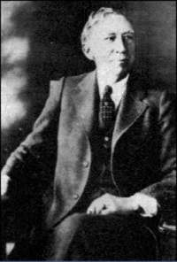
  George Getty left his job as an insurance clerk to strike it rich in Oil at the age of 45
  Jean-Paul Getty's father, George Getty, worked for an insurance company when in 1903, at 45, he was sent by his company in Oklahoma to collect a bad debt. Upon seeing for the first time the extraordinary euphoria surrounding oil extraction, he left insurance at once and started a new life as an oilman. He bought a concession for $ 500 and after 6 month already had 6 wells yielding about 10'000 barrels a month. In three years he became a rich man, with mansion, driver, gardener and Japanese cook. Such destinies were common in the oil regions, and so you'll understand that hordes of adventurers poured each year in the oil fields.

4.3 Transporters and refiners
 | .  The transporters  Oil fields were often scattered in desolated regions. To sell their oil, the oil diggers had to carry it from their wells to the refineries, and then to the retailers. In the euphoria of the beginnings, oil was carried in casks, first by men, then with horses or carriages, then on trains, boats and finally by pipelines. Each change of mean of transport diminished the cost. The quantities produced were so huge and so imprevisible that it was common to see oil pouring on the ground immediately after it came out of the well, for lack of storage space and of sufficient transportation capacity. The carriers had thus an incredible power on the producers, and nobody missed that. | .  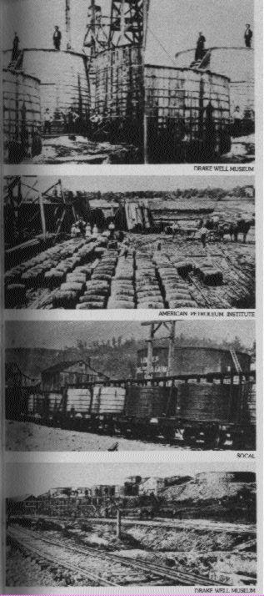  Oil transport from the wells to the refineries  in 1862 already, the oil regions produced 3 millions barrels a day, and the demand to stock and carry it was enormous. From above downward : wooden tanks to store oil, transport by barrels ready to be shipped by train or floated on a river, wholesale transport on special rail cars, and at the bottom a photo of a pipeline terminal.
The refiners
The oil was poured in big metal bowls which were then heated so that the liquid began to evaporate. The fumes were then guided through copper pipes (Yes, I'm describing a still) where they cooled to fall in enameled basins, separated according to their different boiling points, with the most volatile components coming first and the tar left at the bottom. The liquids had then to be chemically cleaned and let still in other basins. Any person who could find this rather simple equipment could refine oil.
At the turn of the century the refining process was changed by the cracking method, which raised the distillation yield considerably.

4.4 End products and retailers
.  The retailers  Once transformed in usable products, oil had to find buyers. Some refiners had their own retailers, but most used wholesalers or placers who distributed kerosene and lubricant among grocery stores.  End products  People realized quickly that they could make many products from oil. The waste from the first distilling soon found a use as raw material to make by products which could be very useful. Nevertheless, most of the production was still used to make fuel, first lamps and then for engines. | .  Standard Oil Advertisement
  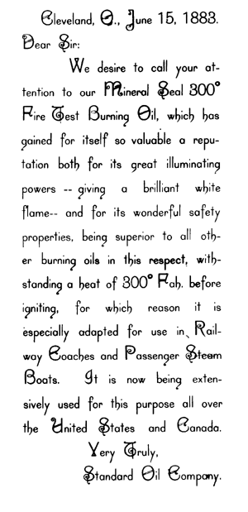
.
Kerosene  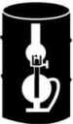 | Also known odorless oil, this is the result from a distillation of oil which removes its aromatic elements. It took the place of whale oil and natural gas, and before electricity came kerosene was the main source of lights for households, powerful and odorless, much cheaper that traditional fuels which had a rotten smell (try to burn cooking oil in your kitchen with a paper fuse to see what it was like)
Lubricants  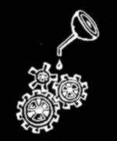 | Many byproducts from oil distillation could be made useful. For example, lubricants, which oiled all kinds of machines.
Gasoline | Kerosene was soon supplanted by a more volatile substance, made possible by new methods of distillation. Production of gasoline increased every year and in 1911 it was more than that of kerosene, thanks to the development of the automobile industry. That year Henry Ford built 1'680'000 vehicles...  Apart from fuels and lubricants, many other substances were made from oil, like Vaseline, naphtha, tar, but they are less important in our story.

5. Oligopolies, trusts and monopolies
.
The first industrial pools in the 80's tried to fix the price of their goods (be it salt, whiskey, cattle, iron, oil ...) no matter the circumstances, to a level high enough to earn them a nice living, but not too high so as not to attract outside competitors. United they could also earn from the other side, by lowering costs. Railroads were forces to give them wholesale rebates, inefficient or poorly situated factories were closed, redundant workers could be laid off, and sometimes a war chest was even made. Outside competitors could generally not survive.  Pools were in their eyes modernity, sweeping the cut throat competition that could only lead to ruin and introducing rational methods of production management. They could also invest in common scientific research and advertisement, and to organize buying centers. As they did not think of themselves as public benefactors, they underlined the exceptional wages in their factories and price stability. Sure, in periods of increasing demand their workers were paid more to be sure that they would not strike, but in normal time the pool allowed drastic wages decrease, as the owner of a striking factory could easily transfer his production in another factory.  Did Rockefeller invent the trust ? (by trust we mean the industrial, not the juridical structure). Not really, and we need not look very far to find many other examples. In the North the pig people had set up a dead pig trust in Chicago.  Continued on next column | In the south, the sugar trust was already well established. In the east, steel baron Andrew Carnegie dominated the whole industry. As he used to say to his competitors, Remember, Gentlemen, I'm the lowest cost producer ! The biggest or most efficient producer could impose his will on the other industry members, and was king to the fragmented links up and downstream of the production chain. If one resisted, his business diminished quickly so as to put him totally out of the market and to allow that one who lead him to the verge of bankruptcy to buy him out for a dime.  Price war was always an option for companies in the same production stage. As soon as bankruptcy had liquidated an dissident, price rose again to allow for a considerable profit, but never enough to draw new competitors. Profits were hoarded in war chest, in case of a new price war.  The walrus moustached banker John Pierpont Morgan, probably the most powerful man of his time, did not like the disorders of natural competition either. He made many gigantic trusts himself, like United Steel, American Tobacco or General Electric, whose control was very centralized. Moreover, as is the case today in Switzerland, many boards were crossed, with members of the board sitting in different companies, which make oligopolistic deals easier.
  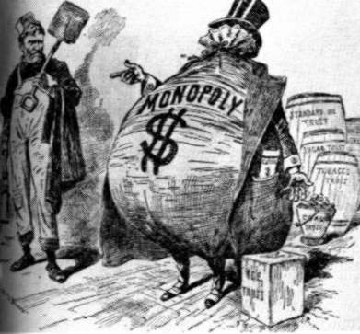
  The public began to understand the power of the monopolies, so different from the free enterprise ideal
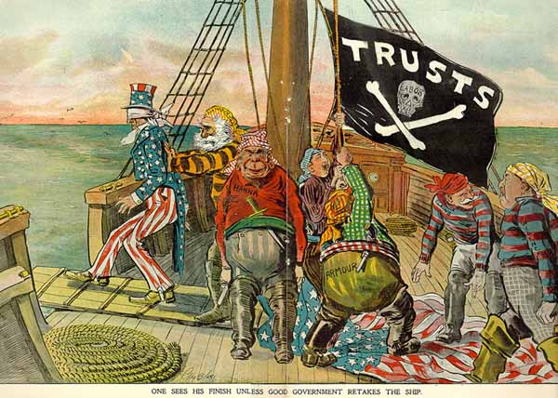
1899 Cartoon showing Uncle Sam killed by the trusts

5.1 Anarchy of the first drillings
.
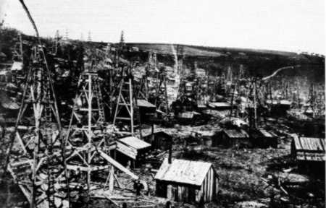 | John Benninghoff farm in Oil Creek, Pennsylvania where you can see the anarchy of 1861
.
Before Mr. Rockfeller took the totality of this industry in his iron hand, the price of oil fluctuated wildly. It soared or fell quickly, depending on the market being flooded with an abundant supply or starved by a strong demand. In 1859 for example, the crude oil barrel was selling for $20 and two years later only for 52 cents ... Speculators bought huge quantities of crude after an especially generous well (a wildcat) had made the prices go down (or knocked the bottom out of the market, in the colorful English of the oilmen) and stored it in tanks, waiting for the prices to rise again. To invest in such a business needed the temper of a gambler, which was not lacking to these men.
5.2 Rockefeller's vision
<<We reached the conclusion that there were three great divisions in the petroleum business - the production, the carriage of it and the preparation of it for market. If any one party controlled absolutely any one of those three divisions, it practically would have a very fair show of controlling the others.>>
Colonel Potts in 1888
In a first stage, Rockefeller devoted himself to the conquest of the better part of the refineries. He did not stop at this almost perfect horizontal concentration of the refining business, though. He realized that by controlling the refining process, he was the master of the whole industry, and worked from that point on to a vertical concentration to the whole industry, taking over every stage of production, from extraction to retail, including transport, research, marketing and even the manufacture of barrels. This was an ambitious plan because of the fierce resistance of the staunchly independent producers, and the great diversity of operations, but nevertheless he succeeded above all hopes. At its peak, the Standard Oil owned not only all the infrastructures necessary to the making of refined oil, but also pipelines, cars, tankers, groceries. The few links that did not belong to it were in perfect monopsony situation, with the Standard as only buyer.

6. Rockefeller's commercial practices
 | .  Silence is Golden  Hide the profit and shut up !  To avoid stimulating the greed of their competitors the men of the Standard, like those who worked with Michael Milken in the 1980's had to commit themselves not the reveal what they earned and to keep a low profile in their standing expenses. The huge profits were mainly reinvested in capital goods. In 1886 net profits were worth $15 mil a year. Rockefeller's strict Baptist faith made him despise personal luxury and drove him to reinvest it all. If we add to this wonderful trait his compulsive tendency for secret, we can understand that its as much by calculation as by taste that the Standard was so discreet.  Industrial Espionage  To work for the Standard Oil, the railroads had to commit themselves to give detailed reports to the Standard on all the oil transport made for competitors, stating the producer's name, quantity, quality and price paid by the client. Rockefeller also places spies who checked that the railroads really used the price discrimination explained above. If this discrimination had not been applied in a case known to the Standard, the culprit railroad quickly received a letter like this:  Economies of scale  A new distillation method discovered in 1875 rose the minimum size of the efficient refinery to a daily capacity of 1000 barrels. Rockefeller soon decided to concentrate most of his refining in three giant refineries conveniently located, like in Bayonne, so as to maximize scales economies. Furthermore, Standard's refineries had a very efficient use of by products | Les petits ruisseaux font les grandes rivières  In an industry producing such important quantities, there was no such thing as as small saving. If cent spared on production costs, each dollar of waste reused, each percent of discount extorted to a supplier was multiplied by millions and transformed in important profits. By making its own barrels, glue, hoods, pipelines, food for horses, etc... John D. Rockefeller enlarged each time his profit margin. The costs of barrels dropped of $1.25 each, sparing $4'000'000 a year, price of metal boxes was lowered of 15 cents, sparing $5'000'000 a year. What some condemned as meanness from Rockefeller and other industrial captains can rather be seen as large scale vision of the crucial importance of the crucial importance of a perfect management of the production process.
  Despite the substantial drop in oil prices, Standard Oil was able to increase its profits by reducing costs from about 3 cents per gallon in 1870 to less than 0.5 cents in 1885.
  <<Wilkerson and Company received car of oil Monday 13th-70 barrels which we suspect slipped through at the usual fifth class rate paying only $41.50 freight from here. Charges 55.40. Please turn another screw. >>
  Here is the contract that the refiners who wanted to collaborate with the Standard (or its predecessor the SIC) had to sign :
  I, -- -, do solemnly promise upon my honor and faith as a gentleman that I will keep secret all transactions which 1 may have with the corporation known as the South lmprovement Company; that should I fail to complete any bargains with the said company, all the preliminary conversations shall be kept strictly private; and finally that I will not disclose the price for which I dispose of any products or any other facts which may in any way bring to light the internal workings or organization of the company. All this I do freely promise.

6.4 Alliances with the railroads
From the beginning, Rockefeller succeeded in extorting from the railroads a deal that gave him major advantage over his competitors : preferential rebates. Moreover, those same railroads also committed themselves to inform the Standard Oil on every move of their competitors, and collaborated on its side in price wars by raising the price of transport for a given area.

How the Secret Rebate System worked
  Independent  Refineries | Independent refineries pay the full price of $2.50 a barrel to the railroad ....
    Full price
  $ 1.00
  $ 1.50
  ... who secretly pays $ 1.00 to Rockefeller !
    Secret Rebate
    $1.00 being the discount that Rockefeller and his allies would have got for the same distance
  South Improvement Company-  ... the railroad cash in $ 1.50 and keeps it. The railroad owner thus gets the same money with both client | Railroad company
    Net Profit

Example of an actual preferential rebate system used by railroads in 1871 for the transport of crude oil from the Oil Regions to New-York. Source Ida Tardell, 1904.
The preferential rebate system
As the biggest client of the railroads, the Standard could get extremely favorable terms from them.
For each destination, a public rate was published, which was almost never used. The members of the Standard Oil scheme got a substantial rebate, like 30-50% off the public price. So far nothing extraordinary, but please go on. People outside of the scheme not only had to pay full price, like $ 2.56 a barrel when their competitor paid only $ 1.56 but the railroad paid back to Rockefeller himself the difference with the public price, here $ 1 ! This deal strangled the competitors who had to compensate for this inflated costs elsewhere.
The resistance of the public and a Pennsylvania court's judgement forbade this scheme, which was the base of the South Improvement Company, but the huge size of the Standard's orders gave it sufficient leverage over the railroads to still gain rebates substantial enough to beat the smaller refineries. These smaller competitors sold their refineries one after the other for a song to Rockefeller.

 | 6.5 The Pipelines
 | The possibility of carrying oil through pipes had been thought of from the beginnings. In 1863 Samuel Van Syckle tried, under heavy mockeries from the other oilmen, to carry oil trough a 5 miles long pipe buried under 60 cm of earth. When the pipeline began working satisfyingly, charging only 1 $ a barrel, hundreds of teamsters (who so far earned 3 $ a barrel for transportation) tried to destroy the pipeline ! The sheriff had to post guards to protect it, and soon others pipelines were built. Transport on men's backs or on carriages disappeared quickly and everyone started building its own pipeline. | 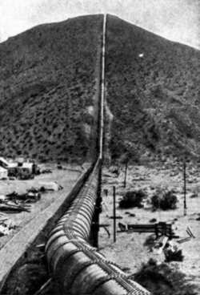  The first pipelines were guarded by armed men
.
In 1872, John D. Rockefeller had bought United Pipe Lines, a group of small lines. Four years later, in 1876, he already controlled the half of all existing pipelines, through the active work of his lieutenants. After a price war and with help from the railroads he succeeded in eradicating his main competitor in this business, colonel Joseph Potts' Empire Transportation Company which passed over to him sword in hand by the weeping colonel. At the end of 1879 he controlled almost all pipelines built in the USA.
In 1879, Pennsylvania's independent producers succeeded in building a pipeline they owned, the Tidewater. Rockefeller first tried to have the government forbid the project, then to buy land on the pipelines proposed way, but without success. This was a major defeat for him, as now the public could see the independents' oil flow freely to the consumers and the price fixing scheme of the Standard Oil appeared in public light, like the railroads deals. An investigation was started and Rockefeller had to testify, but with little success.
Rockefeller began to foment dissentions in the midst of the Tidewater, trying to damage its credit, to buy its directors, to suit it. In the meanwhile his men were buying the Tidewater's stock in secret. He finally took control of the company in 1882. Now the totality of America's pipelines were again under his firm control
In oversupply episodes, especially after the discovery of the famous Bradford field in 1877, his almost perfect control on the carrying of oil from the fields to the refineries allowed Rockefeller to dictate the price he wanted to pay for the crude oil. This was possible because the oilmen could not store the enormous quantities of oil they extracted, and their only option was to sell it at bargain prices to Rockefeller if they didn't want to see it run to the ground and earn them nothing but tears.
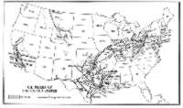 | 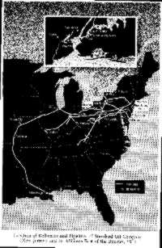
Click on the images above to see in a new window maps of the pipelines networks at the time of the Standard Oil

6.6 Price policy
 | .the quality of the Standard Oil's operations and its efficient methods to get the lowest price from its suppliers and from the railroads made it the lowest cost refiner in the world. This allowed the company to launch a price war on a given market (a city or a whole region) to wipe out all the competitors.  The Standard thus regularly lowered its prices in a given area to eradicate a smaller competitor, who could not resist selling at loss for long enough.  But if this strategy was often used, globally the idea was to maintain price as high as possible to insure a steady, high profit, but not too high. As already mentioned, too high prices would have attracted new competitors, and prices fluctuating with crude oil production would have attracted the general public's attention on what made the price what it was.
  Rockefeller the control freak
  The following legend was to be heard among the men of the Standard Oil : Rockefeller, who started as an accountant is supposed to have sent the following memo to the manager of one of his barrel factories :
  « Last month you reported on hand, 1119 bungs. 1o,ooo were sent you beginning this month. You have used 9,527 this month. You report 1092 on hand. What has become of the other 500?»
  (a bung is a little cork used to close barrels)
6.7 Other methods
Sabotage was sometimes used, as for example in 1887, when the Standard Oil paid a mechanic working for the Vacuum Oil Company in Buffalo to tamper the still so as to make it explode.
In the fight against independents pipelines, armed men defended land bought par Rockefeller on the planned way of the pipelines.
Numerous examples of bribery of judges and politicians are also known.

7. Chronology of the Standard Oil Company
7.1 The South Improvement Company
In 1863, the young Rockefeller started with a partner a small refinery in Cleveland. The company does well and grows. In 1870 he reorganizes his company and found the Standard Oil Company. In 1871, some refiners discuss the possibility of making an alliance big enough to convince the railroads to give them special rebates for the shipping of oil, and extra premiums for their competitors. They realized that the speculative nature of their business would be done with if they became the only buyers and only sellers. Looking for an existing company to buy its name and charter, they found the South Improvement Company. The name was good, as it meant nothing. People involved in this company stood for no more that 10% of the total American refining business, but told the railroads that they stood for the majority. The Standard Oil was the main shareholder and led the operations. This was the beginning of the alliance with the railroads described above. The advantage over the competition was decisive, and the leverage on the producers was soon to be felt.

7.2 The 1872 Oil War
In early 1872, after a leak, a rumor spread through the Oil Regions, a rumor of a "great scheme between the railroads and the refiners to control the purchase and shipping of crude oil". At the same time, an employee disclosed prematurely the new railroads rates, twice as expensive as before. The rage of the producers immediately led to demonstrations, a press campaign in the Oil City Derrick and petitions to the Pennsylvania legislature and to Washington. The producers decided not to deliver a drop of oil more. The Standard Oil Company had to close its refineries for technical unemployment and waited patiently for greed and hunger to break the enemy's front.
After an investigation had revealed the preferential rebates given for rail transport, a court ordered a unique rate. Congress concluded that the South Improvement Company was the most enormous and most daring of all the conspirations that a free country had ever seen. An other man would have let the anger and despise win over him, but not Rockefeller. He had a mind that, when faced to wall, tried to circumvent it subreptiously or to find a hole. And so was did he do ?
He went on asking for preferential rebates ! And the railroads had to yield, as the means of transportation between oil fields and refineries were numerous (several railroads and a canal) and a big client like the Standard could have his will done, always menacing to switch to a competitor in case of non cooperation. The only thing that changed was that the importance of keeping these deals secret were now clearer.
This oil war had after all a nice ending for Mr. Rockefeller, but he had still a lot to do. Too many independent refiners were left to let him make an monopolist price, and he quickly settled to eradicate them.

7.3 Alliances and counter alliances
  To Mr. Rockefeller a day is a year, and a year as a day. He can wait, but he never gives up.
 | End 1872, 80% of the American refiners, unite under the presidency of Rockefeller in the National Refiners Association. As soon as the producers learned it, anxious to see an oligopsone for their good formed, make a counter alliance and unite in the Petroleum Producer's Agency. We have to consider the producers psychology : scattered over vast territories, they had little interest for things outside their own wells, and would unite only under extreme circumstances. Having lived through the euphoric conditions of the first years, they excepted a return on invested capital of no less than 50 %, and if they did not earned their total investment in three years, they felt sorry.  But only oil at $5 a barrel could grant them such profits. And to have such a price, the only way was to unite to restrict production. Note that this is the first time in history that oil producers unite to restrict production, 100 years before OPEC !
  << It is a large order . . . that always breaks a pool. The manufacturer will figure that he can pay his fine to the pool, take a big order, and with the profit on this be in a stronger position than any of his competitors who may then try to break the pool. Suppose there is a ten-per-cent profit in his business, and he can get a $2,000,000 order by cutting to five-per-cent profit. He does not regard it as dishonorable, if it is a 'fine' pool to pay the $5,ooo fine, and then say to his competitors: 'I have paid my fine. >>
  The journalist Barron citing a jurist
Rockefeller thus had to deal with the new producer's association which asked him $ 5 a barrel. Instead of refusing, John D. Rockefeller smartly pledged himself to buy oil at this price as long as the producers effectively restricted their production. He thus showed his "good will and willingness to ally with them for the good of the industry". This unhoped-for collaboration of the Standard calmed the producer's anger and soon they stopped their protest.
But did Rockefeller abandon his dreams of conquest ... ? Only a few months afterwards, the Standard Oil announced that it would no more buy oil from the Petroleum Producer's Agency. You have not restricted production sufficiently, how can you expect that we continue to pay your price ? This reaction caught the producers by surprise and they did not react efficiently. Many were deep in debt and absolutely had to sell oil to avoid bankruptcy. A lasting freezing of production was thus impossible, and the Standard again dictated his terms. Dissentions soon consumed the alliance and after only 10 months, the producers association disappeared.

7.4 Consolidation of the refineries
We mean to secure the entire
refining business in the world

 | Between 1875 and 1878, Rockefeller travels through the US in a campaign to make selected refiners join the Standard. To the interested refiners, he explained in the greatest secret how they were about to gradually control every refinery in the US, and become the only shippers, dictating their terms to the railroads. The Standard Oil's economies of scale and incredible profits were shown to them, and they were promised wealth beyond their wildest dreams if they cooperated with the Standard with Rockefeller at the steering wheel. He succeeded in uniting the 15 biggest refiners in the country, dominating 80 % of the total capacity.  Another method was used with smaller refineries. He first tried to buy them, often offering no more than 40% of the invested capital. Those who refused eventually yielded to the enormous pressures of many kinds. For example, a lubricant producer in Cleveland had the Standard Oil as his only supplier of distilling waste, his raw material. One day, Rockefeller stopped his supply totally, and soon afterwards bought the factory for a song to his crying owner.
  Rockefeller's Arguments to the Refiners
  «Three years ago I took over the Cleveland refineries. I have managed them so that to-day I pay a profit to nobody. I do my own buying I make my own acid and barrels, I control the New York terminals of both the Erie and Central roads, and ship such quantities that the railroads give me better rates than they do any other shipper. In 1873 I shipped over 700'000 barrels by the Central, and my profit on my capitalization,$ 2'500'000, was over $ 1'000'000. This was the result of combination in one city. ... Le us become the nucleus of private company which gradually shall acquire control of all refineries everywhere, become the only shippers, and consequently the master of the railroads in the matter of freight rates.»
 | Others gave in after heavy underselling from the Standard on their markets. Because when Mr. Rockefeller undersold, he went on day after day, week after week, month after month until there was nothing left of his competitors. Nobody had sufficient reserves to successfully resist a price war with the Standard Oil.  If the preferential rebates from the railroads, the cutting off of the crude oil supply and the price war were not sufficient, other methods were used. As said above, a mechanic of the Vacuum Oil Company in Buffalo was bribed to tamper a still. The sabotage worked fine and the refinery exploded, but only years later did the repenting mechanic clear his conscience by telling the story. This cast some light on the muscled methods of the Standard.
  The pool appeared natural to everybody in the industry, with such a destructive competition
  «How much did you make last year? Not a cent? Are you Making anything now? Well, what do you propose to do? Sit here and lose what capital You have got in the business? There is only one way to make any money in a business like the oil business and that is to have a pool.»
Old and poorly placed refineries were shut off and the most efficient enlarged. All the buying, the negotiations with the railroads and the selling of the finished substances were under Rockefeller's management.
The consolidation process went on, par ruse ou par force, so that in 1878 a superstitious fear of resisting to Rockefeller and his men appeared in the Oil Regions, making life unbearable for the independents.
In 1879, after intense juridical battles, the jury of the Clarion county declared John D. Rockefeller and several of his directors of conspiration for gaining monopoly in the buying and selling crude oil, so as to make it impossible for other people to do the same business profitably.
Rockefeller proposed an out-of-court settlement. The producers accepted bitterly, asking for (1) full stop of the preferential rebate system (2) stopping of all discrimination for pipeline transport (3) a sum to pay the lawyers fees. Rockefeller had won again, profiting from the weak waiting capacity of the producers and of their difficulty to unite except when in major difficulties.
He once again escaped the public wrath.

7.5 Conquest of the Pipelines
  The coal-oil business belong to us
 | After having tried to destroy several pipelines developments, Rockefeller saw that this was a much more efficient mean of transportation for oil. When each barrel cost 40 cents to carry to the railroads, which then made the Standard pay 85 cents (against an official rate of $1.30), pipeline transport only cost 16 cents a barrel. The success of the first experiments with pipelines was made by the Tidewater Company, which had its own network of refiners. Rockefeller tried every possible mean to secure control of the Tidewater, like making false rumors to be able to buy its stock at a low price, and finally took control by alliance.  He applied to pipelines the methods that had been so efficient with refineries, and in 1879 he controlled most of the oil-gathering pipelines, those which connected the wells to the shipping points. These lines were organized under the name of United Pipe Lines.  At the summit of its glory, the Standard had thus a quasi monopoly on the US pipelines. more on pipelines  7.6 Expropriation of retailers  The avowed goal of de John D. Rockefeller was to take control of the whole oil business. This implied the capacity of leading the fate of each barrel of petrol, from the time it came out of the earth until it was burned in the housewife's lamp.  He still had to control the retailer network, those who sell kerosene to housewives and lubricants to factories.
  Letter from the Standard to a grocer
  John Fowler
  DES MOINES,
  IOWA
  January 14, 1891 Hampton, Iowa.
  Dear Sir :-Our Marshalltown manager, Mr. Ruth, has explained the circumstances regarding the purchase and subsequent countermand of a car of oil from our competitors. He desires to have us express to you our promise that we will stand all expense provided there should be any trouble growing out of the countermand of this car. We cheerfully promise to do this; we have the best legal advice which can be obtained in Iowa, hearing on the points in this case. An order can be countermanded either before or after the goods have been shipped, and, in fact, can he countermanded even the goods have already arrived and are at the depot. A firm is absolutely obliged to accept a countermand. The fact that the order as been signed does not make any difference. We want you to absolutely refuse, under any circumstances, to accept the car of oil. We are standing back of you in this matter, and will protect you in every way, and would kindly ask you to keep this letter strictly confidential. . . .
  Yours truly, E. P. PRATT
  Source : Ida Tardell, op cit.
Some refiners had their own retailer network, others had wholesalers (or jobbers) who then sold to groceries. To achieve total integration of the industry he still needed his own retailers, which he promptly got.
Very soon the whole US territory was covered with local retailers working under close supervision by the headquarters. The same perfection observed in other parts of the process could be seen in the retailing : excellent service, quality product delivered on time. Informers, often employed by the same companies they were spying, told the Standard Oil of every move of its competitors. If for example a retailer had ordered oil from an independent refiner, an agent of the Standard contacted him and offered cheaper Standard Oil oil. If for some reason the grocer did not want to do business with the Standard, he was then visited by a pseudo independent refiner who offered him special prices. After all the independent producers oil had been evicted from the local market by a few month of such a price war, the kerosene price quickly rose again at its initial level in this region.
If their methods came to public knowledge, the directors of the Standard accused "excessive zeal" from their employees and promised to correct it. As Rockefeller said in a rare interview in 1890 « ... In a business as large as ours, conducted by so many agents, some things are likely to be done which we cannot approve. We correct them as soon as they come to our knowledge. The public hears of the wrong - it never hears of the correction.»
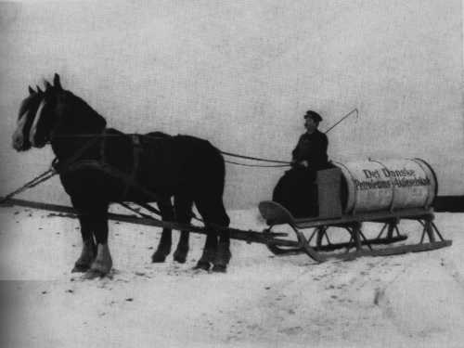
Carrying Standard Oil kerosene through the Danish countryside

7.7 The Standard oil Trust
  The first great industrial trust
 | Until 1881 the forty companies controlled by John D. Rockefeller and his partners was a cordial alliance, welded by cross holding of shares. Standard Oil's jurist, Samuel Dodd, proposed to unite the alliance in a trust. The shareholders of refining, extracting, trading, retailing companies would hand in their actions to 9 trustees, which would give them in exchange trust certificates. The trustees would then become the directors of all the companies in the system, controlling the totality of the operations. Dividends would be paid to the trust's shareholders.  The project was realized and the Standard Oil Trust built his headquarters at 26 Broadway in New-York.  The new organization perfected the great monopoly and began to look like the Vatican. People from all the world brought information to the generals gathered around John D. Rockefeller. They discussed in the greatest secrecy the affaires of their empire, taking decisions which were quickly transmitted around the world in a seemingly frictionless machine.
  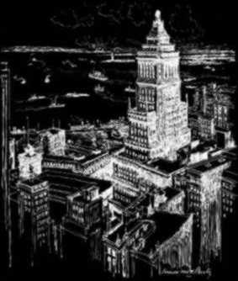
  Standard Oil's headquarters at 26 Broadway
  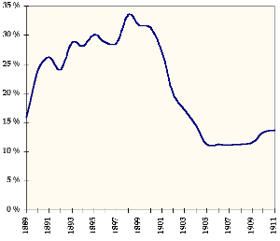
  A reasonable share of oil production ? Maybe, but 90% of the refining capacity in the USA .... Source : Hidy et Hidy, Pioneering in Big Business, NY 1955
7.8 Investigations and trust's dissolution
In 1887, the Standard Oil was one of the best managed companies in the world, mastering almost everything related to its good. Its factories were the most perfect in the whole industry, organized with the greatest economy. Its knowledge of worldwide oil demand was so deep that the company produced only what was necessary to keep prices constant. At the same time marketing departments sold its products all over the world through aggressive campaigns. Who could complain against such a perfect company?
Nevertheless, political pressure was growing. If we leave them, they will have followers, and in 50 years a handful of men will own the country said some, We have the right to lead an independent business, cried others. The sentiment was growing that the public eye should scrutinize the Standard Oil Trust business.
In 1888 a New-York senator investigated the Standard Oil Trust. The investigations wanted to know especially if the control of 90% of the American market was not due to special privileges, like, yes, a preferential rebate from the railroads...
Other investigations ran at the same time, on the sugar trust and the whiskey trust, but no one took the importance of the investigation of the Standard Oil Trust. The latter owned $150 mil of capital, managed by 9 men. Faced with the risk of a court order of the liquidation of the trust, these men decided to liquidate it themselves and to replace the trust certificate by a constant proportion of securities in each of the ensuing 20 companies. John D. Rockefeller personally received 250'000 of the 970'000 shares that came from the liquidation of the Trust. The Standard once again kept its monopoly power and went on paying dividends to its shareholders.
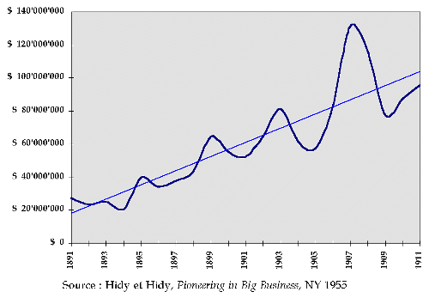
Total annual profit of the Standard Oil and its affiliates, graph is mine

7.9 The 1890 Sherman Antitrust Act
Congress passed this act in 1890, and this is the source of all American anti monopoly laws. The law forbids every contract, scheme, deal, conspiracy to restrain trade. It also forbids conspirations to secure monopoly of a given industry. The ideas were new and had to wait before they could achieve some efficiency. The Standard reorganized once more, in a holding in the Standard Oil Company (New Jersey) which now coordinated the whole machine, that is 70 companies and 23 refineries controlling 84% of the crude oil refined in the US in 1899. Ten years later, international competition (from Canada, Peru, Rumania, Poland, India or Russian) and the struggle of the independents lowered this percentage to 14 %. Theodore Roosevelt committed himself in 1901 and during both of his mandates to a strong war against monopolies, launching the federal government in 1906 in a lawsuit against the Standard because of discriminatory practices on the market, abuse of power and excessive control on the American oil industry.  7.10 Dismantling of the Standard Oil  In 1911, the Supreme Court finds the Standard Oil in violation of the 1890 Sherman Antitrust Act because of excessive restrictions to trade, and in particular its practice of buying out the small independent refiners or that of lowering the price in a given region to force bankruptcy of competitors. The court ordered the Standard Oil Company (New Jersey) to dismantle 33 of its most important affiliates, giving the stocks to its own shareholders and not to a new trust. From these offspring will come Exxon, Mobil, Chevron, American, Esso (that is SO).  This is a landmark ruling in the economic history of the USA, and is the basis for a new doctrine in American antitrust policy, called the rule of reason (because of the famous unreasonable restraints to trade mentioned in the Sherman Antitrust Act. Need for more solid juridical basis led to the Clayton Antitrust Act in 1914, which explicitly condemns commercial practices like price discrimination, exclusive commercial relations, the buying out of competitors and the incestuous boards.
  Rockefeller's testimony before a court
  In his testimony, Rockefeller says he did not take part in the South Improvement Company, did not receive special rebates from the railroads and that lived in good entente with his competitors...
  One may probe Rockefeller's attitude toward the investigation by reading the following part of the transcript. The judge talked of the refiners pool of 1872 :
  -- | Judge : Was there a Southern Improvement Company  Rockefeller : I have heard of such a company  Judge : Were you in it?  Rockefeller : I was not
  Playing on the error of the judge, who should have said "South Improvement Company", he takes the opportunity to reveal nothing while not lying. But this did not stop the investigation.

8. Conclusion
From the beginnings of the oil business, the producers understood the power of monopoly. The erratic fluctuations of the oil price had already convinced them to restrict production in a common effort, but their accord never lasted, so great were the incitations to cheat. A unified organization, a trust, made a rigorous control of the quantities produces possible, and thus of the price. If we add to this monopolist power the gigantic scale economies, we understand the tremendous profits of the Standard Oil. The ruling of 1911 reached its objectives and gave birth to 10 integrated oil companies among the most powerful of the world. The dissolution of the Standard stimulated innovation and expansion through competition, although worldwide competition was quite strong before the dissolution.
The situation from the 1970's, with a producer's cartel controlling the better part of the world's oil output, and which does not always work smoothly, is thus not without precedent. We need not look outside of the oil industry to find forerunners.
My generation (I was born in 1973) did not know the natural state of the oil market, that of the great fluctuations that come from the imprevisible output. Prices today are relatively stable, as the OPEC as taken the seat that once was occupied by Mr. Rockefeller.

9. Chronology
 | 1870 | The Standart Oil Company is founded by John D. Rockfeller in Cleveland, Ohio. The refining industry is at this time decentralised, and Rockefeller's share of the refined oil business is less than 4%, with more thatn 250 competitors in the US.
 | 1870 | John D. Rockefeller and Flagler start the South Improvement Company to pool oil transportation on railroads, letting those who take part in the scheme to get incredibly cheap rates.
 | 1873 | John D. Rockefeller already controls 80% of the refining capacity of Cleveland, which makes a third of the national's total.
 | 1879 | The Standart Oil Trust shuts down 31 of the 53 refineries owned by the Standard Oil and concentrate production in 3 giant refineries.
 | 1880 | Standart Oil controls almost every refinery in the US and has more than $40 mio in cash.
 | 1882 | The alliance of all the companies that made the Standart Oil is transformed into the Standart Oil Trust, the first big trust in the USA. The shareholders of the 14 companies and minority shareholders of a further 26 hand in their bonds and shares to 9 trustees and get in exchange $70 mio in trust certificates. The trustees control the company and pay dividend to the holders of these certificates.
 | 1882 | An Ohio court dissolve the trust, but it is reincorporated in New Jersey, a state that accepts trusts. The trustees leave their initial horizontal integration concept and work for a total vertical integration.
 | 1890 | Congress votes the Sherman Antitrust Act and the Standart is again reincorporated, this time in New Jersey as a holding.
 | 1900 | The Standard Oil controls more than 90% of the refined oil in the USA
 | 1911 | The Supreme Court decides the break up of the Standard Oil in smaller, competing companies.

Bibliography

Content and documents
I based this work mainly on Tardell's book and on Josephson's. I used others as a source of documents and figures. Clicking on the links below will take you to an online bookshop where you can buy the books if you wish.

Chernow, Ron, Titan, The Life of John D. Rockefeller Sr, Random House, New YOrk : 1998
The best book in print about the man and its business, written by an outstanding business historian who also wrote about JP Morgan and the Warburgs. The only book you need for a term paper or to get an extensive understanding of the man.
Dalemont, Etienne, L'industrie du pétrole, PUF (QSJ?) : Paris, 1980
Très bon résumé (court évidemment) de l'aventure de la Standart Oil. Un des bons Que sais-je? à mon avis.
Folsom, Burton, The Myth of the Robber Barons, Young America's Foundation : Herndon, 1991
Right-wing think-tank, that would like us to see Rockfeller as a philanthrop driven by the desire to light poor people's houses with the cheapest oil possible
Hidy, Ralph & Muriel, Pioneering in Big Business 1882-1911, Business History Foundation: NY, 1955
An official history of the Standard, with a portrait galery of old directors. Of course very partial, but good source of documents and figures.
Josephson, Matthew, The Robber Barons, Harcourt Brace : NY, 1934
A book written at a time when the Robber Barons were still remembered in a vivid fashion. Presentation of John D. Rockfeller along with other that had nothing to desire from him.
Knowles, Ruth, The First Pictorial History of the American Oil and Gas Industry 1859-1983, Ohio UP : Athen, 1983
Interesting summary of the SOC operations and their importance in american economic history.
Lee, Jim, The Supreme Court decides to break up Standart Oil,
Article from an american industrial history encyclopedia summarizing the period

Tarbell, Ida, The History of the Standart Oil Company, Mc Millan : NY, 1904
The classic book against the SOC, one that led to the 1911 ruling. Partisan and dated, but very well documented, with many first hand testimonies from the Oil Regions, and well written.

Illustrations
Art Today
Excellent collection of 500'000 images where I found several pictures you'll see in these pages.

