Kykuit, The Rockefeller Estate http://www.hudsonvalley.org/web/kyku-main.html
Kykuit, the Rockefeller estate, now a historic site of the National Trust, is the Hudson Valley's most exceptional house and gardens. No visit to the Hudson Valley would be complete without a stop at this magnificent landmark.
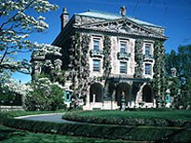
Home to four generations of the Rockefeller family, Kykuit commands a breathtaking view of the Hudson River and occupies a landscape of extensive stone terraces, formal gardens, and glorious fountains. The gardens include Governor Nelson A. Rockefeller's extraordinary collection of 20th-century sculpture. The house itself contains fascinating collections of art, fine furniture, and Chinese ceramics. Horse-drawn vehicles and classic automobiles from the family's collection fill the coach barn.
For the first time visitor, we recommend The House and Garden Tour (daily except Tuesdays during the season), which includes an introduction to each part of Kykuit—the main floor of the house, the art galleries, the terraced gardens with classical and 20th-century sculpture, and the Coach Barn. The sculpture collection, sited throughout the grounds, includes works by Pablo Picasso, Aristide Maillol, Henry Moore, Alexander Calder, Isamu Noguchi, Louise Nevelson, and many others. The guided tour takes approximately 2 hours and is wheelchair accessible.
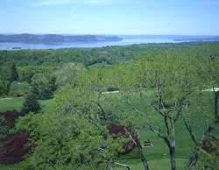

View from the West Terrace
The Garden and Sculpture Tour (offered weekdays except Tuesday at 3 p.m. and weekends at 3:15 p.m.) includes an exploration of Kykuit's formal gardens and Governor Rockefeller's collection of 20th-century sculpture. This tour leads visitors to garden areas not seen on the House and Garden Tour, such as the Morning and Brook gardens, the Italian garden, the Adam and Eve Fountain area, and several terraced areas featuring sculptures by Henry Moore, Gaston Lachaise, Aristide Maillol, Alexander Calder, and others. The Garden and Sculpture Tour does NOT include a tour of the House nor of the Coach Barn, and it is not wheelchair accessible. This two-hour tour is offered only once each day (closed Tuesdays) or for groups of 10 or more by advance reservation at other times of day.
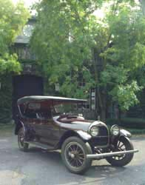

Crane Simplex, 1918
Visits to the estate begin at historic Philipsburg Manor, on Rt. 9 in Sleepy Hollow, New York just 45 minutes north of Manhattan. The Greenhouse Café, a gift and book shop, and free parking are available. Visitors enjoy an introductory video, and then go to Kykuit by shuttle van.
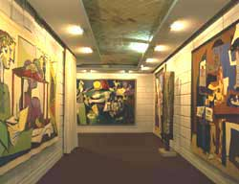

Art Galleries, showing tapestries
by Pablo Picasso
Tours depart from the Visitor Center at Philipsburg from 10 a.m. to 3 p.m. weekdays (closed Tuesdays) and from 10 a.m. to 4 p.m. on weekends. The Visitor Center opens at 9 a.m. to sell tickets for the day. Tickets are sold on a first-come, first-served basis. While every effort is made to accommodate individuals in a timely manner, there may be waiting time for a tour. Please note that weekends are the busiest days of the week for touring, and tours may sell out by midday. Please also note that the Kykuit tours are not appropriate for children under 10.
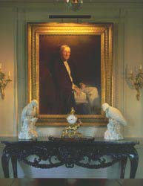

John Singer Sargent, Portrait of John D. Rockefeller, Senior. On the table are two Meissen eagles (circa 1730).
Strollers and backpack carriers are not permitted. Parents are required to supply a car seat for the shuttle bus ride to Kykuit for children age 4 and under. You may also purchase gift certificates using a credit card by calling Historic Hudson Valley at (914) 631-9491. Save $2 per gift certificate by ordering online. Or, Call 1-800-53-FERRY for information about boat trips to Kykuit from Manhattan and New Jersey.
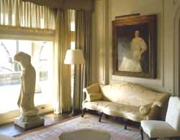

Alcove room, with Bodhisattva (Chinese, 7th century) and portrait of Abby Aldrich Rockefeller, by Adele Herter.
Kykuit, a historic site of the National Trust, is operated and maintained by the Rockefeller Brothers Fund as a center for the Fund's philanthropic programs. Historic Hudson Valley operates the public programs.

