The Rockefeller Monopoly & Oil Rulers

http://www.hermes-press.com/rocky1.htm

John D. Rockefeller's father, called "Doctor" Rockfeller, was a bogus physician who sold patent medicines and had once been indicted for rape. John D.'s mother, a devout Baptist, would tie him to a fence post and beat him when he disobeyed her. Beginning in Cleveland, Ohio as a bookkeeper, he then went into partnership in a refinery with the Clark brothers and soon bought them out.

"He expanded with great daring. Borrowing wherever he could, and bringing in new partners. He realized that the only way to dominate the industry was not by producing oil, but by refining and distributing it, and undercutting his rivals by cheaper transport. With the help of a new partner, Henry Flagler, he persuaded the railroads to give secret rebates to his oil, extending the existing practice of allowing discounts for large quantities of freight."

Anthony Sampson. The Seven Sisters

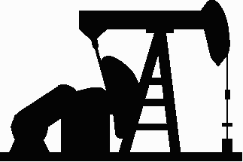
When John D. secretly bought out rival oil companies, the executives pretended to be Rockefeller competitors and reported what other rival company executives told them. By 1870 he established a joint-stock company, called the Standard Oil Company, with a capital of a million dollars, of which he owned 27 percent. Standard Oil was already producing one tenth of the oil in America.

The oil industry has always been plagued with the problem of overproduction. The year after oil was discovered, for example, the price of a barrel was $20. At the end of the next year the price had dropped to 10 cents a barrel because of overproduction.

In the 1870s, two groups vied for control of the oil industry:

• The producers and drillers

• The refiners

By 1875, Rockefeller, as president of the refiners' Central Association, had become the leader of the refiners. The refiners effectively took control from the producers and drillers. John D. formed the Standard Oil Trust in 1883, trading across the entire continent.

"Through the device of a trust, which held shares in each component company, Rockefeller was able to circumvent the laws which then prohibited a company in one state from owning shares in another; at the same time, he could and did pretend that all the companies were independent. He had no personal doubts about the rightness and need for this kind of concentration: 'this movement,' he said later, in a famous passage, 'was the origin of the whole system of modern economic administration. It has revolutionized the way of doing business all over the world. The time was ripe for it. It had to come, although all we saw at the moment was to save ourselves from wasteful conditions . . .The day of combination is here to stay. Individualism has gone, never to return.'"

Anthony Sampson. The Seven Sisters

From the center of his web at 26 Broadway in New York City, Rockefeller bought oilfields as well as refineries as the industry moved from Pennsylvania to Ohio, to Kansas, and on to California. Standard Oil's income was larger than most states and it "bought" federal and state politicians to enhance its position. With its huge profits, Standard could finance its own expansion, remaining free from bankers, whom Rockefeller resented. Standard Oil was now exporting oil to the Middle East, the Far East, and Europe. By 1885, 70% of Standard's business was overseas. Standard now had its own network of agents throughout the world, its own intelligence service which provided information about its competitors and about political leaders in all the target market countries.

The ruthlessness of Rockefeller's tactics against his competitors and his own workers (when they dared to demand a living wage), became the focus for a number of muckrakers such as Henry Demarist Lloyd and Ida Tarbell. Tarbell's History of Standard Oil aroused the public against the monopolistic excesses of Rockefeller. The Sherman Anti-Trust Act was passed in 1890. The Act was only brought to bear during Theodore Roosevelt's presidency. In 1907 a report was published by the Commissioner of Corporations and a special prosecutor, Frank Kellogg, began to detail the evidence of Standard's monopoly and exorbitant profits--nearly a billion dollars in a quarter-century. The case was appealed to the Supreme Court which in 1911 decreed that Standard Oil must divest itself of all it subsidiaries.

The total value of the assets of all living descendants of John D. Rockefeller was estimated in 1974 at 2 billion dollars--something like 2 trillion dollars in today's money.

The Standard Oil progeny included:
- Standard Oil of New Jersey (EXXON)
- Standard Oil Company of New York (MOBIL)
- Standard Oil of California (SOCAL)
- GULF Oil Company
- Texas Company (TEXACO)

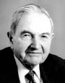
The Rockefellers, under the leadership of David, have continued to control American politics through such organizations as the Council on Foreign Relations and the Trilateral Commission.

The World Plutocracy
Part I:

Oil Rulers

http://www.hermes-press.com/oilrulers1.htm

"The trouble with this country is that you can't win an election without the oil bloc, and you can't govern with it."

Franklin D. Roosevelt
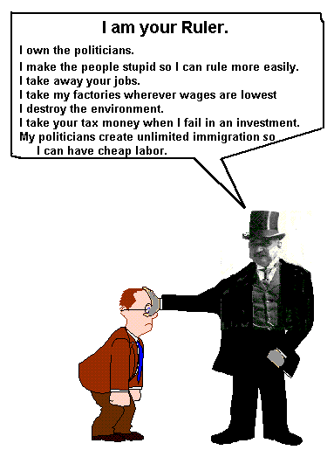

Plutocracy is that form of government in which, instead of the people being represented by their elected officials, those with wealth "buy" the officials. Those officials then create laws and policies which produce obscene profits for the wealthy owners of corporations.

Beginning in the nineteenth century with the Rockefeller monopoly, persons of wealth and political power decided that the energy of choice for the world would be oil (not coal)--just as the drugs of choice would be alcohol and tobacco. They set out to control the world's oil reserves.

British Petroleum (earlier Anglo-Persian and then Anglo-Iranian Oil Company) was started by William Knox D'Arcy in 1901 when he bought a concession from the Grand Vizier in Teheran for 480,000 square miles (nearly twice the size of Texas) in exchange for twenty thousand pounds in cash, twenty thousand one pound shares, and sixteen percent of the net profits. After three years of drilling and finding no oil, D'Arcy convinced the Burmah Oil Company to put up the extra capital needed to keep D'Arcy's venture afloat. After another two years of drilling they finally struck oil and Burmah Oil and D'Arcy formed the new Anglo-Persian Oil Company. In 1914, three months before the start of World War I, the British government, through the insistence of Winston Churchill, First Lord of the Admiralty, bought 51 percent of Anglo-Persian for two million pounds, stipulating that the company must always remain an independent British concern and that every director must be a British subject. The British navy had converted to oil (from coal) in 1910 and during World War I, Britain needed more oil than the Anglo-Persian Company could supply. The remainder was purchased from Royal Dutch Shell.

Oil Wars

In the early part of the twentieth century, there was fierce rivalry between the three largest oil companies: Shell, Exxon, and British Petroleum.

Henri Deterding, head of Shell, bought:

oilfields in Egypt (In 1908)

the Russsian Ural-Caspian oilfields (1910)

Mexican oilfields belonging to Lord Cowdray (Weetman Pearson)

Venezualan oilfields (which still produce a sixth of Shell's supplies)

American oilfields

Walter Teagle, head of Exxon

secretly bought a prosperous Texas oil company misleadingly named Humble (1919)

secretly bought out the Nobels' Russian oil interests for $11.5 million (1920)--though the new communist regime seized the oilfields and paid Exxon nothing

British Petroleum

BP controlled not only Iran (Anglo-Persian Oil Company) but a quarter of the oil from the Iraq Petroleum Company. The Iraq Petroleum Company (earlier called the Turkish Petroleum Company) was formed following the first world war, composed of British Petroleum (BP), Exxon, Gulf, Texaco, Mobil, and Calouste Gulbenkian, an Armenian entrepreneur.

In 1928, Teagle (Exxon), Deterding (Shell), and Sir John Cadman (BP) met in Achnacarry Castle in Scotland. They agreed on a price-fixing scheme that would stop the cutthroat competition that had been harmful to all of them. These three oil rulers controlled the pricing and supply of oil worldwide.

However, a huge new oilfield first drilled in Kilgore, Texas, released a gush of oil, resulting in the price of crude falling to ten cents a barrel. H.L. Hunt bought out the original Kilgore wildcat driller, "Dad Joiner." Hunt became a billionaire, the richest of all the Texans. But the problem of oversupply was so devastatinig that the governors of Texas and Oklahoma called in the national guard and closed down oilfields, enforcing a system of rationing by which the demand in a particualr month was shared among oil producers by a state body called the Texas Railroad Commission.

In 1926 Exxon signed an agreement with the German chemical combine, I.G. Farben, for an exchange of patents and research: Farben was to stay out of the oil business and Exxon would stay out of the chemical business. The agreement gave Nazi Germany hundred-octane avation fuel and synthetic rubber. Exxon held back the research in synthetic rubber in the U.S. In 1941 the Justice Department bought two antitrust suits against Exxon: for conspiring to control oil transportation through pipelines and for making restrictive agreements with I.G. Farben. Exxon was forced to pay a fine of $50,000.

The U.S. was now involved in the second World War and Japan had just seized the Malayan rubber plantations, from which America had earlier derived its supply of rubber. Senator Harry Truman claimed that Exxon's failure to pursue synthetic rubber research in the U.S., while developing it in collaboration with the Germans, constituted treason.

Texaco, under the direction of its swashbuckling president, Torkild Rieber, provided six million dollars worth of oil to Franco, the Spanish dictator. Rieber also made contact through Spain with leading Nazis and agreed to supply oil from Colombia to Germany. Texaco continued to supply oil to Nazi Germany even after the outbreak of the World War II in 1939, receiving as payment three Hamburg tankers. Rieber sealed the deal with Goering in Berlin. At Goering's insistence, Rieber put forward a peace plan to Franklin D. Roosevelt which would ensure Britain's surrender. Roosevelt told Rieber to get out of his dealings with Nazi Germany. Rieber ignored Roosevelt and financed the propaganda mission of Dr. Gerhardt Wesrick, a German lawyer, to dissuade American businessmen from suplying Britain with arms. The head of British Intelligence in New York, the Canadian millionaire William Stephenson, learned of the Westrick fiasco and broke the story to the New York Herald Tribune. Westrick was forced to return to Germany on a Japanese ship. Rieber was discredited and Texaco shares plummeted.

"An honest and scupulous man in the oil business is so rare as to rank as a museum piece."

Harold Ickes, U.S. Petroleum Administrator for War during World War II

Mexican oil was essentially controlled by a Britisher, Weetman Pearson, later to be titled Lord Cowdray. He began as early as 1901 to buy concessions in Mexico and by 1918 he was one of the richest men in the world, the nearest British equivalent to the American Rockefeller. His fortune laid the foundation for Lazards Bank, the Financial Times, The Economist, Longmans and Penguin Books. In 1919, Cowdray sold out the majority of his company to Deterding of Shell. In 1938, Mexican President Lazaro Cardenas nationalized the seventeen foreign-owned oil companies and a monument to the nationalized company, PEMEX, was erected in Mexico City, at which diplomats were required to place wreaths. The American, Dutch, and British oil companies boycotted the nationalized Mexican oil interests and the incompetently-run PEMEX was eventually forced to pay $130 million in compensation for seizing the companies. During the second world war, the big oil companies drained off much of Mexico's oil reserves, then switched their attention to Venzuela where they were in league with Gomez, the dictator.

Meanwhile, in the Middle-East

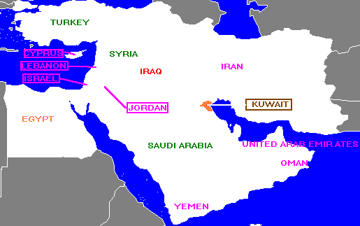
In 1926, King Ibn Saud, the Muslim desert warrior, had conquered his rivals in Mecca and the Hejaz and named the whole territory, from the Persian Gulf to the Red Sea, Saudi Arabia, the only country to be named after its ruling family. One of King Saud's principal advisors was Harry St. John Philby, the Arabist who had quit the British Colonial Service out of disaffection. Philby had become a Muslim and was close to Saud. King Saud needed money to finance his enterprises and Philby suggested that he exploit his land's oil resources. Philby assisted Socal in getting the concession in 1933. King Saud received an immediate loan of thirty thousand pounds, with another twenty thousand pounds eighteen months later, and an annual rent of five thousand pounds, all in gold. Socal paid Philby a salary of one thousand pounds a year.

Socal, short of capital and market outlets, sold half of its Saudi and Bahrain concession to Texaco's Cap Rieber. The joint venture was called Aramco. In May, 1939, King Saud turned the valve on the pipeline and the oil began to flow. Saud was so delighted with the money and gifts he received from Socal and Texaco that he increased the size of the concession to 444,000 square miles, a plot the size of Texas, Louisiana, Oklahoma, and New Mexico combined.

Kuwait, one of many small independent sheikhdoms which had cut into the land mass of Saudi Arabia, had also discovered oil and the concession was purchased by Gulf in 1927 for $50,000. In 1934 Gulf and BP signed an agreement with the Kuwaiti sheikh in a joint venture and huge reserves were discovered in 1938.

During World War II, Britain advanced about twenty million dollars to King Saud to bribe him to renege on the Socal/Texaco concession and go with BP. Socal and Texaco appealed to Washington and Roosevelt sent lend-lease money to Saudi Arabia. Roosevelt and his advisors decided that the United States should have a controlling interest in Aramco, to protect the nation's oil interests. In 1943, Roosevelt authorized the formation of a new corporation to acquire a hundred percent of Aramco.

Harold Ickes, petroleum administrator for War and Secretary of the Interior, was president of the new corporation, the secretaries of State, War, and the Navy among the directors and Abe Fortas as secretary. Aramco would not immediately agree to sell its concession to the new federal corporation, so Ickes said the corporation would build a thousand-mile pipeline to carry Saudi Arabian oil to the Mediterranean. In return, Aramco would guarantee twenty percent of their oilfields as a naval reserve which would be available to the navy at a cut rate. In the end, after much political bickering in the U.S. and internationally, Texaco and Socal built the pipeline themselves, creating the Trans-Arabian Pipeline Company (Tapline). It was not until 1949 that Syria and Lebanon agreed to let the pipeline be built at a cost of $200 million. Over the years, the pipeline was a target for guerrillas, a focus for boycotts, and a bargaining chip for Syria against America. In 1975 it was shut down.

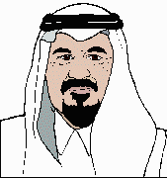
In 1945, Franklin D. Roosevelt promised King Saud that the United States would not change its policy regarding Palestine--and a Jewish state --without consulting the Arabs. However, Harry Truman became U.S. President two months later and gave full support to the establishment of the new state of Israel. Socal and Texaco worried about the political climate in Saudi Arabia. They decided to bring two other American oil companies into Aramco, Exxon (30%) and Mobil (10%).

King Saud continued to demand more money and finally in 1950 the U.S. State Department and Aramco agreed on a scheme whereby the money Aramco gave King Saud would be deducted from the company's tax bill, thus depriving the U.S. Treasury of $50 million or more in taxes each year. Under the U.S. tax laws establishing double taxation, the oil companies would not be taxed inside the United States. All the major oil companies adopted the same tax dodge so that by 1973 the five largest companies were making two-thirds of their profits abroad and paying no U.S. taxes on those earnings. This arrangement allowed oil companies to pay lower U.S. taxes than any group of industries. The United States had essentially turned into a country operated for the profit of the oil rulers.

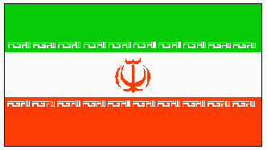
Reza Shah seized power in Iran in 1921and soon took on the trappings of the Persian Peacock Throne. In 1941, when Hitler invaded Russia, the Shah refused to expel his Nazi allies, so the British and Russian armies invaded Iran to ensure oil and supply routes. The Shah was exiled to South Africa, where he died. During the war, Britain and Russia ruled, but at the end of World War II, the old Shah's twenty-one year old son was placed in power. Iran, like most oil-producing countries, resented the power its foreign-owned oil company wielded over it. A shrewd older politician, Dr. Mossadeq, was appointed chairman of a committee on Iranian oil policy. By 1951, Mossadeq was calling for nationalization and when he was elected prime minister by the Iranian parliament, Iran immediately seized BP's oilfields.

Iran was placed under international boycott by BP. When a Panamanian ship, the Rose Mary, took on oil from Abadan, RAF planes forced it into Aden harbor and impounded its cargo. American oil companies joined the BP boycott of Iran. However, President Truman and the Secretary of State, Dean Acheson, were appalled by the naked imperialism of Britain and when Mossadeq came to America to plead his case to the UN Security Council, Acheson befriended him.

However, antitrust fever had again overtaken the U.S. In 1952, the Senate Select Committee on Small Business released a report aptly titled "The International Petroleum Cartel." The report showed that the seven largest oil companies, nicknamed the Seven Sisters, controlled the majority of the oil-producing areas outside the United States, all foreign refineries, divided the world markets between them, shared pipelines and tankers between themselves, and fixed oil prices worldwide. But Eisenhower became President and John Foster Dulles was appointed Secretary of State, with the result that the oil cartel was forgotten and the new foreign policy mythology became anti-communism.

In 1953, the CIA, with British support, began a subversive action against Mossadeq. Mossadeq had taken control over the Iranian army. The Shah tried to oust him, failed, and was forced to flee the country. The CIA coup, led by the CIA's Kermit Roosevelt, spending about $700,000, forced Mossadeq out of office and the Shah returned to Teheran triumphant. British and American oil companies formed an international consortium to buy and develop Iranian oil. BP received 40% of the shares of the consortium, the five American sisters each got 8%, Shell received 14%, and CFP (Compaignie Francaise de Petrole) 6 percent. The oil cartel members congratulated themselves that they had shown the world that no puny nation, such as Iran or Mexico, could seize their assets and long flourish.

OPEC

In 1961 the Organization of Petroleum Exporting Countries (OPEC) was established with members: Iran, Iraq, Kuwait, Saudi Arabia, and Venezuela. Since that beginning, the following countries have attained membership: Qatar (1961), Indonesia and Libya (1962), Abu Dhabi (1967), United Arab Emirates (1974), Algeria (1969), Nigeria (1971), Ecuador (1973), and Gabon (1975). Their headquarters, originally located in Geneva, moved to Vienna in 1965. Policy is determined by delegates from members countries, which meet at least twice a year.

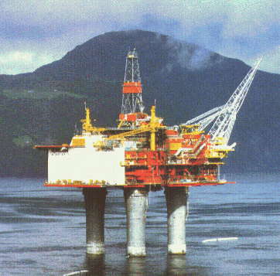
From the beginning of the oil energy monopoly there have been other sources of energy that are more abundant, more environment-friendly, and vastly cheaper. Steam-driven vehicles proved efficient but they were driven out by gasoline-driven vehicles. Since railway engines require less fuel than automobiles and trucks, they have been allowed to fall into disrepair, the decrepit U.S. railway infrastructure now producing frequent calamities.

World oil prices are currently high because OPEC and the American and British oil companies manipulate the prices to gain the highest profits possible. It actually costs only about $1 per barrel to pump oil from the ground, but the present price is $26.41 per barrel. If the market demand for oil products were allowed to operate independently, gas prices at the pump could drop by 50 percent at least.

In 1973, OPEC raised oil prices by 70 percent as a political warfare tactic aimed at western nations supporting Israel in the Yom Kippur War of October, 1973. That same year, in December, prices were hiked another 130 percent and a temporary embargo was placed on oil shipments to the United States and The Netherlands.

By the early 1980s, however, OPEC's influence began to wane as Western oil corporations discovered new sources of oil and began to use political and subversive pressure to force OPEC to cut back production to keep prices artificially high. OPEC's power has been decimated by internal conflicts and the Iran-Iraq war that broke out in 1980. Within the last several months, the U.S. has again warned OPEC about its raising prices by threatening to open up our national strategic oil reserves. The U.S. and British oil corporations insist on being the only ones to manipulate the price of oil.

The Gulf War was perpetrated by British and U.S. rulers to:

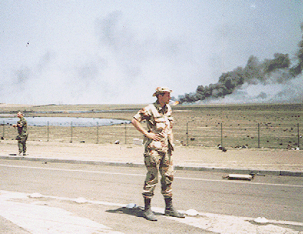
Warn Japan and the European countries (especially Germany) that the U.S. controls the world's oil supply (by armed force if necessary)

Control Iraq's oil production through the embargo resulting from the war

Conquer Iraq since it threatens Israel's military hegemony in the Middle-East

Even though Iraq is under an embargo at present, it's estimated that Iraq ships approximately 100,000 barrels of illicit oil (in excess of the U.N.-approved export quota) per day. At the end of the U.S. rulers' war against Serbia in Bosnia and Kosovo, an embargo was slapped on Serbia. However, recently Serbia has been receiving blackmarket oil from Russia. That's why U.S. Navy SEALs recently boarded a Russian ship in the Gulf of Oman: to warn the Russians not to continue selling oil to Serbia.

The world oil cartel continues to fix gasoline prices worldwide. As this article is being written, for example, prices in California have skyrocketed. During the past year, world crude oil prices have increased by approximately 340%. The April 1999 decision by OPEC to cut production quotas contributes to the hyperinflation of oil prices, but it's only a part of the problem. OPEC now produces about 40% of the world's oil supply.

The real cause of the current rise in price for oil is that speculators are now moving into what are called hard commodities: energy, base metals, and food. On March 8, 2000, Iranian Oil Minister, Bijan Namdar Zanganeh, pointed out in a speech on Iran State TV that speculation, rather than physical shortages in crude oil, lay behind the current surge in oil prices.

This series deals with plutocracy, the rule of a nation by those with wealth. Plutocrats deal in all sectors of the economy, oil as well as all others. Currently these plutocratic speculators are making billions of dollars through their Wall Street scam, primarily in the technology stocks which are being artificially inflated beyond any relation to the real value of the companies offering the stocks.

For example, in February, 2000, Bloomberg News reported that the stock of the $23 million Internet company NetJ.com, which went public in November, 1999, had doubled in share price to nearly $4. This occurred despite the fact that the company plainly disclosed in documents submitted to the Securities and Exchange Commission that it not only had no profits but no revenues and in fact that it did no business of any kind. The documents indicated that NetJ.com might begin doing business soon, but perhaps not. If it did begin doing business, it had no specific idea what kind of work it would do.

Along with their hyperinflationary speculation in the markets, oil corporations continue to buy politicians, resulting in Oil Rulers dominating every nation in the world.

