The Rockefellers
by Edward Jay Epstein

http://edwardjayepstein.com/rockefellers/chap1.htm

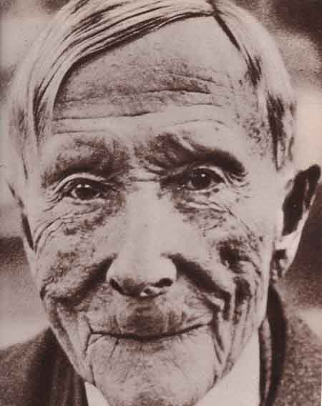

John Davison Rockefeller 1839-1937

The Trust-Builder

CHAPTER 1

Surrounded by round-the-clock armed guards and a barricade of barbed wire, the body of Laura Celeste Spelman Rockefeller awaited burial for some twenty weeks between March and August, 1915, while her husband John Davidson Rockefeller avoided angry mobs and process servers. At that time Rockefeller was perhaps the wealthiest man the modern world had ever known. His personal fortune was equal to 2 percent of the total gross national product of the United States and this did not include the vast fortune passed on to the rest of his family which then controlled banks, railways and philanthropic foundations (which were themselves a newly- created device of Rockefeller). The Standard Oil Companies which he had created and in which he still held a major (25 per cent.) interest, then refined more than 90 percent of the oil sold in America and most of that of the rest of the world. Its political power was such that it was accused of doing everything with state legislatures except 'refining them'.
Yet despite such economic resources, Rockefeller had become an object of hatred and derision in America; he could not bury his wife of more than half a century for fear that the body might be desecrated or that he might be subpoenaed at the funeral by any of a dozen governmental bodies investigating his activities. Indeed, for more than a decade Rockefeller had been hounded by relentless muckrakers, who portrayed him as a ruthless robber baron; investigated continually by state attorney generals and congressional committees who turned him into a fugitive from his own family; and denounced by political leaders of both parties as an 'arch-criminal'. Even charities hesitated to accept Rockefeller's 'tainted money' on the ground, as Senator Robert M. Lafollette argued, that "he gives with two hands but robs with many ... he is the greatest criminal of the age".
In 1915 public passions were further aroused against Rockefeller by widely circulated reports of massacres of women and children at the Colorado Fuel and Iron company which his family controlled. In such an atmosphere wealth was of little use in quieting public opinion. Effective power, Rockefeller learned, depended on control of not merely pipelines, refineries, railways and banks, but also of the leaders and conduits of public opinion. And just as the old Rockefeller was able to organise industries systematically for great profit, his heirs learned to organise just as efficiently the perceptions and passions that constitute that vague realm known as 'public opinion'.
John D. Rockefeller, born on a farm in New York State in 1839, was the son of an adventurer who had made a small fortune selling patent medicines and cancer cures which owed their success, if they were like other 'botanic medicines' of their day, to an opium base. When John D. reached the age of 20, his father advanced him sufficient funds to buy a half interest in a commodity commission business in Cleveland. That same year, 1859, the first oil well in America was drilled at Titusville, Pennsylvania, and part of the oil was shipped down the Cuyohoga River to Cleveland for refining and then re-shipping to New York. In the next few years, the oil fields of Pennsylvania became the main source of kerosene for the entire world and young Rockefeller moved his commodity business from grain, hay and meat into oil. By the time he was 26 he had bought out his partners in what was then the largest refinery in Cleveland, and formed what was eventually known as the Standard Oil Company. Rockefeller immediately foresaw that transportation, not production of oil or retail sales, would be the key to controlling the burgeoning industry. Any refiner who could ship the oil for a few cents a barrel less than other refiners to the major market in New York would drive his competitors out of business. With this insight, Rockefeller proceeded to dominate the oil industry.
By negotiating a 'rebate' with railroads on each barrel his refinery shipped, Rockefeller received a secret lower rate which allowed him to undersell all his compctitors in New York. Since greater profits for all could proceeed from the lower shipping rate, it was in the self-intcrest of competing refineries to join Standard. and most of them rushed to exchange their stock for either Standard stock or cash.
By 1882 the Standard Company, reorganised by Rockefeller's lawyers as a 'trust' (which had previously had a benign meaning) controlled 95 per cent. of the refining capacity, United States. And Rockefeller, at the age of 43 controlled Standard Oil. With this power of refining, he expanded into all phases of the oil industry, including exploration, shipping and marketing.
Before Americans were subject to income tax, the dividends from Standard Oil made Rockefcller the wealthiest man in the country. Eventually, the government, first the states and then the Federal, moved against Standard Oil and laws were passed against 'rebates' and 'trusts . Finally in 1911 under the crusading zeal of President Theodore Roosevelt, the Standard Oil trust was dissolved into 33 separate companies of which the Rockefellers remained large shareholders (receiving about 25 per cent of the shares of each new company).
Rockefeller's organisational genius was not limited to oil. During the boom of the 1890s, he bought up a large share of the entire Pacific Northwest, including railways, steel mills, paper mills, factories, ore deposits, lumber, and vast tracts of real estate, including the entire city of Everett in the state of Washington. A dedicated Baptist, he founded the University of Chicago on the condition that it be "aggressively Christian" with no "infidel teachers". He also created tax-exempt foundations for the "well being of mankind" (just before income tax laws were passed in the United States) which changed the shape of 'philanthropy' in the United States, and insulated a large portion of his fortune from modern taxation.
Rockefeller, who had wanted to live until 100, died in his sleep from sclerotic myocarditis at the age of 97 at The Casements, his Winter home, in Florida. None of his immediate family was with him at the end. A special car was sent to Florida to bring back his body for a funeral at Pocantico Hill and a burial in Lakeview Cemetery in Cleveland, where Rockefeller had began his empire as a $12-a-month clerk.

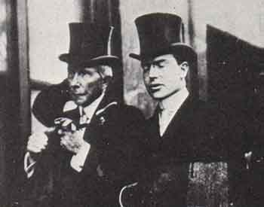

Junior: The Image Maker

CHAPTER 2

Since Rockefeller lived to the amazing age of 98, his only child John Jr did not inherit full control over the fortune - and foundations until he was 63 and nearly retired. When 'Junior', as he was called, attempted to take an active part in the family business in the first decade of the twentieth century, he found that he was being held personally responsible for the reign of terror and bloodshed in industrial America, which reached its height in 1915 after the Rockefeller controlled Colorado Fuel and Iron company was closed down by workers who demanded the right to collective bargaining and the enforcement of state labor laws which the company had been ignoring for years. The company, with the Rockefellers' active support, called in a private army of gunmen and the state militia to crush the strike and in the ensuing violence the tent camp of miners at Ludlow, Colorado, was ruthlessly sprayed with machine gun fire and burned to the ground. Along with several workers, 11 children and two women were killed in what became known nationally as the 'Ludlow Massacre'. With great gusto the national Press used the image of 'roasted children' to portray 'Junior' as a new national villain. Years later Junior told his official biographer Raymond B. Fosdick, that the Colorado strike was "one of the most important things that ever happened to the family" - if nothing else, it demonstrated to him that the future of the family depended on creating a new public image, one outside corporate business. An entire new public relations industry was created to focus public attention completely on the charitable work of the family. Junior turned the family business over to professional managers, and undertook such projects as saving the redwood trees in California and creating three new national parks. He financed crusades such as the Interchurch World Movement, an unsuccessful interdenominationalist effort "to Christianize the world". He also financed the effort to prohibit the consumption of alcohol in the United States.
He assiduously avoided politics, though he married Abby Aldrich, daughter of Senator Winthrop Aldrich, the most important Republican leader of his time. His only important business venture, according to his biographer, was the erection of Rockefeller Center, a colossal office building complex on Fifth Avenue in the heart of New York City which he bravely built at the height of the depression in the 1930s. Rockefeller Center, which today provides some 10 million square feet of office space and brings 174 in rent in the order of a hundred million dollars a year for the Rockefeller family, instantly became a major tourist attraction with its Art Deco murals workers in factories and Radio City from which NBC broadcasts its programs. The Center also provided 'Room 5600' which consists in fact of the entire 55th and 56th floors of the tallest building. From Room 5600, the family's far-flung finances and public were professionally managed.
The public relations operation in Room became especially effective. All Information about the Rockefellers is stored in either "sensitive" or "public"' files. The former, which might conflict with the image being promoted, is embargoed or destroyed, The latter is disseminated to writers of authorized biographies and vetted journalists. Through the careful cultivation of the press, the public image of public enemy that Rockefeller Junior inherited was subtly transformed to one of a public benefactor. When died at the age of 86, his six children had already ascended to the highest strata of the social and political order. No longer outcasts, the Rockefeller heirs became the twentieth-century American aristocracy.

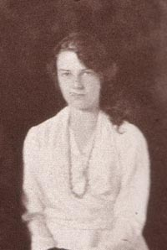

Abbey Rockefeller: The Vanishing Granddaughter

CHAPTER 3

The Rockefeller heirs grew up in the family enclave at Pocantico Hills. a private fiefdom of some 3500 acres on the Hudson River 50 miles north of New York City. There were employed as many as 1500 servants, guards. secretaries and other retainers to care for the eleven baronial mansions on the estate. The playhouse where the heirs spent much of their childhood had an indoor swimming pool, indoor tennis and courts. billiard tables, two bowling alleys and closets full of toys. There were also such recreational facilities on the estate as a private golf course, stables, miles of private riding trails and six swimming pools.
The eldest heir and only daughter, Abby, was born in 1903. "Babs," as she called herself, attended finishing school, and, as their was no place for a woman in the family power machine, married three times. Taking on the surnames of her husbands, she became Abbey Milton Pardee Mauze. Like other women in the Rockefeller family, she was carefully shielded from any public role the Rockefeller managers who invested her funds, and arranged her political contributions. She was rarely during her lifetime mentioned in the press by the Rockefeller public relations machine in Room 5600. Even the authorized biographies of the family, while focusing on her 5 brothers, minimize her existence. For example, the lengthily official biography of her father mentions her only once in passing in a footnote referring to her as "Mrs. Jean Mauze." In almost all other family biographies, she was simply subsumed under the collective title "the Rockefeller messieurs." After she dies in 1976, a number of professorship were created at Rockefeller University in her name, a memorial liaison with the Rockefeller dynasty.

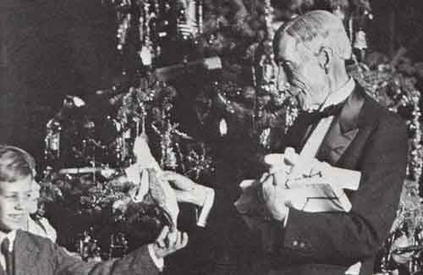

The Philanthropist

CHAPTER 4

The eldest son. John Davidson Rockefeller III, was born in 1906 at a time when his illustrious grandfather was still hiding out from government investigators. The public outcry over the Ludlow massacre was part of his childhood memories. 'Mr John', as he was called, chose like his father to establish himself in philanthropies rather than business.
After graduating from Princeton in 1929, He traveled by ship to Japan immediately the first of sixteen such trips and concentrated his energy on Asia. His mission became to provide the funds and support to assist Asian nations to control their populations. He served in the military government that occupied Japan after the Second World War and as a consultant to the U.S. Peace Settlement Mission in Japan, and helped create the Asia Society. He won such honors in Asia as Grand Cordon Order of the Rising sun (in Japan), president of the Japan Society; chairman of the Asian Society; Most Noble Order of the Crown (in Thailand); Order of the Thousand Elephants and White Parasol (in Laos). The Population Council, which he sponsored, had a staff of some 250 doctors, demographers, and social scientists scattered among the less affluent nations of Asia (and later the world), with "showcases" of birth control in South Korea and Taiwan. Though he was awarded the Order of the Auspicious Star of China when he was director of United China Relief (for the Nationalists) , he subsequently counseled the State Department (in 1949) on another form of population control for Communist China, suggesting that "trade with China . . . should be limited. It seems to me that the fastest way to contain Communism is to discredit it in the eyes of the people of China. It seems to me if the [Chinese] economy worsens that this will arouse opposition to it." He thus helped make food a weapon in the Cold War.
He died in 1978, in a car crash, not far from Pocantico Hills.

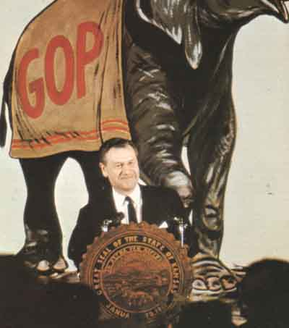

The Vice President

CHAPTER 5

Rockefeller Jr.'s second son, Nelson, born in 1908. With his elder brother superintending the family's cultural power, he turned his attention to the arena of political power.
His first major sphere of activity was political propaganda. Before he was 30, he became a director of the Creole Petroleum Company, the subsidiary of Standard Oil of New Jersey which then provided it with most of its foreign oil from the enormous reserves it controlled in Venezuela. In examining the position of Creole Oil in Venezuela, Nelson became convinced that public relations in the host country was essential to retaining control over Latin American oil. In 1939 he and his associates from the Chase Manhattan Bank and Rockefeller Center prepared a three-page memorandum for President Franklin D. Roosevelt that suggested the creation of a government agency to counter Nazi propaganda and covert infiltration in Latin America. FDR. on the recommendation of an adviser (who later received a loan from Nelson Rockefeller), named Nelson in 1940 to head the new agency which became known as the Coordinator of Inter-American Affairs (CIAA) or simply as the Rockefeller Office.
Before America even entered the second world war in 1941, Nelson was actively recruiting the elites of Latin America. According to a former staff member of the Rockefeller Office, "almost all our efforts were directed into organizing the pro-Western elites of Venezuela and Brazil into a private network of influence". Almost exclusively, Latin-American business executives and public opinion leaders were brought into this network. Then, after the United States entered the war, the Rockefeller Office directed its major efforts towards outright propaganda.
To gain control over the media of Latin America during the War, Rockefeller obtained a ruling from the U.S. Treasury Department which exempted the cost of advertisements placed by American corporations that were cooperating with the Rockefeller Office from taxation. This tax-exempt advertising eventually constituted more than 40 per cent. of all radio and newspaper revenues in Latin America. By selectively directing this advertising towards newspapers and radio stations that accepted guidance from his office and simultaneously denying it to media which he deemed uncooperative or pro-Nazi he skillfully managed to gain economic leverage over the major sources of news throughout South America. Moreover, as the newsprint shortage became critical in South America, his office made sure that the indispensable newsprint licences were allocated only to friendly newspapers. With a staff of some 1,200 in the United States, including mobilized journalists, advertising experts and public opinion analysts, and some $140 million in government funds (expended over five years), the Rockefeller Office mounted a propaganda effort virtually unprecedented in the annals of American history. It was also a formative education for Nelson in the vulnerabilities of the Press.
All the Rockefeller Office's programs were divided into two categories economic warfare" and "psychological warfare." Nelson explained to a Senate committee at the time: "We consider it an information program, the objectives to be to explain what is going on in a military way." A battle plan was thus drawn up for the press campaign. George Gallup, who later became famous as a political pollster, and a group of prominent social scientists quietly conducted systematic surveys of' public opinion in Brazil. In a clear adumbration of the postwar CIA, the Rockefeller Office arranged for a "research division" to employ clandestine "observers" from the Export Bureau of the American Association of Advertising Agencies in Latin America. The advertising men who served as "observers" supplied the Rockefeller Office with data concerning the editorial policy, personal opinions of the owners and editors of the newspapers. Dossiers could thus be systematically organized about the opinions and operations of the major organs of public opinion in Latin America.
Under the brilliant tutelage of Francis A. Jamieson, a Pulitzer Prize-winning journalist and public-relations expert (who stayed with Nelson for most of his public career); James W. Young, head of J. Walter Thompson advertising agency and Karl A. Bickel, former president of United Press and then chairman of Scripps-Howard Radio, Rockefeller learned the rudiments of managing news.
From the beginning it became apparent that news was not the product of journalistic investigation, but of special interest groups. If economic pressure could be brought against the owners, and incentives given to editors, news in Latin America could be surreptitiously authored in Washington rather than Berlin or elsewhere. To this end, the Rockefeller Office provided not only 'canned' editorials, photographs, exclusives, feature stories and other such news material, but manufactured its own mass circulation magazines, supplements, pamphlets and newsreels. To ensure understanding of the 'issues' being advanced in Latin America, the Office sent 13,000 opinion leaders a weekly newsletter which was to help them 'clarify' the issues of the day. The CIAA also arranged trips to the United States for the most influential editors in Latin America (and later scholarships for their children). More than 1200 newspapers and 200 radio stations, which survived the economic warfare, were fed a daily diet of some 30,000 words of news in Spanish and Portuguese, which were disseminated by cooperating news agencies and radio networks in the United States to their clients in Latin America. By the end of the War, the CIAA estimated that more than 75 percent of the news that reached Latin America originated from Washington where it was tightly controlled and monitored by the Rockefeller Office and State Department. The operation, Nelson realized, required only sufficient money, talent and will.
After the War Nelson divided his time between managing various Rockefeller interests and in service in various government administrations in Washington. He served President Harry Truman as chairman of the International Development Advisory Board. He served President Dwight D. Eisenhower as both under-secretary of the Department of Housing, Education and Welfare and as a special assistant for foreign affairs.
Nelson believed in power. He explained "power per se is good or bad depending on how it is used [but] power is essential". To get it, he decided in 1955 to seek the Republican nomination for governor of New York State. Since no Rockefeller had sought elective office before, Room 5600 had to marshal special resources to ensure that Nelson received the nomination of the Republican party. At the time the Republican party in New York State was controlled by a few dozen county leaders in upstate cities, such as Elmira, Syracuse, Rochester and Albany. In New York City, the one place where the Rockefellers could most easily bring their financial and foundation power to bear on politicians, the Republican organization was moribund if not totally deceased.
To this end, Nelson made arrangements with two professional politic operators in New York State, Malcolm Wilson, a legislator who could deal expediently with the Westchester County Republicans, and Lyman Judson Morhouse, the state Republican Chairman, who, according to his defense at a subsequent bribery. trial, was a professed 'influence' seller in New York State.
Morhouse proceeded to select Nelson as the chairman of the Committee on the Preparation of a State Constitutional Convention, which provided convenient access to all grass-root Republican leaders in the state. But behind the scenes, Morhouse played an even more important role in helping Rockefeller make his separate peace with various county leaders, by collecting cash contributions of one sort or another from pro-Rockefeller sources and redistributing them where necessary to help towards securing the Republican nomination for Nelson. Nelson not only succeeded in easily winning the election, but provided more than half the campaign funds for the entire Republican party.
As both chairman of the party and the director of the powerful State Thruway Commission (to which Nelson appointed him), Morhouse continued his service as a political bagman and all-purpose fixer during the first three years of the Rockefeller administration. During these years he collected hundreds of thousands of dollars from watch manufacturers, drug laboratories, lessees for space at the airport, highway contractors (through the Good Road Association), radio and television licensees in New York State, detective agencies seeking concessions at the 1960 World's Fair, and others seeking indulgences from the State of New York. Whether Morhouse was collecting this money for his own account, or simply laundering the money for undercover politics, Nelson was aware of the operation. For example, in June 1959, he personally witnessed Morhouse receive a hundred thousand dollars. in a 'shoe box' at a Republican Party dinner, and ordered the money returned because, he later testified, he "was fearful that this was race track money [from] people who wanted to get a licence for a racetrack".
While such backstage redistributions of cash from those seeking and owed favors was hardly novel in New York State politics, Nelson was able to change the rules of the game by infusing vast amounts of money into the subterranean system through ingenious use of his own personal fortune and the institutions under his family's sway. Providing Morhouse with cash, untraceable in any way to the Rockefellers, required, however, the unique institutional resources of the Rockefeller Brothers and Associates in Room 5600 of Rockefeller Center. It sold Morhouse 2500 shares in a privately held corporation, the Marks Oxygen Company, for a nominal $25,000 (No money actually changed) and then proceed to buy the stock back from Morhouse for $79,375, leaving a profit of more than $50,000 in Morhouse's account. A similar arrangement was made on shares of Geophysics Corporation of America deposited in Morhouse's account, which rose almost tenfold, and left Morhouse with a paper profit of a quarter of a million dollars.
When Morhouse, overheard on a wire tap arranging a hundred thousand dollar bribe for obtaining a liquor licence for the Playboy Club, was convicted of conspiracy and bribery, Nelson, as governor, pardoned him on medical grounds before he could spend any time in prison.
As governor, Rockefeller demonstrated that he was a masterful orchestrator of both the levers and symbols of political power. He immediately found that the condition that satisfied most of the politically important interest groups in the state was the massive government construction program. Journalistic critics of Rockefeller in those years who attributed his monumental building projects to some sort of psychological 'erection complex' underestimated the political profit such vast expenditures on construction gained for him from key unions and business interests in the state. The political problem, which restrained Rockefeller's predecessors from constructing public works on a scale of the Egyptian pyramids, was that they could not be paid for out of taxes, since the wrath of the electorate over tax increases would far outweigh any advantages from special interest groups pleased with the expenditures. Nor was it easy to finance these projects through issuing long-term bonds, which had the obvious advantage of deferring tax burdens to future generations of taxpayers, because such bonds had to be approved by the electorate at a referendum.
With characteristic ingenuity, Nelson over-rode this stumbling block to expansion by devising special authorities which could issue long-term debt without the approval of the voters. These bonds were not legally backed by the full faith of the state, since they by-passed constitutional requirement of a referendum, but Nelson pledged the full moral authority of the state the bonds, bond buyers assumed that this pledge was tantamount to a state obligation. Through these "Moral obligation" bonds, as they came to be called, New York State raised over $6 billion. Through these and other innovation, its debt during the Rockefeller administrations rose from $1 billion to $13 billion, allowing Nelson to engage in a massive building and spending.
Under anyone but Nelson, there might have been great resistance among state officials to such unorthodox bonds. Nelson, however, succeeded in engendering loyalty among his key officials by quietly distributing to them over one million dollars in cash from his private funds. Typically, Rockefeller's secret loans that became gifts went to such instrumental state officials as the Superintendent of Banks, members of the State Housing Financing agency, the Commissioner of the Department of Environmental Conservation and the Commissioner of Housing and Community Renewal. While some officials receive hundreds of thousands of dollars from Rockefeller, others received the promise of future employment in his family's empire.
While Rockefeller's ability to dispense largesse conflicted with the New York State Penal Code which explicitly prohibited conferring "any benefit upon a public official for having engaged in official conduct . Rockefeller asserted, when the gifts were finally made public by an FBI investigation in 1974, that he gave the cash to the public servants. out of his esteem for them, not out of any motive related to the work they were performing for him as governor. Because of his carefully managed reputation as a philanthropist the matter was never referred to a court for adjudication.
Nelson next set his sights on the Presidency. In his first effort to secure the Republican nomination for the presidency, in 1964, he used $12 million of the family's money. He failed, however. To win enough delegates to stop Barry Goldwater, a senator who strongly identified himself as an ideological conservative (and who went on to lose the general election).
Nelson's advisors told him he needed a more conservative image to win the Republican nomination in 1968. The solution he found was an issue that conveyed a tough conservative image to the law and order elements in the Republican Party, but which would not at the same time offend the more moderate elements in the party; it was the suppression of drug addicts. He cited polls that "document that the number one, and growing concern of the American people is crime and drugs, coupled with an all-pervasive fear for the safety of their person and property"
It was this well researched "all-pervasive Rockefeller set out to exploit brilliantly. The crusade against addicts reached its zenith in 1973 Rockefeller declared that a "reign of terror" existed with "whole neighborhoods . . . as effectively destroyed by addicts as by an invading army.
He pressed through the legislature laws which by-passed both the discretion of the court and the prosecutor by making it mandatory that anyone convicted of selling (or possessing more than one-eighth ounce of) heroin, amphetamines, LSD, or other specified drugs would be imprisoned for life without the possibility of parole. Even 16-year-old offenders hitherto protected by the youthful offenders law would receive automatic life sentences. Thousand-dollar bounties would be paid for information about these drugs. In another legal innovation the new law laid down life imprisonment (without parole) for the novel crime of ingesting a hard drug (including amphetamines or LSD) 48 hour's or less before committing a proscribed crime, including criminal mischief, sodomy, burglary, assault and arson. This draconian law made it possible to imprison undesirable users for the balance of their lite since they had only to be convicted of a minor crimes after ingesting drugs to which they were addicted.
The Rockefeller laws succeeded in enhancing Rockefeller's reputation among the hardline element of the Republican party without losing very much support anywhere else, as few people in America were concerned with the fate of drug addicts. To his more moderate supporters, Rockefeller justified the law by explaining, as he did in his senate testimony, "about 135,000 [addicts] were robbing, mugging, murdering day in and day out for their money to fix their habit, and it was costing the people of New York up to $5 billion". Rockefeller had obviously learned in his long experience in psychological warfare that numbers could be effectively employed in political rhetoric, even if they had no basis in fact, if they only sounded enormous and authoritative enough. In this case, if Rockefeller's alleged army of addicts maintained the "day in, day out" schedule they would have to commit something in the order of 49,275,000 robberies, muggings and murders a year, which would mean that the average resident of New York would be robbed, mugged and murdered approximately seven times a year.
The hyperbole not withstanding, Nelson had his issue. In speech after speech, with masterful vampire imagery, he agitated the popular fear that the population of New York would be decimated by a horde of addicts, infecting the innocent children. Through the agency of the generalized fear of drugs, Rockefeller was able not only to win elections but to project in the popular imagination a new nationwide crisis which he alone, among the nation's politicians, had the experience to solve. A newly created commission which supposedly supervised the involuntary rehabilitation of addicts, but which had on its staff many more public relations specialists than medical doctors and psychiatrists, systematically developed through its own nationally circulated newspapers (Attack), newsletters and contacts with the media, the highly dramatized image of heroin addicts as drug slaves, who were ineluctably compelled to steal and ravage by their incurable habit. The size of the addict population in New York proved infinitely flexible. When it was necessary to demonstrate the need for more police measures or judges, Rockefeller expanded the number of putative addicts from 25,000 (1966) to 150,000 (1972) to 200,000 (1973). For other audiences, especially when Rockefeller wanted to show the efficacy of his program, the army of addicts was conveniently contracted to under 100,000.
Nelson asked rhetorically in the New York Law Journal, "How can we defeat drug abuse before it destroys America? I believe the answer lies in summoning the total commitment America has always demonstrated in times of national crisis . . . Drug addiction represents a threat akin to war in its capacity to kill, enslave, and imperil the nation's future; akin to cancer in spreading of deadly disease among us and equal to any other challenge we face in deserving all the brainpower, manpower and resources necessary to overcome it." He then asked rhetorically, "Are the sons and daughters of a generation that survived the great depression and rebuilt a prosperous nation, that defeated Nazism and Fascism and preserved the free world, to be vanquished by a powder, needles and pills?" Indeed, he played the politics of fear so adroitly that President Nixon borrowed much of his rhetoric, images and statistical hyperbole on drugs and crime, when launching his own national heroin crusade.
Although Rockefeller's draconian drug laws had little effect on either drug addiction or crime rate in New York, they helped him to achieve the national prominence and acceptance by the hardline elements of the Republican party that he needed if he was to stand for the presidency when Nixon's final term of office was due to expire in 1976. In December 1973, in what members of his staff foresaw as the beginning of the presidential campaign, Rockefeller resigned as governor and announced that he was going to spend his full time directing the Commission on Critical Choices, which he had set up with family and foundation money several months earlier. Ostensibly, this Commission was designed to "seek a clearer sense of national purpose" but, as did the earlier Rockefeller panels, the well financed organization also served as a vehicle for gathering together the most important molders of public opinion in America and, with their assistance, determining issues of public policy they should support. To articulate possible positions the Commission also paid various academics fees ranging from five to thirty thousand dollars. Every word they wrote was scrutinized by the former governor's Press secretary, Hugh Morrow, to gauge the political impact it might, if published, have on Rockefeller's political ambitions.
The political plan for 1976, however, had to be radically altered after the collapse of the Watergate coverup made it apparent that President Nixon would not finish his term of office. Nixon's vice president Spiro Agnew, had been forced to resign because of his own criminal culpability, and replaced by Gerald Ford, the leader of the Republicans in the House. When Nixon resigned in August 1974, Ford became president. With another term available to him in 1976, Rockefeller's chances for the presidential nominations were effectively ended. He therefore accepted Ford's offer to appoint him his vice president.
After extended Congressional inquiries into his financial resources he was confirmed by a vote of 287 to 128 in the House and 90 to 7 in the Senate. He was sworn in as the 41st vice president on Dec. 19, 1974.
He retired from politics in 1977, and died in 1979 in New York City, during a tryst with a 25 year old lover.

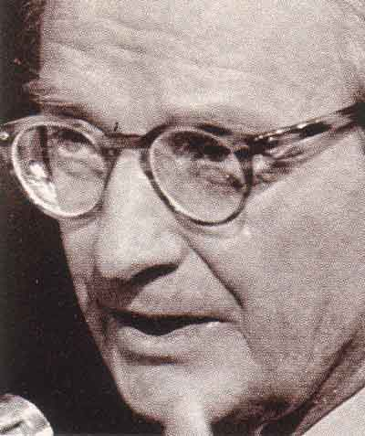

The Conservationist

CHAPTER 6

The middle heir, Laurance Spelman Rockefeller. was born in New York City in 1910. Like his brothers, he attended an Ivy League college, Princeton. When the war broke out in 1941, he joined the Navy. As a lieutenant-commander in the production division, he superintended relations between the Navy and aviation contractors. As such, he developed a keen interest in military technology.
After the war, while his two elder brothers pursued careers in philanthropy and politics, Laurance became a high-technology entrepreneur. He provided the financing for Captain Eddie Rickenbacker, the First World War aviation ace, to buy the aviation division from General Motors and turn it into Eastern Airlines, which subsequently became profitable (after it was awarded the highly lucrative route to Puerto Rico by the government). On the basis of his war-time experience, he assumed that it would only be a matter of time before the government began replacing bombers with missiles, and he bought a New Jersey company, Reaction Motors, Inc., which had developed an early rocket engine along the lines of the captured German V-2 rocket. When the United States government chose Reaction Motors to make the engine for its newly-developed Viking missile, he made a small fortune. As missiles became more sophisticated, he invested heavily in Marquadt Aviation whose stock value increased 1000 per cent after it became publicly known that the government was buying its ram jet rocket engine for its next generation of missiles. Laurance was also instrumental in financing the McDonnell Aircraft Corporation, which became a prime supplier of aircraft for the Navy.
During the 1950s, Laurance continued to invest heavily in newly-formed companies specializing in military technology. The profits generated by the fluctuation of the stock prices of these companies proved a useful source of funds for the Rockefeller family, including his more politically ambitious elder brother, Nelson.
Laurance used his wealth to establish himself as a leading protector of the environment. He provided immense subsidies for America's national parks, including Yellowstone National Park, Marsh- Billings National Historical Park and the Grand Tetons, which helped cordon them off from commercial development. He funded the Conservation foundations, developed resort hotels in natural surrounding to build public support for conservation and served as an environmental advisor under presidents Eisenhower, Kennedy, Johnson, Nixon and Ford.

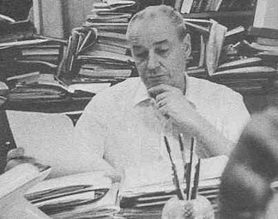

The Governor

CHAPTER 7

Rockefeller's fourth son, Winthrop, was born in 1912. He attended Yale but, unlike his elder brothers, who earned honors degrees at college, Winthrop dropped out before graduating and went to work as a roustabout in the Texas oil fields. Although the Rockefeller family was desperately attempting to dissociate its public image from that of the oil companies, ne became a junior executive at Socony-Vacuum Oil (of which the Rockefeller family owned the largest single share). In World War II, he sought out a combat assignment in the Pacific and after being wounded, emerged as a decorated war hero.
Winthrop also proved a maverick in his marital arrangements. Rather than marrying upward into society, like the rest of the family, he married Barbara "Bo Bo" Sears the beautiful daughter of an impovished farmer who the press had a field day describing as a "Cinderella." After sufficiently embarrassing the family, he divorced her.
At the age of 41, he left the eastern base of the family and moved to Arkansas, buying a sizeable portion of the state. His 50,000-acre cattle ranch, Winrock Farms, was not only used by him to produce beef but as a venue for holding seminars on the future of Arkansas and modernizing the South. He also served as chairman of the Arkansas Industrial Development Commission.
Gradually, he established a base for himself and the Rockefeller family in politics in Arkansas, and the southern wing of the Republican party. In 1966, he was elected governor of Arkansas, and he was reelected to another two-year term in 1968. Win, as he called himself in Arkansas, died of cancer on February 22, 1973, and was buried in Morrilton, Arkansas.

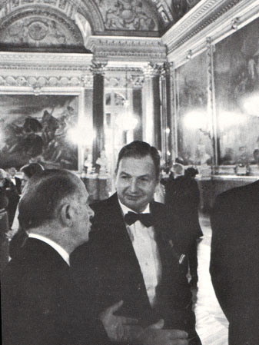

The Banker

CHAPTER 8

Rockefeller Junior's youngest child, David. was the only heir born after the 1915 Ludlow Massacre. After graduating from Harvard and attending the London School of Economics he received his Doctor of Philosophy degree in 1940 from the University of Chicago and then became a trustee of the institution his grandfather founded. He served for eighteen months as an unpaid secretary to the mayor of New York City, and then as a Housing Administrator for the Office of Defense. In 1942, he joined the Army where he rapidly rose as an intelligence officer to the rank of Assistant Military Attache in the American Embassy in Paris. He was duly admitted to the French Legion of Honor in 1945.
His real ambition in life was international banking. Immediately after the War, David went to work for the Chase National Bank, of which his uncle. Winthrop W. Aldrich, was then Chairman of the Board. As an assistant manager of the foreign department, David specialized in opening branches and expanding the bank's influence in the areas of Latin America in which his elder brother had established interests. The former co-ordinator, Nelson, had quietly transferred the operation of the wartime Rockefeller Office to two Rockefeller-owned entities IBEC (International Basic Economics Corporation). a profit-making corporation which was investing in agriculture and marketing companies in South America, and taking full advantage of the network of businessmen which Rockefeller had assembled during the War, and AIA, the American International Association for Economic and Social Development which encompassed non-profit activities such as grants and scholarships, thus maintaining liaisons between local government officials and leading members of the Latin American Press. David was also successful in establishing a close working relation in Panama with the closely-knit financial and political families that more or less ran the government of that country.
With Rockefeller interests owning the largest block of stock in Chase, and two seats on its Board of Directors, David rapidly ascended to the presidency of the bank in 1961, when he was only 44. The Chase Manhattan Bank, as it was called after it absorbed the Manhattan Bank in 1955, was even then one of the three most powerful banks in the United States with assets over $10 billion. As head of this international financial institution, David criss-crossed the world numerous times during the Sixties, dining with kings and heads of states, and compiling index cards of some 20,000 acquaintances on whom he could possibly call for assistance. A member of the elite Council on Foreign Relations since 1942 and an active participant in the public and private gatherings of the so-called Eastern Establishment, David became the single most effective spokesman for the entire American business community.

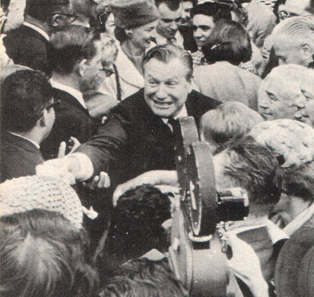

Web of Influence

CHAPTER 9

The brothers Rockefeller had firmly laid the foundation for cultural as well as political power in America. They possessed not only an immense fortune, which was still controlled as a unit from Room 5600 in Rockefeller Center, but also impressive individual qualities and talent. John Rockefeller III had established a sphere of influence in the cultural and scientific universes through his generous disbursement of grants and contributions from the foundations under his aegis. Nelson proved himself a brilliant manager of public opinion and an able politician. Lawrence, an intelligent entrepreneur worthy of his grandfather, demonstrated that he was able to take full advantage of the developments in military technology that came to his attention and play a dominant role in the emerging environmental establishment. Winthrop, though a maverick, managed to establish a political base for himself in the South. And David, through his ability and connections, had assumed full control over a financial institution that touched almost all major forms of business in the world.
Their public image had been elevated from that of outcasts at the time of their grandfather's trust-building to that of dedicated public servants. This feat had been accomplished through a 40-year-long refinement of public data about the family by such masters of public relations as Ivy Lee, Francis Jamieson, and William Ruder, and the organizations these men built for the family account. Through their tax-exempt foundations and "philanthropies," and the dispensation of over $1 billion to intellectual and scientific enterprises, the brothers had also woven a strong, if sometimes invisible, web of influence that touched in one way or another virtually all the activities of those who articulate issues in the mainstream of public life.
In 1956, for example, the brothers involved more than a hundred of the most influential men in America in a four-year long dialogue on various issues of concern to the family. The agenda for these panels was planned by Henry A. Kissinger who would late become President Nixon and Ford's national security adviser and Secretary of State, and who had been an advisor to Nelson Rockefeller for a dozen years. These Rockefeller panels, as they were called, were aimed at forming a consensus among the decision-making elite on such issues"'foreign policy," the nature of the "communist threat," responses to "concealed aggression," "nuclear strategy," "economic policies", and the "reconstruction of the democratic consensus". Through such meetings, they effectively defined what became the establishment position on these issues for the balance of the millennium.
While many families in America aggregated great fortunes, as can be judged by the annual Forbes 500 list, the Rockefellers managed to transmute their accumulated wealth into a much rarer commodity: the power over the political- intellectual cultural complex.

CHAPTER 10 (Coming Soon)

SEE:
http://edwardjayepstein.com/rockefellers/chap10.htm

