**Philip J. Corso 1915 – 1998**

[**http://en.wikipedia.org/wiki/Philip_J._Corso**](http://en.wikipedia.org/wiki/Philip_J._Corso)

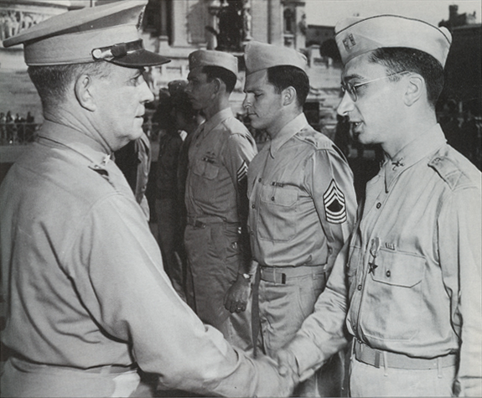 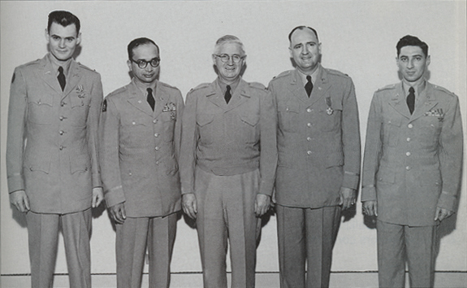 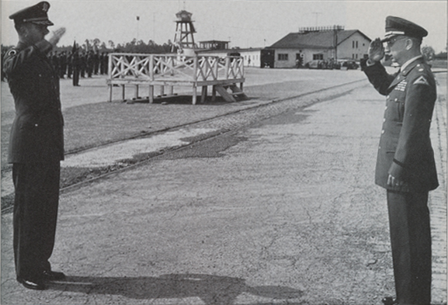

In [Rome](http://en.wikipedia.org/wiki/Rome), [1945](http://en.wikipedia.org/wiki/1945) In [Tokyo](http://en.wikipedia.org/wiki/Tokyo), [1953](http://en.wikipedia.org/wiki/1953) In [Germany](http://en.wikipedia.org/wiki/Germany), [1960](http://en.wikipedia.org/wiki/1960)

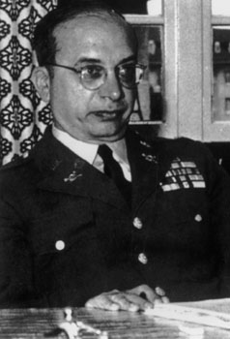 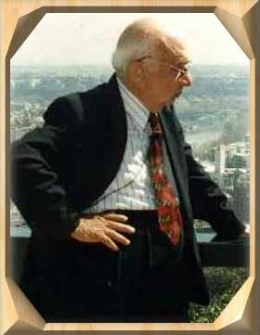 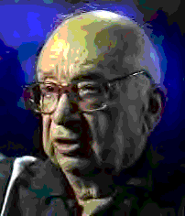 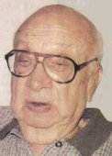

Place of death [Jupiter](http://en.wikipedia.org/wiki/Jupiter%2C_Florida), [Florida](http://en.wikipedia.org/wiki/Florida) Allegiance [United States of America](http://en.wikipedia.org/wiki/United_States) Service/branch [United States Army](http://en.wikipedia.org/wiki/United_States_Army) Years of service [February 23](http://en.wikipedia.org/wiki/February_23), [1942](http://en.wikipedia.org/wiki/1942) – [March 1](http://en.wikipedia.org/wiki/March_1), [1963](http://en.wikipedia.org/wiki/1963) Rank [Lieutenant Colonel](http://en.wikipedia.org/wiki/Lieutenant_Colonel_%28United_States%29) Commands [Battalion Commander](http://en.wikipedia.org/wiki/Battalion_Commander) of European Air Defense  
Intel Staff Officer Plans & Estimate Branch GHQ [Far East Command](http://en.wikipedia.org/wiki/Far_East_Command)  
Chief Special Project Branch G-2 Section of the HQ AFFE 8000th AU Command  
Chief Foreign Technology Division of the [United States Department of Defense](http://en.wikipedia.org/wiki/United_States_Department_of_Defense)  
Staff Officer in the Plans Division OCRD Washington DC, [Fort Riley](http://en.wikipedia.org/wiki/Fort_Riley) Battles/wars [World War II](http://en.wikipedia.org/wiki/World_War_II)  
[Korean War](http://en.wikipedia.org/wiki/Korean_War) Awards [American Campaign Medal](http://en.wikipedia.org/wiki/American_Campaign_Medal)  
[American Defense Service Medal](http://en.wikipedia.org/wiki/American_Defense_Service_Medal)  
[Bronze Star](http://en.wikipedia.org/wiki/Bronze_Star_Medal)  
[Commendation Ribbon](http://en.wikipedia.org/wiki/Commendation_Ribbon)  
[EAME Campaign Medal](http://en.wikipedia.org/wiki/EAME_Campaign_Medal)  
[Legion of Merit](http://en.wikipedia.org/wiki/Legion_of_Merit)  
[World War II Victory Medal](http://en.wikipedia.org/wiki/World_War_II_Victory_Medal)

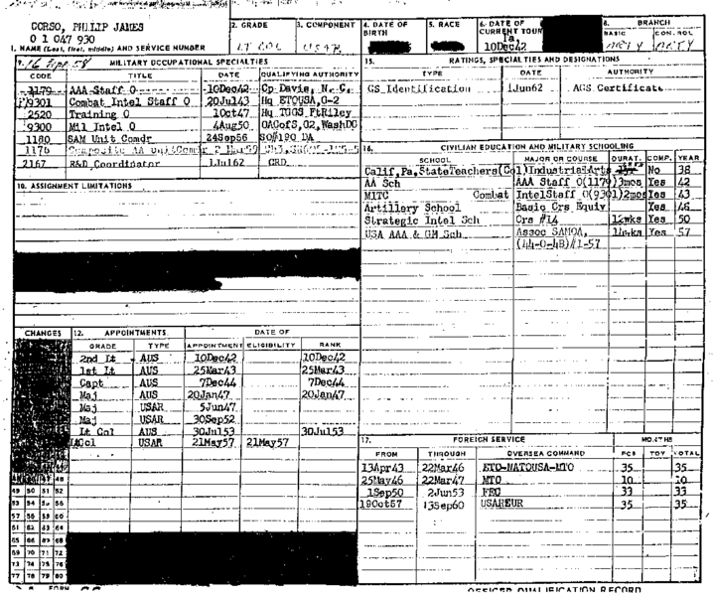 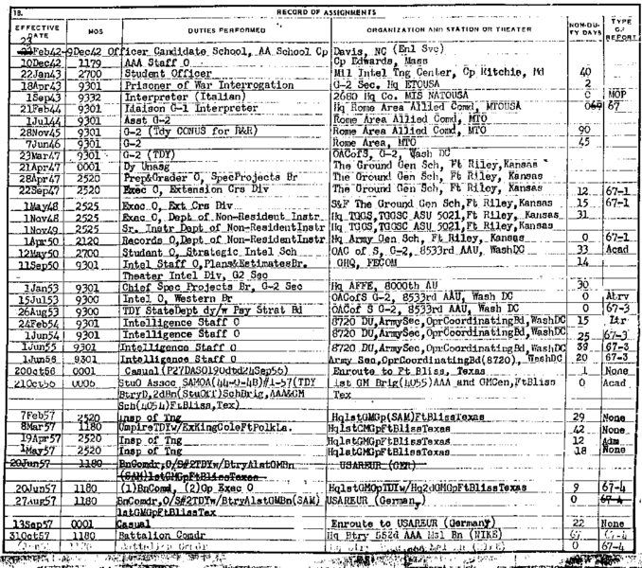

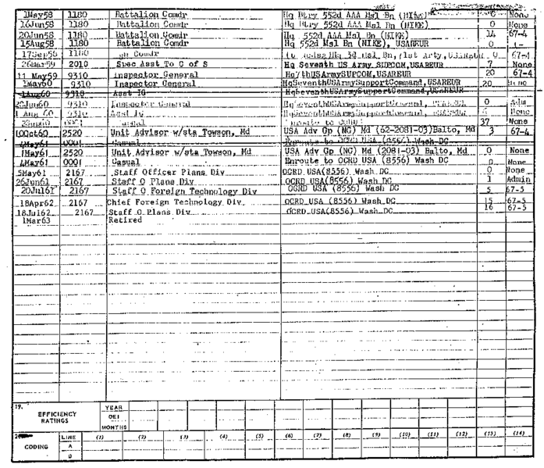 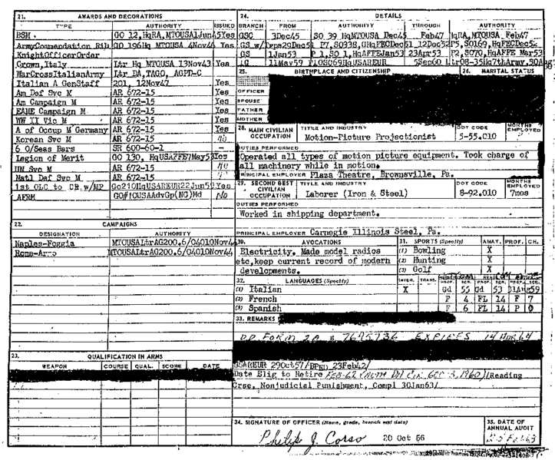

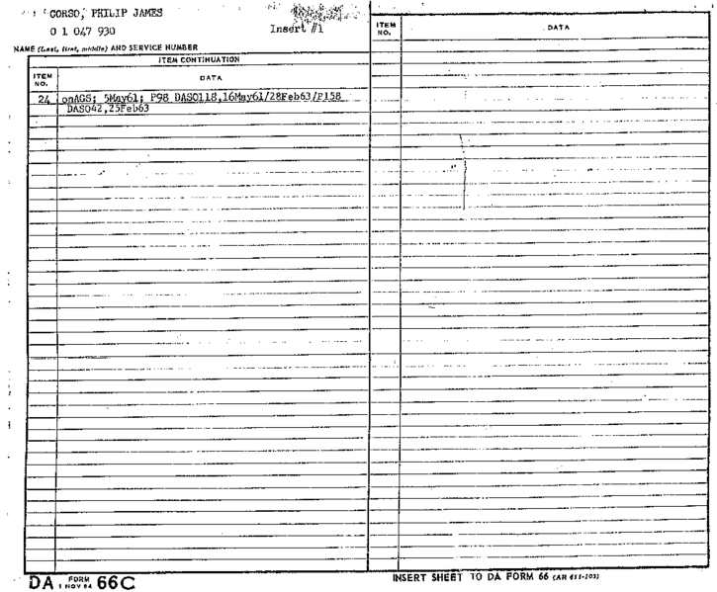 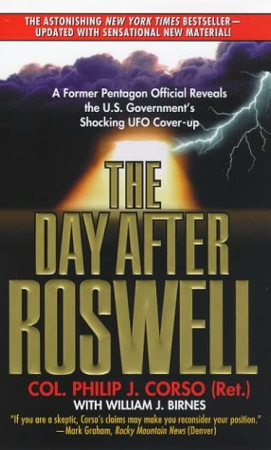

DA Form 66 (page 1 - 5) [Philip J. Corso](http://en.wikipedia.org/wiki/Philip_J._Corso) book: [ISBN 978-0-67-101756-9](http://en.wikipedia.org/wiki/Special:BookSources/9780671017569) The Day After Roswell (paperback, 1998).

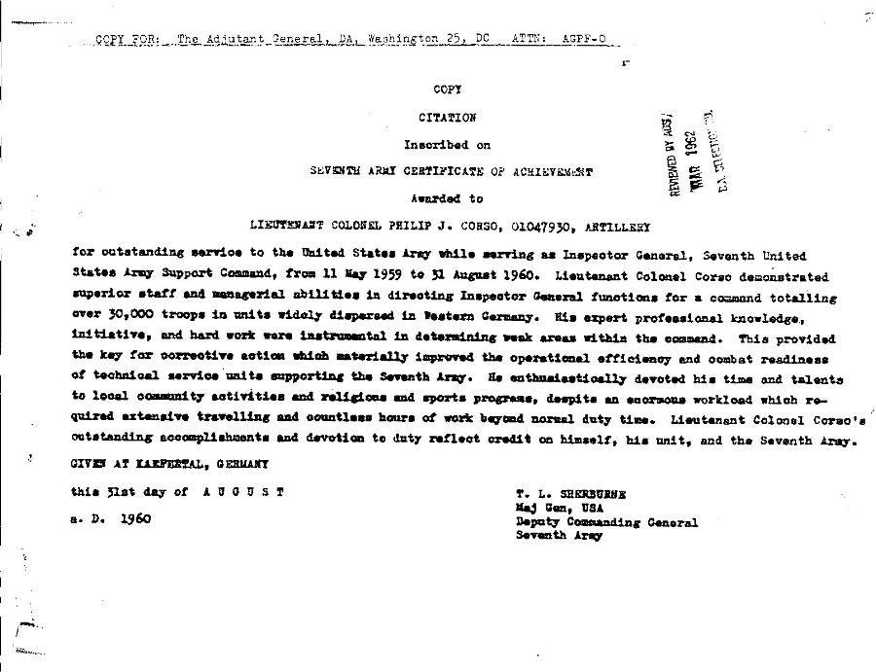

**Philip J. Corso** ([May 22](http://en.wikipedia.org/wiki/May_22), [1915](http://en.wikipedia.org/wiki/1915) - [July 16](http://en.wikipedia.org/wiki/July_16), [1998](http://en.wikipedia.org/wiki/1998)) was an American U.S. Army officer.

He served in the [United States Army](http://en.wikipedia.org/wiki/United_States_Army) from [February 23](http://en.wikipedia.org/wiki/February_23), [1942](http://en.wikipedia.org/wiki/1942) to [March 1](http://en.wikipedia.org/wiki/March_1), [1963](http://en.wikipedia.org/wiki/1963).[[1]](http://en.wikipedia.org/wiki/Philip_J._Corso#cite_note-0), and earned the rank of [Lieutenant Colonel](http://en.wikipedia.org/wiki/Lieutenant_Colonel_%28United_States%29).

Late in his life in the book [*The Day After Roswell*](http://en.wikipedia.org/wiki/The_Day_After_Roswell), Corso claimed that he was involved in the research of extraterrestrial technology recovered from the 1947 [Roswell UFO crash](http://en.wikipedia.org/wiki/Roswell_UFO_crash).

|  |
| --- |
| **Contents**  [1 Biography](http://en.wikipedia.org/wiki/Philip_J._Corso#Biography)   * + [1.1 Military career](http://en.wikipedia.org/wiki/Philip_J._Corso#Military_career)   + [1.2 The Day After Roswell](http://en.wikipedia.org/wiki/Philip_J._Corso#The_Day_After_Roswell) * [2 Gallery](http://en.wikipedia.org/wiki/Philip_J._Corso#Gallery)   + [2.1 Personal](http://en.wikipedia.org/wiki/Philip_J._Corso#Personal)   + [2.2 Files](http://en.wikipedia.org/wiki/Philip_J._Corso#Files) * [3 See also](http://en.wikipedia.org/wiki/Philip_J._Corso#See_also) * [4 References](http://en.wikipedia.org/wiki/Philip_J._Corso#References)   + [4.1 Further reading](http://en.wikipedia.org/wiki/Philip_J._Corso#Further_reading) * [5 External links](http://en.wikipedia.org/wiki/Philip_J._Corso#External_links)   + [5.1 Videos](http://en.wikipedia.org/wiki/Philip_J._Corso#Videos) |

**Biography**

**Military career**

After joining the Army in 1942, Philip Corso served in [Army Intelligence](http://en.wikipedia.org/wiki/Army_Intelligence) in Europe.

In 1945, Corso arranged for the safe passage of 10,000 Jewish [WWII](http://en.wikipedia.org/wiki/World_War_II) refugees out of [Rome](http://en.wikipedia.org/wiki/Rome) to [Palestine](http://en.wikipedia.org/wiki/Palestine).

During the [Korean War](http://en.wikipedia.org/wiki/Korean_War) (1950-1953), Corso performed Intelligence duties under General [Douglas MacArthur](http://en.wikipedia.org/wiki/Douglas_MacArthur) as Chief of the Special Projects branch of the Intelligence Division, Far East Command. One of his primary duties was to keep track of enemy [prisoner of war](http://en.wikipedia.org/wiki/Prisoner_of_war) (POW) camps in [North Korea](http://en.wikipedia.org/wiki/North_Korea). Corso was in charge of investigating the estimated number of U.S. and other [United Nations](http://en.wikipedia.org/wiki/United_Nations) POWs held at each camp and their treatment. At later held congressional hearings of the [Senate Select Committee on POW/MIA Affairs](http://en.wikipedia.org/wiki/Senate_Select_Committee_on_POW/MIA_Affairs), Philip Corso would provide testimony that many hundreds of American POW's were abandoned at these camps.[[2]](http://en.wikipedia.org/wiki/Philip_J._Corso#cite_note-1)[[3]](http://en.wikipedia.org/wiki/Philip_J._Corso#cite_note-2)

Corso was on the [staff](http://en.wikipedia.org/wiki/Staff_officer) of President [Eisenhower](http://en.wikipedia.org/wiki/Dwight_D._Eisenhower)'s [National Security Council](http://en.wikipedia.org/wiki/National_Security_Council) for four years (1953-1957).

In 1961, he became Chief of [the Pentagon](http://en.wikipedia.org/wiki/The_Pentagon)'s Foreign Technology desk in Army Research and Development, working under Lt. Gen. [Arthur Trudeau](http://en.wikipedia.org/wiki/Arthur_Trudeau).

When he left military intelligence in 1963, Corso became a key aide to Senator [Strom Thurmond](http://en.wikipedia.org/wiki/Strom_Thurmond).

In 1964, Corso was assigned to [Warren Commission](http://en.wikipedia.org/wiki/Warren_Commission) member Senator [Richard Russell Jr.](http://en.wikipedia.org/wiki/Richard_Russell_Jr.) as an investigator into the assassination of [John F. Kennedy](http://en.wikipedia.org/wiki/John_F._Kennedy).

Philip Corso married Nancy Janice Moore in 1968. They have a son, Philip Corso Junior.

**The Day After Roswell**

*Main article:* [*The Day After Roswell*](http://en.wikipedia.org/wiki/The_Day_After_Roswell)

Philip Corso relates in his book *The Day After Roswell* (co-author [William J. Birnes](http://en.wikipedia.org/wiki/William_J._Birnes)) how he stewarded extraterrestrial artifacts recovered from a crash at [Roswell, New Mexico](http://en.wikipedia.org/wiki/Roswell%2C_New_Mexico) in 1947.

According to Corso, the [reverse engineering](http://en.wikipedia.org/wiki/Reverse_engineering) of these artifacts indirectly led to the development of accelerated [particle beam](http://en.wikipedia.org/wiki/Particle_beam) devices, [fiber optics](http://en.wikipedia.org/wiki/Fiber_optics), [lasers](http://en.wikipedia.org/wiki/Laser), [integrated circuit](http://en.wikipedia.org/wiki/Integrated_circuit) chips and [Kevlar](http://en.wikipedia.org/wiki/Kevlar) material.

In 1947, according to Corso, a covert government group (see [Majestic 12](http://en.wikipedia.org/wiki/Majestic_12)) was assembled under the leadership of the first [Director of Central Intelligence](http://en.wikipedia.org/wiki/Director_of_Central_Intelligence), Adm. [Roscoe H. Hillenkoetter](http://en.wikipedia.org/wiki/Roscoe_H._Hillenkoetter). Among its tasks was to collect all information on extraterrestrial spacecraft. The US administration simultaneously discounted the existence of flying saucers in the eyes of the public, Corso says.

Corso further relates that the [Strategic Defense Initiative](http://en.wikipedia.org/wiki/Strategic_Defense_Initiative) (SDI), or *Star Wars*, was meant to achieve the capability of killing the electronic guidance systems of incoming enemy warheads and disabling enemy spacecraft, including those of extraterrestrial origin.

Many of the claims made in this book have been challenged by other UFO researchers; for a detailed investigation of his claims, see [Kal K. Korff](http://en.wikipedia.org/w/index.php?title=Kal_K._Korff&action=edit&redlink=1)'s book *The Roswell UFO Crash: What They Don't Want You to Know*.

**References**

|  |
| --- |
| 1. [**^**](http://en.wikipedia.org/wiki/Philip_J._Corso#cite_ref-0) [Philip J. Corso's Department of the Army Form 66, Officer Qualification Record](http://www.cufon.org/cufon/corso_da66.htm). Retrieved on [2007](http://en.wikipedia.org/wiki/2007)-[02-10](http://en.wikipedia.org/wiki/February_10). 2. [**^**](http://en.wikipedia.org/wiki/Philip_J._Corso#cite_ref-1) [Testimony Of Dolores Alfond Before The Pennsylvania Legislature](http://www.nationalalliance.org/korea/k-alfond.htm) ([1999](http://en.wikipedia.org/wiki/1999)-[05-03](http://en.wikipedia.org/wiki/May_3)). Retrieved on [2007](http://en.wikipedia.org/wiki/2007)-[02-09](http://en.wikipedia.org/wiki/February_9). 3. [**^**](http://en.wikipedia.org/wiki/Philip_J._Corso#cite_ref-2) [Senate Select Committee 49](http://aiipowmia.com/ssc/ssc49.html). AII POW-MIA ([1992](http://en.wikipedia.org/wiki/1992)-[11-11](http://en.wikipedia.org/wiki/November_11)). Retrieved on [2007](http://en.wikipedia.org/wiki/2007)-[02-10](http://en.wikipedia.org/wiki/February_10).   **Further reading**   * W. Nelan, Bruce (September 30, 1996). [Lost Prisoners Of War: "Sold Down The River"?](http://www.time.com/time/magazine/article/0,9171,985224,00.html). Time (magazine). Retrieved on [2007](http://en.wikipedia.org/wiki/2007)-[05-05](http://en.wikipedia.org/wiki/May_5). * LeBoutillier, John (June 13, 2000). [POWs: America's Biggest Cover-Up](http://www.newsmax.com/articles/?a=2000/6/12/202658). News Max. Retrieved on [2007](http://en.wikipedia.org/wiki/2007)-[05-05](http://en.wikipedia.org/wiki/May_5). * Huyghe, Patrick (March 20, 2000). [Taking the UFO Case to Court](http://www.space.com/spaceimagined/area51/caus_court_000320.html). Space.com. Retrieved on [2007](http://en.wikipedia.org/wiki/2007)-[05-05](http://en.wikipedia.org/wiki/May_5). * *The Day After Roswell* (paperback, 1998) [ISBN 978-0-67-101756-9](http://en.wikipedia.org/wiki/Special:BookSources/9780671017569)  External links  * [Philip J. Corso - Obit - Death](http://www.obits.com/corsopj.html) * [Philip J. Corso - About - Biography](http://ufos.about.com/od/projectsign/p/corso.htm) * [Philip J. Corso - Coast to Coast AM - Biography](http://www.coasttocoastam.com/guests/454.html) * [Philip J. Corso - Coast to Coast AM - William J. Birnes (interview)](http://www.coasttocoastam.com/shows/2005/01/30.html) * [Philip J. Corso - Voice Stress Analysis - William Michael Kemp](http://www.virtuallystrange.net/ufo/updates/2000/aug/m16-020.shtml) * [Hearings Opened On Korea M.I.A.'S](http://select.nytimes.com/gst/abstract.html?res=F10617FD345B0C728DDDA80994DA494D81&n=Top%2fNews%2fWorld%2fCountries%20and%20Territories%2fChina). New York Times ([1992](http://en.wikipedia.org/wiki/1992)-[11-11](http://en.wikipedia.org/wiki/November_11)). Retrieved on [2007](http://en.wikipedia.org/wiki/2007)-[02-10](http://en.wikipedia.org/wiki/February_10). * [Space Weapons as Defense - Nexus Magazine vol 13:2 - Michael E. Salla Ph.D](http://www.exopolitics.org/Study-Paper-10-Nexus.pdf) * [The Korean War - Tackling the Tough Topics Issue #63 - Darryl Eberhart](http://www.tacklingthetoughtopics.net/Eberhart/eberhart_korean_war.html) * [European American Evangelistic Crusades](http://www.eaec.org/newsletters/2004/NL2004Nov-Dec.htm) * [Phillip Corso Jr. talking about aliens and ufos](http://www.logoschristian.org/ftwaltonbeach/)   **Videos**   * [Disclosure Project](http://en.wikipedia.org/wiki/Disclosure_Project) - Extraterrestrial Contact and Close Encounter: [Part 2](http://video.google.com/videoplay?docid=-1761201284029857279&hl=en) - 2001 * [Dateline (NBC)](http://en.wikipedia.org/wiki/Dateline_NBC) - [Claims of Close Encounters and Cover Ups](http://www.youtube.com/watch?v=enFdECEVGo4) - 1997 * [Coast to Coast AM](http://en.wikipedia.org/wiki/Coast_to_Coast_AM) - [Radio Interview with Art Bell](http://www.youtube.com/watch?v=dDpmCRjx_k8&mode=related&search=) - July 23, 1997 |

<http://ufos.about.com/od/projectsign/p/corso.htm>

Summary: He says that he actually saw the body of a dead alien recovered from the Roswell wreckage of 1947. For more than 50 years now, the world has been captivated by the Roswell incident, and Colonel Philip J. Corso, retired American Army officer, now deceased, has left us details of what he saw in 1947 at Fort Riley in Kansas. He is the highest ranking officer to come forward with details about the famous New Mexico crash.

The Day After Roswell: He claimed that the New Mexico wreckage was definitely not from a balloon, but from an alien spacecraft. Although the Roswell case takes an occasional hit from witnesses whose claims are debunked, or from the fakery of the infamous Santilli Alien Autopsy Film, it always comes back to the forefront of Ufology. Corso's claims became public knowledge in his book, "The Day After Roswell."

Secret Pentagon Files: Not only did Corso claim to have seen an alien body from Roswell, but also secret Pentagon files regarding the incident. He stated that the Pentagon had the bodies of aliens shipped to the Walter Reed Hospital in Washington, D. C. Autopsies were done on the dead aliens. He also tells us that America's best was stumped by the extraordinary technological marvels in the alien craft.

Reserve Engineering: Different parts of the Roswell craft were sent to various defense companies, who reverse engineered their properties. This engineering feat eventually led to a number of breakthroughs. Among them were integrated circuitry, night vision equipment, the laser, particle beams, and fibre optics. The contractors were told that the parts were stolen from Russia.

Kept From the Russians: He also claims that the government cover-up was not only to hide the truth of extraterrestrial intelligence from the public, but also to allow the time needed for the reverse engineering process to be protected from foreign countries, especially the Russians. In his book, Corso stated; "Nobody wanted to come in second place in the silent, unacknowledged alien-technology development race going on at the Pentagon as each service quietly pursued its version of a secret Roswell weapon."

"Above Top Secret": Corso's first breakthrough into the vast "above top secret" box of goodies came when he was stationed at Fort Riley in Kansas in July of 1947. He had become curious about a cache of sealed boxes which were being stored in a high security area of the base. Not being able to hold back his desire to look into the secrets inside, he took a torch and pried open one of the boxes. He was shocked at what he saw.

Contents of the Box: "The contents, enclosed in a thick glass container, were submerged in a thick light blue liquid. At first I thought it was a dead child they were shipping somewhere, but this was no child. "It was a 4ft human-shaped figure with arms, bizarre- looking four-fingered hands - I didn't see a thumb - thin legs and feet, and an over-sized incandescent lightbulb-shaped head that looked like it was floating over a balloon gondola for a chin."

Impressive Resume: Although some investigators reject Corso's claims, there can be no doubt about his credentials. After joining the Army in 1942, he served in Army Intelligence in Europe. During the Korean War, he continued his Intelligence duties under General Douglas MacArthur. He rounded out an impressive resume with four years on President Dwight Eisenhower's national security staff.

Corso's Sworn Oath: June 8, 1998-RETIRED ARMY COLONEL SWEARS UNDER OATH TO SEEING ALIEN BODIES AND AUTOPSY REPORTS. Attorney Peter A. Gersten, executive director of Citizens Against UFO Secrecy, Inc (CAUS), a non-profit Arizona activist organization dedicated to ending all secrecy surrounding this planet's contact with an extraterrestrial intelligence, announced today that retired Army Colonel Philip J. Corso has sworn under oath to statements previously made in his best selling book 'Day After Roswell.'

Request for Information: Gersten stated that Colonel Corso has provided CAUS, for use in its lawsuit against the Department of Army, with a sworn affidavit re-affirming previous statements that he saw alien bodies in July, 1947 and had the opportunity to read their autopsy reports in 1961. The CAUS lawsuit, which was filed March 25, 1998 in the U.S. District Court in Phoenix, is asking the federal court to direct the Army to provide Gersten and CAUS with any and all documents relevant to what the Colonel, now swears under oath, he saw and read.

Corso died of a heart attack at approximately 11:15 pm EDT on Thursday, July 16, 1998. He was 83.

[**www.logoschristian.org/ftwaltonbeach/**](http://www.logoschristian.org/ftwaltonbeach/)

**"There is No Government Conspiracy."**

**Phillip Corso Jr.**

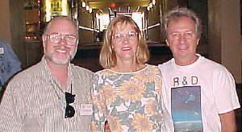

[**Pastor Chris, Liz, and Phillip Corso**](http://www.logoschristian.org/sightings/)

**Click on photo to go to corsofiles.com**

**It was very nice to meet Lt. Col. Phillip J. Corso's son Phillip Jr and his wife Liz. Phill is a member of The Christian Motorcycle Association and a strong believer in the Lord Jesus Christ.**

**Lt. Col. Phillip J. Corso was the author of "The Day After Roswell" with William J. Birnes.**

**"As chief of the Army's Foreign Technology Division in 1961, Phillip J. Corso stewarded the Roswell, New Mexico, alien artifacts in a reverse-engineering project that led to today's:**

* **Integrated circuit chips**
* **Fiber Optics**
* **Lasers**
* **Super-tenacity fibers**
* **and "seeded" the Roswell alien technology to giants of American industry."**

END