Zecharia Sitchin Data:
THE CASE OF THE EVIL WIND
Climate Study Corroborates Sumer’s Nuclear Fate
At the end of the third millennium B.C. the great Sumerian civilization came to an abrupt end. Its sudden demise was bewailed in numerous lamentation texts that have been discovered by archeologists. The texts ascribed the calamity to an Evil Wind that came blowing from the west (from the direction of the Mediterranean Sea) -- a deathly cloud that caused excruciating death to all living beings, people and animals alike, that withered plants and poisoned the waters.
In The Wars of Gods and Men (third book of The Earth Chronicles series), Zecharia Sitchin saw an explanation of the sudden death in a long text known to scholars as The Erra Epos, that described a chain of events that ultimately led to the use of “Weapons of Terror” in a conflict between opposing clans of the Anunnaki ("Those who from Heaven to Earth came").
Based on the descriptions of the weapons in the Erra Epos and in the lamentation texts, Zecharia Sitchin concluded that the Weapons of Terror were nuclear weapons. Used to obliterate the spaceport that then existed in the Sinai Peninsula (and some “sinning cities” such as Sodom and Gomorrah), the nuclear cloud then was carried by the prevailing winds eastward, causing death and desolation in the Lands Between the Rivers (Mesopotamia) -- the empire of Sumer and Akkad.
Besides claiming that nuclear weapons were first used on Earth not in the 1940’s in Hiroshima but thousands of years earlier in the Near East, Zecharia also pinpointed the date: 2024 B.C.!

Scientific Corroboration Now Comes Along
That the civilization that sprang out in Sumer circa 3800 B.C. – reaching unparalleled heights under the last dynasty, the Third Dynasty of Ur (Abraham’s city) -- had come to an abrupt end near the end of the third millennium B.C. has been an accepted and well documented fact. That the end was abrupt, was also certain. What scholars deemed as still lacking was an explanation: How, what caused it?
Beginning in 1999, archaeologists and scholars specializing in the Near East saw mounting evidence that the demise of Sumer and Akkad (Sumer’s northern extension) coincided with an abrupt climate change. An initial study by Harvey Weiss and Timothy C. Wieskel of Harvard University was reinforced by a subsequent study (Geology, April 2000) by H.M. Cullen et al from the Lamont-Doherty Earth Observatory of Columbia University, the University of Utah, the Lawrence Livermore National Laboratory, and the Institute fÜr Geowissenschaften, Germany. Based on studies of unexplained aridity and wind-blown dust storms and radiocarbon datings, they reported that their readings indicated a date of 4025 years ago (plus or minus a margin of 125 years).

A precise date corroborated!
Those and similar climate-change studies, relating the climate conditions to the rise and fall of civilizations in the Old as well as the New Worlds, were summed up in a major study published in the prestigious journal Science in its 27 April 2001 issue. Authored by Peter B. deMenocal of the Lamont-Doherty Earth Observatory of Columbia University, the study paid particular attention to sedimentary remains of Tephra; the telltale rock fragments confirmed the date 4025 Years Before Present.
And 4025 years, before the present year A.D. 2001 -- is exactly 2024 B.C., as Zecharia Sitchin had determined in his 1985 book!

The Tephra Mystery
The reliance of this latest study on the Tephra evidence is doubly significant.
While the previous studies spoke of “wind blown dust,” this latest study focuses on a material called Tephra. And what is Tephra? It is defined in geology textbooks thus:
When a volcano erupts, it will sometimes eject material such as rock fragments into the atmosphere. This material is known as Tephra
These burnt-through pieces of blackened gravel-like rock mostly fall near their volcanic source; but ashlike particles can be carried by prevailing winds over many miles and can stay aloft for more than a year.
The area in the Sinai Peninsula where the destroyed spaceport had been is indeed covered -- to this day! -- with gravelike burnt-through blackened stones (for photo evidence see illustrations 105, 106, & 107 in The Wars of Gods and Men). But as Zecharia has pointed out in his book; there are NO VOLCANOES in the Sinai Peninsula. In the Sinai Peninsula, the source of the wind-carried dust remains a mystery.
And the only explanation for these broken and blackened stones in the Sinai and the windblown desolation in Mesopotamia can be the tale of the Erra Epos, (reflected in the biblical tale of the upheaval of Sodom and Gomorrah): not an eruption by a non-existent volcano, but the use of nuclear weapons in 2024 B.C.
ZS / November 2001
THE CASE OF THE LURKING PLANET
"Far beyond the solar system's nine known planets, a body as massive as Mars may once have been part of our planetary system -- and it might still be there;”
The lead paragraph in a science-fiction script?
The lead paragraph from an article by Zecharia Sitchin about Nibiru?
No. It is the lead paragraph in a report in Science News of April 7, 2001 headlined "A Comet’s Odd Orbit Hints At Hidden Planet.”
The article reports the conclusions of an international team of astronomers who have studied an unusual comet discovered last year, designated 2000 CR/105. It follows a vast elliptical orbit around our Sun – an orbit that takes it way out to some 4.5 billion kilometers from the Sun, and brings it back at its closest to the Sun to the vicinity of Neptune; it is an orbit whose period “takes roughly 3,300 years” (according to Sky&Telescope News of April 5, 2001).
“Such an oblong orbit is usually a sign that an object has come under the gravitational influence of a massive body," wrote R. Cowen in Science News. Was this the gravitational pull of Neptune? In a study to be published in the Journal Icarus, the team of astronomers (led by Brett Gladman of the Observatoire de la Côte d'Azur in Nice, France), after analyzing all the possibilities, does not think so. An alternative solution, they say, is that “the comet's orbit could be the handiwork of an as-yet unseen planet” -- as massive as Mars -- "that would have to lie some 200 AU from the Sun," in the so-called Kuiper Belt of cometary and other planetary debris. This would also explain "why many members of the Belt have orbits that angle away from the plane in which the nine known planets orbit the Sun."
“Undoubtedly, something massive knocked the hell out of the Belt," Harold F. Levison of the Southwest Research institute in Boulder, Colorado, told the magazine. “The question is whether it is still there now."
“Comet’s Course Hints at Mystery Planet,” was how the journal Science headlined the discovery news in its issue of 6 April 2001. The special report, written by the Dutch astronomer Govert Schilling, summed up the findings in the following lead paragraph:
"A Supercomet following an unexpectedly far-flung path around the sun suggests that an unidentified planet once lurked in the outermost reaches of the solar system, an international team of astronomers reports. What's more, the mysterious object may still be there."

Now, As the Sumerians Said…
Readers of my books may well join me now in saying: So what else is new?
Ever since the publication of my first book (The 12th Planet) in 1976 I have asserted that Sumerian and other ancient Near Eastern texts and depictions showed familiarity with a complete Solar System that included, beside the Sun and the Moon, ten (not nine) planets -- the tenth planet (or twelfth member of the Solar System) having a vast elliptical orbit that lasts 3,600 years. Its Sumerian name was Nibiru.
I have-suggested that Sumerian/Akkadian texts such as Enuma Elish (also called the Babylonian Epic of Creation) were not mythological tales, but records of sophisticated advanced knowledge. Establishment scientists and scholars (see a previous article, The Case of the Misplaced Teapot, as an example) resist such an inevitable conclusion because it requires the acceptance of the ancient claim that Earth had been visited by Extraterrestrials, the ANUNNAKI ("Those Who From Heaven to Earth Came") of Sumerian lore.
According to the ancient texts as interpreted by me, Nibiru was a planet ejected from some other planetary system in outer space that was captured into our Solar System as it passed near Neptune. It became involved in a collision with a pre-existing planet where the debris of the Asteroid Belt are now. As a result of that collision, some 4 billion years ago, the Earth and the Moon came to be where they are now.
And, what do you know? In an article titled Neptune Attacks! In the 7 April 2001 issue of the magazine New Scientist, Ivan Semeniak wrote thus:
“There is new evidence that a sudden barrage of deadly debris crashed against the Earth and the Moon 3.9 billion years ago… What triggered this onslaught? Something in the structure of the Solar System must have changed.”
The “something,” I am more certain than ever, was Nibiru.

Sensational Human Genome Discovery
THE CASE OF ADAM’S ALIEN GENES
In whose image was The Adam – the prototype of modern humans, Homo sapiens – created?
The Bible asserts that the Elohim said: “Let us fashion the Adam in our image and after our likeness.” But if one is to accept a tentative explanation for enigmatic genes that humans possess, offered when the deciphering of the human genome was announced in mid-February, the feat was decided upon by a group of bacteria!
“Humbling” was the prevalent adjective used by the scientific teams and the media to describe the principal finding – that the human genome contains not the anticipated 100,000 - 140,000 genes (the stretches of DNA that direct the production of amino-acids and proteins) but only some 30,000+ -- little more than double the 13,601 genes of a fruit fly and barely fifty percent more than the roundworm’s 19,098. What a comedown from the pinnacle of the genomic Tree of Life!
Moreover, there was hardly any uniqueness to the human genes. They are comparative to not the presumed 95 percent but to almost 99 percent of the chimpanzees, and 70 percent of the mouse. Human genes, with the same functions, were found to be identical to genes of other vertebrates, as well as invertebrates, plants, fungi, even yeast. The findings not only confirmed that there was one source of DNA for all life on Earth, but also enabled the scientists to trace the evolutionary process – how more complex organisms evolved, genetically, from simpler ones, adopting at each stage the genes of a lower life form to create a more complex higher life form – culminating with Homo sapiens.
The “Head-scratching” Discovery
It was here, in tracing the vertical evolutionary record contained in the human and the other analyzed genomes, that the scientists ran into an enigma. The “head-scratching discovery by the public consortium,” as Science termed it, was that the human genome contains 223 genes that do not have the required predecessors on the genomic evolutionary tree.
How did Man acquire such a bunch of enigmatic genes?
In the evolutionary progression from bacteria to invertebrates (such as the lineages of yeast, worms, flies or mustard weed – which have been deciphered) to vertebrates (mice, chimpanzees) and finally modern humans, these 223 genes are completely missing in the invertebrate phase. Therefore, the scientists can explain their presence in the human genome by a “rather recent” (in evolutionary time scales) “probable horizontal transfer from bacteria.”
In other words: At a relatively recent time as Evolution goes, modern humans acquired an extra 223 genes not through gradual evolution, not vertically on the Tree of Life, but horizontally, as a sideways insertion of genetic material from bacteria…
An Immense Difference
Now, at first glance it would seem that 223 genes is no big deal. In fact, while every single gene makes a great difference to every individual, 223 genes make an immense difference to a species such as ours.
The human genome is made up of about three billion neucleotides (the “letters” A-C-G-T which stand for the initials of the four nucleic acids that spell out all life on Earth); of them, just a little more than one percent are grouped into functioning genes (each gene consists of thousands of "letters"). The difference between one individual person and another amounts to about one “letter” in a thousand in the DNA “alphabet.” The difference between Man and Chimpanzee is less than one percent as genes go; and one percent of 30,000 genes is 300.
So, 223 genes is more than two thirds of the difference between me, you and a chimpanzee!
An analysis of the functions of these genes through the proteins that they spell out, conducted by the Public Consortium team and published in the journal Nature, shows that they include not only proteins involved in important physiological but also psychiatric functions. Moreover, they are responsible for important neurological enzymes that stem only from the mitochondrial portion of the DNA – the so-called “Eve” DNA that humankind inherited only through the mother-line, all the way back to a single “Eve.” That finding alone raises doubt regarding that the "bacterial insertion" explanation.
A Shaky Theory
How sure are the scientists that such important and complex genes, such an immense human advantage, was obtained by us --“rather recently”-- through the courtesy of infecting bacteria?
“It is a jump that does not follow current evolutionary theories,” said Steven Scherer, director of mapping of the Human Genome Sequencing Center, Baylor College of Medicine.
“We did not identify a strongly preferred bacterial source for the putative horizontally transferred genes,” states the report in Nature. The Public Consortium team, conducting a detailed search, found that some 113 genes (out of the 223) “are widespread among bacteria” – though they are entirely absent even in invertebrates. An analysis of the proteins which the enigmatic genes express showed that out of 35 identified, only ten had counterparts in vertebrates (ranging from cows to rodents to fish); 25 of the 35 were unique to humans.
“It is not clear whether the transfer was from bacteria to human or from human to bacteria,” Science quoted Robert Waterson, co-director of Washington University’s Genome Sequencing Center, as saying.
But if Man gave those genes to bacteria, where did Man acquire those genes to begin with?
The Role of the Anunnaki
Readers of my books must be smiling by now, for they know the answer.
They know that the biblical verses dealing with the fashioning of The Adam are condensed renderings of much much more detailed Sumerian and Akkadian texts, found inscribed on clay tablets, in which the role of the Elohim in Genesis is performed by the Anunnaki – “Those Who From Heaven to Earth Came.”
As detailed in my books, beginning with The 12th Planet (1976) and even more so in Genesis Revisited and The Cosmic Code, the Anunnaki came to Earth some 450,000 years ago from the planet Nibiru – a member of our own solar system whose great orbit brings it to our part of the heavens once every 3,600 years. They came here in need of gold, with which to protect their dwindling atmosphere. Exhausted and in need of help in mining the gold, their chief scientist Enki suggested that they use their genetic knowledge to create the needed Primitive Workers. When the other leaders of the Anunnaki asked: How can you create a new being? He answered:
"The being that we need already exists;
all that we have to do is put our mark on it.”
The time was some 300,000 years ago.
What he had in mind was to upgrade genetically the existing hominids, who were already on Earth through Evolution, by adding some of the genes of the more advanced Anunnaki. That the Anunnaki, who could already travel in space 450,000 years ago, possessed the genomic science (whose threshold we have now reached) is clear not only from the actual texts but also from numerous depictions in which the double-helix of the DNA is rendered as Entwined Serpents (a symbol still used for medicine and healing) -- see illustration ‘A’ below.
When the leaders of the Anunnaki approved the project (as echoed in the biblical ”Let us fashion the Adam”), Enki with the help of Ninharsag, the Chief Medical Officer of the Anunnaki, embarked on a process of genetic engineering, by adding and combining genes of the Anunnaki with those of the already-existing hominids.
When, after much trial and error breathtakingly described and recorded in antiquity, a “perfect model” was attained, Ninharsag held him up and shouted: “My hands have made it!” An ancient artist depicted the scene on a cylinder seal (illustration ‘B’).
And that, I suggest, is how we had come to possess the unique extra genes. It was in the image of the Anunnaki, not of bacteria, that Adam and Eve were fashioned.
A Matter of Extreme Significance
Unless further scientific research can establish, beyond any doubt, that the only possible source of the extra genes are indeed bacteria, and unless it is then also determined that the infection (“horizontal transfer”) went from bacteria to Man and not from Man to bacteria, the only other available solution will be that offered by the Sumerian texts millennia ago.
Until then, the enigmatic 223 alien genes will remain as an alternative – and as a corroboration by modern science of the Anunnaki and their genetic feats on Earth.
ZECHARIA SITCHIN
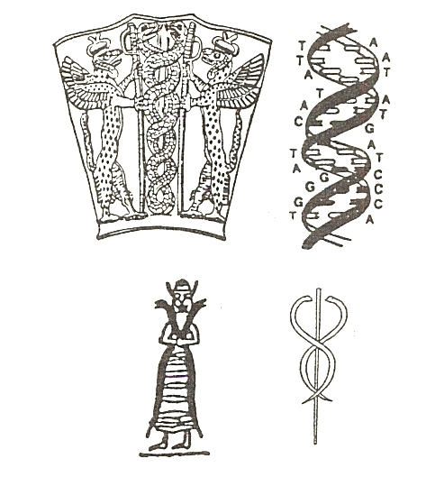 | 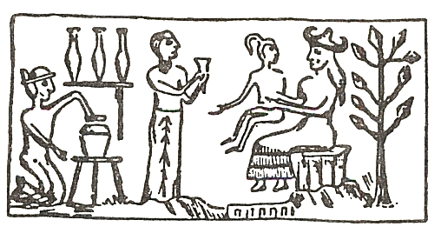
illustration A | illustration B
THE CASE OF THE GENETICALLY MODIFIED PRIMATE
"Ninharsag and her crew are closer to being vindicated as time passes, and soon your theories will no longer be theories!"
So wrote to me a fan (Jack Byrd in Virginia) in a congratulatory letter accompanying a newspaper clipping headlined "Genetically modified primate is world's first." It was the report about the successful birth of ANDi ('inserted DNA' spelled backward), a baby rhesus monkey "created" by a group of researchers at the Oregon Regional Primate Center, whose genetic makeup was modified to include the genes from a jellyfish that make it glow in the dark.
Mice have been previously genetically modified for medical research. But because the rhesus monkey is roughly 95 percent akin to humans genetically, "I think we are at an extraordinary moment in the history of humans, " said the chief researcher Dr. Gerald Schatten.
I was of course pleased to be congratulated. Yet, I wrote back to my fan with thanks coupled with an admonition. "While it is nice to get such reassuring compliments," I wrote to him, "I am trying to get my fans to write about it to others, and first and foremost to the newspapers that carried the reports. In this case, the Associated Press report stresses that it is the world's FIRST genetically modified primate; what a Letter to the Editor should point out is that according to Sumerian texts reported by Zecharia Sitchin in his books The 12th Planet and Genesis Revisited, ADAM was the first genetically modified primate, some 300,000 years ago!"
The news about the genetically modified rhesus monkey was just one item in an avalanche of reports on human genetics, cloning etc. in which the names of Enki and Ninharsag could well replace the names of Dr. Schatten, Dr. Phyllis Leppert (and their other modern colleagues). So please -- TELL IT TO THE NEWSPAPERS!
February 2001 Z. Sitchin

THE OLMEC ENIGMA: ASTRONAUT CORROBORATES SITCHIN
If an astronaut were ever to corroborate an aspect of my writings, I would have expected it to be in regard to planetary matters. Surprisingly, such a corroboration concerns, of all things, the Olmecs of ancient Mexico.
The unexpected corroboration is tucked away in the recently published book A Leap of Faith by the Mercury-7 astronaut Gordon Cooper, in which his story as a test pilot and astronaut is peppered with (to quote from the dust jacket) "his strong views on the existence of extraterrestrial intelligence -- and even the distinct possibility that we have already had contact."
The Olmec Enigma
Readers of my books, and especially of The Lost Realms, as well as of a previous article on this website titled "The Case of the Missing Elephant," know by now that beginning with the discovery of a colossal stone head in 1869, an advanced civilization that preceded the Mayas and Aztecs of Mexico came to light. Its leaders and bearers were unmistakably black Africans. They were arbitrarily named by archaeologists "Olmecs"; and their embarrassing enigma -- of who they were, and how they had come across the ocean, and why, was compounded by the timing of their arrival in the New World.  Once it was conceded (very grudgingly!) that the 'Olmecs' did indeed represent the earliest or even Mother Civilization of Mesoamerica, the date of their arrival was at first set at about 250 B.C.; then at about 500 B.C.; then farther back and back, until 1500 B.C. was acknowledged.  But I have argued for a date twice as old! | 
A God and His Secret Number
My conclusion that the Olmec presence in the New World went back at least 5,000 years, to circa 3000 B.C., was reached by many paths. The first one was an attempt to identify the great god of Mesoamerica, the Winged Serpent (Quetzalcoatl to the Aztecs, Kukulkan to the Mayas), and the significance of his promise to return to those lands on the first day of a 52-year cycle, (AD 1519, when the Aztec king Montezuma believed that the appearance of the Spanish conquistador Cortez was such a Return, coincided with the anticipated sacred date).
The peoples of Mesoamerica employed in addition to a practical calendar of 365 days, called the Haab, also a Sacred Calendar (called Tzolkin) of 260 days. The two cyclical calendars were conceived as two wheels with meshing teeth that turned and returned to the same spot once in 52 years; and 52 was the Sacred Number of the Winged Serpent god?
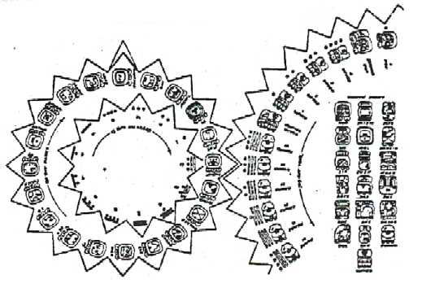
Since 52 was also the Secret Number of the god known to the Egyptians as Thoth; since Thoth as Quetzalcoatl, was the god of science and the calendar; and since Thoth was exiled from Egypt circa 3100 B.C., I have suggested that it was he who took a group of his African followers to a new land, bringing the "Olmecs" to Mesoamerica.
Accordingly, I said, Olmec presence goes back to at least 3000 B.C. -- a date twice as old as that conceded by established archaeologists.

The Mysterious "Day One"
By the time I was writing The Lost Realms, the book devoted to the prehistory of the Americas, I was sure that the arrival of the Olmecs with Thoth/Quetzalcoatl could be established with astounding precision. The key to unlocking the enigma was the Olmec Calendar.
In addition to the Haab and the Tzolkin, there was in Mesoamerica a third calendar, used to inscribe dates on monuments. Given the name the Long Count, it was not cyclical as the other two, but linear -- a continuous one, counting the total number of days that had passed since the counting began on a mysterious Day One.  By means of glyphs denoting groups of days  (1, 20, 360, 7,200 or even 144,000) and dots  and bars giving the number for each group-glyph, monuments were dated by saying: A total of so many days from Day One have passed when this Monument was erected.  But what was that Day One, when did it occur, and what was its significance?  It has been established beyond doubt that this Long Count calendar was the original Olmec calendar; and it is now generally agreed that Day One was equivalent to August 13, 3113 B.C.  But what does that date signify? As far as I know, the only plausible answer was provided by me: It was the date of Thoth/Quetzalcoatl's arrival, with his followers in Mesoamerica! | 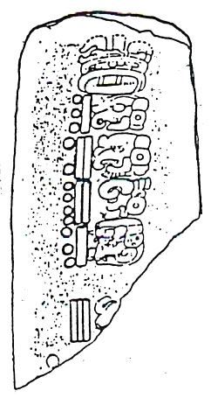

The Unexpected Corroboration
All official publications continue, however, to remain at 1250 B.C. -- 1500 B.C. at most -- as the date of the start of the Olmec presence.
Imagine my pleasant surprise to come across an eye-witness report by the astronaut Gordon Cooper in chapter 11 of his book A Leap of Faith. "During my final years with NASA," he writes, "I became involved in a different kind of adventure: undersea treasure hunting in Mexico." One day, accompanied by a National Geographic photographer, they landed in a small plane on an island in the Gulf of Mexico; local residents pointed out to them pyramid-shaped mounds, where they found ruins, artifacts and bones. On examination back in Texas, the artifacts were determined to be 5,000 years old!
"When we learned of the age of the artifacts," Cooper writes, “we realized that what we'd found had nothing to do with seventeenth-century Spain... I contacted the Mexican government and was put in touch with the head of the national archaeology department, Pablo Bush Romero."
Together with Mexican archeologists the two went back to the site. After some excavating, Cooper writes,
"The age of the ruins was confirmed: 3000 B.C. Compared with other advanced civilizations, relatively little was known about this one --called the Olmec."
Proceeding to describe some of the amazing discoveries about the Olmecs and their achievements, Gordon Cooper continues thus:
"Engineers, farmers, artisans, and traders, the Olmecs had a remarkable civilization. But it is still not known where they originated... Among the findings that intrigued me most: celestial navigation symbols and formulas that, when translated, turned out to be mathematical formulas used to this day for navigation, and accurate drawings of constellations, some of which would not be officially 'discovered' until the age of modern telescopes."
It was this, rather than his experiences as an astronaut, that triggered Gordon Cooper's "Leap of faith": "This left me wondering: Why have celestial navigation signs if they weren't navigating celestially?” And he asks: If ‘someone’ had helped the Olmecs with this knowledge, from whom did they get it?
My readers, of course, know the answers.

Has the Cover-up Ended?
The outstanding museum on the Olmec civilization in Jalapa, in the Veracruz province of Mexico, included when it was built a wall panel showing the extent and dates of Mexico's various cultures. On my first visit there, I could hardly believe my eyes: The first (earliest) civilization, that of the Olmecs, was shown as begun circa 3000 B.C.!  I urged the members of my group to take pictures of me pointing to the date: Finally, the date claimed by me has been officially accepted!  On a second visit, however (to which the previous article, The Case of the Missing Elephant relates), not only the telltale elephant-toy disappeared; the Olmec column starting at 3000 B.C. was also gone... And the official Museum Catalogue, reviewing the Olmec civilization, reverted to 1500 B.C.  But now comes the astronaut Gordon Cooper, and innocently and inter-alia tells, as an eye-witness, what he was told by the chief Mexican archaeologist: 3000 B.C. | 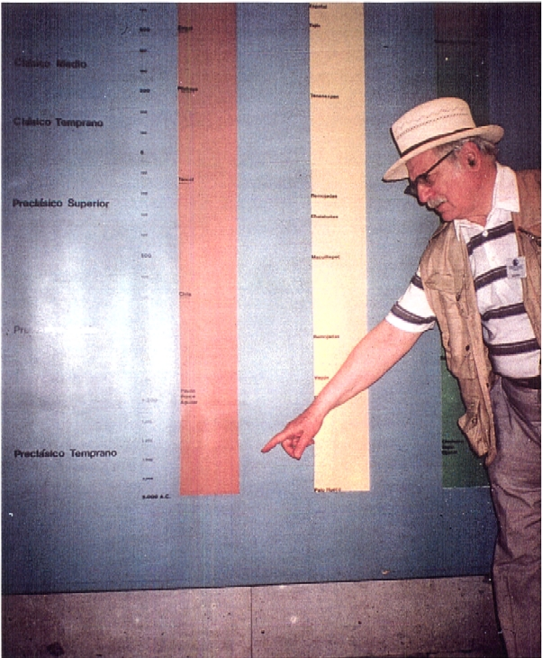
And thus, when all is said and done, I stand vindicated.

THE CASE OF THE ? ? ? ? ASTRONOMER

This is a sequel to the previous case, that of the Misplaced Teapot, in which I reported the challenge, in Sky & Telescope magazine, to my assertion that the depiction on a 4,500 year-old Mesopotamian cylinder seal (Berlin Museum VA./243) shows our solar system with the sun in the center and ALL the planets we know of today, plus one more -- NIBIRU, the home planet of the Anunnaki.
What the magazine’s article (by Dr. E. C. Krupp) and artwork (see previous entry on this website) argued in essence was that this central piece of evidence by me in my book The Twelfth Planet (1976) is no evidence at all, because this depiction shows the planet Jupiter (known to the ancients) passing within the central portion (the “teapot”) of the constellation Sagittarius (also known in antiquity). Hence: No extraordinary knowledge, No extraterrestrial teachers, No Anunnaki, No 12th planet...
But Jupiter, orbiting the Sun almost precisely in the ecliptic, NEVER moves 11-12 degrees south to appear in the Teapot! Hence, No alternative interpretation, and No toppling of this piece of evidence (one of hundreds of textual and pictorial ancient data in support of the Sumerian extraordinary knowledge and the Nibiru/Anunnaki explanation).
After several fruitless letters and faxes to Sky & Telescope seeking a correction and an admission of their error, I received a two page letter from Dr. E.C. Krupp, signed by him with his title Director on official stationery of the Griffith Observatory, Los Angeles, dated 4 August 2000. It explains that my letter to the magazine was forwarded to him, but his response was delayed due to absence in Iran.

And what does the distinguished astronomer say? I quote:
“It is a delight to hear from you. I have all of your books, have read most of them, and have listened to you on the radio a couple of times. I have of course dedicated thought to the arguments you have developed. Although your handling of the data has inspired my skepticism, please let me acknowledge the courtesy and logic of your complaint about the way I evaluated your Twelfth Planet notions in my monthly column on astronomy and culture in Sky & Telescope.”
Well, well – but what about the impossibility of his assertion of Jupiter being in the Teapot of Sagittarius? Finally, the “operative” paragraph:
“You are correct to point out that I was hasty in offering Sagittarius as an option for the imagery on the Akkadian cylinder seal VA/243. Certainly we cannot regard the figure as an accurate map of the Teapot with Jupiter brewing inside.”
So, was the distinguished astronomer “hasty” and not actually plain wrong? The letter continues: “If you’ll allow me Saturn, we get a little closer, but you are right – no tea caddied planet. My caption highlights Jupiter, positions it within Sagittarius, and suggests a real mapping. Your objection is sustained” (emphasis added).
Does, then, an apology follow? Not at all, because the letter continues:
“Of course, there are other candidates among the stars. A planet could have been in the vicinity of Leo, for example, enclosed by Regulus, gamma Leonis, zeta Leonis, epsilon Leonis, alpha Cancri, 38 Cancri, delta Cancri, zeta Hydrae, epsilon Hydrae, and iota Hydra. Given the lack of precision on the cylinder seal, that set of stars works pretty well. If they be unacceptable, however, we can alternatively imagine a planet in a larger enclosure”...
After jumping from Jupiter to Saturn, and from Sagittarius to Leo to Regulus to Cancer, the letter to me offers still other stars in various constellations as alternatives... But what about the obvious alternative, that the depiction indeed represents our solar system? That, in spite of all, is not an alternative for Dr. Krupp.
In my respectful response to Dr. Krupp, I wrote:
“It truly chagrins me that someone like you, in searching for explanations for the seal’s depictions (you list some of the most improbable ones in your letter), would not even consider our solar system as a possibility. This can only stem from an absolute refusal to accept the Extraterrestrial nature of the Anunnaki. But why would someone – I am sure you are included – who would deem it possible that Man from Earth would one day travel to another planet, deem it totally unacceptable that someone from another planet might have come here? If not scientific but religious objections lie therein, please read my dialogue with a Vatican theologian on my website SITCHIN.com. (Dialogue in Bellaria)
And I signed my letter: “Looking forward to a dialogue with you.”
As of this date (September 26th), there has been no response from the magazine to my request for a correction, the publication of my letter to them in the Letters to the Editor column, or for the acceptance of an article from me: and no further communication from Dr. E.C. Krupp – whom I have quoted with respect in my book The Lost Realms – and whose attitude I could not define in the heading of this article: Should the missing word in the title be “Wrong”, “Embarrassed”, “Reluctant”, or (in his own words) just "Hasty”?
The Case of the Misplaced Teapot
A Failed Challenge To An Enigma of Ancient Astronomy
by Zecharia Sitchin
I was recently pleasantly surprised to encounter an old friend: The colorful cover of the first edition of my first book The 12th Planet (1976), reproduced in the April 2000 issue of Sky & Telescope. The photo was provided by the astronomer E.C. Krupp for his article "Lost Worlds" about misconceived predictions of planetary dooms (such as that regarding 5/5/2000).
Almost a full page is then devoted to "a different astronomical misconception" -- "Zecharia Sitchin's books about ancient space colonists from a lost "12th planet" that once violently invaded our solar system." Conceding (or lamenting?) that “credulous readers are persuaded by Sitchin that the traditions of ancient Sumer validate this unorthodox reconstruction of solar system history," the article suggests in a sidebar (see reproduction) that "Sitchin's case originates in an Akkadian cylinder seal from the third millennium B.C.; a portion of it features a six-pointed star surrounded by eleven dots of varying size; Sitchin judged that the star symbolizes the Sun and the smaller elements are supposedly planets, including the lost 12th world."
The Embarrassing Ancient Depiction
My inclusion in an article about misconceived predictions of doom (in which I have not engaged -- and this is not the only misrepresentation in the article) was thus an excuse to tackle the embarrassing depiction on cylinder seal VA/243 which I had found in the Vorderasiatisches Museum in (then East) Berlin. On this seal, as on many others, the "mythological scene" is decorated with celestial symbols -- in this case, I have suggested, showing the Sun surrounded by all the planets we know of today, plus the Moon and plus one more planet passing between Mars and Jupiter, the planet named NIBIRU by the Sumerians:
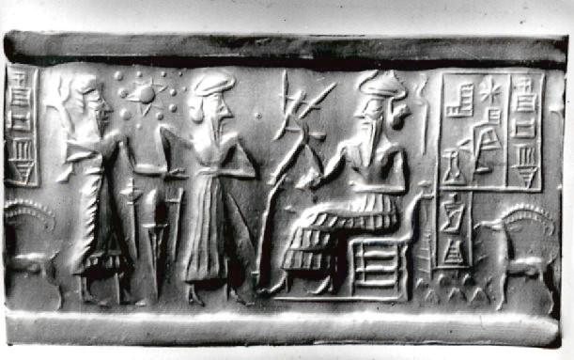
The depiction and my interpretation thereof have embarrassed astronomers for the past quarter of a century, because it is just not possible for ancient peoples to have known about post-Saturn planets, to say nothing about one more yet to be acknowledged "unknown planet." My explanation that the knowledge was provided by the Anunnaki ("Those who from Heaven to Earth came”) -- Extraterrestrial visitors to Earth -- is an even greater anathema to the scientific establishment.
What then to do about cylinder seal VA/243? It exists, it is authentic, it is at least 4,500 years old, If not Sitchin's interpretation -- what?
The "Teapot" of Sagittarius
So now, a quarter of a century after The 12th Planet was published, the Sky &Telescope article comes to the rescue. The sidebar and its two illustrations offer an alternative. The one on the right purports to show my interpretation of the seal -- colorful, but conveniently omitting the key planet between Mars and Jupiter... The other shows how the "dots" around the central object can be connected to "roughly resemble the Teapot of Sagittarius":
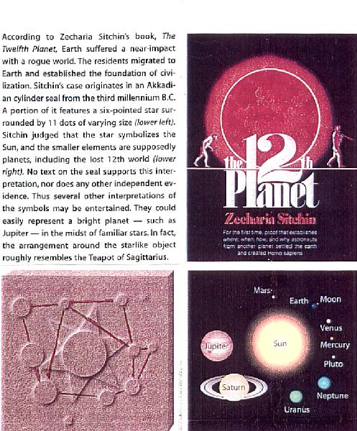
Sky & Telescope's sidebar, reproducing the first edition (1976) cover of
The 12th Planet and the magazine's two illustrations.

The solution to the embarrassing enigma of ancient knowledge, as stated in the article's sidebar, is this: The depiction "could easily represent a bright planet -- such as Jupiter -- in the midst of familiar stars; in fact, the arrangement around the star like object roughly resembles the Teapot of Sagittarius."
And so, if the central object is not the Sun but Jupiter (with which the ancients were familiar) and the surrounding objects not planets but the stars of Sagittarius (with which the ancients were familiar)-- Sitchin's extraterrestrials and Nibiru are not needed.
A clever theory -- but based on a misplaced teapot...
A "Rough Resemblance"?
Sagittarius, one of the twelve zodiacal constellations (a Sumerian first), was named PA.BIL (The Defender) by them and was depicted in antiquity as an Archer, a name and a depiction retained to this day. But some modern astronomers (while having afternoon tea?) decided that the central part of Sagittarius resembles a teapot:
A "spout" formed by connecting the stars Al Nasi, Kaus Media and Kaus Australis (stars gamma, delta and epsilon of the constellation);
A "handle" shaped by the stars designated zeta (Ascella), tau, sigma (Nunki) and phi; and a "lid" indicated by Kaus Borealis (designated lambda).
When these eight stars are connected by imaginary lines, a "teapot" seems to emerge:
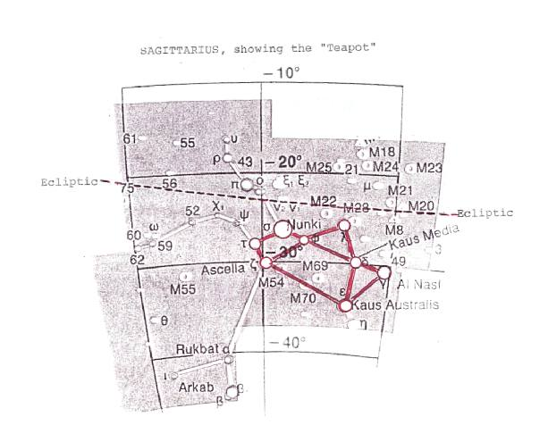

Nice Try -- But An Impossible One
One need not be an astronomer to see that the "teapot" imposed upon the ancient depiction (magazine's left illustration) is far from being similar to the actual celestial one;
But one might have to be an astronomer to realize that the offered solution is not only improbable -- it is impossible: Jupiter moves about the Sun in the ecliptic (the plane of planetary orbits around the Sun); it never dips enough in the southern skies to appear in the midst (the magazine's words!) of the Teapot!
The illustration of Sagittarius that shows the "teapot" also indicates the ecliptical path, in which Jupiter moves. AND THE TWAIN CAN NEVER MEET!
Jupiter, once in about twelve years, does scratch the northernmost protrusion of Sagittarius; but it never comes even close (in astronomical terms) to the Teapot, and could have NEVER been observed "in the midst" of the Teapot.
And so, even after a quarter of a century, "Sitchin’s misconception" continues to stand.

Dialogue in Bellaria

SITCHIN AND VATICAN THEOLOGIAN DISCUSS UFO's,
EXTRATERRESTRIALS, ANGELS, CREATION OF MAN
Report by Zecharia Sitchin

In what must be a historic first, a high official of the Vatican and a Hebrew scholar discussed the issue of Extraterrestrials and the Creation of Man, and though different from each other in upbringing, background, religion and methodology, nevertheless arrived at common conclusions:
* Yes, Extraterrestrials can and do exist on other planets
* Yes, they can be more advanced than us
* Yes, materially, Man could have been fashioned from a pre-existing sentient being.

The Participants
The high Vatican official was Monsignor Corrado Balducci, a Catholic theologian with impressive credentials: A member of the Curia of the Roman Catholic Church, a Prelate of the Congregation for the Evangelization of Peoples and the Propagation of the Faith, leading exorcist of the Archdiocese of Rome, a member of the Vatican's Beatification Committee, an expert on Demonology and the author of several books. Appointed in the Vatican to deal with the issue of UFO's and Extraterrestrials, he has made in recent years pronouncements indicating a tolerance of the subjects; but he has never before met and had a dialogue with a Hebrew scholar, and gone beyond prescribed formulations to include the touchy issue of the Creation of Man.
The Hebrew scholar was me -- Zecharia Sitchin: A researcher of ancient civilizations, a biblical archaeologist, a descendant of Abraham…
The Monsignor and I almost met for such a dialogue last December, but it did not come about. This time we were scheduled to meet in Bellaria, Italy, at a conference whose theme was “The Mystery of Human Existence.” I arrived there with my wife and a score of fans from the USA, on March 31st, scheduled to address the audience of over a thousand the next day. The Monsignor was nowhere in sight; but he was there the next morning to hear my presentation. “I drove the whole night from Rome to hear you,” he said. | 
Sitchin’s Presentation
My talk, ably translated by my Italian editor Tuvia Fogel, included a slide presentation that added a pictorial dimension to the evidence from ancient times in support of Sumerian texts, on which my eight books based the following conclusions:
We are not alone -- not just in the vast universe, but in our own solar system; There is one more planet in our solar system, orbiting beyond Pluto but nearing Earth periodically; Advanced "Extraterrestrials” -- the Sumerians called them Anunnaki, the Bible Nefilim -- started to visit our planet some 450,000 years ago; And, some 300,000 years ago, they engaged in genetic engineering to upgrade Earth's hominids and fashion Homo sapiens, the Adam. In that, they acted as Emissaries for the Universal Creator -- God.

The Dialogue
"We have much to talk about,” Msgr. Balducci said to me as he came forward to congratulate me on my presentation; "I have great esteem for your scholarship," he said.
We returned to the hotel for lunch. Our table was surrounded in a semi-circle by my American fans, intent on not missing a word of the forthcoming dialogue. In the hours-long session, Msgr. Balducci outlined the positions he was going to state, from a prepared text, in his talk the next day. While my approach was based on physical evidence, his was a purely Roman Catholic theological-philosophical one, seeking the spiritual aspects. Yet, our conclusions converged.

Msgr. Balducci's Positions
ON UFO's. "There must be something in it." The hundreds and thousands of eyewitness reports leave no room for denying that there is a measure of truth in them, even allowing for optical illusions, atmospheric phenomena and so on. As a Catholic theologian such witnessing cannot be dismissed. "Witnessing is one way of transmitting truth, and in the case of the Christian religion, we are talking about a Divine Revelation in which witnessing is crucial to the credibility of our faith.”
ON LIFE ON OTHER PLANETS: “That life may exist on other planets is certainly possible... The Bible does not rule out that possibility. On the basis of scripture and on the basis of our knowledge of God's omnipotence, His wisdom being limitless, we must affirm that life on other planets is possible." Moreover, this is not only possible, but also credible and even probable. '"Cardinal Nicolo Cusano (1401-1464) wrote that there is not a single star in the sky about which we can rule out the existence of life, even if different from ours.”
ON INTELLIGENT EXTRATERRESTRIALS: "When I talk about Extraterrestrials, we must think of beings who are like us -- more probably, beings more advanced than us, in that their nature is an association of a material part and a spiritual part, a body and a soul, although in different proportions than human beings on Earth." Angels are beings who are purely spiritual, devoid of bodies, while we are made up of spirit and matter but still at a low level. "It is entirely credible that in the enormous distance between Angels and humans, there could be found some middle stage, that is beings with a body like ours but more elevated spiritually. If such intelligent beings really exist on other planets, only science will be able to prove; but in spite of what some people think, we would be in a position to reconcile their existence with the Redemption that Christ has brought us.”

The Anunnaki and the Creation of Man
Well then, I asked Msgr. Balducci, does it mean that my presentation was no great revelation to you? We appear to agree, I said, that more advanced extraterrestrials can exist, and I use science to evidence their coming to Earth ...I then quote the Sumerian texts that say that the Anunnaki (“Those who from heaven to Earth came”) genetically improved an existing being on Earth to create the being that the Bible calls Adam.
My conclusion regarding your presentation, Msgr. Balducci answered, is that more than anything else your whole approach is based on physical evidence, it concerns itself with matter, not with spirit. This is an important distinction, "because if this distinction is made, I can bring up the view of the great theologian, Professor Father Marakoff, who is still alive and is greatly respected by the Church. He formulated the hypothesis that when God created Man and put the soul into him, perhaps what is meant is not that Man was created from mud or lime, but from something pre-existing, even from a sentient being capable of feeling and perception. So the idea of taking a pre-man or hominid and creating someone who is aware of himself is something that Christianity is coming around to…The key is the distinction between the material body and the soul granted by God."

From Anunnaki to God
Yes, I responded to the Vatican theologian, in my writings I deal with the physical evidence; but already in my first book (The 12th Planet), the very last sentence of the last paragraph raises the question: If the Extraterrestrials "created" us, who created them on their planet?
From this my own thinking and the contents of my subsequent books evolved toward the spiritual or "divine" aspects. The Anunnaki, I have explained, were just emissaries (and that is what the Hebrew word Malachim, translated Angels, means). They thought that it was their decision to come here for selfish reasons and to fashion us because they needed workers; but in truth they only carried out the Almighty God's wishes and plans.
If such Extraterrestrials were so involved, Msgr. Balducci said, even by your own interpretation they had to do with Man's physics, body and rationality: but God alone had to do with the Soul!
My second book, that deals with Man's aspiration to ascend the heavens, is titled The Stairway to Heaven, I told Msgr, Balducci, "it seems to me that we are ascending the same stairway to heaven, though from different steps," I said.
We ended the dialogue as friends, determined to stay in touch and continue.
THE CASE OF THE LAYERED ASTEROID
Once Again, Modern Science Corroborates Ancient Knowledge
by Zecharia Sitchin

It is not every day that I get an overseas call with someone shouting; Congratulations!
But it happened on Friday, February 18th 2000; and the reason was NASA's press conference the day before, reporting the first findings by the spacecraft NEAR (Near Earth Asteroid Rendezvous,) of its examination of the asteroid Eros.
Potato-shaped and about 21 miles long, Eros is one of countless bits and pieces of planetary matter that orbit the Sun between Mars and Jupiter, collectively called the Asteroid Belt. One theory is that these are remains from the time when primordial matter around the Sun coalesced into planets, but these bits and pieces failed to do so. Another theory is that these are remains of a planet that did form there, but that it somehow broke up; the inability to explain how or why it broke up has been the reason why this theory has not been embraced by scientists.
What NASA Announced
To learn more about the origin of the asteroids, NASA launched NEAR four years ago (February 17, 1996) for the purpose of reaching and going into continuous orbit around the asteroid named Eros; this was successfully achieved on St. Valentine's Day, February 14, 2000.
And the first findings. reported at a news conference on Friday February 17th, triggered the congratulatory call to me; for they corroborated an ancient cosmogony pieced together in my 1976 book The 12th Planet.
“Eros has an ancient, heavily cratered surface," reported Dr. Andrew Cheng, chief project scientist. "There are also tantalizing hints that it has a layered structure, as if it were made up of layers, like plywood."
Such stratified features, Dr. Cheng explained, could occur if the asteroid was melted while it was part of a planet (quoted by Associated Press Science News, 2/18/00-, emphasis by Z. S.).
What Sitchin Said
In The12th.Planet I asserted that an ancient Sumerian text, best preserved in a later Babylonian version called Enuma Elish, which has been taken by scholars to be an allegory or myth about gods fighting in the heavens, was in reality a record of a sophisticated cosmogony dealing with the formation of our solar system..
The protagonists Tiamat and Nibiru (which the Babylonians renamed "Marduk" in honor of their national god), I wrote, were not allegorical or mythical celestial gods but actual planets -- one (Tiamat) that existed between Mars and Jupiter, the other (Nibiru,/Marduk) an, invader from outer space that, passing by our solar system and pulled in by the system's gravitational pull, ended up colliding with Tiamat. In this Celestial Battle (as the ancient text names the catastrophic event), Tiamat broke up; one half of her was thrust into a new orbit to become Earth; the other half was smashed in an infernal collision to become the “Hammered Out Bracelet” (which we call the Asteroid Belt):
Nibiru (Marduk) enters our solar system from outer space.
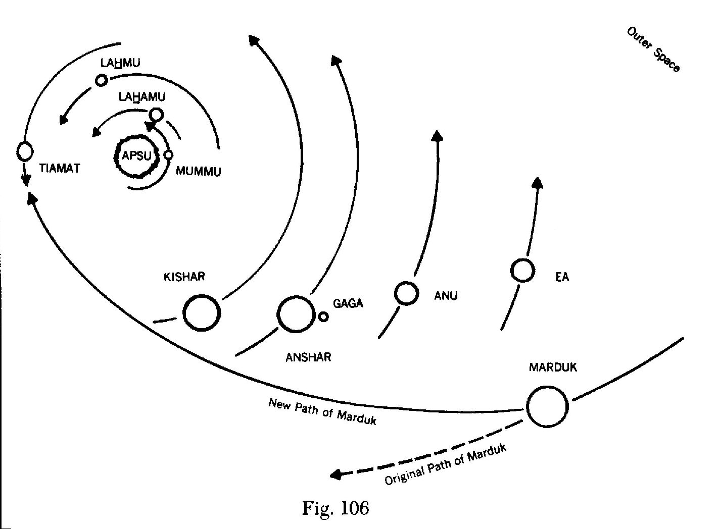

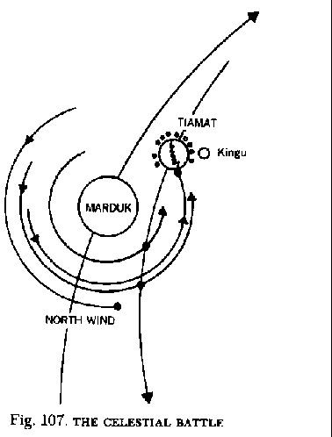 | 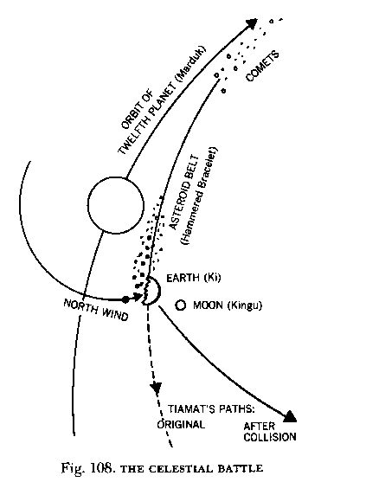

The Sumerian cosmogony, Sitchin asserted back in 1976, offers the best explanation for many enigmas in our solar system, among them the explanation for the Asteroid Belt.
Now little Eros tells its robotic visitor from Earth: Yes indeed, I was once part of a beautiful planet that broke up; yes, I originated as a result of a fiery collision, as the Sumerians described thousands of years ago; and that is why I am layered!
And this, my friends is only the latest modern discovery that corroborates the amazing ancient knowledge.

THE CASE OF THE MISSING ELEPHANT

The ruins and remains of Mexico's pre-Columbian civilizations enchant, intrigue, fascinate and puzzle. Of them the oldest and earliest, that of people referred-to as Olmecs, is the most enigmatic -- for they challenge present-day scholars to explain how had people from Africa come and settled and thrived in this part of the New World, thousands of years before Columbus.
The Discovery
We know how they looked because they left behind countless sculptures, marvelously carved in stone, depicting them; some, in fact, are stone portraits of Olmec leaders; colossal in size, they immortalize in stone what, to many, has been an unpleasant enigma.  The first colossal stone head was discovered in the Mexican state of Veracruz back in 1869. Its discoverer reported it in the Bulletin of the Mexican Geographical and Statistical Society as "a magnificent sculpture that most amazingly represents an Ethiopian." The report included a drawing clearly showing the stone head's Negroid features; and that doomed the discovery to oblivion... | 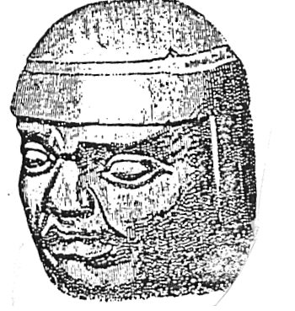
The Re-Discovery
It was not until 1925 that the existence of the Olmecs was reaffirmed when an archaeological team from Tulane University found another such gigantic stone head in the adjoining Mexican state of Tabasco; it measured about eight feet in height and weighed some twenty four tons.
In time, many more such colossal sculptures have been found; they depict distinctly different individuals wearing helmets; they also clearly depict, in each case, a person with African features -- black Africans.  As archaeological discovery followed archaeological discovery, it became evident that in a vast central area of Mexico stretching from the Gulf coast to the Pacific coast, these "Olmecs" built major urban centers, engaged in mining, were the first in Mesoamerica to have a calendar and hieroglyphic writing, and established what is by now recognized as Mesoamerica's Mother Civilization.  The Unpleasant Problem | 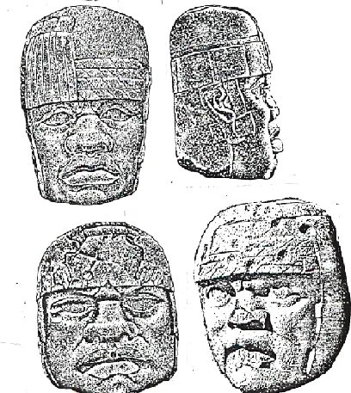
The problem that this posed was twofold: Not only the issue of Negroid Africans somehow crossing the Atlantic Ocean and settling in the New World before others; but also the incredible antiquity of such arrival. This problem was dealt with by first suggesting that the Olmecs appeared after more famed peoples such as the Mayas; then by grudgingly acknowledging earlier dates B.C. --250 B.C., then 500 B.C., then 1250 B.C., then even 1500 B.C.
Faced with such evidence, the solution was to deny that these were Africans ... Even now a noted scholar, writing in the official catalogue of the Museum of Anthropology of Jalapa, states in regard to the individuals depicted in the sculptures: "in spite of the general similarity of features -- flat noses with flaring nostrils and thickened lips (leading some to falsely claim an African origin for the Olmec)," etc.
So: "To falsely claim an African origin for the Olmecs"!
And this brings me to the Case of the Missing Elephant.
An Elephant Among the Wheels
Jalapa, a gem of a town, is about two hours' drive from Veracruz (where the Spanish Conquistador Hernan Cortes landed in 1519). Its museum is undoubtedly second only to the famed one in Mexico City; but unlike Mexico City's which displays artifacts from all over the country, the Jalapa one exhibits only locally discovered artifacts -- predominantly Olmec ones.
Dramatically and effectively displayed in an innovative setting, the Museum boasts several colossal stone heads as well as other stone sculptures. It also displays smaller objects found at Olmec sites; among them, in special display showcases, are what are considered to be Olmec "toys." They include animals mounted on wheels -- a visual and evidentiary negation of the common claim that the people of Mesoamerica (and America in general) were unfamiliar with the wheel.
And included in the same display case were elephants -- "toys" made of clay.
Gone - Where and Why?
I, and some of my fans who accompanied me, saw them on previous visits to the Museum.
BUT when I (and again some of my fans with me) was there recently -- in December 1999 -- the elephants were nowhere in sight!
I could find no one in authority to obtain an explanation from. But that the elephants were once there was a fact indeed, here is a photograph of one, shot on a previous visit:
Now, here is the significance of this small artifact: There are no, and never have been, elephants in the Americas. There are and have been elephants in Africa. And a depiction of an elephant could have been made only by someone who has seen an elephant, i.e. someone who has been to Africa!  At this and other museums later visited in December 1999, guards have asserted that objects that I wished to point out and that were written up in my book The Lost Realms but somehow vanished, were loaned for an overseas exhibit.  Perhaps. But that such a hard-to-explain depiction of an elephant would be selected to highlight Mexico's ancient heritage, is either unlikely or highly significant.  I suppose one will have to revisit Jalapa and find out whether the little elephant is back among the "toys."  ZECHARIA SITCHIN  © Z. Sitchin 2000 | 