Agenda 21 Depopulation of Rural Areas Has Begun

August 26, 2014

[15](http://osnetdaily.com/2014/08/america-2050-the-agenda-21-depopulation-of-rural-areas-has-begun/#comments)

149291

[Share on Facebook](http://www.facebook.com/sharer.php?u=http%3A%2F%2Fosnetdaily.com%2F2014%2F08%2Famerica-2050-the-agenda-21-depopulation-of-rural-areas-has-begun%2F)

[Tweet on Twitter](https://twitter.com/intent/tweet?text=America+2050%3A+The+Agenda+21+Depopulation+of+Rural+Areas+Has+Begun&url=http%3A%2F%2Fosnetdaily.com%2F2014%2F08%2Famerica-2050-the-agenda-21-depopulation-of-rural-areas-has-begun%2F&via=OSNet+Daily)

[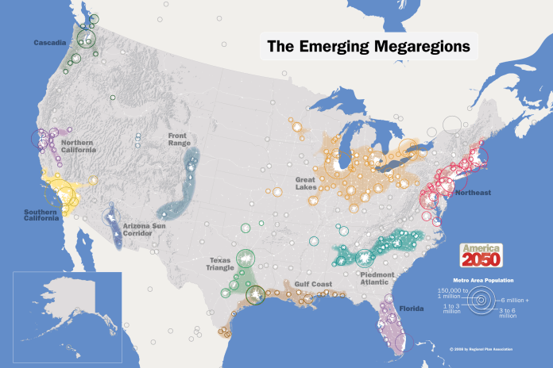](https://i0.wp.com/osnetdaily.com/wp-content/uploads/2014/08/2050_Map_Megaregions2008_150.png?fit=2494%2C1662)

[**The Common Sense Show**](http://www.thecommonsenseshow.com/2014/08/26/the-agenda-21-depopulation-of-rural-areas-will-give-obama-stalin-like-control-over-food/)

**The plan is called**[**America 2050**](http://www.america2050.org/)**and the concept is based upon the creation of megacities. In order for the megacities concept, which is well underway, to come to fruition, American suburbs and rural areas must be completely depopulated. This process is underway and the Obama administration is accelerating the process.**

This will come as a shock to many reading this article because they did not learn of these events from FOX or CNN. However, in actuality, the process of moving the United States towards a complete Agenda 21 style of [**total urbanization**](http://www.un.org/esa/sustdev/csd/csd11/csd11res.pdf) has already commenced and it began nearly 20 years ago. In the case of total urbanization, the United States is in the process of dividing the country into 11 large densely populated urban centers. The concept, which will be the subject of a future investigation, will  explore this “end-game” strategy of the globalists which will depopulate the America’s suburbs and and rural areas. The concept is called megacities and the framework was laid in 1994,  when the United States became official participants in the North American Free Trade Agreement ([**NAFTA**](http://www.globalexchange.org/resources/wto/agriculture)), which was a ‘liberalized’ trade agreement between Canada, the U.S. and Mexico. Under NAFTA, farmers’ income in all three countries has plummeted and millions of small farmers have lost their land, while agribusiness corporations (i.e. large government subsidized corporate farms) have reaped huge profits. Subsequently, NAFTA has had [**three**](http://www.globalexchange.org/resources/wto/agriculture)dramatic effects on farmers in North America and all three effects further the cause dense urbanization as outlined in Agenda 21 documents.

**NAFTA Was the Beginning of Rural Flight In the United States**

The first notable effect of NAFTA is that it it is credited with greatly accelerating illegal immigration and almost immediately [bankrupted](http://www.thecommonsenseshow.com/2013/06/19/the-forced-depopulation-of-americas-rural-areas/) over three million farmers in northern Mexico and this group became the vanguard of millions of Mexicans illegally entering the US in search for subsistence work of any type.

The second dramatic impact of NAFTA lies in the fact that it has had catastrophic consequences for U.S. farmers as a record number of small farmers have lost their farms and have gone through [foreclosure](http://www.thecommonsenseshow.com/2013/06/19/the-forced-depopulation-of-americas-rural-areas/) while the government subsidized corporate farms have thrived. Since NAFTA*,*the average annual growth of the US trade deficit has been 45% higher. Also since NAFTA took effect, about 170,000 small family farms have gone bankrupt which represents a decline of 21% of family farms in the U.S. The 21% of American small farmers who have been bankrupted since the advent of NAFTA, represents a higher percentage of displaced American farmers than what is happening with the forced relocation of Chinese farmers to the ghost cities as covered in the first part of this series. And what happens to American small farmers who have lost their livelihood? They either work on their former competitors corporate farms as hired hands, or they relocate to urban areas in search of employment.

In a case of “death by a thousand cuts”, the American farmer is rapidly moving towards extinction. If it is not the EPA enforcing its Agenda 21 wetlands regulations with devastating consequences on farmers, it is the FDA harassing farmers for pursuing time-honored farm related industries such as the raw milk industry. [**Congress**](http://dailycaller.com/2013/06/17/federal-government-has-new-group-in-its-sights/) is plotting new attacks on the U.S. farmer as I write these words. Even [**Amish farmers**](http://www.mrconservative.com/2012/02/2090-the-fdas-amish-farmer-fresh-milk-raid/) have felt the “swat-team wrath of the federal government. Average, everyday Americans are being [**arrested**](http://www.permanentculturenow.com/are-governments-attempting-to-stop-citizens-from-growing-their-own-food/) for merely growing their own food. The relationship between the federal government and the independent American farmer has become so strained that a 17 county region in northern California and southern Oregon have come together to try and form a 51st state dubbed the[State of Jefferson.](http://www.thecommonsenseshow.com/2013/10/27/the-next-shot-heard-round-the-world-will-be-in-northern-california/)

[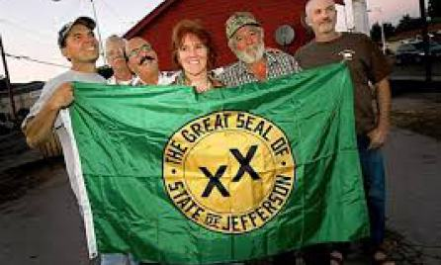](https://i2.wp.com/www.thecommonsenseshow.com/siteupload/2012/11/state-of-jefferson-banner.jpg)

Whether it is China or the U.S., the United Nations Agenda 21 urbanization policies are designed for the purpose of herding people into dense urban areas for reasons of control and the primary method of control has to do with dominating food production.

**The US Government Is Gaining Control Over All Food**

Through the [collectivization](http://www.thecommonsenseshow.com/2014/08/23/the-chinese-provide-a-glimpse-of-an-american-post-collapse-society/) of the food production, the Chinese government is working towards gaining complete control over all food in order to control the people. On an ever increasing basis, NAFTA is providing the U.S. government with the exact same ability. Therefore, the third draconian impact of NAFTA is that it has led to even more nefarious free trade agreements and executive orders which led to the loss of control for local communities over their own food supply.

Underlying the World Trade Organization, the Free Trade Area of the Americas (FTAA which has now morphed into the Organization of American States), and the Central American Free Trade Agreement is the philosophy that all food (i.e. from basic grains, meat, fruits and vegetables) should be exclusively produced for international export. This is a drastic departure from the time honored practice where each country produced the majority of food its citizens needed on local, small farms and only traded in certain products that could not be successfully grown locally. If anyone wonders where this is headed, we only have to look to Africa for the answer. The very first great wave of a [**NAFTA**](http://www.globalexchange.org/resources/wto/agriculture) style of globalization in agriculture took place in Africa, Asia, and Latin America as global corporations forced local farmers to give up local food production, and shifted production to plantations using enslaved Indigenous and African labor to grow the luxury crops of coffee, sugar, bananas, and cocoa for export to the colonizing countries.

If the changing nature of food production in Africa are not enough to raise the level of concern for most, perhaps a quick history lesson will jolt the more complacent among you into a state of full awareness.

Josef Stalin engaged in his own Soviet style Holocaust when, in 1932 and 1933, and estimated six to 20 million people in the Ukraine died from starvation when Stalin implemented his prescription of “hope and change” policies in order to eliminate the Ukrainian’s desire for becoming their own nation-state.

Upon assuming power, the Stalinist Communist regime rapidly nationalized the food industry and forced all of the region’s farms into collectives. Thus, Stalin’s version of the Holocaust came to fruition in what history has dubbed, the “Holdomor,” in which millions perished in only a two year period when the Soviet government began to exterminate the Ukrainian population by taking control of food and food production. The large corporate collectivization of food is precisely the same thing that is presently happening in the United States under Obama.

The lesson here is, if the government controls the food, the government controls the people.

**Starvation Will Be Used to Enforce the Agenda 21 Depopulation of Rural Areas**

The use of food by the U.S. government has been a matter of official U.S. governmental covert policy since 1974-1975.

In December, 1974, the National Security Council directed by Henry Kissinger completed a classified study entitled, [**“National Security Study Memorandum 200: Implications of Worldwide Population Growth for U.S. Security and Overseas Interests.”**](http://en.wikipedia.org/wiki/National_Security_Study_Memorandum_200) The study was based upon the unproven claims that population growth in Lesser Developed Countries (LDC) constituted a serious risk to America’s national security.

In November 1975, President Ford, based upon the tenets of NSSM 200, outlined a classified plan to forcibly reduce population growth in LDC countries through birth control, war and **famine**. Ford’s new national security adviser, Brent Scowcroft, in conjunction with CIA  Director, George H. W. Bush, were tasked with implementing the plan and the secretaries of state, treasury, defense, and agriculture assisted in the implementation of these insane genocidal plans.

NSSM 200 formally raised the question, “Would food be considered an instrument of national power? … Is the U.S. prepared to accept food rationing to help people who can’t/won’t control their population growth”? Kissinger has answered these questions when he stated that he was predicting a series of contrived famines, created by mandatory programs and this would make exclusive reliance on birth control programs unnecessary in this modern day application of eugenics in a scheme that would allow Henry to have his cake and eat it too in that the world would finally be rid of the “useless eaters!”

[**Third world population control, using food as one of the primary weapons**](http://www.rense.com/general59/kissingereugenics.htm), has long been a matter of official covert national policy and a portion of President Obama’s Executive Order (EO 13603), [**National Defense Resources Preparedness**](http://www.whitehouse.gov/the-press-office/2012/03/16/executive-order-national-defense-resources-preparedness)**is** a continuation of that policy. Only now, the intended target are not the LDC’s but, instead, the American people.

With the stroke of his pen, Obama has total and absolute control over all food where his EO 13603  states:

e)  “Food resources” means all commodities and products, (simple, mixed, or compound), or complements to such commodities or products, that are capable of being ingested by either human beings or animals, irrespective of other uses to which such commodities or products may be put, at all stages of processing from the raw commodity to the products thereof in vendible form for human or animal consumption.  “Food resources” also means potable water packaged in commercially marketable containers, all starches, sugars, vegetable and animal or marine fats and oils, seed, cotton, hemp, and flax fiber, but does not mean any such material after it loses its identity as an agricultural commodity or agricultural product.

(f)  “Food resource facilities” means plants, machinery, vehicles (including on farm), and other facilities required for the production, processing, distribution, and storage (including cold storage) of food resources, and for the domestic distribution of farm equipment and fertilizer…”

NAFTA was merely the opening artillery bombardment against the American farmer and the ultimate depopulation of rural areas. The death of the American farmer will ultimately come at the hands of EO 13603 and I believe this will be fully implemented when Obama declares martial law.

**“Thank God That I Do Not Live On a Farm”**

Do you think that you and your family are actually safe from the ravages of depopulating the rural areas through economic blackmail and ultimate starvation? Think again! Unless you presently live in the core inner city and occupy less than 500 square feet of living space, the Obama administration, as I write these words, is actively plotting to get you out of your home and into densely populated urban areas and this will be fully exposed in Part Four of this series as the draconian concept of megacities is fully explored.