The Making of a Phase 1 Kit

Some tips & guidelines & examples by Rebecca Huston

Creating picture cards:

The collection of pictures created by Angela Thomson provides pictures for approximately 90% of the items in a typical phase 1 kit. These pictures have several purposes:
- use as cue cards: the nurturer can use these to remember to use all the words in the activity. She can mix them up and flip through them to do this.
- GPs who don’t have the toys & objects at home and need to listen to their recordings can use a set of pictures at home when strengthening & refreshing with their recordings.
- The pictures can be used by the nurturer to remember to do activities with all the items / actions in the word log.
- Some specific pictures are used directly in activities & games.

Here are tips on creating the picture cards:
- Use coloured cardstock which is approximately 100-120 gram weight [regular paper is 70-80 gram weight].
- Use light-coloured cardstock so the pictures show up.
- Use one colour for Phase 1A and a different colour for Phase 1B. Also, for the info-gap activities in Phase 1B (sessions 3 & 8), use a different coloured cardstock for the second set. (that way you won’t get the two sets of 16 cards etc mixed up).
- Label the backs of the pictures with their session and activity number. Then if they get mixed up, they are easy to re-sort. For example, label 1A-1.1 would refer to Phase 1A, Session 1, activity 1. 1B-3.4 would refer to phase 1B session 3 activity 4.
- Trim the edges from the pictures, then laminate the pages. After laminating, you can cut the individual pictures apart. *
- Put sets of pictures for each activity in an envelope. Label the envelope with the session # and activity #. Again, you may want to use different coloured envelopes for Phase 1A and Phase 1B. Or you could use different coloured markers or pens to label the envelopes.
- Keep the envelopes in a small basket in order. Then they are easy to find when preparing for a session or reviewing after a session.
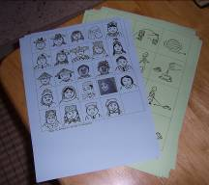 | 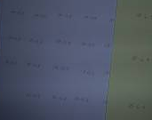  Backs of cards are labeled with session & activity #. | 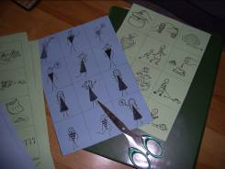
Pictures are printed on cardstock. In this set, blue is used for Phase 1A and green for Phase 1B. | The backs of each card are labeled with session & activity #. This makes them easy to sort after activities. | Here, the edges have been trimmed ready for laminating.

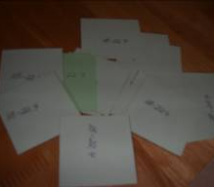 | 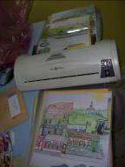 | 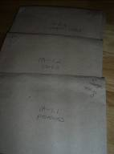 | 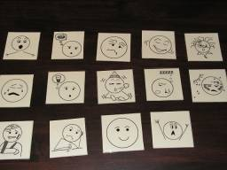
Once laminated, cards can be cut apart individually. Since the backs are labeled, they can be sorted into envelopes easily. | Sheets once prepared are ready to be laminated and then trimmed or cut apart into individual pictures | Each set of pictures can be stored in it’s own labelled envelope. You may want to use one colour of envelope for phase 1A and one for Phase 1B. Or label them with different coloured pens. If you have multiple sets you loan out, make sure you assign a set # also. | When recording the words from a new dirty dozen activity, the cards can be lined up and a digital photo taken. Then nurturer can name them in order for the recording of the list of words.

* Note that an A4/letter size laminating machines costs about $35-$45. It will last for about 15-20 Phase 1 kits. Local prices vary on laminating pouch prices.

Colours:
You can also laminate full sheets of construction paper or other coloured paper in all the major colours [red, yellow, green, blue, orange, purple, black, white, grey, pink, navy blue, etc.]. Once full sheets are laminated, then you can cut small squares, large squares and if you want to, medium squares. For each full sheet of paper, you should be able to produce enough for 3-4 phase 1 kits.
For the large & small coloured objects, you may want to avoid using M & M –like candies as bugs and mice and basic aging keeps these from being practical long-term. Other options include:
large & small buttons
large & small decorator items like little foam pieces shaped like hearts & stars
large & small coloured paper clips
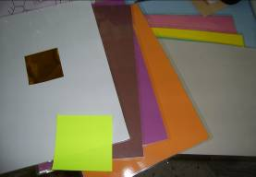 | 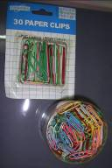 | 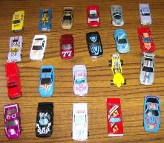
Laminate full sheets of coloured construction paper. Then you can use a pattern to cut large & small squares. I started with a piece note-block paper as my “large” pattern. | One option for large & small coloured items is paper clips. | For a language with gender-marked colour adjectives, you may want to add a couple extra sets of stuff, one for each gender such as cars, flowers, etc.

Large Pictures Items File:
It’s a good idea to have a large legal-sized envelope for storing your large pictures. This will include the scenery & community scenes and other full-page size pictures. In addition, but a world map such as those sold in school supply or stationery stores. The kind sold for teaching children is always significantly cheaper than maps sold in the “adult” section. They may run you only $2-$4. You can trip the edges of the map and fold it into four to store it in the envelope.
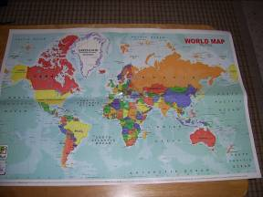

Categories:
Now you want to work on 5 main categories of items. Here are the groupings I came up with:
Food & Beverages | Home & Transport | Tools & Personal Care | Animals, People & Nature | Dishes
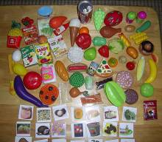 | 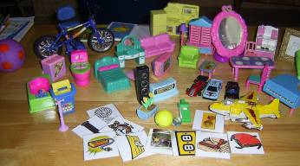 | 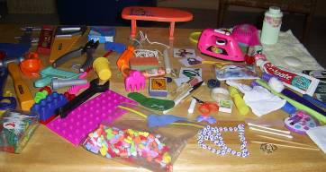 | 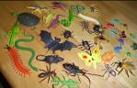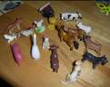  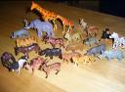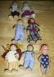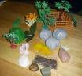 | 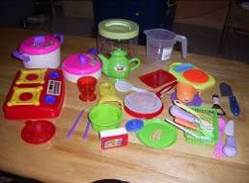

I have found these categories work pretty well as it lets me sort items into 5 large plastic baskets or clear plastic boxes.

Food & Beverage Category:

The absolutely best way to get mostly all of the food & beverage items in “one go” is to buy this Toys ‘r Us set. Since Toys “R Us now has branches in many countries, this is very possible. There are two sets one with a lot of duplicate items. I tend to buy the bigger set since I’m making more than one kit anyway. To find at Toys ‘r Us web site—go to site & search “play food set”
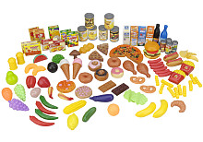 | 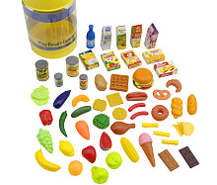
This is the 120-item set from Toys ‘r Us. U.S. retail price $17. | This is the smaller set from Toys ‘R Us.  Note that items may vary by country & when purchased.

If you end up trying to buy food in smaller toy sets locally, you will end up with quite a bit of duplication and still be missing some really useful items, so go ahead and spring for this larger purchase up front.
In addition to the food set above, here are some other ways to get useful food & beverage items:
Beverages etc.:
- put a tea bag in a tiny plastic bag to represent tea.
- add an individual Nescafe packet to represent coffee
- empty a small milk carton & wash well if you need a milk carton, ditto with juice cartons
- empty a mini-coke can and wash for soda/coke
- grab a salt & pepper packet at McDonalds or save from the airplane. Put in tiny plastic bags to keep clean & dry long-term. [You can empty it first.]

Imitation fruit, veggies, etc.
Look for imitation fruit & vegetables to fill in items you can’t find in toy form. Make sure you look for toy items first as they will be a lot cheaper. Imitation fruit can sometimes run you $1 per item unless they are miniature sized. If you can find a miniature-sized grouping, these are good as they give you duplicates for multiple sets. Sometimes you can find imitations also on things like walnuts & peanuts.
You may also look for refrigerator magnets of fruits & vegetables. For example, in the market in Damascus, you could find a big selection & bargain for a discount on buying a lot.

Your last resort is making pictures of the odd food items you can’t find, but this is a last resort—you can’t DO anything with the pictures L once you have them except learn their names [you can’t put them inside things, pour them, “eat” them, throw them, cut them, etc.]
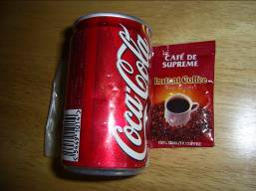 | 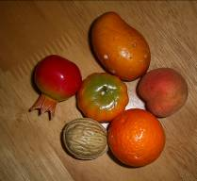 | 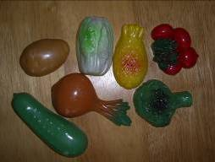 | 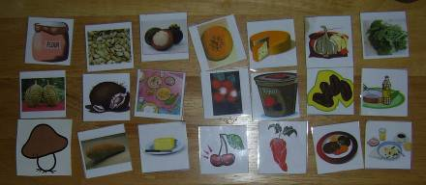
mini coke can washed out, individual instant coffee packet | imitation fruits, vegetables, and a walnut too | fridge magnets | For items you just can’t find, you can make clip art pictures. I’ve posted most of the above on the GP site to save you having to search for them.

Dry goods:
Take small samples of “dry good” items and put them in tiny plastic bags. These can then be stapled closed. Examples of items to include [depending on what is eaten by you and your friends] would be rice, lentils, various kinds of beans, unpopped popcorn, grains like oats or barley, pasta, whole spices, etc.

The tiny plastic bags can be purchased at grocery stores or plastics/disposable supply stores.
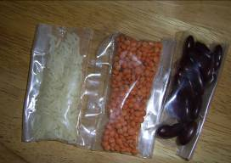 | 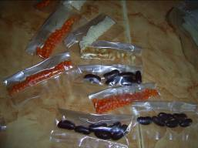
Each sample is put in a tiny plastic bag & stapled closed. | Make extras for future phase 1 kits.

Dishes Category:
For this category, you can usually buy just the small children’s sets with plates, cups, spoons, forks, knives, pans, stovetop, etc. However, be picky on which sets you buy based on their having the “hard-to-find” items. Here is the list of more hard-to-find items: cutting board, kettle, teapot, pitcher, opener.

You will need to buy multiple sets to get everything, but that’s okay as it is useful to have extras on the cups & silverware & dishes for doing counting and plurals activities.

You may buy one or two small items in the “real” category but note that real items cost more and also are bigger & heavier in most cases [an issue when transporting or fitting 300+ items on your table at the same time]. Do save things like some disposable chopsticks . . . if such are used locally.

“Real” items I have bought include: small jug, small bottle opener [cost 30 cents]. My rule of thumb on cost is not to pay more than 30 cents per item. Otherwise I will just make a picture for the odd missing item.

Note that when doing some preposition activities, you may want to bring out some larger real items from your kitchen, but long-term, keeping a big mixing bowl or pitcher in a phase 1 kit isn’t cost or space-effective. On the containers in general, I do like them if they are larger [like pot, frying pan, etc.] so that you can stick things inside them—the really tiny ones just won’t do for “Put the dog in the pan. Put the fly in the teapot, etc.].

Animals, People & Nature Category:

People: For the people category, your centrepiece is a complete family. I make a point of finding a good wooden doll set than includes grandparents as these are the hardest to find. The 6-person wooden doll sets which I like include grandma, grandpa, mom, dad, boy & girl. To this set you can add a baby and extra siblings as needed [I recommend at least one extra sibling.]. Then also add a few extra people for when doing activities with “lots of people/a few people” and extended family like aunts & cousins.

In addition, get a larger baby doll or doll to use for body parts. Make sure it is a doll with fully-articulated fingers & toes, and even a belly-button is good, so avoid the ones with cloth bodies and arms.
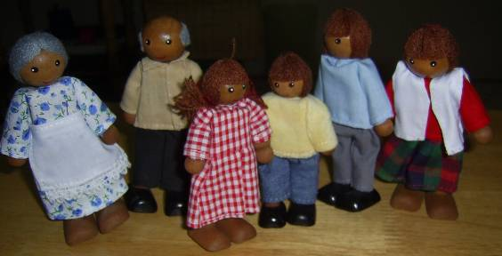 | 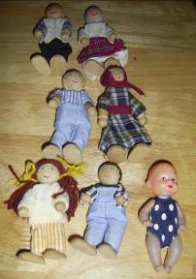 | 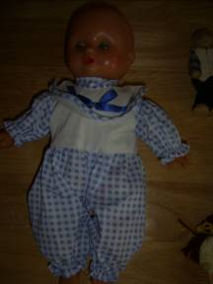 | 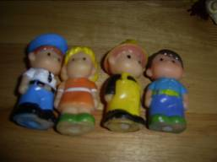
Family set—I love the skin colour on this set for Southeast Asia. Note also that this set has hair. Retail price $14 in Malaysia. | This set included the six wooden dolls. The plastic baby is my own addition [found in a set of babies for sell, have been able to purchase in S. Asia & Middle East]. Anyway, this set came without hair—I used brown yarn to add hair to the little girl so she looks like a girl. | A larger baby doll [this one about 10 inches tall] let’s you do body parts easily. | A few extra people are helpful for various activities.

Animals: Toy animals are pretty easy to find in most countries. I favour the smallest size as they save you on weight, cost, and table space. Buy a bag of “farm animals”, a bag of “wild animals,” and a bag of “creepy crawlys.” Be picky about which sets you buy. In the farm animals, make sure the poultry are included as they are hard to find [e.g. chickens, ducks, geese]. For wild animals, the camel is hard to find. For creepy crawlys, some sets are missing flies, mice, bats, etc. Try to find one with almost everything.

Fish and birds may also be difficult to find. Once I found birds as whistle party favours. Another time I found bird-shaped sharpeners. Or else find someone who can make you an origami bird.

Make sure you buy 10 of one animal also for the activities in Phase 1A.

For some hard to find animals, especially “local” fauna, you may have to make do with pictures. I have not yet found a toy mosquito [real ones are easy to find but not to preserve L ].
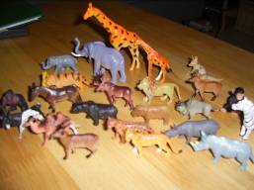 | 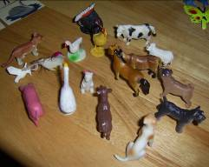 | 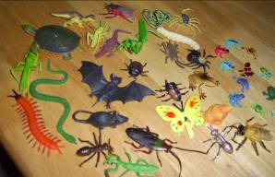
Wild animals | Farm animals – note goose, pig, rabbit, chicken, duck, et. | Creepy crawlys
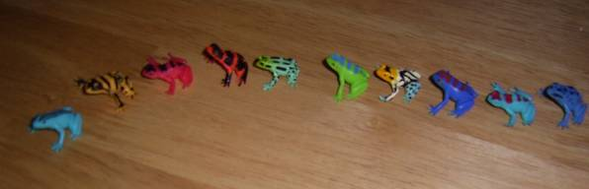 |  | 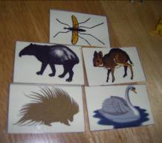
10 frogs |  | pictures for hard to find animals

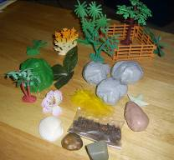 | You will often get enough nature items just with what comes in animal sets. it is great if you get some trees, rocks, fence pieces, coral, etc. Also cut leaves off the imitation fruit/vegetables you bought for food sets. Buy an imitation flower if you don’t have one around the house you can cut off. Take some feathers off a duster. Put a little dirt & a little sand in little plastic bags & staple closed. Avoid real rocks as they are heavy to transport. A seashell or two is nice.  You can save seashells from walking on the beach or bring in rocks & twigs also from outdoors. The artificial flowers also provide stems/twigs.

Tools & Personal Care Category:

You should be able to find a set of toy tools like hammer, screwdriver, etc. A couple of them may be hard to find. These include the saw & the axe. For these, I’ve included patterns on the GP web site for making some [mirror print on cardstock. Fold front & back together. Laminate to keep sturdy]. See picture below. You may in a pinch get a really cheap small screwdriver, but in general the toy plastic tools will be safer to have than real items in a set that kids may handle or that you do hitting & other activities with.

For stationery tools, buy the cheapest ones possible or use used-up/empty items from home such as old glue sticks, erasers, tape rolls, pencils, pens that no longer write, etc.

The other advantage to the cheapest pen possible or really cheap scissors is they won’t disappear from the set just ‘cause someone needs a pen to write with or some scissors to cut with J

My favourite trick where I live is filching Ikea pencils every time I’m down in the capital as they are such a nice handy size. Dollar & value stores are great for small rulers, cheap erasers, sharpeners, hardly useable glue stick, etc. From your office supplies also grab a rubber band, paper clip, etc.

It is fun to pick up toy/cheap jewellery items also such as bracelets, necklaces, rings, hair clips, etc.
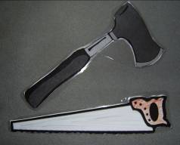 | 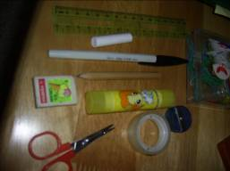 | 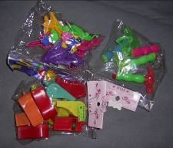 | 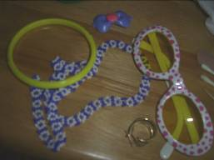
I print a front/back on cardstock for these two hard-to-find items. Colour them brown & silver and laminate them. | Stationery items | Party favours are a great source of some hard-to-find items. Here from top clockwise: airplanes, bag of hammers/axes, whistles | toy jewellery

For personal care items, you should be able to borrow almost all from your household stuff or save used/empty containers. For example, go through and grab a cotton ball, a band-aid, a Q-tip, etc. Save empty nail polish, powder, toothpaste tubes, medicine tubes, etc. Buy cheap or disposable items for various things you need. I believe it is worth investing for even some really cheap nail clippers as they aren’t just for learning the names but also the actions that go with them. Save a bar of hotel soap & free disposable toothbrush & little toothpaste. Avoid hotel shampoo bottles as they ALWAYS leak & you end up with sticky toys. An individual shampoo packet emptied & washed out works well.

Lastly, don’t forget to check out party favours. I’ve found all kinds of useful things in party favours included hammers, axes, airplanes, sharpeners, whistles, tops, . . .

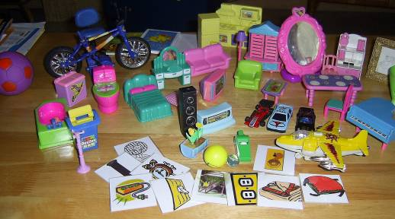

Home & furniture category:

A good toy doll house set (retail $20) may give you almost all the furniture you need including a good house. If you can’t get a set like that, you may have to look for a number of the smaller sets in bubble packs to meet your needs. Again, be picky about bubble sets looking for ones that give you the hard-to-find items like toilet & bathtub, etc.

You can use the house model that Angela made to make your own house. Print it on coloured cardstock & laminate it to help it last longer (Patterns are on the GP site). You can cut out & add your own curtains made of scrap cloth or coloured paper if the dollhouse doesn’t have curtains. To make a flat-roofed house is easy—use a box & do cut-outs.

Note that a good sturdy plastic doll house is worth investing in as it will last for a while & gives you lots of action & location options.

Also buy toy cars, bicycles, and airplanes to add to your house set. Again, for some other items to add, I look for party favours. From those I’ve gotten airplanes, cars, balls, whistles, tops, etc. I like as many small handy items as possible. Remember not just for the items but for the actions: think—fly, blow, roll, hit, spin/turn, . . .

Again, for hard-to-find items or reminder pictures for my nurturer to use things in the room, I will settle for printing a few pictures, but as much as possible, use real items in the room or toys that can be manipulated.

In addition to the toys, I buy these other “real” items:
small stand mirror [good for having a front & back & under for prepositions]
tiny picture frame
small notebook [take some paper out for “paper”]
small book
small ball
marbles
. . .
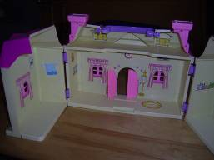 | 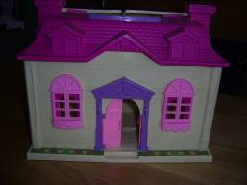
dollhouse inside | dollhouse front

Something Old . . .
Get people to save you old & used stuff that can easily go in kits. Here’s a wish list to share:
Personal care-
empty travel toothpaste tubes
empty nail polish bottles
empty lipstick
broken nail clippers
empty medicine containers or tubes or boxes
hotel soap
almost finished tissue packet
emptied individual shampoo or perfume or etc. sample packets
cloth scrap [you can even use cloth scraps for colours]

food:
emptied individual Nescafe or Milo packets
salt & pepper packets
sugar packet

Stationery:
used eraser bits
old pens
old pencils
empty glue stick
almost finished roll of tape
broken stapler
old ruler

Household:
old keys
old padlocks (small)
other small broken items
old magnet

Around the House:

Here are things I gather from around the house for phase 1 kits:

Cleaning—
cut a sponge in half, one half per kit
cut a rag in half or quarters

Personal care—
band-aid
cotton
Q-tip

Stationery—
rubber band
paper clip
pencil (a stub is adequate)
pen (an old one is adequate, good if it doesn’t write as no one takes it from the kit)

miscellaneous—
twist-tie
matches
birthday candle [makes a smaller candle for each set rather than a big candle which is heavier]

