Welcome to Phase 2!
Welcome to Phase 2. Below you will find instructions and examples for Phase 2A, B, and C.
Contents
Introduction to Phase 2 2
Check to see if you are ready for Phase 2 3
Books to Use 4
Additional Supercharged Participation Activities for Phase 2 5
Challenges 5
Introduction to Phase 2A 6
Phase 2A Example of Session 1 7
Page 1 8
Page 2 9
Phase 2A Example of Session 2 10
Page 3 11
Page 4 11
Phase 2A Example of Session 3 12
Page 5 13
Page 6 13
Phase 2A Example of Session - End of Book - 14
Introduction to Phase 2B 15
Phase 2B Example of Session 1 (same format as Session 1 in Phase 2A) 16
Phase 2B, Perhaps Session 5 (or 10 or 15...) 17
Introduction to Phase 2C 18

Introduction to Phase 2
Congratulations! You now can begin Phase 2. Phase 2 is different from Phase 1. Phase 1 was “Hear and Now Description.” Phase 2 is storytelling. What are the benefits of storytelling?
Benefits of storytelling
- Provides memorable context for vocabulary and grammar
- Review is easier because you have recorded stories that you can just listen to again.
- Different language accessed in stories than in here-and-now descriptions
- Increases ability to interact socially
Phase 2 is divided in 3 parts (A B C) described below.
- Phase 2A uses wordless books.
- You Take the Lead. Talk about the books. The point is to get you to talk spontaneously. You can’t plan all that you are going to say and memorize it in advance. As you keep noticing things you might try to say, you must struggle to come up with the necessary words and phrases on the spot. Thus, rather than producing smooth, natural speech such as you see in the in the previous section, you’ll be speaking your host language in a more “broken” version
- Get help from your nurturer as often as you need it in order to say things you are not sure how to say, or even things that you have no idea how to say.
- Avoid the temptation to converse in English. If you get stuck, do not revert to talking in English until the debriefing part.
- Phase 2B also uses wordless books, but the native nurturer helps you.
- the nurturer takes the lead and talks through many books, while you negotiate meanings frequently.
- Phase 2C requires you to make stories.

Time for each phase:
2A: Getting Your Tongue Loose | 50 hours
2B: Shift Perspective | 75 hours
2C: Telling Life Stories with Simple Pictures | 25 hours

Check to see if you are ready for Phase 2
You should have the following:
- Familiarity with language needed to talk about the “here-and-now.” This includes familiarity with language such as:
  - “I, we, you, s/he, they etc.” as subject, object, possessor, etc.
  - names for basic objects, actions and properties, animals, and humans
  - properties of these: size, shape, emotions, etc.
  - spatial-locational descriptions (in the box, under the table, etc.)
  - terms for human relationships (such as kinship terms) and perhaps some roles (such as shopkeeper)
- Some familiarity with simple sentence forms that enable you to
  - make statements
  - ask questions
  - describe situations that are in view
  - give instructions
- Ability to use “power tools” (language that helps you learn more language), such as:
  - “Please repeat.”
  - “Please speak more slowly.”
  - “Please speak more clearly.”
  - “What is this called?”
  - “What am I doing?” (asked while acting out an action)
  - “What is he doing?”
  - “What kind of X is this?”

Books to Use
Alexander, Martha. Bobo’s Dream. New York: Dial Press, 1970. OOP
Anno, Mitsumasa. Anno’s Journey.
Anno, Mitsumasa. All in a Day. Paperstar, 1986.
Anno, Mitsumasa. Anno’s Counting Book.
Aruego, Jose. Look What I Can Do. New York: Scribner, 1971.
Baker, Jeannie. Window. New York: Greenwillow Books, 1991.
Bank, Molly. The Grey Lady and the Strawberry Snatcher.
Blake, Quentin. Clown. New York: Holt.
Briggs, Raymond. The Snowman. OOP
Brinton, Turkle. Deep in the Forest. Dutton Children’s Books, 1987.Hoban, Tana.
Brouillard, Anne. Three Cats.
Brouillard, Anne. Three Topsy-Turvy Tales. Charlottesville, VA: Thomasson-Grant, 1992. (Originally published in Belgium by Editions Dessain entitled Petites Histoires). OOP
dePaola, Tomie. Pancakes for Breakfast. New York: Harcourt, Brace & Company, 1978.
dePaola, Tomie. The Hunter and the Animals. Holiday House, 1981. OOP
Day, Alexandra. Good Dog, Carl. New York: Simon & Schuster, 1986.
Drescher, Henrik. The Yellow Umbrella. New York: Bradbury Press, 1987. OOP
Dupasquier, Philippe. I Can’t Sleep. New York: Orchard Books, 1990. OOP
Giannini, Enzo. Goldilocks and the Three Bears. Boston: Houghton Mifflin, 1991. OOP
Goodall, John S. Creepy Castle. Simon & Schuster, 1998. OOP
Goodall, John S. Naughty Nancy. Simon & Schuster, 1975. OOP
Goodall, John S. The Surprise Picnic. Simon & Schuster, 1997. OOP
Graham, Alastair. Full Moon Soup. Boxer Books, 2009.
Hartelius, Margaret A. The Chicken’s Child. New York: Scholastic Book Services, 1975. OOP
Henrietta. (No family name given). A Mouse in the House. London: Stoddart, 1991. OOP
Hughes, Shirley. Up and Up. New York: Trumpet Club, 1979. Reprinted in UK. OOP in U.S. OOP
Hunt, Roderick and Alex Brychta. Oxford Reading Tree, Stage 1, Kipper Books. Oxford, 2008.
Hutchins, Pat. Changes, Changes.
Jenkins, Steve. Looking Down. Sandpiper Houghton Mifflin, 1995.
Krahn, Fernando. The Secret in the Dungeon. New York: Clarion Books, 1983. OOP
Ladwig, Tim. Psalm Twenty-Three. Eerdmans, 1993.
Lehman, Barbara. Rainstorm. Houghton Mifflin, 2007.
Lehman, Barbara. Trainstop. Houghton Mifflin, 2008.
Mayer, Mercer. A Boy, A Dog, and a Frog. New York: Dial Press, 2003.
Mayer, Mercer. A Boy, a Dog, a Frog and a Friend. Dial.
Mayer, Mercer. One Frog too Many. Dial.
Mayer, Mercer. Ah Choo. Puffin Pied Piper, 1976. OOP
Mayer, Mercer. Frog Goes to Dinner. Dial.
Mayer, Mercer. Frog on His Own. Dial.
Mayer, Mercer. The Great Cat Chase: A Wordless Book. 1974. OOP
Mayer, Mercer. Oops. New York: Dial Books, 1977. OOP
Mayer, Mercer. Hiccup. Puffin Pied Piper, 1976. OOP
McCully, Emily Arnold. First Snow. Harper Collins, 1985.
Meyer, Renate. Hide-and-Seek. New York: Bradbury, 1969. OOP
Ormerod, Jan. Moonlight. New York: Lothrop Lee & Shepherd (or Puffin?), 1982.
Ormerod, Jan. Sunshine. Puffin, 1981.
Popov, Nikolai. Why? OOP
Robinson, Colin. Sunrise. New York: Bedrick/Blackie, 1992. OOP
Schories, Pat. Mouse Around. Canada: Harper Collins, 1991. OOP
Spier, Peter. Noah’s Ark. Dell Yearling.
Spier, Peter. Peter Spier’s Rain. OOP
Wezel, Peter. The Good Bird. New York: Harper & Row, 1969. OOP
Wiesner, David. Free Fall. New York: Lothrop, Lee and Shepherd, 1988.
Winter, Paula. Sir Andrew. OOP
Young, Ed. Up a Tree. Harper & Row, 1983. OOP

Additional Supercharged Participation Activities for Phase 2
Remember, for an occasional change of pace, to increase variety and enrich communication, here are some other activities you can intersperse in your story building activities.

Lexicarry
Try to tell your nurturer what is happening in each story strip of Lexicarry.

Picture Strips and Acting out Activities
Try using simple wordless cartoon strips.
Or you could also act out activities and have your nurturer talk about what you are doing.
These would depict common everyday activities, such as the steps in brushing your teeth.

Role-Plays
Continue doing occasional role-plays of real life communication situations as in Phase 1. You can role-play any activity in which you participate in everyday life in your host community: Shopping, using a taxi, paying your phone bill, etc.

Grammar and Phonetic Awareness
Repeat many of the grammar awareness activities from Phase 1, and the phonetic discrimination activities for sound distinctions that you still have difficulty hearing.

Busy Pictures
Describe busy pictures to add exposure to more vocabulary, if you are not adding enough words to your iceberg in your sessions. Busy pictures are pictures in which a large number of people or animals are involved in a large number of actions or situations.

Challenges
Introverts: Turning to more personal issues, highly introverted learners may prefer to view language as primarily something cognitive, rather than as participation in life with people. It is crucial to encourage such people to recognize the problems that their personality may raise for them as language learners!
Extraverts: A warning is in place for extraverts as well—their drive to have relationships may lead them to find host friends who know another language that they already know, such as English, rather than building relationships in the host language.
Need for Structure: Other learners may feel a strong need for a clear advance-plan of the specific details of what they are going to learn, word-by-word, structure-by-structure. The idea of letting the learning arise out of unplanned, free interaction during Story-Building activities may frustrate them greatly.
Loss of Previous Identity: For some, the idea of talking about children’s picture stories might be the last straw! They want to talk about adult themes that reinforce their adult identities.
Tolerance for Ambiguity: There are many details of a language that will be too complex to fully understand, and it may still be necessary for puzzled language learners to tell themselves, “I’m just not getting it right now—let’s leave it and come back to it in a few months!”

Introduction to Phase 2A
Let’s begin by talking about Phase 2a
Phase 2A goes through a “55 minute cycle.” In this cycle, you:
- Talk about everything on one page for 30 minutes
- Debrief for 5 minutes
- Record for 10 minutes
- Listen and point and act out for 10 minutes – and record a sampling of this.
The following page begins by giving an example of Session 1 of Phase 2A. However, you should use the same pattern for every other session in Phase 2A. Note: I wrote this assuming that you have 2 hour sessions and have included Examples for Session 1, 2, and 3 to help you get started. At approximately Session 7 or 10, you will have to use an “End of Book Activity” so see the example for that.
You can see the type of things you can learn to say in the page after the session. They are divided into two options. Some things you can say are based on Phase 1, but there are many new things you can try to say that you never said in Phase 1.

Phase 2A Example of Session 1
Steps | Description | Resources
Small talk | Try to learn at least one new fact about your nurturer. | 5 to 10 min
55 min cycle | Show the nurturer the picture story you're about to use. Allow her to flip through the entire picture story | picture story, word log, recording device
Talk about the page | Open to the first page of the book (in our examples here, Frog, Where are You?).  Begin trying to describe the first picture.  Describe everything you can.  Find out how to say things that you don’t know how to say.  Write things in your word log | 30 min  Book Frog where are you  Word log
Debriefing (optional) | Deal with any areas you “couldn’t get across.”  This is for fluency, not vocabulary.  Do NOT get English translations of all the new words and phrases encountered | 5 min  book  notes from first page
Recording | Go over page with Nur.  Remind of all the new words and phrases.  Make a recoding for each page. | 10 min  book  recording device,  word log
Listen and point (and act out) | Nur talks about things based on word log and you point to what s/he talks about.  If possible, act it out – like if a dog is catching the fly, say “arf” and grab at make-believe fly. | 10 min  picture story,  word log
Record a brief sample of this
Repeat the 55 minute cycle as time allows

Page 1

Possible Ideas for Page 1 Based on Abilities at the End of Phase 1

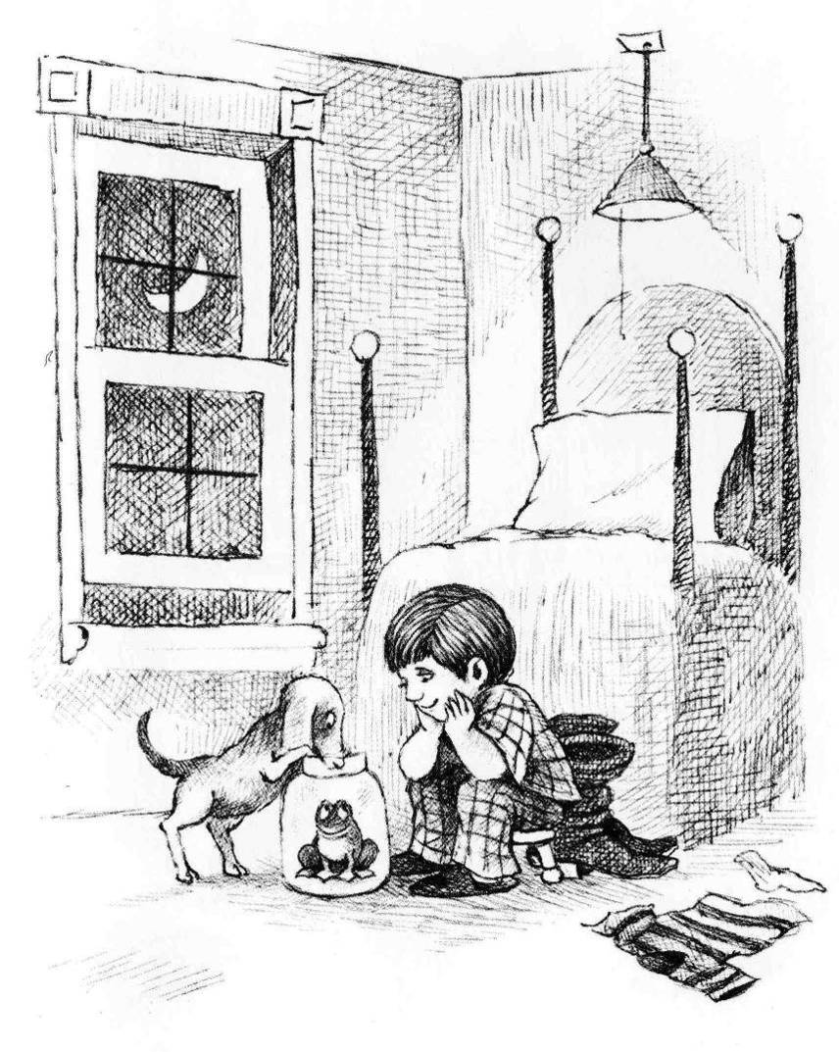
- This is a boy.
- He is not wearing his boots.
- He is wearing slippers.
- His socks are on the floor.
- He is sitting in front of his bed.
- The bed is near the corner.
- The window is open.
- There is a light over the bead.
- There is a blanket on the bed.
- The boy has a frog
- There is no lid.
- The dog is looking into the jar.
- He is smiling. Everyone is smiling.
- They are all very happy.
- The boy is saying “Sleep in the jar frog”. “Good Night” “I’m going to bed.” “I’ll see you in the morning.”
- He is in his bedroom.
- The boots are behind him.
- He is wearing pyjamas.
- He is sitting on a small stool.
- It is a very high bed.
- It is night time.
- There is no curtain on the window.
- There is a string on the light.
- The dog’s tail is curved.
- The frog is in a big jar.
- The dog is standing with his front paws on the edge of the jar.
- The dog is looking at the frog.
- The boy is looking at the frog and he is happy.
- The boy is sleepy.
- The boy is saying to the dog, “We like this frog. He is our friend.”
- These are his boots.
- They are between the boy and the bed.
- His shirt is on the floor.
- The stool has three legs.
- The bed is against the wall.
- This is the moon.
- There is a pillow on the bed.
- It is warm outside.
- The boy has a dog.
- Where is the lid?
- The dog’s nose is in the jar.
- The dog is happy.
- The frog is looking at the boy and he is happy.
- The dog is saying, “I like you, frog”. “You are a good frog.”
- The frog is saying, “I am happy. I like this jar. I like this room. I like you, boy. I like you, dog. You are my friends. Thank you for the fly”.

New Things You Might Try to Learn to Say for Page 1

- The dog’s tail is wagging.
- There is a shadow under the dog.
- The boy is saying, “Don’t bark at the frog.” “He will be frightened.”
- The dog’s ears are hanging down.
- The frog might go out.
- The boots have high heels. They have high tops and pointed toes.
- The boy’s shirt is spread out on the floor. In is not bunched up.
- There are four posts at the corners of the bed.
- His hair is parted here.
- This is the window frame.
- How old is the boy?
- The frog says, “I am in jail. I will go out.”
- Pull the string and turn out the light.
- The boy is resting his face in his hands and resting his elbows on his knees.
- The wind comes through the window.
- The dog is saying, “I will guard the frog.”
- The boots are wrinkled (the bed is wrinkled).
- Inside the light is on. It is very bright.
- It is striped
- The boy’s hair is very thick.
- This is the windowsill.
- One sock is missing.
- When the boy goes to sleep, the frog may go out through the window.
- The frog might go out.
- They should close the window.
- The glass is clear. (The window is clear.)
- The boy is saying, “Dog, catch a fly. Give it to the Frog. Frog, eat the fly.”
- The jar has a big opening.
- The moon is bright. Outside it is not very dark.
- There is a pillowcase on the pillow.
- The pyjamas are plaid ones.
- The window slides up and down.
- Where is the other sock?
- There are eight panes.
- The boots are longer than his feet.
- The frog can hop. He can hop high.

Page 2

Possible Ideas for Page 2 based on Phase 1

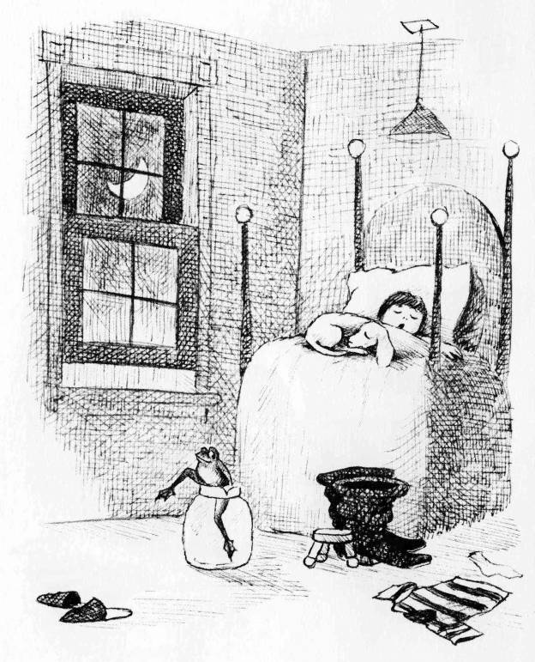
- There is no lid
- The frog is not asleep.
- The boy is yawning.
- One leg is out of the jar.
- The boy is under the blanket.
- He is happy. He has a wide smile.
- His slippers are on the floor.
- What does he want to do?
- It is dark in the room.
- His eyes are closed.
- He is not hopping.
- The dog is lying/sleeping by his feet.
- The frog has a wide mouth.
- Now he is not wearing his slippers.
- Where is the frog going?
- The dog is asleep.
- The frog is climbing out of the jar.
- His eyes are closed.
- The frog’s hand is on the rim of the jar.
- His head is on the pillow.
- What time is it?
- The light is out

Possible New Ideas for Page 2

- The dog is curled up on the bed.
- The moon is shining through the window.
- They are dreaming about their frog.
- He is green.
- One leg is still in the jar.
- His legs are strong.
- It is still dark outside. The moon is still bright. It is not very dark.
- The boy and the dog are dreaming.
- He has strong legs.
- The frog is thinking, “The boy and the frog are asleep. They are not watching me.”
- His legs are long.
- He is thinking, “The window is open. I will go out.”
- The window is still open. It is still night. The shirt is still on the floor. The sock is still on the floor. The other sock is still missing.
- The frog has webbed feet.
- They are snoring.
- His leg is bent.
- The frog’s chest is sticking out.

Phase 2A Example of Session 2
Steps | Description | Resources
Small talk | Try to learn at least one new fact about your nurturer. | 5 to 10 min
Talk about yesterday’s pages | Go over the pages of the book that you covered during Session 1, trying to quickly refresh all the things you talked about  Describe everything you can, and find out how to say things that you don’t know how to say | 30 min  Previous pages  Notes from yesterday
55 min cycle |  | picture story, word log, recording device
Talk about the page | Open to the next page of the book (in our examples here, Frog, Where are You?).  Begin trying to describe the first picture.  Describe everything you can.  Find out how to say things that you don’t know how to say.  Write things in your word log | 30 min  Book Frog where are you  Word log
Debriefing (optional) | Deal with any areas you “couldn’t get across.”  This is for fluency, not vocabulary.  Do NOT get English translations of all the new words and phrases encountered | 5 min  book  notes from first page
Recording | Go over page with Nur.  Remind of all the new words and phrases.  Make a recoding for each page. | 10 min  book  recording device,  word log
Listen and point (and act out) | Nur talks about things based on word log and you point to what s/he talks about.  If possible, act it out – like if a dog is catching the fly, say “arf” and grab at make-believe fly. | 10 min  picture story,  word log
Record a brief sample of this
Repeat the 55 minute cycle as time allows

Page 3

Possible Ideas for Page 3

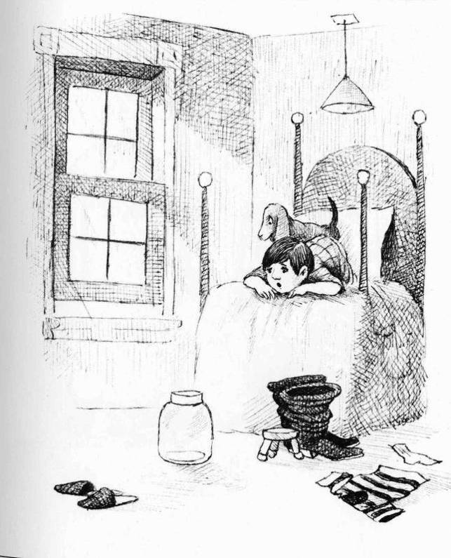
- It is day.
- His eyes are wide open.
- The dog is awake.
- It is morning.
- The dog is standing on the bed.
- The light is not on.
- He is looking at the jar.
- He is not under the blanket.
- The boy is surprised.
- The frog is not in the jar.
- His mouth is wide open.
- The dog is also surprised, etc.
- The dog is looking out the window.
- The boy is laying on his belly.
- The sun is shining through the window.
- He is looking down from the bed.
- The boy is saying, “Where is the frog”. “The frog is gone.”
- His head is at the foot of the bed and his feet are at the head of the bed.
- The slippers are still there, the boots are still there, the stool is still there, the shirt is still there, the sock is still there, the jar is still there, but the frog is not there. The boy sees everything, but he does not see the frog.
- There is a shadow behind the pillow.
- The boy is awake.
- The boy can see the jar.
- There is no frog.
- It is bright outside.
- His arms are bent.
- It is light in the room.
- The jar is empty.
- He is upset.
- He is frightened.

Possible New Ideas for Page 3

- It is not night any more.
- The boy’s bum is sticking up.
- The boy says, “We must find the frog”.
- His elbows are pointing toward the posts on the corner of the bed.
- The boy is saying, “Maybe someone stole the frog”. “Maybe a kidnapper took him.” “Maybe an enemy took him.” “Maybe a robber took him.” “Maybe an animal took him.”
- The boy is saying, “Maybe he is just hiding.” “Maybe he is playing.” “Maybe he is in danger.” “Maybe he will die.”
- The slippers are facing away from the bed. The boots are pointing away from the chair.
- These are the sun’s rays.
- His face is resting on the backs of his hands.
- The blankets are pushed back.

Page 4

Possible ideas

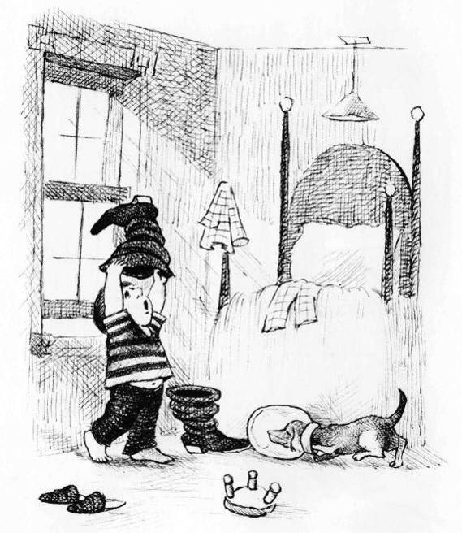
Try mainly to stay in the present tense. Not, “The boy took off his pajamas”, but “The boy is not wearing his pajamas.”
We’ll let you try out your own creativity on page 4

Phase 2A Example of Session 3
Steps | Description | Resources
Small talk | Try to learn at least one new fact about your nurturer. | 5 to 10 min
Talk about yesterday’s pages | Go over the pages of the book that you covered during Session 1, trying to quickly refresh all the things you talked about  Describe everything you can, and find out how to say things that you don’t know how to say | 30 min  Previous pages  Notes from yesterday
55 min cycle |  | picture story, word log, recording device
Talk about the page | Open to the next page of the book (in our examples here, Frog, Where are You?).  Begin trying to describe the first picture.  Describe everything you can.  Find out how to say things that you don’t know how to say.  Write things in your word log | 30 min  Book Frog where are you  Word log
Debriefing (optional) | Deal with any areas you “couldn’t get across.”  This is for fluency, not vocabulary.  Do NOT get English translations of all the new words and phrases encountered | 5 min  book  notes from first page
Recording | Go over page with Nur.  Remind of all the new words and phrases.  Make a recoding for each page. | 10 min  book  recording device,  word log
Listen and point (and act out) | Nur talks about things based on word log and you point to what s/he talks about.  If possible, act it out – like if a dog is catching the fly, say “arf” and grab at make-believe fly. | 10 min  picture story,  word log
Record a brief sample of this
Repeat the 55 minute cycle as time allows

Page 5

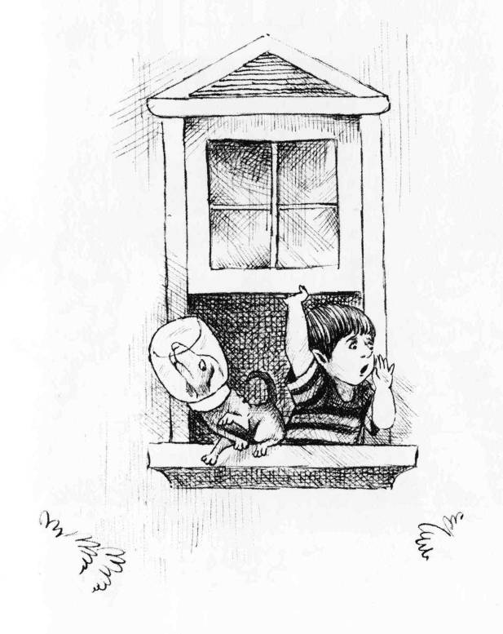
- The boy is looking out the window.
- He is holding the window.
- All of his feet are outside the window.
- He is about to fall.
- The top of the window is shaped like a roof.
- The dog cannot hear him well.
- The dog is not thinking about the frog.
- The boy is facing to the right and the dog is facing to the left.
- What will happen next?
- The dog’s hind leg is touching the boy’s side.
- The frog is outside.
- The window is wide open.
- His rear end is on the windowsill.
- There are bushes on each side of the window.
- The boy is holding his hand beside his mouth.
- The boy does not see (notice) the dog.
- The dog is pointing his nose upward.
- The dog is looking out of the corner of his eye.
- The boy keeps yelling and yelling, “Frog, where are you? Come home frog? Are you O.K.? Can you hear me?”
- The boy is leaning against the windowsill.
- He is saying, Frog, Where are You?
- The dog’s head is still stuck in the jar.
- He is losing his balance.
- There are leaves on the bushes.
- He is shouting very loudly.
- The boy is thinking about the frog.
- The dog is pawing at the air.
- Maybe he is looking at the boy.
- The dog can’t breath. He is suffocating.
- Who will help the dog?

Page 6
You’re on your own.
If you still find it hard to be creative, don’t worry about it. You may just need to use more picture stories than someone who is more creative. Instead of spending 150 hours in five picture stories, you may use thirty picture stories.
In fact, some people might argue that there are advantages in using a larger number of stories. Each story brings a new theme, topic, problem, moral, etc.

Phase 2A Example of Session - End of Book -
Steps | Description | Resources
Small talk | Try to learn at least one new fact about your nurturer. | 5 to 10 min
Talk about yesterday’s pages |  | 30 min  Previous pages  Notes from yesterday
55 min cycle |  | picture story, word log, recording device
Talk about the page |  | Book Frog where are you  Word log
Debriefing (optional) |  | book  notes from first page
Recording |  | book  recording device,  word log
Listen and point (and act out) |  | picture story,  word log
Record a brief sample of this
Repeat the 55 minute cycle as time allows until you reach the end of the book
Hearing the “Story Form | So far you have been describing the pages of your wordless picture book mainly in the “here-and-now” form (which in English would be present tenses, with lots of progressive forms and use of the verb to be, as in He is smiling; he is sitting on the stool, he is looking at the frog). Now you want to hear the story you have been building in the normal story form (which in English would now include a lot of simple past tense verbs as in He sat down on the stool and smiled. He looked at the frog.).
Highly Detailed Version | Start with Page 1  Remind Nur of everything.  Ask Nur to include as many details as possible.  Record Nur talking about Page 1  Repeat with other pages.  Record the whole story in the form of a story. | Book  Recorder  30 min
Recording less detailed, retelling using Book | Instead of going page by page and making a recording, make one recording for the whole story. | Book  Recorder  20 min
Recording retelling from Memory | Now ask her to tell the whole story from memory, not looking at the pictures at all | Book  Recorder  10 min

You now have much to listen to in the evening. This will be your first heavy exposure to “the past tense”
Keep this in your listening library.
Your listening library will be useful during long flights (better than airline movies), cross-country motor-trips, holidays at the lake, while relaxing in the bathtub, walking to work, etc. You really can’t listen too much.
Use the Frog Where Are You sessions as a pattern for other books during Phase 2A, which lasts for 50 hours (at 2 hours a day, it’s 25 days).

Introduction to Phase 2B
Congratulations! Now you are in Phase 2B.
How Phase 2B differs from 2A
The format of sessions in Phase 2B is very similar to Phase 2A, but the approach is a little different.
Phase 2A uses wordless books, but uses a timer to make sure you have enough time for negotiation and debriefing. Phase 2B also uses wordless books, but the host person helps you.
Up to this point, the growing participator has been taking the lead in talking about the pictures. This is to get your tongue loose. Now that you are talking a lot more freely, it is good to change your approach. You need to be hearing a lot more of what your nurturer would say, because you want to eventually sound like her and other host people
“In Phase 2A, you controlled the perspective, which limited the variety of new vocabulary that was used. You weren’t yet ready to follow the stories that the nurturer might tell. However, now you have listened many times to the stories in your listening library, and are gaining greater ability to follow a simple story that has pictures to go along with it.”
The nurturer takes the lead and talks through many books, while you negotiate meanings frequently.
Phase 2B lasts for 75 hours, at 2 hours a day, that is ~33 days.
Some tips
- Let them speak - “you are discovering the world that host people experience, and the ways they talk about their shared world.”
- Stepping in if needed “There will be instances, when the nurturer misinterprets a picture so seriously that it will make it difficult to go on in the story. For example, they might refer to a mouse as a dog. Since this is an interactive activity, the growing participator was able to step in and say, “It isn’t a dog, it’s a mouse.””
- How to record new vocabulary – “It is good to have the basic word spoken, followed by a sentence containing it, followed by the basic word again. Suppose the new word is the verb churn. The nurturer would record a sentence such as the following, with the word churn preceding and trailing: “Churn. The woman is churning the butter. Churn.”

Phase 2B Example of Session 1
Steps | Description | Resources
Small talk | Try to learn at least one new fact about your nurturer. | 5 to 10 min
55 min cycle | Picture Story Activity | picture story, word log, recording device
Talk about the page | Step 1: Nur starts the recorder and talks freely, describing successive pages in a new wordless picture story. | 10 min  Picture story  Recorder
Massage the recording | Step 2: Monologinually massage the recording. Listen to the recording together. Students stop the recording whenever they hear a new word or phrase they does not understand. Negotiate meaning. Write new words in word log. | 30 to 80 min  word log
Debriefing (optional) | 1. Deal with any areas you “couldn’t get across.”  2. This is for fluency, not vocabulary.  3. Do NOT get English translations of all the new words and phrases encountered | 5 min  book  notes from first page
Recording | Make a recording for new vocabulary. Nur records the new word, a sentence that uses the new word, and the new word again.  Ex. Churn. The woman is churning the butter. Churn. | 10 min  book  recording device  word log
Listen and point (and act out) | 1. Nur talks about things based on word log and you point to what s/he talks about.  2. If possible, act it out – like if a dog is catching the fly, say “arf” and grab at make-believe fly. | 10 min  picture story,  word log
Record a brief sample of this
Repeat the 55 minute cycle as time allows

Phase 2B, Perhaps Session 5 (or 10 or 15...)
Jumping ahead a bit, the time may soon come when the page-by-page descriptions of the situations and activities are getting highly redundant.
What will be wholly new will be the plot of the story that is depicted. At this point you can move to the following format for language sessions:
As you may have been doing already, let the nurturer take the picture book home each day to reflect on it before the next day’s sessions. Emphasize to her that she is not to plan in detail what she will be saying—it is to be spontaneous, natural interaction. However, she can make sure she understands all of the pictures.
Timing | Activity | Resources Needed
10 min or more | Step 1: The nurturer tells the story “in the past tense” as you follow the pictures. You record this as she talks. | picture story, recording device
30 to 70 min | Step 2: Massage the story that she told. | recording; picture story; word log
15 minutes | Step 3: Make a vocabulary recording | word log, recording device
10 minutes | Step 4 and 5: Listen and point (and act out), then record a sample of this | picture story, word log, recording device
Repeat cycle as time allows

1. Small talk
Bit by bit, your ability to interact and strengthen this relationship is increasing.

2. Monolingual Half Hour (or more)- Start with the Whole Story
The nurturer now begins by telling you the whole story. In Phase 2A, this was the “End of the Book Activity”, Step 6A. At the beginning of Phase 2B, it was Step 7, and still the “End of the Book Activity”. Now it becomes Step 1. The nurturer will at once simply tell the story, picture by picture, without pausing. You will record this.

3. Monolingual Half Hour , Continued- Massage the Story
Then you massage the recorded story in the usual way: Listen to the recording together with the nurturer. Point out to her anything she said that that you cannot understand. Negotiate the meanings of unknown words and expressions—don’t revert to English (or any other shared language besides the host language that you are learning). Add all new words to your word log.

4. Vocabulary recording
Then you can make a special vocabulary recording as earlier, and strengthen new vocabulary with the listen and point activity, or simply by discussing each new word again.

Introduction to Phase 2C
Congratulations! Now you are in Phase 2C.
How Phase 2C differs from 2A and 2B
Phase 2A uses wordless books, but uses a timer to make sure you have enough time for negotiation and debriefing. Phase 2B also uses wordless books, but the host person helps you.
In Phase 2C, you tell a story about yourself. You make your own picture story, using stick figures. You can tell the basic outline of your own life story from birth to the present time, or your nurturer can tell hers. You can also tell the story of some portion of your life, or events in your life that are especially entertaining, or that are especially important for understanding the person you are today._
Phase 2C lasts for 75 hours, at 2 hours a day, that is ~33 days.
Format:
Timing | Activity | Resources Needed
5 to 10 min | Small Talk
30 to 70 min or more | Step 1: The growing participator tells a story from his or her life, drawing key characters as they are introduced, and other pictures to symbolise key components of the story. Since this is tied to pictures, much of it may be “in the present tense”. | Pencil and paper
10 min | Step 2: Once the entire story has been told, the nurturer relies on the drawings to retell the story naturally “in the past tense” and you record this. | Drawing, Recording device
15 minutes | Step 3: Make a vocabulary recording. | word log, recording device
10 minutes | Step 4 and 5: Listen and point (and act out), then record a sample of this. | word log, recording device
Repeat cycle as time allows
Some tips
- Choose your drawing method. You can draw the pictures as you talk, or you can prepare them in advance.
- Improve your ability to draw.
- Have them draw After the nurturer has seen you draw pictures depicting parts of your own life, she can attempt to share her own life in the same way.
- Talk about a setting. Draw a setting and then tell of events that occurred in that setting.
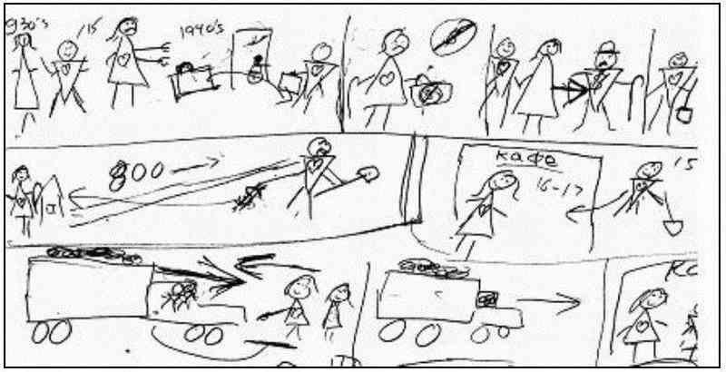
Example of how grandpa and grandma moved
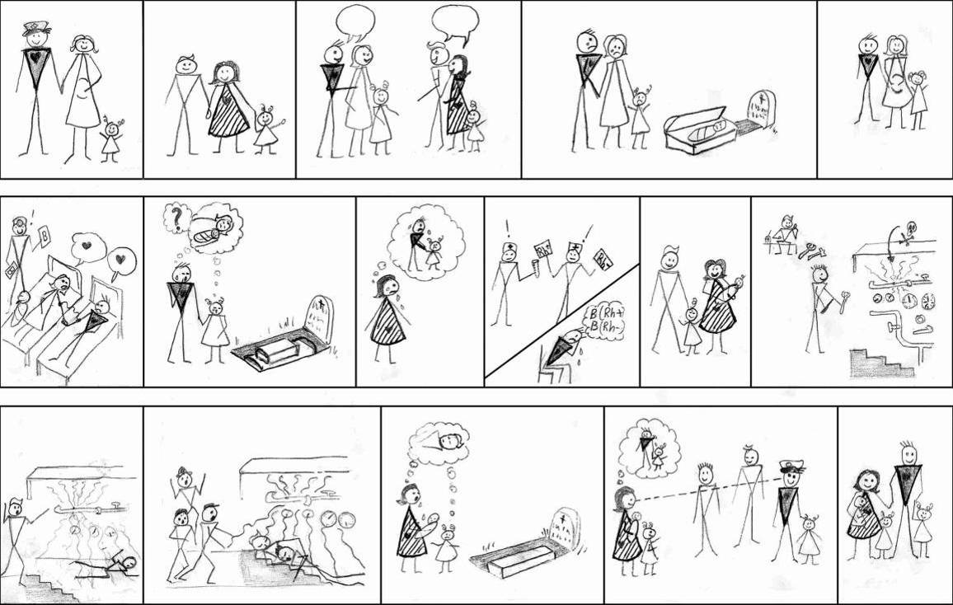
Example of story of how parents met
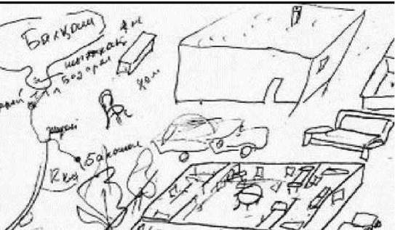
Example of all in one scene

