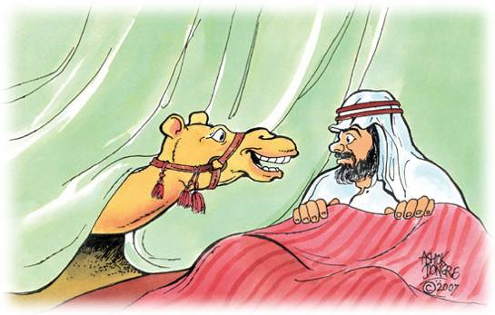
The Camel's Nose in The Tent.
One cold night, as an Arab sat in his tent, a camel gently thrust his nose under the flap and looked in. "Master," he said, "let me put my nose in your tent. It's cold and stormy out here." "By all means," said the Arab, "and welcome" as he turned over and went to sleep.
A little later the Arab awoke to find that the camel had not only put his nose in the tent but his head and neck also. The camel, who had been turning his head from side to side, said, "I will take but little more room if I place my forelegs within the tent. It is difficult standing out here." "Yes, you may put your forelegs within," said the Arab, moving a little to make room, for the tent was small.
Finally, the camel said, "May I not stand wholly inside? I keep the tent open by standing as I do." "Yes, yes," said the Arab. "Come wholly inside. Perhaps it will be better for both of us." So the camel crowded in. The Arab with difficulty in the crowded quarters again went to sleep. When he woke up the next time, he was outside in the cold and the camel had the tent to himself.
Another version of this story
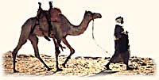
One day an Arab and his camel were crossing the desert. Night came and the temperature became colder. The Arab put up his tent and tied the camel to it. The Arab went to sleep.
The temperature became slightly colder and the camel asked the Arab if he (camel) could just put his nose in the tent to warm up. The Arab agreed that the camel could just put his nose in, because the tent was small and there was no room for 2. So the camel's nose became warm and after a while the temperature went down even more.
The camel asked the Arab again, if he (camel) could just put his fore legs in because they were very cold. The Arab reluctantly agreed that the camel could only put his fore legs in and no more. So the camel moved in his fore legs and they became warm. After sometime the camel asked the Arab again that he had to put in his hind legs or else he won't be able to make the journey the next morning with frozen legs. So the Arab agreed and once the camel moved his hind legs in, there was no more room in the tent for the Arab and the Arab was kicked out.

