**Charlie Sheen 'categorically denies' raping 13-year-old Corey Haim on the set of the movie Lucas after claims made by a friend of the late child-actor**

* **New allegations have emerged about a 13-year-old Corey Haim being raped by Charlie Sheen while filming the 1986 movie 'Lucas'**
* **Former actor Dominick Brascia alleges that Haim told him about his incident with Sheen and that a 19-year-old Sheen rejected him after their encounter**
* **Corey Feldman, Haim's closest friend, wrote in his memoir about Haim being sodomized on the set of 'Lucas' but never named Sheen**
* **Additionally it is alleged Sheen kissed an underage woman, who was 17 at the time, on the set of 'Lucas' and propositioned her for sex as well**
* **A defiant looking Sheen emerged from his parents home Wednesday smoking a cigarette after the bombshell allegations were made public**
* **Wednesday afternoon Sheen, who is now living with HIV, released a statement saying he 'categorically denies these allegations'**
* **Haim battled drug addiction for years and died in 2010 at 38-years-old**

By [Jessica Finn For Dailymail.com](http://www.dailymail.co.uk/home/search.html?s=&authornamef=Jessica+Finn+For+Dailymail.com)

**PUBLISHED:** 15:49 GMT, 8 November 2017 | **UPDATED:** 07:32 GMT, 9 November 2017

* [e-mail](mailto:?subject=Read%20this:%20Charlie%20Sheen%20%27categorically%20denies%27%20raping%2013-year-old%20Corey%20Haim%20on%20the%20set%20of%20the%20movie%20Lucas%20after%20claims%20made%20by%20a%20friend%20of%20the%20late%20child-actor&body=Charlie%20Sheen%20%27categorically%20denies%27%20raping%2013-year-old%20Corey%20Haim%20on%20the%20set%20of%20the%20movie%20Lucas%20after%20claims%20made%20by%20a%20friend%20of%20the%20late%20child-actor%0A%0ACharlie%20Sheen%20is%20being%20accused%20of%20sodomizing%20a%20then%2013-year-old%20Corey%20Haim%20on%20the%20set%20of%20the%20movie%20%27Lucas.%27%0A%0Ahttp%3A%2F%2Fwww.dailymail.co.uk%2Fnews%2Farticle-5062721%2FCharlie-Sheen-sodomized-Corey-Haim-13-set-Lucas.html%3Fito%3Demail_share_article-top%0A%0A%0AMost%20Read%20Articles%3A%0A%0ACharlie%20Sheen%20%27categorically%20denies%27%20raping%2013-year-old%20Corey%20Haim%20on%20the%20set%20of%20the%20movie%20Lucas%20after%20claims%20made%20by%20a%20friend%20of%20the%20late%20child-actor%0Ahttp%3A%2F%2Fwww.dailymail.co.uk%2Fnews%2Farticle-5062721%2FCharlie-Sheen-sodomized-Corey-Haim-13-set-Lucas.html%3Fito%3Demail_share_article-top_most-read-articles%0A%0ASingle%20mother%2C%2024%2C%20complains%20that%20she%20and%20her%20four%20young%20children%20are%20forced%20to%20live%20in%20one%20tiny%20room%20with%20her%20triplet%20babies%20sleeping%20in%20baskets%20on%20the%20floor%20while%20she%20waits%20for%20a%20council%20house%C2%A0%0Ahttp%3A%2F%2Fwww.dailymail.co.uk%2Fnews%2Farticle-5062547%2FMother-children-forced-live-tiny-room.html%3Fito%3Demail_share_article-top_most-read-articles%0A%0A%27She%20laughed%20and%20just%20threw%20it%27%3A%20Acid%20attack%20victim%20who%20took%2015%20months%20to%20die%20in%20agony%20tells%20murder%20trial%20from%20beyond%20the%20grave%20how%20his%20ex-lover%2C%2048%2C%20%27maimed%20him%20so%20no%20one%20else%20could%20have%20him%27%C2%A0%0Ahttp%3A%2F%2Fwww.dailymail.co.uk%2Fnews%2Farticle-5062297%2FFormer-girlfriend-48-murdered-ex-29-acid.html%3Fito%3Demail_share_article-top_most-read-articles%0A%0A)

**64k**shares

**[2.3k](http://www.dailymail.co.uk/news/article-5062721/Charlie-Sheen-sodomized-Corey-Haim-13-set-Lucas.html" \l "comments)**

[View comments](http://www.dailymail.co.uk/news/article-5062721/Charlie-Sheen-sodomized-Corey-Haim-13-set-Lucas.html" \l "comments)

[**Charlie Sheen**](http://www.dailymail.co.uk/tvshowbiz/charlie_sheen/index.html) is being accused of sodomizing a then 13-year-old Corey Haim on the set of the movie 'Lucas.'

According to the [**National Enquirer**](https://www.nationalenquirer.com/true-crime/charlie-sheen-corey-haim-rape-claims/), a now deceased Haim had told others about how he was allegedly raped as a minor by Sheen, who was 19 at the time, while filming the 1986 movie.

Former actor Dominick Brascia claims Haim disclosed to him what happened between him and Sheen. Brascia went on the record about what he says Haim told him before he died in 2010 at 38-years-old.

'Haim told me he had sex with Sheen when they filmed 'Lucas,' Brascia told the Enquirer. 'He told me they smoked pot and had sex. He said they had anal sex. Haim said after it happened Sheen became very cold and rejected him. When Corey wanted to fool around again, Charlie was not interested.'

Meanwhile on Wednesday, Sheen emerged from his parents Martin and Janet Sheen's home looking defiant while smoking a cigarette in the face of the bombshell allegations against him.

By the afternoon Sheen released statement through his representatives to the [**Hollywood Reporter**](http://www.hollywoodreporter.com/news/charlie-sheen-denies-corey-haim-sexual-assault-allegation-1056181) saying 'Charlie Sheen categorically denies these allegations'

Scroll for video

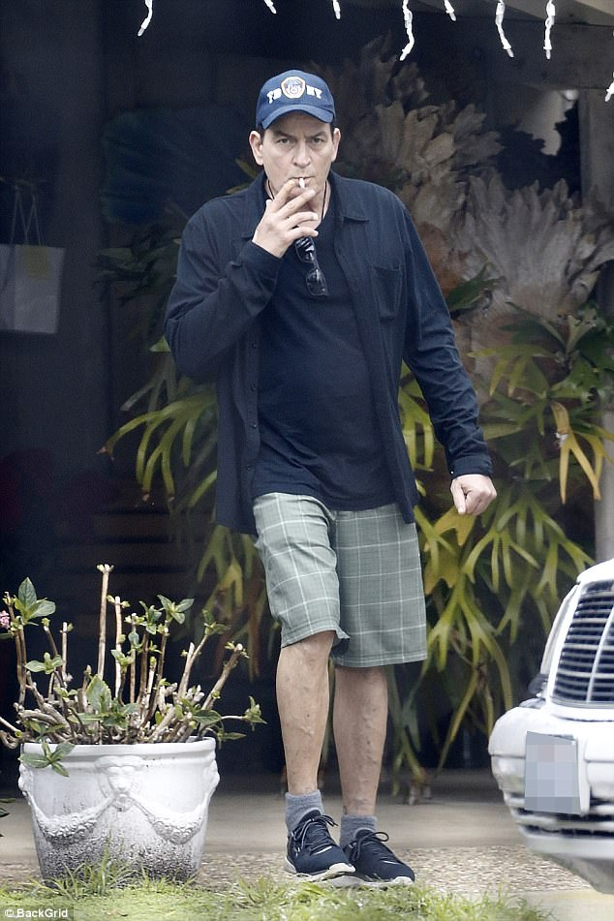

+12

Hours after the allegations of raping a young Corey Haim were made public, Sheen emerged Wednesday from his parents' house defiantley smoking a cigarette

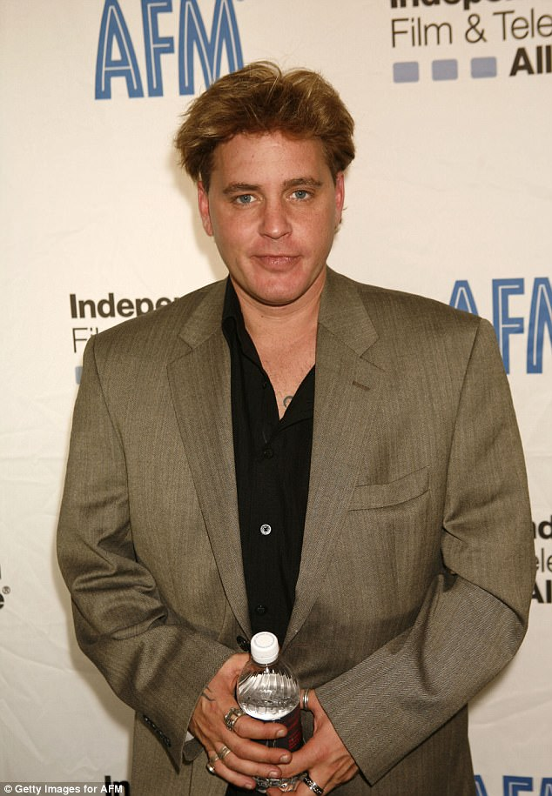

+12

A now deceased Corey Haim (left) told others about how he was 13-years-old when he allegedly had sex with Charlie Sheen, who was 19, during the filming of 'Lucas'

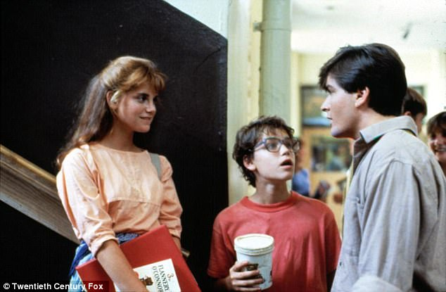

+12

Left to right: Kerri Green, Corey Haim, Charlie Sheen, from the 1986 film 'Lucas.' Sheen is accused of raping a then 13-year-old Haim during filming while Sheen was 19

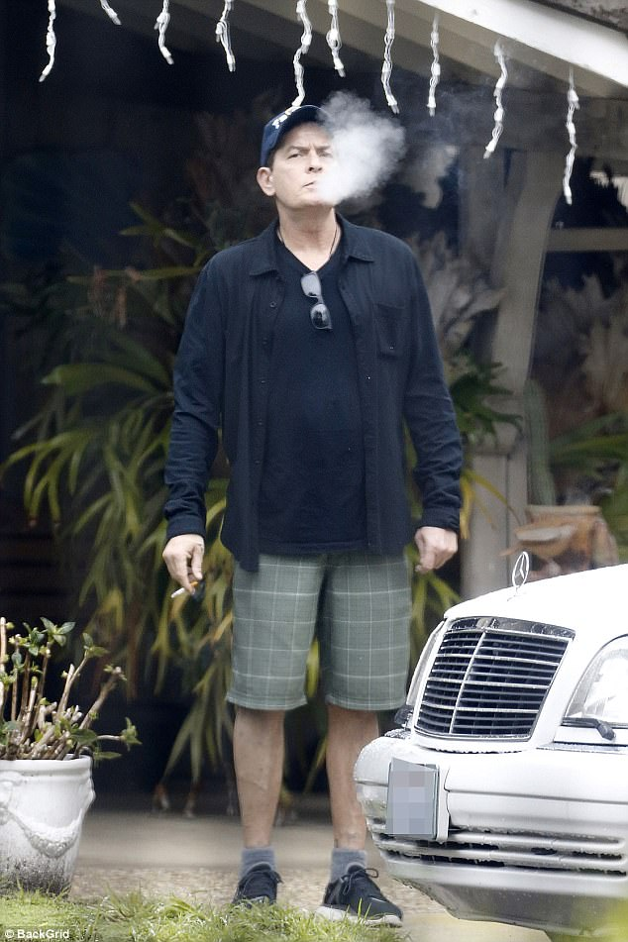

+12

Smoking away his trouble: Sheen puffed away on a cigarette in front of his parents' home Wednesday- hours after bombshell accusations were made against the actor that he raped fellow star Corey Haim when Haim was 13-years-old

The magazine also says that Lost Boys actor's closest friend, Corey Feldman, alluded to the alleged incident in his book 'Coreyography: A Memoir.'

'At some point during the filming [of 'Lucas,' Haim] explained an adult male convinced him it was perfectly normal for older men and younger boys in the business to have sexual relations, that it was ''what all guys do,'' Feldman wrote.

'So they walked off to a secluded area between two trailers during a lunch break for the cast and crew,' continued Feldman,' and Haim, innocent and ambitious as he was, allowed himself to be sodomized.' Feldman never named Sheen as the man in the incident.

In 2011, according to the Enquirer, when Feldman was asked about Sheen he said: 'I'm not a huge fan of Charlie Sheen…especially the way he's affected other people that I know.' Tellingly, Feldman also said Haim 'fought for his entire life to recover from those early experiences and to get his life together.'

And, just last week, on the Today Show, Feldman said a report coming from the National Enquirer was to be expected.

**Video playing bottom right...**

ExpandClose

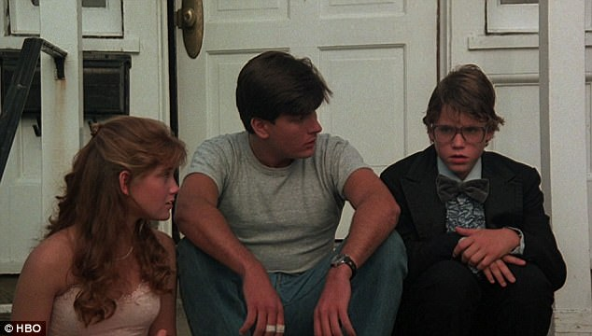

+12

Left to right: Kerri Green, Charlie Sheen and Corey Haim from the 1986 film 'Lucas'

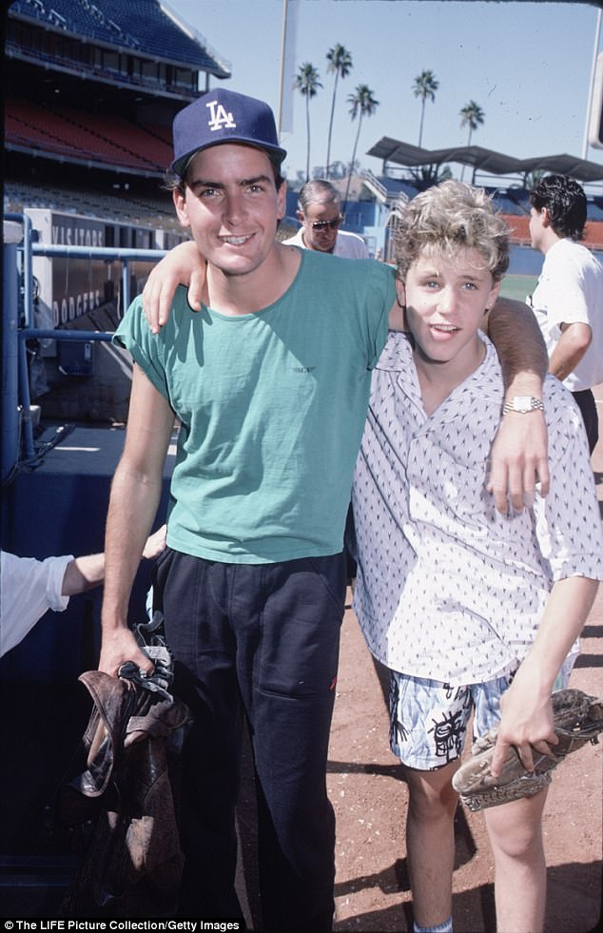

+12

Sheen and Haim are seen together in August 1986. Sheen is being accused of raping a 13-year-old Haim while filming 'Lucas' in Chicago approximately one year before this photo was taken

**Charlie Sheen allegedly raped Corey Haim on set**

Loaded: 0%

Progress: 0%

0:00

Previous

Play

Skip

Mute

Current Time0:00

/

Duration Time0:58

Fullscreen

Need Text

'They cover it up. They protect it. I know of a friend of mine that actually went and spoke to a reporter and gave all the information and they were -- the day before I launched my campaign, they were supposed to put out a story in the [National] Enquirer.'

'I believe there's a lot of darkness in Hollywood right now, and I believe it's been there for quite some time,' said Feldman. 'It's going to continue unraveling. This is just the beginning, it's just the tip of the iceberg.'

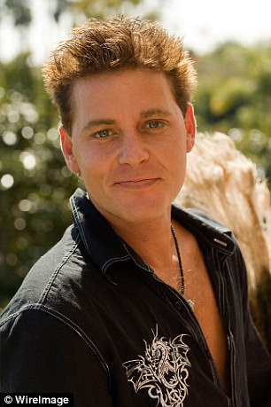

+12

Haim allegedly told several people close to him about Sheen's abuse during the filming of 'Lucas'

Other sources came forward to support the claims made by Brascia about Haim's interaction on set with Sheen- who is now living with HIV.

Another insider alleges that 'Corey was so confused by the sexual encounter he believed, like so many victims, he was 'in love' with his abuser,' adding that the actor bullied the young teen actor into a vulnerable position for sex.

Brascia added that Haim told him he later had consensual sex with the 'Wall Street' star while in his mid-to-late 20s. 'Haim told me he had sex with Sheen again,' Brascia said, adding 'He claimed he didn't like it and was finally over Sheen. He said Charlie was a loser.'

According to the report, the Enquirer says they spoke with dozens of sources who say Haim told them about his alleged abuse at Sheen's hands before he died of pneumonia in 2010.

Additionally, a confidant close to Sheen claims that the 'Platoon' actor had said he had a liaison with Haim, but said it was consensual.

Other allegations in the report emerged about Sheen's behavior with at least one other minor on the set of 'Lucas,' in which the report says a total of eight set witnesses spoke out as part of the investigation.

One of the women on the set claims she was just 17 when Sheen inappropriately kissed her and solicited sex from her in a bathroom: 'I [admit], I did have a thing for Sheen,' said the now 49-year-old woman, who revealed the incident happened at Chicago's Navy Pier.

'I talked with him for a long time,' she said, 'and kissed him.' However, the woman alleges, Sheen pressed for more than a kiss.

'I was in a bathroom with him at one point. He tried to get me to have sex.' She also claimed that Sheen had become increasingly 'sloppy and wasted' as the evening progressed.

Another woman who was on set claimed that she had just turned 18-years-old in time for the cast wrap party.

'He found out about [my birthday] and he grabbed me and gave me this elaborate kiss,' she said, adding Sheen had a mouthful of steak at the moment he landed a 'disgusting,' slimy, saliva-smooch on her lips: 'To this day I can remember that. Is that sad?'

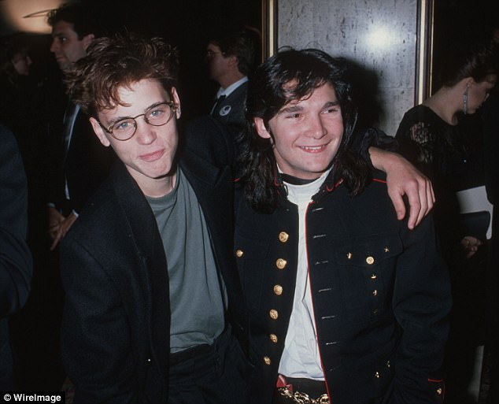

+12

Best friends: Haim with Corey Feldman (file). In Feldman's memoir Coreyography (2013) he alleged that Haim was sodomized during the filming of 'Lucas' but never named Sheen

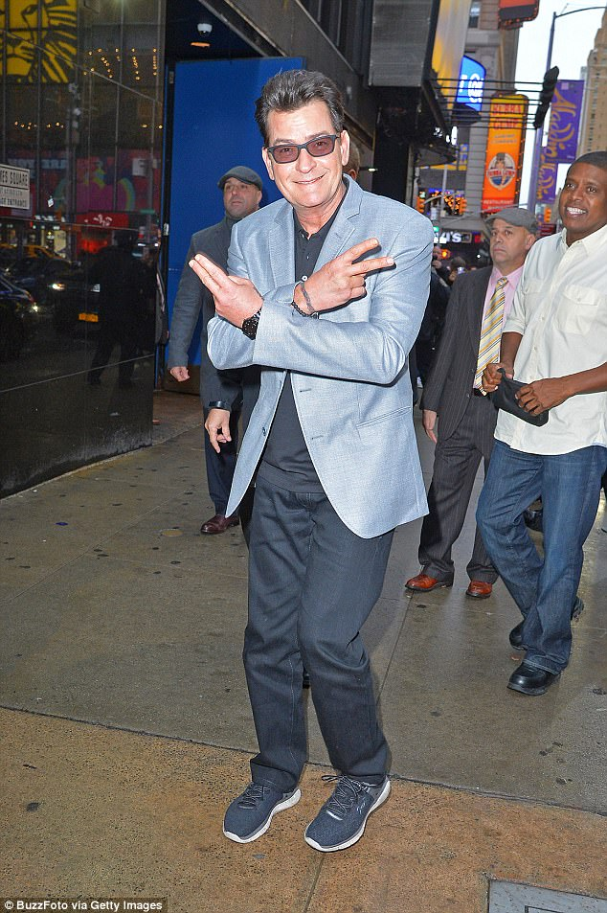

+12

Troubled star. Sheen opened up in 2015 about being diagnosed with HIV in 2011

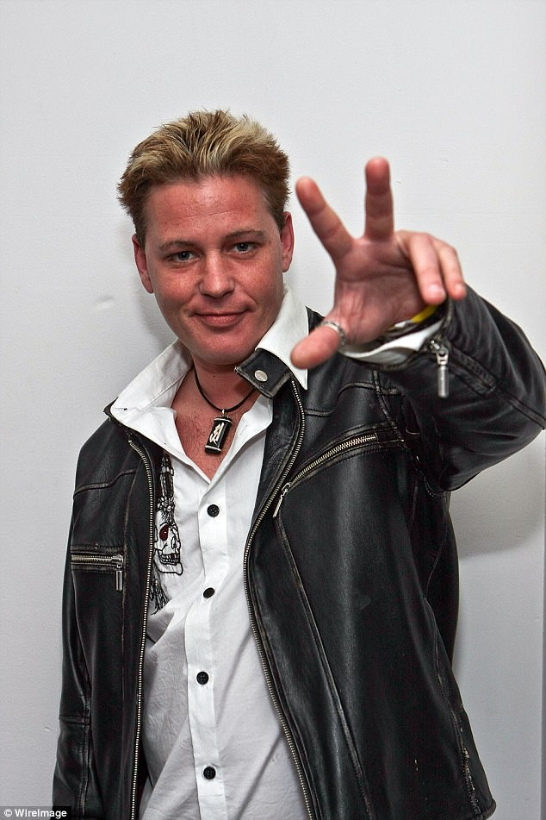

+12

Tragic ending: After battling drug addiction for years, Haim died of pneumonia in 2010 at the Oakwoods apartments in Los Angeles

The just barely 18-year-old says she shut down Sheen after the kiss.

'I had no interest in doing anything with him, so I let him know that,' she told the Enquirer. 'I didn't think he was all that special actually, like some of the girls in my class did. I actually thought he was a conceited a–hole. He was really obnoxious on the set.'

Bolstering the report, the Enquirer says in a 2006 court filing about Sheen, ex-wife Denise Richards allegedly claimed he visited websites featuring young men and girls who appeared underage.

Richards' hand signed declaration was filed to stop Sheen from getting overnight visits with their daughters.

**RELATED ARTICLES**

* [Previous](http://www.dailymail.co.uk/news/article-5062721/Charlie-Sheen-sodomized-Corey-Haim-13-set-Lucas.html)
* [1](http://www.dailymail.co.uk/news/article-5062721/Charlie-Sheen-sodomized-Corey-Haim-13-set-Lucas.html)
* [Next](http://www.dailymail.co.uk/news/article-5062721/Charlie-Sheen-sodomized-Corey-Haim-13-set-Lucas.html)
* [**[](http://www.dailymail.co.uk/news/article-5062541/Ex-news-anchor-says-Spacey-sexually-assaulted-relative.html)'Shame on you': Former Boston anchor claims Kevin Spacey got...**](http://www.dailymail.co.uk/news/article-5062541/Ex-news-anchor-says-Spacey-sexually-assaulted-relative.html)[**[](http://www.dailymail.co.uk/news/article-5062307/Second-woman-tells-Scotland-Yard-Blaine-sex-victim.html)EXCLUSIVE - 'Just suck my d\*\*\* for a few seconds': SECOND...**](http://www.dailymail.co.uk/news/article-5062307/Second-woman-tells-Scotland-Yard-Blaine-sex-victim.html)[**[](http://www.dailymail.co.uk/news/article-5062765/Assistant-accusing-Brett-Ratner-rape-comes-forward.html)'I stand by my claim': Former assistant accusing Brett...**](http://www.dailymail.co.uk/news/article-5062765/Assistant-accusing-Brett-Ratner-rape-comes-forward.html)[**[](http://www.dailymail.co.uk/news/article-5062447/Harvey-Weinstein-tried-Paz-la-Huerta-records.html)Harvey Weinstein spy? Paz de la Huerta's lawyer says that an...**](http://www.dailymail.co.uk/news/article-5062447/Harvey-Weinstein-tried-Paz-la-Huerta-records.html)

**SHARE THIS ARTICLE**

Share

**64k** shares

The actress alleged he 'belonged' to 'disturbing' sites 'which promoted very young girls, who looked underage to me with pigtails, braces and no pubic hair performing oral sex with each other.'

Other sites visited by Sheen, Richards alleged, involved 'gay pornography also involving very young men who also did not look like adults.'

Brascia also claims in the report that he had witnessed Haim approach Sheen one night, while the actor was sitting at a table with two A-list stars.

He said Sheen was drunk when Haim walked over and asked, 'Hey Charlie, remember me? How you doing, Charlie?' In reply, Sheen coldly claimed he didn't know Haim, and that Sheen said: 'Who are you? I don't know who you are.'

**Corey Feldman allegations led LAPD to investigate**

Loaded: 0%

Progress: 0%

0:00

Previous

Play

Skip

Mute

Current Time0:00

/

Duration Time2:29

Fullscreen

Need Text

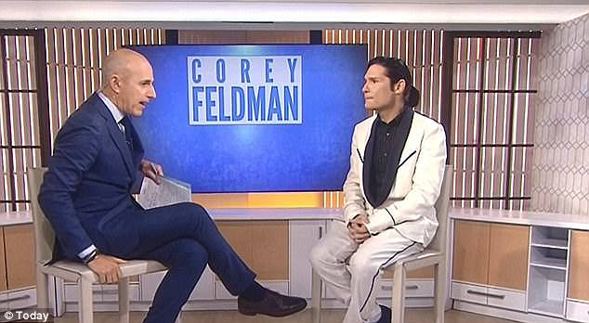

+12

Feldman went on the Today Show and said he knew of a report coming out in the National Enquirer about a story related to a Hollywood sex predator

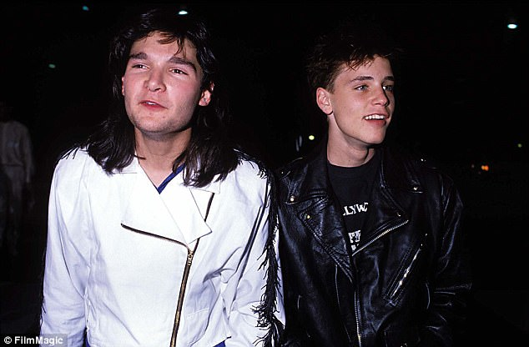

+12

His best friend couldn't save him. Feldman wrote in his memoir about alleged abuse Haim suffered during the filming of 'Lucas,' saying he explained to Haim that the behavior he experienced was not appropriate

**Corey Feldman reveals plan to expose pedophile ring in Hollywood**

Loaded: 0%

Progress: 0%

0:00

Previous

Play

Skip

Mute

Current Time0:00

/

Duration Time6:55

Fullscreen

Need Text

He also says later in the evening, Brascia found himself face-to-face with Sheen who told him: 'I'm really not that drunk. I just don't like that little a–hole. I hate that a–hole. Get him out of here. He's a freaking jerk.'

Sheen also allegedly shoved Haim's mother Judy, after interacting with her in a favored Los Angeles spot saying: 'I hate your f—–g son. If I ever see him, I'm going to flush his head down the f—–g toilet. Get the f–k away from me,' before pushing her away and into a wall.

An insider said the mere mention of Haim's name to Sheen and the actor would 'shut down on me completely. There's no doubt in my mind that something went down…enough that he had a grudge against Haim forever.'

DailyMail.com reached out to Sheen's team and have not heard back.

The statute of limitations for the alleged incidents on the set of 'Lucas' which was filmed in Chicago, have long expired.

Sheen's lawyers told the Enquirer he never had sex with Haim, and they did not respond in time about other allegations from the set of 'Lucas.'

Read more: <http://www.dailymail.co.uk/news/article-5062721/Charlie-Sheen-sodomized-Corey-Haim-13-set-Lucas.html#ixzz4xvABbDMb>   
Follow us: [@MailOnline on Twitter](http://ec.tynt.com/b/rw?id=bBOTTqvd0r3Pooab7jrHcU&u=MailOnline) | [DailyMail on Facebook](http://ec.tynt.com/b/rf?id=bBOTTqvd0r3Pooab7jrHcU&u=DailyMail" \t "_blank)