**RETIRED CIA AGENT CONFESSES ON DEATHBED: “I KILLED MARILYN MONROE”**

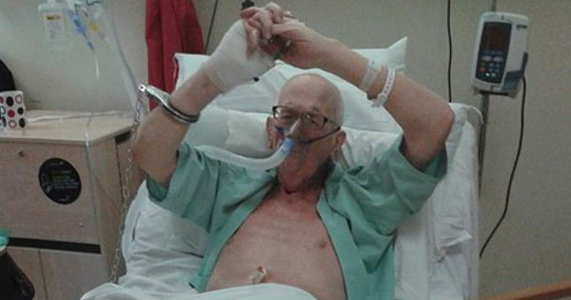

[Share**104K**](https://www.facebook.com/share.php?u=http%3A%2F%2Fworldnewsdailyreport.com%2Fretired-cia-agent-confesses-on-deathbed-i-killed-marilyn-monroe%2F)

[Tweet](https://twitter.com/share?original_referer=/&text=Retired+CIA+Agent+Confesses+on+Deathbed%3A+%E2%80%9CI+Killed+Marilyn+Monroe%E2%80%9D&url=http://worldnewsdailyreport.com/retired-cia-agent-confesses-on-deathbed-i-killed-marilyn-monroe/)

**Norfolk, Virginia | A 78-year old retired officer of the CIA, Normand Hodges, has made a series of astonishing confessions since he was admitted at the Sentara General Hospital on Monday. He claims he committed 37 assassinations for the American government between 1959 and 1972, including the actress and model, Marilyn Monroe.**

Mr. Hodges, who worked for the CIA for 41 years as an operative with top-level security clearances, claims he was often employed as a hitman by the organization, to assassinate individuals who could represent a threat to the security of the country.

 Trained as both a sniper and a martial arts expert, Mr. Hodges says he also has significant experience with more unconventional methods of inflicting harm upon others, like poisons and explosives.

**[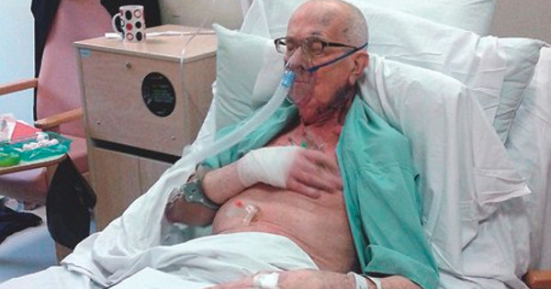](http://worldnewsdailyreport.com/wp-content/uploads/2015/03/marilyn.jpg)**

Mr. Hodges swears he remembers vividly, each of the assassinations he committed for the CIA.  He claims that all 37 of the murders he committed on the American soil, were ordered by his commanding officer, Major James “Jimmy” Hayworth.

The elderly man claims he committed his assassinations between August 1959 and March 1972, at a time when he says “*the CIA had its own agenda*“. He says he was part of an operative cell of five members which carried out political assassinations across the country. Most of their victims were political activists, journalists, and union leaders, but he also claims that he killed a few scientists and artists whose ideas represented a threat to the interests of the United States.

Mr. Hodges says that Marilyn Monroe remains unique among his victims, as she is the only woman he ever assassinated. He claims he has no regrets, however, as he says that she had become a “*threat to the security of the country*”  and had to be eliminated.

***“We had evidence that Marilyn Monroe had not only slept with Kennedy, but also with Fidel Castro”***claims M. Hodges.***” My commanding officer, Jimmy Hayworth, told me that she had to die, and that it had to look like a suicide or an overdose. I had never killed a woman before, but I obeyed orders… I did it for America! She could have transmitted strategic information to the communists, and we couldn’t allow that! She had to die! I just did what I had to do!”***

**[](http://worldnewsdailyreport.com/wp-content/uploads/2015/03/marily4.jpg)**

Marilyn Monroe died between midnight and 1 AM, on August 5, 1962. Mr Hodges claims he entered her room while she was sleeping and injected her with a massive dose of chloral hydrate (a powerful sedative), mixed with Nembutal (a short-acting barbiturate), causing her death.

The 78-year old man was placed under custody by the FBI, which is taking Mr. Hodges’ confession very seriously and has opened an investigation to verify his allegations. The investigation might be very complicated, however, as very few written files are available on such secret activities and most of the actors implicated in the various cases are already dead.

The most important witness in the story after Mr. Hodges himself, his alleged commanding officer, Major James Hayworth, died of a heart attack in 2011. Two of the other three “CIA assassins” identified by Mr. Hodges are also dead, and the last one, Captain Keith McInnis, went missing in action in 1968 and is presumed dead.