Hollywood promotes war on behalf of the Pentagon, CIA and NSA

US military intelligence agencies have influenced over 1,800 movies and TV shows

[](https://medium.com/@tomsecker?source=post_page-----36433107c307----------------------)

[Tom Secker](https://medium.com/@tomsecker?source=post_page-----36433107c307----------------------)

Follow

[Jul 4, 2017](https://medium.com/insurge-intelligence/exclusive-documents-expose-direct-us-military-intelligence-influence-on-1-800-movies-and-tv-shows-36433107c307?source=post_page-----36433107c307----------------------) · 10 min read

By Tom Secker and Matthew Alford

https://miro.medium.com/max/60/1*UCfJ71PaFR9wkLZ7Ib_Jiw.jpeg?q=20

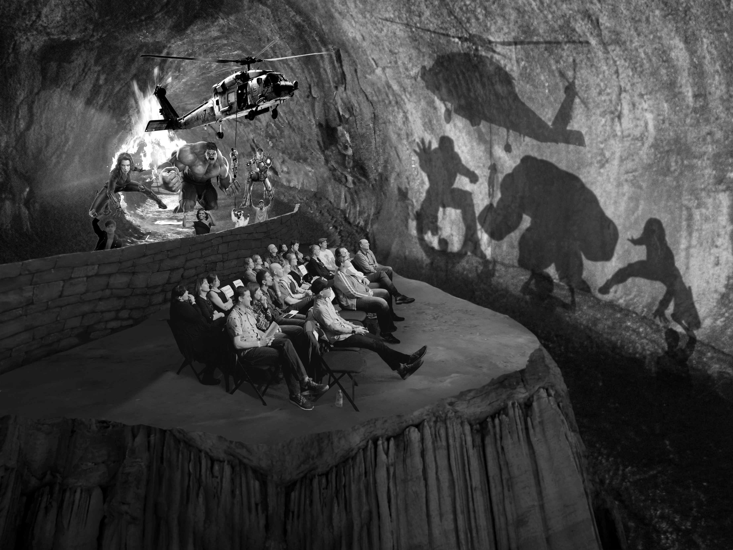

Plato’s Cave reimagined for the Hollywood era — copyright Derek Swansonn

*Published by*[*INSURGE INTELLIGENCE*](http://medium.com/insurge-intelligence)*, a crowdfunded investigative journalism project for people and planet.*[*Support INSURGE*](http://patreon.com/nafeez)*to keep digging where others fear to tread.*

**Tom Secker and Matthew Alford report on their astonishing findings from trawling through thousands of new US military and intelligence documents obtained under the Freedom of Information Act.**

**The documents reveal for the first time the vast scale of US government control in Hollywood, including the ability to manipulate scripts or even prevent films too critical of the Pentagon from being made — not to mention influencing some of the most popular film franchises in recent years.**

**This raises new questions not only about the way censorship works in the modern entertainment industry, but also about Hollywood’s little known role as a propaganda machine for the US national security apparatus.**

When we first looked at the relationship between politics, film and television at the turn of the 21st century, we accepted the consensus opinion that a small office at the Pentagon had, on request, assisted the production of around 200 movies throughout the history of modern media, with minimal input on the scripts.

How ignorant we were.

More appropriately, how misled we had been.

We have recently acquired 4,000 new pages of documents from the Pentagon and CIA through the Freedom of Information Act. For us, these documents were the final nail in the coffin.

These documents for the first time demonstrate that the US government has worked behind the scenes on over 800 major movies and more than 1,000 TV titles.

The previous best estimate, in a dry academic book way back in 2005, was that the Pentagon had worked on less than 600 films and an unspecified handful of television shows.

The CIA’s role was assumed to be just a dozen or so productions, until very good books by Tricia Jenkins and Simon Willmetts were published in 2016. But even then, they missed or underplayed important cases, including *Charlie Wilson’s War*and *Meet the Parents*.

https://miro.medium.com/max/60/1*P5IS_w2zrFYohnaapICR1w.png?q=20

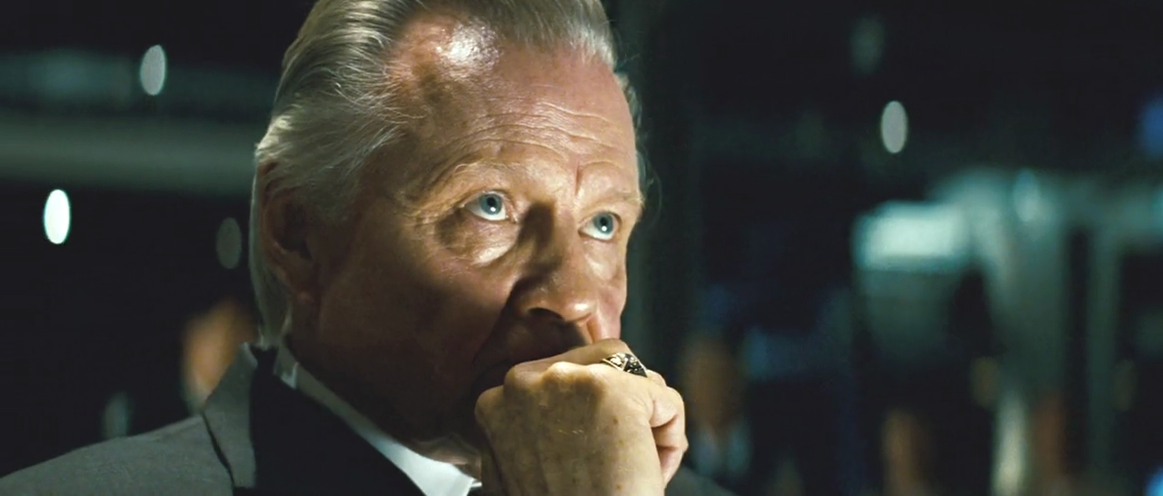

Jon Voight in Transformers — in this scene, just after American troops have been attacked by a Decepticon robot, Pentagon Hollywood liaison Phil Strub inserted the line ‘Bring em home’, granting the military a protective, paternalistic quality, when in reality the DOD does quite the opposite.

Alongside the massive scale of these operations, our new book [*National Security Cinema*](https://www.amazon.com/National-Security-Cinema-Government-Hollywood/dp/1548084980) details how US government involvement also includes script rewrites on some of the biggest and most popular films, including James Bond, the *Transformers* franchise, and movies from the Marvel and DC cinematic universes.

A similar influence is exerted over military-supported TV, which ranges from *Hawaii Five-O* to *America’s Got Talent*, *Oprah* and *Jay Leno* to *Cupcake Wars*, along with numerous documentaries by PBS, the History Channel and the BBC.

*National Security Cinema* also reveals how dozens of films and TV shows have been supported and influenced by the CIA, including the James Bond adventure *Thunderball*, the Tom Clancy thriller *Patriot Games* and more recent films, including *Meet the Parents* and *Salt*.

The CIA even helped to make an episode of *Top Chef*that was hosted at Langley, featuring then-CIA director Leon Panetta who was shown as having to skip dessert to attend to vital business. Was this scene real, or was it a dramatic statement for the cameras?

https://miro.medium.com/max/60/1*K5S55g8URkEDkWt3WJTaYw.png?q=20

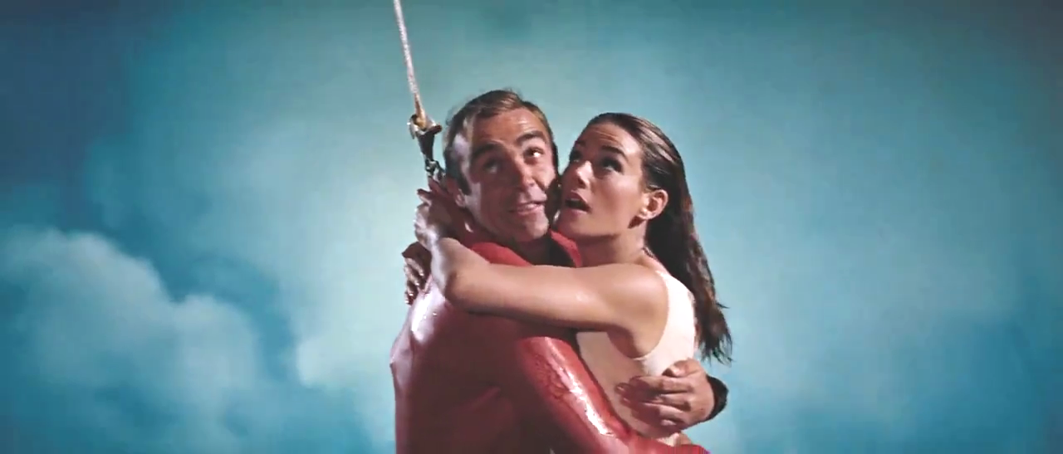

James Bond and Domino are rescued via a plane and skyhook that was loaned to the production by CIA front company Intermountain Aviation — Thunderball

**The Military’s Political Censorship of Hollywood**

When a writer or producer approaches the Pentagon and asks for access to military assets to help make their film, they have to submit their script to the entertainment liaison offices for vetting. Ultimately, the man with the final say is Phil Strub, the Department of Defense’s (DOD) chief Hollywood liaison.

If there are characters, action or dialogue that the DOD don’t approve of then the film-maker has to make changes to accommodate the military’s demands. If they refuse then the Pentagon packs up its toys and goes home. To obtain full cooperation the producers have to sign contracts — Production Assistance Agreements — which lock them into using a military-approved version of the script.

This can lead to arguments when actors and directors ad lib or improvise outside of this approved screenplay.

On set at Edwards Air Force base during the filming of *Iron Man,*there was an angry confrontation between Strub and director Jon Favreau.

Favreau wanted a military character to say the line, ‘People would kill themselves for the opportunities I have’, but Strub objected. Favreau argued that the line should remain in the film, and according to Strub:

*‘He’s getting redder and redder in the face and I’m getting just as annoyed. It was pretty awkward and then he said, angrily, “Well how about they’d walk over hot coals?” I said “fine.” He was so surprised it was that easy.’*

In the end, this compromised line did not appear in the finished film.

https://miro.medium.com/max/60/1*wyja0X3V_V1ieXXmrnqFLg.png?q=20

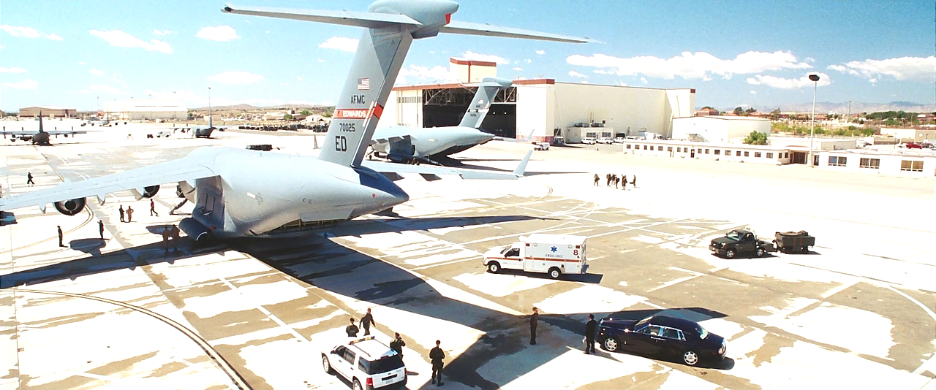

One of several scenes for Iron Man filmed at Edwards Air Force Base

It seems that any reference to military suicide — even an off-hand remark in a superhero action-comedy adventure — is something the DOD’s Hollywood office will not allow. It is understandably a sensitive and embarrassing topic for them, when during [some periods](http://www.dailymail.co.uk/news/article-4074942/More-troops-commit-suicide-die-combat-war-ISIS.html) of the ever-expanding and increasingly futile ‘War on Terror’, more US servicemen have [killed themselves](http://www.independent.co.uk/news/uk/home-news/mod-confirms-more-british-soldiers-commit-suicide-than-are-killed-in-battle-8707958.html) than have died in combat. But why shouldn’t a movie about a man who builds his own flying suit of armour not be able to include such jokes?

Another one-line quip that was censored by the DOD came in the James Bond film *Tomorrow Never Dies*.

When Bond is about to HALO jump out of a military transport plane they realise he’s going to land in Vietnamese waters. In the original script Bond’s CIA sidekick jokes ‘You know what will happen. It will be war, and maybe this time we’ll win.’

This line was removed at the request of the DOD.

Strangely, Phil Strub denied that there was any support for *Tomorrow Never Dies*, while the pre-eminent scholar in the field Lawrence Suid only lists the DOD connection under ‘Unacknowledged Cooperation’.

But the DOD are credited at the end of the film and we obtained a copy of the Production Assistance Agreement between the producers and the Pentagon.

The DOD-approved version of the HALO scene in Tomorrow Never Dies

Vietnam is evidently another sore topic for the US military, which also removed a reference to the war from the screenplay for *Hulk*(2003). While the military are not credited at the end of the film, on IMDB or in the DOD’s own database of supported movies, we acquired a dossier from the US Marine Corps detailing their ‘radical’ changes to the script.

This included making the laboratory where the Hulk is accidentally created into a non-military facility, making the director of the lab an ex-military character, and changing the code name of the military operation to capture the Hulk from ‘Ranch Hand’ to ‘Angry Man’.

‘Ranch Hand’ is the name of a real military operation that saw the US Air Force dump millions of gallons of pesticides and other poisons onto the Vietnamese countryside, rendering millions of acres of farmland poisoned and infertile.

They also removed dialogue referring to ‘all those boys, guinea pigs, dying from radiation, and germ warfare’, an apparent reference to covert military experiments on human subjects.

The documents we obtained further reveal that the Pentagon has the power to stop a film from being made by refusing or withdrawing support. Some movies such as *Top Gun*, *Transformers* and *Act of Valor* are so dependent on military cooperation that they couldn’t have been made without submitting to this process. Others were not so lucky.

The movie *Countermeasures* was rejected by the military for several reasons, and consequently never produced. One of the reasons is that the script included references to the Iran-Contra scandal, and as Strub saw it ‘There’s no need for us to… remind the public of the Iran-Contra affair.’

Similarly *Fields of Fire* and *Top Gun 2* were never made because they couldn’t obtain military support, again due to politically controversial aspects of the scripts.

This ‘soft’ censorship also affects TV. For example, a planned Louis Theroux documentary on Marine Corps recruit training was rejected, and as a result was never made.

It is impossible to know exactly how widespread this military censorship of entertainment is because many files are still being withheld. The majority of the documents we obtained are diary-like reports from the entertainment liaison offices, which rarely refer to script changes, and never in an explicit, detailed way. However, the documents do reveal that the DOD requires a preview screening of any project they support and sometimes makes changes even after a production has wrapped.

The documents also record the pro-active nature of the military’s operations in Hollywood and that they are finding ways to get involved during the earliest stages of development, ‘when characters and storylines are most easily shaped to the Army’s benefit.’

The DOD’s influence on popular culture can be found at all stages of production, granting them the same kind of power as major studio executives.

**Agencywood: The CIA and NSA’s Influence on Movie Scripts**

Despite having far fewer cinematic assets the CIA has also been able to wield considerable influence on some of the projects they have supported (or refused to support).

There is no formal CIA script review process but the Agency’s long-serving entertainment liaison officer Chase Brandon was able to insert himself into the early stages of the writing process on several TV and film productions.

The new recruits arrive at CIA training facility The Farm in *The Recruit*

Brandon did this most prominently on the spy thriller *The Recruit*, where a new agent is put through CIA training at The Farm — an obvious vehicle for inducting the audience into that world and giving them a glimpse behind the curtain. The original story treatment and early drafts of the script were written by Brandon, though he is only credited on the film as a technical advisor, covering up his influence on the content.

*The Recruit*includes lines about the new threats of the post-Soviet world (including that great villainous justification for a $600 billion defense budget, Peru), along with rebuttals of the idea that the CIA failed to prevent 9/11. And it repeats the adage that ‘the CIA’s failures are known, but its successes are not’. All of this helped to propagate the idea that the Agency is a benevolent, rational actor in a chaotic and dangerous world.

The CIA has also managed to censor scripts, removing or changing sequences that they didn’t want the public to see. On *Zero Dark Thirty* screenwriter Mark Boal ‘verbally shared’ his script with CIA officers, and they removed a scene where a drunk CIA officer fires an AK-47 into the air from a rooftop in Islamabad, and removed the use of dogs from the torture scenes.

In a very different kind of film, the hugely popular romantic comedy *Meet the Parents*, Brandon requested that they change a scene where Ben Stiller’s character discovers Robert De Niro’s (Stiller’s father-in-law to be) secret hideaway. In the original script Stiller finds CIA torture manuals on a desk, but Brandon changed that to photos of Robert De Niro with various dignitaries.

https://miro.medium.com/max/60/1*0PRAg7ActRnJK3ITmlx0JA.png?q=20

Ben Stiller discovers that Robert De Niro is working for the CIA — Meet the Parents

Indeed, the CIA’s ability to influence movie scripts goes back to their early years. In the 1940s and 50s they managed to prevent any mention of themselves appearing in film and TV until *North by Northwest* in 1959. This included rejecting requests for production support, meaning that some films were never made, and censoring all references to the CIA in the script for the Bob Hope comedy *My Favourite Spy*.

The CIA even sabotaged a planned series of documentaries about their predecessor, the OSS, by having assets at CBS develop a rival production to muscle the smaller studio out of the market. Once this was achieved, the Agency pulled the plug on the CBS series too, ensuring that the activities of the OSS remained safe from public scrutiny.

While very little is known about the NSA’s activities in the entertainment industry we did find indications that they are adopting similar tactics to the CIA and DOD.

Internal NSA emails show that the producers of *Enemy of the State* were invited on multiple tours of NSA headquarters. When they used a helicopter to film aerial footage of Fort Meade, the NSA did not prevent them from using it in the movie.

According to a 1998 [interview](http://articles.baltimoresun.com/1998-02-15/features/1998046083_1_nsa-guy-fort-meade-nsa-agents/2) with producer Jerry Bruckheimer, they changed the script at the NSA’s request so that the wrongdoings were the actions of one bad apple NSA official, and not the agency in general.

Bruckheimer said:

‘I think the NSA people will be pleased. They certainly won’t come out as bad as they could have. NSA’s not the villain.’

This idea of using cinema to pin the blame for problems on isolated rogue agents or bad apples, thus avoiding any notion of systemic, institutional or criminal responsibility, is right out of the CIA/DOD’s playbook.

https://miro.medium.com/max/60/1*9nhlrmfpz6nXiVtkk3n64w.png?q=20

NSA headquarters at Fort Meade — Enemy of the State

In all, we are looking at a vast, militarised propaganda apparatus operating throughout the screen entertainment industry in the United States.

It is not quite an official censor, since decisions on scripts are made voluntarily by producers, but it represents a major and scarcely acknowledged pressure on the kind of narratives and images we see on the big and small screens.

In societies already eager to use our hard power overseas, the shaping of our popular culture to promote a pro-war mindset must be taken seriously.

**Tom Secker and Matthew Alford are co-authors of the new book,**[***National Security Cinema: The Shocking New Evidence of Government Control in Hollywood***](https://www.amazon.com/National-Security-Cinema-Government-Hollywood/dp/1548084980)***.***

**Secker is a British-based writer who covers the security services, Hollywood and the history of terrorism. He runs the [SpyCulture](http://spyculture.com/" \t "_blank) blog which can be supported via**[**Patreon.com**](https://www.patreon.com/tomsecker)**. His work has been covered by The Mirror, The Express, Salon, TechDirt and elsewhere.**

**Dr Alford is a Teaching Fellow in the Department of Politics, Language and International Studies at the University of Bath. His documentary film based on his research, *The Writer with No Hands,*was premiered in 2014 at Hot Docs, Toronto and won runner-up at the Ammar Popular Film Festival, Tehran.**