Sir Henry Rider Haggard 1856-1925
http://en.wikipedia.org/wiki/H._Rider_Haggard
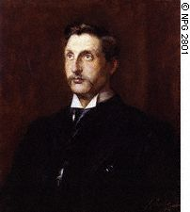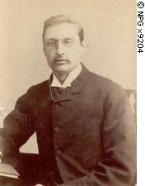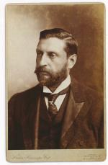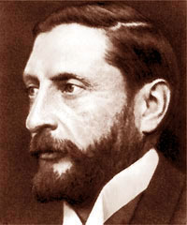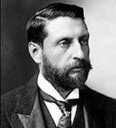
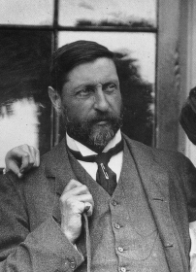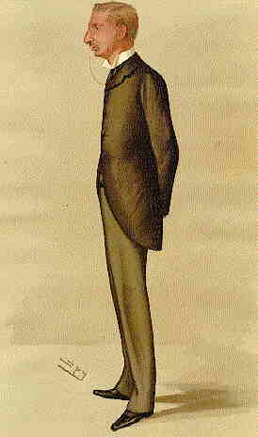

Sir Henry Rider Haggard (June 22, 1856 – May 14, 1925), born in Norfolk, England, was a Victorian writer of adventure novels set in locations considered exotic by readers in his native England. He attended Ipswich School.
Haggard had some firsthand experience of these locations, thanks to his extensive travels. He first travelled to Natal Colony in 1875, as secretary to the colonial Governor Bulwer. It was in this role that Haggard was present in Pretoria for the official announcement of the British annexation of the Boer Republic of the Transvaal. In fact, Haggard was forced to read out much of the proclamation following the loss of voice of the official originally entrusted with the duty.
In 1878 he became Registrar of the High Court in the Transvaal, in the region that was to become part of South Africa. He was eventually to return to England to find a wife, bringing Mariana Louisa Margitson back to Africa with him as a bride. Later they had a son named Jock (who died of measles at the age of 10) and three daughters.
Returning again to England in 1882, the couple settled in Ditchingham, Norfolk. Later he lived in Kessingland and had connections with the church in Bungay, Suffolk. He turned to the study of law and was called to the bar in 1884. His practice of law was somewhat desultory, and much of his time was taken up by the writing of novels.
While his novels contain many of the strong preconceptions common to the culture of British colonialism, they are unusual for the degree of sympathy with which he often treats the native populations. Africans often serve heroic roles in his novels, though the protagonists are typically, though not invariably, European. A notable example is Ignosi, the rightful king of Kukuanaland in King Solomon's Mines. Having developed an intense mutual friendship with the three Englishmen who help him reclaim his throne, he wisely accepts their advice to abolish witch hunts and arbitrary capital punishment.
Haggard is most famous as the author of the best-selling novel King Solomon's Mines, as well as many others such as She, Ayesha (sequel to She), Allan Quatermain (sequel to King Solomon's Mines), and the epic Viking romance, Eric Brighteyes.
In She, a Cambridge professor, Horace Holly and his adopted son, Leo Vincey travel to Africa. They encounter a white queen, Ayesha who has made herself immortal by bathing in a pillar of fire, the source of life itself. She becomes the prototypical all powerful female figure. She is to be both desired and feared. She is a breathtakingly beautiful creature who will not hesitate to kill any one who displeases her or stands in her way. The travelers discover that Ayesha has been waiting for 2000 years for the reincarnation of her lover Kallikrates, whom she had slain in a fit of jealous rage. She believes that Vincey is the reincarnation of Kallikrates.
In the climax of the novel, Ayesha takes the two men to see the pillar of fire. She wants Leo to bathe in it as she did so that he can become immortal and remain with her forever. His doubts about its safety lead her to step into the flames once more. However, with this second immersion she reverts to her true age and immediately withers and dies. Before dying she tells Vincey;"I die not. I shall come again."
Throughout the book Haggard explores the themes of power, life, death, reincarnation, sexuality, and fate.
Though Haggard is no longer as popular as he was when his books appeared, some of his characters have had a notable impact on early-twentieth-century thought. Ayesha, the female protagonist of She, was even cited by both Sigmund Freud in The Interpretation of Dreams and by Carl Jung as a female prototype. Allan Quatermain, the hero of King Solomon's Mines and its sequel still appears in Western popular culture today. As a populariser of the Lost World genre Haggard has had a wide influence on the spheres of science fiction and fantasy through the works of Edgar Rice Burroughs. Allan Quatermain has been identified as one of the fictitious and real people on whom Indiana Jones, in the films Raiders of the Lost Ark, the Temple of Doom and Indiana Jones and the Last Crusade is said to be based.
Haggard also wrote on social issues and agricultural reform, in part inspired by his experiences in Africa but also based on what he saw in Europe.

Contents
- 1 Chronology of works
  - 1.1 Allan Quatermain Series
  - 1.2 Ayesha Series
- 2 External links
- 3 See also

Chronology of works
- Dawn (1884)
- The Witch's Head (1884)
- King Solomon's Mines (1885)
- She (1887)
- Jess (1887)
- Allan Quatermain (1887)
- A Tale of Three Lions (1887)
- Mr. Meeson's Will (1888)
- Maiwa's Revenge (1888)
- My Fellow Laborer and the Wreck of the Copeland (1888)
- Colonel Quaritch, V.C. (1888)
- Cleopatra (book) (1889)
- Allan's Wife (1889)
- Beatrice (1890)
- The World's Desire (1890) (co-written with Andrew Lang)
- Eric Brighteyes (1891)
- Nada the Lily (1892)
- Montezuma's Daughter (1893)
- The People of the Mist (1894)
- Joan Haste (1895)
- Heart of the World (1895)
- Church and State (1895)
- The Wizard (1896)
- Dr. Therne (1898)
- Swallow (1898)
- A Farmer's Year (1899)
- The Last Boer War (1899)
- The Spring of Lion (1899)
- Montezuma's Daughter (1899)
- Elissa; the doom of Zimbabwe. Black Heart and White Heart; a Zulu idyll. (1900)
- The New South Africa (1900)
- A Winter Pilgrimage (1901)
- Lysbeth (1901)
- Rural England (1902)
- Pearl Maiden (1903)
- Stella Fregelius (1904)
- The Brethren (1904)
- The Poor and the Land (1905)
- Ayesha (1905)
- A Gardener's Year (1905)
- Report of Salvation Army Colonies (1905)
- The Way of the Spirit (1906)
- Benita (1906)
- Fair Margaret (1907)
- The Ghost Kings (1908)
- The Yellow God (1908)
- The Lady of Blossholme (1909)
- Queen Sheba's Ring (1910)
- Regeneration: An account of the social work of the Salvation Army (1910)
- Morning Star (1910)
- Red Eve (1911)
- The Mahatma and the Hare (1911)
- Rural Denmark (1911)
- Marie (1912)
- Child of Storm (1913)
- The Wanderer's Necklace (1914)
- A call to Arms (1914)
- The Holy Flower (1915)
- After the War Settlement and Employment of Ex-Service Men (1916)
- The Ivory Child (1916)
- Finished (1917)
- Love Eternal (1918)
- Moon of Israel (1918)
- When the World Shook (1919)
- The Ancient Allan (1920)
- Smith and the Pharaohs (1920)
- She and Allan (1921)
- The Virgin of the Sun (1922)
- Wisdom's Daughter (1923)
- Heu-Heu (1924)
- Queen of the Dawn (1925)
- The Days of my Life: An autobiography of Sir H. Rider Haggard (1926)
- Treasure of the Lake (1926)
- Allan and the Ice Gods (1927)
- Mary of Marion Isle (1929)
- Belshazzar (1930)

[] Allan Quatermain Series
- King Solomon's Mines
- Allan Quatermain
- Allan's Wife
- Maiwa's Revenge: or, The War of the Little Hand
- Marie
- Child of Storm
- (Allan and) The Holy Flower
- Finished
- The Ivory Child
- The Ancient Allan
- She and Allan
- Heu-heu: or The Monster
- The Treasure of the Lake
- Allan and the Ice-gods

[] Ayesha Series
- She
- Ayesha: The Return of She
- She and Allan
- Wisdom's Daughter: The Life and Love Story of She-Who-Must-Be-Obeyed

[] External links
- Rider Haggard Society
- Works by H. Rider Haggard at Project Gutenberg
- Works at Project Gutenberg Australia
- H. Rider Haggard quotes at LitQuotes
- Rider Haggard

[] See also
- Louis Henri Boussenard
- Alexandre Dumas
- Karl May
- Baroness Orczy
- Emilio Salgari
- Samuel Shellabarger
- Lawrence Schoonover
- Jules Verne
- Frank Yerby
- A. E. W. Mason
- P. C. Wren
- Anthony Hope
- Frederick Russell Burnham
- Frank Collection
===========================================================================================================================
END

