LOST CIVILIZATIONS

The Famous Mu Series

http://www.brotherhoodoflife.com/

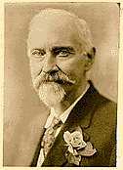

Col. James Churchward

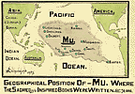
For centuries the cache of stone tablets outlining man's earliest civilization had lain practically forgotten in an East Indian temple vault. Befriended and found worthy by the Temple Priest, Col. James Churchward, serving in the British Army in 1868, was taught to decipher the story carved in the stones. The tablets told of a great civilization, far earlier than our own, that emerged, flourished and vanished beneath the sea 25,000 years ago. Churchward spent the next fifty years of his life piecing together the remnants of this lost continent and its legacy. These titles show convincing evidence of a single source that unites mankind with a common heritage. All volumes measure 5.5 X 8.5 and are thoroughly illustrated including maps, diagrams and line-drawings.

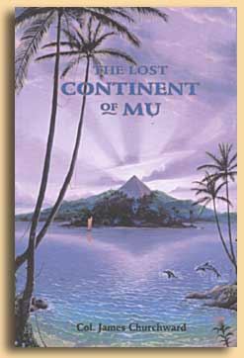
THE LOST CONTINENT OF MU, Col. James Churchward
Mu was an immense continent covering nearly one-half of the Pacific Ocean. When she sank during volcanic destruction, fifty million square miles of water claimed her place. This vast continent and culture was the center of civilization some 25,000 years ago and her history dates back 200,000 years. This is the story of Churchward's search for the lost continent, from the vaults of the Indian temple to the four corners of the world. Tracing legends, histories, traditions and stone carvings from later civilizations, Churchward shows that they all contain references to a highly advanced, earlier civilization from which they trace their legends and heritage.
COMPLETE LOST CONTINENT EDITION. This is the original 1926 edition, with beautiful typography and containing material not printed in subsequent editions. The Addendum contains the additions to the 1931 printing, making this the most comprehensive version ever published. Over 100 illustrations, including 30 reprocessed photographs bringing back their brilliance.
Cover art by Jeffrey K. Bedrick.
392pp., 5.5 X 8.5, 0-914732-19-6 $24.95

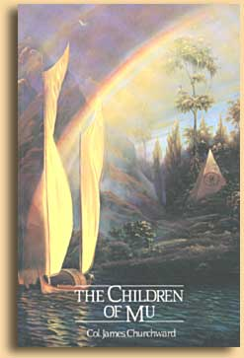
THE CHILDREN OF MU, Col. James Churchward
The spread of the Mu culture throughout the world and her influence upon later civilizations. Her first colonies were in North America and the Orient, yet colonies had been started in all parts of the world. India, Egypt and Yucatan all trace their legacy to this great civilization.
Cover art by Jeffrey K. Bedrick.
267pp., 5.5 X 8.5, 0-914732-22-6 $15.95

THE SACRED SYMBOLS OF MU, Col. James Churchward
By comparing myths, legends, religions, traditions and inscriptions from civilizations worldwide, including modern, ancient and extinct, Churchward presents abundant evidence linking them to the common source of Mu, the Motherland.
Cover art by Jeffrey K. Bedrick.
296pp., 5.5 X 8.5, 0-914732-24-2 $16.95

COSMIC FORCES OF MU, Volume 1, Col. James Churchward
The Universal Laws at work, an orderly procession of powers creating the Universe and the Earth; the natural sciences as they were taught on Mu. Many of these theories are counter to what modern science teaches yet they explain many anomolies modern science cannot. "There is one great infinite force that governs all." Over 60 plates and diagrams.
Cover art by Jeffrey K. Bedrick.
246pp., 5.5 X 8.5, 0-914732-27-7 $17.95

COSMIC FORCES OF MU, Volume 2, Col. James Churchward
The Universal Laws at work as Geologic forces within the Earth. Their creation and interaction, the Great Gas Belts, mountain formation, Earth changes. Over 75 maps and diagrams.
Cover art by Jeffrey K. Bedrick.
269pp., 5.5 X 8.5, 0-914732-28-5 $17.95

