Ignatius Loyola Donnelly 1831-1901
http://en.wikipedia.org/wiki/Ignatius_Donnelly

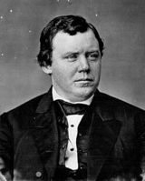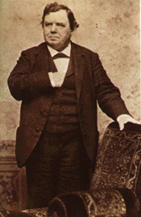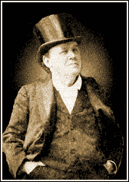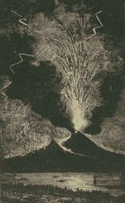
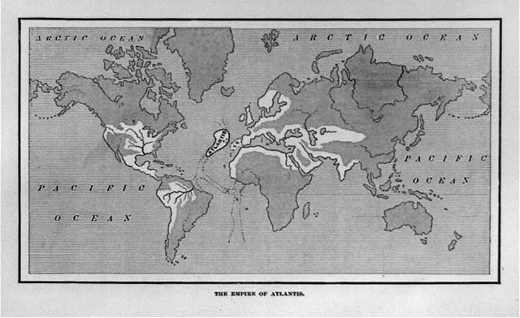

Ignatius Loyola Donnelly (November 3, 1831 – January 1, 1901) was a U.S. Congressman, populist, and writer, known primarily today for his theories on the history of Atlantis and Shakespearean authorship.

Contents
- 1 Early life and education
- 2 Political career
- 3 Marriages
- 4 Death
- 5 Works
- 6 References
- 7 External links

Early life and education
Donnelly was born in Philadelphia, Pennsylvania, studied law, and was admitted to the bar in 1852. In 1855, he married Katherine McCaffrey, with whom he fathered three children. He moved to Minnesota in 1857, where he settled in Dakota County. Together with several partners, Donnelly founded a utopian community called Nininger City. However, the Panic of 1857 doomed that attempt at a cooperative farm and community and left Donnelly deeply in debt.

[] Political career
Donnelly entered politics and was lieutenant governor of Minnesota from 1860 – 1863. He was a Republican Congressman from Minnesota in the 38th, 39th, and 40th Congresses (1863 – 1868) and a state senator from 1874 – 1878. As a legislator, Donnelly advocated extending the powers of the Freedmen's Bureau to provide education for the freedmen, so that they could protect themselves once the bureau was withdrawn. Donnelly was also an early supporter of women's suffrage.
After leaving the Minnesota State Senate in 1878, Donnelly returned to his law practice and writing. In 1882, he published Atlantis: The Antediluvian World, his best known work, detailing his theories concerning the mythical lost continent of Atlantis. He made several other runs for public office during the 1880s. He made a losing run for Congress (this time as a Democrat) in 1884. In 1887, he successfully ran for the Minnesota State Legislature as an Independent. During this period, he was also an organizer of the Minnesota Farmers' Alliance.
Donnelly undertook a foray into national politics in 1892, writing the preamble of the People's Party's Omaha Platform. He was nominated for Vice President of the United States in 1900 by the People's Party. Also known as the Populist Party, the People's Party rose out of the national Farmers' Alliance movement and stood on a platform that called for abandonment of the Gold Standard (and later for Free Silver), abolition of national banks, a graduated income tax, direct election of senators, civil service reform, and an eight-hour work day. That year, Donnelly also ran for governor of Minnesota but was defeated.

[] Marriages
His wife Katherine died in 1894. In 1898, he remarried, wedding his secretary, Marion Hanson.

[] Death
Donnelly died on January 1, 1901, the first day of the 20th century, in Minneapolis, Minnesota and is buried at Calvary Cemetery in St. Paul, Minnesota. His personal papers are archived at the Minnesota Historical Society.[1]

[] Works
His books include:
- Atlantis: The Antediluvian World (1882), in which he attempted to establish that all known ancient civilizations were descended from its high-Neolithic culture.
- Ragnarok, the Age of Fire and Gravel (1883), in which he proposed that a comet hit the earth in prehistoric times and destroyed a high civilization. (This book also is available as an online facsimile from the University of Georgia Library (DjVu or Layered PDF).)
- The Shakespeare Myth (1887)
- Essay on the Sonnets of Shakespeare
- The Great Cryptogram: Francis Bacon's Cipher in Shakespeare's Plays (1888), in which he maintained he had discovered codes in the works of Shakespeare indicating that their true author was Francis Bacon.
- Caesar's Column (1890), a science fiction novel set in 1988 about a worker revolt against a global oligarchy. (Published under the pseudonym of Edmund Boisgilbert.)
- Doctor Huguet: A Novel (1891) (Published under the pseudonym of Edmund Boisgilbert.)
- The Golden Bottle or the Story of Ephraim Benezet of Kansas (1892)
- The American People's Money (1896)
- The Cipher in the Plays, and on the Tombstone (1899)

[] References
- Hicks, JD (1921). 'The Political Career of Ignatius Donnelly', Mississippi Valley Historical Review, vol. 8, pp. 80-132.
- Ridge, M (1912). Ignatius Donnelly: The Portrait of a Politician, Chicago: University of Chicago Press.

[] External links
- Atlantis, the Antediluvian World, at sacred-texts.com
- Ragnarok, at sacred-texts.com
- Cæsar's Column, at sacred-texts.com
- The Antediluvian World by Ignatius Donnelly
- Works by Ignatius Donnelly at Project Gutenberg
- Donnelly entry in the Biographical Directory of the United States Congress
- Biography
- Biography
- Personal history
- Image of Ignatius Donnelly from "1888 Presidential Possibilities" card set t207.com
Preceded by  William Holcombe | 2nd Lieutenant Governor of Minnesota  1860 – 1863 | Succeeded by  Henry Adoniram Swift
Preceded by  Cyrus Aldrich | U.S. Representative from the 2nd Congressional District of Minnesota  1863 – 1869 | Succeeded by  Eugene McLanahan Wilson
Preceded by  Thomas E. Watson | Populist Party Vice Presidential candidate  1900 (lost) | Succeeded by  Thomas Tibbles

===================================================================================================================================
END

