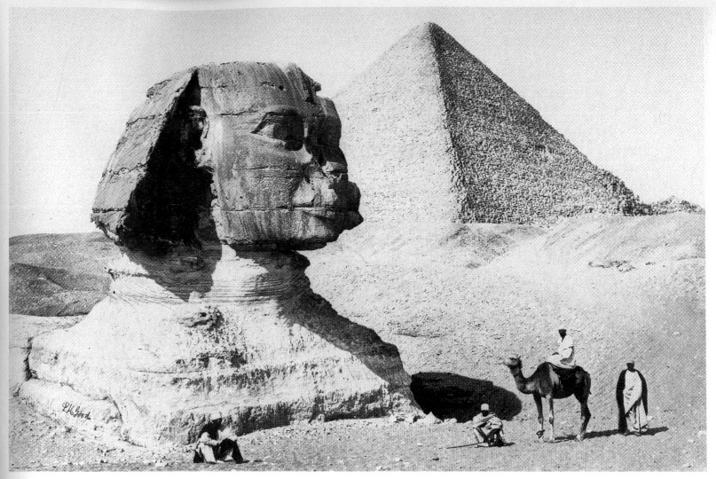
1. The Great Sphinx of Giza, as this nineteenth-century photograph shows, has spent a large part of its known history covered up to its neck in desert sands. Whilst thus covered, its body has not been subject to wind-erosion, yet the body is heavily weathered. Could there have been some other weathering agency at work?
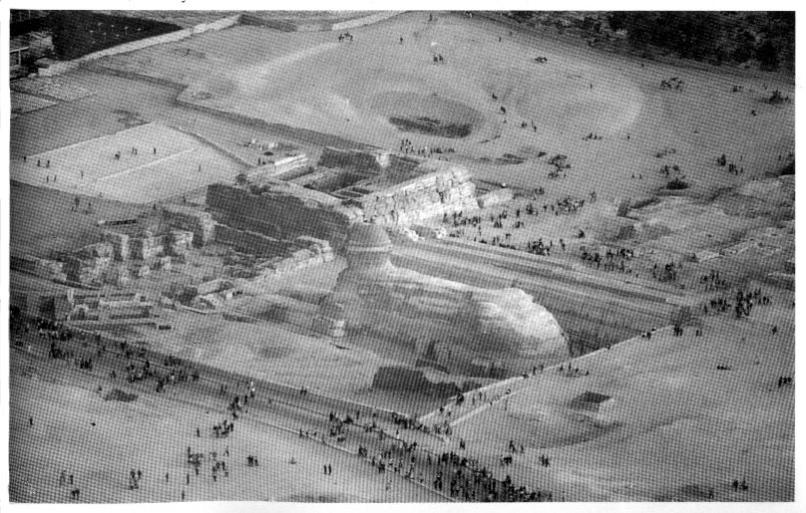
2. The Sphinx was carved by first excavating a large trench around a monolithic central core of limestone which was then shaped into the form of a lion. This photograph, taken from the Great Pyramid, shows the Sphinx in its trench, the remains of the so-called Sphinx Temple (immediately in front, i.e. to the east, of the monument) and Valley Temple (a little to the south). Also shown, running down the south side of the Sphinx, is part of the gigantic causeway of Khafre.
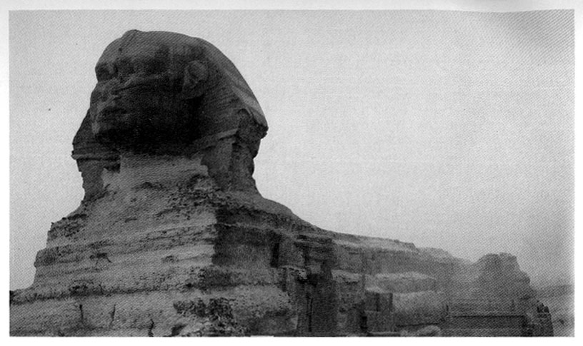
3. Heavily eroded core body of the Sphinx. The weathering patterns, which have been studied by geologists from Boston University, have been identified as having been caused by prolonged exposure to heavy rains. In 2500 bc, when Egyptologists presume that the Sphinx was built, Egypt was as bone dry as it is today. Between 15,000 bc and 7000 bc however, the science of palaeo-climatology indicates that Egypt several times passed through periods of wet climate which could have caused weathering patterns such as these.
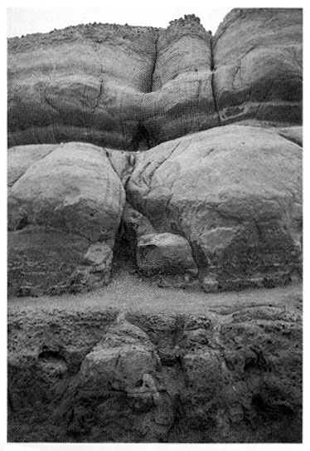
4. The trench surrounding the Great Sphinx, which was created at the same time that the Sphinx was carved, very clearly illustrates the rolling scalloped ‘coves’ and deep vertical fissures characteristic of precipitation-induced weathering in limestone. The sciences of geology and palaeo-climatology alone, however, can only demonstrate that the Sphinx and its enclosure are much older than previously thought. Archaeo-astronomical analysis provides a far more accurate tool for dating the Sphinx.
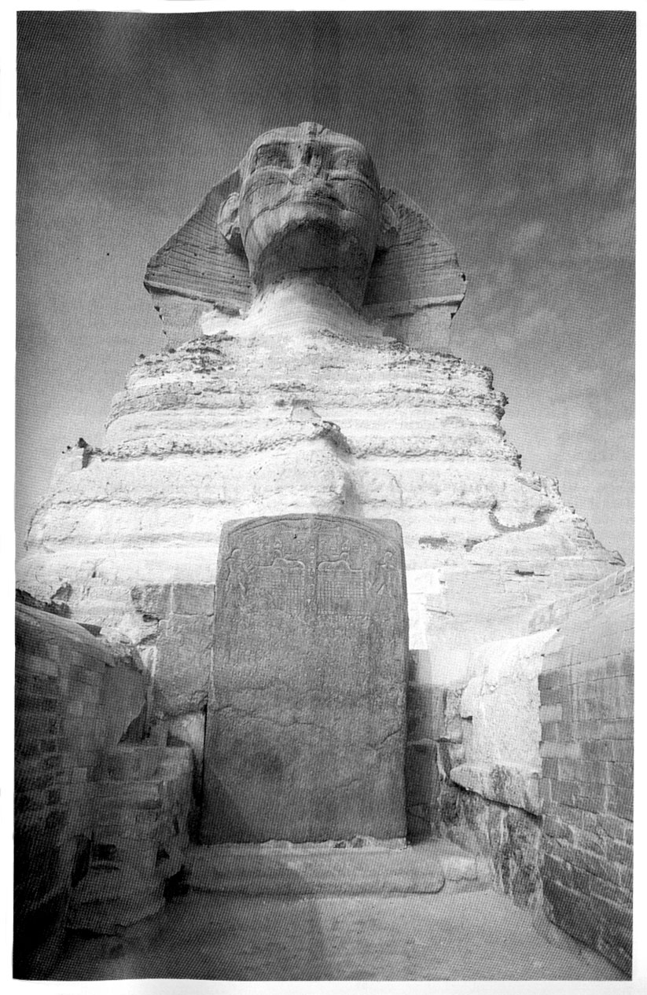
5. This granite stela between the paws of the Sphinx was erected to commemorate a renovation campaign carried out by Pharaoh Thuthmosis IV (1401 bc-1391 bc). The stela bears the single syllable ‘Khaf’ which, oddly, has led Egyptologists to conclude that the Sphinx was originally built by the Fourth Dynasty Pharaoh Khafre, circa 2500 bc. The stela also states, however, that the Giza necropolis is the ‘Splendid Place of the First Time’—associating it with a far earlier epoch.
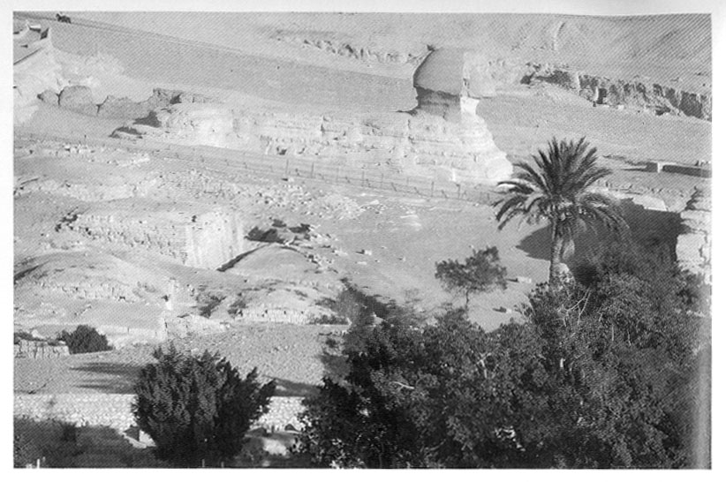
6. The Sphinx viewed from the south, over the so--called Khafre causeway. Its heavily eroded lion body lies half-buried in the artificial ‘horizon’ of Giza from this perspective, mimicking the half-buried constellation of Leo as viewed at the cross-quarter sunrise between the winter solstice and the spring equinox in 10,500 bc (see Chapter Seventeen).
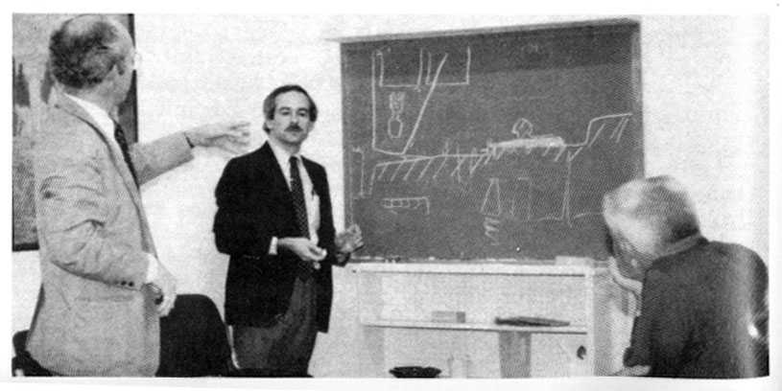
7. Professor Mark Lehner (centre), Egyptology’s leading expert on the Sphinx, lecturing to senior staff of the Edgar Cayce Foundation at the Association for Research in Enlightenment in Virginia Beach, USA (see Chapter Five).
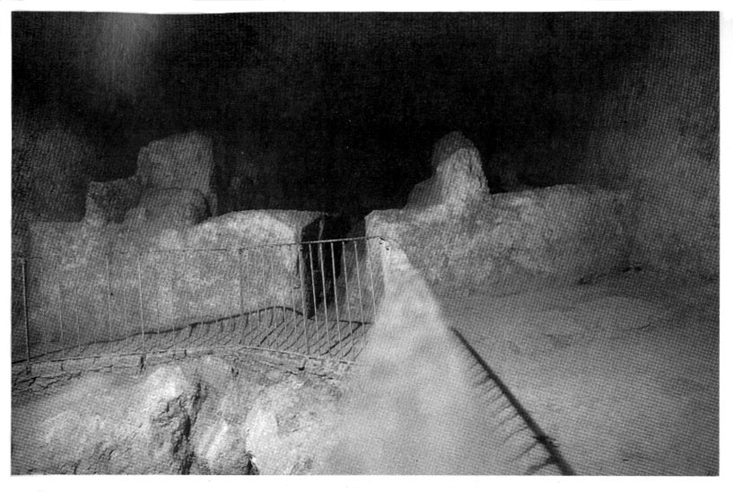
8. The subterranean chamber of the Great Pyramid of Giza, situated at a depth of 100 feet beneath the plateau, precisely under the apex of the Pyramid.
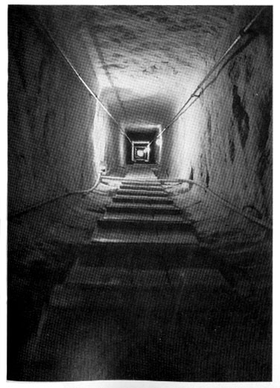
9. The descending corridor connecting the Pyramid’s original entrance in the north face with the subterranean chamber is 350 feet long from top to bottom and does not vary by more than a quarter of an inch from perfectly straight along its entire length. This photograph is taken from the bottom of the corridor, looking up towards the distant sunlight filtering through the entrance. The strange internal corridors and passageways of the Great Pyramid closely resemble ancient Egyptian depictions of the afterlife realm and Kingdom of Osiris, known as the Duat.
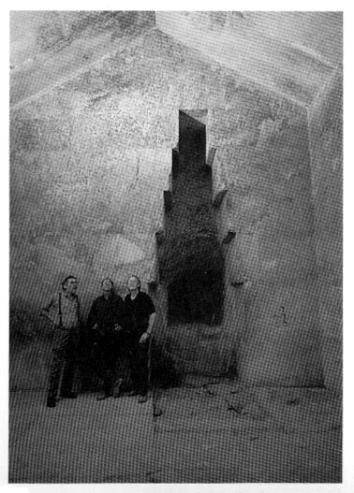
10. The authors with John Anthony West in the Queen’s Chamber.
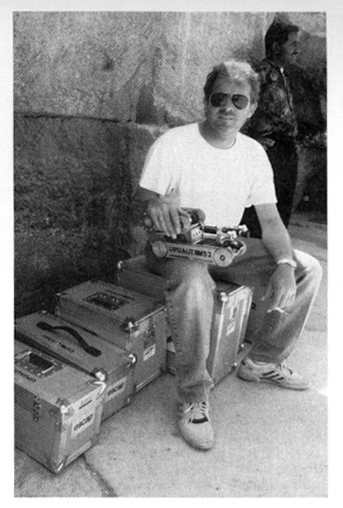
11. Rudolf Gantenbrink photographed with his equipment during his project to explore the shafts of the King’s and Queen’s Chambers in the Great Pyramid (see Chapter Seven).
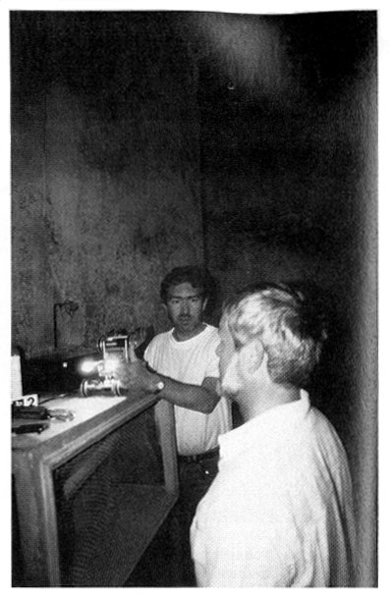
12. Rudolf Gantenbrink, Uli Kapp of the German Archaeological Institute, and the robot Upuaut in the Queen’s Chamber near the entrance to the southern shaft.
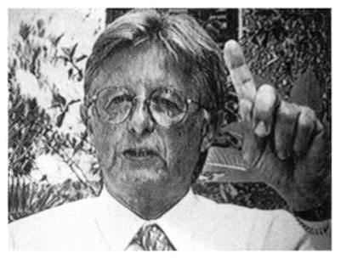
13. Rainer Stadelmann, Director of the German Archaeological Institute in Cairo.
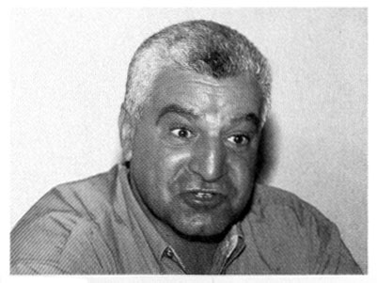
14. Zahi Hawass, Director of the Giza Pyramid Plateau for Egypt’s Supreme Council of Antiquities.
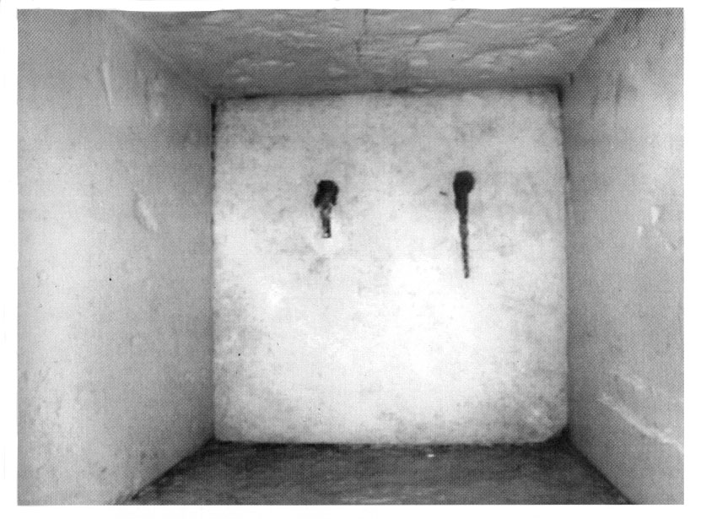
15. The door, complete with unusual metal fittings, that was filmed by Upuaut at the end of the southern shaft of the Queen’s Chamber on 22 March 1993 after a journey of some 200 feet along the shaft.
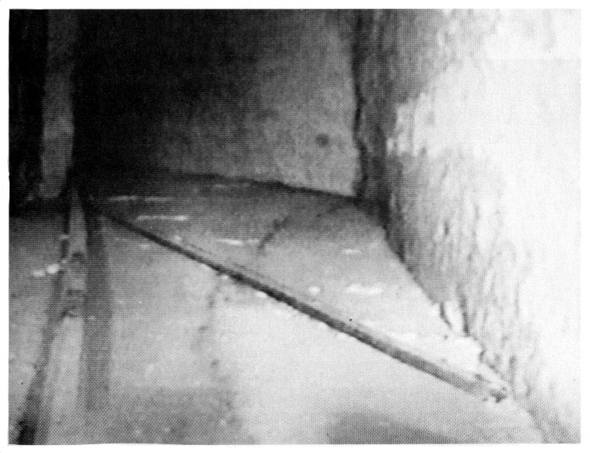
16. This photograph, taken from film shot by Upuaut, shows the deep interior of the northern shaft of the Queen’s Chamber. Lying diagonally across the floor of the shaft can be seen a length of wood which, if retrieved, could be carbon dated (see Appendix 5).
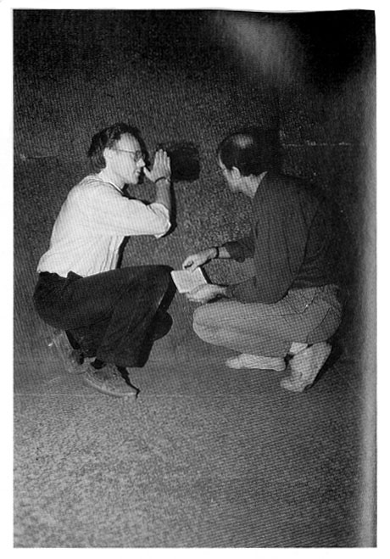
17. The authors examining the entrance to the northern shaft of the King’s Chamber.
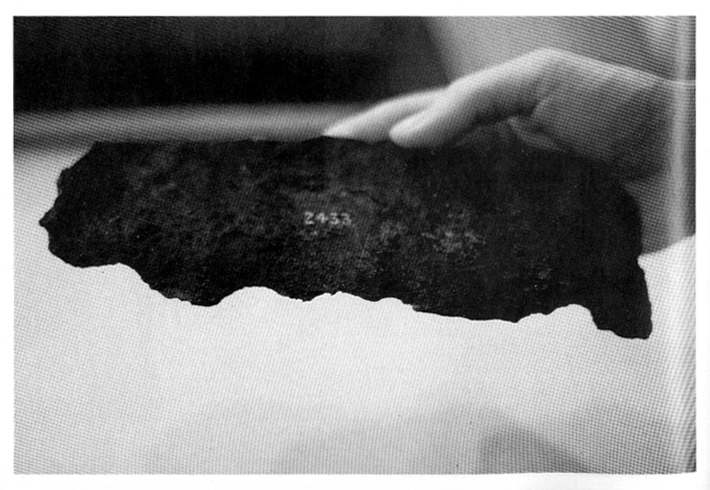
18. Fragment of the iron plate, originally coated with gold, that was extracted from the core masonry of the great Pyramid near the exit point of the southern shaft of the King’s Chamber in 1837 (see Chapter Six). Egyptologists have dismissed this curious piece of wrought iron as a late intrusion, but all the evidence suggests that it is contemporary with the Great Pyramid (which was, of course, built long before the ‘iron age’) and that its function may have been related to complex ideas concerning the stellar rebirth of the soul expressed in ancient Egyptian funerary texts.
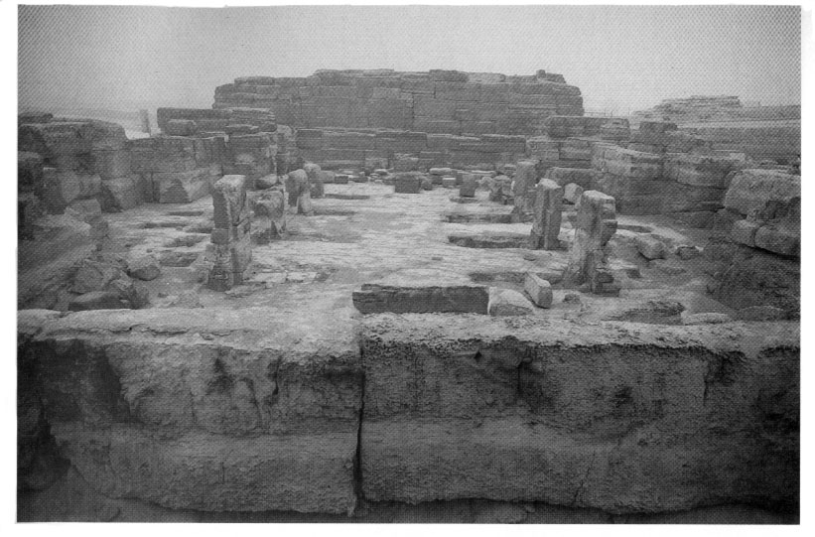
19. The megalithic architecture of the Sphinx Temple, at dawn, with the squat, massive form of the Valley Temple in the background. Many of the blocks used in the construction of the Valley Temple weigh in excess of 200 tons each. Modern engineers are unable to explain how—or why—such enormous blocks were put into position.
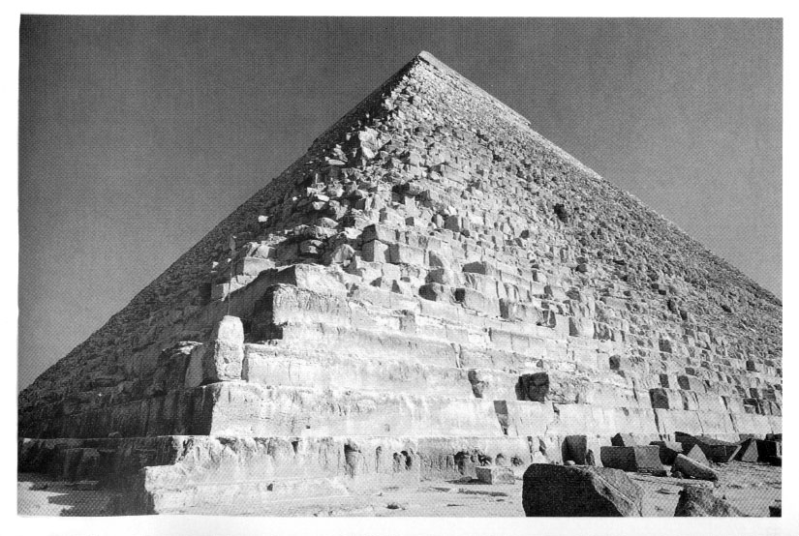
20. The lower courses at the western end of the Second Pyramid were hewn out of solid bedrock with the upper courses later built on top. It is possible that the original ‘foundation platform’ might be much older than the rest of the Pyramid.
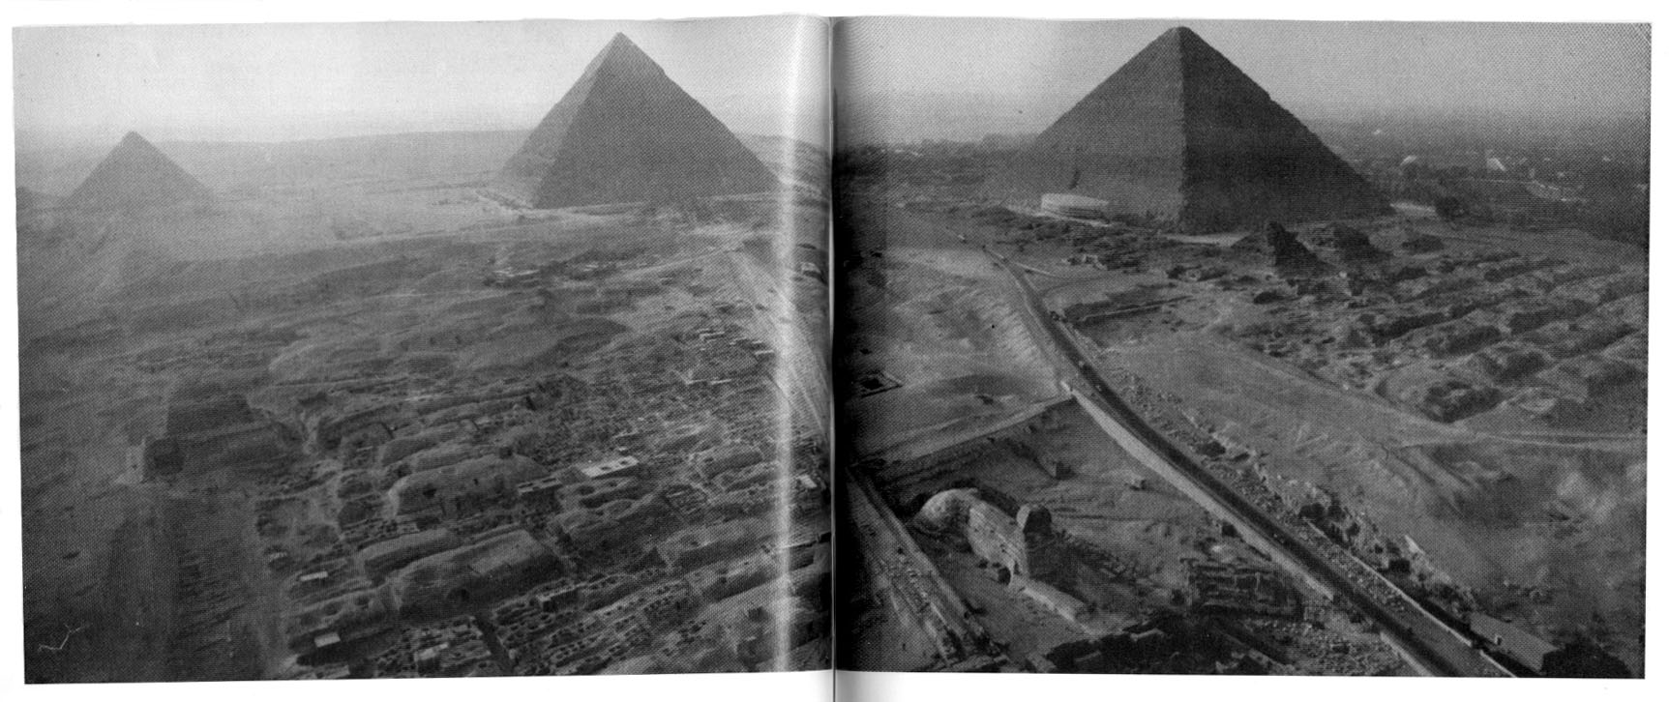
21. Overview of the Giza necropolis with the Great Sphinx and its causeway in the foreground. The causeway, which has a bearing of fourteen degrees south of due east, is not to be confused with the modern road running to the right (north) of the Sphinx.
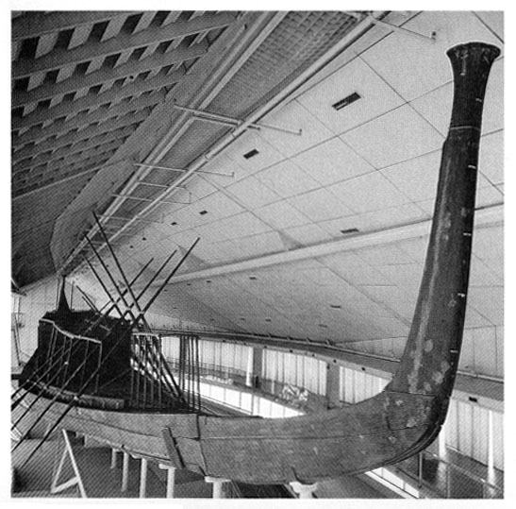
22. The so-called ‘solar boat’, 143 feet long, that was found buried in a rock-hewn trench beside the southern face of the Great Pyramid. There is much to suggest that this magnificent boat was originally used on the Nile by the Horus-Kings of Egypt in astronomical rituals that mimicked the apparent passage of the sun across the Milky Way - the celestial counterpart of the River Nile.
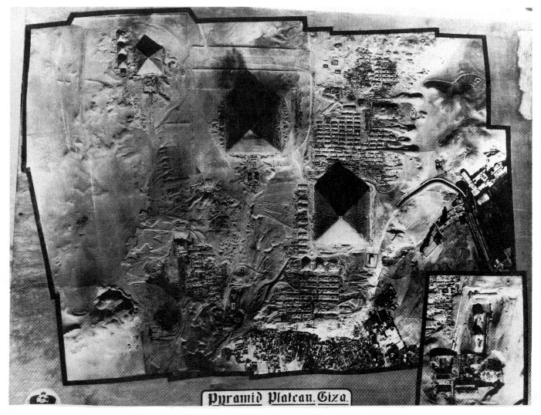
23. Aerial overview of Giza Pyramid Plateau.
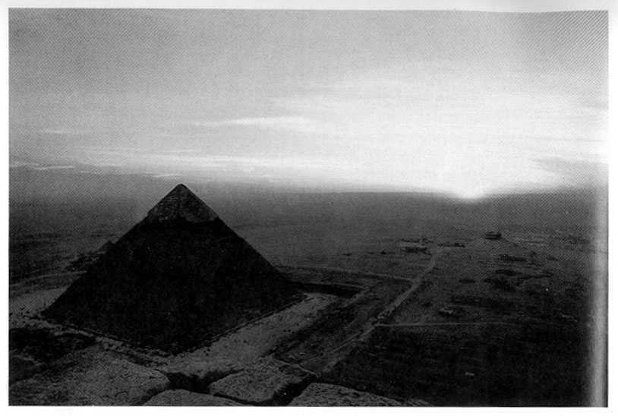
24. The Second Pyramid, viewed from the top of the Great Pyramid one month before the Spring Equinox, with the sun setting a little to the south of due west.
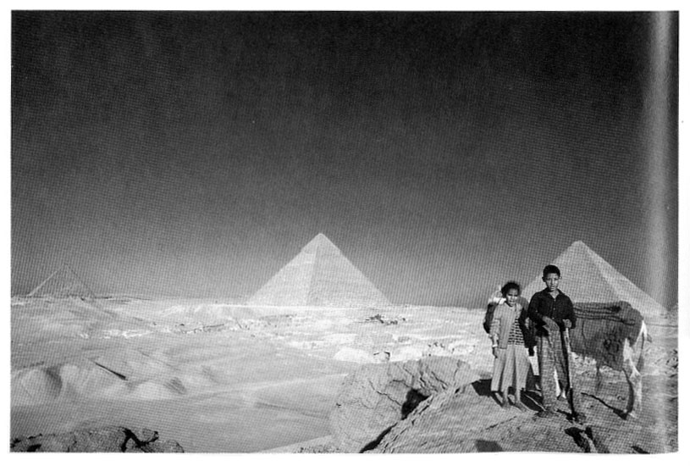
25. Overview of the Giza Pyramids from the south-east.
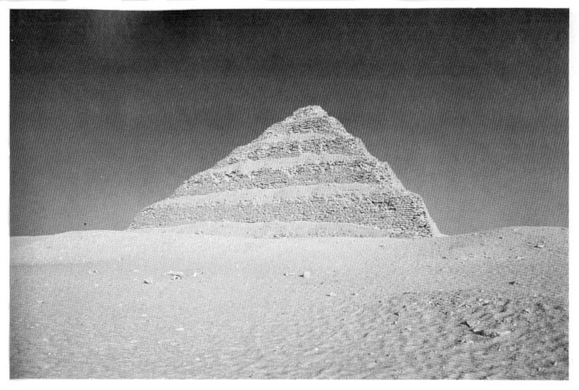
26. Step-Pyramid of Zoser at Saqqara - supposedly the oldest massive construction in Egypt. However, recent carbon-dating evidence from organic compounds in the mortar of the Great Pyramid (see Appendix 5) suggests that the Great Pyramid may be older than the Pyramid of Zoser, a state of affairs that throws orthodox Egyptological chronology into confusion.
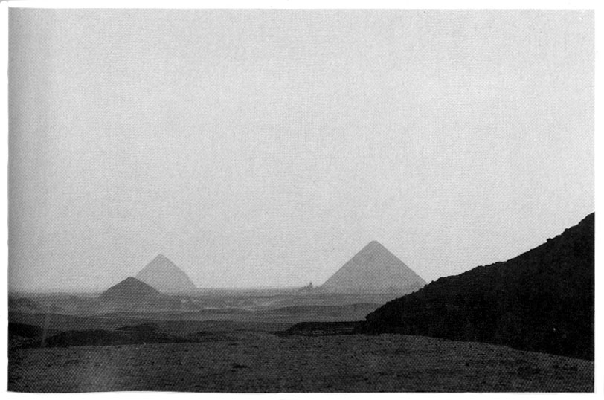
27. The Bent and ‘Red’ Pyramids of Dhashour in silhouette.
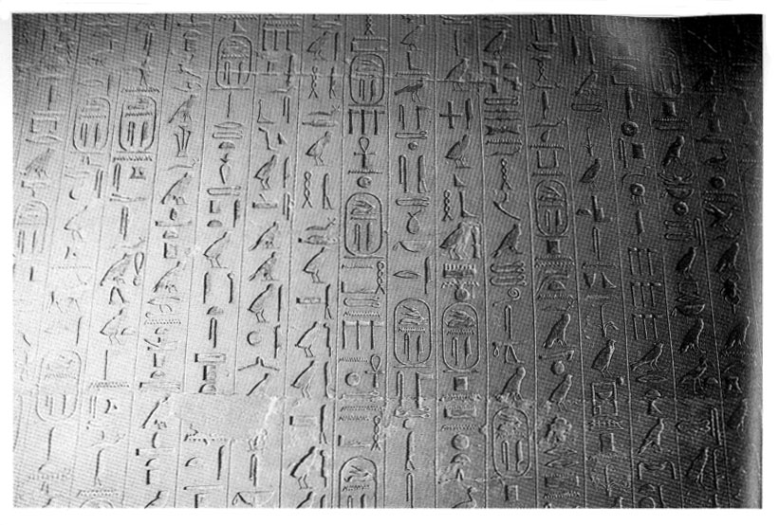
28. These inscriptions, more than 4000 years old, were carved on the walls of the tomb-chamber of Unas, last Pharaoh of the Fifth Dynasty. Belonging to a larger body of scripture now known as the ‘Pyramid Texts’, they contain complex astronomical notations that have been badly misunderstood by Egyptologists, and references to the remote ‘First Time’, Zep Tepi, when the Gods established their Kingdom in Egypt.
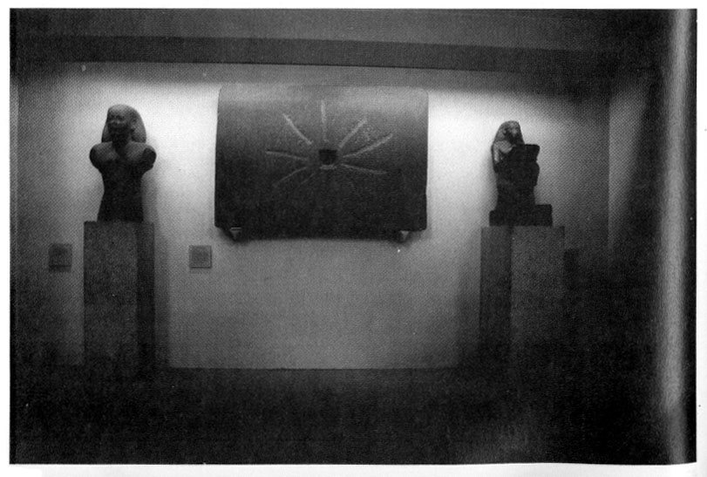
29. The ‘Shabaka Stone’ photographed in the British Museum. Inscribed with hieroglyphic texts, this relic is a vital source for the reconstruction of the lost epoch of the ‘First Time’.
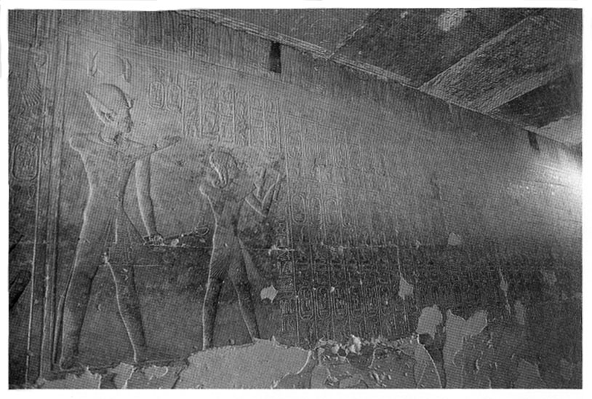
30. The Abydos King List at the Temple of Seti I in Abydos, with Pharaoh Seti I showing his young son Rameses II a list of all the Pharaohs of Egypt who had ruled before them. On the opposite wall is a list of the Gods who ruled in Egypt, going back to the remote ‘First Time’. Like the Pyramid Texts, the Shabaka Texts, and the Edfu Building Texts, the list indicates that the civilisation of ancient Egypt was seen as a legacy handed down by the ‘gods’ thousands of years before the beginning of the recognised historical period.
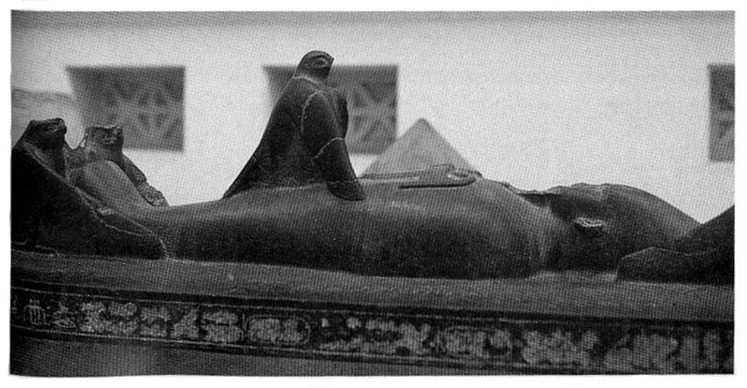
31. ‘Osiriform’ sarcophagus lid in Cairo Museum showing Isis in the form of a kite being impregnated by the mummified Osiris. The fruit of this union was Horus, archetype for all the ‘Horus-Kings’ of ancient Egypt.
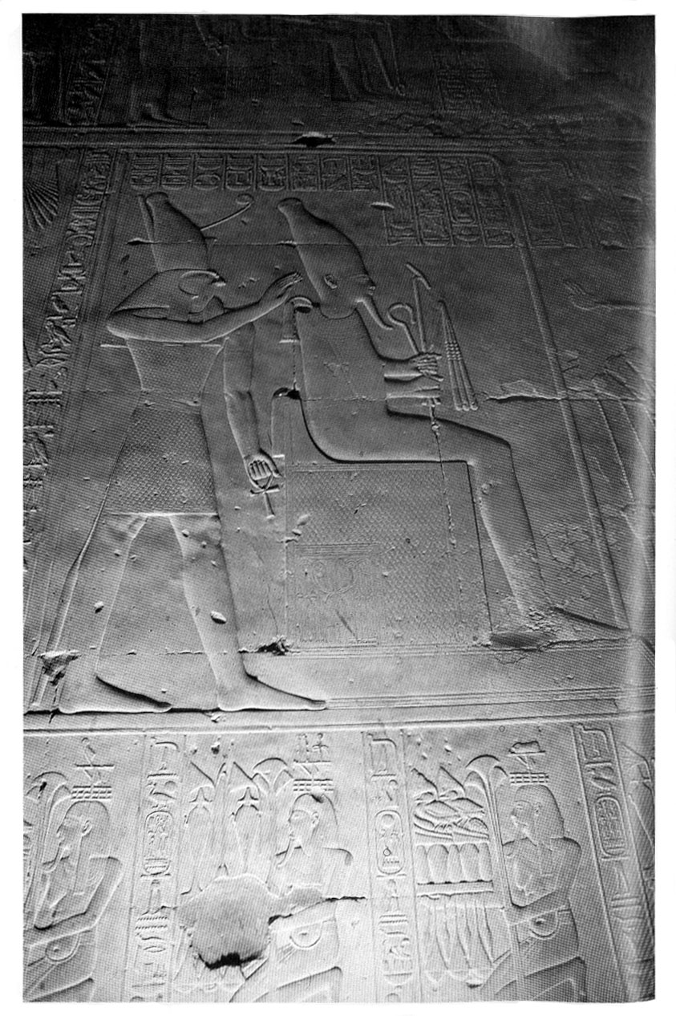
32. Relief at Abydos showing Osiris, the paramount deity of the First Time, mummified and seated, being attended to by his son Horus. In his left hand, Horus holds the ankh, symbol of immortal life.

