**Grandson of Malcolm X 'beaten to death in robbery' in Mexico 15 years after he was jailed for starting fire which killed his grandmother**

* **Malcolm Shabazz, 28, was the son of Malcolm X's second daughter, Qubilah Shabazz**
* **Malcolm X's 'first male heir' was born in 1984 and never met his activist grandfather who was assassinated in 1965**
* **Had a troubled youth shuffling from various relatives as his mother battled alcohol and drug addiction**
* **At age 12, admitted to starting apartment fire that killed his 63-year-old grandmother Betty Shabazz in 1997**
* **Was an aspiring writer, attending John Jay College in New York**
* **He was in Mexico City to meet with labor organizers before his death**

By [Daily Mail Reporter](http://www.dailymail.co.uk/home/search.html?s=&authornamef=Daily+Mail+Reporter)

Published: 12:56 GMT, 10 May 2013 | Updated: 20:33 GMT, 10 May 2013

[93](http://www.dailymail.co.uk/news/article-2322541/Grandson-Malcolm-X-beaten-death-robbery-Mexico-15-years-jailed-starting-killed-grandmother.html" \l "comments)

[View   
comments](http://www.dailymail.co.uk/news/article-2322541/Grandson-Malcolm-X-beaten-death-robbery-Mexico-15-years-jailed-starting-killed-grandmother.html" \l "comments)

Malcolm X's grandson Malcolm Shabazz died in Mexico on Thursday.

The 28-year-old was reportedly beaten to death during a robbery but the circumstances surrounding the death are unclear.

The son of Malcolm X's second daughter, Qubilah Shabazz, had a troubled childhood and at the age of 12 pleaded guilty in 1997 to setting a fire that killed his grandmother, Malcolm X's widow Betty Shabazz.

**Scroll down for video**

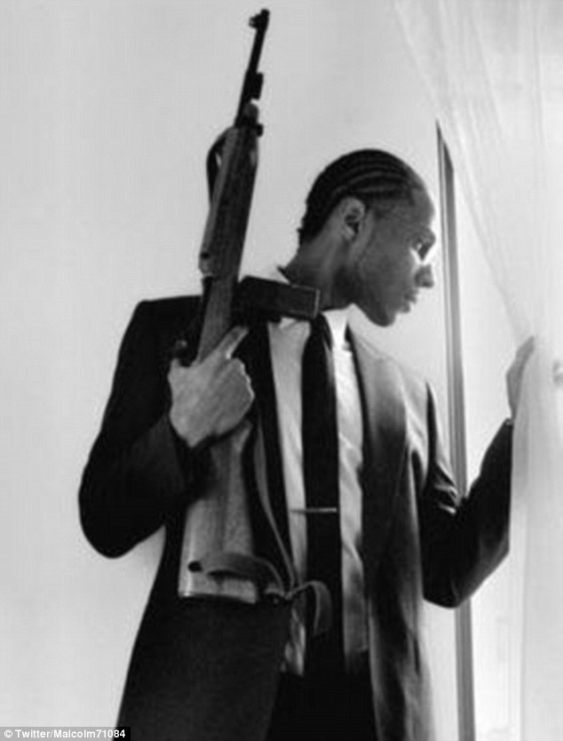

Mystery: Malcolm X's grandson Malcolm Shabazz, 28, was reportedly beaten to death during a robbery in Mexico on Thursday morning but the circumstances surrounding the death are unclear

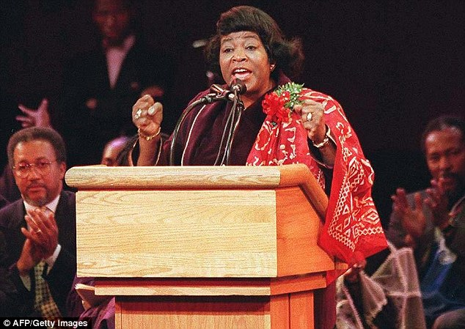

Tragedy: Malcolm Shabazz spent 18 months in jail for setting fire to his grandmother's apartment in 1997. His grandmother, Malcolm X's widow Betty (pictured in May 1995), died in the fire at age 63

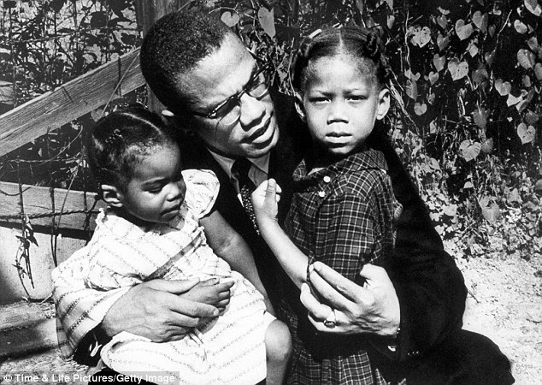

Grandfather: Malcolm Shabazz's mother, Qubilah (pictured left in 1963) was the second daughter of the Black Muslim activist Malcolm X (center) with oldest daughter Attilah (right)

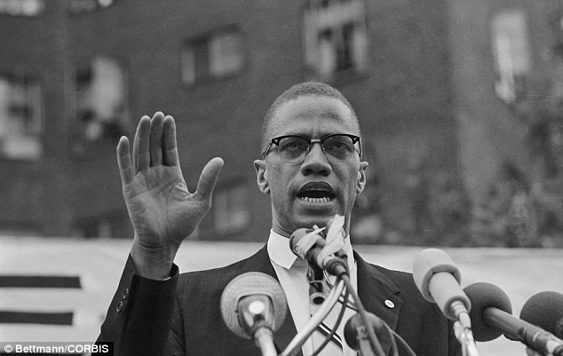

Heritage: Malcolm Shabazz was born in 1984 and never met his activist grandfather, who was assassinated in 1965 in New York (pictured the Nation of Islam leader in New York in June 1963)

The man is believed to have died early on Thursday after sustaining serious injuries from an assault, with The Amsterdam News reporting he was either thrown from a building or was shot in the course of a robbery.

The location of the rumored attack has not yet been confirmed, as some websites have claimed he died in Tijuana and other news outlets have listed the place of death as Mexico City.

Shabazz was reportedly in Mexico to meet with labor movement organizers, Talking Points Memo said.

**RELATED ARTICLES**

* [Previous](http://www.dailymail.co.uk/news/article-2322541/Grandson-Malcolm-X-beaten-death-robbery-Mexico-15-years-jailed-starting-killed-grandmother.html)
* [1](http://www.dailymail.co.uk/news/article-2322541/Grandson-Malcolm-X-beaten-death-robbery-Mexico-15-years-jailed-starting-killed-grandmother.html)
* [2](http://www.dailymail.co.uk/news/article-2322541/Grandson-Malcolm-X-beaten-death-robbery-Mexico-15-years-jailed-starting-killed-grandmother.html)
* [Next](http://www.dailymail.co.uk/news/article-2322541/Grandson-Malcolm-X-beaten-death-robbery-Mexico-15-years-jailed-starting-killed-grandmother.html)
* [[](http://www.dailymail.co.uk/news/article-2322321/Ariel-Castro-Cleveland-kidnapping-suspects-daughter-calls-given-death-penalty.html)EXCLUSIVE: 'Execute him': Cleveland kidnapping suspect's own...](http://www.dailymail.co.uk/news/article-2322321/Ariel-Castro-Cleveland-kidnapping-suspects-daughter-calls-given-death-penalty.html)[[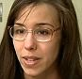](http://www.dailymail.co.uk/news/article-2321978/Jodi-Arias-suicide-watch-saying-prefer-death-sentence-life-prison.html)Jodi Arias' sentencing delayed because the convicted...](http://www.dailymail.co.uk/news/article-2321978/Jodi-Arias-suicide-watch-saying-prefer-death-sentence-life-prison.html)
* [[](http://www.dailymail.co.uk/news/article-2322505/The-Barefoot-Bandit-outran-police-years-stolen-cars-boats-planes-pens-bizarre-letter-court.html)'If I have learned any truth, it's that absolutely anything...](http://www.dailymail.co.uk/news/article-2322505/The-Barefoot-Bandit-outran-police-years-stolen-cars-boats-planes-pens-bizarre-letter-court.html)

**Share this article**

Share

Juan Ruiz, part of the California-based labor group Rumec, told the website that Shabazz was in Mexico City to meet with one of Rumec's leaders, Miguel Suarez.

Suarez had been deported from the United States last month.

'He’s a supporter of our organization. He went to Mexico to meet with Miguel,' Mr Ruiz told TPM.

'He was murdered. He was in Mexico City and I believe they attempted to rob him and he didn't allow it, so they beat him to death and he died on his way to the hospital. This is all I can confirm, everything else is under investigation for the meantime,' he added.

Imam Dawud Walid, an acquaintance of Shabazz and executive director of the Council on American-Islamic Relations in Michigan, told NBC Newns, 'I do know that Malcolm was involved in human rights and that he had a relationship with a gentleman named Suarez in Mexico.'

The U.S. State Department confirmed on Friday that a U.S. citizen had been killed in Mexico City but said it was not releasing the individual's name at the family's request.

The U.S. Embassy in Mexico City is closed on Friday as Mexico celebrates Mother's Day.

Malcolm Shabazz on setting the fire that killed his grandmother

Loaded: 0%

Progress: 0%

0:00

Play

LIVE

Mute

00:00

Current Time 0:00

/

Duration Time 1:07

Fullscreen

Need Text

Video Quality

356p

272p

172p

Foreground

Background

Window

Font Size

Text Edge Style

Font Family

DefaultsDone

MinimizeExpandClose

**Video courtesy of** [**Black and Nobel Books**](http://www.blackandnobel.com/)**. Watch more** [**here**](http://www.youtube.com/watch?v=U5Tdq7n_DZM)**.**

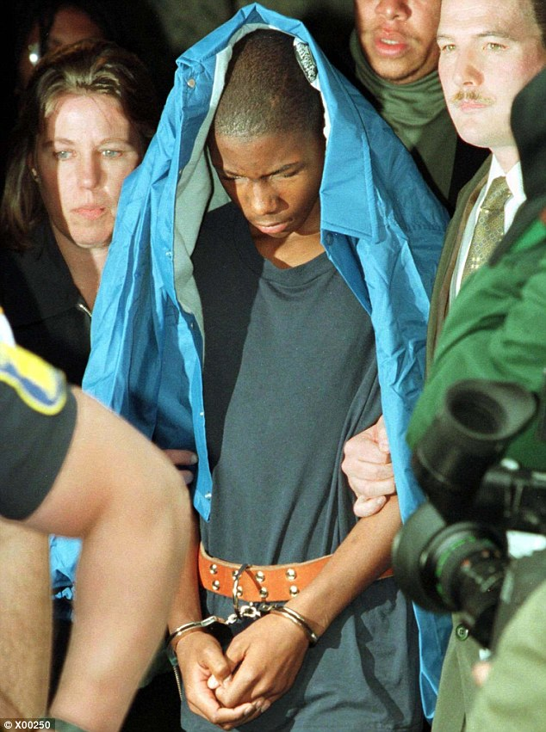

Troubled: At the age of 12, Malcolm Shabazz admitted to setting fire to his grandmother's apartment in Yonkers, New York in June 1997. He was sentenced to 18 months in a juvenile detention for manslaughter and arson

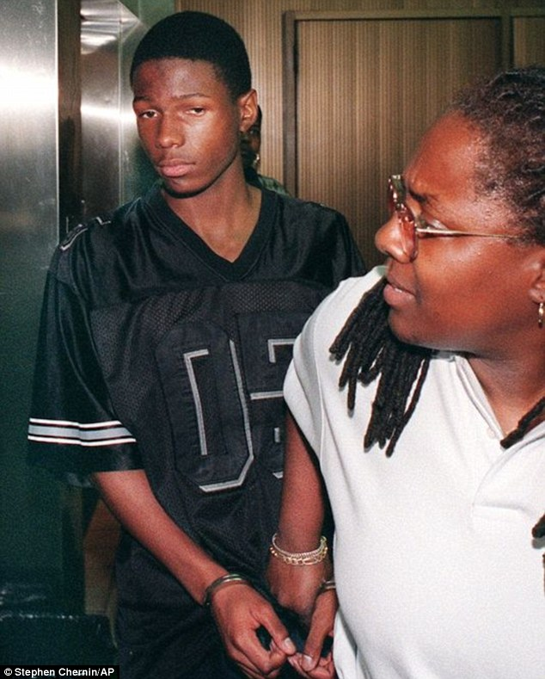

Disturbed: Malcolm Shabazz, pictured at age 14 in court in 1999, spent much of his childhood living with relatives as his mother Qubilah struggled with drug and alcohol issues

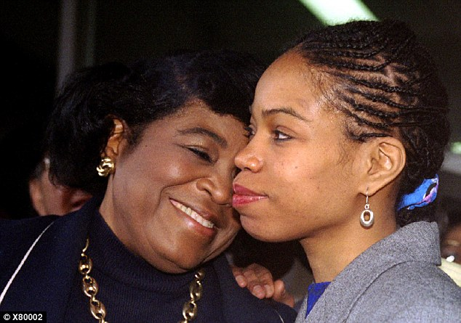

Mother: Malcolm Shabazz's mother Qubilah Shabazz (pictured right in 1995 with her mother Betty) had a relationship with an Algerian man in Paris in the eighties. She gave birth to Malcolm in 1984

The Amsterdam News first reported the man's death and later stated that the U.S. Embassy had confirmed the death.

A family friend of the Shabazz family, Terrie M. Williams, wrote in a Facebook posting, 'I'm confirming, per US Embassy, on behalf of the family, the tragic death of Malcolm Shabazz, grandson of Malcolm X. Statement from family to come.'

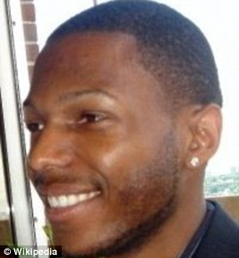

Malcolm Shabazz had tried to turn his life around. He was an aspiring author and was attending John Jay College in New York

Malcolm Shabazz was born in 1984 and never met his activist grandfather, who was assassinated in 1965 in New York.

Malcom Shabazz's father was an Algerian man, his mother had a relationship with when she studied in Paris.

His mother struggled with alcohol and drug addiction so during his childhood Malcolm Shabazz lived with various relatives.

Tragedy struck with the youth set fire to his grandmother's apartment in Yonkers, New York in 1997. The woman, Betty Shabazz, sustained burns over 80 per cent of her body and died

Malcom Shabazz, then aged 12, was sentenced to 18 months in juvenile detention for pleading guilty to manslaughter and arson.

At a court hearing in the case, experts described Shabazz as psychotic and schizophrenic.

After his release, he returned to jail in 2002 for a robbery charge and was arrested again in 2006.

He claimed earlier in 2013 that he was being harassed by the FBI, in an impassioned blog posting.

Shabazz described himself as the 'first male heir of the greatest revolutionary leader of the 20th century,' on his Twitter profile.

On his Twitter profile he lists Washington D.C. as his hometown but was said to be attending John Jay College of Criminal Justice in New York before his death.

He suggested on his blog that he was an aspiring writer and was in the process of working on the manuscripts for two books.

'Malcolm is a humble, passionate and forceful speaker who’s emerging as a voice for our generation as a writer,' his biography states.

He is survived by his mother and two daughters.

Read more: <http://www.dailymail.co.uk/news/article-2322541/Grandson-Malcolm-X-beaten-death-robbery-Mexico-15-years-jailed-starting-killed-grandmother.html#ixzz40crj1DLp>   
Follow us: [@MailOnline on Twitter](http://ec.tynt.com/b/rw?id=bBOTTqvd0r3Pooab7jrHcU&u=MailOnline) | [DailyMail on Facebook](http://ec.tynt.com/b/rf?id=bBOTTqvd0r3Pooab7jrHcU&u=DailyMail)