**NYPD Cop’s Deathbed Confession Implicates FBI and NYPD in the Assassination of Malcom X**

March 3, 2021

[0](https://www.sgtreport.com/2021/03/nypd-cops-deathbed-confession-implicates-fbi-and-nypd-in-the-assassination-of-malcom-x/#respond)

12

*by Matt Agorist,*[*The Free Thought Project*](https://thefreethoughtproject.com/malcolm-x-deathbed-confession-nypd-fbi-conspiracy/)*:*

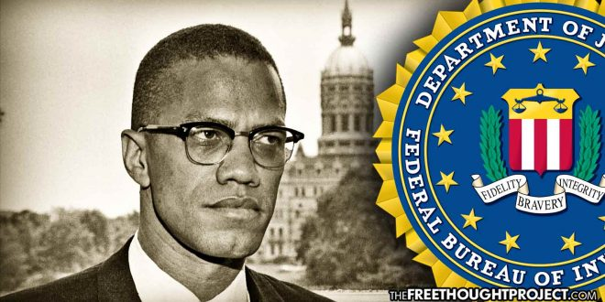

Manhattan, NY — Last month marked the [56th anniversary](https://thefreethoughtproject.com/watch-malcolm-prophetically-describes-todays-police-situation-50-year-interview/) of the assassination of Malcom X. Since that fateful day back in 1965, controversy has swarmed the case with conspiracy theories abounding. The official story happens to be one of the most flawed versions.

According to the official story, Malcolm X, born Malcolm Little in 1925, was assassinated by rival Black Muslims on February 21, 1965 while addressing his Organization of Afro-American Unity at the Audubon Ballroom in Washington Heights.

Three members of the Nation of Islam (NOI) — Talmadge Hayer or Thomas Hagan (a.k.a Mujahid Abdul Halim), Norman Butler (a.k.a Muhammad Abdul Aziz) and Thomas Johnson (a.k.a Khalil Islam) — were convicted of his murder in 1966 — despite glaring inconsistencies in the case.

TRUTH LIVES on at <https://sgtreport.tv/>

Officials at the time of his murder claimed Malcolm’s assassination was the result of an ongoing dispute between him and the NOI. Though Malcolm had left the group in 1964 on bad terms, Butler (Aziz) and Johnson (Islam) have consistently professed their innocence, and scholars who have studied the case have raised doubts about the killing’s circumstances.

What’s more, there was **no evidence linking Butler or Johnson to the crime.** Butler even had an [alibi](https://www.innocenceproject.org/malcolm-x-murder-innocent-aziz-butler/) for the time of the murder: He was at home resting after injuring his leg. This was backed up by a doctor who had treated him and who took the stand during the trial. Nonetheless, all three men were found guilty in 1966 and sentenced to life in prison. Case closed.

Following the release of a Netflix documentary series last year, that delved into these doubts, Manhattan District Attorney Cy Vance announced that his office was going to review the case. Little has come from this investigation and it looked like more lip service from officials.

Then, last week, a [letter was released](https://abc7ny.com/malcolm-x-murder-assassination-civil-rights/10357490/), reportedly written by Ray Wood who was an undercover police officer at the time. Wood’s attorney and family claim Wood wrote the letter on his deathbed confessing the NYPD and the FBI conspired to kill Malcolm X.

According to Wood’s cousin, Reggie Wood, who released the letter, Ray Wood wrote it after being diagnosed with stomach cancer back in 2011. His wishes were that the letter be released after his death. Because Ray Wood would go into remission, Reggie did not release the letter until now.

**“For 10 years I’ve carried this confession secretly in fear of what could happen to my family and myself if the government found out what I knew,” Reggie Wood said.**

Raymond Wood, he said, “lived in constant fear for 46 years, worried about what the NYPD and FBI would do to his family if he had told the dark secrets that he held that helped destroy Black leaders and Black power organizations.”

After Wood’s death in November, Reggie Wood contacted civil rights attorney Ben Crump and the letter was [released.](https://abc7ny.com/malcolm-x-murder-assassination-civil-rights/10357490/)

The letter described how Raymond Wood, while working as an undercover NYPD officer, was assigned to a unit that infiltrated civil rights groups in search of illegal activities so that the FBI could arrest their leaders.

The Washington post [reported](https://www.washingtonpost.com/history/2021/02/27/malcom-x-letter-fake/) that on February 1965, according to the letter, Wood’s supervisors had him lure two key players on Malcolm X’s security team into a plot to bomb the Statue of Liberty. Four people were arrested on Feb. 16 on charges that they sought to blow the head off the structure, and Wood was credited on the [front page of the New York Times](https://timesmachine.nytimes.com/timesmachine/1965/02/17/95531017.html?pageNumber=1) for infiltrating the group.