**Role in Assassination of Malcolm X**

**HEADLINE**FEB 22, 2021

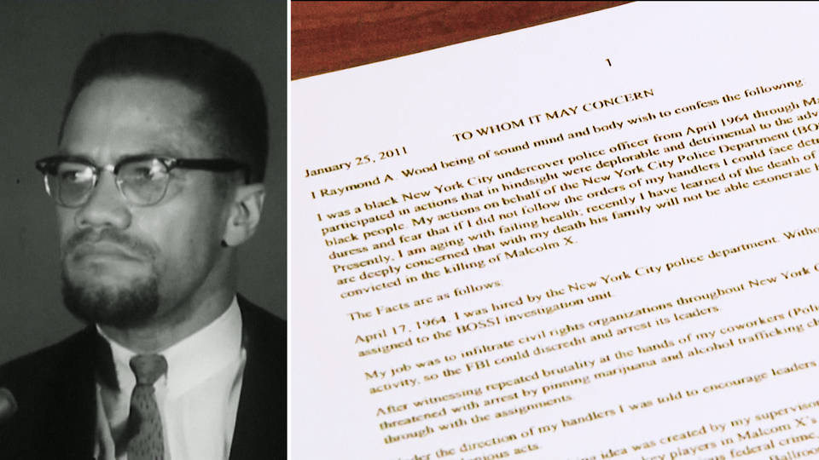

The family of civil rights icon Malcolm X is demanding authorities reopen an investigation of his assassination, after new evidence was unveiled in a letter by a former police officer. Raymond Wood — who did not want the letter to be made public until after his death — wrote he was manipulated by New York police and the FBI, who covered up key details of a plot to kill Malcolm X. Wood says he was tasked with arresting members of Malcolm X’s security team. This is Raymond Wood’s cousin Reggie Wood, reading the letter at a press conference Saturday, a day before the anniversary of Malcolm X’s assassination in 1965.

**Reggie Wood**: “It was my assignment to draw the two men into a felonious federal crime so that they could be arrested by the FBI and kept away from managing Malcolm X’s Audubon Ballroom door security on February 21st, 1965. On February 16th, 1965, the Statue of Liberty plot was carried out, and the two men were arrested, just days before the assassination of Malcolm.”