A NEW LOOK AT AN OLD DESIGN
THE PREHISTORIC ALIGNMENT OF WORLD WONDERS
BY JIM ALISON
http://home.hiwaay.net/~jalison/
PART I - ON THE LINE
Easter Island is exactly aligned along a straight line around the center of the Earth, with the Nazca lines, Ollantaytambo , Tassili n'Ajjer and the Great Pyramid of Egypt. Other world wonders that are within one tenth of one degree of this alignment include: Perseopolis, the capital city of ancient Persia; Mohenjo Daro, the ancient capital city of the Indus Valley; the Oracle of Zeus-Amon at Siwa; and the lost city of Petra. The Ancient Sumarian city of Ur and Angkor temples in Cambodia and Thailand are within one degree of latitude of this alignment.
The alignment of these sites is easily observable on a globe of the Earth with a horizon ring. If you line up any two of these sites on the horizon ring, all of the sites will be right on the horizon ring. 3-D world atlas software programs can also draw this line around the Earth. Start on the Equator, at the mouth of the Amazon River, at 48° 36' West Longitude; go to 30° 22' North Latitude, 41° 24' East Longitude, in the Middle East, which is the maximum latitude the line touches; then go to the Equator at 131° 24' East Longitude, near the Northwest tip of New Guinea; then to 30° 22' South Latitude, 138° 36' West Longitude, in the South Pacific; and then back to 48° 36' West Longitude, at the Equator.
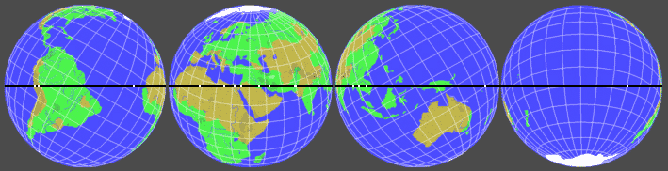
Images © On Top of the World

Centered on:

0.00° N 48° 36' W | 30° 22' N 41° 24' E | 0.00° N 131° 24' E | 30° 22' S 138° 36' W
The circumference of this line around the center of the Earth is 24,892 miles. Along this line, the great circle distance from the Great Pyramid to Ollantaytambo 7,472 miles, 30.0% of the circumference. Ollantaytambo is 2,579 miles from Easter Island, 10.3%. Easter Island is 10,096 miles from Angkor Wat, 40.6%. Angkor Wat is 2,490 miles from Mohenjo Daro, 10.0%. Mohenjo Daro is 2255 miles from from the Great Pyramid, 9.1%. In addition to calculating the distances between these sites as a percentage of the circumference of the Earth, the distances may also be calculated in degrees of the 360° circumference, by multiplying the percentage by 3.6. For example, the Great Pyramid is 108° away from Ollantaytambo. Near Ollantaytambo, Machupicchu is within one quarter of a degree and Cuzco is within one third of a degree of the alignment.
Angkor Wat and Angkor Thom were constructed at a time when 72 temples were built around Angkor. The temple at Prassat Preah Vihear, 90 miles Northeast of Angkor Wat, is within one fourth of one degree of the line. Bearing a striking visual resemblance to Angkor Wat, the temple at Phimai in Southeastern Thailand is within one half of one degree of the line. The ancient temple cities of Sukhothai in Thailand and Pyay in Myanmar are within one tenth of one degree of the line.
Halfway between Angkor Wat and the Great Pyramid is the Indus Valley, the city of Mohenjo Daro, and the unexcavated city of Ganweriwala, which is East of Mohenjo Daro, and thought to be just as large. Both of these sites are on the line between Angkor and the Great Pyramid. The Indus Valley is also antipodal to Easter Island. It is an interesting coincidence concerning these two sites, opposite each other on Earth, that of the few ancient written languages of the world that remain undeciphered, two are Indus Valley Script and Rongorongo, the written language of ancient Easter Island. The world's first known written languages, Egyptian Hieroglyphics and Sumerian Cuneiform, were also developed along this line of ancient sites. The Jewish, Christian, Muslim, Hindu, Brahman and Buddhist religions, as well as ancient Egyptian and Peruvian religions, were also developed along this line.
Anatom Island is the southernmost Island in the new Republic of Vanuatu, formerly known as the New Hebrides. Anatom Island is exactly halfway between Easter Island and Angkor Wat 5,048 miles each way, or 20.3% of the circumference of the Earth. Stone ruins on Anatom Island once housed the largest missionary church in the southern hemisphere.
The line crosses over the source and the mouth of the Amazon, the mouth of the Nile, the mouth of the Tigris-Euphrates, the Indus River and the Bay of Bengal near the mouth of the Ganges.
The line also crosses over a number of areas of the world that are largely unexplored or unexcavated, including the Sahara Desert, the Brazilian Rainforest, the highlands of New Guinea, and underwater areas of the North Atlantic Ocean, the South Pacific Ocean and the South China Sea. For example, the midway point between the Great Pyramid and Machupicchu is in the North Atlantic Ocean, less than one degree south of the Cape Verde Islands. This is also the midway point between Easter Island and the Indus Valley. Although the Cape Verde Islands were found to be uninhabited when they were rediscovered in 1460 A.D., maps and geographical descriptions for the past 2000 years have shown this location to be the home of ancient island civilizations, including maps showing this location to be the site of Atlantis. In Plato's account of Atlantis, there was a mountainous region north of the city. Are the higher elevations of those mountains now the Cape Verde Islands?
PART 2 - ALIGNMENTS OF THE NAZCA LINES & FIGURES
The glyphs and lines at Nazca are oriented along the line of ancient sites. This image of the glyphs at Nazca, with a compass bearing, is available on the internet, but it is usually oriented away from the cardinal points so that the figures are roughly horizontal and vertical. Rotating this image so that the north-south axis is vertical, aligns the figures and geometric drawings to the line of ancient sites as it crosses Nazca. | 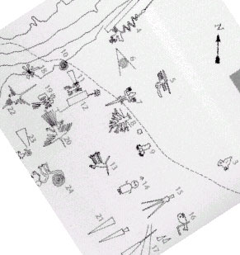

Nazca is marked by the yellow cross on the illustration. The vertical line in the center of the picture is 75° West Longitude. The horizontal line is 15° South Latitude. The white dot touching the north side of the line on the upper right side of the illustration is Machupicchu. | 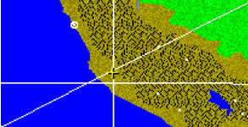  Image © On Top of the World

This illustration of the Nazca lines has also been rotated so that the north-south axis is vertical, and shows the primary orientation of the lines is from Southwest to Northeast, along the line of ancient sites. | 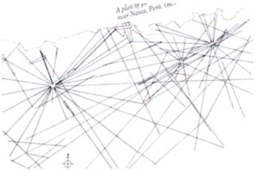

PART 3 - COORDINATES AND CALCULATION OF ALIGNMENT
http://home.hiwaay.net/~jalison/links.html
 |  |  |  |  |  | Distance To: |  |  | Distance To:
Links: |  | Latitude |  | Longitude |  | 59°38'N 138°36'W |  |  | Line of Ancient Sites
The Great Pyramid |  | 29° 59' N |  | 31° 09' E |  | 6,215 miles |  |  | 0 miles
Siwa |  | 29° 14' N |  | 25° 31' E |  | 6,223 miles |  |  | 8 miles
Ollantaytambo |  | 13° 15' S |  | 72° 16' W |  | 6,215 miles |  |  | 0 miles
Machupicchu |  | 13° 06' S |  | 72° 35' W |  | 6,198 miles |  |  | 17 miles
Nazca |  | 14° 42' S |  | 75° 06' W |  | 6,215 miles |  |  | 0 miles
Easter Island |  | 27° 06' S |  | 109° 20' W |  | 6,215 miles |  |  | 0 miles
Anatom Island |  | 20° 10' S |  | 169° 48' E |  | 6,215 miles |  |  | 0 miles
Preah Vihear |  | 14° 24' N |  | 104° 40' E |  | 6,235 miles |  |  | 20 miles
Phimai |  | 15° 13' N |  | 102° 50' E |  | 6,240 miles |  |  | 25 miles
Sukothai |  | 17° 01' N |  | 99° 42' E |  | 6,218 miles |  |  | 3 miles
Pyay |  | 19° 15' N |  | 95° 05' E |  | 6,207 miles |  |  | 8 miles
Mohenjo Daro |  | 27° 15' N |  | 68° 17' E |  | 6,231 miles |  |  | 16 miles
Perseopolis |  | 29° 56' N |  | 52° 55' E |  | 6,211 miles |  |  | 4 miles
Ur |  | 30° 57' N |  | 46° 07' E |  | 6,169 miles |  |  | 46 miles
Petra |  | 30° 19' N |  | 35° 28' E |  | 6,210 miles |  |  | 5 miles

PART 4 - THE AXIS POINT
Just as every point along the equator is 6,215 miles from both the North and South Poles, every point along the line of ancient sites is 6,215 miles from two axis points on Earth. The axis point in the Northern Hemisphere is near the Southeastern coast of Alaska, at 59° 38' N 138° 36' W, 20 miles Northeast of Yakutat, Alaska
The North and South Poles have not always been in their present locations. Several theories have been offered to explain observed and suspected movements of the poles in relation to the surface of the Earth. Plate tectonics, the prevailing theory, suggests gradual movements of the surface of the Earth. This theory has been called into question by recent measurements of relative movements of the earth's surface, and by accumulating seismological data. Alternative theories include: Axial shifts; polar wander; and a catastrophic form of polar wander known as Earth crust displacement.
Charles Hapgood advocated the Earth crust displacement theory in a book entitled The Path of the Poles. Hapgood supported this theory with geomagnetic and carbon dated evidence. In a book entitled When the Sky Fell, Rose and Rand Flem-Ath also advocate the Earth crust displacement theory, with additional geological and archeological evidence. Both of these works conclude that the North Pole was located in the Yukon, at 63° N 135° W, approximately 80,000 to100,000 years ago.  This is about 250 miles Northeast of the axis point for the line of ancient sites at 59° 38' N 138° 36' W. It is interesting to note that some of the heaviest remaining glaciation in all of North America is on the Southeastern coast of Alaska, surrounding Yakutat.  If 59° 38' N 138° 36' W was the location of the North Pole, then the line of ancient sites would have been the equator at that time. The concentric circles in the diagram represent lines of latitude from 59° 38' N 138° 36' W. The circle closest to the center of the diagram is 75°N, followed by 60°N, 45°N, 30°N and 15°N. The line of ancient sites is just beyond the horizon. | 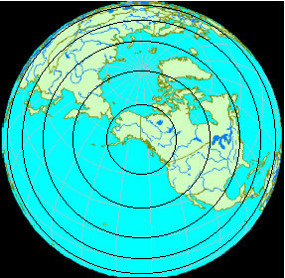  Image © Cosmi 3-D World Atlas
Since many of the sites along the line are precisely oriented to the present North and South Poles, it is not suggested that they were constructed when the poles were in a prior location. However, if this line had previously been the equator, the placement of these sites on this line would be a remarkable coincidence.
In a book entitled Atlantis Blueprint, Rand Flem-Ath and Colin Wilson have listed some of these sites, and a number of other sites, in relation to their calculation of the North Pole in the Yukon, including sites that would have been on the equator during this prior polar alignment. A line around the center of the earth, with the Yukon Pole as it’s axis point, approaches and crosses over the line of ancient sites at antipodal points in Peru and Cambodia. Along the line of ancient sites, the sites in these two areas are close to being equally distant from the Yukon Pole and from the Yakutat axis point.
None of the theories offered to explain the motions of the surface of the Earth, relative to the poles, can pinpoint exact prior polar positions. The round number coordinates that are used by Hapgood and the Flem-Aths for the Yukon Pole indicate that they are approximations. If the line of ancient sites was originally selected because of its equatorial relationship with a prior polar alignment, the most accurate way to determine the location of the prior alignment is to simply calculate it from the location of the line of ancient sites.
PART 5 - THE GREAT PYRAMID, PERU & PYTHAGORAS
The Great Pyramid precisely expresses the 2π relationship between the circumference and the radius of the Earth. The height of the Great Pyramid is 481.4 feet. The perimeter of the Great Pyramid (the length of all four sides at the base of the pyramid) is 3,023 feet. The height of the Great Pyramid times 2π (6.28) is 3,023 feet.
The relationship of the distances between the Great Pyramid, Nazca, and the axis point of the line of ancient sites, precisely expresses this same 2π relationship.  Inspired by Charles Hapgood's Earth crust displacement theory, Jim Bowles, a retired NASA engineer, wrote The Gods, Gemini, and the Great Pyramid. In his book, Bowles provides a scientific explanation for the causes of Earth crust displacements. He also discusses many similarities between the lines and figures at Nazca, the Great Pyramid and ancient Egyptian hieroglyphic texts. Bowles observes that the Great Pyramid and the Nazca lines and figures would have been on the equator if the North Pole had been in southeastern Alaska, and in a lengthy proof using coordinate derivations and spherical trigonometry he demonstrates the 2π relationship between the three sites. Of course, this 2π relationship exists between the Great Pyramid, Nazca and the axis point for the line of ancient sites, regardless of whether or not the axis point was once the North Pole. | 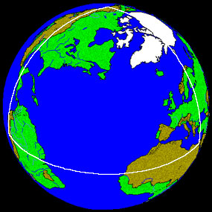  Image © On Top of the World

This relationship may also be demonstrated by diagramming the great circle distances between the three sites on a flat surface. Along the line of ancient sites, the distance from the Great Pyramid to the Nazca lines is 7,677.6 miles. The distance from the line of ancient sites to the axis point in southeastern Alaska is 6,215 miles. This triangle, with a base of 7,677.6 miles and sides of 6,215 miles, forms an isosceles triangle with base angles of 51° 51' and a height of 4,887.72 miles. The height of the triangle is calculated using Pythagoras' theory (a² + b² = c²). The height of the triangle times 2π equals the base of the triangle times four.  3.1416 x 2 = 6.2832  4,887.72 miles x 6.2832 = 30,710.4 miles  7,677.6 miles x 4 = 30,710.4 miles | 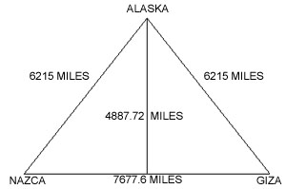

Another special triangular relationship, found in the dimensions of the King's Chamber in the Great Pyramid, is the 3-4-5 right triangle that elegantly expresses Pythagoras' theory (3² + 4² = 5²). In the King's Chamber, the diagonal length of the east wall is 309", the length of the chamber is 412", and the long central diagonal is 515". The stone over the entrance to the King's Chamber is the only stone in the walls that is two courses high. This stone also expresses a 3-4-5 right triangle relationship by its measurements of 124"L x 93"H x 155" diagonal.
The distances between the Great Pyramid, Ollantaytambo, and the axis point of the line of ancient sites, express this same 3-4-5 relationship. The distance from the Great Pyramid to Ollantaytambo (7,472 miles) is exactly 30.0% of the circumference of the Earth. The distance from the Great Pyramid and from Machupicchu to the axis point for the line of ancient sites is exactly 25% of the circumference of the Earth. Dividing this isosceles triangle by it's height forms two 15%-20%-25% right triangles. | 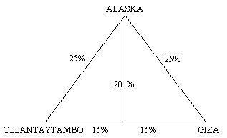

PART 6 - LIGHT AND SHADOW - FACES IN THE ANDES
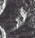
On November 7, 1995, this satellite image of the Peruvian Andes was generated by synthetic aperture radar. This image may also be viewed at NASA's Tropical Rainforest Information Center, on tile X23 - mosaic 123 - image 151330724195311. In the middle of the image below, about three inches from the left edge, is Machupicchu, Peru, although Machupicchu does not have structures large enough to be clearly visible. Near the line of ancient sites, about twenty miles east of Machupicchu (two inches from the top of the image below and an inch from the right edge) is the image pictured above.
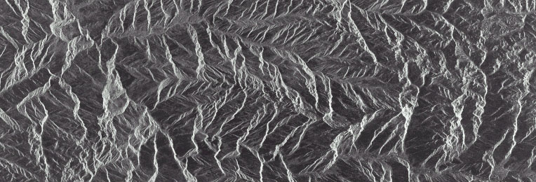
Image © NASDA/MITI - #151330724195311
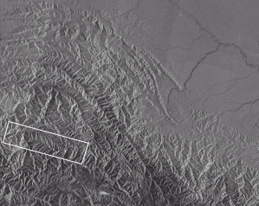  Image © NASDA/MITI - TILE X23 | 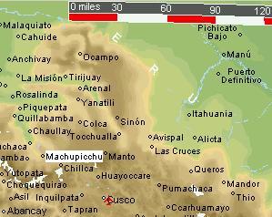  Image © VectorGlobe

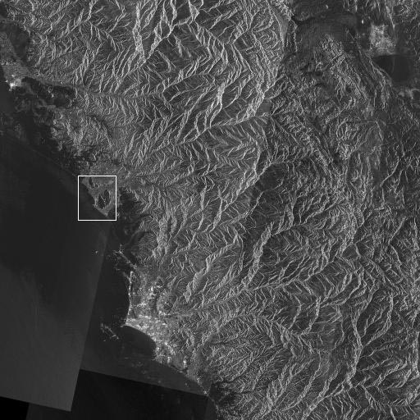 | Along the coast of Peru, the lighter area towards the lower portion of this satellite image is Lima. The close up below shows a large rock outcrop in the shape of two faces with headdress.  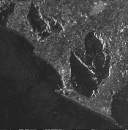

PART 7- WHERE IN THE RAINFOREST
After the discovery of America by Europeans, there were early reports an abandoned city of megalithic stone construction in the Amazon rainforest. The legendary golden city of El Dorado was also believed to be hidden under the rainforest. Explorers such as Percy Fawcett and Sir Walter Raleigh have searched for these sites, but their location(s) remain unknown.
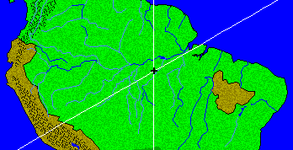  Image © On Top of the World | 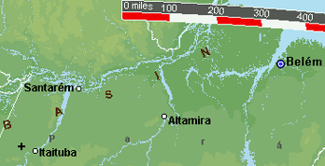  Image © VectorGlobe

Along the line of ancient sites, the great circle distance from the Great Pyramid to 4° 06' South Latitude, 56° 21' West Longitude, is 6,215 miles (exactly 25% of the circumference of the Earth). The distance from these sites to the axis point in Southeast Alaska is also 6,215 miles, forming a perfect equilateral triangle.  As the line of ancient sites goes around the Earth, the azimuth, or compass bearing, of the line changes. It is interesting to note that at 4° 06' S, 56° 21' W, the azimuth of the line of ancient sites is precisely 60° (the angle between the line of ancient sites going in the direction of the Great Pyramid, and a verticle line of longitude going North). | 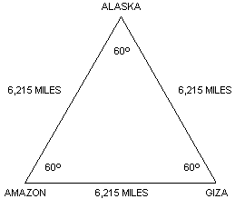
The Amazon Basin has been mapped by satellite photography, but most areas are hidden under the rainforest.
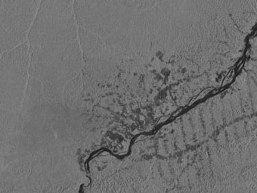  Image © NASDA/MITI | 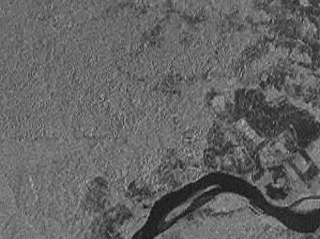  Image © NASDA/MITI
These are satellite images of Itaituba and 4° 06' S, 56° 21' W. The image on the right is a 4x magnification. The dark areas on the images are areas where the forest has been cleared around Itaituba.
During construction of the Transamazon highway, significant gold deposits were discovered near Itaituba. There are numerous caverns with drawings over 8,300 years old in this area, including caverns along the line of ancient sites near Paraiso and Itaituba.  If the special triangular relationships between the axis point of the line of ancient sites, the Great Pyramid, Nazca and Machupicchu are not coincidences, a good place to look for another marker of geometric significance would be six miles northeast of the village of Paraiso, at 4° 06' S, 56° 21' W. | 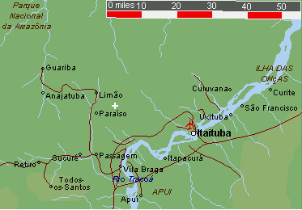  Image © VectorGlobe

PART 8 - EASTER ISLAND SYNCHRONICITY
The three volcanic peaks on Easter Island form an isosceles triangle with base angles of 36°. The relationship between the length of the base of this triangle and the lengths of the sides precisely expresses φ:  1.95 x 1.618 = 3.16.  The Great Pyramid is 10,055 miles from the Southwestern volcanic peak on Easter Island. A triangle formed by the great circle distances between Easter Island, the Great Pyramd, and the axis point for the line of ancient sites in S. E. Alaska, has the same angular dimensions as the triangle formed by the volcanic peaks on Easter Island, and also precisely expresses φ:  6, 215 x 1.618 = 10,055  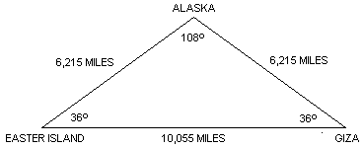 | 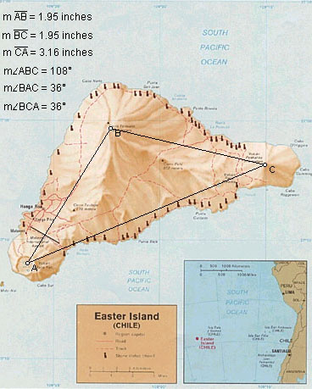

The large triangles in five pointed stars have these same angular dimensions, and express the same φ relationship. All of the angles in five pointed stars, 36°, 72° and 108°, are numbers that have been associated with the precession of the equinoxes, as well as the internal designs of the Great Pyramid and other ancient sites around the world.  There are 72 major monuments at Angkor, 108 stone figures surround Angkor Thom, and the highest terraces of Angkor Thom house 72 Buddhas in latticework stupas. | 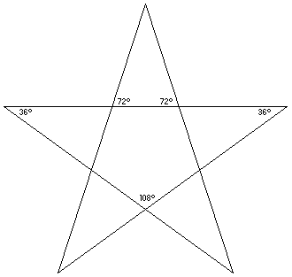

The great circle distances between Angkor Thom, the ziggurat at Ur, and the axis point of the line of ancient sites, forms an isosceles triangle with base angles of 72°. The small triangles in five pointed stars have these same angular dimensions, also precisely expressing φ:  3,841 x 1.618 = 6,215.  These relationships are also clearly demonstrated by the metric system, which is based on a distance of 10,000 kilometers from the North Pole to the Equator. The distance from Easter Island to the Great Pyramid is 16,180 kilometers and the distance from Ur to Angkor is 6,180 kilometers:  6,180 x 1.618 = 10,000.  10,000 x 1.618 = 16,180. | 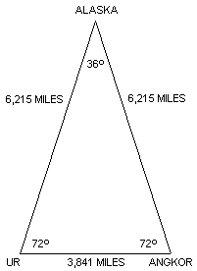

PART 9 - SINE LANGUAGE
As the Earth rotates on it’s axis, the Equator remains aligned, but the line of ancient sites describes a sine wave as a result of it’s tilt relative to the Equator. The line of the ecliptic may be observed describing a similar wave by spinning a globe that has a line of the ecliptic. The wave may also be visualized by drawing the line of ancient sites on a flat projection of the Earth.
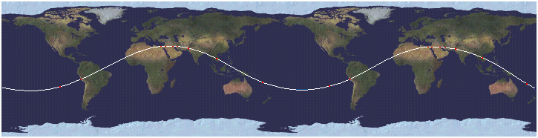
Image © Cosmi 3-D World Atlas
Harmonics, electricity, and many other aspects of nature are based on sine waves. Because this particular wave repeats with each full rotation of the earth, the frequency of the wave is equal to the circumference of the Earth. The amplitude of this wave, measured from the middle of the wave (the equator), is 30° of latitude. Recall that the 30th parallels are ½ of the height of each hemisphere, or ½ of the radius of the Earth.
Since the height of the wave is equal to ½ of the Earth’s radius, the ratio between the frequency of the wave and it’s amplitude is 4π. Measuring the amplitude from the top of the wavelength to the bottom (from 30° N to 30° S), the amplitude is equal to the radius of the Earth, and the ratio between the frequency and the amplitude of the wave is 2π.

PART 10 - THE GREAT PYRAMID AND THE 30th PARALLEL
This circle has a different orientation than the previous diagrams and is two inches in diameter. The horizontal axis is the Equator, FC is the 30th parallel, D is 60° North latitude and E is the North Pole. The 30th parallel is exactly one-third of the great circle distance from the Equator to the North Pole, and it is located at exactly one-half of the height of the Northern Hemisphere. Like the Great Pyramid, the maximum latitude of the line of ancient sites is very close to the 30th parallel. | 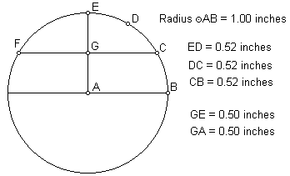

This diagram illustrates that the relationship of the 30th parallel to the circumference of the Earth is the geometric relationship known as the Vesica Pisces. In relation to the lower circumference, DE is at 30° N latitude. In relation to the upper circumference, DE is at 30° S latitude. The ratio between the straight line distance of the 30th parallel and the radius of the Earth is 1.732 to one. 1.732 is the square root of three. | 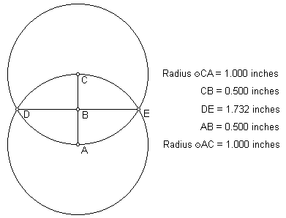

Paul Michell and Charles Henry have noted the relationship between the Great Pyramid and the Vesica Pisces. The small circles in this diagram are one inch in diameter, and the large circles are three inches in diameter, forming a small Vesica Pisces circumscribed by a larger one. The triangle in this diagram has the same angular dimensions as the Great Pyramid. | 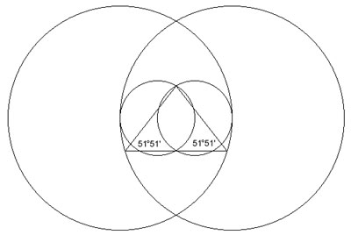

The circle in this diagram also represents the circumference of the Earth with the poles on the vertical axis. The radius of the circle is 1.00 inch. The exterior and interior equilateral triangles touch the circle only at the 30th parallels and the poles. The height of each equilateral triangle is 87% of the length of each of it’s sides:  3.00 ÷ 3.46 = .87  1.50 ÷ 1.73 = .87  1.00 ÷ 1.15 = .87  The length of each of the sides of the interior triangles, including the straight line distance through the earth at the 30th parallel, is also 87% of the diameter of the Earth:  1.73 ÷ 2.00 = .87  The radius of the Earth is also 87% of the distance from the center of the Earth to the point of the exterior triangles’ intersections (AP, AQ, AR, etc.):  1.00 ÷ 1.15 = .87 | 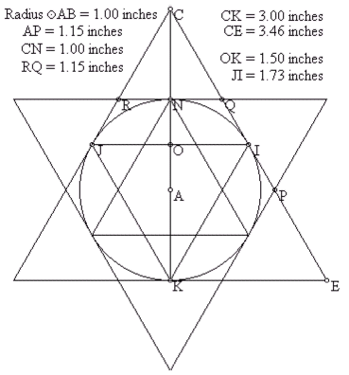
The Greek foot is thought to have been developed before the size and shape of the Earth was known and independently from the foot, which is also thought to have been developed before the size and shape of the Earth was known. The foot is 87% of the length of the Greek foot.
The mile, which is thought to have been developed before the size and shape of the Earth was known, is 87% of the length of the nautical mile, which was developed specifically in relation to the size of the Earth. The nautical mile equals one minute of latitude, so 60 nautical miles equals one degree of latitude and 5,400 nautical miles equals the 90 degrees of latitude between the Equator and the poles. The distance from the Equator to the poles is 6,215 miles:
5,400 ÷ 6,215 = .87
One minute of latitude equals one nautical mile at any longitude. At the equator, one minute of longitude also equals one nautical mile, but at higher latitudes, the distances between each minute of longitude become shorter. Because the straight line distance through the Earth at the 30th parallel is 87% of the diameter of the Earth, the circumference around the Earth at the 30th parallel is 87% of the circumference of the Earth at the Equator, and each minute of longitude at the 30th parallel is 87% of the distance of each minute of longitude at the Equator. As a result, just as one nautical mile equals one minute of longitude at the Equator, one standard mile equals one minute of longitude at the 30th parallel.
The currently accepted value for the Equatorial diameter of the Earth is 7,926 miles, with an Equatorial radius of 3,963 miles. The ratio of the radius of the Earth to the straight line distance through the Earth at the 30th parallel is 1:1.732.
3,963 miles x 1.732 = 6,864 miles (the straight line distance through the Earth at the 30th parallel).
6,864 miles x π = 21,564 miles (the circumference of the Earth at the 30th parallel).
21,564 miles ÷ 360 degrees = 59.9 miles (one degree of longitude at the 30th parallel).
59.9 miles ÷ 60 minutes = .998 miles (one minute of longitude at the 30th parallel).
As an alternative proof, the currently accepted value for the Equatorial circumference of the Earth is 24,902 miles, and the circumference of the 30th parallel is 87% of the circumference of the Earth.
24,902 miles x .87 = 21,664 miles (the circumference of the Earth at the 30th parallel).
21,664 miles ÷ 360 degrees = 60.1 miles (one degree of longitude at the 30th parallel).
60.1 miles ÷ 60 = 1.00 miles (one minute of longitude at the 30th parallel).

PART 11 - LINES THROUGH THE EARTH
The line of ancient sites may be viewed as a circle because all of the sites are on a straight line around the center of the Earth. The intervals between the sites are based on their great circle distances from each other.  The circle is oriented so that the two points where the circle crosses the equator are on the horizontal axis, and the two points where the circle reaches its greatest latitudes are on the vertical axis. | 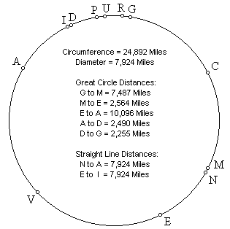
  G = The Great Pyramid  C = Cape Verde Islands  M = Machupicchu  N = Nazca  E = Easter Island  V = Anatom Island | A = Angkor Wat  I = Indus Valley  D = Mohenjo Daro  P = Perseopolis  U = Ur  R = Petra

Straight lines may be drawn through the Earth, connecting Easter Island to Machupicchu, the Great Pyramid, Angkor Wat, and the Indus Valley (antipodal to Easter Island).  The straight line distance, through the Earth, from Angkor Wat to Easter Island (7,574 miles), plus the straight line distance from Easter Island to Macchupicchu (2,522 miles), equals the great circle distance from Angkor Wat to Easter Island (10,096 miles).  The straight line distance from the Great Pyramid to Easter Island (7,566 miles) is three times the straight line distance from Easter Island to Machupicchu (2,522 miles).  The straight line distance from Easter Island to its antipodal point in the Indus Valley (7,924 miles), which is also the diameter of the Earth, is 3.1416 times the straight line distance from Easter Island to Machupicchu (2,522 miles), a precise expression of π. | 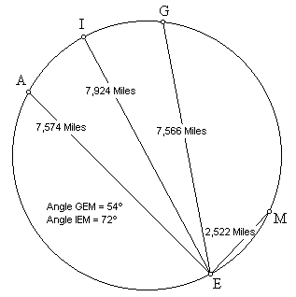
Since the circumference of the Earth is also 3.1416 times the diameter of the Earth, the straight line distance from Easter Island to Machupicchu times π² equals the circumference of the Earth.
The angle formed by the lines from Easter Island to Machupicchu, and to the Indus Valley, is 72°. The angle formed by the lines from Easter Island to Machupicchu, and to the Great Pyramid, is 54°.

Lines connecting Easter Island, the Great Pyramid, and the Angkor temples near Rolous, form an isosceles triangle with base angles of 72.9°. The base of this triangle (AG) is 4462 miles long. The height of this triangle (HE) is 7220 miles long. The length of the base of the triangle times φ equals the height of the triangle:  4,462 miles x 1.618 = 7,220 miles  The length of the base of each face of the Great Pyramid is 755.6 feet. The slant height of each face is 611 feet. One half of the length of the base times φ equals the slant height of the Great Pyramid:  755.6 feet ÷ 2 = 377.8 feet  377.8 feet x 1.618 = 611 feet  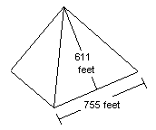 | 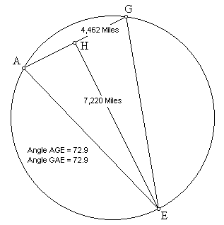  The ratio of the base to the slant height of the Great Pyramid is exactly two times the ratio of the base to the height of the triangle formed by through the earth straight lines connecting the Great Pyramid, Angkor and Easter Island.

Lines connecting Easter Island with it's antipodal point in the Indus Valley, Nazca with it's antipodal point at Angkor, Easter Island with Nazca and Angkor with the Indus Valley, form two isosceles triangles with base angles of 72.9°. With the same angular dimensions as the triangle formed by Easter Island, Angkor and the Great Pyramid, the length of the bases of these triangles times φ also equals the height of these triangles:  2,337 miles x 1.618 = 3,782 miles  The ratio of the base to the slant height of the Great Pyramid is also exactly two times the ratio of the base to the height of the triangles formed by through the earth straight lines connecting Easter Island, Nazca and the center of the Earth, and Angkor, the Indus Valley and the center of the Earth. | 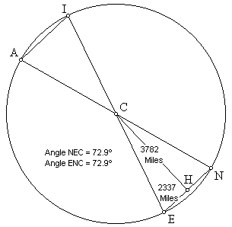

Because the distance between the Great Pyramid and Angkor is very nearly 20% of the circumference, they are very nearly 72° apart, along the circle. Because the distance from the Great Pyramid to Easter Island is very nearly 40% of the circumference, and the distance from Angkor to Easter Island is very nearly 40% of the circumference, the Great Pyramid and Angkor are both very nearly 144° away from Easter Island, along the circle.
The number 72, and to a lesser extent the numbers 54, 108, and 144, have all been associated with the internal designs of these sites as well, particularly at the Great Pyramid and Angkor. The number of temples built around Angkor Wat is 72, and the number 54 is reflected in the number of statuary towers at Angkor Thom. The use of these numbers is also prevalent in ancient writings and folklore surrounding these sites. The number 54 is itself a factor of 72, in that 72 plus one-half of 72, or 36, equals 108, which divided by two equals 54. The number 72 is also associated with the astronomical phenomenon known as precession, because 72 years is the length of time it takes for the constellations to move one degree due to precession.
The radius of any sphere times 2π equals the circumference of the sphere. Because of the unusual angle of 51 51' that was chosen for the slope of the sides of the Great Pyramid (unique among Egyptian pyramids), the height of the Great Pyramid times 2π exactly equals the perimeter of the pyramid. Because of this, it has been suggested that the Great Pyramid was built as a scale model of one hemisphere of the Earth, in the scale of 43,200 to one.
Given the base 60 systems of seconds and minutes that are used for time as well as for degrees of distance across the Earth, 43,200 is a very significant number. One second times 60 equals one minute, times 60 minutes equals one hour, times 12 equals twelve hours. In other words, 43,200 seconds equals one-half day. 30 seconds times 2 equals one minute, times 60 equals one degree, times 360 equals the circumference of the Earth. In other words, one-half minute of latitude times 43,200 equals the circumference of the Earth.
In the 2nd century B.C., the Greek mathematician, Archimedes, wrote an article entitled The Sand Reckoner, in which he cited earlier Greek mathematicians (like Archimedes, they had studied in Alexandria and Heliopolis) who had calculated that the Sun occupied 1/720 of the circle of the constellations. 720 times base 60 equals exactly 43,200. The precessional number of 72, times base 60 times ten also exactly equals 43,200.
Unless the 43,200 to one ratio between the Great Pyramid and the size of the Earth is a coincidence, the builders must have been aware of the size of the Earth. This ratio, as well as the presence of the number 72 and its multiples and factors in other sites and ancient writings, also suggests an awareness of the duration of the precession of the equinoxes. In any event, the existence of these numbers in the geometric relationships between these sites is complementary to the use of these numbers in their internal designs.

PART 12 - THE GOLDEN SECTION
Angkor Wat is 4,745 miles from the Great Pyramid and the Great Pyramid is 7,677 miles from Nazca. This is a precise expression of φ, the Golden Section:
4,745 x 1.618 = 7,677

Ninety miles northeast of Angkor Wat are the Angkor temples at Prassat Preah Vihear. Prassat Vihear is 4754 miles from the Great Pyramid. The line of ancient sites crosses over the Great Pyramid and Angkor Vihear.  Twenty five miles northwest of the city of Nazca is a figure known as the Hummingbird. The Hummingbird is 7,692 miles from the Great Pyramid. The line of ancient sites also crosses over the Hummingbird.  The relationship between the distances from Angkor Vihear to the Great Pyramid and from the Great Pyramid to the Nazcan Hummingbird is also a precise expression of φ:  4,754 x 1.618 = 7,692  Because the distance from the Hummingbird to Angkor Vihear is one-half of the circumference of the earth, two Golden Section relationships between these sites are shown by the circumference of the earth along the line of ancient sites:  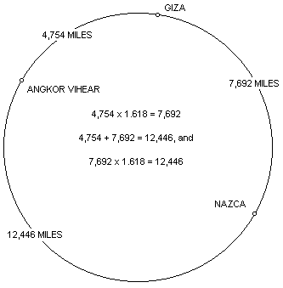 | 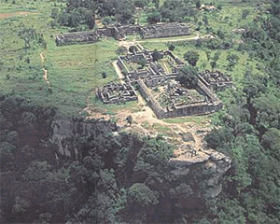Angkor Prassat Preah Vihear  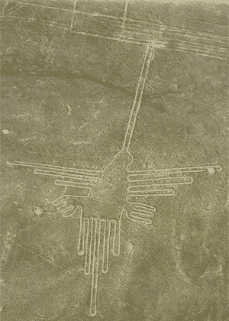The Hummingbird
These Golden Section relationships may also be diagramed on a straight line:
The line of ancient sites is a line, from the perspective of the illustration in Part One, and it is a circle, from the perspective of the illustration in Part Six. The line and the circle are found in the greek letter φ and the number 10. Zero and one are also the first two numbers and the only two numbers in the binary code.
The phi relationships between these sites are reflected repeatedly in the first 500 Fibonacci numbers. The first three prime numbers, 2, 3 and 5, approximate the intervals along the circumference of 20%, 30% and 50%, between these three sites. This same percentage of the circumference relationship, accurate to three digits, is found in Fibonacci numbers 137-139:
Percentage of circumference: | First three digits of Fibonacci numbers:
Angkor to Giza: 19.1% | #137: 191... (Prime)
Giza to Nazca: 30.9% | #138: 309...
Nazca to Angkor: 50.0% | #139: 500...
The next prime Fibonacci number after #137 is #359. The distances between these sites, in miles, is reflected by Fibocacci numbers 359-361, accurately to five digits:
Distance between sites: | First five digits of Fibonacci numbers:
Angkor to Giza: 4,754 miles | #359: 47542... (Prime)
Giza to Nazca: 7,692 miles | #360: 76924...
Nazca to Angkor: 12,446 miles | #361: 12446...

PART 13 - IN SEARCH OF ATLANTIS
The story of Atlantis is generally credited to Plato, even though he ascribed the story to much earlier Egyptian sources. According to those sources, the ancient, advanced Atlanteans ruled over Islands and Continents from an Island Kingdom outside of the Pillars of Hercules, which is thought to be the Straights of Gibralter. In Greek Mythology, Atlas was the first king of Atlantis. Atlas had seven daughters known as the Atlantides. Because their mother was named Hesperis, they were also known as the Hesperides.
Machupicchu and the Great Pyramid are equally distant from the Cape Verde Islands. Easter Island and the Indus Valley are also equally distant from Cape Verde. When the Cape Verde Islands were rediscovered by European mariners in 1460 they were found to be uninhabited. However, islands in this location are found on earlier maps and described as inhabited in ancient times.
The Mecia de Viladestes map of 1413 shows islands in the location of Cape Verde labeled Gades. The information in this map is thought to have come from Roman sources dating back to the first century AD.
The Discoveries of the World from their first originall unto the yeere of our Lord 1555, written by Antonio Galvao in 1563, lists the ancient names for the Cape Verde Islands as the Dorcades, Hesperides and the Gorgades. A 1587 map by Richard Hakluyt also labels the Cape Verde Islands as the Gorgades and the Hesperides.
According to Plato, there was a mountainous region North of the city of Atlantis. If the location of world wonders along a single line around the Earth is not a coincidence, and if there are wonders yet to be discovered along the line, one good place to look might be in the Atlantic Ocean, just South of the Cape Verde Islands.
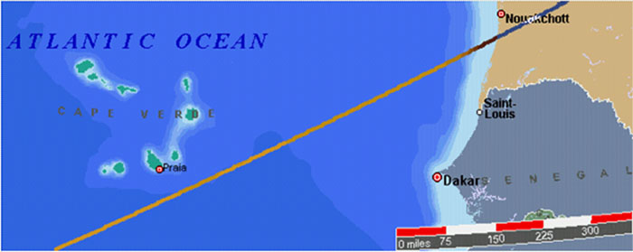

A Brazilian Nuclear Phycisist named Arysio Nunes dos Santos has proposed that Atlantis was originally located in the Bay of Bengal, just south of the mouth of the Ganges, and in the South China Sea. These areas were above sea level during the Earth's last glaciation. The landmass that forms the shallow bottom of the South China Sea is the only known area on Earth, large enough to meet Plato's description of the size of Atlantis, that sank at the end of the last Ice Age. On his website, Atlantis - The Lost Continent Finally Found, Professor Santos argues that scientific evidence, and references in ancient writings, folklore and myths, proves that the South China Sea and the Bay of Bengal were the original sites of Atlantis and Lemuria. Professor Santos contends that a super eruption of Krakatoa in Atlantean times destroyed Atlantis and caused the end of the last Ice Age by covering the Earth with volcanic ash which absorbed sunlight and melted the ice. The alignment of world wonders crosses over the Bay of Bengal, just south of the mouth of the Ganges, and goes right across the middle of the South China Sea. The halfway point betwen Mohenjo-Daro and Angkor is also located in the Bay of Bengal. | 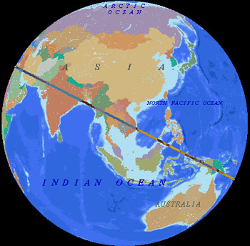

Another good place to look for Atlantis might be halfway between the Great Pyramid and Easter Island, at 4 ° 19' North Latitude, 41 ° 30' West Longitude, also under the North Atlantic Ocean:
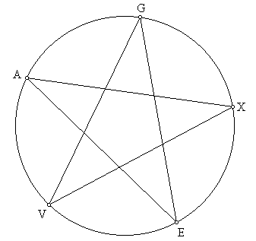 | G = Great Pyramid  A = Angkor Wat  V = Anatom Island  E = Easter Island  X = Atlantis?
The distance from the Great Pyramid to Easter Island is approximately 40% of the circumference of the Earth. The X in the diagram is halfway between the two, 20% each way. Machupicchu is halfway between the X in the diagram and Easter Island, 10% each way. The Distance from the Great Pyramid to Angkor Wat is approximately 20% of the circumference, and the Indus Valley is halfway between the two, 10% each way. The Distance from Easter Island to Angkor Wat is approximately 40% of the circumference, and Anatom Island is halfway between them, 20% each way. These sites are located in multiples of 10% of the circumference of the Earth, and particularly at 20% intervals. Although there are no islands near the location of the X in the diagram, it is interesting to note that the famous Piri Reis map shows a large island in this location, and the geology of recent core samples, taken from the ocean floor in this area, is of continental rather than oceanic type rock.

PART 14 - OTHER GREAT CIRCLE ALIGNMENTS OF ANCIENT SITES
- A SECOND EASTER ISLAND ALIGNMENT also includes Tiahuanaco, Bandiagara Dendera, Luxor, Mohenjo-Daro, Varanasi, Bodh Gaya and Mandalay.

- A THIRD EASTER ISLAND ALIGNMENT also includes Fatima, Filarosa, Rome, Constantinople, Van, Mohenjo-Daro and Bali.

- A FOURTH EASTER ISLAND ALIGNMENT also includes Napata, Mecca, Mohenjo-Daro, Mohenjo-Daro, Agra, Kathmandu, Pohnpei and Tahiti.

- A SECOND GREAT PYRAMID ALIGNMENT also includes Jerusalem, Xian, and Pohnpei.

- A THIRD GREAT PYRAMID ALIGNMENT also includes La Quemada, Poverty Point, Serpent Mound, Brittany, Rome, Alexandria, Mecca and Marib.

- A SECOND PERSEOPOLIS ALIGNMENT also includes Nippur, Baalbek, Byblos, Palaikastro, Knossos, Malta, Timgad, Volubilis and Ingapirca.

- A SECOND ANGKOR ALIGNMENT also includes Paracus, Newgrange, Castlerigg, Gotland, Zagorsk, Llasha, Phimai and Uluru.

- A SECOND NAZCA ALIGNMENT also includes Tiahuanaco, Khami, Great Zimbabwe, Angkor Wat, Preah Vihear, My Son and Hawaii.

- A SECOND MACHUPICCHU ALIGNMENT also includes Ollantaytambo, Saqsaywaman, Cusco, Ingapirca, Tazumal, Mixco Viejo, Bonampak, Palenque, La Venta, Mesa Verde and Chaco Canyon.

- A SECOND CHACO CANYON ALIGNMENT also includes Cahokia Mounds, the Newark Earthworks, Audaghast, Koumbi Saleh Djenne, and Meteor Crater, Arizona.

- A SECOND PALENQUE ALIGNMENT also includes Coba, Bimini, Fatima, Abydos, the Valley of the Kings, Luxor, Mecca and Taupo.

- CONVERGENT ALIGNMENTS include Easter Island, Chaco Canyon, Palenque, Ingapirca, Nazca, Ollantaytambo, Bandiagara, Fatima, Rome, Siwa, Giza, Luxor, Mecca, Perseopolis, Mohenjo-Daro, Angkor and Pohnpei.

- CONVERGENT ALIGNMENTS - PART II include Easter Island, Fatima, Rome, Siwa, Giza, Luxor, Mecca and Mohenjo-Daro.

- THE AVENUE OF THE DEAD at Teotihuacan points directly at Mohenjo-Daro to the Northeast, and very nearly at Easter Island to the Southwest.

- THE GOLDEN SECTION - PART II demonstrates the Φ relationships between a number of additional ancient sites around the world.

- A SMALLER CIRCLE WITH A CIRCUMFERENCE EQUAL TO THE 15TH PARALLELS crosses directly over the Great Pyramid, Easter Island, Palenque, Stonehenge, the Acropolis, and what remains of the Island of Thera.

PART 15 - UTILITIES
- On Top of the World, 3-D world atlas shareware, is freely available in demo versions on the internet, and will precisely draw the line around the center of the Earth with good distance measurement and zoom features.
- VectorGlobe is an easy to navigate 3-D world atlas with excellent topographical, bathymetric and political features, and a huge database of sites.
- GcmWin by Roger Hedin is a freeware equal azimuthal global projection program that can be centered on any selected coordinates.
- The Cosmi 3-D world atlas is easy to navigate and offers very wide angle views of the Earth. Also contains a selection of flat projection maps.
- The Global Gazetteer lists the exact coordinates of over 2.8 million sites worldwide.
- The NASDA/MITI website has satellite images of the world's rainforests, with an easy to navigate image browser.
- The Geometer's Sketchpad is freely available in demo versions on the internet, and will draw diagrams with distance and angle measurements.
- How far is it is a freely available internet utility that provides great circle distances from cities or lat-long coordinates.

PART 16 - LINKS TO RELATED SITES AND SUBJECTS
http://home.hiwaay.net/~jalison/ref.html
- Graham Hancock has authored or co-authored several books that discuss alignments and many other remarkable and related aspects of these sites, including: Fingerprints of the Gods; Keeper of Genesis, with Robert Bauval; and Heaven's Mirror, with Santha Faiia.
- Terry Walsh has authored a wonderful booklet entitled Global Sacred Alignments, that describes several great circle alignments, including the alignment of Easter Island, Machupicchu, Giza and Perseopolis. This booklet is available through the Sacred Geometry Group, Library of Avalon, 2 - 4 High Street, Glastonbury, Somerset BA6 9DU.
- Carrie Kozikowski has authored a letter and an article entitled Geological History Recorded by Missing Ancient Civilizations, that describes the alignment of the North Pole in Southern Alaska and discusses the alignment of sites along the Equator and the Tropic of Cancer, with the North Pole in Southern Alaska.
- Jim Bowles has authored a book entitiled The Gods, Gemini, and the Great Pyramid that discusses the scientific causes of Earth crust displacements, and the similarities between the lines and figures at Nazca, the Great Pyramid, and ancient Egyptian hieroglyphic texts. Bowles also demonstrates a geographic/geometric relationship between the Great Pyramid and Nazca that is also found in the dimensions of the Great Pyramid itself.
- Becker/Hagens: The Global Grid Solution.
- Simon M. Miles: The To-Mera Grid and the Chessboard of Europe.
- Jean-Pierre Lacroix has authored an article entitled The Mapmakers from the Ice Age, that demonstrates the alignment of several of these and other sites, and discusses astronomical relationships of these alignments.
- Rand Flem-Ath has co- authored two books (When the Sky Fell with Rose Flem-Ath, and Atlantis Blueprint with Colin Wilson) about the Earth crust displacement theory. Some of these sites and others are discussed, ancient writings and folklore about the origins of some of these sites is reviewed, and evidence of the existence and location of Atlantis is examined.
- Andrew Collins' new book, Gateway to Atlantis, reviews evidence of contacts around the world in ancient times, and examines ancient to recent evidence regarding the existence and location of Atlantis. Andrew Collins' Website also explores these issues and includes links to related sites.
- This large Atlantis website discusses marine geology and includes extensive discussions of the related myths and folklore of ancient cultures. The Bay of Bengal at the Mouths of the Ganges River and the South China Sea are proposed as Atlantis sites. It is interesting to note that the line of ancient sites crosses over both of these locations (see map) and the Bay of Bengal is halfway between Angkor and the Indus Valley.
- The Mid Atlantic Geomancy website has a section entitled Sacred Geometry that discusses pi, phi, and the square roots of 2, 3 and 5. This website also has extensive links to related subjects.
- Charles Johnson’s Earth/matriX website includes essays on the geometry of ancient sites, including some of these sites and other ancient sites. He has also written several books about ancient sites and ancient science that are described in his website.
- Antonio de la Cova's Latin American Studies website includes excellent descriptions and photographs of ancient civilizations of the Americas.
- David Hixson's Mesoamerican Photo Archives.
- Jon Bodsworth's Gizaview offers great photographs of ancient Egyptian constructions.
- Crichton Miller's website discusses the Celtic Cross and other crosses found in ancient myths, writings and artifacts. The use of the Working Celtic Cross for precise surveying and navigation is also demonstrated.
- Alex Sokolowski's website explores many of these sites and includes extensive links.
- Edgar Cayce gave several descriptions of Atlantis in his readings. Also in his readings is a spiritual explanation of the origins of mankind that could explain how the ancients were able to align and construct ancient sites.
- The UNESCO World Heritage List includes many of these sites. This website by Lynn Salmon is interactive and has links to many of the heritage sites as well as an interactive world map of the heritage sites.
- The official UNESCO website has extensive links to many ancient sites.
- The Ancient Atlas is a large website with excellent maps and descriptions of ancient sites and the ancient world.
- Ellie Crystal's Crystalinks website has extensive links to Ancient and Lost Civilizations and to Sacred Places.
- Morgana's Observatory has extensive links to websites that discuss myths and folklore about ancient sites as well as extensive links to websites that discuss the astroarcheological significance of ancient sites.
- Alaa Ashmawy's Forgotten Wonders website has links to many of these sites, and an interactive map of the sites.
- The Labyrinthina has lots of photographs and articles on Machupicchu, Nazca, and other sites in and around Peru that are close to the line of ancient sites. This website also has extensive links to related sites.
- The Ancient World Web has extensive links to sites, theories and other information about the ancient world.
- Fusion anomaly is an interesting website that has a lot of information about the mathematical and geometric relationships found in the Great Pyramid.
- Martin Gray’s Website has photographs and descriptions of many of these sites. This website also has photographs and descriptions of other sites in Burma, Thailand, India, Africa and the Middle East, that are close to the line of ancient sites.
- Archimedes' work, The Sand Reckoner, as well as Euclid's works on geometry, and other works on the origins of mathematics and geometry as we know it, are contained in the Great Books collection by Britannica, and elsewhere.

