osajohns@yahoo.com osajohns@yahoo.com www.safarimuseum.com


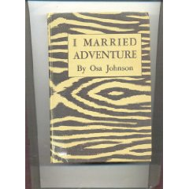

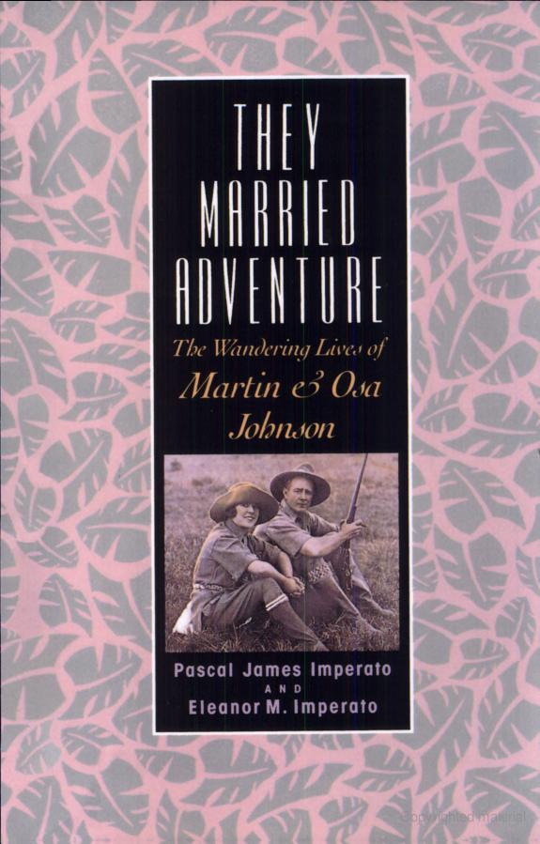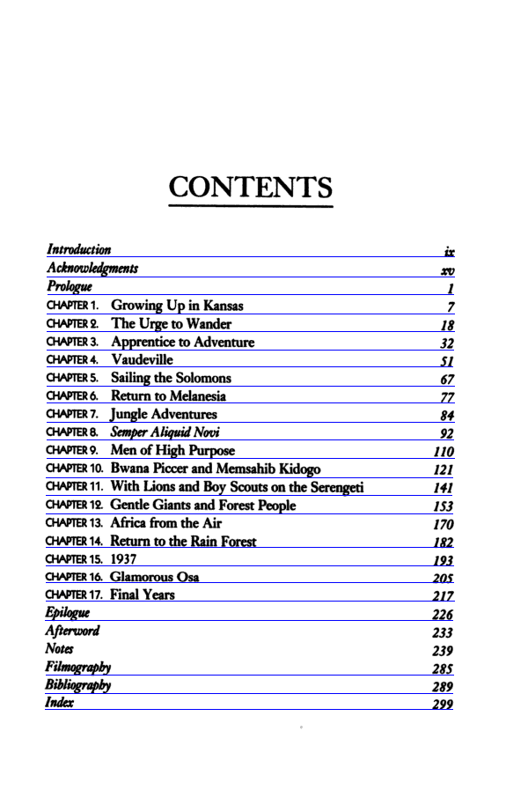

(Foreword) "In light of the placid expectation that because I was born in Chanute, Kansas, I would grow up, marry, raise a family, and die there,..."

Martin and Osa lived exceptional lives, of a sort that can't really be lived today. The strength of the book is that it is Osa's first-person narrative. This is someone who was really there. And the Johnsons do some amazing things together. The book keeps moving at a fast pace, the adventures keep coming, and I didn't want it to end.
The book is a window into a very different era. The Johnsons were products of their time, and some of their viewpoints will bother a few readers. They were not bigots, and in fact appear to me to be rather enlightened for the time, but some of her descriptions of native peoples seem slightly condescending. I may be reading something that isn't there. Some of their practices while exploring and photographing new places would now be totally unacceptable--Stirring up inoffensive animals to get some action for the cameras, or casually introducing an alien plant (watercress) into Africa. Again, these are products of the views of that day, rather than something to condemn.
Perhaps that's the strongest thing to say about the book--That it left me wanting to know more, and inspired to find it out! I'm also going to visit the museum in Kansas dedicated to their work.

Amazon.com: I Married Adventure: The Lives of Martin and Osa ...
Customers buy this book with They Married Adventure: The Wandering Lives of Martin and Osa Johnson by Pascal James Imperato ...
www.amazon.com/Married-Adventure-Martin-Johnson-Kodansha/dp/1568361289 - 290k - Cached - Similar pages

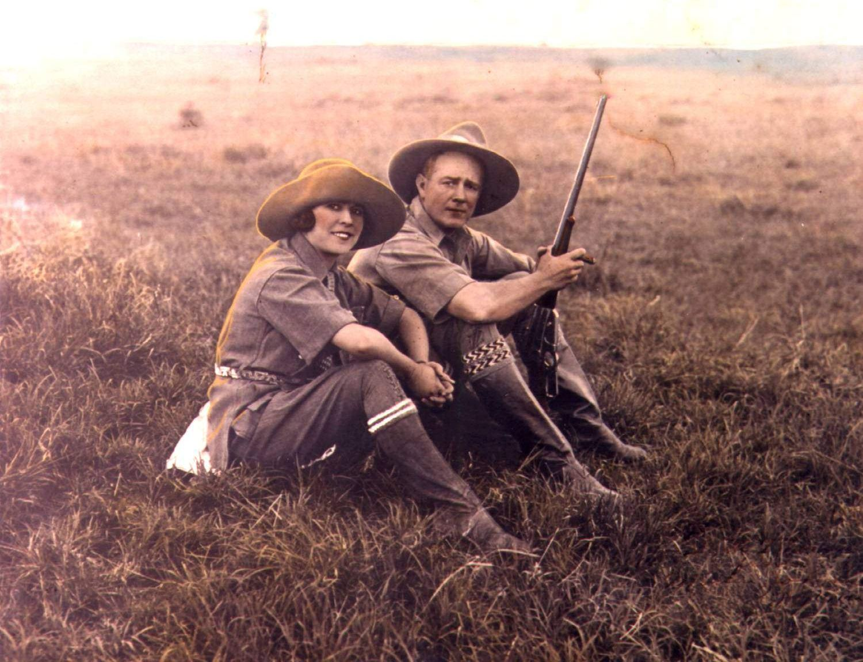
In the first half of the 20th century an American couple from Kansas named Martin and Osa Johnson captured the public's imagination through their films and books of adventure in exotic, far-away lands...Photographers, explorers, naturalists and authors, Martin and Osa studied the wildlife and peoples of East and Central Africa, the South Pacific Islands and British North Borneo...They explored then unknown lands and brought back knowledge of cultures thousands of miles away through their films, writings and lectures.
From 1917-1936, the Johnsons set up camp in some of the most remote areas of the world and provided an unmatched photographic record of the wildernesses of Kenya, the Congo, British North Borneo and the Solomon and New Hebrides Islands...Their equipment was the most advanced motion pictures apparatus of the day, some of it designed by Martin Johnson himself.
When the young adventurers left their home in Kansas to explore and photograph these lands, little did they realize that they would provide the world with a photographic record of the African game of unimagined magnitude and beauty...The Johnsons gave the filmmakers and researchers of today an important source of ethnological and zoological material which would otherwise have been lost.
Their photographs represent one of the great contributions to the pictorial history of the world...Their films serve to document a wilderness that has long since vanished, tribal cultures and customs that ceased to exist.
Through popular movies such as SIMBA (1928) and BABOONA (1935) and best-selling books still in print such as I Married Adventure (1940), Martin and Osa popularized camera safaris and an interest in African wildlife conservation for generations of Americans...Their legacy is a record of the animals and cultures of many remote areas of the world which have undergone significant changes.
The outstanding accomplishments and legacy of Martin and Osa Johnson - their films, photographs, expedition reports, correspondence and personal memorabilia - are housed here at The Martin and Osa Johnson Museum.

- Timeline -
Martin Johnson born (October 9) | 1884
 | 1894 | Osa Leighty born (March 14)
Martin departs aboard Jack London's boat (April 23) | 1907
 | 1909 | Martin returns to Independance, Kansas
Martin & Osa are married in Independance, Kansas (May 15) | 1910
 | 1917 | Martin & Osa leave from San Francisco for their first South Seas trip (June 5)
Their first movie Among the Cannibals of the South Pacific premieres (July 21) | 1918
 | 1919 | Martin & Osa leave on their second trip to the South Pacific (April 8)
Jungle Adventures premieres (September 11) | 1921
 | 1921 | Martin, Osa and Martin's father arrive in Mombasa, Kenya for their first African safari (September)
Their film Trailing African Wild Animals is released (April 15) | 1923
 | 1924 | Martin and Osa arrive in Kenya for their second safari. This trip is also known as Four Years in Paradise (January 26)
Martin and Osa sail from New York for their third trip to Africa (December 14) | 1927
 | 1928 | Simba premieres (January 23)
Martin and Osa make their fourth trip to Africa which results in Congorilla; the first movie with sound shot in Africa (November) | 1929
 | 1930 | The film Across the World with Mr & Mrs. Martin Johnson opens (January 1)
Congorilla opens (July 21) | 1932
 | 1933 | Martin and Osa arrive in Africa for their fifth and final safari
The Johnson's leave for Borneo, their last adventure together (August 12) | 1935
 | 1937 | Martin dies of injuries sustained in a commercial plane crash in Burbank, California (January 13)
Osa passes away in New York City at the age of 58 (January 7) | 1953
 | 1961 | The Martin and Osa Safari Museum opens in Chanute, Kansas (June 11)
The Safari Museum relocates to it's present location, the newly renovated Santa Fe depot | 1993

Martin and Osa Johnson

From Wikipedia, the free encyclopedia
(Redirected from Osa Johnson)
Jump to: navigation, search
For other people named Martin Johnson, see Martin Johnson (disambiguation)
Martin Johnson (October 9, 1884 – January 13, 1937) and his wife Osa Johnson (née Leighty, March 14, 1894 – January 7, 1953) were adventurers from Kansas, United States.

Contents
- 1 Biography
- 2 Safaris
- 3 End of an Era
- 4 Martin and Osa Johnson Safari Museum
- 5 Selected filmography
- 6 References
- 7 External links

Biography
In the first half of the 20th century an American couple, Martin and Osa Johnson, from Lincoln and Chanute Kansas respectively, captured the public's imagination through their films and books of adventure in exotic, far-away lands. Photographers, explorers, marketers, naturalists and authors, Martin and Osa studied the wildlife and peoples of East and Central Africa, the South Pacific Islands and British North Borneo. They explored then unknown lands and brought back knowledge of civilizations thousands of miles away through their films, writings and lectures.
Martin Johnson took part as a crew member and cook in Jack London's 1907–1909 voyage across the Pacific aboard the Snark. After that, he started a traveling road show that toured the United States displaying photographs and artifacts collected on the voyage. He met Osa Leighty while passing through her hometown of Chanute, Kansas, and they married in 1910.

Safaris
In 1917, Martin and Osa departed on a nine-month trip through the New Hebrides (Vanuatu) and Solomon Islands. The highlight of the trip was a brief, but harrowing, encounter with a tribe called the Big Nambas of northern Malekula. Once there, the chief was not going to let them leave. The intervention of a British gunboat helped them escape. The footage they got there inspired the feature film Among the Cannibal Isles of the South Seas (1918).
The Johnsons returned to Malekula in 1919 to film the Big Nambas once again, this time with an armed escort. The escort proved unnecessary as the Big Nambas were disarmed by watching themselves in Among the Cannibal Isles of the South Seas. Martin and Osa finished their trip in 1920 with visits to British North Borneo (now Sabah) and a sailing expedition up the coast of East Africa. After returning home, they released the features Jungle Adventures (1921) and Headhunters of the South Seas (1922).
The Johnson's first Africa expedition, from 1921 to 1922, resulted in their feature film Trailing Wild African Animals (1923).
During the second and longest trip, from 1924 to 1927, the Johnsons spent much of their time in northern Kenya by a lake they dubbed Paradise, at Mount Marsabit. The movies Martin's Safari (1928), Osa's Four Years in Paradise (1941), and the film Simba: King of the Beasts (1928) were made with footage of these trips.
In 1925, Osa and Martin met the Duke and Duchess of York, Albert Frederick Arthur George (George VI) and Elizabeth Bowes-Lyon while on Safari in Kenya.^{[1]}
The third African safari from 1927 to 1928 was a tour of the Nile with friend and supporter George Eastman (of Eastman Kodak fame). This trip, along with previous footage was one of the first talkies for the Johnsons, Across the World with Mr. and Mrs. Johnson (1930) which included Martin's narrative.
From 1929 to 1931, the Johnsons spent a fourth tour in Africa in the Belgian Congo. There they filmed the Mbuti people of the Ituri Forest and the gorillas in the Alumbongo Hills. The 1932 feature movie Congorilla was in part a product of this trip, and was the first movie with sound authentically recorded in Africa.
In 1932 the Johnsons learned to fly at the airfield in Osa's hometown of Chanute. Once they had their pilot's licenses, they purchased two Sikorsky amphibious planes, a S-39-CS "Spirit of Africa" and S-38-BS "Osa's Ark". On their fifth African trip, from 1933 to 1934, the Johnsons flew the length of Africa getting now classic aerial scenes of large herds of elephants, giraffes, and other animals moving across the plains of Africa. They were the first pilots to fly over Mt. Kilimanjaro and Mt. Kenya in Africa and film them from the air. The 1935 feature film Baboona was made from this footage.
The Johnsons' final trip together took them to British North Borneo again, from 1935 to 1936. They used their smaller amphibious plane, now renamed "The Spirit of Africa and Borneo", and produced footage for the feature Borneo (1937).

End of an Era
Martin Johnson died in the crash of a Western Air Express Boeing 247 commercial flight near Newhall, California in 1937. Osa was severely injured but recovered. By October 1937, the New York Times was publishing dispatches of Osa's latest trip to Africa, in which she described lifestyles and practices of the Masai and other tribes.
She died in New York City of a heart attack in 1953.

Martin and Osa Johnson Safari Museum
The Martin and Osa Johnson Safari Museum is located in Osa's hometown of Chanute, Kansas. Formed in 1961 to preserve the Johnsons' achievements and to encourage further research into their fields of study, the Safari Museum (as it was originally named) has grown and flourished. The museum started with a core collection of the Johnsons' films, photographs, manuscripts, articles, books, and personal belongings donated by Osa's mother. The museum shares the beautiful old railroad depot with the Chanute Library.
American Eagle launched Martin + Osa, a new line of stores named after Martin and Osa Johnson, in 2006.

Selected filmography
- Cannibals of the South Seas (1912)
- Jack London's Adventures of the South Seas (1913)
- Among the Cannibal Isles of the South Seas (1918)
- Jungle Adventures (1921)
- Headhunters of the South Seas (1922)
- Trailing Wild African Animals (1923)
- Martin's Safari (1928)
- Simba: King of the Beasts (1928)
- Across the World with Mr. and Mrs. Johnson (1930)
- Wonders of the Congo (1931)
- Congorilla (1932)
- Wings Over Africa (1934)
- Baboona (1935)
- Children of Africa (1937)
- Jungle Depths of Borneo (1937)
- Borneo (1937)
- Jungles Calling (1937)
- I Married Adventure (1940)
- African Paradise (1941)
- Tulagi and the Solomons (1943)
- Big Game Hunt (1950s), on TV

References
- ^ Johnson, Osa. I Married Adventure. (1940). J.B. Lippincott Company. U.S.A. 6th Edition chap. 23 page. 289-293

External links
- Martin E. Johnson at the Internet Movie Database
- Osa Johnson at the Internet Movie Database
- Martin and Osa Johnson Safari Museum website
- Martin and Osa Johnson Safari Museum

