BOOKS by Alfred de Grazia

ALFRED DE GRAZIA
COMPLETE WORKS IN QUANTAVOLUTION AND CATASTROPHE
IN 15 VOLUMES
5,000 PAGES OF TEXT AND ILLUSTRATIONS
INCLUDING THREE VOLUMES WITH EARL R. MILTON
AND COLLABORATING SCHOLARS, AND WITH THE
PARTICIPATION OF I. VELIKOVSKY,
AND TWO BY HUGH CROSTHWAITE.
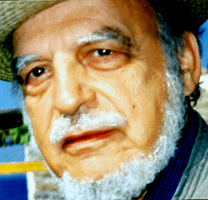
THE GRAZIAN ARCHIVE - WELCOME!
Oh, yes, we almost forgot the New Year of 2003, recovering from Al de Grazia’s 83rd Birthday celebration. Happy New Year to you all!! His latest manifestation is as Professor of Methodology and the History of Science in the Department of Mathematics, Statistics, and Informatics at the University of Bergamo in Italy. "What is to be plugged into Chaos and Complexity theory?"

http://www.grazian-archive.com/quantavolution/QuantaSeries.htm

DOWNLOAD | VOL. | TITLE  (Click to read  the book  with Acrobat Reader  Numbers bring you to different parts of the title.) | COMMENT
  1645 KByte | 0. | STARTING  PAGE  AND  INDEX  FILES | This File you have to download in any case, to provide you with the genereal Acrobat Reader structure (Table of contents) for all the books. It also contains the index files for the Acrobat Reader's search engine.
3250 KByte | 1. | WHAT  IS  QUANTAVOLUTION? | Audio comment by Alfred de Grazia; the Q Paradigm; a Self-test of Attitudes in Quantavolution and Conventional Science; Index of topics
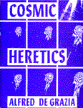  1933 KByte | 2. | COSMIC  HERETICS:  2 3 4 5 | A Personal History of Attempts to Establish and Resist Theories of Quantavolution and Catastrophe in the Natural and Human Sciences, 1962-1983.
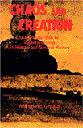  3396 KByte | 3. | CHAOS  AND  CREATION:  2 3 4 5 6 | An Introduction to Quantavolution in Human and Natural History.  First of the Quantavolution series, it is a predecessor of many ideas and reports engendered over the past fifteen years. It is a classic overall account of the prehistoric and historical global natural and human catastrophes that helped create humans in the first place and then destroyed and created civilizations and cultures. Superior explanation of sources of universal myth. Powerful arguments support a brief solar system chronometry. Printed in India, it is the systematic scientific theory for much of natural and social theory.
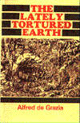  2069 KByte | 4. | THE  LATELY  TORTURED  EARTH:  2 3 4 5 6 7 | The first systematic treatment of the role of exoterrestrial forces in the Earth Sciences.  The elements of geology and geography are discussed in the light of new discoveries about quantavolution and catastrophes as they shaped the globe. A riveting theory of the explosion of the Moon from Earth in recent times, accompanying the global fracture and rafting of the continents.
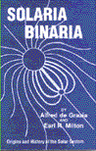  3757 KByte | 5. | SOLARIA  BINARIA:  2 3 4 5 6 7  8 9 10 11 12 | An astronomer and astro-physicist join to perfect an elegantly coherent and logical theory, backed by physical, psychological, and mythological studies, of the origins and history of the solar system with Jupiter as the remnant of the Uranian binary partner of Sol. By Alfred de Grazia and Earl R. Milton.
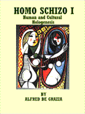  1046 KByte | 6. | HOMO  SCHIZO  I:  2 3 | Human and cultural hologenesis in a quantavolution caused by micro-second brain hemisphere delay, with ensuing genetic schizotypicality. Possible exoterrestrial movements, intrusions and electromagnetic effects with new electrical equilibrium altering hominids into humans, including variants such as "Lucy" and the widespread Homo Erectus. Single-case origin proffered , prior to or concomitant with breakup of Pangea.
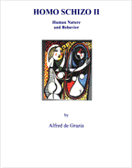  921 KByte | 7. | HOMO  SCHIZO  II:  2 3 | Mankind today analyzed as normally evidencing all basic traits of schizophrenia, whereby culture becomes the virtual reality educating and enforcing normal schizoid behavior and penalizing so-called schizophrenics. Paranoia, obsession-compulsion, catatonia, cognitive disorder culturally constrained and termed rationality, and located in myriad constellations of sublimation.
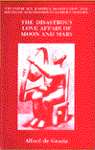  1013 KByte | 8. | THE  DISASTROUS  LOVE  AFFAIR  OF  MOON  AND  MARS:  2 3 | Celestial sex, earthly destruction, and dramatic sublimation in Homer's Odyssey. A complete but incredible case can be built up from an ancient chant that has Mars, Moon, Venus, and Earth in close and destructive encounters.
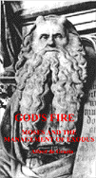  2928 KByte | 9. | GOD'S  FIRE:  2 3 4 5 6 7 8 | Moses and the Management of Exodus.  I have found no book that deals adequately with the psychology of Moses, and therefore have portrayed fully the workings of his mind. No study has properly embraced Moses in his two great capacities as a manager and scientist, and so I have reconstructed these his qualities as well. Furthermore, the Exodus and Wanderings, those operations that Moses directed, are generally misunderstood, both in their particulars as Jewish history and in their representation of what was happening throughout the world in those days.
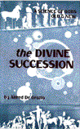  756 KByte | 10. | THE  DIVINE  SUCCESSION:  2 | A Science of Gods Old and New:  An astonishing theory of theology that spells out the history of the gods from common ancestors emerging from disasters and existing as active agents in all human minds. A new astrophysical proof of the existence of gods is put forth, and a phenomenological and pragmatic catechism is composed.
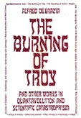  1497 KByte | 11. | THE  BURNING  OF  TROY:  2 | A host of essays on quantavolution, scientific idiocies, and numerous penetrations of subjects such as the Paleolithic Caves, the exo-terrestrial destruction of Troy, the sacred Irish origins of O.K., and the 600-year gap in Roman history.
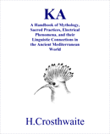  1230 KByte | 12. | KA:  2 3 4 | A Handbook of Mythology by Hugh Crosthwaite,  with an Introduction by Alfred de Grazia.  Sacred Practices, Electrical Phenomena, and Their Linguistic Connections in the Ancient Mediterranean World. A consolidation of the origins of ancient languages, revealing contemporary linkages never suspected but supportive of quantavolution.
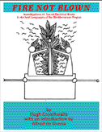  588 KByte | 13. | A  FIRE  NOT  BLOWN..:  2 | A sequel to KA especially commenting upon Minos and Crete, by Hugh Crosthwaite, with an Introduction by Alfred de Grazia.
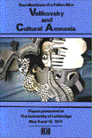  865 KByte | 14. | RECOLLECTIONS  OF  A  FALLEN  SKY :  2 3 4 | An early symposium of the 1970's from Lethbridge University, Canada, planned and edited by Professor Earl R. Milton, concurrent with the granting of an honorary doctorate to Immanuel Velikovsky, the eminent catastrophist. Addresses on various fields (art symbolism, astro-physics, psychology of forgetting tragedy, Catastrophic symbolism in Shakespeare, etc., by authors from Canadian and American universities.  (Earl R. Milton, Editor, with contributions by I. Velikovsky, Alfred de Grazia, John M. MacGregor, William Mullen, Irving Wolfe, George Grinnell, Patrick Doran, et al.)
  930 KByte | 15. | THE  VELIKOVSKY  AFFAIR:  2 3  DEUTSCHE ÜBERSETZUNG:  DIE VELIKOVSKY AFFAIRE | We dedicate this book to people who are concerned about the ways in which scientists behave and how science develops. It deals especially with the freedoms that scientists grant or withhold from one another. The book is also for people who are interested in new theories of cosmogony - the causes of the skies, the earth, and humankind as we see them. It is, finally, a book for people who are fascinated by human conflict, in this case a struggle among some of the most educated, elevated, and civilized characters of our times.  Alfred de Grazia, editor and co-author, with Livio Stecchini, Ralph Juergens, and Immanuel Velikovsky
Published by Metron Publications Copyright © 1997 by Alfred de Grazia of all materials except Volumes 12, 13, and 14, the copyright holders of which have granted to Metron Publications permission to publish them in printed and electronic form.
AUTOBIOGRAPHY AND JOURNALS

THE JOURNALS OF ALFRED DE GRAZIA

1959 1960
Two new volumes of Works, two years of notes and reflections, day by day, unabridged. After a gap of 15 years, from the third autobiographical volume, The Taste of War, and shortly after his appointment to New York University, as Director of the new Center for Applied Social Research and Professor of Social Theory in Government, De Grazia commenced a journal. It was continued for a decade in some fullness, but then largely sidetracked by the Vietnam War and a concentration upon the dozen books that marked the decade from 1968 on. The founding of a college in Switzerland and the beginning of his Naxos Island adventures also came then. Additional Volumes will follow here on the Grazian Archive in due course. They will overtake and pass over two autobiographical volumes also on line now, Cosmic Heretics and The End of Spydom. A burgeoning family life in Princeton and the many toils of avantgarde academia in Manhattan are the leitmotifs of the new works here published for the first time.

THE BABE
Autobiography of a child of Chicago of the roaring twenties and the great depression. Politics, family, schools, gangs, churches, games, sex --all through a child's senses from birth through the fifteenth year. Hailed as an extraordinary utterly frank excursion into deep memory, anthropologically correct, yet written in the style of the Chicago Tribune of the old days

THE STUDENT
Rare in American literature -- or any other -- an intimate account of student life, this at the University of Chicago in Robert Maynard Hutchins' hey-day. Classics, sports, music, sex, and cheap labor as they were there in the Great Depression, when it seemed that great ideas and planning could solve the world's problems. Wisconsin resorts and European travels. Research and graduate study in the social sciences. Campus radicals and conservatives.

THE TASTE OF WAR
An unexcelled account of World War II as experienced from Private to Commanding Officer in artillery, intelligence and combat propaganda units of the U.S. Army, from Maryland to the Mohave Desert and then in six campaigns in Africa, Italy, France and Germany. Highly commended by experts, "best account of Cassino" (Paul Fussell), "tough, picturesque, humane" (Stephanie Neuman of West Point and Columbia).

COSMIC HERETICS
A Personal History of Attempts to Establish and Resist Theories of Quantavolution and Catastrophe in the Natural and Human Sciences, 1963 to 1983. A journal, treatise on the sociology of science, and the story behind the Velikovsky Affair, in the intellectual fabric of Princeton and London, authoritative, informative and written in an original style.

THE END OF SPYDOM
Fall of Spydom: earlier entitled "The Venus Spy-Trap," . A full and true account of the arrest, indictment, investigation and trial for espionage of a Swiss computer expert and afficionado of quantavolution -- particularly with regard to the catastrophes involving planet Venus. A cosmopolitan setting, centering in Basle. A seemingly serious case treated with high irony and amusing at the conduct of practically everyone involved, including the author.

