**Carl Edward Sagan 1934 – 1996**



[**http://en.wikipedia.org/wiki/Carl_Sagan**](http://en.wikipedia.org/wiki/Carl_Sagan)

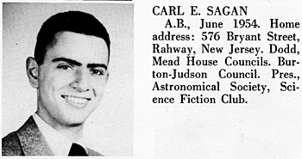 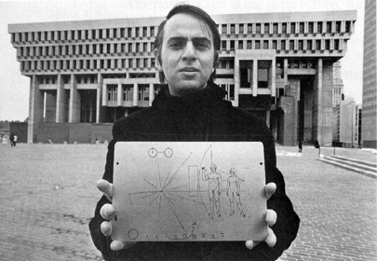

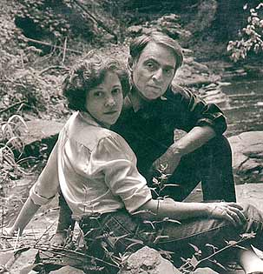 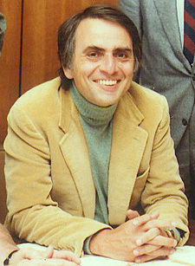 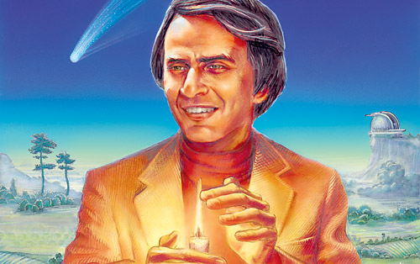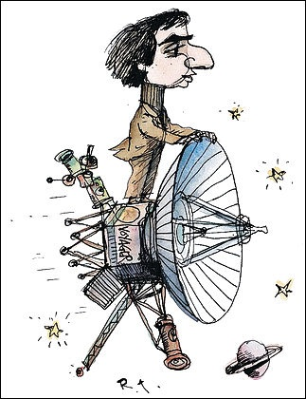 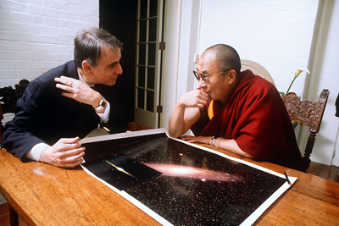 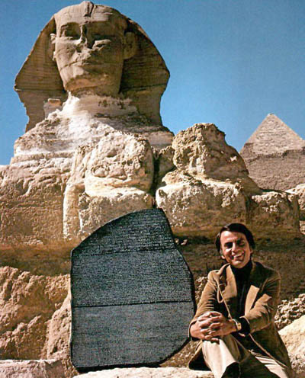

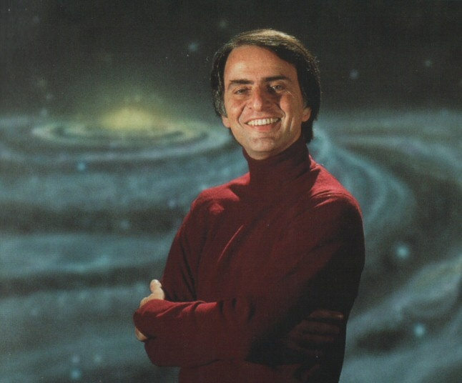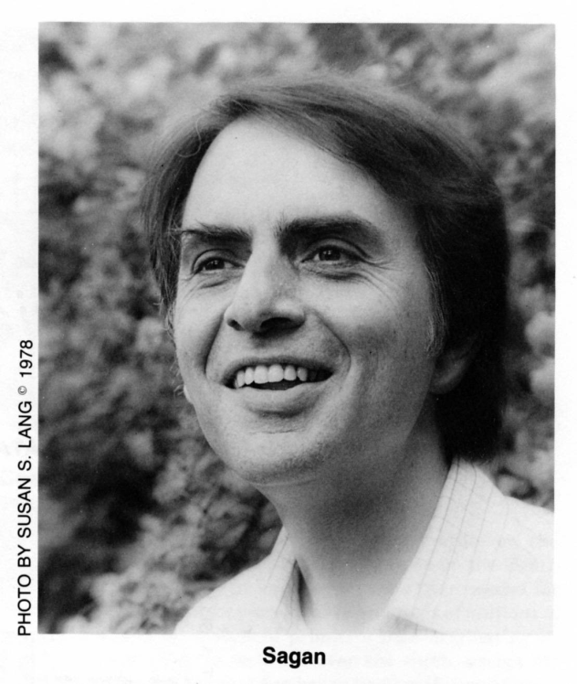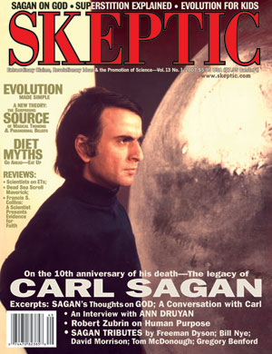  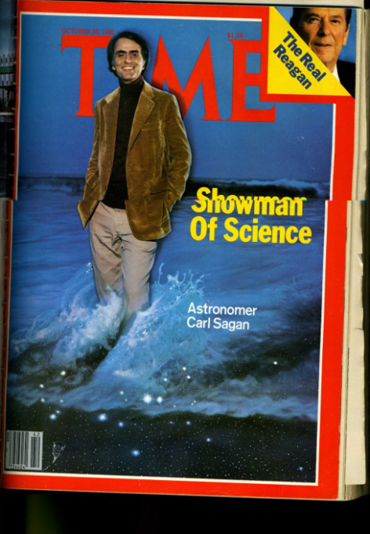 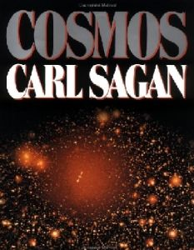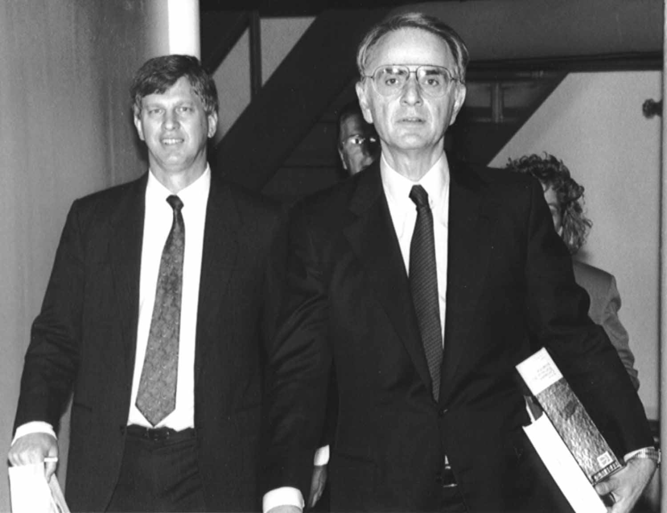 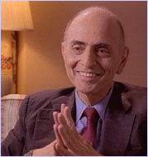 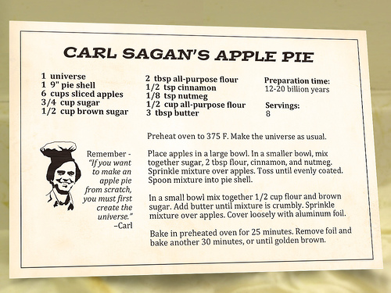

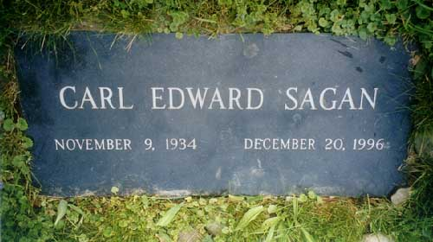

**Carl Edward Sagan** ([November 9](http://en.wikipedia.org/wiki/November_9), [1934](http://en.wikipedia.org/wiki/1934) – [December 20](http://en.wikipedia.org/wiki/December_20), [1996](http://en.wikipedia.org/wiki/1996)) was an [American](http://en.wikipedia.org/wiki/United_States) [astronomer](http://en.wikipedia.org/wiki/Astronomer), [astrochemist](http://en.wikipedia.org/wiki/Astrochemistry), author, and highly successful popularizer of [astronomy](http://en.wikipedia.org/wiki/Astronomy), [astrophysics](http://en.wikipedia.org/wiki/Astrophysics) and other [natural sciences](http://en.wikipedia.org/wiki/Natural_science). He pioneered [exobiology](http://en.wikipedia.org/wiki/Astrobiology) and promoted the [Search for Extra-Terrestrial Intelligence (SETI)](http://en.wikipedia.org/wiki/SETI).

He is world-famous for writing [popular science](http://en.wikipedia.org/wiki/Popular_science) books and for co-writing and presenting the award-winning 1980 television series [*Cosmos: A Personal Voyage*](http://en.wikipedia.org/wiki/Cosmos:_A_Personal_Voyage), which has been seen by more than 600 million people in over 60 countries, making it the most widely watched [PBS](http://en.wikipedia.org/wiki/Public_Broadcasting_Service) program in history.[[1]](http://en.wikipedia.org/wiki/Carl_Sagan#cite_note-0) A [book](http://en.wikipedia.org/wiki/Cosmos_%28book%29) to accompany the program was also published. He also wrote the novel [*Contact*](http://en.wikipedia.org/wiki/Contact_%28novel%29), the basis for the 1997 [Robert Zemeckis](http://en.wikipedia.org/wiki/Robert_Zemeckis) [film of the same name](http://en.wikipedia.org/wiki/Contact_%28film%29) starring [Jodie Foster](http://en.wikipedia.org/wiki/Jodie_Foster). During his lifetime, Sagan published more than 600 scientific papers and popular articles and was author, co-author, or editor of more than 20 books. In his works, he frequently advocated [skeptical inquiry](http://en.wikipedia.org/wiki/Scientific_skepticism), [secular humanism](http://en.wikipedia.org/wiki/Secular_humanism), and the [scientific method](http://en.wikipedia.org/wiki/Scientific_method).

|  |
| --- |
| **Contents**  [1 Education and scientific career](http://en.wikipedia.org/wiki/Carl_Sagan#Education_and_scientific_career)   * [2 Scientific achievements](http://en.wikipedia.org/wiki/Carl_Sagan#Scientific_achievements) * [3 Scientific advocacy](http://en.wikipedia.org/wiki/Carl_Sagan#Scientific_advocacy) * [4 Social concerns](http://en.wikipedia.org/wiki/Carl_Sagan#Social_concerns) * [5 Popularization of science](http://en.wikipedia.org/wiki/Carl_Sagan#Popularization_of_science) * [6 Personal life and beliefs](http://en.wikipedia.org/wiki/Carl_Sagan#Personal_life_and_beliefs) * [7 Sagan and UFOs](http://en.wikipedia.org/wiki/Carl_Sagan#Sagan_and_UFOs) * [8 Death and legacy](http://en.wikipedia.org/wiki/Carl_Sagan#Death_and_legacy) * [9 Awards and honors](http://en.wikipedia.org/wiki/Carl_Sagan#Awards_and_honors) * [10 Bibliography](http://en.wikipedia.org/wiki/Carl_Sagan#Bibliography)   + [10.1 By Sagan](http://en.wikipedia.org/wiki/Carl_Sagan#By_Sagan)   + [10.2 About Sagan](http://en.wikipedia.org/wiki/Carl_Sagan#About_Sagan) * [11 References](http://en.wikipedia.org/wiki/Carl_Sagan#References) * [12 External links](http://en.wikipedia.org/wiki/Carl_Sagan#External_links) |

**Education and scientific career**

Carl Sagan was born in [Brooklyn](http://en.wikipedia.org/wiki/Brooklyn), [New York](http://en.wikipedia.org/wiki/NY)[[2]](http://en.wikipedia.org/wiki/Carl_Sagan#cite_note-poundstone-1) to a [Jewish](http://en.wikipedia.org/wiki/Jewish) family. His father, Sam Sagan, was a [garment](http://en.wikipedia.org/wiki/Garment) worker; his mother, Rachel Molly Gruber, was a housewife. Carl was named in honor of Rachel's biological mother, Chaiya Clara, "the mother she never knew", in Sagan's words. Sagan graduated from [Rahway High School](http://en.wikipedia.org/wiki/Rahway_High_School) in [Rahway, New Jersey](http://en.wikipedia.org/wiki/Rahway,_New_Jersey) in 1951.[[3]](http://en.wikipedia.org/wiki/Carl_Sagan#cite_note-2) He attended the [University of Chicago](http://en.wikipedia.org/wiki/University_of_Chicago), where he received a [A.B.](http://en.wikipedia.org/wiki/Bachelor_of_Arts) with general and special honors (1954), a [S.B.](http://en.wikipedia.org/wiki/Bachelor_of_Science) (1955) and a [S.M.](http://en.wikipedia.org/wiki/Master_of_Science) (1956) in [physics](http://en.wikipedia.org/wiki/Physics), before earning a [Ph.D.](http://en.wikipedia.org/wiki/Doctor_of_Philosophy) degree (1960) in [astronomy](http://en.wikipedia.org/wiki/Astronomy) and [astrophysics](http://en.wikipedia.org/wiki/Astrophysics).[[4]](http://en.wikipedia.org/wiki/Carl_Sagan#cite_note-3) During his time as an undergraduate, Sagan spent some time working in the laboratory of the [geneticist](http://en.wikipedia.org/wiki/Geneticist) [H. J. Muller](http://en.wikipedia.org/wiki/Hermann_Joseph_Muller). From 1960 to 1962 he was a Miller Fellow at the [University of California, Berkeley](http://en.wikipedia.org/wiki/University_of_California,_Berkeley). From 1962 to 1968, he worked at the [Smithsonian Astrophysical Observatory](http://en.wikipedia.org/wiki/Smithsonian_Astrophysical_Observatory) in Cambridge, Massachusetts.

Sagan lectured annually at [Harvard University](http://en.wikipedia.org/wiki/Harvard_University) until 1968, when he moved to [Cornell University](http://en.wikipedia.org/wiki/Cornell_University). He became a full Professor at Cornell in 1971 and directed the Laboratory for [Planetary Studies](http://en.wikipedia.org/wiki/Planetary_science) there. From 1972 to 1981 he was Associate Director of the Center for Radio Physics and Space Research at Cornell.

Sagan was a leader in the U.S. [space program](http://en.wikipedia.org/wiki/Space_program) since its inception. From the 1950s onward, he worked as an adviser to [NASA](http://en.wikipedia.org/wiki/NASA). One of his many duties during his tenure at the space agency included briefing the [Apollo](http://en.wikipedia.org/wiki/Apollo_program) [astronauts](http://en.wikipedia.org/wiki/Astronaut) before their flights to the [Moon](http://en.wikipedia.org/wiki/Moon). Sagan contributed to most of the [robotic spacecraft](http://en.wikipedia.org/wiki/Robotic_spacecraft) missions that explored the [solar system](http://en.wikipedia.org/wiki/Solar_system), arranging experiments on many of the expeditions. He conceived the idea of adding an unalterable and universal message on spacecraft destined to leave the solar system that could be understood by any [extraterrestrial intelligence](http://en.wikipedia.org/wiki/Extraterrestrial_intelligence) that might find it. Sagan assembled the first physical message that was sent into [space](http://en.wikipedia.org/wiki/Outer_space): a [gold](http://en.wikipedia.org/wiki/Gold)-[anodized](http://en.wikipedia.org/wiki/Anodized) [plaque](http://en.wikipedia.org/wiki/Pioneer_plaque), attached to the space probe [Pioneer 10](http://en.wikipedia.org/wiki/Pioneer_10), launched in 1972. [Pioneer 11](http://en.wikipedia.org/wiki/Pioneer_11), also carrying the plaque, was launched the following year. He continued to refine his designs throughout his lifetime; the most elaborate message he helped to develop and assemble was the [Voyager Golden Record](http://en.wikipedia.org/wiki/Voyager_Golden_Record) that was sent out with the [Voyager](http://en.wikipedia.org/wiki/Voyager_program) space probes in 1977.

At Cornell, Sagan taught a course on [critical thinking](http://en.wikipedia.org/wiki/Critical_thinking) until his death in 1996 from a rare bone marrow disease. The course had only a limited number of seats. Although hundreds of students applied each year, only about 20 were chosen to attend each semester. The course was discontinued immediately after Sagan's death, but was later resumed by Professor [Yervant Terzian](http://en.wikipedia.org/w/index.php?title=Yervant_Terzian&action=edit&redlink=1) in 2000.

**Scientific achievements**

Carl Sagan's contributions were central to the discovery of the high surface temperatures of the planet [Venus](http://en.wikipedia.org/wiki/Venus). In the early 1960s no one knew for certain the basic conditions of that planet's surface and Sagan listed the possibilities in a report later depicted for popularization in a [Time-Life](http://en.wikipedia.org/wiki/Time-Life) book, [*Planets*](http://en.wikipedia.org/w/index.php?title=Planets_%28book%29&action=edit&redlink=1). His own view was that Venus was dry and very hot as opposed to the balmy paradise others had imagined. He had investigated radio emissions from Venus and concluded that there was a surface temperature of 500 °C (932 °F). As a visiting scientist to NASA's [Jet Propulsion Laboratory](http://en.wikipedia.org/wiki/Jet_Propulsion_Laboratory), he contributed to the first [Mariner](http://en.wikipedia.org/wiki/Mariner_program) missions to Venus, working on the design and management of the project. [Mariner 2](http://en.wikipedia.org/wiki/Mariner_2) confirmed his conclusions on the surface conditions of Venus in 1962.

Sagan was among the first to hypothesize that [Saturn](http://en.wikipedia.org/wiki/Saturn)'s moon [Titan](http://en.wikipedia.org/wiki/Titan_%28moon%29) might possess oceans of liquid compounds on its surface and that [Jupiter](http://en.wikipedia.org/wiki/Jupiter)'s moon [Europa](http://en.wikipedia.org/wiki/Europa_%28moon%29) might possess subsurface oceans of water. This made Europa potentially habitable for life.[[5]](http://en.wikipedia.org/wiki/Carl_Sagan#cite_note-4) Europa's subsurface ocean of water was later indirectly confirmed by the spacecraft [Galileo](http://en.wikipedia.org/wiki/Galileo_probe). Sagan also helped solve the mystery of the reddish haze seen on Titan, revealing that it is composed of complex [organic molecules](http://en.wikipedia.org/wiki/Organic_molecules) constantly raining down onto the moon's surface.

He further contributed insights regarding the atmospheres of Venus and Jupiter as well as seasonal changes on [Mars](http://en.wikipedia.org/wiki/Mars_%28planet%29). Sagan established that the atmosphere of Venus is extremely hot and dense with pressures increasing steadily all the way down to the surface. He also perceived [global warming](http://en.wikipedia.org/wiki/Global_warming) as a growing, man-made danger and likened it to the natural development of Venus into a hot, life-hostile planet through a kind of runaway [greenhouse effect](http://en.wikipedia.org/wiki/Greenhouse_effect). Sagan and his Cornell colleague [Edwin Ernest Salpeter](http://en.wikipedia.org/wiki/Edwin_Ernest_Salpeter) speculated about [life in Jupiter's clouds](http://en.wikipedia.org/wiki/Jupiter#Life_on_Jupiter), given the planet's dense atmospheric composition rich in organic molecules. He studied the observed color variations on Mars’ surface and concluded that they were not seasonal or vegetational changes as most believed but shifts in surface dust caused by [windstorms](http://en.wikipedia.org/wiki/Dust_storm#on_other_planets).

Sagan is best known, however, for his research on the possibilities of [extraterrestrial life](http://en.wikipedia.org/wiki/Exobiology), including experimental demonstration of the production of [amino acids](http://en.wikipedia.org/wiki/Amino_acid) from basic chemicals by [radiation](http://en.wikipedia.org/wiki/Radiation).[[6]](http://en.wikipedia.org/wiki/Carl_Sagan#cite_note-5)

He is also the 1994 recipient of the [Public Welfare Medal](http://en.wikipedia.org/wiki/Public_Welfare_Medal), the highest award of the [National Academy of Sciences](http://en.wikipedia.org/wiki/United_States_National_Academy_of_Sciences) for "distinguished contributions in the application of science to the public welfare."[[7]](http://en.wikipedia.org/wiki/Carl_Sagan#cite_note-6)

**Scientific advocacy**

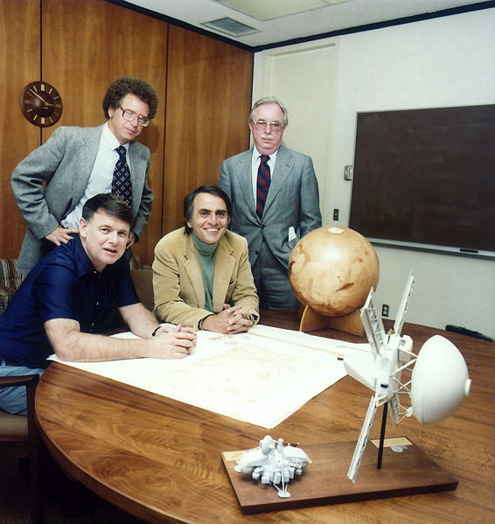

Planetary society founders.

Original caption: "Founding of the Planetary Society

Carl Sagan, Bruce Murray and Louis Friedman, the founders of The Planetary Society at the time of signing the papers formally incorporating the organization. The fourth person is Harry Ashmore, an advisor, who greatly helped in the founding of the Society. Ashmore was a Pulitizer Prize winning journalist and leader in the Civil Rights movement in the 1960s and 70s."

Sagan was a proponent of the search for extraterrestrial life. He urged the scientific community to listen with [radio telescopes](http://en.wikipedia.org/wiki/Radio_telescope) for signals from intelligent extraterrestrial lifeforms. So persuasive was he that by 1982 he was able to get a petition advocating [SETI](http://en.wikipedia.org/wiki/SETI) published in the journal *Science* and signed by 70 scientists including seven [Nobel Prize](http://en.wikipedia.org/wiki/Nobel_Prize) winners. This was a tremendous turnaround in the respectability of this controversial field. Sagan also helped Dr. [Frank Drake](http://en.wikipedia.org/wiki/Frank_Drake) write the [Arecibo message](http://en.wikipedia.org/wiki/Arecibo_message), a radio message beamed into space from the [Arecibo radio telescope](http://en.wikipedia.org/wiki/Arecibo_radio_telescope) on [November 16](http://en.wikipedia.org/wiki/November_16), [1974](http://en.wikipedia.org/wiki/1974), aimed at informing extraterrestrials about Earth.

Sagan was chief technology officer of the professional planetary research journal [*Icarus*](http://en.wikipedia.org/wiki/Icarus_%28journal%29) for twelve years. He co-founded the [*Planetary Society*](http://en.wikipedia.org/wiki/Planetary_Society), the largest space-interest group in the world, with over 1,000,000 members in more than 149 countries, and was a member of the [SETI Institute](http://en.wikipedia.org/wiki/SETI_Institute) Board of Trustees. Sagan served as Chairman of the Division for Planetary Science of the [American Astronomical Society](http://en.wikipedia.org/wiki/American_Astronomical_Society), as President of the Planetology Section of the [American Geophysical Union](http://en.wikipedia.org/wiki/American_Geophysical_Union), and as Chairman of the Astronomy Section of the [American Association for the Advancement of Science](http://en.wikipedia.org/wiki/American_Association_for_the_Advancement_of_Science).

At the height of the [Cold War](http://en.wikipedia.org/wiki/Cold_War), Sagan became involved in public awareness efforts for the effects of [nuclear war](http://en.wikipedia.org/wiki/Nuclear_warfare) when a mathematical climate model suggested that a substantial nuclear exchange could upset the delicate balance of life on Earth. He was the last of five authors — the "S" of the ["TTAPS"](http://en.wikipedia.org/wiki/Nuclear_winter#TTAPS_.281983.29) report as the research paper came to be known. He eventually co-authored the scientific paper hypothesizing a global [nuclear winter](http://en.wikipedia.org/wiki/Nuclear_winter) following nuclear war.[[8]](http://en.wikipedia.org/wiki/Carl_Sagan#cite_note-7) He also co-authored the book *A Path Where No Man Thought: Nuclear Winter and the End of the Arms Race*, a comprehensive examination of the phenomenon of nuclear winter.

Sagan erroneously predicted in January 1991 that so much smoke from the [Kuwaiti oil fires](http://en.wikipedia.org/wiki/Kuwaiti_oil_fires) "might get so high as to disrupt agriculture in much of South Asia...." He acknowledged the error in *The Demon-Haunted World*: "as events transpired, it *was* pitch black at noon and temperatures dropped 4-6 C over the Persian Gulf, but not much smoke reached stratospheric altitudes and Asia was spared."[[9]](http://en.wikipedia.org/wiki/Carl_Sagan#cite_note-8)

In his later years Sagan advocated the creation of an organized search for near Earth objects that would impact the Earth. ( [Head, Tom](http://en.wikipedia.org/w/index.php?title=Tom_Head&action=edit&redlink=1" \o "Tom Head (page does not exist)) (2006). Conversations With Carl Sagan. University Press of Mississippi, 86-87. [ISBN 1578067367](http://en.wikipedia.org/wiki/Special:BookSources/1578067367).  ) When others suggested creating large nuclear bombs that could be used to alter the orbit of an NEO that was predicted to hit the Earth, Sagan proposed the Deflection Dilemma: If we create the ability to deflect an asteroid away from the Earth, then we also create the ability to deflect an asteroid towards the Earth - providing an evil power with a true doomsday bomb. ("David Morrison - Taking a Hit: Asteroid Impacts & Evolution". [[*Valley Astronomy Lectures*](http://www.astrosociety.org/education/podcast/index.html%7CSilicon)]. [2007](http://en.wikipedia.org/wiki/2007)-[10-03](http://en.wikipedia.org/wiki/October_3). ) (Sagan, Carl & Ostro, "Long-Range Consequences of Interplanetary Collisions", Issues in Science and Technology **Vol X**(Number 4) )

## Social concerns

Sagan believed that the [Drake equation](http://en.wikipedia.org/wiki/Drake_equation) suggested that a large number of extraterrestrial civilizations would form, but that the lack of evidence of such civilizations pointed out by the [Fermi paradox](http://en.wikipedia.org/wiki/Fermi_paradox) suggests [technological](http://en.wikipedia.org/wiki/Technological) civilizations tend to destroy themselves rather quickly. This stimulated his interest in identifying and publicizing ways that humanity could destroy itself, with the hope of avoiding such a [cataclysm](http://en.wikipedia.org/wiki/Cataclysm) and eventually becoming a [spacefaring](http://en.wikipedia.org/wiki/Spacefaring) species. Sagan's deep concern regarding the potential destruction of [human civilization](http://en.wikipedia.org/wiki/End_of_civilization) in a [nuclear holocaust](http://en.wikipedia.org/wiki/Nuclear_holocaust) was conveyed in a memorable cinematic sequence in the final episode of [*Cosmos*](http://en.wikipedia.org/wiki/Cosmos:_A_Personal_Voyage), called "Who Speaks for Earth?". Following his marriage to his third wife (novelist [Ann Druyan](http://en.wikipedia.org/wiki/Ann_Druyan)) in June 1981, Sagan became more politically active — particularly in regard to the escalation of the [nuclear arms race](http://en.wikipedia.org/wiki/Nuclear_arms_race) under President [Ronald Reagan](http://en.wikipedia.org/wiki/Ronald_Reagan).

In March 1983, hoping to blunt the momentum of the [nuclear freeze](http://en.wikipedia.org/wiki/Nuclear_freeze) movement, Reagan announced the [Strategic Defense Initiative](http://en.wikipedia.org/wiki/Strategic_Defense_Initiative) — a multi-billion dollar project to develop a comprehensive [defense](http://en.wikipedia.org/wiki/Missile_defense) against attack by [nuclear missiles](http://en.wikipedia.org/wiki/Nuclear_missiles), which was quickly dubbed the "Star Wars" program. Sagan spoke out against the project, arguing that it was technically impossible to develop a system with the level of perfection required, and far more expensive to build than for an enemy to defeat through [decoys](http://en.wikipedia.org/wiki/Decoy) and other means — and that its construction would seriously destabilize the nuclear balance between the United States and the [Soviet Union](http://en.wikipedia.org/wiki/Soviet_Union), making further progress toward [nuclear disarmament](http://en.wikipedia.org/wiki/Nuclear_disarmament) impossible.

When Soviet leader [Mikhail Gorbachev](http://en.wikipedia.org/wiki/Mikhail_Gorbachev) declared a unilateral moratorium on the [testing of nuclear weapons](http://en.wikipedia.org/wiki/Nuclear_testing), which would begin on [August 6](http://en.wikipedia.org/wiki/August_6), [1985](http://en.wikipedia.org/wiki/1985) — the 40th anniversary of the [atomic bombing](http://en.wikipedia.org/wiki/Atomic_bomb) of [Hiroshima](http://en.wikipedia.org/wiki/Atomic_bombings_of_Hiroshima_and_Nagasaki) — the Reagan administration dismissed the dramatic move as nothing more than [propaganda](http://en.wikipedia.org/wiki/Propaganda), and refused to follow suit. In response, American [anti-nuclear](http://en.wikipedia.org/wiki/Anti-nuclear) and peace [activists](http://en.wikipedia.org/wiki/Activists) staged a series of protest actions at the [Nevada Test Site](http://en.wikipedia.org/wiki/Nevada_Test_Site), beginning on [Easter Sunday](http://en.wikipedia.org/wiki/Easter_Sunday) of 1986 and continuing through 1987. Hundreds of people, including Sagan, who had previously been arrested for participating in an [anti-war protest](http://en.wikipedia.org/wiki/Anti-war_protest) during the [Vietnam War](http://en.wikipedia.org/wiki/Vietnam_War), were arrested on two separate occasions as he climbed over a chain-link fence at the Test Site.

## Popularization of science

Sagan's capability to convey his ideas allowed many people to better understand the Cosmos — simultaneously emphasizing the value and worthiness of the human race, and the relative insignificance of the earth in comparison to the [universe](http://en.wikipedia.org/wiki/Universe). He delivered the 1977/1978 [Christmas Lectures for Young People](http://en.wikipedia.org/wiki/Royal_Institution_Christmas_Lectures) at the [Royal Institution](http://en.wikipedia.org/wiki/Royal_Institution). He hosted and, with Ann Druyan, co-wrote and co-produced the highly popular thirteen-part [PBS](http://en.wikipedia.org/wiki/PBS) television series [*Cosmos: A Personal Voyage*](http://en.wikipedia.org/wiki/Cosmos:_A_Personal_Voyage) modeled on [Jacob Bronowski](http://en.wikipedia.org/wiki/Jacob_Bronowski)'s [*The Ascent of Man*](http://en.wikipedia.org/wiki/The_Ascent_of_Man).

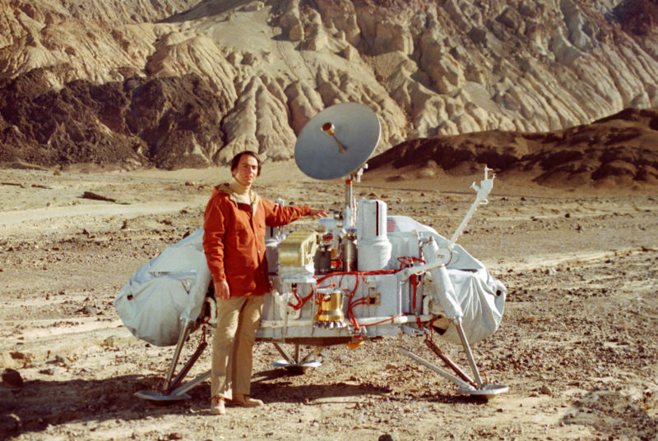

Sagan with a model of the [Viking Lander](http://en.wikipedia.org/wiki/Viking_Lander) probes which would land on [Mars](http://en.wikipedia.org/wiki/Mars_%28planet%29). Sagan examined possible landing sites for Viking along with Mike Carr and Hal Masursky.

*Cosmos* covered a wide range of scientific subjects including the [origin of life](http://en.wikipedia.org/wiki/Origin_of_life) and a perspective of our place in the [universe](http://en.wikipedia.org/wiki/Universe). The series was first broadcast by the [Public Broadcasting Service](http://en.wikipedia.org/wiki/Public_Broadcasting_Service) in 1980, winning an [Emmy](http://en.wikipedia.org/wiki/Emmy_Award) and a [Peabody Award](http://en.wikipedia.org/wiki/Peabody_Award). According to the NASA Office of Space Science, it has been since broadcast in more than 60 countries and seen by over 500 million people.[[10]](http://en.wikipedia.org/wiki/Carl_Sagan#cite_note-9)

Sagan also wrote books to popularize science, such as [*Cosmos*](http://en.wikipedia.org/wiki/Cosmos_%28book%29), which reflected and expanded upon some of the themes of *A Personal Voyage*, and became the best-selling science book ever published in English;[[11]](http://en.wikipedia.org/wiki/Carl_Sagan#cite_note-10) [*The Dragons of Eden: Speculations on the Evolution of Human Intelligence*](http://en.wikipedia.org/wiki/The_Dragons_of_Eden), which won a [Pulitzer Prize](http://en.wikipedia.org/wiki/Pulitzer_Prize); and [*Broca's Brain: Reflections on the Romance of Science*](http://en.wikipedia.org/wiki/Broca%27s_Brain:_Reflections_on_the_Romance_of_Science). Sagan also wrote the best-selling [science fiction](http://en.wikipedia.org/wiki/Science_fiction) novel [*Contact*](http://en.wikipedia.org/wiki/Contact_%28novel%29), but did not live to see the book's 1997 [motion picture adaptation](http://en.wikipedia.org/wiki/Contact_%28film%29), which starred [Jodie Foster](http://en.wikipedia.org/wiki/Jodie_Foster) and won the 1998 [Hugo Award](http://en.wikipedia.org/wiki/Hugo_Award).

From *Cosmos* and his frequent appearances on [*The Tonight Show*](http://en.wikipedia.org/wiki/The_Tonight_Show), Sagan became associated with the [catch phrase](http://en.wikipedia.org/wiki/Catch_phrase) "billions and billions." Sagan never actually used the phrase in the *Cosmos* series,[[12]](http://en.wikipedia.org/wiki/Carl_Sagan#cite_note-11) however his frequent use of term *billions*, and distinctive delivery with emphasis on the “b”, made him a favorite target of performers and comedy routines of [Johnny Carson](http://en.wikipedia.org/wiki/Johnny_Carson), [Gary Kroeger](http://en.wikipedia.org/wiki/Gary_Kroeger), [Mike Myers](http://en.wikipedia.org/wiki/Mike_Myers_%28actor%29),[[13]](http://en.wikipedia.org/wiki/Carl_Sagan#cite_note-12) [Bronson Pinchot](http://en.wikipedia.org/wiki/Bronson_Pinchot), [Harry Shearer](http://en.wikipedia.org/wiki/Harry_Shearer) and others. Sagan took this in good humor, and his final book was entitled [*Billions and Billions*](http://en.wikipedia.org/wiki/Billions_and_Billions:_Thoughts_on_Life_and_Death_at_the_Brink_of_the_Millennium) and opened with a tongue-in-cheek discussion of this catch phrase. The [indefinite and fictitious number](http://en.wikipedia.org/wiki/Indefinite_and_fictitious_large_numbers) [*Sagan*](http://en.wikipedia.org/wiki/Sagan_%28unit_of_measurement%29) has arisen in popular culture to indicate a count greater than 4 billion.

He wrote a sequel to *Cosmos,* [*Pale Blue Dot: A Vision of the Human Future in Space*](http://en.wikipedia.org/wiki/Pale_Blue_Dot_%28book%29), which was selected as a notable book of 1995 by [*The New York Times*](http://en.wikipedia.org/wiki/The_New_York_Times). He appeared on [PBS](http://en.wikipedia.org/wiki/PBS)' [Charlie Rose](http://en.wikipedia.org/wiki/Charlie_Rose) program in January 1995.[[14]](http://en.wikipedia.org/wiki/Carl_Sagan#cite_note-13) Sagan also wrote an introduction for the bestselling book by [Stephen Hawking](http://en.wikipedia.org/wiki/Stephen_Hawking), [*A Brief History of Time*](http://en.wikipedia.org/wiki/A_Brief_History_of_Time).

Sagan caused mixed reactions among other professional scientists. On the one hand, there was general support for his popularization of science, his efforts to increase scientific understanding among the general public, and his positions in favor of [scientific skepticism](http://en.wikipedia.org/wiki/Scientific_skepticism) and against [pseudoscience](http://en.wikipedia.org/wiki/Pseudoscience). Most notable perhaps was his ironically more emotional than scientific [debunking](http://en.wikipedia.org/wiki/Debunker) of the book [*Worlds in Collision*](http://en.wikipedia.org/wiki/Worlds_in_Collision) by [Immanuel Velikovsky](http://en.wikipedia.org/wiki/Immanuel_Velikovsky). As popular as this condescending assault was with science writers and the public the flaws in its reasoning were ultimately brought to light by astronomer [Robert Jastrow](http://en.wikipedia.org/wiki/Robert_Jastrow) and Sagan's student, astronomer David Morrison.[[15]](http://en.wikipedia.org/wiki/Carl_Sagan#cite_note-14)[[16]](http://en.wikipedia.org/wiki/Carl_Sagan#cite_note-15) Concerning Sagan's great odds against a collision of 1 in 30,000 per 1000 years, using his statistical approach and Velikovsky's actual scenario, e.g., no grazing encounters, S. F. Kogan (Velikovsky's older daughter)[[17]](http://en.wikipedia.org/wiki/Carl_Sagan#cite_note-16) showed the odds would be drastically reduced to 1 in 12 per 1000 years.[[18]](http://en.wikipedia.org/wiki/Carl_Sagan#cite_note-17) Furthermore, Sagan's Appendix 3 on the cooling of Venus has nothing to do with cooling, but instead is a trivial identity that merely equates the heat radiated to Venus by the Sun in one hour at 6000K to the heat radiated from Venus in 3500 years at 79K.[[19]](http://en.wikipedia.org/wiki/Carl_Sagan#cite_note-18) On the other hand there was some unease over the possibility that the public would misconstrue some of the personal positions and interests that Sagan took as being part of the scientific consensus.

Late in his life, Sagan's books elaborated on his skeptical, [naturalistic](http://en.wikipedia.org/wiki/Naturalism_%28philosophy%29) view of the world. In [*The Demon-Haunted World: Science as a Candle in the Dark*](http://en.wikipedia.org/wiki/The_Demon-Haunted_World:_Science_as_a_Candle_in_the_Dark), he presented tools for testing arguments and detecting fallacious or fraudulent ones, essentially advocating wide use of critical thinking and the [scientific method](http://en.wikipedia.org/wiki/Scientific_method). The compilation, [*Billions and Billions: Thoughts on Life and Death at the Brink of the Millennium*](http://en.wikipedia.org/wiki/Billions_and_Billions:_Thoughts_on_Life_and_Death_at_the_Brink_of_the_Millennium), published in 1997 after Sagan's death, contains essays written by Sagan, such as his views on [abortion](http://en.wikipedia.org/wiki/Abortion), and his widow Ann Druyan's account of his death as a [skeptic](http://en.wikipedia.org/wiki/Skepticism), [agnostic](http://en.wikipedia.org/wiki/Agnosticism), and [freethinker](http://en.wikipedia.org/wiki/Freethought).[[*citation needed*](http://en.wikipedia.org/wiki/Wikipedia:Citation_needed)]

In 2006, Ann Druyan edited Sagan's 1985 Glasgow [*Gifford Lectures*](http://en.wikipedia.org/wiki/Gifford_Lectures) *in Natural Theology* into a new book, [*The Varieties of Scientific Experience: A Personal View of the Search for God*](http://en.wikipedia.org/w/index.php?title=The_Varieties_of_Scientific_Experience:_A_Personal_View_of_the_Search_for_God&action=edit&redlink=1), in which he elaborates on his views of divinity in the [natural world](http://en.wikipedia.org/wiki/Nature).

## Personal life and beliefs

In 1966, Sagan was asked to contribute an interview about the possibility of extraterrestrials to a proposed introduction to the film [*2001: A Space Odyssey*](http://en.wikipedia.org/wiki/2001:_A_Space_Odyssey_%28film%29). Sagan responded by saying that he wanted editorial control and a percentage of the film's box office receipts. These terms were rejected.[[20]](http://en.wikipedia.org/wiki/Carl_Sagan#cite_note-19)

In 1994, [Apple Computer](http://en.wikipedia.org/wiki/Apple_Computer) began developing the [Power Macintosh 7100](http://en.wikipedia.org/wiki/Power_Macintosh_7100). They chose the internal code name "*Carl Sagan*", the reference being that the mid-range PowerMac 7100 should make Apple "billions and billions."[[2]](http://en.wikipedia.org/wiki/Carl_Sagan#cite_note-poundstone-1) Though the internal project name was never used in public marketing, it did come up in usenet postings and news of the name grew from there. When Sagan learned of this he sued Apple Computer to force the use of a different project name. Other models released conjointly had code names such as "[*Cold fusion*](http://en.wikipedia.org/wiki/Cold_fusion)" and "[*Piltdown Man*](http://en.wikipedia.org/wiki/Piltdown_Man)", and Sagan was displeased at being associated with what he considered pseudoscience. (He was at the time writing a book discrediting pseudoscience.) Though Sagan lost the suit Apple engineers complied with his demands anyway and renamed the project "*BHA*" (for [Butt-Head Astronomer](http://en.wikipedia.org/wiki/Notable_litigation_of_Apple_Computer#Libel_dispute_with_Carl_Sagan)). Sagan promptly sued Apple for [libel](http://en.wikipedia.org/wiki/Libel) over the new name, claiming that it subjected him to contempt and ridicule, but he lost this lawsuit as well. Still, the 7100 saw another name change: it was finally referred to internally as "*LAW*" (Lawyers Are Wimps).[[21]](http://en.wikipedia.org/wiki/Carl_Sagan#cite_note-20)[[22]](http://en.wikipedia.org/wiki/Carl_Sagan#cite_note-21)

Sagan wrote frequently about [religion](http://en.wikipedia.org/wiki/Religion) and the relationship between religion and science, expressing his skepticism about many conventional conceptualizations of [God](http://en.wikipedia.org/wiki/God). Sagan once stated, for instance, that "The idea that God is an oversized white male with a flowing beard, who sits in the sky and tallies the fall of every sparrow is ludicrous. But if by 'God' one means the set of [physical laws](http://en.wikipedia.org/wiki/Physical_laws) that govern the universe, then clearly there is such a God. This God is emotionally unsatisfying... it does not make much sense to [pray](http://en.wikipedia.org/wiki/Prayer) to the law of [gravity](http://en.wikipedia.org/wiki/Gravity)."[[23]](http://en.wikipedia.org/wiki/Carl_Sagan#cite_note-22) Sagan is also widely regarded as a freethinker or skeptic; one of his most famous quotations as seen in *Cosmos*, was "Extraordinary claims require extraordinary evidence." (This was actually based on a nearly identical earlier quote by fellow [CSICOP](http://en.wikipedia.org/wiki/Committee_for_the_Scientific_Investigation_of_Claims_of_the_Paranormal) founder [Marcello Truzzi](http://en.wikipedia.org/wiki/Marcello_Truzzi), "Extraordinary claims require extraordinary proof."[[24]](http://en.wikipedia.org/wiki/Carl_Sagan#cite_note-23)) The quote is also known, under different wording, as the principle of [Laplace](http://en.wikipedia.org/wiki/Pierre-Simon_Laplace) — attributed to Pierre-Simon Marquis de Laplace (1749-1827), a [French](http://en.wikipedia.org/wiki/France) [mathematician](http://en.wikipedia.org/wiki/Mathematician) and astronomer: "The weight of evidence for an extraordinary claim must be proportioned to its strangeness."

Sagan married three times: to biologist [Lynn Margulis](http://en.wikipedia.org/wiki/Lynn_Margulis), mother of [Dorion Sagan](http://en.wikipedia.org/wiki/Dorion_Sagan) and [Jeremy Sagan](http://en.wikipedia.org/wiki/Jeremy_Sagan), in 1957; to artist [Linda Salzman](http://en.wikipedia.org/wiki/Linda_Salzman_Sagan), mother of [Nick Sagan](http://en.wikipedia.org/wiki/Nick_Sagan), in 1968; and to author [Ann Druyan](http://en.wikipedia.org/wiki/Ann_Druyan), mother of Alexandra Rachel (Sasha) and Samuel Democritus (Sam), in 1981. His marriage to Druyan continued until his death in 1996.

[Isaac Asimov](http://en.wikipedia.org/wiki/Isaac_Asimov) described Sagan as one of only two people he ever met who were smarter than Asimov himself. The other was [computer scientist](http://en.wikipedia.org/wiki/Computer_science) and expert on [artificial intelligence](http://en.wikipedia.org/wiki/Artificial_intelligence), [Marvin Minsky](http://en.wikipedia.org/wiki/Marvin_Minsky).

Sagan was a user of [marijuana](http://en.wikipedia.org/wiki/Cannabis_%28drug%29). Under the [pseudonym](http://en.wikipedia.org/wiki/Pseudonym) "Mr. X", he wrote an essay concerning cannabis smoking in the 1971 book *Marihuana Reconsidered*, written by Sagan's close friend [Lester Grinspoon](http://en.wikipedia.org/wiki/Lester_Grinspoon).[[25]](http://en.wikipedia.org/wiki/Carl_Sagan#cite_note-24)[[26]](http://en.wikipedia.org/wiki/Carl_Sagan#cite_note-25) In his essay, Sagan wrote how marijuana use had helped to inspire some of his works and enhance sensual and intellectual experiences. After Sagan's death, Grinspoon disclosed this to Sagan's biographer, Keay Davidson. The publishing of this biography, *Carl Sagan: A Life*, in 1999, brought much media attention to the issue of the use and legalization of marijuana.[[27]](http://en.wikipedia.org/wiki/Carl_Sagan#cite_note-26)

Sagan warned against our tendency for anthropocentrism, and was the faculty adviser for the Cornell Students for the Ethical Treatment of Animals. In the COSMOS chapter "Blues For a Red Planet" Sagan states "If there is life on Mars, then I believe we should do nothing to disturb that life. Mars then, belongs to the Martians, even if they are microbes."

## Sagan and UFOs

Sagan had some interest in [UFO](http://en.wikipedia.org/wiki/UFO) reports from at least 1964, when he had several conversations on the subject with [Jacques Vallee](http://en.wikipedia.org/wiki/Jacques_Vallee).[[28]](http://en.wikipedia.org/wiki/Carl_Sagan#cite_note-westrum-27) Though quite skeptical of any extraordinary answer to the UFO question, Sagan thought scientists should study the phenomenon, at least because there was widespread public interest in UFO reports.

[Stuart Appelle](http://en.wikipedia.org/wiki/Stuart_Appelle) notes that Sagan "wrote frequently on what he perceived as the [logical](http://en.wikipedia.org/wiki/Logic) and [empirical](http://en.wikipedia.org/wiki/Empiricism) [fallacies](http://en.wikipedia.org/wiki/Fallacy) regarding UFOs and the [abduction experience](http://en.wikipedia.org/wiki/Abduction_phenomenon). Sagan rejected an [extraterrestrial explanation](http://en.wikipedia.org/wiki/Extraterrestrial_hypothesis) for the phenomenon but felt there were both empirical and [pedagogical](http://en.wikipedia.org/wiki/Pedagogy) benefits for examining UFO reports and that the subject was, therefore, a legitimate topic of study."[[29]](http://en.wikipedia.org/wiki/Carl_Sagan#cite_note-28)

In 1966, Sagan was a member of the Ad Hoc Committee to Review [Project Blue Book](http://en.wikipedia.org/wiki/Project_Blue_Book), the U.S. Air Force's UFO investigation project. The committee concluded Blue Book had been lacking as a scientific study, and recommended a university-based project to give the UFO phenomenon closer scientific scrutiny. The result was the [Condon Committee](http://en.wikipedia.org/wiki/Condon_Committee) (1966-1968), led by physicist [Edward Condon](http://en.wikipedia.org/wiki/Edward_Condon), and in their final report they formally concluded that UFOs, regardless of what any of them actually were, did not behave in a manner consistent with a threat to national security.

[Ron Westrum](http://en.wikipedia.org/wiki/Ron_Westrum) writes that "The high point of Sagan's treatment of the UFO question was the [AAAS](http://en.wikipedia.org/wiki/American_Association_for_the_Advancement_of_Science)'s symposium in 1969. A wide range of educated opinions on the subject were offered by participants, including not only proponents such as [James McDonald](http://en.wikipedia.org/wiki/James_E._McDonald) and [J. Allen Hynek](http://en.wikipedia.org/wiki/J._Allen_Hynek) but also skeptics like astronomers [William Hartmann](http://en.wikipedia.org/wiki/William_Hartmann) and [Donald Menzel](http://en.wikipedia.org/wiki/Donald_Menzel). The roster of speakers was balanced, and it is to Sagan's credit that this event was presented in spite of pressure from [Edward Condon](http://en.wikipedia.org/wiki/Edward_Condon)".[[28]](http://en.wikipedia.org/wiki/Carl_Sagan#cite_note-westrum-27) With physicist [Thornton Page](http://en.wikipedia.org/w/index.php?title=Thornton_Page&action=edit&redlink=1), Sagan edited the lectures and discussions given at the symposium; these were published in 1972 as *UFO's: A Scientific Debate*. [Jerome Clark](http://en.wikipedia.org/wiki/Jerome_Clark) writes that Sagan's perspective on UFO's irked Condon: "... though a skeptic, [Sagan] was too soft on UFOs for Condon's taste. In 1971, [Condon] considered [blackballing](http://en.wikipedia.org/wiki/Blackballing) Sagan from the prestigious [Cosmos Club](http://en.wikipedia.org/wiki/Cosmos_Club)".[[30]](http://en.wikipedia.org/wiki/Carl_Sagan#cite_note-29)

Some of Sagan's many books examine UFOs (as did one episode of *Cosmos*) and he recognized a religious undercurrent to the phenomenon. However, Westrum writes that "Sagan spent very little time researching UFOs ... he thought that little evidence existed to show that the UFO phenomenon represented alien spacecraft and that the motivation for interpreting UFO observations as spacecraft was emotional".[[28]](http://en.wikipedia.org/wiki/Carl_Sagan#cite_note-westrum-27)

Sagan again revealed his views on interstellar travel in his 1980 *Cosmos* series. In one of his last written works, Sagan argued that the chances of extraterrestrial spacecraft visiting Earth are vanishingly small. However, Sagan did think it plausible that [Cold War](http://en.wikipedia.org/wiki/Cold_War) concerns contributed to governments misleading their citizens about UFOs, and that "some UFO reports and analyses, and perhaps voluminous files, have been made inaccessible to the public which pays the bills ... It's time for the files to be declassified and made generally available." He cautioned against jumping to conclusions about suppressed UFO data and stressed that there was no clear evidence that aliens were visiting the Earth either in the past or present.[[31]](http://en.wikipedia.org/wiki/Carl_Sagan#cite_note-30)

## Death and legacy

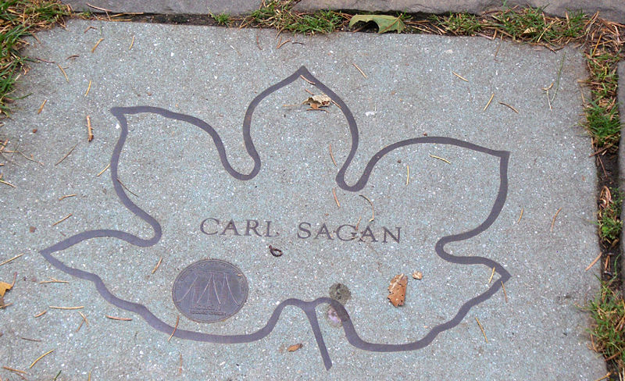

New York City

Stone dedicated to Carl Sagan at Brooklyn Botanical Garden.

After a long and difficult fight with [myelodysplasia](http://en.wikipedia.org/wiki/Myelodysplastic_syndrome), which included three [bone marrow transplants](http://en.wikipedia.org/wiki/Bone_marrow_transplant), Sagan died of [pneumonia](http://en.wikipedia.org/wiki/Pneumonia) at the age of 62 at the [Fred Hutchinson Cancer Research Center](http://en.wikipedia.org/wiki/Fred_Hutchinson_Cancer_Research_Center) in [Seattle, Washington](http://en.wikipedia.org/wiki/Seattle,_Washington) on [December 20](http://en.wikipedia.org/wiki/December_20), [1996](http://en.wikipedia.org/wiki/1996). Surviving him were his wife and five children. Sagan was a significant figure, and his supporters credit his importance to his popularization of the [natural sciences](http://en.wikipedia.org/wiki/Natural_science#Natural_sciences), opposing both restraints on science and reactionary applications of science, defending [democratic](http://en.wikipedia.org/wiki/Democracy) traditions, resisting [nationalism](http://en.wikipedia.org/wiki/Nationalism), defending [humanism](http://en.wikipedia.org/wiki/Humanism), and arguing against [geocentric](http://en.wikipedia.org/wiki/Geocentrism) and [anthropocentric](http://en.wikipedia.org/wiki/Anthropocentrism) views.

After landing, the unmanned [Mars Pathfinder](http://en.wikipedia.org/wiki/Mars_Pathfinder) spacecraft was renamed the [*Carl Sagan Memorial Station*](http://en.wikipedia.org/wiki/Mars_Pathfinder#End_of_the_mission) on [July 5](http://en.wikipedia.org/wiki/July_5), [1997](http://en.wikipedia.org/wiki/1997). Asteroid [2709 Sagan](http://en.wikipedia.org/wiki/2709_Sagan) is also named in his honor.

The 1997 movie [*Contact*](http://en.wikipedia.org/wiki/Contact_%28film%29), based on Sagan's novel of the same name and finished after his death, ends with the dedication "For Carl".

On [November 9](http://en.wikipedia.org/wiki/November_9), [2001](http://en.wikipedia.org/wiki/2001), on what would have been Sagan’s 67th birthday, the [NASA Ames Research Center](http://en.wikipedia.org/wiki/NASA_Ames_Research_Center) dedicated the site for the Carl Sagan Center for the Study of Life in the Cosmos. "Carl was an incredible visionary, and now his legacy can be preserved and advanced by a 21st century research and education laboratory committed to enhancing our understanding of life in the universe and furthering the cause of space exploration for all time", said NASA Administrator [Daniel Goldin](http://en.wikipedia.org/wiki/Daniel_Goldin). Ann Druyan was at the Center as it opened its doors on [October 22](http://en.wikipedia.org/wiki/October_22), [2006](http://en.wikipedia.org/wiki/2006).

Sagan's son, [Nick Sagan](http://en.wikipedia.org/wiki/Nick_Sagan), wrote several episodes in the [*Star Trek*](http://en.wikipedia.org/wiki/Star_Trek) franchise. In an episode of [*Star Trek: Enterprise*](http://en.wikipedia.org/wiki/Star_Trek:_Enterprise) entitled "Terra Prime", a quick shot is shown of the relic rover [Sojourner](http://en.wikipedia.org/wiki/Mars_Pathfinder), part of the Mars Pathfinder mission, placed by a historical marker at Carl Sagan Memorial Station on the Martian surface. The marker displays a quote from Sagan: "Whatever the reason you're on Mars, I'm glad you're there, and I wish I was with you."

Sagan has at least three awards named in his honor: the [Carl Sagan Memorial Award](http://en.wikipedia.org/wiki/Carl_Sagan_Memorial_Award) presented jointly since 1997 by the [American Astronautical Society (AAS)](http://en.wikipedia.org/wiki/American_Astronautical_Society) and the [Planetary Society](http://en.wikipedia.org/wiki/Planetary_Society); the [Carl Sagan Medal](http://en.wikipedia.org/wiki/Carl_Sagan_Medal) for Excellence in Public Communication in Planetary Science presented since 1998 by the American Astronomical Society's [Division for Planetary Sciences](http://en.wikipedia.org/wiki/Division_for_Planetary_Sciences) (AAS/DPS) for outstanding communication by an active planetary scientist to the general public. Carl Sagan was one of the original organizing committee members of the DPS; and the [Carl Sagan Award for Public Understanding of Science](http://en.wikipedia.org/wiki/Carl_Sagan_Award_for_Public_Understanding_of_Science) presented by [Council of Scientific Society Presidents](http://en.wikipedia.org/w/index.php?title=Council_of_Scientific_Society_Presidents&action=edit&redlink=1) (CSSP). Sagan himself was the first recipient of the CSSP award in 1993.[[32]](http://en.wikipedia.org/wiki/Carl_Sagan#cite_note-31) In 2006, the Carl Sagan Medal was awarded to astrobiologist and author [David Grinspoon](http://en.wikipedia.org/wiki/David_Grinspoon), the son of Sagan's friend [Lester Grinspoon](http://en.wikipedia.org/wiki/Lester_Grinspoon).

Sagan's student [Steve Squyres](http://en.wikipedia.org/wiki/Steve_Squyres) led the team that landed the [Spirit Rover](http://en.wikipedia.org/wiki/Spirit_Rover) and [Opportunity Rover](http://en.wikipedia.org/wiki/Opportunity_Rover) successfully on Mars in 2004.

On [December 20](http://en.wikipedia.org/wiki/December_20), [2006](http://en.wikipedia.org/wiki/2006), the tenth anniversary of Sagan's death, a blogger, Joel Schlosberg, organized a Carl Sagan "blog-a-thon" to commemorate Sagan's death, and the idea was supported by Nick Sagan.[[33]](http://en.wikipedia.org/wiki/Carl_Sagan#cite_note-32) Many members of the blogging community participated.

## Awards and honors

* Annual Award for Television Excellence - 1981 - [Ohio State University](http://en.wikipedia.org/wiki/Ohio_State_University) - PBS series [*Cosmos*](http://en.wikipedia.org/wiki/Cosmos:_A_Personal_Voyage)
* [Apollo](http://en.wikipedia.org/wiki/Apollo_program) Achievement Award - [National Aeronautics and Space Administration](http://en.wikipedia.org/wiki/NASA)
* [NASA Distinguished Public Service Medal](http://en.wikipedia.org/wiki/NASA_Distinguished_Service_Medal#NASA_Distinguished_Public_Service_Medal) - National Aeronautics and Space Administration (twice)
* [Emmy](http://en.wikipedia.org/wiki/Emmy) - Outstanding Individual Achievement - 1981 - PBS series *Cosmos*
* Emmy - [Outstanding Informational Series](http://en.wikipedia.org/wiki/Primetime_Emmy_Award_for_Outstanding_Informational_Series) - 1981 - PBS series *Cosmos*
* [Exceptional Scientific Achievement Medal](http://en.wikipedia.org/wiki/NASA_Exceptional_Achievement_Medal) - National Aeronautics and Space Administration
* [Helen Caldicott](http://en.wikipedia.org/wiki/Helen_Caldicott) Leadership Award - Women's Action for Nuclear Disarmament
* [Homer Award](http://en.wikipedia.org/wiki/Homer_Award) - 1997 - [*Contact*](http://en.wikipedia.org/wiki/Contact_%28novel%29)
* [Hugo Award](http://en.wikipedia.org/wiki/Hugo_Award) - 1981 - *Cosmos*
* [Humanist of the Year](http://en.wikipedia.org/wiki/American_Humanist_Association#AHA.27s_Humanists_of_the_Year) - 1981 - Awarded by the [American Humanist Association](http://en.wikipedia.org/wiki/American_Humanist_Association)
* In Praise of Reason Award - 1987 - [Committee for the Scientific Investigation of Claims of the Paranormal](http://en.wikipedia.org/wiki/Committee_for_the_Scientific_Investigation_of_Claims_of_the_Paranormal)
* [Isaac Asimov Award](http://en.wikipedia.org/wiki/Isaac_Asimov_Award) - 1994 - [Committee for the Scientific Investigation of Claims of the Paranormal](http://en.wikipedia.org/wiki/Committee_for_the_Scientific_Investigation_of_Claims_of_the_Paranormal)
* [John F. Kennedy](http://en.wikipedia.org/wiki/John_F._Kennedy) [Astronautics](http://en.wikipedia.org/wiki/Astronautics) Award - [American Astronautical Society](http://en.wikipedia.org/wiki/American_Astronautical_Society)
* [John W. Campbell Memorial Award](http://en.wikipedia.org/wiki/John_W._Campbell_Memorial_Award) - 1974 - [*Cosmic Connection: An Extraterrestrial Perspective*](http://en.wikipedia.org/wiki/Cosmic_Connection:_An_Extraterrestrial_Perspective)
* [Joseph Priestley Award](http://en.wikipedia.org/wiki/Joseph_Priestley) - "For distinguished contributions to the welfare of mankind"
* [Klumpke-Roberts Award](http://en.wikipedia.org/wiki/Klumpke-Roberts_Award) of the [Astronomical Society of the Pacific](http://en.wikipedia.org/wiki/Astronomical_Society_of_the_Pacific) - 1974
* [Konstantin Tsiolkovsky](http://en.wikipedia.org/wiki/Konstantin_Tsiolkovsky) Medal - Awarded by the Soviet Cosmonauts Federation
* [Locus Award](http://en.wikipedia.org/wiki/Locus_Award) 1986 - *Contact*
* [Lowell Thomas](http://en.wikipedia.org/wiki/Lowell_Thomas) Award - [Explorers Club](http://en.wikipedia.org/wiki/Explorers_Club) - 75th Anniversary
* [Masursky Award](http://en.wikipedia.org/wiki/Masursky_Award) - [American Astronomical Society](http://en.wikipedia.org/wiki/American_Astronomical_Society)
* [Miller Research Fellowship](http://en.wikipedia.org/wiki/Miller_Research_Fellows) - [Miller Institute](http://en.wikipedia.org/wiki/Miller_Institute) (1960-1962)
* [Oersted Medal](http://en.wikipedia.org/wiki/Oersted_Medal) - 1990 - [American Association of Physics Teachers](http://en.wikipedia.org/wiki/American_Association_of_Physics_Teachers)
* [Peabody Award](http://en.wikipedia.org/wiki/Peabody_Award) - 1980 - PBS series *Cosmos*
* [Prix Galbert](http://en.wikipedia.org/w/index.php?title=Prix_Galbert&action=edit&redlink=1) - The international prize of [Astronautics](http://en.wikipedia.org/wiki/Astronautics)
* [Public Welfare Medal](http://en.wikipedia.org/wiki/Public_Welfare_Medal) - 1994 - [National Academy of Sciences](http://en.wikipedia.org/wiki/United_States_National_Academy_of_Sciences)
* [Pulitzer Prize for General Non-Fiction](http://en.wikipedia.org/wiki/Pulitzer_Prize) - 1978 - [*The Dragons of Eden*](http://en.wikipedia.org/wiki/The_Dragons_of_Eden)
* [SF Chronicle Award](http://en.wikipedia.org/wiki/The_San_Francisco_Chronicle#Awards_given_by_the_Chronicle) - 1998 - [*Contact*](http://en.wikipedia.org/wiki/Contact_%28film%29)
* Named the “[99th Greatest American](http://en.wikipedia.org/wiki/Greatest_American)” on the [June 5](http://en.wikipedia.org/wiki/June_5), [2005](http://en.wikipedia.org/wiki/2005) *Greatest American* show on the [Discovery Channel](http://en.wikipedia.org/wiki/Discovery_Channel).

## Bibliography

### By Sagan

* *Planets* ([LIFE Science Library](http://en.wikipedia.org/wiki/LIFE_Science_Library)), Sagan, Carl, Jonathon Norton Leonard and editors of Life, Time, Inc., 1966
* *Intelligent Life in the Universe*, [I.S. Shklovskii](http://en.wikipedia.org/wiki/Iosif_Samuilovich_Shklovskii) coauthor, Random House, 1966, 509 pgs
* *UFO's: A Scientific Debate*, Thornton Page coauthor, Cornell University Press, 1972, 310 pgs
* [*Communication with Extraterrestrial Intelligence*](http://en.wikipedia.org/wiki/Communication_with_Extraterrestrial_Intelligence). MIT Press, 1973, 428 pgs
* *Mars and the Mind of Man*, Sagan, Carl, et al., Harper & Row, 1973, 143 pgs
* [*Cosmic Connection: An Extraterrestrial Perspective*](http://en.wikipedia.org/wiki/Cosmic_Connection:_An_Extraterrestrial_Perspective), Jerome Agel coauthor, Anchor Press, 1973, [ISBN 0-521-78303-8](http://en.wikipedia.org/wiki/Special:BookSources/0521783038), 301 pgs
* *Other Worlds*. Bantam Books, 1975
* *Murmurs of Earth: The Voyager Interstellar Record*, Sagan, Carl, et al., Random House, [ISBN 0-394-41047-5](http://en.wikipedia.org/wiki/Special:BookSources/0394410475), 1978
* [*The Dragons of Eden: Speculations on the Evolution of Human Intelligence*](http://en.wikipedia.org/wiki/The_Dragons_of_Eden). Ballantine Books, 1978, [ISBN 0-345-34629-7](http://en.wikipedia.org/wiki/Special:BookSources/0345346297), 288 pgs
* [*Broca's Brain: Reflections on the Romance of Science*](http://en.wikipedia.org/wiki/Broca%27s_Brain:_Reflections_on_the_Romance_of_Science). Ballantine Books, 1979, [ISBN 0-345-33689-5](http://en.wikipedia.org/wiki/Special:BookSources/0345336895), 416 pgs
* [*Cosmos*](http://en.wikipedia.org/wiki/Cosmos_%28book%29). Random house, 1980. Random House New Edition, [May 7](http://en.wikipedia.org/wiki/May_7), [2002](http://en.wikipedia.org/wiki/2002), [ISBN 0-375-50832-5](http://en.wikipedia.org/wiki/Special:BookSources/0375508325), 384 pgs
* *The Nuclear Winter: The World After Nuclear War*, Sagan, Carl et al., Sidgwick & Jackson, 1985
* [*Comet*](http://en.wikipedia.org/wiki/Comet), [Ann Druyan](http://en.wikipedia.org/wiki/Ann_Druyan) coauthor, Ballantine Books, 1985, [ISBN 0-345-41222-2](http://en.wikipedia.org/wiki/Special:BookSources/0345412222), 496 pgs
* [*Contact*](http://en.wikipedia.org/wiki/Contact_%28novel%29). Simon and Schuster, 1985; Reissued August 1997 by Doubleday Books, [ISBN 1-56865-424-3](http://en.wikipedia.org/wiki/Special:BookSources/1568654243), 352 pgs
* *The Varieties of Scientific Experience: A Personal View of the Search for God*, Ann Druyan editor, 1985 [Gifford lectures](http://en.wikipedia.org/wiki/Gifford_lectures), Penguin Press, 2006, [ISBN 1-59420-107-2](http://en.wikipedia.org/wiki/Special:BookSources/1594201072), 304 pgs
* *A Path Where No Man Thought: Nuclear Winter and the End of the Arms Race*, Richard Turco coauthor, Random House, 1990, [ISBN 0-394-58307-8](http://en.wikipedia.org/wiki/Special:BookSources/0394583078), 499 pgs
* *Shadows of Forgotten Ancestors: A Search for Who We Are*, [Ann Druyan](http://en.wikipedia.org/wiki/Ann_Druyan) Coauthor, Ballantine Books, October 1993, [ISBN 0-345-38472-5](http://en.wikipedia.org/wiki/Special:BookSources/0345384725), 528 pgs
* [*Pale Blue Dot: A Vision of the Human Future in Space*](http://en.wikipedia.org/wiki/Pale_Blue_Dot:_A_Vision_of_the_Human_Future_in_Space). Random House, November 1994, [ISBN 0-679-43841-6](http://en.wikipedia.org/wiki/Special:BookSources/0679438416), 429 pgs
* [*The Demon-Haunted World: Science as a Candle in the Dark*](http://en.wikipedia.org/wiki/The_Demon-Haunted_World). Ballantine Books, March 1996, [ISBN 0-345-40946-9](http://en.wikipedia.org/wiki/Special:BookSources/0345409469), 480 pgs
* [*Billions and Billions: Thoughts on Life and Death at the Brink of the Millennium*](http://en.wikipedia.org/wiki/Billions_and_Billions:_Thoughts_on_Life_and_Death_at_the_Brink_of_the_Millennium), [Ann Druyan](http://en.wikipedia.org/wiki/Ann_Druyan) coauthor, Ballantine Books, June 1997, [ISBN 0-345-37918-7](http://en.wikipedia.org/wiki/Special:BookSources/0345379187), 320 pgs
* *The Varieties of Scientific Experience: A Personal View of the Search for God*, Carl Sagan (writer) & Ann Druyan (editor), Penguin Press HC, November 2006, [ISBN 1594201072](http://en.wikipedia.org/wiki/Special:BookSources/1594201072), 304 pgs

### About Sagan

* Davidson, Keay (1999). Carl Sagan: A Life. New York: John Wiley & Sons, p. 33-41. [ISBN 0471252867](http://en.wikipedia.org/wiki/Special:BookSources/0471252867).
* Head, Tom (ed.) (2005). Conversations with Carl Sagan. Jackson, Mississippi: University Press of Mississippi. [ISBN 1578067367](http://en.wikipedia.org/wiki/Special:BookSources/1578067367).
* Poundstone, William (1999). Carl Sagan: A Life in the Cosmos. New York: Henry Holt & Company. [ISBN 0805057668](http://en.wikipedia.org/wiki/Special:BookSources/0805057668).
* Morrison, David (2006). Carl Sagan: The People's Astronomer. *AmeriQuests*, vol. 3. no. 2: <<http://ejournals.library.vanderbilt.edu/ameriquests/include/getdoc.php?id=402&article=93&mode=pdf>>.
* Achenbach, Joel (1999). *Captured by Aliens: the search for life and truth in a very large universe*. New York: Simon & Schuster. [ISBN 0684848562](http://en.wikipedia.org/wiki/Special:BookSources/0684848562). Includes detailed account of Sagan's role in the search for extraterrestrial life.

## References

1. [**^**](http://en.wikipedia.org/wiki/Carl_Sagan#cite_ref-0) "[StarChild: Dr. Carl Sagan](http://starchild.gsfc.nasa.gov/docs/StarChild/whos_who_level2/sagan.html" \o "http://starchild.gsfc.nasa.gov/docs/StarChild/whos_who_level2/sagan.html)". NASA. Retrieved on [2007](http://en.wikipedia.org/wiki/2007)-[05-02](http://en.wikipedia.org/wiki/May_2).
2. ^ [***a***](http://en.wikipedia.org/wiki/Carl_Sagan#cite_ref-poundstone_1-0) [***b***](http://en.wikipedia.org/wiki/Carl_Sagan#cite_ref-poundstone_1-1) Poundstone, William (1999). Carl Sagan: A Life in the Cosmos. New York: Henry Holt & Company, pp. 363-364, 374-375. [ISBN 0805057668](http://en.wikipedia.org/wiki/Special:BookSources/0805057668).
3. [**^**](http://en.wikipedia.org/wiki/Carl_Sagan#cite_ref-2) Davidson, Keay (1999). Carl Sagan: A Life. John Wiley & Sons, p. 33-41. [ISBN 0471252867](http://en.wikipedia.org/wiki/Special:BookSources/0471252867).
4. [**^**](http://en.wikipedia.org/wiki/Carl_Sagan#cite_ref-3) [Graduate students receive first Sagan teaching awards](http://chronicle.uchicago.edu/931111/sagan.shtml)
5. [**^**](http://en.wikipedia.org/wiki/Carl_Sagan#cite_ref-4) Much of Sagan's research in the field of planetary science is outlined by William Poundstone. Poundstone's biography of Sagan includes an 8-page list of Sagan's scientific articles published from 1957 to 1998. Detailed information about Sagan's scientific work comes from the primary research articles. Example: Sagan, C., Thompson, W. R., and Khare, B. N. [*Titan: A Laboratory for Prebiological Organic Chemistry*](http://en.wikipedia.org/w/index.php?title=Titan:_A_Laboratory_for_Prebiological_Organic_Chemistry&action=edit&redlink=1), Accounts of Chemical Research, volume 25, page 286 (1992). There is commentary on this research article about Titan at [The Encyclopedia of Astrobiology, Astronomy, and Spaceflight](http://www.daviddarling.info/encyclopedia/T/Titanprebiotic.html).
6. [**^**](http://en.wikipedia.org/wiki/Carl_Sagan#cite_ref-5) The Columbia Encyclopedia. "[Sagan, Carl Edward](http://www.bartelby.com/65/sa/Sagan-Ca.html)". *Sixth Edition*. Columbia University Press. Retrieved on [2007](http://en.wikipedia.org/wiki/2007)-[05-02](http://en.wikipedia.org/wiki/May_2).
7. [**^**](http://en.wikipedia.org/wiki/Carl_Sagan#cite_ref-6) The Planetary Society accessdate=2007-05-14. "[Carl Sagan](http://www.planetary.org/about/founders/carl_sagan.html)". The Planetary Society.
8. [**^**](http://en.wikipedia.org/wiki/Carl_Sagan#cite_ref-7) Turco RP, Toon OB, Ackerman TP, Pollack JB, Sagan C. [*Climate and smoke: an appraisal of nuclear winter*](http://en.wikipedia.org/w/index.php?title=Climate_and_smoke:_an_appraisal_of_nuclear_winter&action=edit&redlink=1)*,* [Science](http://en.wikipedia.org/wiki/Science_%28journal%29), volume 247, pages 166-176 (1990). [PubMed abstract](http://www.ncbi.nlm.nih.gov/entrez/query.fcgi?cmd=Retrieve&db=PubMed&list_uids=11538069&dopt=Abstract) [JSTOR](http://links.jstor.org/sici?sici=0036-8075%2819900112%293%3A247%3A4939%3C166%3ACASAAO%3E2.0.CO%3B2-V) link to full text article. Carl Sagan discussed his involvement in the political nuclear winter debates and his erroneous global cooling prediction for the Gulf War fires in his book, [*The Demon-Haunted World*](http://en.wikipedia.org/wiki/The_Demon-Haunted_World).
9. [**^**](http://en.wikipedia.org/wiki/Carl_Sagan#cite_ref-8) Sagan, Carl. The Demon-Haunted World. p. 257.
10. [**^**](http://en.wikipedia.org/wiki/Carl_Sagan#cite_ref-9) www.mnsu.edu/emuseum/information/biography/pqrst/sagan_carl.html
11. [**^**](http://en.wikipedia.org/wiki/Carl_Sagan#cite_ref-10) "[Meet Dr. Carl Sagan](http://science.discovery.com/convergence/cosmos/bio/bio.html?clik=fsmain_feat3)". The Science Channel. Retrieved on [2007](http://en.wikipedia.org/wiki/2007)-[05-02](http://en.wikipedia.org/wiki/May_2).
12. [**^**](http://en.wikipedia.org/wiki/Carl_Sagan#cite_ref-11) Sagan, Carl; p. 3-4 (1998). [*Billions and Billions*](http://en.wikipedia.org/wiki/Billions_and_Billions:_Thoughts_on_Life_and_Death_at_the_Brink_of_the_Millennium). New York: Ballantine Books. [ISBN 0-345-37918-7](http://en.wikipedia.org/wiki/Special:BookSources/0345379187).
13. [**^**](http://en.wikipedia.org/wiki/Carl_Sagan#cite_ref-12) Myers portrayed Sagan in "SNL: Carl Sagan's Global Warming Christmas Special [VIDEO]"<<http://www.alternet.org/blogs/video/71374/>>
14. [**^**](http://en.wikipedia.org/wiki/Carl_Sagan#cite_ref-13) [[Sagan, Astronomer: Author of Pale Blue Dot: A Vision of the Human Future in Space](http://video.google.com/videoplay?docid=-1127834163386485385#2370s%7CCarl)]. Interview with Charlie Rose. Charlie Rose. PBS New York. 1995-01-05. Retrieved on [2007](http://en.wikipedia.org/wiki/2007)-[04-25](http://en.wikipedia.org/wiki/April_25). starts at 00:39:29
15. [**^**](http://en.wikipedia.org/wiki/Carl_Sagan#cite_ref-14) Jastrow, Robert (1979). Velikovsky, a Star-Crossed Theoretician of the Cosmos. New York *Times*, December 2, 1979, p. E22 <<http://select.nytimes.com/gst/abstract.html?res=F10710FC3F5512718DDDAB0894DA415B898BF1D3&scp=1&sq=&st=p>> and Jastrow, Robert (1980). Hero or Heretic? *Science Digest Special*, Sept/Oct, pp. 92-96. Carl Sagan's letter replying to Jastrow, "Immanuel Velikovsky's Unlikely Collisions", was published in New York *Times*, December 29, 1979, p. 20, with a rebuttal from Clark Whelton, "Unrefuted 'Worlds in Collision'" appearing January 11, 1980, p. A22.
16. [**^**](http://en.wikipedia.org/wiki/Carl_Sagan#cite_ref-15) Morrison, David (2001). Velikovsky at Fifty: Cultures in Collision on the Fringes of Science. *Skeptic*, **9** (1), 62-76; reprinted in Shermer, Michael (editor) (2002). [The Skeptic Encyclopedia of Pseudoscience](http://en.wikipedia.org/wiki/The_Skeptic_Encyclopedia_of_Pseudoscience), Santa Barbara, Calif. [ISBN 1576076539](http://en.wikipedia.org/wiki/Special:BookSources/1576076539). pp. 473-488.
17. [**^**](http://en.wikipedia.org/wiki/Carl_Sagan#cite_ref-16) [Ellenberger, Leroy](http://en.wikipedia.org/wiki/C._Leroy_Ellenberger) (1999). Sagan and Velikovsky (letter submitted to *Skeptical Inquirer*). <<http://abob.libs.uga.edu/bobk/velidelu.html#CS>>
18. [**^**](http://en.wikipedia.org/wiki/Carl_Sagan#cite_ref-17) Kogan, S. F. (1980). Sagan versus Velikovsky (letter). *Physics Today*, Sept., pp. 97-98.
19. [**^**](http://en.wikipedia.org/wiki/Carl_Sagan#cite_ref-18) Talbott, George R. (1978). *Kronos*, **4** (2), 3-25; reported by [C.L. Ellenberger](http://en.wikipedia.org/wiki/C._Leroy_Ellenberger) (letter) in *Physics Today*, April 1981, p. 72, and (letter) in *Skeptical Inquirer*, March/April 2000, pp. 67-68. <<http://findarticles.com/p/articles/mi_m2843/is_2_24/ai_60302620/pg_5>>
20. [**^**](http://en.wikipedia.org/wiki/Carl_Sagan#cite_ref-19) Anthony Barnes ([2005](http://en.wikipedia.org/wiki/2005)-[10-23](http://en.wikipedia.org/wiki/October_23)). "[2001: The secrets of Kubrick's classic](http://arts.independent.co.uk/film/news/article321643.ece)". The Independent. Retrieved on [2007](http://en.wikipedia.org/wiki/2007)-[05-02](http://en.wikipedia.org/wiki/May_2).
21. [**^**](http://en.wikipedia.org/wiki/Carl_Sagan#cite_ref-20) "[This Week in Apple History: November 14-20](http://www.macobserver.com/columns/thisweek/2004/20041120.shtml)". The Mac Observer.
22. [**^**](http://en.wikipedia.org/wiki/Carl_Sagan#cite_ref-21) Carl Sagan, Plaintiff, v. Apple Computer, Inc., Defendant CV 94-2180 LGB (BRx) United States District Court for the Central District of California 874 F. Supp. 1072; 1994 U.S. Dist. Lexis 20154 [June 27](http://en.wikipedia.org/wiki/June_27), [1994](http://en.wikipedia.org/wiki/1994), Decided June 27, 1994, Filed
23. [**^**](http://en.wikipedia.org/wiki/Carl_Sagan#cite_ref-22) A similar quote can be found in Chapter 23 of Sagan's book [*Broca's Brain*](http://en.wikipedia.org/wiki/Broca%27s_Brain:_Reflections_on_the_Romance_of_Science). "Some people think God is an outsized, light-skinned male with a long white beard, sitting on a throne somewhere up there in the sky, busily tallying the fall of every sparrow. Others — for example [Baruch Spinoza](http://en.wikipedia.org/wiki/Baruch_Spinoza) and [Albert Einstein](http://en.wikipedia.org/wiki/Albert_Einstein) — considered God to be essentially the sum total of the physical laws which describe the universe. I do not know of any compelling evidence for anthropomorphic patriarchs controlling human destiny from some hidden celestial vantage point, but it would be madness to deny the existence of physical laws."
24. [**^**](http://en.wikipedia.org/wiki/Carl_Sagan#cite_ref-23) Marcello Truzzi (1998). "[On Some Unfair Practices towards Claims of the Paranormal](http://www.skepticalinvestigations.org/anomalistics/practices.htm)". *Oxymoron: Annual Thematic Anthology of the Arts and Sciences, Vol.2: The Fringe*. Oxymoron Media, Inc. Retrieved on [2007](http://en.wikipedia.org/wiki/2007)-[05-02](http://en.wikipedia.org/wiki/May_2).
25. [**^**](http://en.wikipedia.org/wiki/Carl_Sagan#cite_ref-24) Grinspoon, Lester, M.D. (1994). Marihuana Reconsidered, 2nd edition, Oakland, CA: Quick American Archives. [ISBN 0932551130](http://en.wikipedia.org/wiki/Special:BookSources/0932551130).
26. [**^**](http://en.wikipedia.org/wiki/Carl_Sagan#cite_ref-25) Carl Sagan (1971). "[Mr. X](http://www.marijuana-uses.com/essays/002.html)". *Marihuana Reconsidered*. Marijuana Uses. Retrieved on [2007](http://en.wikipedia.org/wiki/2007)-[05-02](http://en.wikipedia.org/wiki/May_2).
27. [**^**](http://en.wikipedia.org/wiki/Carl_Sagan#cite_ref-26) **a.** Dr David Whitehouse ([1999](http://en.wikipedia.org/wiki/1999)-[10-15](http://en.wikipedia.org/wiki/October_15)). "[Carl Sagan: A life in the cosmos](http://news.bbc.co.uk/1/hi/sci/tech/475954.stm)", BBC News. Retrieved on [2007](http://en.wikipedia.org/wiki/2007)-[05-02](http://en.wikipedia.org/wiki/May_2).   
    **b.** "[Billions and Billions of '60s Flashbacks](http://www.druglibrary.org/think/%7Ejnr/sagan.htm)", San Francisco Examiner ([1999](http://en.wikipedia.org/wiki/1999)-[08-22](http://en.wikipedia.org/wiki/August_22)). Retrieved on [2007](http://en.wikipedia.org/wiki/2007)-[05-02](http://en.wikipedia.org/wiki/May_2).   
    **c.** Dana Larsen ([1999](http://en.wikipedia.org/wiki/1999)-[11-01](http://en.wikipedia.org/wiki/November_1)). "[Carl Sagan: Toking Astronomer](http://cannabisculture.com/articles/63.html)", Cannabis Culture magazine. Retrieved on [2007](http://en.wikipedia.org/wiki/2007)-[05-02](http://en.wikipedia.org/wiki/May_2).
28. ^ [***a***](http://en.wikipedia.org/wiki/Carl_Sagan#cite_ref-westrum_27-0) [***b***](http://en.wikipedia.org/wiki/Carl_Sagan#cite_ref-westrum_27-1) [***c***](http://en.wikipedia.org/wiki/Carl_Sagan#cite_ref-westrum_27-2) Westrum, Ron; Jacobs, David Michael (ed.) (2000). "Limited Access: Six Natural Scientists and the UFO Phenomenon", UFOs and abductions: Challenging the Borders of Knowledge. Lawrence, Kansas: University Press of Kansas, p. 30-55. [ISBN 0700610324](http://en.wikipedia.org/wiki/Special:BookSources/0700610324).
29. [**^**](http://en.wikipedia.org/wiki/Carl_Sagan#cite_ref-28) Appelle, Stuart; Jacobs, David Michael (ed.) (2000). "Ufology and Academia: The UFO Phenomenon as a Scholarly Discipline", UFOs and abductions: Challenging the Borders of Knowledge. Lawrence, Kansas: University Press of Kansas, p. 7-30. [ISBN 0700610324](http://en.wikipedia.org/wiki/Special:BookSources/0700610324).
30. [**^**](http://en.wikipedia.org/wiki/Carl_Sagan#cite_ref-29) Clark, Jeromne (1998). The UFO book: Encyclopedia of the Extraterrestrial. Detroit, Michigan: Visible Ink Press, p. 603. [ISBN 1578590299](http://en.wikipedia.org/wiki/Special:BookSources/1578590299).
31. [**^**](http://en.wikipedia.org/wiki/Carl_Sagan#cite_ref-30) Sagan, 1996: 81-96, 99-104
32. [**^**](http://en.wikipedia.org/wiki/Carl_Sagan#cite_ref-31) "[Sagan Award for Public Understanding of Science](http://cssp.us/index.php?option=content&task=view&id=17&Itemid=47)". The Council of Scientific Society Presidents. Retrieved on [2007](http://en.wikipedia.org/wiki/2007)-[05-02](http://en.wikipedia.org/wiki/May_2).
33. [**^**](http://en.wikipedia.org/wiki/Carl_Sagan#cite_ref-32) [Joel's humanistic blog: Announcing the Carl Sagan memorial blog-a-thon](http://joelschlosberg.blogspot.com/2006/11/announcing-carl-sagan-memorial-blog.html)

## External links

* [The Carl Sagan Portal](http://www.carlsagan.com/)
* [Carl Sagan](http://www.imdb.com/name/nm0755981/) at the [Internet Movie Database](http://en.wikipedia.org/wiki/Internet_Movie_Database)
* [*Can We Know the Universe?*](http://www.stephenjaygould.org/ctrl/sagan_science.html) – 1979 essay by Carl Sagan, taken from his book *Broca's Brain*
* [*Talk of the Nation*](http://www.npr.org/templates/story/story.php?storyId=1011828) – Ira Flatow interviews Sagan on his book *The Demon-Haunted World: Science as a Candle in the Dark* ([May 3](http://en.wikipedia.org/wiki/May_3), [1996](http://en.wikipedia.org/wiki/1996))
* [Skeptical Inquirer: *Carl Sagan's Life & Legacy*](http://www.csicop.org/si/2007-01/sagan.html) (Jan./Feb. 2007)
* [*We Are Here: The Pale Blue Dot*](http://www.youtube.com/watch?v=2pfwY2TNehw) – A short film narrated by Carl Sagan [(40 min extended version)](http://video.google.ca/videoplay?docid=2588435272514121795)
* [Carl Sagan](http://www.charlierose.com/guests/carl-sagan) [*Charlie Rose*](http://en.wikipedia.org/wiki/Charlie_Rose_%28talk_show%29) interviews
* [Carl Sagan Prize for Science Popularization](http://www.wonderfest.org/html/sagan_prize_info.html)
* [Carl Sagan Medal for Excellence in Public Communication in Planetary Science](http://dps.aas.org/prizes/sagan), presented by the American Astronomical Society's Division for Planetary Sciences (AAS/DPS)
* [Cosmos Magazine](http://www.cosmosmagazine.com/), an Australian popular science magazine inspired by Carl Sagan and launched in June 2005
* [Works by or about Carl Sagan](http://worldcat.org/identities/lccn-n79-64998) in libraries ([WorldCat](http://en.wikipedia.org/wiki/WorldCat" \o "WorldCat) catalog)
* [Carl Sagan](http://www.findagrave.com/cgi-bin/fg.cgi?page=gr&GRid=1347) at [Find A Grave](http://en.wikipedia.org/wiki/Find_A_Grave)

|  |  |
| --- | --- |
| [**Persondata**](http://en.wikipedia.org/wiki/Wikipedia:Persondata) | |
| NAME | Sagan, Carl Edward |
| ALTERNATIVE NAMES |  |
| SHORT DESCRIPTION | [Astronomy](http://en.wikipedia.org/wiki/Astronomy) and [planetary science](http://en.wikipedia.org/wiki/Planetary_science) |
| DATE OF BIRTH | November 9, 1934(1934-11-09) |
| PLACE OF BIRTH | [Brooklyn](http://en.wikipedia.org/wiki/Brooklyn,_New_York), [New York](http://en.wikipedia.org/wiki/NY) |
| DATE OF DEATH | December 20, 1996 |
| PLACE OF DEATH | [Seattle, Washington](http://en.wikipedia.org/wiki/Seattle,_Washington) |

Retrieved from "<http://en.wikipedia.org/wiki/Carl_Sagan>"

[Categories](http://en.wikipedia.org/wiki/Special:Categories): [1934 births](http://en.wikipedia.org/wiki/Category:1934_births) | [1996 deaths](http://en.wikipedia.org/wiki/Category:1996_deaths) | [American agnostics](http://en.wikipedia.org/wiki/Category:American_agnostics) | [American astronomers](http://en.wikipedia.org/wiki/Category:American_astronomers) | [American humanists](http://en.wikipedia.org/wiki/Category:American_humanists) | [American science fiction writers](http://en.wikipedia.org/wiki/Category:American_science_fiction_writers) | [American science writers](http://en.wikipedia.org/wiki/Category:American_science_writers) | [American skeptics](http://en.wikipedia.org/wiki/Category:American_skeptics) | [Cornell University faculty](http://en.wikipedia.org/wiki/Category:Cornell_University_faculty) | [Deaths from pneumonia](http://en.wikipedia.org/wiki/Category:Deaths_from_pneumonia) | [Jewish American scientists](http://en.wikipedia.org/wiki/Category:Jewish_American_scientists) | [Jewish skeptics](http://en.wikipedia.org/wiki/Category:Jewish_skeptics) | [Jewish agnostics](http://en.wikipedia.org/wiki/Category:Jewish_agnostics) | [People from Brooklyn](http://en.wikipedia.org/wiki/Category:People_from_Brooklyn) | [Planetary scientists](http://en.wikipedia.org/wiki/Category:Planetary_scientists) | [Pulitzer Prize for General Non-Fiction winners](http://en.wikipedia.org/wiki/Category:Pulitzer_Prize_for_General_Non-Fiction_winners) | [Rahway High School alumni](http://en.wikipedia.org/wiki/Category:Rahway_High_School_alumni) | [SETI](http://en.wikipedia.org/wiki/Category:SETI) | [Interstellar messages](http://en.wikipedia.org/wiki/Category:Interstellar_messages) | [Space advocates](http://en.wikipedia.org/wiki/Category:Space_advocates) | [University of Chicago alumni](http://en.wikipedia.org/wiki/Category:University_of_Chicago_alumni) | [American anti-nuclear weapons activists](http://en.wikipedia.org/wiki/Category:American_anti-nuclear_weapons_activists) | [Infectious disease deaths in Washington](http://en.wikipedia.org/wiki/Category:Infectious_disease_deaths_in_Washington)

END