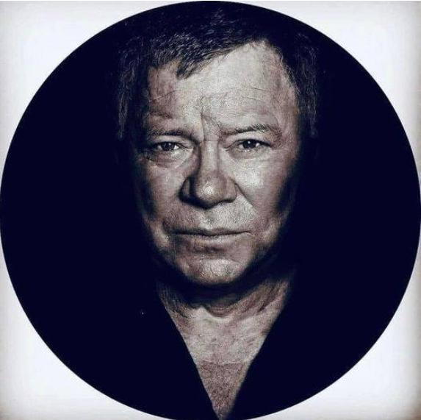

**William Shatner goes on a shuttle ride and his thoughts of space travel Oct 2023**

“Last year, I had a life-changing experience at 90 years old. I went to space, after decades of playing an iconic science-fiction character who was exploring the universe. I thought I would experience a deep connection with the immensity around us, a deep call for endless exploration.

"I was absolutely wrong. The strongest feeling, that dominated everything else by far, was the deepest grief that I had ever experienced.

"I understood, in the clearest possible way, that we were living on a tiny oasis of life, surrounded by an immensity of death. I didn’t see infinite possibilities of worlds to explore, of adventures to have, or living creatures to connect with. I saw the deepest darkness I could have ever imagined, contrasting so starkly with the welcoming warmth of our nurturing home planet.

"This was an immensely powerful awakening for me. It filled me with sadness. I realized that we had spent decades, if not centuries, being obsessed with looking away, with looking outside. I did my share in popularizing the idea that space was the final frontier. But I had to get to space to understand that Earth is and will stay our only home. And that we have been ravaging it, relentlessly, making it uninhabitable."

**William Shatner: My Trip to Space Filled Me With ‘Overwhelming Sadness’ (EXCLUSIVE)**

Oct 6, 2022

**https://variety.com/2022/tv/news/william-shatner-space-boldly-go-excerpt-1235395113/**

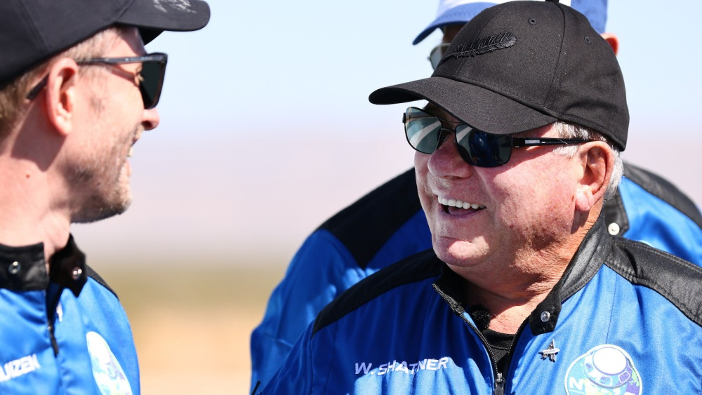

*Mario Tama/Getty Images*

*In this exclusive excerpt from* [*William Shatner*](https://variety.com/t/william-shatner/)*‘s new book, “*[*Boldly Go*](https://variety.com/t/boldly-go/)*: Reflections on a Life of Awe and Wonder,” the “*[*Star Trek*](https://variety.com/t/star-trek/)*” actor reflects on his voyage into space on Jeff Bezos’* [*Blue Origin*](https://variety.com/t/blue-origin/) *space shuttle on Oct. 13, 2021. Then 90 years old, Shatner became the* [*oldest living person to travel into space*](https://variety.com/2021/tv/news/william-shatner-space-blue-origin-jeff-bezos-1235086529/)*, but as the actor and author details below, he was surprised by his own reaction to the experience.*

So, I went to space.

Our group, consisting of me, tech mogul Glen de Vries, Blue Origin Vice President and former NASA International Space Station flight controller Audrey Powers, and former NASA engineer Dr. Chris Boshuizen, had done various simulations and training courses to prepare, but you can only prepare so much for a trip out of Earth’s atmosphere! As if sensing that feeling in our group, the ground crew kept reassuring us along the way. “Everything’s going to be fine. Don’t worry about anything. It’s all okay.” *Sure, easy for them to say*, I thought. *They get to stay here on the ground.*

During our preparation, we had gone up eleven flights of the gantry to see what it would be like when the rocket was there. We were then escorted to a thick cement room with oxygen tanks. “What’s this room for?” I asked casually.

“Oh, you guys will rush in here if the rocket explodes,” a Blue Origin fellow responded just as casually.

Uh-huh. A safe room. Eleven stories up. In case the rocket explodes.

*Well, at least they’ve thought of it.*

When the day finally arrived, I couldn’t get the Hindenburg out of my head. Not enough to cancel, of course—I hold myself to be a professional, and I was booked. The show had to go on.

We got ourselves situated inside the pod. You have to strap yourself in in a specific order. In the simulator, I didn’t nail it every time, so as I sat there, waiting to take off, the importance of navigating weightlessness to get back and strap into the seat correctly was at the forefront of my mind.

That, and the Hindenburg crash.

Then there was a delay.

“Sorry, folks, there’s a slight anomaly in the engine. It’ll just be a few moments.”

*An anomaly in the engine?!* That sounds kinda serious, doesn’t it?

An anomaly is something that *does not belong*. *What is currently in the engine that doesn’t belong there?!*

More importantly, *why would they tell us that?* There is a time for unvarnished honesty. I get that. *This wasn’t it.*

Apparently, the anomaly wasn’t too concerning, because thirty seconds later, we were cleared for launch and the countdown began. With all the attending noise, fire, and fury, we lifted off. I could see Earth disappearing. As we ascended, I was at once aware of pressure. Gravitational forces pulling at me. The g’s. There was an instrument that told us how many g’s we were experiencing. At two g’s, I tried to raise my arm, and could barely do so. At three g’s, I felt my face being pushed down into my seat. *I don’t know how much more of this I can take,* I thought. *Will I pass out? Will my face melt into a pile of mush? How many g’s can my ninety-year-old body handle?*

And then, suddenly, relief. No g’s. Zero. Weightlessness. We were floating.

We got out of our harnesses and began to float around. The other folks went straight into somersaults and enjoying all the effects of weightlessness. I wanted no part in that. I wanted, *needed* to get to the window as quickly as possible to see what was out there.

I looked down and I could see the hole that our spaceship had punched in the thin, blue-tinged layer of oxygen around Earth. It was as if there was a wake trailing behind where we had just been, and just as soon as I’d noticed it, it disappeared.

I continued my self-guided tour and turned my head to face the other direction, to stare into space. I love the mystery of the universe. I love all the questions that have come to us over thousands of years of exploration and hypotheses. Stars exploding years ago, their light traveling to us years later; black holes absorbing energy; satellites showing us entire galaxies in areas thought to be devoid of matter entirely… all of that has thrilled me for years… but when I looked in the opposite direction, into space, there was no mystery, no majestic awe to behold . . . all I saw was death.

I saw a cold, dark, black emptiness. It was unlike any blackness you can see or feel on Earth. It was deep, enveloping, all-encompassing. I turned back toward the light of home. I could see the curvature of Earth, the beige of the desert, the white of the clouds and the blue of the sky. It was life. Nurturing, sustaining, life. Mother Earth. Gaia. And I was leaving her.

Everything I had thought was wrong. Everything I had expected to see was wrong.

I had thought that going into space would be the ultimate catharsis of that connection I had been looking for between all living things—that being up there would be the next beautiful step to understanding the harmony of the universe. In the film “Contact,” when Jodie Foster’s character goes to space and looks out into the heavens, she lets out an astonished whisper, “They should’ve sent a poet.” I had a different experience, because I discovered that the beauty isn’t out there, it’s down here, with all of us. Leaving that behind made my connection to our tiny planet even more profound.

It was among the strongest feelings of grief I have ever encountered. The contrast between the vicious coldness of space and the warm nurturing of Earth below filled me with overwhelming sadness. Every day, we are confronted with the knowledge of further destruction of Earth at our hands: the extinction of animal species, of flora and fauna . . . things that took five billion years to evolve, and suddenly we will never see them again because of the interference of mankind. It filled me with dread. My trip to space was supposed to be a celebration; instead, it felt like a funeral.

I learned later that I was not alone in this feeling. It is called the “Overview Effect” and is not uncommon among astronauts, including Yuri Gagarin, Michael Collins, Sally Ride, and many others. Essentially, when someone travels to space and views Earth from orbit, a sense of the planet’s fragility takes hold in an ineffable, instinctive manner. Author Frank White first coined the term in 1987: “There are no borders or boundaries on our planet except those that we create in our minds or through human behaviors. All the ideas and concepts that divide us when we are on the surface begin to fade from orbit and the moon. The result is a shift in worldview, and in identity.”

It can change the way we look at the planet but also other things like countries, ethnicities, religions; it can prompt an instant reevaluation of our shared harmony and a shift in focus to all the wonderful things we have in common instead of what makes us different. It reinforced tenfold my own view on the power of our beautiful, mysterious collective human entanglement, and eventually, it returned a feeling of hope to my heart. In this insignificance we share, we have one gift that other species perhaps do not: we are *aware*—not only of our insignificance, but the grandeur around us that *makes* us insignificant. That allows us perhaps a chance to rededicate ourselves to our planet, to each other, to life and love all around us. If we seize that chance.

*“Boldly Go: Reflections on a Life of Awe and Wonder,” co-authored by Josh Brandon, was published by Atria Books on Oct. 4, 2022.*

# William Shatner experienced profound grief in space. It was the 'overview effect'

October 23, 2022

<https://www.npr.org/2022/10/23/1130482740/william-shatner-jeff-bezos-space-travel-overview-effect>

By Enrique Rivera



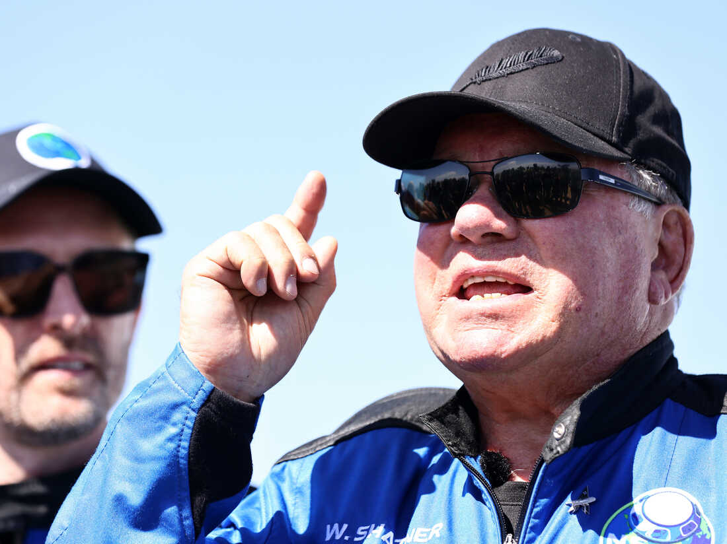

Star Trek actor William Shatner flew into space on October 13, 2021.

Mario Tama/Getty Images

William Shatner is probably the most famous astronaut in the world. But of course, he's not an astronaut. He's an actor. The 91-year-old Canadian has been an icon since he played Captain Kirk in the original Star Trek series, which debuted in 1966.

But Captain Kirk, er, William Shatner, did actually go to space — last year, aboard a capsule piloted by Jeff Bezos's company Blue Origin. Shatner details his experiences in his new memoir Boldly Go.

"I was crying," Shatner told NPR. "I didn't know what I was crying about. I had to go off some place and sit down and think, what's the matter with me? And I realized I was in grief."

[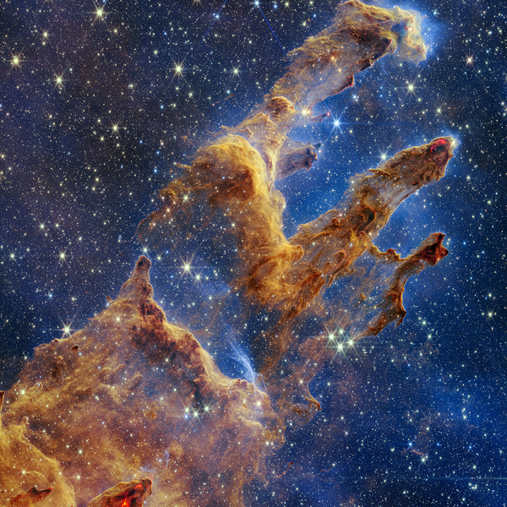](https://www.npr.org/2022/10/20/1130188178/james-webb-telescope-photo-pillars-creation-stars)

### [Space](https://www.npr.org/sections/space/)

### [Hubble's 1995 image of a star nursery was amazing. Take a look at NASA's new version](https://www.npr.org/2022/10/20/1130188178/james-webb-telescope-photo-pillars-creation-stars)

While he wasn't sure what to expect, Shatner did not predict this. He had been excited to travel to space, and had thought about it for nearly 60 years, but didn't think he'd be overwhelmed with sadness, or that he'd go through "the strongest feelings of grief" that he's ever experienced.

There's a name for what Shatner felt: it's called the "overview effect." The term was coined by space philosopher Frank White in his 1987 book of the same name.

"The overview effect is a cognitive and emotional shift in a person's awareness, their consciousness and their identity when they see the Earth from space," White told NPR. "They're at a distance and they're seeing the Earth ... in the context of the universe."

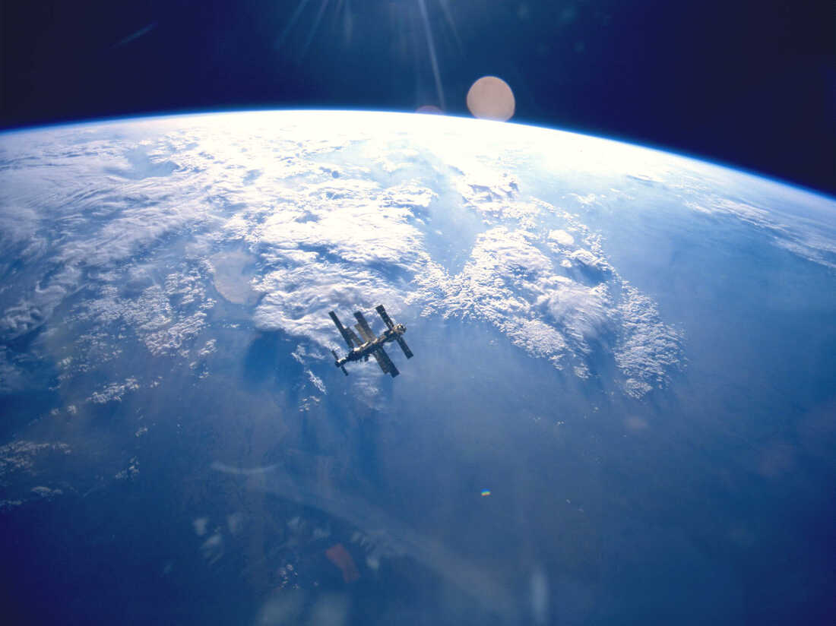

The overview effect is known to affect astronauts.

NASA/Getty Images

This context was what struck Shatner the most.

"It was the death that I saw in space and the lifeforce that I saw coming from the planet — the blue, the beige and the white," he said. "And I realized one was death and the other was life."

According to White, everyone who travels to space experiences an "overview effect" — an emotional or mental reaction strong enough to disrupt that person's previous assumptions about humanity, Earth, and/or the cosmos. Everyone's overview effect is unique to them, but there are reactions that are more common than others.

White has interviewed more than 40 astronauts, and says that Shatner's response is typical. "People often cry when they first see the Earth from space," he said.

"I wept for the Earth because I realized it's dying," Shatner said. "I dedicated my book, Boldly Go, to my great-grandchild, who's three now — coming three — and in the dedication, say it's them, those youngsters, who are going to reap what we have sown in terms of the destruction of the Earth."

### Astronauts often return with a greater distaste for war

After traveling to space, astronauts gain a greater understanding of how precious, and delicate, the Earth is. Many astronauts report that they were aware of climate change and global warming, but they became much more sensitive to the subject after traveling to space.

White said that one astronaut told him that the biggest lesson they learned from space travel was "the difference between intellectual knowledge and experiential knowledge."

"I saw more clearly than I have, with all the studying and reading I've done, the writhing, slow death of Earth and we on it," Shatner said.

"It's a little tiny rock with an onion skin air around it. That's how fragile it all is. It's so fragile. We hang by a thread ... we're just dangling."

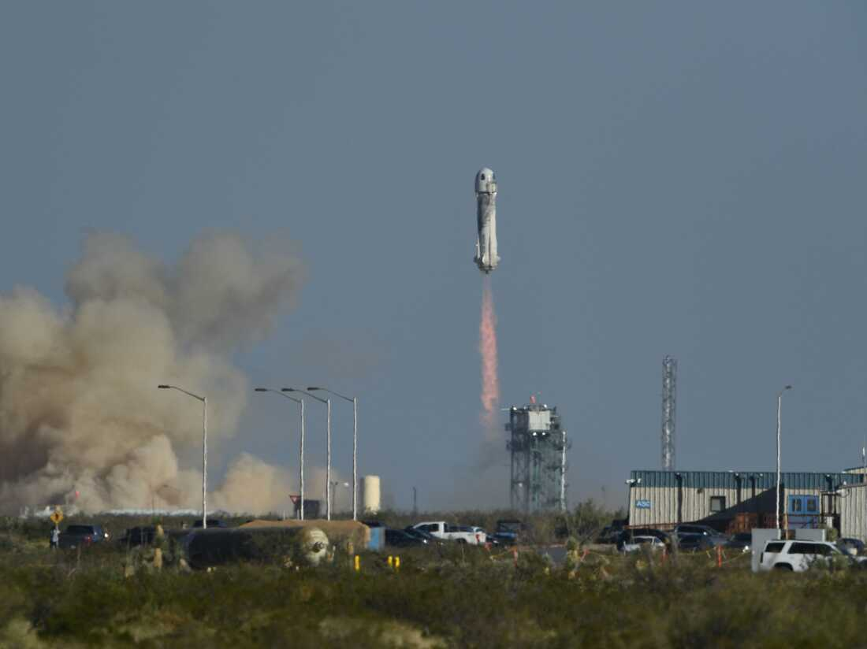

The New Shepard rocket launched on October 13, 2021 with Shatner on board.

Patrick T. Fallon/AFP via Getty Images

Although we are just dangling, Shatner adds that we're dangling together.

"We're entangled with each other," he said, decrying conflicts between human beings. "We have a war ... the stupidity of it all is so obvious."

Like Shatner, astronauts often return from space more convinced of the interconnectedness of humanity. According to White, space travelers return to our planet with "a greater distaste for war and violence, and a desire to do something to improve life back on the surface, because they've seen the truth of our situation."

And although the truth may not be pretty, a more universal perspective can only aid in reconnecting our long disconnected species. White says that astronauts return more eager than ever to be part of the solution, so that humanity may, one day, live long and prosper.

END