**Don R. Patton, Ph.D.**

http://www.bible.ca/tracks/ask-creationist.htm

Email: [dpatton693@aol.com](mailto:dpatton693@aol.com)

|  |  |
| --- | --- |
|  |  |
| **Worked as Geologist** inUS, Canada, Australia, England, Mexico, Peru, Bolivia, Jordan, Israel and Turkey. | |
| Participated in dinosaur excavations in Colorado, Texas, Wyoming, Canada.    Dr. Don Patton is pictured excavating a stegosaurus, together with a Camarasaurus, near Dinosaur, Colorado. | [click to view](http://www.bible.ca/tracks/tracks-Dr-Don-Patton-PhD+dino.jpg) |
| [click to view](http://www.bible.ca/tracks/don-patton-geologist-excavator-turnage-patton-136-continuous-dinosaur-trail.jpg) | [Turnage-Patton Dinosaur Trail](http://www.bible.ca/tracks/turnage-patton-trail.htm)  136 continuous dinosaur tracks    Supervised the excavation of the longest consecutive dinosaur trail on the American continent. |
|  |  |
| **Worked as an Archeologist**  inthe United States, Mexico, Peru, France, Italy, Israel, Jordan, Cambodia, Turkey. | |
| [click to view](http://www.bible.ca/tracks/don-patton-geologist-excavator-cambodia-stegosaurus.jpg) | [Cambodian Stegosaurus](http://www.bible.ca/tracks/tracks-cambodia.htm) Temple of Ta Prohm  Dr. Patton, along with Dr. Dennis Swift, discovered a stone carving of a dinosaur, an obvious Stegosaurus on the outer wall of the Cambodian temple of Ta Prohm, originally dedicated in 1186 AD. |
| **Israel: Pool of Siloam**  Excavated at the City of David under Eli Sukron of the Israeli Dept. Antiquities *(Pool of Siloam, 2004-08; Tower of Siloam, 2005-06, Palace of David, 2007-08)*  Learn more about the [pool of Siloam](http://www.bible.ca/archeology/bible-archeology-pool-of-siloam.htm). | [click to view](http://www.bible.ca/tracks/don-patton-archeologist-excavator-pool-of-siloam.jpg) |
| [click to view](http://www.bible.ca/tracks/don-patton-geologist-excavator-joshuas-altar.jpg) | **Israel: Joshua's altar** Participated in Altar of Joshua excavations at Mt. Ebal under Adam Zertal, U. of Haifa.  Learn more about [Joshua's Altar](http://www.bible.ca/archeology/bible-archeology-altar-of-joshua.htm). |
| **Israel: Qum'ran**  Geological Consultant for the Qumran Plateau Excavation under Randall Price. This  is the site of the discovery of the Dead Sea Scrolls. | [click to view](http://www.bible.ca/tracks/don-patton-geologist-excavator-qumran.jpg) |
| [click to view](http://www.bible.ca/tracks/don-patton-geologist-excavator-qumran-cave-1.jpg) | View on line [video presentation of the Dead Sea Scrolls](http://www.bible.ca/tracks/videos-quotes.htm) by Dr. Patton |
|  |  |
| **Searching for Noah's Ark** | |
| **Noah's Ark:** Dr. Patton climbed Mt Ararat, investigating possible location of Noah's ark in 2008, 2009 and twice in 2010. An exciting, promising expedition is planned for 2011. | [click to view](http://www.bible.ca/tracks/don-patton-geologist-excavator-ark-hunter-mt-ararat-noahs-ark.jpg) |
| **[click to view](http://www.bible.ca/tracks/don-patton-geologist-excavator-ark-hunter-mt-ararat-noahs-ark-summit-17000ft.jpg)** | Learn about Dr. Patton's personal investigation of the fraudulent claims to have found the ark, made recently by a Chinese evangelistic group (NAMI).    Details: [www.Noahs-Ark.TV](http://www.Noahs-Ark.TV) |
|  |  |
|  |  |

**Professional Profile of Dr. Don Patton:**

**Professional membership affiliation:**

1.      American Association For The Advancement Of Science

2.      Geological Society of America (Spoke at annual convention)

3.      The Society of Vertebrate Paleontology

**4.    Society for Sedimentary Geology**

5.      National Speleological Society

6.      International Who's Who, Honored Member

**Lectured on college campuses, including:**

1.      Austin Peay State University, Clarksville, TN

2.      Fresno State University, Fresno, CA

3.      Lamar University, Beaumont, TX

4.      Louisiana State University, Baton Rouge, LA

5.      McMaster University, Hamilton, OT, Canada

6.      Ogelthorpe University, Atlanta, GA

7.      Texas A&M University, College Station, TX

8.      Texas A&M University, Galveston, TX

9.      Texas A&M University, Commerce, TX

10.  University of Central Arkansas, Conway, AR

11.  University of Southwestern Missouri, Joplin, MO

**Additional experiences include:**

1.      Conducted up to twelve Creation/Evolution Seminars a year for thirty years

2.      Numerous public debates on creation/evolution including radio and TV debates

3.      Appeared on NBC Special w/Charlton Heston: *"Mysterious Origins of Man"*

4.      Testified three times before Texas State Textbook Committee, Austin, TX

5.      Staff geologist of Creation Evidence Museum, Glen Rose, TX

6.      Vice Chairman of Metroplex Institute of Origin Science

7.      Preached the gospel as an evangelist for over 40 years

**Education:**

1.      Florida College, Temple Terrace, FL (Bible) 1959-1963

2.      Austin Peay State University, Clarksville, TN (Geology) 1973-1974

3.      Indiana Univ./Purdue Univ., Indianapolis, IN (Geology) 1974-1976

4.      Pacific School of Graduate Studies, Melbourne, Australia (Geology) 1989-1991

5.      Pacific School of Graduate Studies, Melbourne, Australia (Education) 1992-1993

6.      Ph.D. in Education granted 12/10/1993 (Pacific School of Graduate Studies)  
(A brief history of the [Pacific School of Graduate Studies](http://www.bible.ca/tracks/Pacific-College-of-Graduate-Studies-Melbourne-Australia-brief-history.htm) in Melbourne, Australia, [click here](http://www.bible.ca/tracks/Pacific-College-of-Graduate-Studies-Melbourne-Australia-brief-history.htm).)

[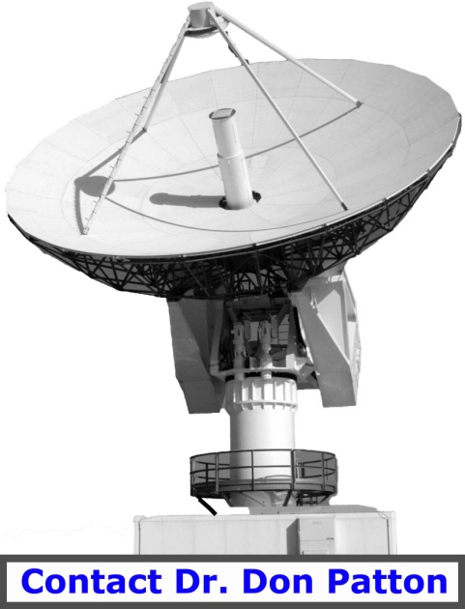](mailto:dpatton693@aol.com?subject=Question%20from%20Bible.ca)

[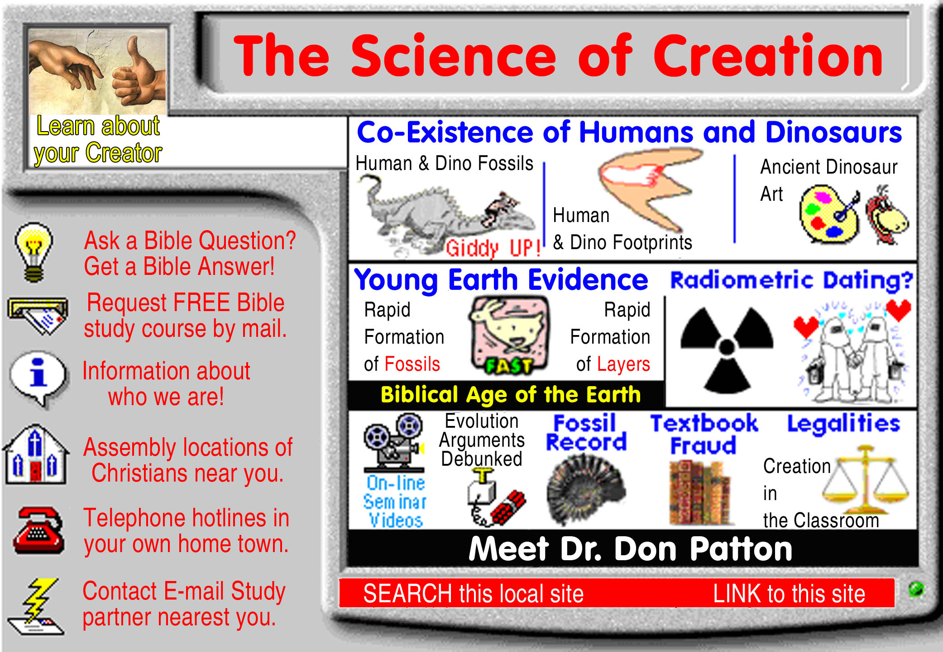](http://www.bible.ca/tracks/tracks.map)

[Go To Start: WWW.BIBLE.CA](http://www.bible.ca/)