**7 Ways EMF Technology Seriously Threatens Entire Populations**

[Print Friendly or Save as PDF](https://wakeup-world.com/2017/10/31/7-ways-emf-technology-seriously-threatens-entire-populations/)

[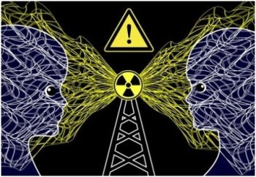](https://wakeup-world.com/wp-content/uploads/2017/10/7-Ways-EMF-Technology-Seriously-Threatens-Entire-Populations-Picture-1.jpg)

October 31st, 2017

By [Paul A. Philips](http://www.newparadigm.ws/)

Guest writer for [Wake Up World](https://wakeup-world.com/2017/10/31/7-ways-emf-technology-seriously-threatens-entire-populations/)

Recently, over 180 medics and scientists sent a document to the European Union appealing for the suspension of the new 5G EMF technology planned to roll out. Essentially, the 11 page document warns that EMF technology is a serious environmental hazard, harmful to life. That the new 5G EMF technology has not been properly tested for safety and has been blindly approved without health evaluation. The medics and scientists call for a proper health evaluation and while being carried out a suspension of the [5G.](https://www.newparadigm.ws/articles/scientists-physicians-send-appeal-about-5g-rollout-health-dangers-to-the-european-union/)

However, the unconditional push for EMF technology continues. The push involves a number of individuals, particularly those in high places, biased and blinded by money or the want for control or [population reduction,](https://www.newparadigm.ws/my-blogs/7-ways-to-protect-yourself-from-the-ruling-elite-s-world-depopulation-agenda/) only seeing the EMF technology’s advantages. Flawed ideology and insanity ensues…

In reflection of this, if allowed to continue uncontested, here are 7 ways by which EMF technology seriously threatens not just the health and life of humans, but also endangers the existence of non-human populations through upsetting the delicate balance of life. Remember, without nature’s delicate and intricate balance we will cease to exist.

1. **Invisible nature of EMF’s**

Because of the invisible ubiquitous nature of EMF exposure, unable to see its effects, it has been met with relatively little protest from the people. Further, as with smoking, we have seen many cases of cover-up and denial of the evidence linking EMF’s to disease such as cancer.

It doesn’t help that there are long latency periods before any noticeable harm kicks in. Electrosensitivity -the reactions to EMF signals are many, making it difficult for doctors to diagnose, as symptoms are so diverse.

1. **Cell phone usage and cancer**

A number of us know that the mainstream media has been covering up the fact that there is a link between frequent long-term cell phone usage and cancer. The mainstream media don’t want to expose their major sponsors the cell phone industry on this matter.

Then there are the cell phone industry’s sponsored research establishments, deliberately designed to whitewash the industry with biased, false scientific claims that there is no link to cancer. Thus, both the mainstream media and the cell phone industry have done very little to protect its users. The same applies to users of other wireless applications in conjunction with the antennas or cell masts all operating on the harmful EM frequencies in the network.

A substance called melatonin is secreted by the pineal gland located at the base of the brain. Melatonin is an extremely powerful antioxidant. As with all anti-oxidants is has the effect of mopping up potential cell-damaging free radicals in the body. Thus, it plays a major role in cell repair; body rejuvenation and disease prevention. **Melatonin is produced during sleep and herein lays the problem:**

Night time and sleep serve as a signal for the pineal gland to produce melatonin, but EMF’s suppress the production**. The pineal gland can’t tell the difference between natural light and EMF waves.** Bathing in a sea of ubiquitous EMF’s waves, with the pineal gland unable to detect night time leads to a lack of melatonin production and immunological protection. In the long run this may lead to disease such as cancer.

[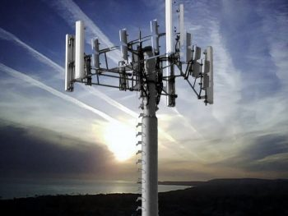](https://wakeup-world.com/wp-content/uploads/2017/10/7-Ways-EMF-Technology-Seriously-Threatens-Entire-Populations-Picture-2.jpg)

1. **Other Diseases**

Not just cancer, the melatonin deficiency may lead to other [serious illnesses](https://www.newparadigm.ws/articles/34-scientific-studies-showing-adverse-health-effects-from-wi-fi/) such as heart disease. Indeed, we need to understand this and take the necessary precautions. For example, at least keep your wireless application at a distance from your body during sleep…  (More on illnesses through EMF’s and precautions to follow).

*Wireless radiation in the MHz, GHz and THz is millions, billions and trillions times (respectively) the normal frequency of the Earth – the Schumann Resonance of 7.83 Hz. [*[*Source*](https://wakeup-world.com/2017/04/10/5g-and-iot-total-technological-control-grid-being-rolled-out-fast/)*]*

*Also see:* [*Is Your Heart Being Electromagnetically Distorted by Microwave Radiation?*](https://wakeup-world.com/2016/05/07/is-your-heart-being-electromagnetically-distorted-by-microwave-radiation/)

1. **Schumann resonance and circadian rhythms**

The Schuman resonance frequency (7.83Hz) has been described as the Earth’s universal magnetic pulse. An experiment by [Professor R.Wever](http://new-paradigm.ws/experiment-proves-staying-tune-earths-pulse-key-wellbeing/) showed that when subjects were kept underground and isolated from the Schuman resonance frequency, after a while, they developed a whole range of nervous, hormonal and behavioural problems.

What’s this got to do with EMF’s? **–EMF’s and the related wireless technology interfere with the Schuman resonance and the body’s natural circadian rhythm.** When coming out of the underground, receiving the Schumann resonance again, the subjects became well. In humans, brain alpha waves are virtually identical to the Schuman resonance, needed for healthy function.

EMF pollution also interferes with the circadian rhythms of plants and animals.

1. **Bee colony collapse disorder**

As well as humans, animals and insects are sensitive to electromagnetic frequencies. Besides pesticides, it has been said that another major explanation for the large drop in [bee populations](https://www.newparadigm.ws/natural-health/wakeup-call-347-native-bee-species-spiraling-toward-extinction/) in many countries is that the EMF technology interferes with the bee’s own sensory electromagnetic frequencies used in its navigational system.

This has been proven experimentally. For example, by Dr John Kuhn. He found that when cell phones were placed at hives far fewer bees returned than normally over recorded time intervals. Placing a cell phone at one of the hives had the effect of NO returning bees. -The bees could not navigate their way back to the hives due the cell phone’s [interference with their navigational system.](http://emfsafetynetwork.org/cell-phone-radiation-disturbs-honey-bees/)

Roughly 70% of the world’s crops are pollinated by bees. Consider the dire consequences of EMF pollution on the bee population if this insect is not around to play its vital role in pollination, affecting the food chain and seriously upsetting the [balance of nature.](https://www.naturalblaze.com/2016/10/do-you-really-understand-the-health-risks-from-microwave-technology.html)

[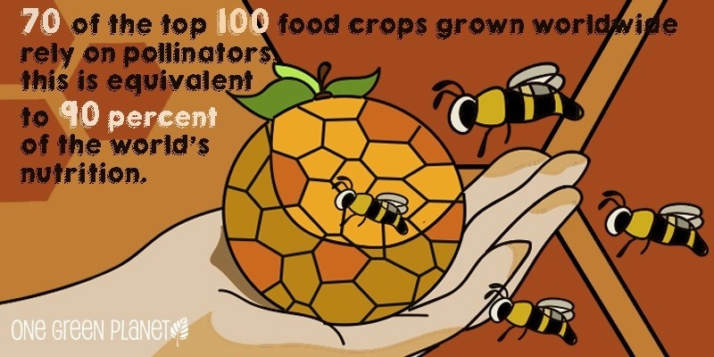](https://wakeup-world.com/wp-content/uploads/2017/10/7-Ways-EMF-Technology-Seriously-Threatens-Entire-Populations-Picture-3.jpg)

1. **Cryptochromes**

Not just bees, but in animals, EMF’s disrupt the navigational ability by affecting [cryptochrome cells](http://www.definitions.net/definition/CRYPTOCHROME) present in the eye. The cryptochrome cells give insects and animals the ability to physically see changing energy waves located for flight guidance.

For example, the lowest intensity of EMF’s can disrupt the cryptochrome cells in birds and their ability for flight guidance during migration. Butterflies have this biological compass and their navigational system is also affected by the EMF’s. Consequently, the bird, bee, butterfly and other [insect populations have declined.](https://www.newparadigm.ws/articles/the-windscreen-phenomenon-why-your-car-is-no-longer-covered-in-dead-insects/)

1. **Lack of acknowledgement to hypersensitivity**

The harmful effects of EMF technology are confounded by a lack of acknowledgement, funding and research by **independent scientists not having industry ties.**The WHO (Word Health Organization) as with other agencies acknowledges the dangers such as the potential carcinogenic effects, but more research is desperately needed on [electromagnetic hypersensitivity.](https://www.newparadigm.ws/articles/prestigious-karolinska-institute-forces-emf-researcher-to-retire-a-call-to-action/) The results from this research can be used to not only expose the industry related biased science, moneyed self-interests and unethical, immoral reckless disregard for health, but also establish the vital and necessary precautions needed.

**Finally…**

Once again, as with so many things we are facing in this end-game scenario, one positive action we can all take is to stop cooperating. Refuse to have a ‘smart meter’ (dumb meter) installed, stop using the EMF applications. At least don’t give these applications to your children.

The new 5G, if allowed to roll out, is a [health crisis waiting happen](https://www.newparadigm.ws/my-blogs/5g-technology-a-health-crisis-waiting-to-happen/) and the harmful ubiquitous EM frequencies produced will be *everywhere***.** Get campaigning in any way you can to raise public awareness so that something can be done…

Do it not just for the future of you, your family and friends, but for the life of entire non-human populations, before it’s too late.

**Recommended articles by Paul A. Philips:**

* [Played By The System: It’s Time For a New Paradigm](https://wakeup-world.com/2017/08/07/played-by-the-system-its-time-for-a-new-paradigm/)
* [Consciousness is the Key to World Change](https://wakeup-world.com/2017/08/30/consciousness-is-the-key-to-world-change/)
* [Monopoly Medicine: How Big Pharma Stops Its Competitors and Monopolizes the Health Industry](https://wakeup-world.com/2016/08/27/monopoly-medicine-how-big-pharma-stops-its-competitors-and-monopolizes-the-health-industry/)
* [Permaculture: The Future of Self-Sufficient, Community-Based Living](https://wakeup-world.com/2016/11/17/permaculture-the-future-of-self-sufficient-community-based-living/)
* [The Deliberate Dumbing Down of America: 7 Ways the Ruling Elite Are Making Us Dumber](https://wakeup-world.com/2016/10/24/the-deliberate-dumbing-down-of-america-7-ways-the-ruling-elite-are-making-us-dumber/)
* [10 Signs of Our Global Awakening](https://wakeup-world.com/2016/06/08/10-signs-of-our-global-awakening/)
* [Another Brick In The Wall – Modern Education and the System of Deception](https://wakeup-world.com/2015/10/13/another-brick-in-the-wall-modern-education-and-the-system-of-deception/)
* [World Transformation: 7 Paradigm-Shifting Humanitarian Solutions](https://wakeup-world.com/2017/03/22/world-transformation-7-paradigm-shifting-humanitarian-solutions/)
* [7 Things Ridiculed By Conventional Science – But Which Are Said To Be True](https://wakeup-world.com/2015/12/22/7-things-ridiculed-by-conventional-science-but-which-are-said-to-be-true/)
* [The Magic of Being in the Here and Now](https://wakeup-world.com/2017/04/13/the-magic-of-being-in-the-here-and-now/)
* [7 Suppressed Technologies That Could Have Changed the World](https://wakeup-world.com/2017/09/10/7-suppressed-inventions-that-could-have-changed-the-world/)

**About the author:**

[](https://wakeup-world.com/wp-content/uploads/2015/09/Paul-A-Philips-.jpg)*Paul Philips:*My blogs, articles and videos and my related alternative news/natural health website [NewParadigm.ws](http://www.newparadigm.ws/) are my stand for the possibility of creating a world that makes a difference for everyone. I graduated in biomedical sciences. My website is slanted on health matters and exposes the related deceptions…

However, over the years I have come to the firm conclusion that just about every subject under the sun needs redefining using more truthful, honest and integral approaches in theory and practice, hence the name ‘New Paradigm’. From these new approaches, from the ‘imagination of ourselves,’ from our visions – a ‘new era’ in humanity can result!

Please visit [NewParadigm.ws](http://www.newparadigm.ws/) for more.